**DESIGN AND IMPLEMENTATION OF A WEB BASED LECTURER EVALUATION SYSTEM**

**(A CASE STUDY OF ELECTRICAL AND ELECTRONICS ENGINEERING DEPARTMENT, ISA MUSTAPHA AGWAI I POLYTECHNIC (IMAP), LAFIA)**

**By**

## 1. Jibrin Abdullahi

## Jibo1abdullahi@gmail.com

## 2.Aminu Alhaji Abdulhamid

## aminujeto@gmail.com

## 3.Andah Mamman

## andahmamman@gmail.com.

## Department of Electrical and Electronics Engineering Technology,

## Isa Mustapha Agwai l Polytechnic,Lafia.

## 

## Abstract: *The evaluation of lecturers is essential for upholding educational standards and enhancing teaching quality in academic institutions. This study introduces a web-based Lecturers’ Evaluation System (LES) designed specifically for the Electrical and Electronics Engineering Department at Isa Mustapha Agwai I Polytechnic (IMAP), Lafia. To develop this system, we employed a structured System Analysis and Design Methodology (SSDAM). The system was built using PHP, CSS5, HTML, JavaScript, and MySQL. The application consists of three modules: Admin, Student, and Lecturer. The Admin module allows for the creation of students, courses, evaluation questions, and criteria. It also enables the management of lecturers, academic sessions, and evaluation reports. The Student module provides a platform for students to rate their lecturers at the end of each semester, while the Lecturer module allows lecturers to view their ratings at the end of the evaluation period. The study utilized both primary and secondary data sources. The goal of the system was to simplify the lecturer evaluation process by offering a user-friendly and efficient platform for students. By harnessing web-based technologies, the system provides flexibility and accessibility, enabling students to submit evaluations conveniently from any location with internet access.*

**Keywords:** Evaluation, rating, system, module

**Introduction**

The evaluation of lecturers is a vital aspect of maintaining quality in higher education institutions. It helps assess teaching effectiveness, pinpoint areas for improvement, and enhance overall educational outcomes. Traditionally, lecturer evaluations at IMAP might have relied on paper-based surveys or manual processes, which can be cumbersome, time-consuming, and prone to errors. These traditional methods also face challenges such as data loss, inconsistent feedback collection, and delayed reporting.

To address these issues, a web-based Lecturers’ Evaluation System (LES) offers a practical solution. This system utilizes web technologies to streamline the evaluation process, making it more efficient, transparent, and accessible to stakeholders, especially students. The Electrical and Electronics Department at IMAP is an ideal candidate for this case study due to its diverse range of courses and the ongoing need for improvements in teaching methodologies.

By implementing a web-based LES, the department aims to achieve several objectives: Enhanced Efficiency: Automating the collection and aggregation of feedback saves time for both students and administrative staff, resulting in quicker evaluation processes. Improved Accuracy: Digital surveys minimize errors related to manual data entry and processing, leading to more reliable and consistent evaluation results. Transparency and Accountability: A user-friendly interface for submitting evaluations promotes transparency and encourages lecturers to actively seek feedback and engage in professional development. Data-Driven Decision Making: The LES generates detailed reports and analytics that support evidence-based decision-making for department administrators and faculty members. Continuous Quality Improvement: Systematic feedback collection helps identify strengths and areas for improvement in teaching practices, curriculum design, and student engagement. The platform includes the following features: User Authentication: Secure login for students to access the system. Questionnaire Design: Customizable evaluation forms to gather specific feedback on teaching effectiveness, course content, and lecturer interaction. Data Collection: Automated aggregation of evaluation data for comprehensive analysis. Reporting and Analysis: Detailed reports and statistical analysis provide actionable insights for departmental decision-making. Accessibility: Compatibility with various devices (desktops, tablets, and smartphones) ensures ease of use across different platforms.

**Objectives of the Study**

The primary objective of this study was to design and implement a Web Based Lecturer Evaluation System for Isa Mustapha Agwai I Polytechnic, Lafia, a case study of Electrical and Electronic Engineering Department. The following specific objectives were pursued:

1. To develop a platform where students rate their lecturers at the end of a semester.
2. To create a form of decision making system for the institution regarding lecturers’ promotion, appointment, and retrenchment etc.
3. To develop a form of personal work performance check system for lecturers

**Significance of the Study**

The design and implementation of a web-based Lecturers’ Evaluation System (LES) for the Electrical and Electronics Department at Isa Mustapha Agwai I Polytechnic (IMAP), Lafia, hold significant importance in several key areas:

Enhanced Educational Quality Assurance: The LES will serve as a tool to systematically collect feedback from students regarding teaching effectiveness, course content relevance, and lecturer-student interactions. This data will enable IMAP to uphold and enhance educational standards by identifying areas for improvement and implementing targeted interventions.

Promotion of Accountability and Transparency: By implementing a web-based LES, IMAP promotes transparency in the evaluation process. Students can provide anonymous feedback, encouraging honesty in their responses. This transparency fosters accountability among lecturers to continuously improve their teaching methods and engage actively with student feedback.

Efficiency in Data Management: Moving from paper-based evaluations to a digital platform streamlines the data collection and management process. Automated data aggregation and reporting reduce administrative burden and allow for faster dissemination of evaluation results. This efficiency enables timely decision-making regarding faculty development, curriculum enhancement, and resource allocation.

Support for Evidence-Based Decision Making: The LES generates comprehensive reports and analytics based on aggregated feedback. These insights provide departmental administrators and faculty members with actionable data to make evidence-based decisions. For example, identifying lecturers who excel in specific teaching methodologies or pinpointing areas where additional support and training are needed.

Alignment with Global Educational Standards: Implementing a web-based LES aligns IMAP with global best practices in educational quality assurance. It demonstrates a commitment to continuous improvement and responsiveness to the needs of stakeholders, including students, faculty, and external accrediting bodies.

Facilitation of Continuous Improvement: The LES serves as a mechanism for ongoing assessment and improvement of teaching and learning processes within the Electrical and Electronics Department. By fostering a culture of continuous improvement, IMAP can adapt quickly to changing educational trends and student expectations.

Empowerment of Stakeholders: The LES empowers students by giving them a voice in evaluating their educational experience. It also empowers lecturers by providing constructive feedback that supports professional growth and development.

**Literature Review**

Students’ rating of teachers’ teaching effectiveness is not a recent phenomenon in the world of Education. The initiative to evaluate teaching effectiveness started as early as 1915 [5]. The first teacher rating scale was published in 1915 and the first study of students’ evaluation of teacher’s effectiveness was in 1920 [5]. The outcome of students’ rating of teachers’ effectiveness is an important tool for measuring the teaching quality of a teacher. This helps to reflect on qualities associated with good teaching such as teachers’/lecturers’ subject knowledge, communication skills or ability, classroom management, use of effective teaching strategies, good lecturer cum students’ relationship, punctuality and coverage of the curriculum [7]

Moreover, according to [3], besides being a measurement tool, the feedbacks obtained from the rating can help the teachers/lecturers concerned to grow and develop professionally through self-reflecting on their practices. To the institution, the results of the evaluation is beneficial to identifying specific areas for improving the effectiveness of the teachers/lecturers and as such organizing relevant continuous in-service professional development trainings for skill enhancement [7]. The outcome of the evaluation can be used to formulate key performance index for teachers/lecturers in staff appraisal for both promotion and tenure decisions [2]

Although methodological problems have been identified in students’ rating of their teachers but there are good support for both the reliability and validity of student ratings. Overall, the literature supports the view that, properly designed student ratings can be a valuable source of information for evaluating certain aspects of lecturer teaching effectiveness [6]

**Methodology**

The structured system analysis and design methodology was used. The stages involved are as follows:

1. Needs Assessment and Requirements Gathering

Stakeholder Identification: Identify key stakeholders including students, lecturers, administrators, and IT support staff.

Needs Assessment: Conduct surveys, interviews, and workshops to understand current evaluation processes, challenges faced, and desired functionalities.

Requirements Gathering: Document functional and non-functional requirements based on stakeholder feedback and best practices in educational evaluation systems.

2. System Design

Architecture Design: Determine the overall system architecture, including client-server model, database schema, and integration points.

User Interface Design: Design intuitive and user-friendly interfaces for students to provide evaluations and for administrators to manage the system.

Database Design: Develop a robust database schema to securely store evaluation data, ensuring data integrity and efficient querying.

3. Development

Frontend Development: Implement frontend components using modern web technologies (HTML5, CSS3, JavaScript) to create responsive and accessible user interfaces.

Backend Development: the backend and front end functionalities was developed using PHP,Mysql, HTML, JSP to handle user authentication, data storage, and processing.

Integration: third-party libraries or APIs for features like data visualization, reporting, and email notifications were integrated

4. Implementation

Deployment Planning

Testing: Conducted unit testing, integration testing, and user acceptance testing (UAT) to ensure the system meets functional and performance requirements.

Training: Provided training sessions for administrators, lecturers, and students on how to use the system effectively.

5. Evaluation and Iteration

Pilot Testing: Deployed the system in a controlled environment (e.g., pilot testing with a select group of students and lecturers).

Feedback Collection: Gathered feedback from users regarding system usability, functionality, and performance.

Iterative Improvement: Incorporated feedback to make iterative improvements to the system, addressing identified issues and enhancing user experience.

6. Documentation and Maintenance

Documentation: Prepared comprehensive system documentation including user manuals, technical specifications, and troubleshooting guides.

Maintenance Plan: Develop a maintenance plan outlining procedures for system updates, bug fixes, and ongoing support.

Monitoring and Evaluation: Implemented monitoring tools to track system performance, usage metrics, and user satisfaction over time.

7. Ethical Considerations

Data Privacy: Ensured compliance with data protection regulations (e.g., GDPR, CCPA) by implementing secure data handling practices and obtaining necessary permissions for data collection and storage.

Anonymity and Confidentiality: Maintained anonymity of student respondents and ensure confidentiality of evaluation data to encourage honest feedback.

8. Project Management

Timeline and Milestones: Developd a project timeline with clear milestones for each phase of development and implementation.

Risk Management: Identified potential risks (e.g., technical challenges, resistance to change) and develop mitigation strategies to minimize their impact.

Communication: Established regular communication channels with stakeholders to provide updates, gather feedback, and address concerns throughout the project lifecycle.

**System Design**

**Database Format:**

The relational Database Management System (DBMS) was used and it contained the following tables:

Table 1: **Login**

|  |  |  |
| --- | --- | --- |
| **Name** | **Data type** | **Length** |
| Username | Varchar | 30 |
| Password | Varchar | 100 |

Table 2: **Criteria**

|  |  |  |  |  |  |
| --- | --- | --- | --- | --- | --- |
| **#** | **Name** | **Type** | **Collation** | **Null** | **Default** |
| 1 | **idPrimary** | int(30) |  | No | *None* |
| 2 | **Criteria** | text | utf8mb4_general_ci | No | *None* |
| 3 | **order_by** | int(30) |  | No | *None* |

Table 3: **Answers**

Top of Form

| **#** | **Name** | **Type** | **Null** | **Default** |
| --- | --- | --- | --- | --- |
| 1 | **evaluation_id** | int(30) | No | *None* |
| 2 | **question_id** | int(30) | No | *None* |
| 3 | **Rate** | int(20) | No | *None* |

Bottom of Form

Table 4**: Teacher**

Top of Form

| **#** | **Name** | **Type** |
| --- | --- | --- |
| 1 | **idPrimary** | int(30) |
| 2 | **teacher_id** | varchar(100) |
| 3 | **Firstname** | varchar(200) |
| 4 | **Lastname** | varchar(200) |
| 5 | **Email** | varchar(200) |
| 6 | **Password** | text |
| 7 | **date_created** | datetime |

Bottom of Form

Table 5: **Student**

|  |  |  |  |  |  |
| --- | --- | --- | --- | --- | --- |
| **#** | **Name** | **Type** | **Collation** | **Null** | **Default** |
| 1 | **idPrimary** | int(30) |  | No | *None* |
| 2 | **std_id** | varchar(100) | utf8mb4_general_ci | No | *None* |
| 3 | **firstname** | varchar(200) | utf8mb4_general_ci | No | *None* |
| 4 | **lastname** | varchar(200) | utf8mb4_general_ci | No | *None* |
| 5 | **email** | varchar(200) | utf8mb4_general_ci | No | *None* |
| 6 | **password** | Text | utf8mb4_general_ci | No | *None* |
| 7 | **class_id** | int(30) |  | No | *None* |
| 8 | **date_created** | datetime |  | No | CURRENT_TIMESTAMP |  |

Table 6: **Question**

Top of Form

| **#** | **Name** | **Type** | **Collation** | **Null** | **Default** | **Extra** |
| --- | --- | --- | --- | --- | --- | --- |
| 1 | **idPrimary** | int(30) |  | No | *None* | AUTO_INCREMENT |
| 2 | **academic_id** | int(30) |  | No | *None* |  |
| 3 | **question** | Text | utf8mb4_general_ci | No | *None* |  |
| 4 | **order_by** | int(30) |  | No | *None* |  |
| 5 | **criteria_id** | int(30) |  | No | *None* |  |

**Program Flow Diagram**

Insert URL

Login as Student, Admin or Lecturer

Is Username and Password Correct?

Yes

No

Admin page

Student rating page

Lecturer Page

**Input Format:**

Fig 1: Login

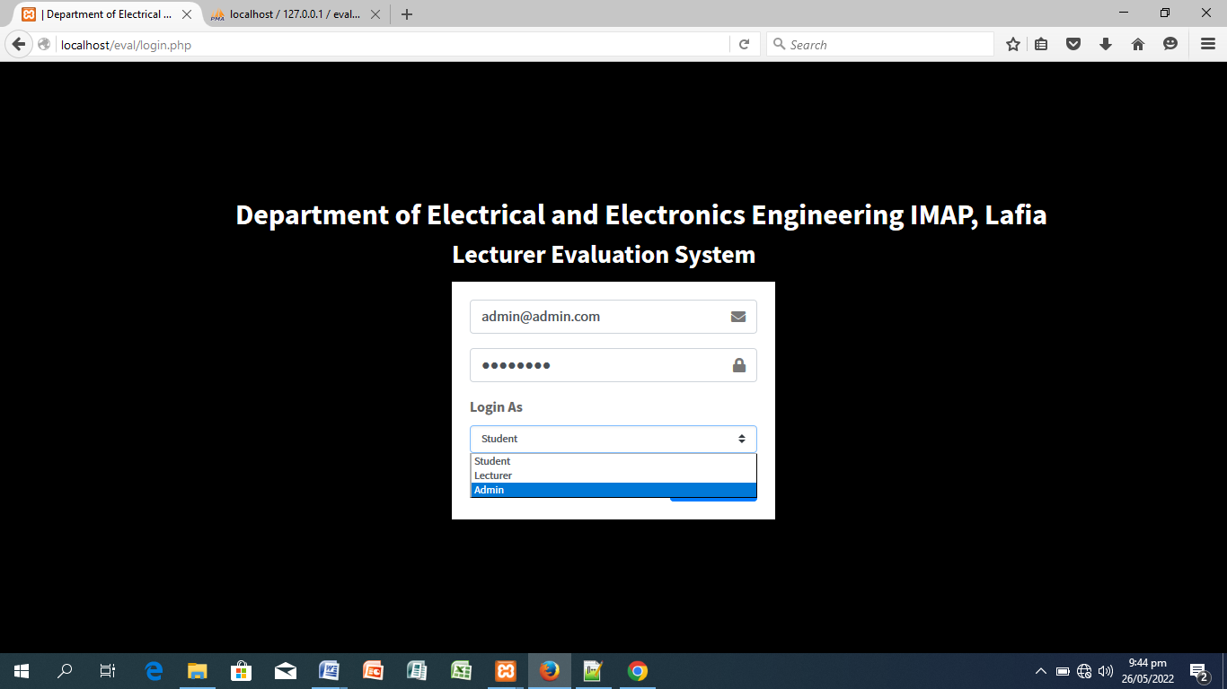

Fig 2: Adding new course

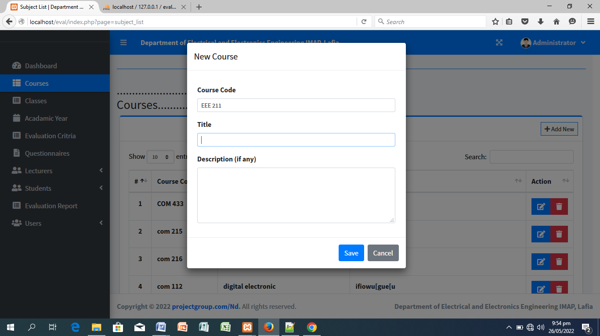

Fig 3: Adding new Class

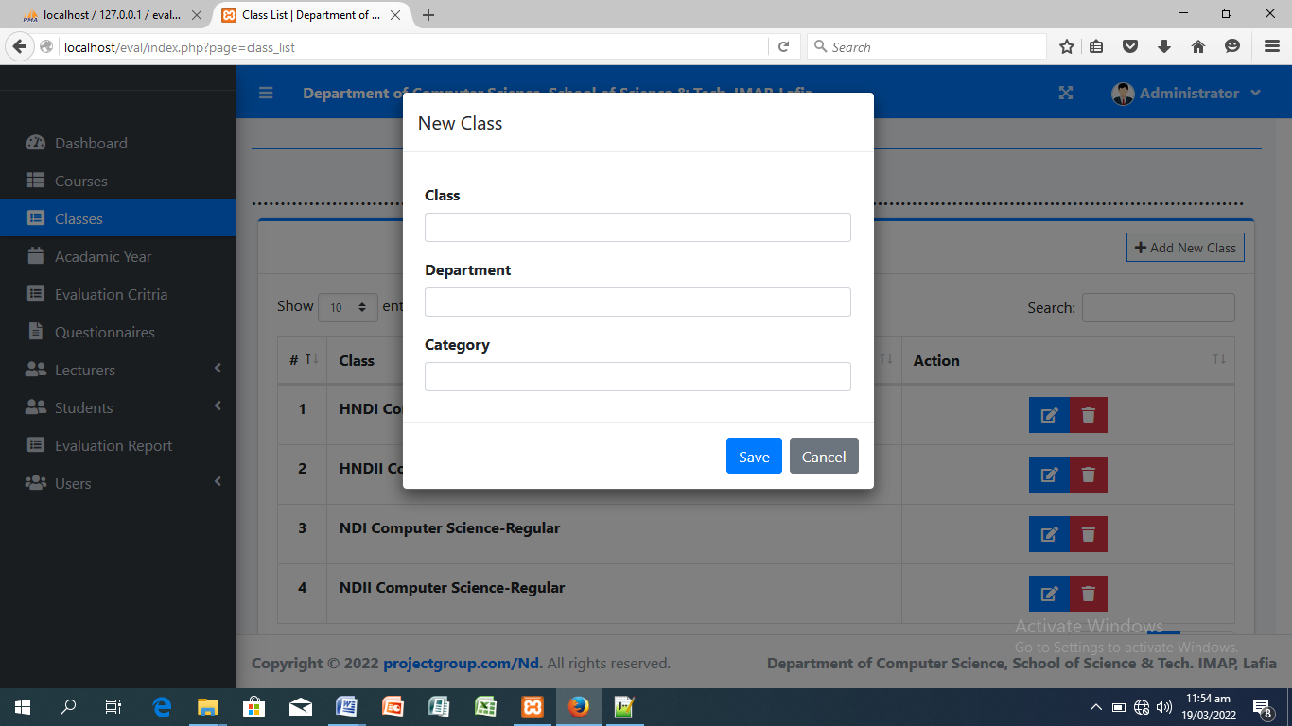

Fig 4: Setting the Academic year

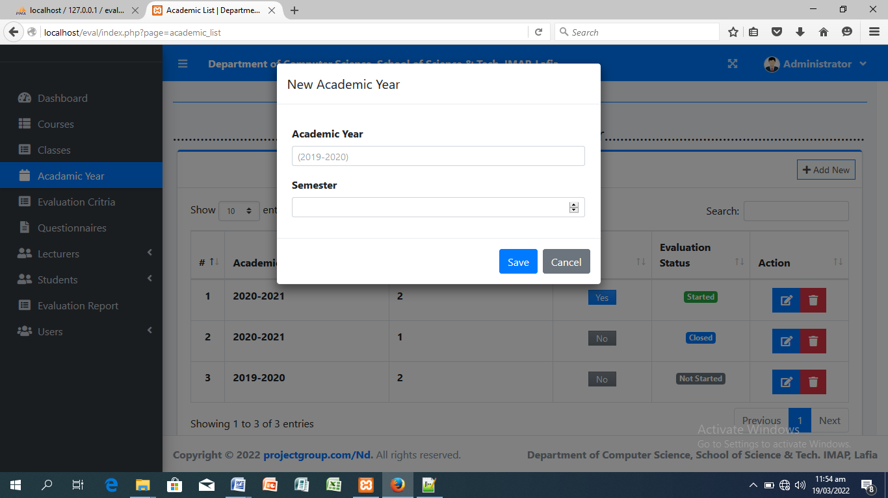

Fig 5: Adding Lecturer

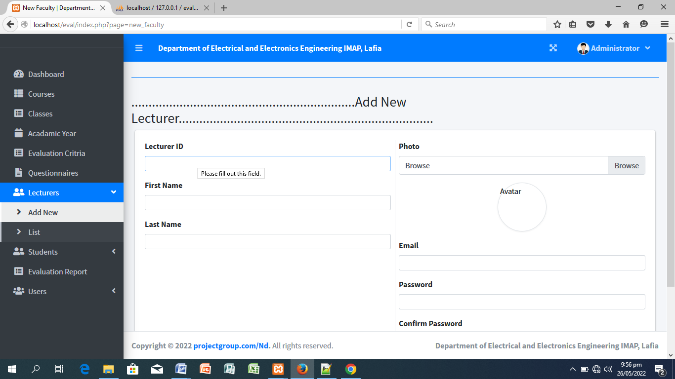

Fig 6: Adding Student

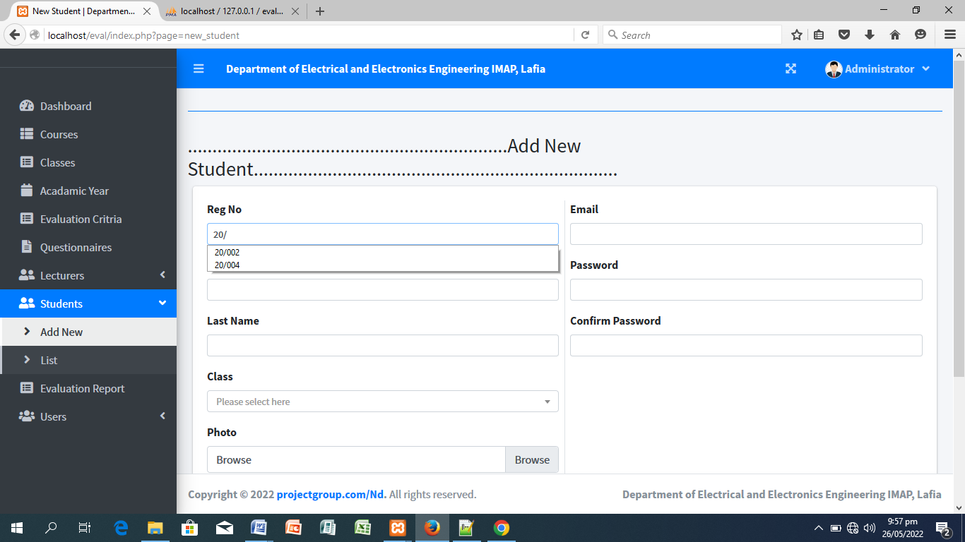

**Fig 7:** Evaluation Criteria

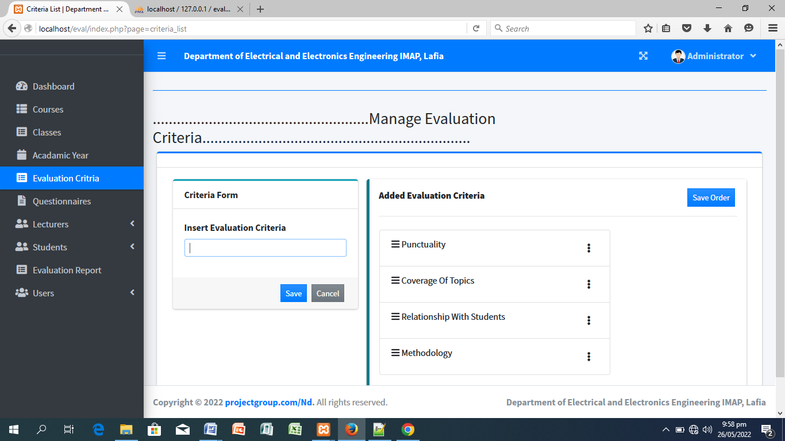

Fig 8: Evaluation question

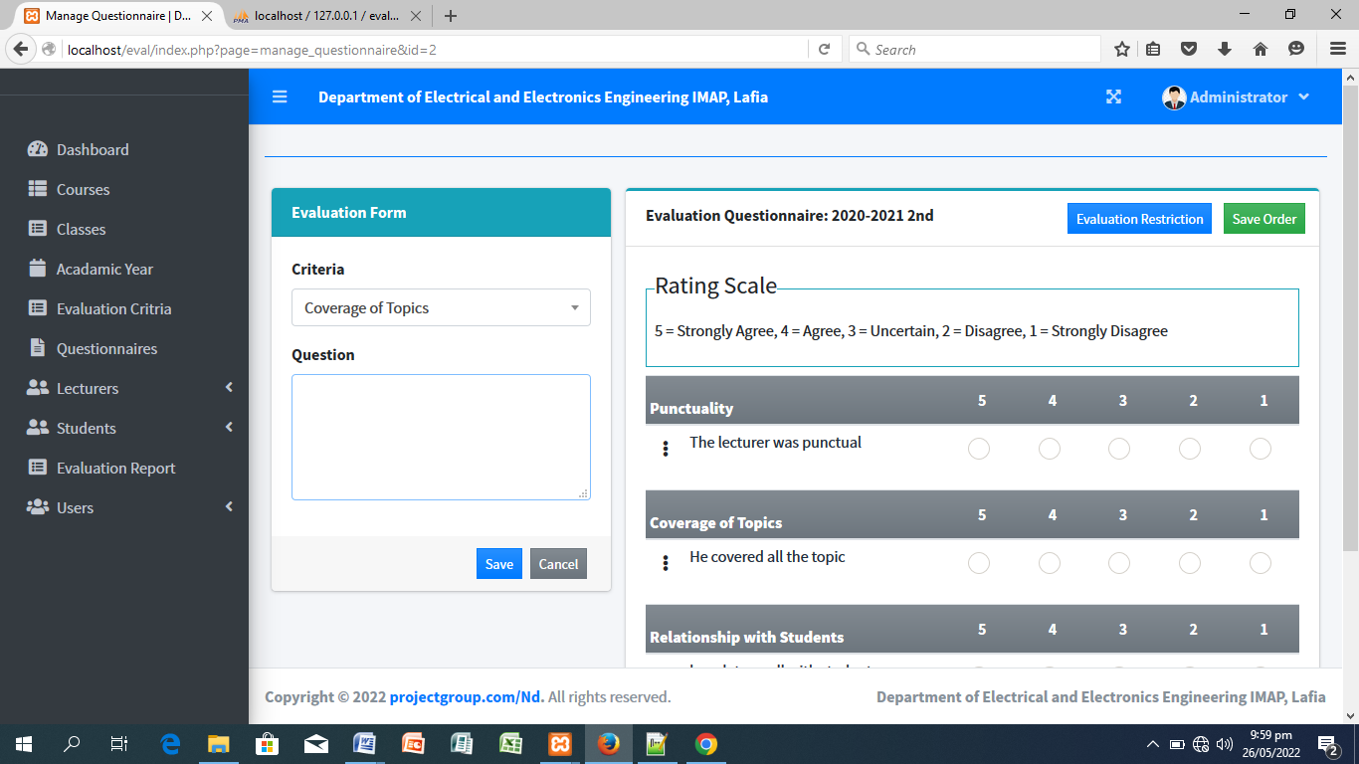

**Output Format:**

Fig 9: Manage Courses

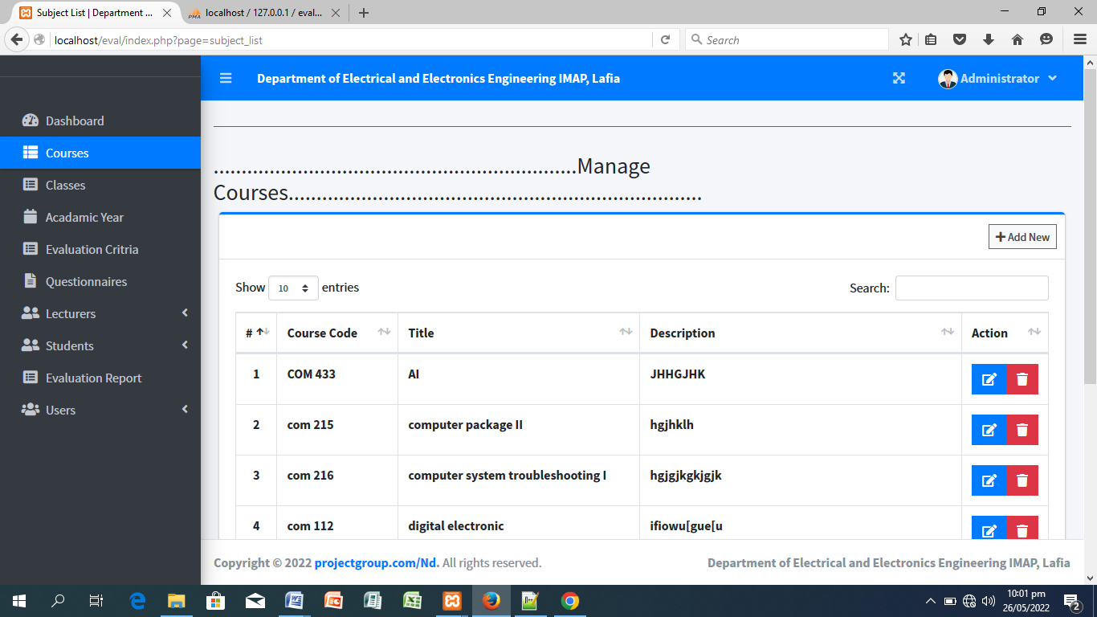

Fig 10: Evaluation Report

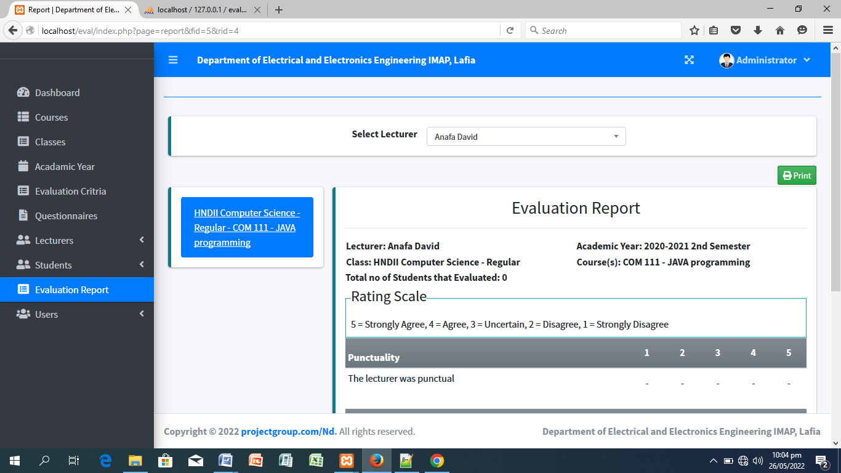

**System Implementation**

Structured system analysis and design was used to design the application. The implementation was done on Windows platform.

**System Requirement**

Hardware:

The minimum requirements for the application to run are:

1. Minimum of Pentium II and above.
2. Minimum of 126 MB RAM.
3. Minimum of 20 GB Hard disk.
4. An uninterrupted power supply (UPS)

Software:

1. Any version of windows operating system or Linux
2. Web browser (Mozilla Firefox or any other highly recommended browser).
3. Internet connectivity

**How to Use the Software**

1. Load the browser
2. Insert the URL to load the index page
3. Supply your login name and password and hit the enter key.

**Usability Test Result**

To evaluate the proper operation and robustness of the application, the software was locally hosted in Electrical department for a period of one semester in 2020-2021. To assess the educational value of the software, both student and lecturers were asked to complete a questionnaire. 7 lecturers and 15 students were sampled out of the entire staff and students of the department. They were asked the following four questions:

(i) User interface: How well did you find the ‘user interface’ of the application?

(ii) User friendliness: How easy (overall) did you find the software in terms of usage?

(iii) Robustness: How easy did you find it to start the application and exit from the it?

(iv) Functionality-logic and level of automation: How functional did you find the application in terms of logic and level of automation.

The scale 1-5 was used in the answers (1 = poor; 5 = excellent). 40 survey data were collected and the responses are contained in table 1.

**Table 1:** Usability Test Responses

|  |  |  |  |  |  |
| --- | --- | --- | --- | --- | --- |
| **Parameters** | **Poor (1)** | **Fair (2)** | **Good (3)** | **Very good(4)** | **Excellent (5)** |
| User interface | 0 (0%) | 0 (0%) | 0 (0%) | 10(45.5%) | 12(54.5%) |
| User friendliness | 0 (0%) | 0 (0%) | 2(9.1%) | 9(40.9%) | 11(50%) |
| Robustness | 0 (0%) | 0 (0%) | 0 (0%) | 6(27.3%) | 16(72.7%) |
| Functionality | 0 (0%) | 0 (0%) | 0 (0%) | 15(68.2%) | 7(31.8%) |

Table 1 shows that, 45% of the respondents perceived the user interface of the application as excellent while 45.5% perceive it to be very good. On user friendly feature of the software, over 90.9% of the respondents are quite satisfied with the software graphical user interface (GUI). Over 72.7% of the respondents perceived the software to be excellently robust while 27.3% were of the opinion that the software is very robust. They are satisfied with the current version of the software. In terms of functionality, over 68% of the respondent opined that the software is very functional, logic and automation wise while over 31.8% of the respondents perceived the software to be functionally excellent.

**Conclusion**

This study investigated lecturers’ teaching effectiveness using students’ end of semester evaluation. The findings of the study revealed that none of the items on lecturers’ teaching effectiveness was given an ‘excellent’ rating. The students perceived the teaching effectiveness of the lecturers as ‘good’ in 5 of the items surveyed. These five items were related to the lecturers’ ability in conducting teaching learning activities in accordance with the course pro-forma; providing awareness on the development of human capital, commitment to teaching and learning, monitoring and giving feedbacks and motivating students to pursue learning activities. This application is timely and definitely makes lecturers to sit up in their responsibilities.

**References**

[1] Bates, A. W., & Sangrà, A. (2011). *Managing Technology in Higher Education: Strategies for Transforming Teaching and Learning*. Jossey-Bass.

[2] Welling, L., & Thomson, L. (2016). *PHP and MySQL Web Development*. Addison-Wesley Professional.

[3] Tidwell, J. (2011). *Designing Interfaces: Patterns for Effective Interaction Design*. O'Reilly Media.

[4] Date, C. J. (2003). *An Introduction to Database Systems*. Addison-Wesley.

[6] Scriven, M., & Coryn, C. L. S. (2014). *Evaluation Theory, Models, and Applications*. Jossey-Bass.

[7] Reeves, T. C., & Cuthrell, K. (2012). *Research Foundations for Understanding Pedagogical Practices in Online Learning*. IGI Global.

[8] W., & Wang, S. (2013). *Web-Based Learning Solutions for Communities of Practice: Developing Virtual Environments for Social and Pedagogical Advancement*. IGI Global.

[9] Sommerville, I. (2016). *Software Engineering*. Pearson Education Limited.

**Appendix**

1. **PROGRAM CODES**

**Login Codes**

<!DOCTYPE html>

<html lang="en">

<?php

session_start();

include('./db_connect.php');

ob_start();

// if(!isset($_SESSION['system'])){

$system = $conn->query("SELECT * FROM system_settings")->fetch_array();

foreach($system as $k => $v){

$_SESSION['system'][$k] = $v;

}

// }

ob_end_flush();

?>

<?php

if(isset($_SESSION['login_id']))

header("location:index.php?page=home");

?>

<?php include 'header.php' ?>

<body class="hold-transition login-page bg-black">

<h2><b> <marquee><?php echo $_SESSION['system']['name'] ?> </marquee><b></h2>

<div class="login-box">

<h3><b>Lecturer Evaluation System</b></h3>

<div class="login-box">

<div class="login-logo">

<a href="#" class="text-blue"></a>

</div>

<!-- /.login-logo -->

<div class="card">

<div class="card-body login-card-body">

<form action="" id="login-form">

<div class="input-group mb-3">

<input type="email" class="form-control" name="email" required placeholder="Email">

<div class="input-group-append">

<div class="input-group-text">

<span class="fas fa-envelope"></span>

</div>

</div>

</div>

<div class="input-group mb-3">

<input type="password" class="form-control" name="password" required placeholder="Password">

<div class="input-group-append">

<div class="input-group-text">

<span class="fas fa-lock"></span>

</div>

</div>

</div>

<div class="form-group mb-3">

<label for="">Login As</label>

<select name="login" id="" class="custom-select custom-select-sm">

<option value="3">Student</option>

<option value="2">Lecturer</option>

<option value="1">Admin</option>

</select>

</div>

<div class="row">

<div class="col-8">

<div class="icheck-primary">

<input type="checkbox" id="remember">

<label for="remember">

Remember Me

</label>

</div>

</div>

<!-- /.col -->

<div class="col-4">

<button type="submit" class="btn btn-primary btn-block">Sign In</button>

</div>

<!-- /.col -->

</div>

</form>

</div>

<!-- /.login-card-body -->

</div>

</div>

<!-- /.login-box -->

<script>

$(document).ready(function(){

$('#login-form').submit(function(e){

e.preventDefault()

start_load()

if($(this).find('.alert-danger').length > 0 )

$(this).find('.alert-danger').remove();

$.ajax({

url:'ajax.php?action=login',

method:'POST',

data:$(this).serialize(),

error:err=>{

console.log(err)

end_load();

},

success:function(resp){

if(resp == 1){

location.href ='index.php?page=home';

}else{

$('#login-form').prepend('<div class="alert alert-danger">Username or password is incorrect.</div>')

end_load();

}

}

})

})

})

</script>

<?php include 'footer.php' ?>

</body>

</html>

**Index Page Codes**

<!DOCTYPE html>

<html lang="en">

<?php session_start() ?>

<?php

if(!isset($_SESSION['login_id']))

header('location:login.php');

include 'db_connect.php';

ob_start();

if(!isset($_SESSION['system'])){

$system = $conn->query("SELECT * FROM system_settings")->fetch_array();

foreach($system as $k => $v){

$_SESSION['system'][$k] = $v;

}

}

ob_end_flush();

include 'header.php'

?>

<body class="hold-transition sidebar-mini layout-fixed layout-navbar-fixed layout-footer-fixed">

<div class="wrapper">

<?php include 'topbar.php' ?>

<?php include $_SESSION['login_view_folder'].'sidebar.php' ?>

<!-- Content Wrapper. Contains page content -->

<div class="content-wrapper">

<div class="toast" id="alert_toast" role="alert" aria-live="assertive" aria-atomic="true">

<div class="toast-body text-white">

</div>

</div>

<div id="toastsContainerTopRight" class="toasts-top-right fixed"></div>

<!-- Content Header (Page header) -->

<div class="content-header">

<div class="container-fluid">

<div class="row mb-2">

<div class="col-sm-6">

<h1 class="m-0"></h1>

</div><!-- /.col -->

</div><!-- /.row -->

<hr class="border-primary">

</div><!-- /.container-fluid -->

</div>

<!-- /.content-header -->

<!-- Main content -->

<section class="content">

<div class="container-fluid">

<?php

$page = isset($_GET['page']) ? $_GET['page'] : 'home';

if(!file_exists($_SESSION['login_view_folder'].$page.".php")){

include '404.html';

}else{

include $_SESSION['login_view_folder'].$page.'.php';

}

?>

</div><!--/. container-fluid -->

</section>

<!-- /.content -->

<div class="modal fade" id="confirm_modal" role='dialog'>

<div class="modal-dialog modal-md" role="document">

<div class="modal-content">

<div class="modal-header">

<h5 class="modal-title">Confirmation</h5>

</div>

<div class="modal-body">

<div id="delete_content"></div>

</div>

<div class="modal-footer">

<button type="button" class="btn btn-primary" id='confirm' onclick="">Continue</button>

<button type="button" class="btn btn-secondary" data-dismiss="modal">Close</button>

</div>

</div>

</div>

</div>

<div class="modal fade" id="uni_modal" role='dialog'>

<div class="modal-dialog modal-md" role="document">

<div class="modal-content">

<div class="modal-header">

<h5 class="modal-title"></h5>

</div>

<div class="modal-body">

</div>

<div class="modal-footer">

<button type="button" class="btn btn-primary" id='submit' onclick="$('#uni_modal form').submit()">Save</button>

<button type="button" class="btn btn-secondary" data-dismiss="modal">Cancel</button>

</div>

</div>

</div>

</div>

<div class="modal fade" id="uni_modal_right" role='dialog'>

<div class="modal-dialog modal-full-height modal-md" role="document">

<div class="modal-content">

<div class="modal-header">

<h5 class="modal-title"></h5>

<button type="button" class="close" data-dismiss="modal" aria-label="Close">

<span class="fa fa-arrow-right"></span>

</button>

</div>

<div class="modal-body">

</div>

</div>

</div>

</div>

<div class="modal fade" id="viewer_modal" role='dialog'>

<div class="modal-dialog modal-md" role="document">

<div class="modal-content">

<button type="button" class="btn-close" data-dismiss="modal"><span class="fa fa-times"></span></button>

<img src="" alt="">

</div>

</div>

</div>

</div>

<!-- /.content-wrapper -->

<!-- Control Sidebar -->

<aside class="control-sidebar control-sidebar-dark">

<!-- Control sidebar content goes here -->

</aside>

<!-- /.control-sidebar -->

<!-- Main Footer -->

<footer class="main-footer">

<strong>Copyright &copy; 2022 <a href="https://www.projectgroup.com/">PPPPPP.com</a>.</strong>

All rights reserved.

<div class="float-right d-none d-sm-inline-block">

<b><?php echo $_SESSION['system']['name'] ?></b>

</div>

</footer>

</div>

<!-- ./wrapper -->

<!-- REQUIRED SCRIPTS -->

<!-- jQuery -->

<!-- Bootstrap -->

<?php include 'footer.php' ?>

</body>

</html>