**An Exploration of Block chain Technology in Decentralized Finance (DeFi)**

**Dr.K.Baranidharan1 T.Anushya2, K.Pavithra3**

**1Professor in MBA, 2,3Final Year MBA**

**Sri Sai Ram Institute of Technology**

**Chennai – 44**

**Abstract**

Block chain technology has caused a huge shift in the banking industry with the rise of Decentralized Finance (DeFi). This piece looks into blockchain's main role in supporting DeFi ecosystems by focusing on its decentralization, transparency, and security features. We look at the technical side of blockchain, specifically how smart contracts are used to make sure that financial deals are carried out automatically and without the need for middlemen. The piece also talks about how blockchain could be used in decentralized financial infrastructure (DeFi), including lending protocols, asset management, yield farming, and decentralized exchanges. Concerns about scalability, security holes, legal issues, and barriers to user growth are some of the issues and chances we talk about when it comes to blockchain-based DeFi. The article also talks about the current state of study and how blockchain technology could be used to make future decentralized financial systems stronger. In the end, this study shows how blockchain technology can change the way traditional financial systems work through DeFi innovations and make financial services easier for more people to access.

**Keywords : Finance, liquidity, Technology, Decentralised, Blockchain,**

**1. INTRODUCTION**

The concept of decentralized finance, or "DeFi," signifies a revolutionary change in the development, accessibility, and utilization of financial services. Aiming to democratize access to financial services internationally, DeFi operates on blockchain networks, principally Ethereum, in contrast to traditional finance that relies on centralized middlemen like banks and exchanges. The foundation of DeFi is based on smart contracts, which are agreements whose conditions are encoded into code and can execute themselves. This automation makes trust less transactions possible by doing away with middlemen.

An up-and-coming financial system known as decentralized finance (DeFi) uses distributed ledgers, which are secure, much like cryptocurrencies. Financial institutions in the United States, such as banks and brokerages, are governed by the Federal Reserve and the Securities and Exchange Commission (SEC). Customers depend on these organizations to provide them with direct access to capital and financial services. By facilitating direct transactions between users, DeFi undermines the central bank system.

* Decentralized finance, or DeFi, is a method of conducting financial transactions that does away with centralized institutions and third parties by utilizing developing technologies.
* DeFi consists of software that facilitates financial transactions between users, blockchain technology, and cryptocurrency.
* Hacks and thefts can occur in the still-developing DeFi ecosystem due to careless programming and an absence of security testing prior to application launches.

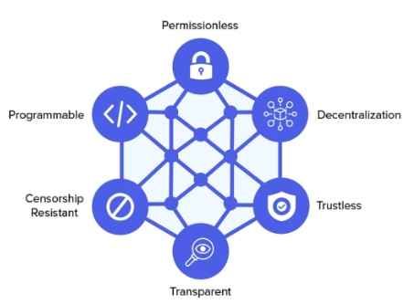

**Important aspects of DeFi comprise:**

1. The code for DeFi applications is usually open-source, so anyone can look at it and see how it works. This makes them accessible and makes them open. This openness encourages creativity and trust.

2. Composability is made possible by the smooth interaction of different DeFi applications. This opens the door for developers to construct more intricate financial products by extending current protocols.

3. Without requiring approval from a governing body, DeFi services are accessible to anybody with an internet connection and a suitable wallet. This is known as permission less innovation. As a result, innovation is fostered and obstacles to entry are reduced.

4. In terms of financial inclusion, DeFi has the ability to provide banking services to people who do not currently have access to them.

5. With DeFi, users may buy, sell, lend, and earn interest on digital assets, creating liquidity and yield opportunities. In many cases, the returns from these pursuits outstrip those of more conventional savings accounts.

6.Regulatory ambiguity, security flaws in smart contracts, and other similar issues are among the risks and problems posed by DeFi. Before using DeFi platforms, users should exercise caution and read up on the subject.

**2. DeFi, ReFi, and DeSci**

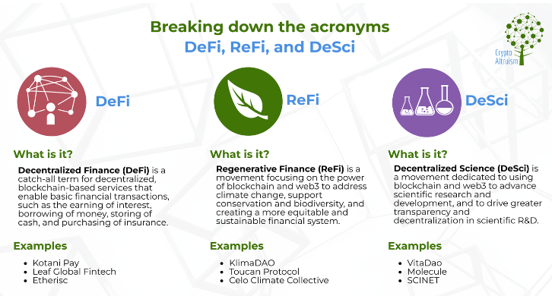

## 3. TRADITIONAL FINANCE VS DECENTRALIZED FINANCE

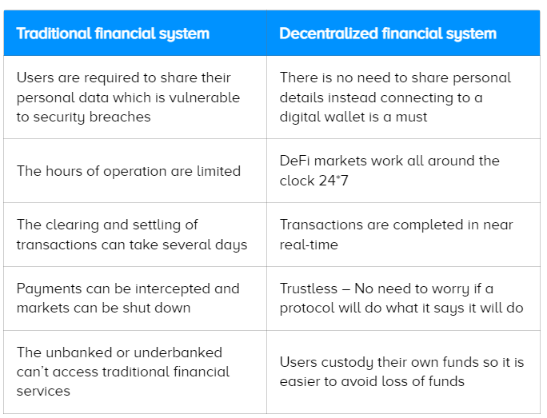

**The Shift to DeFi (Decentralized Finance)**

We may expect our ideas about banking, economic transactions, and money to change as a result of a new paradigm that is taking root in the dynamic world of international finance. The Decentralized Finance (DeFi) concept is about to change the financial world in India in a big way. In an effort to make financial services more accessible to a wider range of people, "decentralized finance," or "DeFi," is utilizing blockchain technology to build a decentralized ecosystem where users can access financial services directly from one another, rather than going through traditional intermediaries like banks or other centralized systems. Among the many benefits of this decentralization trend are more openness, lower prices, and expanded access to financial services for hitherto underserved populations.

**Rising DeFi Rates in India**

One of the most important places for the DeFi revolution to take place is India, because to its huge and quickly expanding digital economy. The country is well-suited for the implementation of DeFi technologies due to its strong fintech industry and increasing need for creative financial solutions. "Marwar Mentors explores the complex relationship between decentralized finance (DeFi) and India's digital goals. This in-depth study shows how DeFi can revolutionize financial inclusion and give voice to India's underbanked and unbanked citizens." The huge number of people in India who do not have bank accounts is a major factor in the expansion of DeFi in the country. With DeFi, these people can bypass the hurdles that have long prevented them from accessing traditional banking services, such as lending, borrowing, and investing opportunities. "Collaboration among regulators, industry stakeholders, and technology developers is identified as a critical factor for the responsible and sustainable growth of DeFi in India."

**4. DeFi's FUNCTIONS**

Using innovations in software, hardware, connection, and security protocols, DeFi facilitates peer-to-peer financial networks. Financial service providers like banks and other middlemen are rendered obsolete by this approach. Businesses and consumers must pay these corporations to use their services; doing so is essential to the present system. By leveraging blockchain technology, DeFi is able to cut out middlemen.

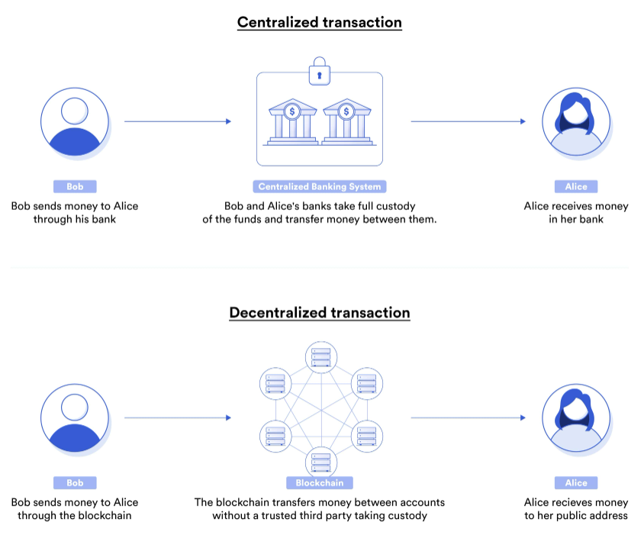

**5. BLOCKCHAIN TECHNOLOGY IN DeFi**

Block chain technology and DeFi (Decentralized Finance) are closely intertwined, with blockchain serving as the foundational technology enabling the innovation and operation of DeFi applications. Here’s how blockchain and DeFi relate to each other:

1. **Foundation of Trust and Transparency**: Blockchain provides a decentralized and immutable ledger where transactions and smart contracts can be recorded. This transparency and immutability are crucial for establishing trust in DeFi applications, as users can verify transactions and smart contract operations without relying on centralized intermediaries.
2. **Smart Contracts**: Smart contracts, which are self-executing contracts with the terms directly written into code, are a key feature enabled by blockchain technology. DeFi applications often rely on smart contracts to automate processes such as lending, borrowing, trading, and yield farming. Smart contracts ensure that transactions occur according to predefined rules, reducing the need for intermediaries and enhancing efficiency.
3. **Decentralization**: Both blockchain and DeFi aim to decentralize traditionally centralized financial systems. Blockchain achieves decentralization by distributing transaction validation and storage across a network of nodes, while DeFi extends this decentralization to financial applications such as lending, borrowing, trading, and asset management.
4. **Tokenization**: Blockchain allows for the creation and management of digital assets and tokens. DeFi leverages tokenization to represent various assets (e.g., crypto currencies, stable coins, synthetic assets) and enable their use within decentralized applications. Tokens can represent ownership rights, participation in governance, or serve as collateral in lending protocols.
5. **Interoperability**: Blockchain networks can support interoperability between different DeFi protocols and applications. This interoperability is crucial for the seamless transfer of assets and data across various platforms and blockchains, facilitating a more integrated DeFi ecosystem.
6. **Innovation in Financial Services**: DeFi harnesses blockchain technology to innovate and expand the range of financial services available to users. It enables access to financial products such as decentralized lending and borrowing, automated trading, liquidity provision, derivatives trading, and more, often with lower barriers to entry compared to traditional finance.
7. **Challenges and Opportunities**: While blockchain and DeFi offer significant opportunities for innovation and financial inclusion, they also face challenges such as scalability, security vulnerabilities, regulatory compliance, and user experience. Research and development efforts continue to address these challenges to realize the full potential of blockchain-based DeFi.

Blockchain technology provides the technical infrastructure necessary for the decentralized and transparent operation of DeFi applications. Together, they represent a transformative force in reshaping financial systems and enabling new economic possibilities globally.

**6. DIGITAL LEDGER**

A blockchain is a decentralized and encrypted record keeping system. Blockchain technology allows for the automated recording and verification of transactions in blocks. After a transaction is confirmed, the block is sealed and encrypted. A new block is generated using the data from the previous block and any subsequent transactions that have occurred.

Blockchain refers to the interconnected network of blocks that are "chained" together by the data contained in each block that comes before it. The inability to modify one block of data without influencing subsequent blocks renders blockchains immutable. The safety of a blockchain is ensured by this idea and other security protocols.

Private keys to tokens or cryptocurrencies function similarly to passwords; users save them in applications known as wallets, which can transmit data to a blockchain. They can access value-based virtual tokens using these keys. To transfer token ownership, one must first "send" a certain amount to another entity through a wallet, which will then produce a new private key for that entity. This ensures that they are the rightful owner of the token, and the immutability of the blockchain makes it impossible to undo the transfer.

Although DeFi services are accessible on other blockchain networks, the Ethereum blockchain is now home to the vast bulk of the DeFi ecosystem. Compound, Aave, and Marker DAO are a few of the important DeFi services that are now available. Uniswap is another important player in the DeFi market; it is a decentralized exchange (DEX) that lets users trade cryptocurrencies directly with each other, bypassing the need for banks or other intermediaries. A unique trading methodology that does not depend on conventional order books is employed by Uniswap, known as an automated market maker (AMM) system, to ascertain liquidity and prices. Since anybody may join the network and earn fees by adding liquidity, it enables more decentralized and accessible trading.

Both within and outside of DeFi's purview

Defined By

* Exchanges that are not centralized (DEXs)
* Loan and borrowing platforms that are not centralized
* Consistent coins
* Dispersed payment networks

Not Concerned

* Financial services that have traditionally been controlled by governments and necessitate licenses, such banking and lending.
* Assets that cannot be easily converted into tokens and sold on blockchain networks, such real estate or commodities.

**Use case**

Users are able to transact with one another directly, without the need for a middleman, using DeFi apps that are built to interface with a blockchain. These apps are software programs that may be downloaded and installed on mobile devices, tablets, or desktop computers to enhance their functionality and user experience. Even without the apps, DeFi could function, but it would require users to have a good grasp of their device's operating system's command line or terminal.

With the help of DeFi applications, customers are presented with a variety of financial possibilities, which streamlines transactions between them. You can use the interface to enter terms like interest or collateral if you wish to charge someone for a loan, for instance. Everyone from banks to private individuals could be a potential lender for you if you're in need of a loan; all you have to do is agree on the conditions and apply for the loan. You can match with another user using some apps that enable you specify the services you need. You may send or receive money from any location in the globe using the blockchain because it is a worldwide network.

**Decentralized Financial Objectives**

The fundamental idea behind DeFi is P2P financial transactions, in which two users agree to trade cryptocurrencies for goods and services directly with each other, bypassing the need for a middleman. With DeFi,

• No geographical limitations on users or transactions: a DeFi platform is accessible to everyone with an internet connection.

With DeFi, any two parties can lend each other money or cryptocurrencies through DeFi networks at low or no cost, and the interest rates can be negotiated directly.

You remain anonymous while anybody can see records of your transactions and smart contracts posted on a blockchain, ensuring both security and transparency. It is impossible to alter a blockchain since it is immutable.

The independence of DeFi platforms from traditional banking systems is one of its key features. The necessity and expense of overseeing financial services are reduced by the decentralized character of DeFi protocols.

**As an illustration,**

DeFi encompasses all applications that provide financial services through the use of blockchain and cryptocurrency techniques or technology. The services offered by these apps range from the most fundamental, like savings accounts, to the most sophisticated, like lending money to companies or investors. Among the many DeFi service providers, Aave stands out. It is a "decentralized non-custodial liquidity market protocol" that opens up the liquidity market to everybody. If you own cryptocurrency, you can stake it on Aave and earn interest from other users who borrow it. "Introduction to Aave."

**Reasons to Use Decentralized Finance**

The concept of decentralized finance has evolved from its original intent of providing previously inaccessible people with access to banking and loan services to a wide range of industries and pursuits. Some of the most common ones are these:

One of the most popular features of the defi app is the ability to access decentralized exchanges. You can connect with other cryptocurrency users through the apps of exchanges such as Uniswap and Pancake Swap.

• Providers of liquidity: Many people who have used cryptocurrencies have run into issues with liquidity, which is defined as the speed with which assets can be sold. In order for exchanges to offer selling opportunities to their users, liquidity providers often serve as pools where users can deposit funds.

• Lending/Yield Farming: You may find lending services through a plethora of defi apps. Users deposit funds into a pool and then lend them out to others, a process known as yield farming, in the same manner that a liquidity pool works. Many of them give short-term loans that don't need borrowers to put up any security.

ZKasino, Horse Racing Slot Keno Roulett, Azuro, and UpvsDown are just a few of the defi applications that users use daily to gamble with millions of dollars' worth of cryptocurrencies. Prediction markets allow users to wager on the result of almost any event. While interest from general investors and collectors has waned, non-fungible tokens (NFTs) continue to enjoy a devoted following.

**7. THE INDIAN REVOLUTION IN DECENTRALIZED FINANCE**

Decentralized Finance (DeFi) is a game-changing ecosystem that is quickly gaining traction and has the potential to radically alter India's financial environment. This has put the nation on the verge of a spectacular financial revolution. With forecasts showing the worldwide DeFi market reaching an astounding $507.92 billion by 2028 at a CAGR of 43.8%, India is quickly becoming a key player in the financial revolution.

• This change is based on the present situation of DeFi in India, which is a complicated web of regulations, new initiatives, and the unrealized possibilities of this game-changing technology. We explore the complexities of India's DeFi ecosystem to decipher this story, revealing the possibilities and challenges that will shape the country's financial destiny.

**Dealing with the Uncertainty of the Regulatory Landscape**

• "Decentralized Finance (DeFi) is an emerging sector that poses unique regulatory challenges, as its decentralized and often pseudonymous nature makes it difficult to apply traditional financial regulations."

• DeFi regulations in India have been the topic of heated discussion and investigation. Uncertainty reigns due to the absence of definitive policies, despite the government's careful approach in investigating the possible consequences and hazards of this new financial paradigm.

• "Several DeFi projects and initiatives have emerged, aiming to address financial inclusion and streamline traditional financial processes."

• Indian innovators and entrepreneurs have continued to push the boundaries of what is possible in the face of regulatory uncertainty, creating DeFi apps that address the specific challenges faced by India's varied financial sector. Various projects are working to improve the accessibility and efficiency of financial services, such as decentralized lending platforms and cross-border remittance solutions.

**The First Movers in the New DeFi Ecosystem**

• The DeFi ecosystem in India is a mosaic of ground-breaking programs and projects, all working to promote financial inclusion and alleviate particular problems in the financial sector. Unocoin is a pioneer in this regard; it is a top cryptocurrency exchange that has spearheaded the DeFi movement in India.

• "Unocoin, a leading cryptocurrency exchange, has been at the forefront of the DeFi revolution in India, offering a range of decentralized financial services to its growing user base."

Users are able to access credit and earn returns on their cryptocurrency holdings through innovative DeFi solutions offered by Uno coin’s platform, which also allows for the trade of digital assets.

• The scalable and interoperable blockchain network Polygon has made a big splash throughout the world, and it's also making waves in the Indian DeFi scene. DeFi projects that want to use blockchain technology often choose Polygon because of how well it integrates with Ethereum.

• "Polygon, a scalable and interoperable blockchain network, has gained significant traction globally and has become a preferred choice for DeFi projects looking to leverage the power of blockchain technology."

• These trailblazers, in conjunction with an increasing number of DeFi start-ups, are propelling decentralized finance's adoption in India, opening up new channels for financial inclusion and empowerment.

**8.Prospects and Difficulties: Making Sense of the DeFi Frontier**

Streamlining conventional banking procedures and combating financial exclusion are only two of the many promising new avenues opened up by the proliferation of DeFi in India. The regulatory environment and the complexity of technology present substantial obstacles, making progress difficult.

• "Decentralized Finance (DeFi) is gaining momentum in India, showcasing both the current state and future potential of this transformative financial ecosystem."

• The possibility of helping India's large unbanked or underbanked population close the financial inclusion gap is a promising opportunity. Because of DeFi's decentralized and user-friendly design, these underserved populations will be able to gain agency and access to financial services that were previously unavailable to them.

• "Several DeFi projects and initiatives have emerged, aiming to address financial inclusion and streamline traditional financial processes."

• Individual users and institutional players alike can benefit greatly from DeFi's capacity to simplify conventional financial operations including lending, borrowing, and asset management. The DeFi platform has the potential to transform the Indian financial services industry by harnessing the immutability, scalability, and automation offered by blockchain technology.

• On the other hand, a major obstacle is the lack of clarity regarding regulations in India regarding DeFi. This revolutionary technology has not been able to reach its full potential due to the cautious atmosphere fostered by the absence of defined regulations and standards.

• "Decentralized Finance (DeFi) is an emerging sector that poses unique regulatory challenges, as its decentralized and often pseudonymous nature makes it difficult to apply traditional financial regulations."

• DeFi's technical complexity is an additional obstacle, especially when considering user experience and security. The public and commercial sectors will need to work together to educate the public and bring them on board with this new financial paradigm.**Part of the DeFi**

Despite initial apprehension, there are numerous entry points into the world of decentralized money. If you're interested in DeFi, the first step is to find out what kinds of activities you would enjoy doing the most. There are a lot of wallets out there, so it's up to you to do some research and pick one that suits your needs. Finding a trustworthy exchange that offers the activity you wish to participate in or utilize, purchasing cryptocurrency, and getting started are all possible after you've established your wallet and activity.

**Issues with DeFi**

The evolution of decentralized finance is on-going. Its environment is open to frauds, hacks, and bad programming because it is unregulated. For instance, exploiting security holes in DeFi apps is a common tactic for cybercriminals to steal cryptocurrency. There has been a lag between technological development and the legislation. The foundation of most modern legislation is the concept of distinct financial jurisdictions, each with its own regulatory framework. For this kind of regulation, the fundamental concerns raised by DeFi's capacity for borderless transactions are paramount. Take this case in point:

* When a financial crime happens that transcends borders, protocols, and DeFi apps, who is accountable for investigating it?
* To what end would the rules be enforced?
* What measures would they use to ensure compliance?

A lot of people are spreading false information about decentralized finance in an effort to get people to invest in it, as they have with other projects, businesses, and initiatives connected to blockchain and cryptocurrencies. The value of cryptocurrencies, blockchain, and related technologies can fluctuate wildly. Many Cryptocurrencies, But Not Nearly What You Might Expect There is a sizable quantity of capital moving via cryptocurrency exchanges, but it's far less than what you might anticipate. Conventional banking methods are still in use by the majority of people. If you're wondering whether it's worth it to use or invest in DeFi apps, platforms, or cryptocurrency, you should know that only 0.56 percent of the world's money is locked up in these areas.

When cryptocurrency prices fall precipitously and remain low for an extended length of time, often reaching tens of thousands of dollars, this is called a crypto-winter. The most recent one took place in the years 2022 and 2023. Prior to 2022, prices had been climbing sharply as investors sought refuge in anything they could find in the wake of the first COVID-19 breakout and subsequent pandemic. At that time, they found out Bitcoin was doing more than just keeping its value; it was actually increasing. However, they probably just caused the price increases themselves, thus it was probably all a result of their own hype and self-fulfilling prophecies.

However, prices started falling when the year 2022 came to a close and remained low. During this period, a staggering amount of money was lost. Aside from what seemed like an SEC-led persecution campaign, no real rumours or regulatory changes occurred during this time in the US. But the hype was back in full swing and prices went up in October 2023 when rumours started circulating regarding the approval of a Spot Bitcoin ETF. After a few months of steady price increases (apparently signalling the end of winter) with the announcement of eleven Bitcoin Spot ETFs' acceptance in January 2024, a sideways market once again surfaced in March of the same year.

**Does It Make Sense to Slay**

In terms of your money, DeFi might be the answer you've been seeking. But it might not; most individuals are taking a chance since the decentralized finance industry is still developing and in its early stages. You should think about whether it's worth it to invest in decentralized finance because of the little quantity of real money invested in cryptocurrency and the effects of hype on prices. The space can be highly lucrative if your capital is risk-tolerant, but it also has the potential to incur substantial losses. Defi and cryptocurrencies shouldn't be considered as an investment option unless you're risk-averse and seeking ways to save for retirement or increase your wealth over time. Do not stake your future on them just yet because they are novel and unpredictable.

**Finance that is not centralized**

One of the main tenets of DeFi is the idea that all financial transactions should not involve a single party or centralized financial institution. Cryptocurrency—Bitcoin included. While Bitcoin is an integral aspect of the DeFi ecosystem, it is not DeFi itself. Taken together, all the cryptocurrencies that have been staked, borrowed, pooled, or utilized for other financial transactions within DeFi make up the total value locked (TVL). As an alternative, it might stand in for the total value of a collection of monetary cryptocurrencies like ether or bit coin.

**9. FINANCIAL BACKING**

An investment in DeFi entails buying a hack able coin that is utilized in DeFi. While DeFi hacking has been a problem for a while, 2023 saw a marked decline, according to Chainalysis's blockchain experts. Having said that, it is still possible for it to resume. Investing in bitcoin or blockchain always comes with a certain level of risk.

The present centralized banking system is under threat from a new financial technology known as decentralized finance (DeFi). While promoting peer-to-peer transactions, DeFi aims to eradicate the fees charged by banks and other financial service providers. Much like the blockchains and digital currencies it underpins, DeFi is a relatively new concept. It has a long way to go before it can supplant the current financial system, which is fraught with problems of its own. Finally, banks and other financial service providers will battle tooth and nail to maintain their positions in the industry as we move toward a blockchain-based financial system. At your service is one of the most prominent cryptocurrency exchanges on the planet. Trade safely with competitive costs and devoted customer support. With Binance's resources at your fingertips, seeing your transaction history, managing auto-investments, viewing price charts, and making fee-free conversions is easier than ever. Get in on the global crypto market with millions of other traders and investors by creating an account for free.

**Bring attention to DeFi**

* Forecasts indicate that by 2024, the DeFi market will have generated $203.5 million in revenue.
* Revenue is anticipated to grow at a CAGR (compound annual growth rate) of 3.88% from 2024 to 2028, with a predicted total of $237.0m by 2028.
* In the DeFi industry, the average income per user is $39.9 USD in the year 2024.
* The United States rakes in the most dough, with $12,530,000.00 in 2024, according to a global comparison.
* By 2028, the predicted user count in the DeFi market is 6.26 million.
* The predicted user penetration rate for 2024 is 0.35% and for 2028 it is 0.42%.

**The Financial Sector's Seismic Shift: The Ascent of DeFi**

Decentralized finance (DeFi) is a rapidly growing ecosystem that threatens the established financial order and is causing a seismic shift in the financial sector. In light of the continued economic uncertainty and the global fallout from the COVID-19 epidemic, DeFi has surfaced as a potential replacement for conventional finance, which is characterized by its centralization, opaqueness, and inaccessibility.

Demystifying finance, empowering individuals, and fostering greater transparency and accessibility are at the heart of DeFi. "The potential for financial inclusion and the realization of a truly decentralized future are within reach, but only if we address the challenges with security and commitment." The goal of DeFi is to build a more accessible and efficient financial system by eliminating the need for conventional intermediaries like banks and brokerages through the use of blockchain and smart contracts.

**Disrupting the Norm: How DeFi Can Revolutionize Finance**

When it comes to fixing the problems with the existing financial system, DeFi has the potential to be very disruptive. The decentralized nature of DeFi is one of its main advantages; it does away with the need for centralized authorities and intermediaries, which is a major drawback of traditional finance that is often marked by high fees, restricted access, and bureaucracy. "DeFi offers the interesting potential to reduce costs and increase speed in payments by eliminating friction in terms of technology, contracting, and coordination between multiple parties." Financial transactions become more efficient and quick as a result, and they also become less complicated and expensive.

Blockchain technology also makes DeFi more open and transparent, which could make it easier for more people to have access to financial services. To empower individuals and promote greater financial empowerment, DeFi lowers barriers to entry, which allows underbanked and unbanked communities to engage in the global financial system.

**Resolving Security and Regulatory Issues: A Guide to Overcoming Difficulties**

Challenges are inevitable with every revolutionary technology, and DeFi is no exception. To stay afloat in the long run, the DeFi ecosystem needs to be nimble and proactive due to the complicated environment it has become as a result of the lack of clear regulatory standards and the quick pace of its evolution. "The absence of clear guidelines and the evolving nature of regulations create a complex environment, demanding adaptability and proactive measures to ensure compliance and long-term viability."

The matter of security is one of the main worries related to DeFi. Hacks, smart contract flaws, and other forms of malevolent activity are more likely to occur in a decentralized economy. In order to gain trust and encourage widespread use, it is critical to guarantee the safety and soundness of DeFi platforms. The regulatory environment surrounding DeFi is also not well-defined, with different jurisdictions taking different methods. Building transparent standards and frameworks that strike a balance between innovation and consumer safety will be crucial for DeFi inventors, lawmakers, and regulatory agencies to navigate this unpredictable landscape.

**An Advantage of DEX**

A sea change in mind set amongst crypto investors is crucial to the DEX revolution. The decentralized, peer-to-peer nature of DEXs allows traders to keep complete control of their assets, in contrast to the centralized nature of CEXs, which force users to entrust their money to a third party custodian. There are significant changes taking place in the ownership and custody of tokens, which affects the security and transparency of crypto trading. One such change is the rise of decentralized exchanges, or DEXs, where users can connect with a web3 crypto wallet and execute trades using smart contracts, which are self-executing programs. Because they do not rely on any one entity, decentralized exchanges (DEXs) are much more secure than their centralized equivalents, which have been the target of hackers, attacks, and poor management. "Users do not need to give any information about who they are in order to use the DEX, which is not possible for CEXs as they are required by regulations to have the information from their users in order to operate."

**The Effects of DeFi on Conventional Financing**

Traditional financial institutions are feeling the heat from the advent of DeFi, which is causing them to revaluate their methods and adjust to the changing digital world. The elimination of intermediaries is a major way in which DeFi is disrupting traditional finance. "With advantages such as the instant settlement of funds, the ability to use digital assets as collateral and no credit checks, these DeFi platforms have a lot of appeal over existing credit systems." Financial services like lending, borrowing, and trading can be made more available to more people through DeFi platforms since they eliminate intermediaries, allowing for much cheaper prices. For communities that have historically been unable to access conventional banking services, such as the unbanked and underbanked, new opportunities for financial inclusion have emerged thanks to DeFi's decentralized structure and the collateralization of digital assets.

**Analysis and Development by DeFi**

Research and development must be prioritized in order to fully realize the promise of decentralized finance (DeFi) as the globe ventures into its unexplored realms. The DeFi ecosystem, which is based on blockchain technology, might revolutionize the financial sector by bringing forth hitherto unseen levels of accessibility, efficiency, and innovation. Policymakers, regulators, and industry stakeholders must collaborate to create a climate that is favourable to growth, as the road is not devoid of obstacles.10.**INDIAN DeFi's RAPID ASCENT: EMBRACING FINTECH'S FUTURE**

Decentralized Finance (DeFi) is sweeping the financial industry, and India, a country known for its innovation and entrepreneurship, is leading the charge. India is becoming a world leader in decentralized financial innovation, with the potential to revolutionize its financial landscape as the rest of the globe faces the massive consequences of blockchain technology. The attractiveness of the DeFi ecosystem, India's large unbanked population, and the country's strong IT ecosystem are coming together to drive this change. With a record-breaking $177 billion in revenue and 6.1% growth in the 2019 fiscal year, India's IT-BPM (business process management) sector has fostered a flourishing talent pool that is prepared to spearhead the DeFi revolution. Quona Capital's co-founder Ganesh Rengaswamy remarked, "A lot of development happened in the Indian IT ecosystem, and now those skilled engineers are looking at DeFi as the next frontier." The company's mission is to empower emerging markets' financial markets. With India's large unbanked population and this skill pool, DeFi has a great chance to thrive. In light of the country's current struggles with financial inclusion, the decentralized and easily available DeFi platform offers hope for the underprivileged by providing them with access to banking services and giving them more control over their own money.

**11.CONCLUSION**

Blockchain technology has significantly impacted the banking industry with the rise of Decentralized Finance (DeFi). DeFi operates on blockchain networks, primarily Ethereum, to democratize access to financial services internationally. DeFi is based on smart contracts, automating trust less transactions by eliminating middlemen. DeFi applications are usually open-source, encouraging creativity and trust. DeFi services are accessible to anyone with an internet connection and a suitable wallet, fostering permission less innovation and reducing entry barriers. India is a key location for the DeFi revolution due to its rapidly expanding digital economy and strong fintech industry. The country's large number of unbanked and underbanked citizens can benefit from DeFi, bypassing hurdles that have long prevented them from accessing traditional banking services. Collaboration among regulators, industry stakeholders, and technology developers is crucial for the responsible and sustainable growth of DeFi in India.

DeFi applications range from basic savings accounts to sophisticated lending to companies or investors. India is on the verge of a significant financial revolution due to the growing popularity of DeFi in the country. The global DeFi market is projected to reach $507.92 billion by 2028 at a CAGR of 43.8%. Decentralized Finance (DeFi) is gaining momentum in India, aiming to help the unbanked and underbanked population access financial services. DeFi's decentralized design allows underserved populations to gain agency and access to financial services. However, challenges include lack of clarity on regulations, technical complexity, and the need for public and commercial sectors to educate the public. DeFi aims to eliminate fees charged by banks and other financial service providers, promoting peer-to-peer transactions. It reduces costs and increases speed in payments by eliminating friction in technology, contracting, and coordination. Investing in DeFi involves buying a hackable coin, but it still has risk. The DeFi market is predicted to generate $203.5 million in revenue by 2024, with a CAGR of 3.88% from 2024 to 2028. DeFi platforms offer instant fund settlement, digital asset use as collateral, and no credit checks, making financial services more accessible to more people. Research and development are crucial to realize DeFi's promise, and collaboration between policymakers, regulators, and industry stakeholders is essential for growth.

**12,REFERENCE:**

1.Defining decentralized finance, https://www.investopedia.com/5113835

2.Visit https://www.statista.com/outlook/fmo/digital-assets/defi/india for more information. Since

3.Link: https://www.ijnrd.org/papers/IJNRD2305621.pdf this article

4.https://www.tavily.com/the-rise-and-rise-of-blockchain-and-defi-and-what-it-means-to-india/ is one source that discusses the impact of block chain technology on India.

5.A Look at India's Unbanked Financial Future - SSRN: https://papers.ssrn.com/sol3/papers.cfm?description: 4303764

6.This is the third source: https://www.tavily.com/the-road-to-financial-empowerment-exploring-defis-impact-on-india/, which explains how DeFi has affected India.

7.https://inc42.com/features/how-the-rise-of-defi-will-transform-indias-fintech-future/ [4] How DeFi's Ascent Will Change India's Fintech Future - Inc42 Media

8.Thanos Tsavlis. "Decentralized Finance: Risks And Rewards In The DeFi Ecosystem." Link to Forbes.

## 9. A Study on the Application of Financial Analytics in the Field of Block chain Technology, **Dr.K.Baranidharan, Research Scholar K. Sabitha, Research Scholar V. Deepika,**International Journal of Science, Engineering and Technology, July 2024, DOI: [/10.61463/ijset.vol.12.issue3.190](http://doi.org/10.61463/ijset.vol.12.issue3.190)

# 10. Block chain-Based Secure Menger's Authentication for Industrial IOT, [C. Saravanabhavan](https://ieeexplore.ieee.org/author/37088843671); [S. Ranjithkumar](https://ieeexplore.ieee.org/author/37089457473); [M. Subashini](https://ieeexplore.ieee.org/author/37089457832); [K. Baranidharan](https://ieeexplore.ieee.org/author/37089453929); [P. Preethi](https://ieeexplore.ieee.org/author/37088843374); [P. Ashok](https://ieeexplore.ieee.org/author/37089457042), <https://ieeexplore.ieee.org/abstract/document/9823904>.

11. <https://bap-software.net/en/knowledge/defi-finance/>

12. <https://appinventiv.com/blog/decentralized-finance-defi-guide/>

13. https://www.cryptoaltruism.org/blog/infographic-defi-refi-desci