Morphology of Alstonia scholaris (L.) R. Br.
Dr. S. REJITHA¹ AND Dr. S. UMA DEVI²
¹Department of Botany, Nesamony Memorial Christian College, Marthandam, Tamil Nadu, India. E-mail: rejithastalin14@gmail.com
²Department of Botany, Sree Ayyappa College for Women, Nagercoil, Tamil Nadu, India. E-mail: umapradeep80@gmail.com

ABSTRACT
In the present investigation is to study the morphology of the ornamental plant Alstonia scholaris. It is an evergreen large tree with greyish bark and milky sap. The branches are cylindrical and older branches are strongly fluted. This tree has clusters of seven large leaves and small light green flowers. The tree is frequently planted as a garden adornment and as a plant for avenues. The plant is found in India in the sub Himalayan region, abundantly found in West Bengal and South India. According to the IUCN, Red List of Threatened Species (2011), the plant is rated as being of "Least Concern". These findings are valuable for botanical identification of the species Alstonia scholaris.
Keywords: Alstonia scholaris, Apocynaceae, Morphology, Ornamental.

INTRODUCTION
Alstonia scholaris is an evergreen large tree, growing upto 40 meters tall with greyish bark and milky sap. The branches are cylindrical and older branches are strongly fluted. This tree has clusters of seven large leaves and small light green flowers. The tree is often deciduous, losing their leaves for brief periods at irregular intervals. It was planted for its ornamental and shade.
Historically, Echites scholaris was named by Linnaeus. Robert Brown changed its name to Alstonia scholaris in honour of the botanist Prof. Charles Alston. Scholaris is the name of a plant that was formerly used in Myanmar to produce slates for classrooms. Alstonia scholaris is popularly known as ‘Saptaparni’ or ‘Devil’s tree’. The Sanskrit word Saptaparna (Saptaparni), which translates to ‘seven leaves’. The name Devil's tree is based on a belief in Western India that the tree is an abode of evil spirits. According to the IUCN, Red List of Threatened Species (2011), the plant is rated as being of "Least Concern". This tree is designated as the 'State Tree' of West Bengal.
Flower morphology is important marking characters in identification. Proper recording of the morphological characters helps in easy identification and distinction of ornamental species as well as utilization in the suitable designs. The study is planned to analyze the vegetative and floral morphology of the species Alstonia scholaris.

MATERIALS AND METHODS
In the present study, the fresh leaves and flowers of Alstonia scholaris were collected from Kanyakumari District, Tamil Nadu, India during the month of November to December 2022. Kanyakumari District was the Southernmost tip of Indian Peninsula. The soil is red, varying in the quantity of ferruginous element. The climate of the District is warm and humid.
Shoots of three plants were collected and used for leaf and flower data collection. From those shoots, 20 mature leaves and 20 flowers were randomly collected and measured the traits of the species. For each leaf and flower Length and Width were measured with a common ruler. Following this qualitative and quantitative morphological leaf and flower traits were studied. Longevity of the flower was determined by recognizing the day of opening and shedding.

RESULT

I. General Information

Classification : APG IV
Kingdom : Plantae
Clade : Tracheophytes
Clade : Angiosperms
Clade : Eudicots
Clade : Asterids
Order : Gentianales
Family : Apocynaceae
Subfamily : Rauvolfioideae
Tribe : Alstonieae
Genus : Alstonia
Species : scholaris
Synonyms
Echites scholaris L.
Pala scholaris (L.) Roberty
Common Name
Blackboard Tree, Devil's Tree, Dita Tree, Indian Devil tree, Milk wood Pine, Saptaparna.
Vernacular Name
Assamese: Chatiyan; Bengali: Chhatni; Gujarati: Satvana; Hindi: Satvan; Kannada: Bantale; Malayalam: Daivappala; Marathi: Satvin; Nepali: Chhataun; Odisa: Chhatiana; Punjabi: Satouna; Sanskrit: Phalagaruda; Tamil: Ezhilaipalai; Telugu: Devasuruppi; Urdu: Chatiana.
Native
China, India
Distribution
Africa, Australia, Bangladesh, Brazil, Cambodia, China, India, Malaysia, Myanmar, Nepal, Pakistan, Singapore, Sri Lanka and Vietnam.

Habitat

The plant is found in India in the sub Himalayan region, abundantly found in West Bengal and South India. It is also found in secondary and primary forests, savannas, along streams, coastal plains, ridges or montane, clay or ultrabasic soils, granite bedrock and limestone.
Propagation
It is propagated by seeds and also grafted.
Uses
The tree is frequently planted as a garden adornment and as a plant for avenues. It is typically advised for planting in lawns, gardens and parks.
Habit
Tree
Flowering & Fruiting
November – February
Flower Longevity
1 day
II. Morphological Characteristics
STEM
The stem was either smooth or slightly rough with whorled branches, greyish brown bark that was lenticellate and released milky latex when the bark was damaged. The young stem was glabrous and greenish black.
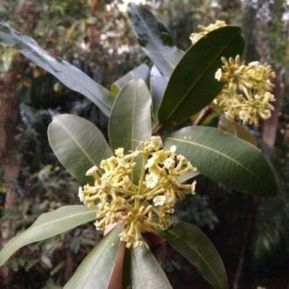 | 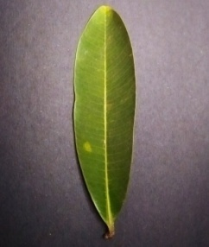 | 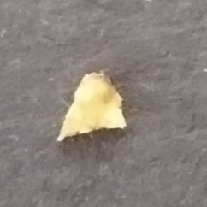 | 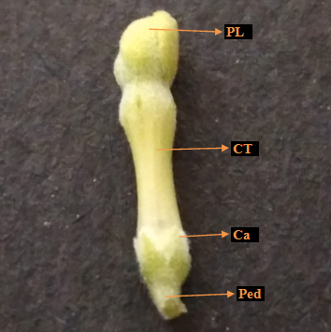
Plate 1. Habit | Plate 2. Leaf (Dorsal View) | Plate 3. Bract | Plate 4. Flower Bud: PL- Petal Lobe; CT- Corolla Tube; Ca- Calyx; Ped- Pedicel

LEAVES
Leaves are seven in a whorl, coriaceous, glabrous, elliptic to oblanceolate, entire margin, acute base and rounded apex (Plate 2). The leaf blade was 11.3–18.6 cm in length and 3.9–5.8 cm in breadth with a greyish green abaxial surface and a dark green adaxial surface. The petiole is brownish green, glabrous, flattened and slightly winged, 0.5–1 cm length and 0.2 cm width. The leaf venation is pinnate and has 38–50 secondary veins. The sucking insect causes the galls on the leaves is related to aphids and cicadas.
INFLORESCENCE
The inflorescence is umbellate cyme. The peduncle was green, glabrous with 2–5 cm long and 0.3–0.5 cm wide. The bracts are pubescent, rounded lobes, light green, 0.2–0.3 cm length and 0.1–0.2 cm width (Plate 3).
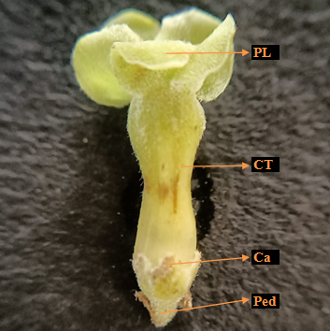 | 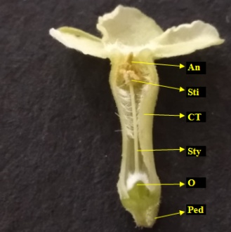 | 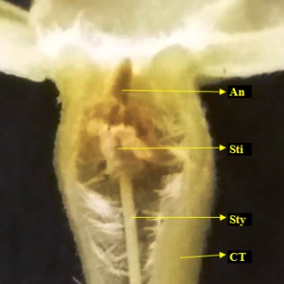 | 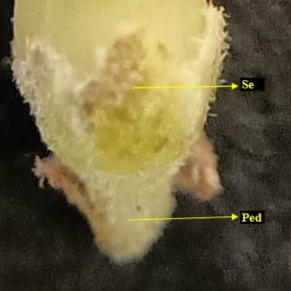
Plate 5. Flower: PL- Petal Lobe; CT- Corolla Tube; Ca- Calyx; Ped- Pedicel | Plate 6. L.S of Flower: An- Anther; Sti- Stigma; CT- Corolla Tube; Sty- Style; O- Ovary; Ped- Pedicel | Plate 7. L.S of Flower Stigma Overview: An- Anther; Sti- Stigma; Sty- Style; CT- Corolla Tube | Plate 8. Calyx: Se- Sepal; Ped- Pedicel

FLOWER
Flowers are numerous, small, bisexual, salverform, light green, pubescent, strongly perfumed, 1.4–1.7 cm length and 0.8–1.2 cm breadth (Plate 5). The pedicel was typically shorter than the calyx and it was green, pubescent and 0.1 cm long and wide. The mature bud formed as an ovoid head, cylindrical shape, green lobe and light green tube with 1.4–1.5 cm length and 0.3 cm width (Plate 4).
CALYX
The calyx consists of five sepals, synsepalous with quincuncial aestivation. The sepals are green, obtuse lobes, pubescent outside, glabrous inside of about 0.2 cm length and 0.2 cm width (Plate 8).
COROLLA
The sympetalous corolla has the corolla tube and single whorl of five petal lobes (Plate 5). The corolla is light green of about 1.3–1.6 cm length and 0.8–1.2 cm breadth. The corolla lobe was rounded, pubescent with 0.3–0.5 cm length and 0.4–0.6 cm width. The corolla tube was almost cylindrical and widened slightly towards the base, around the anther and ovary. It was light green on both sides, mouth with ring of hairs, pubescent inside, but frequently glabrous on basal half of inner region with 0.9 cm long and 0.2–0.3 cm wide. The corolla has twisted aestivation and overlapping to the left side (anti-clockwise).
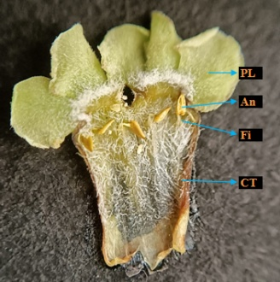 | 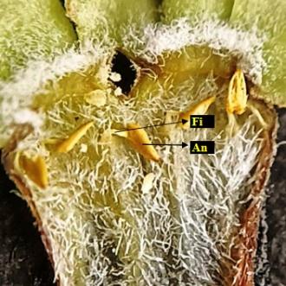 | 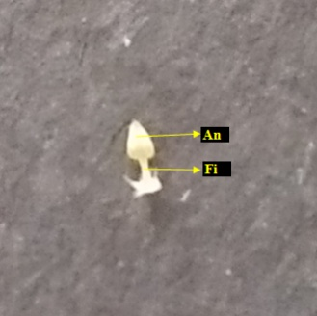 | 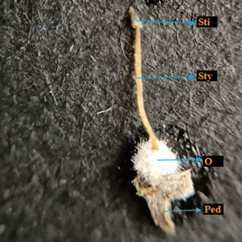
Plate 9. Corolla cut open: PL- Petal Lobe; An- Anther; Fi- Filament; CT- Corolla Tube | Plate 10. Corolla cut open Androecium Overview: Fi- Filament; An- Anther | Plate 11. Androecium: An- Anther; Fi- Filament; | Plate 12. Gynoecium: Sti- Stigma; Sty- Style; O- Ovary; Ped- Pedicel

ANDROECIUM
The androecium consists of five epipetalous stamens, it was situated near the throat of the corolla tube (Plate 6, 7, 9 & 10). The anthers are ovate, glabrous, yellow with about 0.1 cm length and 0.1 cm width. The filaments are small, filiform, white and 0.1 cm length (Plate 11).
GYNOECIUM
The gynoecium consists of two carpels. The stigma was green, conical with 0.1 cm length and 0.1 cm width. The style was light green and 0.5–0.6 cm long. The ovary was superior, pubescent, white, 0.1 cm length and 0.2 cm width (Plate 12 & 13). Bicarpellary, syncarpous ovary with several ovules on the marginal placentation.
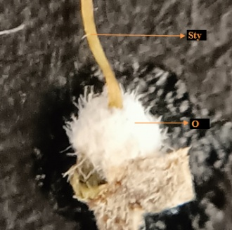 | 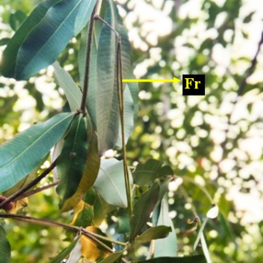 | 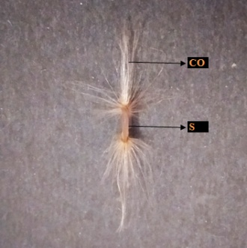
Plate 13. Gynoecium Ovary Overview: Sty- Style; O- Ovary | Plate 14. Fruit | Plate 15. Seed: Co- Coma; S- Seed

FRUIT
The fruits are two slender follicles which are long, pendulous, cylindrical, linear, green, 42–45 cm long and 0.3–0.5 cm wide (Plate 14). The mature fruit was brown and dehisced longitudinally from the base into two halves and released large number of compressed small seeds.
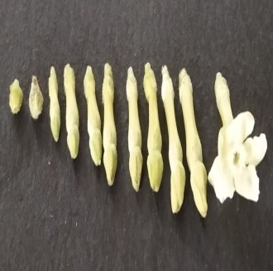
Plate 16. Stages of Flower Development

SEED
Seeds are linear, cylindrical, glabrous, smooth with a tuft of hairs on both ends. The seed was brown, 0.7–0.8 cm length and 0.1 cm width. The hairs are brownish white and 1–1.5 cm long (Plate 15).
DISCUSSION
Khyade & Vaikos (2009) reported Alstonia scholaris leaf length (5–15 cm), width (2–6 cm) and number of secondary veins (50–60) which are contrasting to the present study. Albert et al. (2011) documented the morphology of Alstonia scholaris which are similar to the present study. The morphology of Alstonia scholaris was studied by Pratap et al., 2013 and Chauhan & Nisha, 2018. The leaf morphology of Alstonia scholaris was studied by Rijhwani, 2013 and Das et al., 2020.
CONCLUSION
Each and every living organism has a definite form. Study of the external structure or morphology helps us to identify and distinguish the species. Knowledge of morphology of plant is also helpful in the study of various other fields such as genetics, plant breeding, genetic engineering, horticulture, crop protection and others. Based on these findings, the Alstonia scholaris plant species were distinguished from other species of the Apocynaceae family.
REFERENCES
- Albert, S, Amee Padhiar, Dhara Gandhi & Priyanka Nityanand 2011, ‘Morphological, anatomical and biochemical studies on the foliar galls of Alstonia scholaris (Apocynaceae)’, Revista Brasileira de Botanica, vol. 34, no. 3, pp. 343-358.
- Chauhan, S & Nisha 2018, ‘Reproductive biology of Alstonia scholaris (L.) R.Br. (Apocynaceae)’, International Journal of Plant Reproductive Biology, vol. 10, no. 2, pp. 119-126.
- Das, M, Rajesh Bolleddu, Avijit Banerji & Jayram Hazra 2020, ‘Phyto-Pharmacognostical Evaluation and Hptlc Finger-Printing Profile of Leaves of Saptaparna [Alstonia scholaris (L.) R. Br.]’, International Journal of Pharmaceutical Sciences and Research, vol. 11, no. 9, pp. 4449-4457.
- Khyade, MS & Vaikos, NP 2009, ‘Pharmacognostical studies on the Leaves of Alstonia scholaris R. Br’, Journal of Pharmacy Research, vol. 2, no. 5, pp. 858-861.
- Pratap, B, Chakraborthy, GS & Nandini Mogha 2013, ‘Complete Aspects of Alstonia scholaris’, International Journal of Pharm Tech Research, vol. 5, No. 1, pp. 17-26.
- Rijhwani, S 2013, ‘Epidermal and venation studies in Carissa carandas L. and Alstonia scholaris R. Br’, The IIS University Journal of Science and Technology, vol. 2, no. 1, pp. 43-48.

