A Comparative Analysis of Flat Slab and Conventional Slab Designs

**1Pranali Suresh Ganorkar, 2Dr. Jyoti Yadav**

1M.Tech Scholar, 2Assistant Professor,Department of Civil Engineering, Sarvepalli Radhakrishnan University, Bhopal, M.P, India

---------------------------------------------------------------------***----------------------------------------------------------------------

**Abstract: –**  Many building construction projects have embraced the flat slab technique, using the lower floor height to cater to the lucrative architectural market. A building's general geometry, structural system, and load component are all part of it. The behavior of such factors varies between typical slab structures and flat slab structures. If the customer want to employ convention in order to meet their needs while changing the interior, Not only has research on the structure's design begun in India, but also in other wealthy nations. The building is still damaged as a result of the earthquake for many causes. The structure configuration system has been crucial in the catastrophe, despite all of the flaws in the structure, including errors in analysis and design or in the coding. Normal frame construction often uses beams, slabs, and columns.But, it would be feasible to build without using beams; in that instance, the frame system would be made up of a slab and a column in place of a beam. Our research is to examine a building with a standard slab and a flat slab in relation to different loading scenarios.Our project's main goal is to use software to compare the performance of buildings with standard slabs and those with flat slabs.

**Key Words: -** Keyword- Building, flat-slab, Conventional slab, Period Time, STAAD PRO

# Introduction

The comparison study between the standard slab and the flat slab is the focus of the present effort. Conventional slab constructions that act at distinct stress positions are used in this setup. Because the flat slab and traditional R.C. slab are situated differently inside a framework, they function differently depending on the loading position. Compared to traditional slab structures, flat slab structures have a lower bulk. Due to the differences between the components of a typical slab and a flat slab, the performance was examined in terms of lateral displacement, period duration, base shear, story drift, and base shear. STAAD PRO V8i software was used for all modeling, analysis, and design. The advantages of flat-slab reinforced concrete structures are widely known but there are also known disadvantages concerning their earthquake resistance. Remarkably, both Greek codes, Reinforced Concrete Code and Seismic Code do not forbid the use of such structural systems however both Codes provide specific compliance criteria in order for such structures to be acceptable.

The advantages of these systems are:

1. The ease of the construction of formwork.
2. The ease of placing of flexural reinforcement.
3. The ease of casting concrete.
4. The free space for water, air pipes, etc. Between slab and a possible ceiling.
5. The clear placing of walls in the ground plan.

7) The minimization of building height in multi-story structures by saving one story height.

**2. Details of Parameter for Design**

# Description Loading:-

The loading on the buildings is considered as per following calculations

1) Dead Loads

1. Wall load of 200mm thickness on all beams

=20x2.85x0.20 = 11.40 KN/m

1. Load of 100mm thickness on all beams =20x2.85x0.10 =

5.70 KN/m

1. Dead load of Floor finish on slab = 1 KN/m2
2. Slab Dead load =0.150x25x1=3.75 KN/m2
3. Slab Dead load =0.125x25x1=3.125 KN/m2

d) Self-weight of building is automatically considered by the STAAD PRO V8i software.

1. Live load on slab = 2 KN/m2

c) Earthquake zone and soil type has been changed as per requirement.

1. Loading Combinations

The different loading combinations for the analysis of the building have been taken by STAAD PRO V8i softwar

# BUILDING DESCRIPTION:-

# Table 1: Description of Building

|  |  |  |  |  |  |  |
| --- | --- | --- | --- | --- | --- | --- |
| **Building Details** | | | | | | |
|  | | **Flat Slab** | **Conventional Slab** | | | |
| **Column Size** | | 300 mm X 300 mm | 300  mm | mm | X | 300 |
| **Beam Size** | | 300 mm X 175 mm(Hidden beam) | 200  mm | mm | X | 400 |
| **Slab Size** | | 150 mm thick | 125 mm thick | | | |
| **No. of Bays** | | 3No. | 3No. | | | |
| **C/c length** | **Span** | 3.0 mt | 3.0 mt | | | |

* **Section Details:**

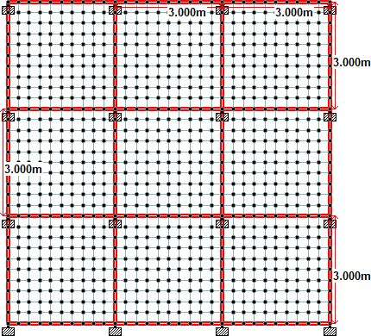

# Figure 1: Plan of a Slab Structure

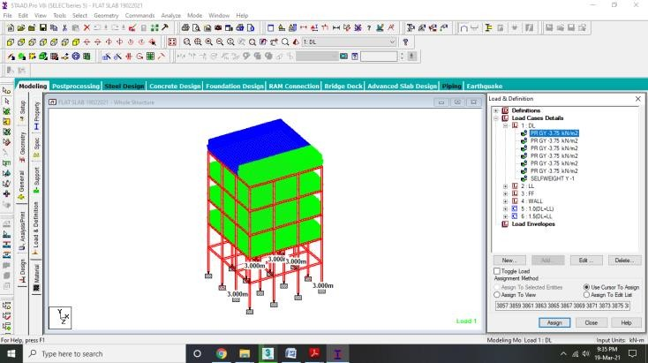

Figure 2: Load apply on Structure Plan of wall load on Structure

**3. Methodology**

The buildings are modelled in STAAD PRO V8i software the buildings consist of stories G+3 is unique moment resisting frame assumed subjected to gravity and dynamic loads are analyzed by equivalent static analysis, response spectrum analysis, time history analysis is carried out taking data. Beams and column members have been defined as concrete area elements. Conventional Slabs are defined as area elements having the properties of concrete area elements and plate elements, Flat slabs having the properties of plate element, Buildings having grade of concrete for beam, column, and slab is M25 with unit weight of concrete being 25kN/m3. Column size for building up to 4th floor is 0.3 mx0.3m, while the beam size is 0.30mx0.175m.The Building models having each storey height of 3m.

1. **Results and Discussions**

The study of results has been divided into the following points:

1. Comparison Base shear force and maximum top storey displacement (Sway) for Flat slab building and Conventional R.C. framed building of 4 floors for different soil condition.

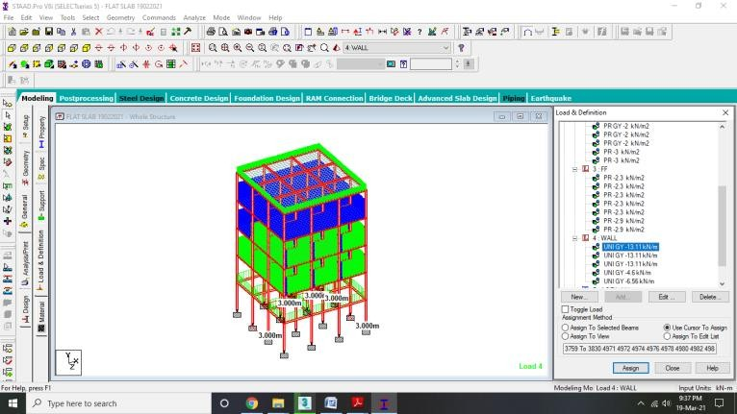

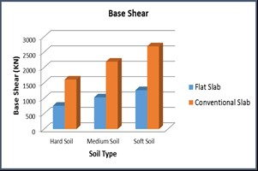

Figure 3: Comparison Base shear force and maximum top storey displacement

1. Comparison of Floor Sway for different Soil Type for Flat slab and Conventional RC slab structure.

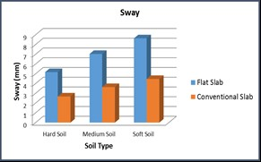

Figure 4:Comparison of Floor Sway for different Soil Type for Flat slab and Conventional RC slab structure

1. Graph Sowing Column axial force due to load combinations for change in numbers of floor of Flat slab and Conventional RC slab structure

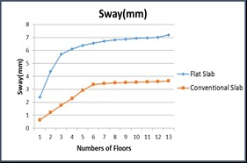

# Figure 5:Column axial force due to load combinations for change in numbers of floor of Flat slab and Conventional RC slab structure

# **5. Conclusions**

Based on comparison study of flat slab and conventional slab the following conclusions are drawn:

1. Base shear of conventional R.C. framed building is more than the flat slab building.
2. Base shear in flat slab is increases constantly up to 3 floors and then it increases very slowly. And in conventional R.C. framed it increases up to 2 floors and then it decreases slowly.
3. Sway increment as the numbers of floors increment.
4. Sway at terrace level is record for both types of building.

Story drift (Sway) in buildings with flat slab construction is significantly more as compared to conventional R.C.C building. As a result of this additional moments are developed. Therefore, the columns of such buildings should be designed by considering increased moment caused by the drift.

1. Axial force on column due to all load combination is almost same in both building but shear force and bending moment is similarly more in conventional slab building.
2. The column reinforcement changes as building height increment.

# 6. Future Scope

1. This study was done between flat slab and conventional slab in future flat slab with Perimeter beams comparison with drop and without drop can also be studied for all seismic zones.
2. This analysis was done using STAAD PRO V8i software.
3. In future, analysis of flat slab structure with perimeter Beams can be done while considering different load condition
4. In this study, fixed supports are considered for the analysis of the structure. In the future, it can be extended for different support conditions.

**References**

1. A.A.Sathawane [2012] studied about the most economical slab between flat slab with drop, flat slab without drop and grid slab.

2.Dr Ramakrishna Hegde,Chethana, Nanditha Vinod Kumar “Comparative study on seismic analysis of Conventional slab, Flat slab and Grid slab system for a R.C. framed structures” International Research Journal of Engineering and Technology (IRJET) Vol.5, Issue 9, Sept- 2018.

3.(STAAD.Pro) is a structural analysis and design software application originally developed by

4.Bhavikatti S.S, “Advance R.C.C. Design” , New Age International (p) Limited, Publishers, New Delhi, India

5.IS 456:2000 - Plain and reinforced concrete – Code of Practice, BIS, New Delhi.

6.B.C. Punmia, Ashok Kumar Jain, Arun Kumar Jain (2003), “Soil Mechanics and Foundations”, Published by Laxmi Publications (P) Ltd.

7. K.S.Sable, Er.V.A.Ghodechor, S.B.Kandekar “Comparative study of seismic behaviour of multistory flat slab and conventional reinforced concrete framed structures” International Journal of Computer Technology and Electronics Engineering (IJCTEE) Vol.2, Issue 3, June 2012.

8. M.S.Kiran Parmar, Mazhar Dhankot “Comparative study between dual systems for lateral load resistance in buildings of variable heights” Journal of Information, Knowledge and Research in Computer Engineering Vol.2, Issue 2, October 2013.

9. Navyashree.K, Sahana.T.S “Use of flat slab in multi-storey commercial building situated in high seismic zone” International Journal of Research in Engineering and Technology (IJRET) Vol.3, Issue 8, August 20