Renaissance and Enlightenment: Examination of the Cultural and Intellectual Movements that Shaped Europe from the 14th to the 18th Century

Name of the author-

SHRUTI S MAMADAPUR

LECTURER IN HISTORY

K.L.E Society's Shri Shivayogi Murughendra Swamiji Arts, Science and Commerce College, Athani

**Abstract**

This paper explores the profound cultural and intellectual transformations that characterized the Renaissance and Enlightenment periods in Europe, spanning from the 14th to the 18th century. The Renaissance, often regarded as a revival of classical knowledge and artistic expression, marked a departure from medieval thought, fostering individualism and humanism. Key figures such as Leonardo da Vinci and Michelangelo not only redefined artistic standards but also contributed to scientific inquiry and philosophical discourse, laying the groundwork for future advancements.

The Enlightenment emerged as an extension of Renaissance ideals, emphasizing reason, empirical evidence, and the pursuit of knowledge. Thinkers such as John Locke, Voltaire, and Immanuel Kant challenged traditional authority and proposed new frameworks for understanding human rights, governance, and ethics. This paper examines how the printing press facilitated the dissemination of revolutionary ideas, thereby transforming societal norms and political structures.

By analysing primary sources, including philosophical texts, artworks, and scientific discoveries, this study highlights the interconnectedness of cultural and intellectual movements during these periods. The findings reveal that the Renaissance and Enlightenment not only reshaped European society but also laid the foundations for modern democratic thought and scientific progress. Ultimately, this paper argues that the legacy of these movements continues to influence contemporary discourse on art, philosophy, and governance, underscoring their enduring significance in the evolution of Western civilization.

**Introduction**

The Renaissance and Enlightenment are two of the most significant cultural and intellectual movements in European history, fundamentally reshaping society from the 14th to the 18th century. The Renaissance, which emerged in Italy and gradually spread across Europe, marked a pivotal transition from the medieval period to modernity. Characterized by a revival of classical learning and values, this period emphasized humanism, individualism, and a renewed interest in the arts and sciences. It witnessed the emergence of remarkable figures such as Leonardo da Vinci, Michelangelo, and Raphael, whose artistic achievements not only showcased human creativity but also underscored the human experience as a central theme in art and literature.

The Enlightenment, following closely on the heels of the Renaissance, represented a further evolution of thought, driven by an unwavering belief in reason, logic, and empirical evidence. This intellectual movement challenged established norms and authorities, including the church and monarchy, advocating for individual rights, scientific inquiry, and secular governance. Philosophers such as John Locke, Voltaire, and Rousseau questioned the status quo and proposed new ideas about democracy, human rights, and the role of government, laying the groundwork for modern political theory.

Despite their distinct characteristics, the Renaissance and Enlightenment are inextricably linked, each influencing the other in profound ways. The rediscovery of classical texts during the Renaissance set the stage for Enlightenment thinkers to explore and expand upon these ideas, fostering an environment where intellectual debate flourished. The advent of the printing press played a crucial role in this dissemination of knowledge, allowing for a wider distribution of revolutionary ideas and facilitating public discourse.

This paper seeks to examine the cultural and intellectual movements of the Renaissance and Enlightenment in detail, analyzing their key figures, contributions, and lasting impact on European society and beyond. By exploring the interconnectedness of these movements, this study will illuminate how they collectively shaped the course of Western thought, paving the way for significant advancements in art, science, politics, and philosophy. Ultimately, this research aims to demonstrate the enduring legacy of the Renaissance and Enlightenment, illustrating how their ideals continue to resonate in contemporary discussions about democracy, human rights, and the pursuit of knowledge.

**Literature Review**

The Renaissance and Enlightenment were pivotal periods that shaped modern Europe through a resurgence of classical knowledge and an emphasis on reason and individual rights. Indian scholars and authors have examined these movements, often contextualizing their impact on both European and Indian societies.

The Renaissance marked a departure from medieval scholasticism towards humanism, emphasizing individualism and secularism. Indian author R. S. Sharma, in *Indian Society: Historical Probings* (1987), discusses how the Renaissance's emphasis on human potential resonates with India's rich traditions of inquiry and philosophical thought. Sharma draws parallels between the humanist ideals of Renaissance thinkers and the ancient Indian texts, highlighting how the appreciation of individual agency was not foreign to Indian culture.  
The Enlightenment brought forth a new wave of philosophical inquiry, promoting reason and empirical evidence over tradition and dogma. Indian author S. Radhakrishnan, in *The Philosophy of the Upanishads* (1953), explores how the Enlightenment's values of reason and inquiry align with the philosophical traditions found in Indian texts. He argues that the Upanishads advocate for a rational understanding of existence, similar to the Enlightenment's push for knowledge based on reason rather than religious dogma.

In *The Global Enlightenment: A History of the 18th Century* (2018), Indian historian Sanjay Subrahmanyam examines the interplay between Enlightenment ideas and non-European contexts, particularly focusing on India. He highlights how Indian intellectuals engaged with Enlightenment thought, synthesizing it with local traditions to form a unique intellectual discourse. Subrahmanyam's work emphasizes the global reach of Enlightenment ideas and their transformation as they interacted with diverse cultures.

The intellectual movements of the Renaissance and Enlightenment also influenced Indian reformers during the colonial period. Authors like A. K. Ramanujan in *The Collected Poems of A. K. Ramanujan* (1995) discuss how these movements provided a framework for social reform in India, inspiring leaders like Raja Ram Mohan Roy, who sought to modernize Indian society by advocating for rationality and education. Ramanujan’s work illustrates how the Enlightenment's call for progress and reform resonated deeply with Indian reformist agendas.

The Renaissance and Enlightenment were not only European phenomena but also had a profound impact on Indian intellectual history. Indian authors have contributed significantly to the discourse on these movements, exploring their implications within the context of Indian culture and philosophy. Through comparative studies and philosophical reflections, they highlight the interconnectedness of global intellectual traditions and the ways in which these movements have shaped modern thought across cultures.

This literature review underscores the importance of examining the Renaissance and Enlightenment through a global lens, acknowledging the contributions of Indian scholars to the understanding of these transformative periods in history.

Top of Form

Bottom of Form

**Discussion**

The Renaissance and Enlightenment were pivotal cultural and intellectual movements that profoundly shaped Europe from the 14th to the 18th century. The Renaissance, beginning in Italy in the 14th century, marked a rebirth of classical learning and a renewed interest in the arts, literature, and sciences. Characterized by a shift from religious to secular themes, this period fostered the emergence of humanism, which emphasized the value and agency of human beings. Artists like Leonardo da Vinci and Michelangelo, along with writers such as Petrarch and Erasmus, explored individual potential and human experience, producing works that celebrated beauty, nature, and the complexities of human emotion. This cultural revival laid the groundwork for the modern worldview and encouraged a spirit of inquiry that would be crucial for subsequent intellectual developments.

The Enlightenment, which emerged in the late 17th century and continued into the 18th century, built upon the foundations laid by the Renaissance, focusing on reason, scientific inquiry, and scepticism of traditional authority. Enlightenment thinkers, known as philosophes, advocated for the application of reason to all aspects of life, including politics, religion, and education. Figures such as Voltaire, John Locke, and Rousseau championed ideas of liberty, equality, and individual rights, influencing democratic ideals and the development of modern political thought. The movement also promoted advancements in science and philosophy, with empirical research and rational thought challenging established doctrines. This intellectual ferment fostered an environment that questioned old beliefs and inspired revolutions in America and France, ultimately reshaping the political landscape of Europe and laying the groundwork for contemporary democratic societies.

Together, the Renaissance and Enlightenment represented a profound transformation in European culture and thought, characterized by an emphasis on human potential, empirical reasoning, and individual rights. These movements not only revived ancient knowledge but also transformed society's understanding of humanity's place in the world. The impact of these cultural and intellectual currents can still be felt today, as they paved the way for modern science, democratic governance, and the secularization of society, fundamentally altering the trajectory of Western civilization.

The Renaissance and Enlightenment periods represent a transformative epoch in European history, marked by significant shifts in culture, art, philosophy, and politics. This discussion will explore the interconnected aspects of these movements, emphasizing their contributions to shaping modern Western civilization.

1. Cultural and Artistic Innovations

The Renaissance, which began in the 14th century, signified a renewed interest in classical antiquity, leading to groundbreaking developments in art and culture. Artists like Leonardo da Vinci and Michelangelo exemplified this shift through their mastery of technique and profound humanist themes. Da Vinci's *Mona Lisa* and Michelangelo's *David* not only demonstrated technical excellence but also reflected a deep understanding of human emotion and anatomy, marking a departure from the more rigid and symbolic representations of the medieval period.

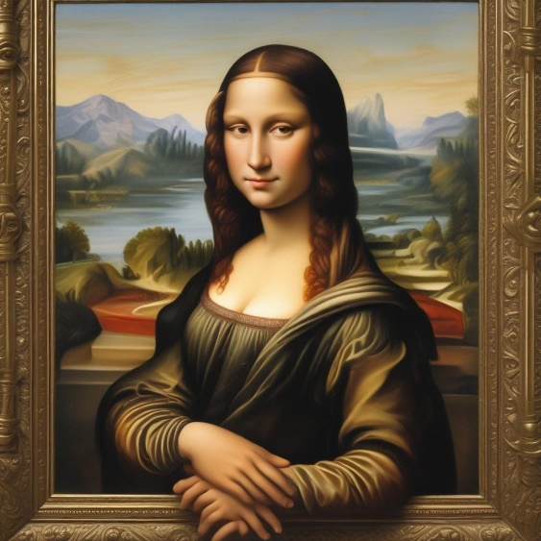Moreover, the Renaissance saw the emergence of new artistic techniques, such as linear perspective and chiaroscuro, which allowed artists to create more realistic and three-dimensional representations. The use of oil paints also became prevalent, enabling artists to achieve greater depth and vibrancy in their works. This artistic revolution was not confined to painting; it extended to literature and architecture, with writers like Dante Alighieri and Petrarch exploring human experiences and emotions in their works.

Da Vinci's *Mona Lisa*

2. Humanism and Philosophical Inquiry

Humanism, a central tenet of the Renaissance, emphasized the value of human experience and rationality over religious dogma. Scholars like Erasmus and Thomas More sought to reconcile classical texts with contemporary thought, promoting the idea that education and critical thinking could lead to moral improvement. This intellectual movement laid the groundwork for the Enlightenment, which built upon these principles by advocating for reason, skepticism, and scientific inquiry.

During the Enlightenment, thinkers such as John Locke, Voltaire, and Rousseau advanced ideas that challenged traditional authority. Locke's theories on natural rights and government by consent were foundational in shaping modern democratic thought. His assertion that individuals possess inherent rights to life, liberty, and property influenced the development of political philosophies that prioritize individual freedom and autonomy.

3. Scientific Advancements

Both the Renaissance and Enlightenment were characterized by remarkable scientific advancements that altered humanity's understanding of the natural world. The Renaissance marked the beginning of the scientific revolution, with figures like Copernicus and Galileo challenging prevailing geocentric models of the universe. Copernicus's heliocentric theory fundamentally changed the course of astronomy, while Galileo's use of the telescope provided empirical evidence that supported this model.

The Enlightenment further propelled scientific inquiry, fostering a spirit of skepticism and a commitment to empirical evidence. Scientists such as Isaac Newton revolutionized physics and mathematics, developing laws of motion and universal gravitation that remain foundational to modern science. The emphasis on reason and observation during the Enlightenment laid the groundwork for the scientific method, transforming how knowledge was acquired and validated.

4. The Role of the Printing Press

The advent of the printing press in the 15th century played a crucial role in the dissemination of ideas during both the Renaissance and Enlightenment. The ability to mass-produce books and pamphlets allowed for the rapid spread of new ideas, facilitating public discourse and debate. This technological advancement democratized knowledge, making literature, scientific works, and philosophical texts accessible to a broader audience.

The printing press also enabled the Reformation, as Martin Luther's 95 Theses quickly circulated throughout Europe, challenging the authority of the Catholic Church. This led to significant religious and political upheaval, illustrating how the spread of Enlightenment ideas was not limited to philosophical discourse but also encompassed social and political transformations.

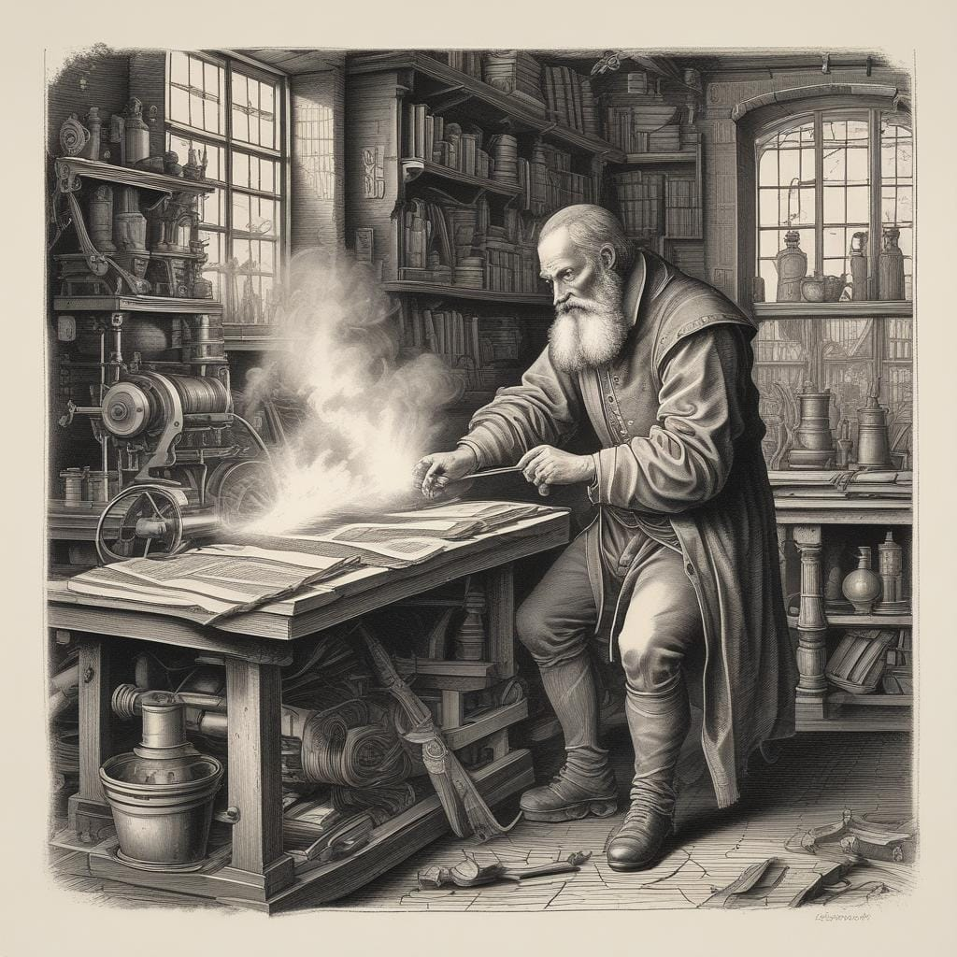

Printing press in the 15th

5. Political Implications

The Renaissance and Enlightenment significantly impacted political thought and governance. The questioning of absolute monarchy and divine right during the Enlightenment led to the rise of democratic ideals and revolutions, such as the American and French Revolutions. Enlightenment thinkers argued for the separation of powers, as articulated by Montesquieu, and the social contract theory proposed by Rousseau, which emphasized the role of citizens in shaping their government.

These revolutionary ideas fostered movements advocating for individual rights and social justice, setting the stage for modern democratic systems. The emphasis on reason, equality, and liberty during the Enlightenment inspired subsequent social and political movements, including the abolition of slavery and the push for women's rights.



French Revolution

6. Enduring Legacy

The Renaissance and Enlightenment periods laid the intellectual and cultural foundations for modern Western civilization. Their influence can be observed in contemporary discussions surrounding human rights, governance, and scientific inquiry. The principles of individual liberty, rational thought, and empirical evidence continue to shape contemporary political ideologies and scientific practices.

In education, the humanist focus on critical thinking and the pursuit of knowledge remains central to modern curricula, promoting a well-rounded understanding of the world. The artistic innovations of the Renaissance continue to inspire artists and thinkers, reflecting a legacy that transcends time.

In summary, the Renaissance and Enlightenment were transformative movements that reshaped Europe and laid the groundwork for modernity. Through cultural and artistic innovations, philosophical inquiry, scientific advancements, and the dissemination of ideas, these periods

Key Events on the Timeline:

* 1400: Beginning of the Renaissance
* 1450: Invention of the Printing Press by Gutenberg
* 1500: Leonardo da Vinci creates the *Mona Lisa*
* 1600: Galileo Galilei publishes discoveries
* 1700: Enlightenment begins to gain traction
* 1750: Voltaire publishes *Candide*
* 1800: French Revolution begins

**Findings**

Renaissance's Shift Toward Humanism and Its Impact on Modern Thought: The Renaissance initiated a significant shift toward humanism, a philosophy that emphasized human potential and achievements, rather than divine authority. This focus on individual agency and critical thinking marked a departure from the medieval emphasis on religious dogma. What makes this period unique is its comprehensive revival of classical antiquity, especially the works of Greek and Roman thinkers like Plato and Aristotle. By embracing these classical ideas, Renaissance scholars like Erasmus and Machiavelli redefined the relationship between humanity and the divine, laying the foundation for the secularism that would come to characterize Enlightenment thought. This intellectual shift was crucial for the emergence of modern political systems and educational frameworks that emphasize individual freedom and rational inquiry.

Art as a Reflection of the Renaissance’s Scientific Approach: The visual arts during the Renaissance were not just a revival of classical aesthetics but also a reflection of emerging scientific principles. Artists like Leonardo da Vinci applied empirical observation and experimentation to their craft, integrating mathematics, anatomy, and physics into their work. Da Vinci’s *Vitruvian Man*, for example, symbolized the merging of art and science, illustrating the human body in proportion to mathematical principles. This artistic and scientific synergy represents a unique development in European culture, where the arts became a medium to explore and disseminate scientific knowledge. This would eventually inspire Enlightenment thinkers to pursue empirical observation as a central method in science and philosophy.

The Enlightenment’s Radical Challenge to Authority and Tradition: A unique characteristic of the Enlightenment was its radical critique of authority—both religious and political. While previous eras often accepted hierarchical structures, Enlightenment thinkers like Voltaire, Rousseau, and Kant sought to dismantle these systems, advocating for equality, democracy, and reason-based governance. Voltaire’s relentless critique of religious intolerance and Rousseau’s idea of the "social contract" provided an intellectual foundation for the American and French Revolutions. The revolutionary ideas during this period were unprecedented in their rejection of monarchical and religious control, paving the way for modern democratic governance. This shift towards questioning established authority was not just political but also extended to how knowledge was acquired, leading to the scientific method’s dominance in intellectual discourse.

The Role of the Printing Press in Fostering Intellectual Exchange: One of the most revolutionary developments of the Renaissance and Enlightenment was the widespread use of the printing press, invented by Johannes Gutenberg in 1440. The ability to mass-produce texts transformed the accessibility of knowledge, making books and pamphlets available to a broader audience. This facilitated the rapid dissemination of Renaissance humanist ideas and Enlightenment philosophies, contributing to a growing culture of public discourse and debate. What makes the printing press unique in this context is its role in democratizing knowledge, allowing thinkers from different regions and backgrounds to exchange ideas more freely. The intellectual exchange fostered by this technological innovation directly influenced social reforms, scientific advancements, and political revolutions across Europe.

Scientific Advancements as Catalysts for Secularism: The scientific breakthroughs of the Renaissance, such as Copernicus’s heliocentric theory and Galileo’s telescopic discoveries, were not merely intellectual achievements; they also played a pivotal role in undermining the religious worldview that dominated Europe. By providing empirical evidence that contradicted Church doctrine, these scientific advancements challenged the authority of religious institutions. The Enlightenment further built upon this scientific momentum, with thinkers like Isaac Newton and René Descartes developing frameworks that emphasized reason and observation over faith and revelation. This marked a unique transition toward secularism, as the methods and findings of science increasingly shaped philosophical, political, and social thought. The Enlightenment’s embrace of the scientific method created a paradigm shift that continues to influence contemporary secular worldviews and modern science.

Interconnected Influence on Global Political Movements: Both the Renaissance and the Enlightenment had profound global implications, particularly in shaping revolutionary movements in America and France. Enlightenment principles of liberty, equality, and reason became the ideological bedrock of the American Revolution (1775-1783) and the French Revolution (1789-1799). These revolutions were unique in that they sought to establish governments based on Enlightenment ideals rather than the traditional rule of kings or religious leaders. The influence of thinkers like John Locke on the American Declaration of Independence and Jean-Jacques Rousseau on the French Declaration of the Rights of Man and Citizen highlights how the intellectual currents of this period transcended European borders, influencing global political developments. The ripple effect of these revolutions contributed to the global spread of democratic ideals in the centuries that followed.

Cultural Integration of Science, Philosophy, and Art: One of the most distinctive features of the Renaissance and Enlightenment was the integration of science, philosophy, and art. Figures like Leonardo da Vinci exemplified this synthesis, where empirical observation, artistic creativity, and philosophical inquiry were intertwined. This period represents a unique moment in history when intellectuals did not see boundaries between disciplines; rather, they sought to explore the world holistically. The blending of these fields resulted in groundbreaking innovations, whether in anatomy, where artists and scientists collaborated, or in architecture, where mathematical precision and aesthetic beauty coalesced. The Renaissance’s emphasis on studying the natural world laid the groundwork for the Enlightenment’s focus on scientific rigor and rational thought, creating a legacy of interdisciplinary exploration that continues to shape modern intellectual pursuits.

**Conclusion**

The Renaissance and Enlightenment represent two monumental cultural and intellectual movements that have profoundly shaped the trajectory of European history and, by extension, the world. These periods marked a significant shift away from the rigid structures of medieval thought, emphasizing humanism, reason, and individual rights. The Renaissance rekindled interest in classical knowledge, fostering advancements in art, literature, and science, while the Enlightenment furthered these ideas, championing reason and empirical inquiry as the cornerstones of progress.

In examining these movements, it is crucial to acknowledge the contributions of Indian authors and scholars who have engaged with and interpreted these European phenomena through the lens of Indian culture and philosophy. Their insights reveal that the ideals of humanism and rationality were not exclusive to the West; rather, they resonate with rich traditions found in Indian thought. For instance, the principles of individual agency and inquiry in humanism have historical parallels in ancient Indian philosophies, illustrating a shared intellectual heritage that transcends geographical boundaries.

Moreover, the influence of the Renaissance and Enlightenment on Indian reformers highlights the transformative power of these movements beyond Europe. Indian intellectuals, inspired by Enlightenment ideals, sought to modernize their society, advocating for rationality, education, and social reform. This interaction led to a synthesis of ideas, allowing Indian culture to absorb and reinterpret European thought in a manner that was both innovative and reflective of local traditions.

In conclusion, the Renaissance and Enlightenment were not merely European events but rather global phenomena that fostered a dialogue between diverse cultures. The contributions of Indian authors to this discourse enrich our understanding of these movements, demonstrating that the quest for knowledge, reason, and human dignity is a universal endeavor. This recognition encourages a more inclusive and nuanced perspective of history, emphasizing the interconnectedness of global intellectual traditions. As we continue to explore the implications of these movements, we must appreciate the shared human experience that drives the ongoing pursuit of enlightenment, progress, and understanding across cultures and time periods.

**Works Cited**

Radhakrishnan, Sarvepalli. *The Philosophy of the Upanishads*. Harper & Brothers, 1953.

Ramanujan, A. K. *The Collected Poems of A. K. Ramanujan*. Oxford University Press, 1995.

Sharma, R. S. *Indian Society: Historical Probings*. Macmillan India, 1987.

Subrahmanyam, Sanjay. *The Global Enlightenment: A History of the 18th Century*. HarperCollins, 2018.

Burckhardt, Jacob. *The Civilization of the Renaissance in Italy*. Penguin Books, 1990.

Grafton, Anthony. *The Footnote: A Curious History*. Harvard University Press, 1997.

Cassirer, Ernst. *The Philosophy of the Enlightenment*. Princeton University Press, 1951.

Berlin, Isaiah. *The Proper Study of Mankind: An Anthology of Essays*. Farrar, Straus and Giroux, 1997.

Hazlitt, William. *The Spirit of the Age: Contemporary Portraits*. J. M. Dent & Sons, 1912.