**A COMPARATIVE STUDY ON THE SGX NIFTY AND GIFT NIFTY WITH NIFTY INDEX USING THE SPILL-OVER EFFECT**

1. **Pavan Kumar**

Masters of Business Administration, Sahyadri College of Engineering and Management, Mangalore

1. **Pooja Yashwanth Rai**

Assistant Professor, Department of Business Administration, Sahyadri College of Engineering and Management, Mangalore.

**ABSTRACT**

With a special emphasis on the spillover effects between these indexes, this study compares the SGX Nifty, GIFT Nifty, and Nifty Index. The goal of the study is to present a thorough knowledge of the causal interactions and interrelationships between these important market indicators. The study explores the dynamic interactions that form these indices by utilizing sophisticated time series econometric approaches such as impulse response function, ADF test , GARCH and Vector Autoregression (VAR) models. The underlying Nifty 50 index is a derivative of the SGX Nifty, which is traded on the Singapore Exchange. On the other side, the Gujarat International Finance Tec-City (GIFT City) exchange in India is home to the GIFT Nifty, a derivative. These two indices are frequently employed as stand-ins for the Indian equity market. The foundational benchmark for the SGX Nifty and GIFT Nifty is the Nifty Index, which lists the top 50 firms that are listed on the National Stock Exchange of India (NSE).

**Keyword :** Spillover Effect, SGX, GIFT Nifty, Nifty50, GARCH, Impact, VARR Model, NSEIX, NSE, ADF test, Volatility, Indian Stock Market, Comparison.

**INTRODUCTION**

The global financial markets have become increasingly interconnected, leading to increased co-movements between domestic and international equity indices. The Nifty Index, a benchmark for the Indian equities market, and its offshore counterparts, the SGX Nifty and GIFT Nifty, have become key focus areas for analysis. This study aims to understand the intricate relationships between these indices by quantifying their co-movements and assessing the influence of external factors. The Nifty 50, the benchmark for the SGX Nifty and GIFT Nifty, represents the top 50 companies listed on the National Stock Exchange of India. The study aims to understand how changes in one index affect the others, whether these indices are causally related, and the impact of external shocks on information flow and volatility. This study contributes to a deeper understanding of the Indian and international equities markets, providing valuable insights for investors, policymakers, and market participants.

**SPILLOVER EFFECT**

The "spillover effect" refers to the interconnected nature of the global economy, where events in one region can affect others. Factors like shock nature, economic integration, financial linkages, and economic resilience influence the magnitude and direction of spillovers. Financial crises, geopolitical tensions, and trade disputes can have significant negative spillover effects, such as credit losses, weakened lending, and economic slowdowns in other countries, disrupting supply chains and reducing export demand.

**CONCEPTUAL FRAMEWORK**

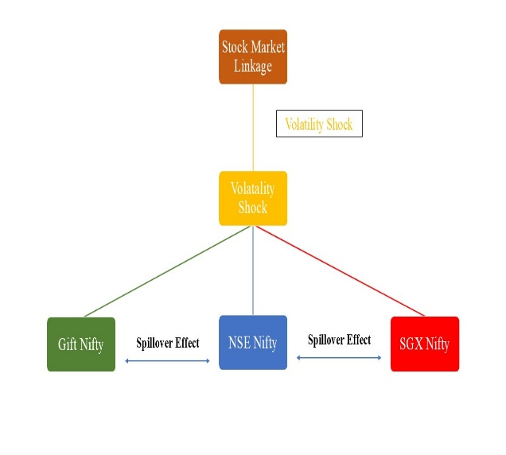

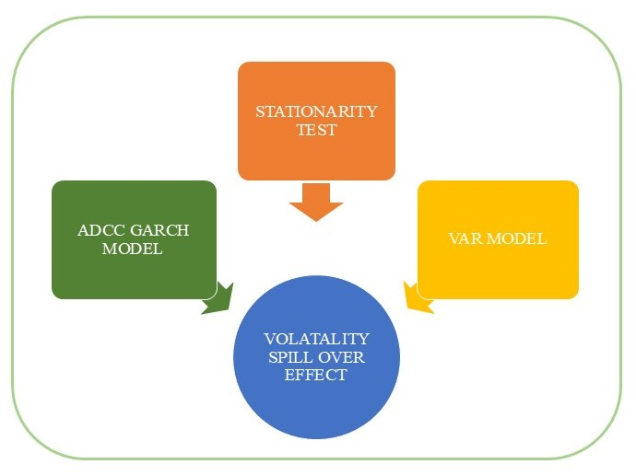

**LITERATURE REVIEW**

(M Shetty, RKS Kumar, 2024) The interdependencies between the SGX NIFTY and NSE NIFTY indices are examined in this study of the literature. Previous studies emphasize how global financial markets are interrelated and how time-varying correlations can be analyzed using DCC models. Although there isn't much research on the SGX NIFTY and NSE NIFTY in particular, this study tries to fill that gap by offering a thorough analysis utilizing the ADCC GARCH model. Investors and market players will need to consider the findings.

(Seghal S, 2019) The study looks at the dynamic relationships between the stock markets of 12 Asian nations between January 2000 and June 2017. It analyzes conditional correlations and return and volatility spillovers using the Diebold and Yilmaz (2012) spillover index approach and the ADCC-GARCH model. It is discovered that Singapore has the strongest correlations with other markets, and that these correlations are stronger during times of financial crisis, suggesting financial contagion. According to the report, Singapore is the leading market in terms of spillovers from volatility and return. The results add to the body of knowledge on financial integration for Asian markets and have important ramifications for foreign investors and policymakers.

(AK Mishra, 2007) The study looks at the dynamic relationships between the stock markets of 12 Asian nations between January 2000 and June 2017. It analyzes conditional correlations and return and volatility spillovers using the Diebold and Yilmaz (2012) spillover index approach and the ADCC-GARCH model. It is discovered that Singapore has the strongest correlations with other markets, and that these correlations are stronger during times of financial crisis, suggesting financial contagion. According to the report, Singapore is the leading market in terms of spillovers from volatility and return. The results add to the body of knowledge on financial integration for Asian markets and have important ramifications for foreign investors and policymakers.

(Kiran Kumar Kotha, 2017) Using data from July 15, 2010 to July 15, 2016, the study examines the dynamic relationships between the Nifty stock index and Nifty index futures contracts traded on the National Stock Exchange (NSE) and the Singapore Stock Exchange (SGX). It discovers a causal relationship in both exchanges between the results of the spot market and the Nifty futures market. The study verifies that the spot market is the primary market for price discovery using the Vector Error Correction model, the Granger causality test, Variance Decomposition, and Impulse Response Analysis.

(Wang Y, 2016) The aim of this research is to present an empirical approach for calculating the spillover index in Asian stock markets, which was first proposed by Diebold and Yilmaz (2009). Design, methodology, and approach: A VAR-structural-GARCH model serves as the foundation. Conclusions: The data unequivocally demonstrate that the USA is the primary source of volatility in the Asian financial markets, with China having minimal trading relationships with other regions. Moreover, there is proof of financial contagion during the global financial crisis of 2008 as well as the Asian financial crisis of 1997. Originality/value: - The method is both dynamic and uniquely defined, which are two advantages.

(Jebran K, 2016) This study looks into the ways that stock markets and foreign exchange markets in Asian nations like China, Hong Kong, Japan, India, Pakistan, and Sri Lanka can affect each other's volatility. The analysis, which makes use of the EGARCH model, shows that volatility transmission is unidirectional in India but bidirectionally asymmetric in Pakistan, China, Hong Kong, and Sri Lanka. Nevertheless, there isn't any proof of volatility transmission in Japan. The results improve financial stability and decision-making in these markets by providing insightful information to investors and economic policy makers on foreign portfolio and currency risk strategies.

(Sundararajan S, 2023) This study examines the dynamic relationships that exist between US stock indices and Indian Nifty index futures on the offshore Singapore Exchange (SGX) when the Nifty futures spot market is closed. The authors investigate volatility spillover using high-frequency 5-min overlapping pricing data and the Granger causality test, BEKK-GARCH model, and Johansen cointegration test. The empirical results show that the US DJIA market and the SGX Nifty futures market are cointegrated, with the US DJIA stock index having a significant impact on price discovery and previous market innovations having an impact on current volatility. The results have application for those involved in the market, especially international investors and portfolio managers, as well as policymakers assessing the stability of the market.

**OBJECTIVES**

1. To Investigate the dynamic relationship between the SGX nifty and GIFT Nifty with Nifty Index.
2. To quantify the extent to which changes in one index influence the other index.
3. To compare the spill-over effect between the selected indices.

**NEED OF THE STUDY**

Future work on this project will focus on exploring the intricacies of the spillover effects among SGX Nifty, GIFT Nifty, and Nifty Index. There are a number of possible directions to pursue, such as analyzing particular occurrences in-depth, using high-frequency data, reviewing non-linear relationships, comparing situations internationally, analyzing investor behavior, looking at risk management implications, and evaluating policy implications.

**SCOPE OF THE STUDY**

The findings of the volatility spill-over effect aid in the investigation of sensible asset allocation, risk diversification, and other management choices by academics, policymakers, and portfolio managers.

**RESEARCH METHODOLOGY**

**a. Data Sample:** Daily closing price of the NSE, NSEIX, SGX

**b. Data Source:** NSE, Yahoo Finance, Investing.com

**C. Research Tool:** R Studio (RGARCH package, which contains rugarch and rmgarch.)

**d. Research Technique:** ADF test, VAR model, GARCH

**e. Research Timeframe:** SGX and NSE data from 03/07/2022 to 03/07/2023. NSEIX and NSE data from 03/07/2023 to 03/07/2024

**DATA ANALYSIS AND**

**INTERPRETATION :**

Table 1 : Descriptive Statistics of SGX and NSE Nifty

|  |  |  |  |  |
| --- | --- | --- | --- | --- |
| **NSE AND SGX DAILY SETTLEMENT PRICE ( 03/07/22 - 03/07/23)** | | | | |
|  | **Mean** | **SD** | **MIN** | **MAX** |
| **NSE** | 0.0008558 | 0.0074 | -0.0194 | 0.0258 |
| **SGX** | 0.0000436 | 0.00903 | -0.0469 | 0.0294 |

The table shows that the NSE NIFTY index has a slightly higher average daily return of 0.08558% compared to the SGX NIFTY index, which has an average daily return of 0.00436%. However, the SGX NIFTY index is more volatile, with a standard deviation of 0.903% compared to the NSE NIFTY's standard deviation of 0.74%. This indicates that the SGX NIFTY's returns are more variable and less predictable.

Table 2 : Descriptive Statistics of NSEIX and NSE Nifty

|  |  |  |  |  |
| --- | --- | --- | --- | --- |
| **NSE AND NSEIX DAILY SETTLEMENT PRICE ( 03/07/23 - 03/07/24)** | | | | |
|  | **Mean** | **SD** | **MIN** | **MAX** |
| **NSE** | 0.0009756 | 0.008011 | -0.0593 | 0.0336 |
| **NSEIX** | 0.0009452 | 0.008395 | -0.0648 | 0.0343 |

The table shows that the NSE and NSEIX indices have similar average daily returns of 0.09756% and 0.09452%, respectively. However, the NSEIX index is slightly more volatile with a standard deviation of 0.8395% compared to the NSE's standard deviation of 0.8011%. Both indices have experienced both positive and negative returns.

**VARR Estimation Result :**

VAR Model of SGX and NSE

|  |  |  |
| --- | --- | --- |
| **CORELATION (Residual Value)** | | |
|  | **RSGX** | **RNSE** |
| **RSGX** | 1 | 0.874 |
| **RNSE** | 0.874 | 1 |
|  |  |  |
| **COVARIANCE (Residual Value)** | | |
|  | **RSGX** | **RNSE** |
| **RSGX** | 7.89E-05 | 0.000007 |
| **RNSE** | 0.000007 | 0.000055 |

The correlation matrix indicates a strong positive correlation of 0.874 between the residual values of the SGX NIFTY and NSE NIFTY indices. This suggests that the two indices exhibit similar patterns of movement, even after accounting for their individual mean returns.

The covariance matrix provides the covariance between the residual values of the two indices. The off-diagonal elements of the matrix (0.000007) are positive, confirming the positive correlation between the residuals. The diagonal elements represent the variance of the residuals for each index. The variance of the SGX NIFTY residuals is 7.89E-05, while the variance of the NSE NIFTY residuals is 0.000055.

VAR Model of NSEIX and NSE

|  |  |  |
| --- | --- | --- |
| **CORELATION (Residual Value)** | | |
|  | **RNSEIX** | **RNSE** |
| **RNSEIX** | 1 | 0.987 |
| **RNSE** | 0.987 | 1 |
|  |  |  |
| **COVARIANCE (Residual Value)** | | |
|  | **RNSEIX** | **RNSE** |
| **RNSEIX** | 0.0000615 | 0.0000077 |
| **RNSE** | 0.0000077 | 0.0000631 |

The correlation and covariance matrices reveal a strong positive relationship between the residual values of NSEIX and NSE. The correlation coefficient of 0.987 indicates a very high degree of linear association, suggesting that the returns of RNSEIX and RNSE move together in a similar direction. The covariance values, while smaller in magnitude due to the scaling of the data, confirm this positive relationship. These findings suggest that the residual values of NSEIX and NSE are highly correlated, implying a shared pattern in their variability.

GARCH Model :

1. NSE and SGX

Based on the GARCH model results, there is evidence of a significant spillover effect between SGX and NSE. When one market experiences a shock, it tends to influence the other market's volatility. Moreover, this correlation is relatively persistent, suggesting a strong and enduring relationship between the two markets. This information is crucial for investors and policymakers as it highlights the interconnectedness of these markets and the potential for contagion effects during periods of market turbulence.

2. NSEIX and NSE

Based on the GARCH model results, there is evidence of a significant spillover effect between NSEIX and NSE. When one market experiences a shock, it tends to influence the other market's volatility. Moreover, this correlation is relatively persistent, suggesting a strong and enduring relationship between the two markets. This information is crucial for investors and policymakers as it highlights the interconnectedness of these markets and the potential for contagion effects during periods of market turbulence.

**Comparision of SGX and NSE, and NSEIX and NSE**

While both are volatile series with persistence in clustering, the central distinction lies in the DCC parameter. The combined higher value of dcca1 and dccb1 of the NSEIX-NSE24 model stands for stronger and more persistent correlation. This thus means that in the pairing of NSEIX-NSE24, the shocks or fluctuations to one index will have a stronger amplification and transmission to the other. In simple words, interdependence is more severe between the two indices.

The spillover effects are therefore higher in the NSEIX–NSE24 relationship. This would then imply that market movements in one index are likely to have a larger impact on the other, hence the possibility of greater volatility contagion. Such strong interdependence could create difficulties for portfolio diversification and risk management by reducing the benefits of spreading investments across these two indices.

**FINDINGS**

* The SGX and NSE exhibit a significant spillover effect, indicating high interdependence between the two index markets, with even stronger effects observed in NSEIX and NSE.
* The SGX and NSEIX exhibit strong correlations with the NSE, highlighting their interdependencies and aiding in portfolio diversification.
* Due to the high interdependence between NSEIX and NSE, investors would need to adopt a different investment strategy compared to the SGX approach.

**SUGGESTION**

* Develop risk management strategies that account for the interdependence and spillover effects between indices, thereby reducing potential market risks for investors.
* The SGX and NSEIX exhibit strong correlations with the NSE, highlighting their interdependencies and aiding in portfolio diversification.
* Understanding the economic factors causing spillover effects and interconnectedness can help identify trends and predict future market fluctuations.

**CONCLUSION**

The analysis of volatility, correlation, and spillover effects between the SGX and NSE, and NSEIX and NSE, reveals a complex interplay. Strong volatilities and surges in market activities are observed for both index pairs, with strong spillover effects indicating quick transmission of shocks. The highly correlated and covariate residuals support a strong connection between the Indian and global equity markets.

**REFFERENCE**

Shetty, M., Rahiman, H. U., Kodikal, R., & Kumar, R. S. (2024). Analyzing Stock Market Linkages: Exploring Volatility Spillover Effects Between SGX and NSE Nifty Using ADCC GARCH Model. In *The AI Revolution: Driving Business Innovation and Research: Volume 2* (pp. 599-613).

Sehgal, S., Bijoy, K., & Saini, S. (2019). Stock market linkages and spillover effects: An empirical analysis of select Asian markets. *Theoretical Economics Letters*, *9*(5), 1447-1472.

Mishra, A. K., Swain, N., & Malhotra, D. K. (2007). Volatility Spillover between Stock and Foreign Exchange Markets: Indian Evidence. *International journal of business*, *12*(3).

Kotha, K. K., & Bose, S. (2016). Dynamic linkages between Singapore and NSE listed NIFTY futures and NIFTY spot markets. *The Journal of Prediction Markets*, *10*(2), 1-13.

Wang, Y., & Liu, L. (2016). Spillover effect in Asian financial markets: A VAR-structural GARCH analysis. *China Finance Review International*, *6*(2), 150-176.

Jebran, K., & Iqbal, A. (2016). Dynamics of volatility spillover between stock market and foreign exchange market: evidence from Asian Countries. *Financial Innovation*, *2*, 1-20.

Riyazahmed, K. (2022). Volatility Spillover and Pandemic–Analysis of Selected Sectoral Indices in India. *Икономическа мисъл*, (6), 655-670.

Sundararajan, S., & Balasubramanian, S. A. (2023). International linkages of emerging market index futures, under the closure of underlying spot market–evidence from Indian Nifty futures. *Managerial Finance*, *49*(3), 577-593.

GC, S. B. (2016). Volatility spillover effect in Indian stock market. *Janapriya Journal of Interdisciplinary Studies*, *5*.

Chaudhary, R., Bakhshi, P., & Gupta, H. (2020). Volatility in international stock markets: An empirical study during COVID-19. *Journal of Risk and Financial Management*, *13*(9), 208.

Lingaraja, K., Selvam, M., & Vasanth, V. (2014). Co movements and inter-linkages among emerging and developed stock markets in Asia with reference to Singapore stock exchange. *International Research Journal of Finance and Economics*, *122*, 102-120.