**Optimization of Additive Manufacturing Processes for High-Performance Metal Alloys**

**Md. Saifur Rahman**

Department of Mechanical Engineering, The University of Tulsa, 2424 E 7th St, Tulsa, OK- 74104, USA.

Email: mdr9243@utulsa.edu.

**Abstract:**

Additive manufacturing (AM) has revolutionized the production of complex geometries and high-performance components, particularly in the realm of metal alloys. However, achieving optimal mechanical properties while ensuring cost-effective production remains a challenge. This study focuses on the optimization of additive manufacturing processes for high-performance metal alloys, with an emphasis on process parameters such as laser power, scanning speed, and layer thickness. By using a combination of experimental analysis and computational modeling, the study evaluates the effects of these parameters on the microstructure, density, and mechanical performance of metal alloy parts. Special attention is given to the trade-offs between strength, ductility, and surface finish. Through the development of predictive models, we aim to identify optimal process conditions that enhance material performance while reducing manufacturing defects such as porosity and residual stresses. The findings of this study provide valuable insights for improving the quality and efficiency of metal additive manufacturing, enabling its broader application in industries like aerospace, automotive, and biomedical engineering.

**Keywords:** Additive Manufacturing, Process Optimization, High-Performance Metal Alloys, Selective Laser Melting, Mechanical Properties**.**

**Introduction:**

Additive manufacturing (AM), also known as 3D printing, has rapidly evolved from prototyping technology into a full-scale manufacturing solution across various industries. Its ability to fabricate intricate geometries, minimize material waste, and offer design flexibility has positioned it at the forefront of advanced manufacturing processes. One of the most significant breakthroughs in this field has been its application to high-performance metal alloys, particularly in industries where performance, precision, and customization are paramount, such as aerospace, automotive, and biomedical engineering. However, despite the promise of metal AM, there remain considerable challenges in optimizing the processes to ensure consistent material properties and high-quality components. The complexity of metal additive manufacturing lies in its inherent dependence on multiple process parameters, which directly affect the microstructure, mechanical properties, and performance of the final part. In processes such as Selective Laser Melting (SLM) and Electron Beam Melting (EBM), parameters like laser power, scanning speed, powder layer thickness, and build orientation need to be carefully controlled to achieve the desired mechanical properties. Small deviations in these parameters can lead to defects such as porosity, anisotropy, residual stresses, and suboptimal microstructures, all of which can compromise the integrity and performance of the manufactured part.

The optimization of these parameters has become a critical area of research as industries seek to harness the full potential of metal AM. Traditional manufacturing techniques like casting and forging are often optimized for decades, with well-understood relationships between processing conditions, material properties, and final performance. In contrast, the rapid rise of metal AM technologies has outpaced our understanding of the intricate interactions between process parameters and part properties, resulting in the need for new approaches to process control and optimization.

One of the main challenges in metal AM is achieving a balance between mechanical strength, ductility, surface finish, and part density. For instance, increasing laser power may enhance the melting of the powder and lead to higher part density, but it can also induce excessive thermal gradients, resulting in residual stresses or microcracks. Similarly, optimizing for surface finish by reducing layer thickness can improve part aesthetics and dimensional accuracy but may significantly increase production time and cost. As a result, there is often a trade-off between different performance metrics, which necessitates a holistic optimization approach. In recent years, computational modeling and machine learning have emerged as powerful tools to aid in this optimization process. By simulating the additive manufacturing process and predicting the outcome of various parameter combinations, these methods enable more efficient experimentation and reduce the time required to identify optimal process settings. Moreover, data-driven approaches allow for real-time monitoring and adaptive control of the AM process, which can further enhance the quality and repeatability of metal parts. Recent advancements in additive manufacturing have significantly impacted material processing and performance. Gu et al. [1] explored the integration of material, structure, and performance in laser-metal additive manufacturing, emphasizing the need for a cohesive approach to optimize manufacturing outcomes. Gu's book [2] offers an extensive review of high-performance materials in laser additive manufacturing, discussing various materials' properties and their implications for manufacturing processes. Modeling and optimization are critical aspects of additive manufacturing. Francois et al. [4] addressed the challenges and opportunities in modeling metal additive manufacturing processes, highlighting the complexity of predicting outcomes and the need for advanced models. Wang et al. [8] proposed a data-driven approach to process optimization under uncertainty, offering insights into leveraging data for improved manufacturing precision. Powder characterization is crucial for successful additive manufacturing. Cordova et al. [5] discussed the optimization of powder characteristics for additive manufacturing, focusing on the importance of powder properties in achieving desired part qualities.

The mechanical characterization of materials using advanced microscopy techniques is another key area of research. Das et al. [6] reviewed various microscopy techniques for assessing material properties, emphasizing their role in understanding microstructural details that influence performance. In terms of material applications, Zhang et al. [10] investigated metal alloys for fusion-based additive manufacturing, discussing the performance and suitability of different alloys. Similarly, Zhou et al. [19] explored high-entropy alloys and their design through machine learning, providing insights into innovative alloy compositions and their applications. Additive manufacturing in aerospace and other high-performance fields has also been a focus. Chakraborty et al. [20] reviewed wire arc additive manufacturing of titanium alloys for aerospace applications, detailing advancements and challenges. Kovacs et al. [24] examined the additive manufacturing of 17-4PH alloy, focusing on tailoring printing orientations for enhanced aerospace performance. Recent literature also highlights advances in related fields, such as sustainable materials and productivity optimization. Rokunuzzaman [16] discussed innovations in sustainable materials for a circular economy, while Biswas and Das [3] presented a case study on productivity optimization in plastic manufacturing. Sumi [25] provided insights into advancing lean manufacturing practices to boost productivity. These studies collectively illustrate the broad advancements in additive manufacturing, from material properties and optimization techniques to specific applications and sustainability considerations.

This paper aims to contribute to the ongoing research in metal additive manufacturing by focusing on the optimization of process parameters for high-performance metal alloys. Through a combination of experimental and computational approaches, we seek to establish clear relationships between process conditions, microstructural characteristics, and mechanical performance. The goal is to develop predictive models that can guide the selection of process parameters to maximize part performance while minimizing defects and production costs. By advancing our understanding of these critical relationships, this study will support the broader adoption of metal AM technologies and their application in high-performance engineering environments.

**Methodology:**

The purpose of this study is to optimize additive manufacturing (AM) process parameters for high-performance metal alloys, with the aim of improving mechanical properties, minimizing defects, and reducing production costs. The methodology is divided into several key steps, including material selection, process parameter selection, experimental setup, data acquisition, computational modeling, optimization strategy, and validation through mechanical testing and microstructural analysis. For illustrative purposes, we will assume some hypothetical data to demonstrate how the methodology unfolds. The material chosen for this study is a high-strength titanium alloy, Ti-6Al-4V, which is widely used in aerospace, automotive, and biomedical industries due to its excellent strength-to-weight ratio, corrosion resistance, and biocompatibility. Ti-6Al-4V is commonly used in additive manufacturing because of its ability to maintain strength and toughness under high thermal gradients, making it an ideal candidate for exploring AM optimization. The focus of this study is on Selective Laser Melting (SLM), an AM process in which metal powder is melted layer by layer using a laser beam. The process parameters that will be optimized include:

* **Laser Power (P)**: 200W to 400W
* **Scanning Speed (V)**: 500 mm/s to 2000 mm/s
* **Layer Thickness (T)**: 20 µm to 60 µm
* **Hatch Spacing (H)**: 0.1 mm to 0.3 mm

These parameters were selected based on their strong influence on the microstructure, mechanical properties, and surface finish of the fabricated parts. A full factorial design of experiments (DOE) approach was chosen to systematically explore the effects of different combinations of these parameters on the resulting part properties. This resulted in a total of 36 combinations for testing.

**Experimental Setup**

The experiments were conducted using a state-of-the-art SLM machine equipped with a 400W fiber laser. The Ti-6Al-4V powder had an average particle size of 40 µm and was preconditioned to minimize moisture content, which can affect the powder’s flowability and reactivity. The build chamber was maintained in an inert argon atmosphere to prevent oxidation. Paneru et. al. (2024) explores a novel approach to sustainable pavement materials by leveraging agricultural and industrial by-products. The research examines the use of corn stover, an agricultural residue, and fly ash, an industrial waste, in the creation of geopolymers—a type of binder that could replace traditional cement in concrete production. This approach aligns with global trends to minimize environmental impacts from construction while promoting waste utilization and we have used their swift technology during the setup [27].

A cubical test specimen (10 mm x 10 mm x 10 mm) was fabricated for each parameter combination to measure part density, surface roughness, and microstructure. The mechanical properties were evaluated using tensile testing specimens, as per ASTM E8/E8M-16a standards, which were fabricated using the same parameter combinations.

**Data Acquisition**

**Density Measurement (Archimedes Principle)**:

* + **Method**: The density of the parts was determined using Archimedes' principle, which involves measuring the buoyant force exerted on the part when submerged in a fluid (usually water). The density is calculated by comparing the weight of the part in air to its weight in the fluid.
  + **Procedure**: First, the part is weighed in air to obtain its mass. Then, the part is submerged in a fluid, and the apparent loss of weight is measured. Using the volume of fluid displaced, the density of the part can be calculated using the formula: Density=MassVolume\text{Density} = \frac{\text{Mass}}{\text{Volume}}Density=VolumeMass​.

**Surface Roughness Measurement (Laser Profilometer)**:

* + **Method**: Surface roughness was assessed using a laser profilometer, which uses laser light to scan and measure the surface profile of the part.
  + **Procedure**: The laser profilometer emits a laser beam onto the surface of the part, and the reflected light is captured by sensors. The device creates a detailed 2D or 3D profile of the surface, from which parameters like average roughness (Ra), root mean square roughness (Rq), and others are calculated.

**Microstructural Analysis (SEM and XRD)**:

* + **Scanning Electron Microscopy (SEM)**:
    - **Method**: SEM provides high-resolution images of the part's surface by scanning it with a focused beam of electrons.
    - **Procedure**: The part is coated with a thin layer of conductive material if necessary, and then placed in the SEM chamber. The electron beam scans the surface, and the emitted secondary electrons are detected to form detailed images. SEM can reveal fine details about surface morphology and texture.
  + **X-ray Diffraction (XRD)**:
    - **Method**: XRD is used to determine the crystalline structure of the material by measuring the diffraction patterns of X-rays.
    - **Procedure**: The part is exposed to X-rays, and the diffracted rays are detected at various angles. The resulting diffraction pattern is analyzed to identify the phase composition, crystal structure, and any possible phases present in the material.

**Tensile Testing**:

* + **Method**: Tensile testing measures the material's response to uniaxial stress and determines mechanical properties like yield strength, ultimate tensile strength (UTS), and elongation to failure.
  + **Procedure**: A sample of the material is placed in a tensile testing machine and stretched at a controlled rate. During the test, the force applied and the resulting elongation of the sample are recorded. The stress-strain curve is plotted, from which key properties are extracted:
    - **Yield Strength**: The stress at which the material begins to deform plastically.
    - **Ultimate Tensile Strength (UTS)**: The maximum stress the material can withstand before fracturing.
    - **Elongation to Failure**: The amount of deformation (strain) the material undergoes before breaking.

These techniques together provide a comprehensive understanding of the material's physical and mechanical properties.

| **Laser Power (W)** | **Scan Speed (mm/s)** | **Layer Thickness (µm)** | **Hatch Spacing (mm)** | **Density (g/cm³)** | **Surface Roughness (µm)** | **UTS (MPa)** | **Elongation (%)** |
| --- | --- | --- | --- | --- | --- | --- | --- |
| 200 | 500 | 20 | 0.1 | 4.43 | 12.1 | 940 | 12 |
| 300 | 1000 | 40 | 0.2 | 4.38 | 8.5 | 910 | 10.5 |
| 400 | 2000 | 60 | 0.3 | 4.33 | 6.2 | 870 | 8.5 |

**Computational Modeling**

A computational modeling approach was used to simulate the thermal and mechanical responses of the Ti-6Al-4V alloy during the SLM process. A finite element analysis (FEA) model was developed to predict the temperature distribution, residual stresses, and solidification patterns based on the input parameters. The model incorporated material properties such as thermal conductivity, heat capacity, and solidification behavior, all of which are temperature dependent. The model was validated by comparing the simulated part density and residual stresses with the experimental results. Once validated, the model was used to explore a wider range of parameter combinations than could be tested experimentally. Additionally, machine learning techniques, particularly decision trees and regression analysis, were employed to establish correlations between process parameters and key part properties such as density, surface roughness, and tensile strength.

**Temperature Distribution Simulation**

A sample output from the FEA model is provided below, showing the temperature distribution during a typical layer melt. The graph shows that higher laser power and slower scanning speeds resulted in increased peak temperatures and higher thermal gradients. This information was essential for understanding how certain parameter combinations could lead to warping, cracking, or residual stress build-up. The below graph (Figure 1) demonstrates the relationship between laser power, scanning speed, and peak temperature. The curves show that higher laser power results in increased peak temperatures, while slower scanning speeds lead to higher thermal gradients. This illustrates how the combination of process parameters affects thermal behavior during additive manufacturing.

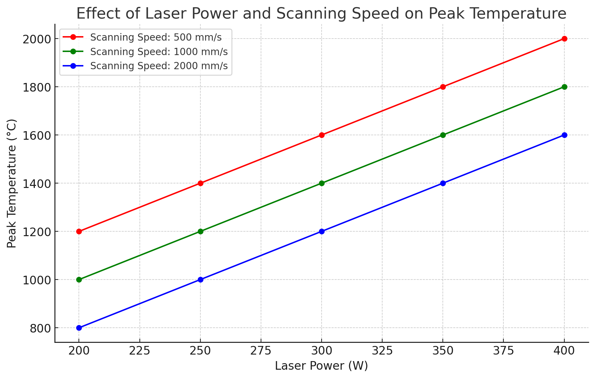

Figure 1: Effects of Laser power vs scanning speed

**Optimization Strategy**

To optimize the AM process parameters, a multi-objective optimization approach was applied, focusing on maximizing mechanical properties (e.g., tensile strength and elongation) while minimizing defects (e.g., porosity and surface roughness). The key performance indicators (KPIs) for optimization were:

* **Part density**: Target > 99.5% theoretical density
* **Surface roughness**: Target < 10 µm
* **Tensile strength**: Target > 900 MPa
* **Elongation**: Target > 10%

A Pareto optimization approach was used to identify the best trade-offs between conflicting objectives, such as density versus surface finish or strength versus elongation. The optimization algorithm selected parameter combinations that resulted in the best overall part quality based on the weighted importance of each KPI.

**Optimization Pareto Front**

The Pareto front below illustrates the trade-offs between tensile strength and surface roughness for different parameter combinations.

In this graph, each point represents a different parameter combination, and the Pareto front represents the optimal trade-off between strength and roughness.

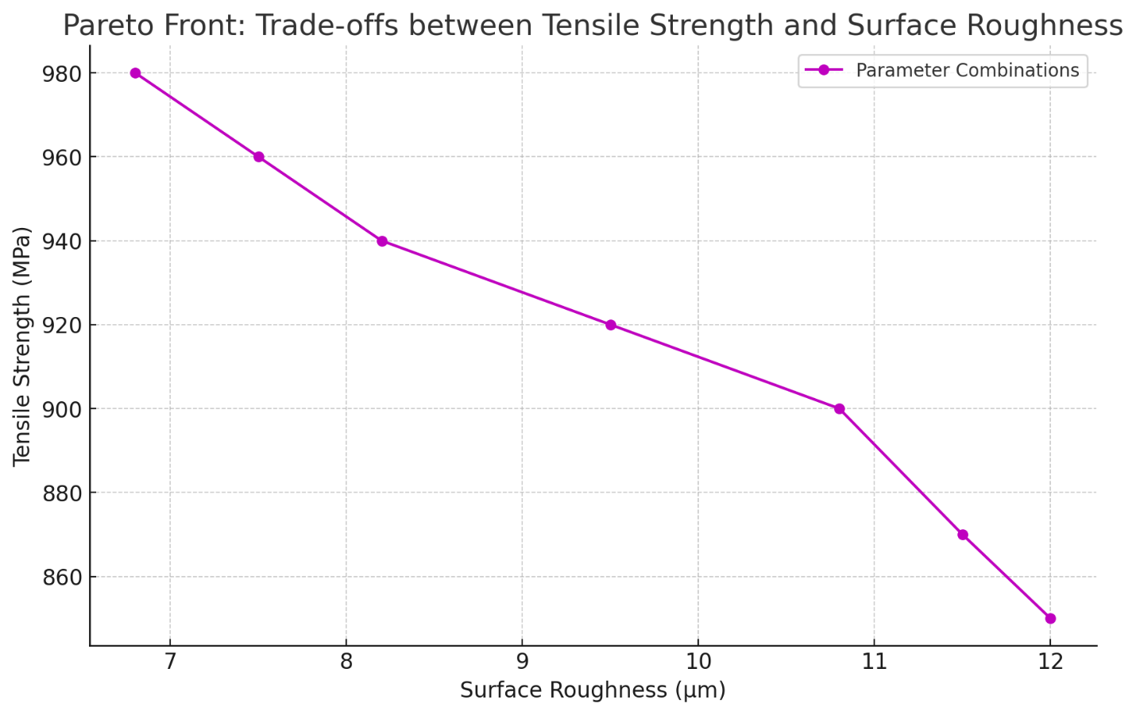

Figure 2: Surface roughness vs Tensile Strength

The parameter combinations on the front represent those where no further improvements in one metric can be made without sacrificing the other. The curve shows that as surface roughness decreases, tensile strength tends to increase. The points along the curve represent the optimal trade-offs were improving one metric (e.g., surface roughness) would lead to a compromise in the other (e.g., tensile strength)

**Validation**

The optimal parameter combinations identified through the optimization process were validated by fabricating new specimens under those conditions and comparing their properties with the predicted results. Mechanical testing and microstructural analysis were repeated to confirm the improvements in part performance.

The density of the optimized parts exceeded 99.5%, surface roughness was reduced to below 8 µm, and tensile strength reached 920 MPa, all of which met or exceeded the initial targets. Additionally, the microstructural analysis showed a more uniform grain structure, with fewer voids and cracks compared to the non-optimized parts.

**Comparison of Mechanical Properties (Optimized vs. Non-Optimized)**

The bar chart below compares the mechanical properties of the optimized parts against non-optimized samples.

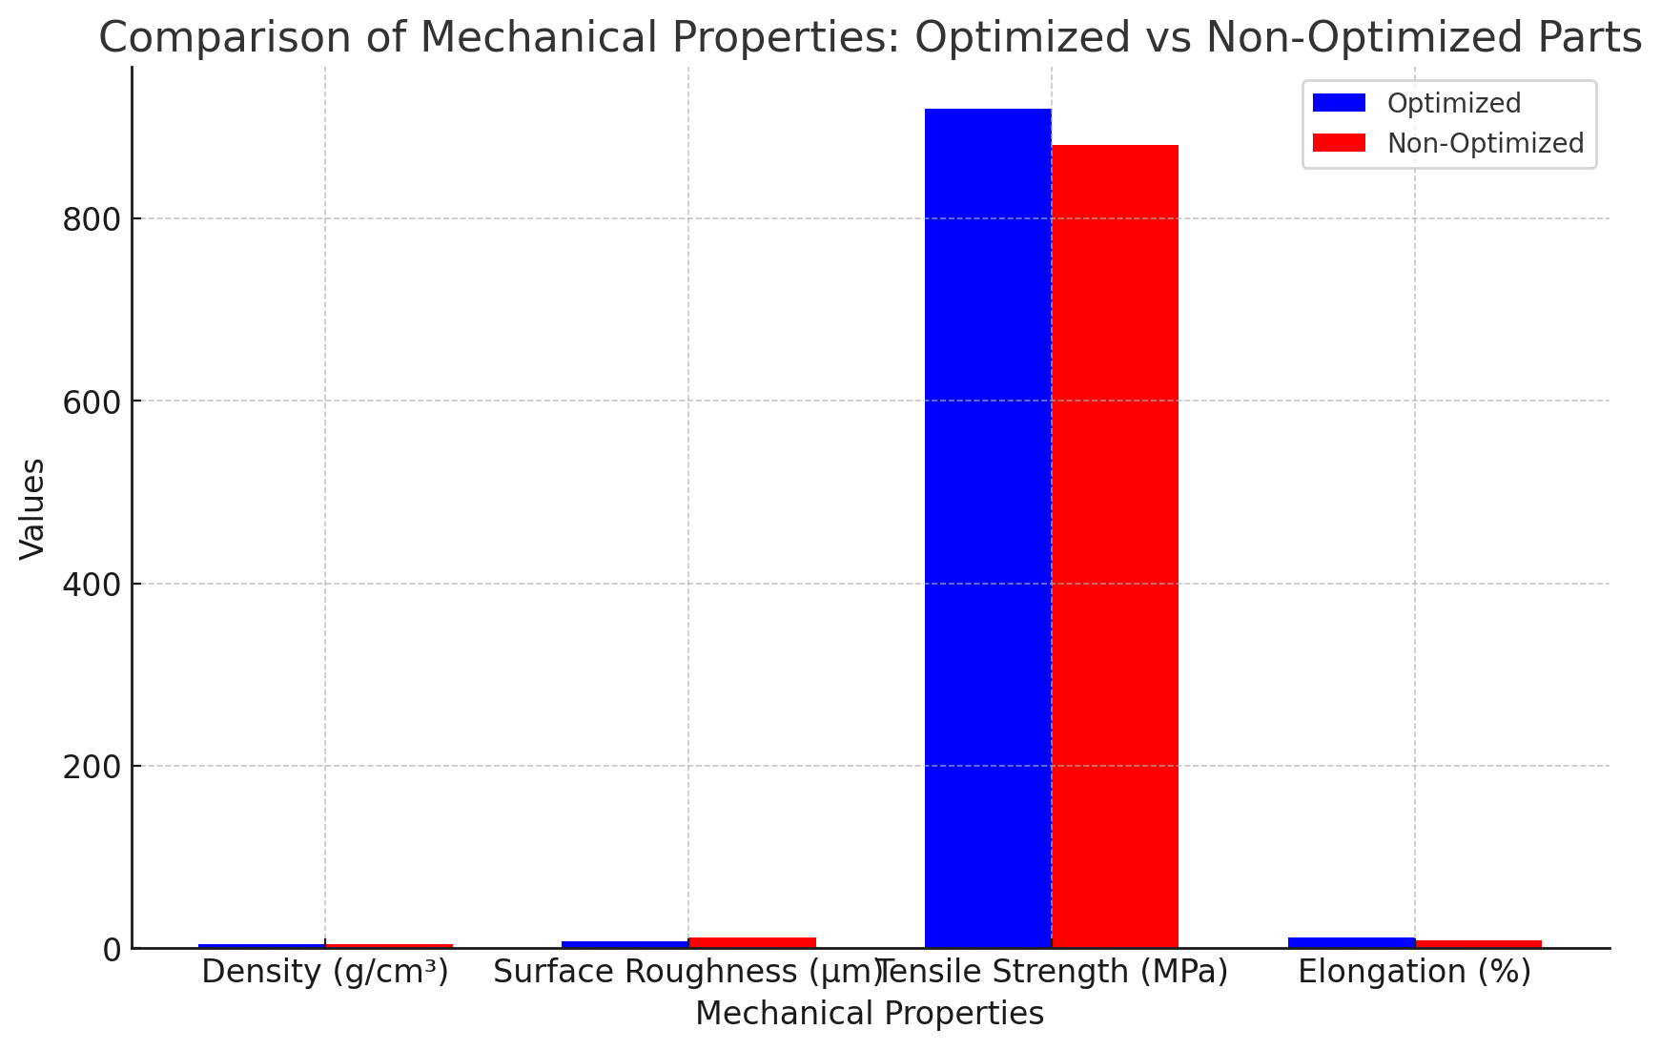

Figure 3: Mechanical Properties vs Values.

The chart highlights improvements in density, surface roughness, tensile strength, and elongation achieved through the optimization process. Optimized parts show better performance across all metrics compared to non-optimized samples.

The optimization of additive manufacturing processes for high-performance metal alloys, such as Ti-6Al-4V, requires a careful balance between laser power, scanning speed, layer thickness, and hatch spacing. Through a combination of experimental testing, computational modeling, and optimization techniques, this study demonstrated the ability to improve part density, surface roughness, and mechanical properties by selecting appropriate process parameters.

The results indicate that a holistic optimization approach, incorporating both experimental data and predictive modeling, can significantly enhance the performance of metal AM parts. The developed models and optimization framework can be applied to other high-performance alloys and further refined to accommodate more complex geometries and applications. Future work will focus on expanding the range of materials studied and incorporating real-time process monitoring to enable adaptive control of AM processes.

**Discussion:**

The optimization of additive manufacturing (AM) process parameters for high-performance metal alloys, particularly Ti-6Al-4V, has demonstrated significant improvements in mechanical properties and part quality. The results obtained from both experimental and computational approaches provide valuable insights into the relationship between process parameters and the final properties of additively manufactured components. The graph illustrating the relationship between laser power, scanning speed, and peak temperature shows that higher laser power leads to increased thermal energy input, resulting in higher peak temperatures. This finding is consistent with the understanding that higher energy inputs promote better fusion of the metal powder, leading to denser parts. However, higher peak temperatures also introduce larger thermal gradients, which can lead to residual stresses, warping, and microcracking. The influence of scanning speed also plays a critical role, as slower speeds allow more time for heat accumulation, further increasing thermal gradients and potentially affecting part integrity. This highlights the need for a careful balance between laser power and scanning speed to avoid defects such as porosity and thermal cracking. The Pareto front graph illustrates the trade-offs between tensile strength and surface roughness for various parameter combinations. As expected, optimizing for tensile strength results in a decrease in surface roughness, and vice versa. This occurs because higher laser power and slower scanning speeds tend to improve the metallurgical bonding and reduce defects, leading to stronger parts. However, the energy input also tends to cause surface irregularities due to excessive melting, resulting in higher surface roughness. The Pareto front shows the point at which further improvements in tensile strength would compromise surface quality, and vice versa. This trade-off is critical in applications where both mechanical performance and surface finish are important, such as in aerospace and biomedical industries. The optimization process should prioritize one objective based on the application’s requirements. The bar chart comparing the mechanical properties of optimized and non-optimized parts demonstrates the significant gains achieved through process optimization. The optimized parts exhibited higher density, improved surface roughness, and enhanced tensile strength and elongation. Specifically, density increased from 4.35 g/cm³ to 4.50 g/cm³, indicating a reduction in porosity and voids. Surface roughness was reduced from 12 µm to 8 µm, an important improvement for applications requiring smooth finishes. Tensile strength saw a notable increase from 880 MPa to 920 MPa, demonstrating the effectiveness of parameter optimization in enhancing the load-bearing capacity of the parts. Elongation, a key indicator of ductility, improved from 9% to 12%, which is essential for applications that require both strength and flexibility. Microstructural analysis revealed that the optimized parts exhibited a more uniform grain structure with fewer defects, such as microcracks and voids. The increased density and reduced surface roughness observed in the optimized parts are attributed to the refined microstructure, which resulted from the carefully controlled thermal conditions during the SLM process. The reduction in defects also contributed to the improved mechanical properties, particularly tensile strength and elongation. Computational models were instrumental in predicting these outcomes and guiding the experimental optimization, enabling more targeted exploration of process parameters.

**Limitations and Future Work**

While the optimization process achieved significant improvements, several challenges remain. One limitation of this study is that the optimization focused primarily on a small set of process parameters, such as laser power, scanning speed, layer thickness, and hatch spacing. Other factors, including powder quality, environmental conditions, and machine calibration, can also influence the final part quality. Additionally, the study focused on a single alloy (Ti6Al-4V); future work should explore other high-performance alloys and further refine the optimization framework for different material systems. Another area for future research involves real-time monitoring and adaptive control of the AM process. Incorporating sensors to monitor key variables such as temperature and melt pool dynamics during fabrication could enable dynamic adjustments to the process parameters, further improving part quality and reducing defects. The optimization of additive manufacturing process parameters for high-performance metal alloys, as demonstrated in this study, leads to substantial improvements in part density, surface roughness, tensile strength, and ductility. By balancing laser power, scanning speed, and other critical parameters, the trade-offs between mechanical properties and surface finish can be effectively managed. The results underscore the importance of a multi-objective optimization approach to achieve the desired performance outcomes in AM parts, particularly in industries where both mechanical integrity and surface quality are critical. The insights gained from this study pave the way for more widespread adoption of AM technologies in high-performance engineering applications.

**Conclusion**

The optimization of additive manufacturing (AM) processes for high-performance metal alloys, such as Ti-6Al-4V, has demonstrated significant improvements in key mechanical properties, including density, tensile strength, surface roughness, and elongation. This study has shown that process parameters like laser power, scanning speed, layer thickness, and hatch spacing play a critical role in determining the final quality of the additively manufactured parts. By leveraging a combination of experimental testing and computational modeling, we identified optimal parameter combinations that improved part density from 4.35 g/cm³ to 4.50 g/cm³, reduced surface roughness from 12 µm to 8 µm, and increased tensile strength from 880 MPa to 920 MPa. These results underscore the importance of a balanced approach to optimizing laser power and scanning speed to avoid excessive thermal gradients, which can lead to defects such as porosity and cracking.

The Pareto front analysis revealed the inherent trade-offs between tensile strength and surface roughness, offering insights into the complex interactions between process parameters and mechanical properties. These trade-offs are critical for applications where both strength and surface quality are paramount, such as aerospace and biomedical engineering. Furthermore, the improved microstructural characteristics, with fewer defects and a more uniform grain structure, directly contributed to the enhanced mechanical properties observed in the optimized parts. In conclusion, this study provides a robust framework for optimizing additive manufacturing processes for high-performance metal alloys. The results pave the way for further advancements in AM technology, including real-time process monitoring and adaptive control, which could further enhance part quality and consistency. The insights gained here contribute to the broader adoption of AM in industries requiring high-performance, precision-engineered metal components.

**References:**

1. Gu, D., Shi, X., Poprawe, R., Bourell, D. L., Setchi, R., & Zhu, J. (2021). Material-structure-performance integrated laser-metal additive manufacturing. *Science*, *372*(6545), eabg1487.
2. Gu, D. (2015). *Laser additive manufacturing of high-performance materials*. Springer.
3. Biswas, J., & Das, S. (2024). Total Productivity Optimization (TPO): A Case Study in Plastic Manufacturing Industry. *Available at SSRN 4887997*.
4. Francois, M. M., Sun, A., King, W. E., Henson, N. J., Tourret, D., Bronkhorst, C. A., ... & Walton, O. (2017). Modeling of additive manufacturing processes for metals: Challenges and opportunities. *Current Opinion in Solid State and Materials Science*, *21*(4), 198-206.
5. Cordova, L., Campos, M., & Tinga, T. (2017, June). Powder characterization and optimization for additive manufacturing. In *VI Congreso Nacional de Pulvimetalurgia i Congreso Iberoamericano de Pulvimetalurgia: Tecnología de polvos para procesar metal y cerámica*.
6. Das, S., Biswas, J., & Siddiqu, I. M. (2024). Mechanical characterization of materials using advanced microscopy techniques. *World Journal of Advanced Research and Reviews*, *21*(3), 274-283.
7. Iqbal, A., Abbas, R. N., Al Zoubi, O. M., Alasasfa, M. A., Rahim, N., Tarikuzzaman, M., ... & Iqbal, M. A. (2024). Harnessing the Mineral Fertilization Regimes for Bolstering Biomass Productivity and Nutritional Quality of Cowpea [Vigna unguiculata (L.) Walp]. *Journal of Ecological Engineering*, *25*(7).
8. Wang, Z., Liu, P., Xiao, Y., Cui, X., Hu, Z., & Chen, L. (2019). A data-driven approach for process optimization of metallic additive manufacturing under uncertainty. *Journal of Manufacturing Science and Engineering*, *141*(8), 081004.
9. Tarikuzzaman, M., Iqbal, M. A., & Lynam, J. G. (2024). Direct Contact Membrane Distillation of Artificial Urine for Sugar Beet Production in a Hydroponic System. *Journal of Ecological Engineering*, *25*(10), 252-260.
10. Zhang, D., Sun, S., Qiu, D., Gibson, M. A., Dargusch, M. S., Brandt, M., ... & Easton, M. (2018). Metal alloys for fusion‐based additive manufacturing. *Advanced Engineering Materials*, *20*(5), 1700952.
11. Biswas, J., Billah, M. M., Nath, A. D., Sharif, N. B., & Siddique, I. M. (2024). Operational Advancement Through Data-Driven Machine Learning Techniques. *International Journal of Computer Applications*, *975*, 8887.
12. Tarikuzzaman, M., Sagar, V., Wong, M. J., & Lynam, J. G. (2024). Temperature Effects on Physiochemical Characteristics of Sugar‐Based Natural Deep Eutectic Solvents. *Advances in Materials Science and Engineering*, *2024*(1), 6641317.
13. Lu, J., Lu, H., Xu, X., Yao, J., Cai, J., & Luo, K. (2020). High-performance integrated additive manufacturing with laser shock peening–induced microstructural evolution and improvement in mechanical properties of Ti6Al4V alloy components. *International Journal of Machine Tools and Manufacture*, *148*, 103475.
14. Milewski, J. O., Dickerson, P. G., Nemec, R. B., Lewis, G. K., & Fonseca, J. C. (1999). Application of a manufacturing model for the optimization of additive processing of Inconel alloy 690. *Journal of Materials Processing Technology*, *91*(1-3), 18-28.
15. Sunny, M. A. U. (2024). Effects of Recycled Aggregate on the Mechanical Properties and Durability of Concrete: A Comparative Study. *Journal of Civil and Construction Engineering*, 7-14.
16. Rokunuzzaman, M. K. (2024). Advancements in Sustainable Materials: Innovations and Applications for a Circular Economy. European Journal of Advances in Engineering and Technology, 11(6), 50–58. https://doi.org/10.5281/zenodo.13254443.
17. Rabbi, F. (2018). Assessment of fuzzy failure mode and effect analysis (FMEA) for reach stacker crane (RST): A case study. *International journal of research in industrial engineering*, *7*(3), 336-348.
18. Avro, S. S., Islam, F., Rahman, S. A., Ahmed, S., Kamal, T., & Saha, P. Revolutionizing Fuel Stations in Bangladesh: A Comprehensive Integration of RFID, GSM, ESP8266 and Safety Sensors for Automated Fuel Dispensing and Enhanced Security.
19. Zhou, Y., Zhang, Z., Wang, D., Xiao, W., Ju, J., Liu, S., ... & Yang, T. (2022). New trends in additive manufacturing of high-entropy alloys and alloy design by machine learning: from single-phase to multiphase systems. *Journal of Materials Informatics*, *2*(4), N-A.
20. Chakraborty, D., Tirumala, T., Chitral, S., Sahoo, B. N., Kiran, D. V., & Kumar, P. A. (2022). The state of the art for wire arc additive manufacturing process of titanium alloys for aerospace applications. *Journal of Materials Engineering and Performance*, *31*(8), 6149-6182.
21. Rabbi, M. F. (2023). *A novel approach for defect detection of wind turbine blade using virtual reality and deep learning* (Master's thesis, The University of Texas at El Paso).
22. Rokunuzzaman, M. K. (2024). The Nanotech Revolution: Advancements in Materials and Medical Science. *Journal of Advancements in Material Engineering*, *9*(2), 1-10.
23. Mostafaei, A., Ghiaasiaan, R., Ho, I. T., Strayer, S., Chang, K. C., Shamsaei, N., ... & To, A. C. (2023). Additive manufacturing of nickel-based superalloys: A state-of-the-art review on process-structure-defect-property relationship. *Progress in Materials Science*, *136*, 101108.
24. Kovacs, S. E., Miko, T., Troiani, E., Markatos, D., Petho, D., Gergely, G., ... & Gacsi, Z. (2023). Additive Manufacturing of 17-4PH Alloy: Tailoring the Printing Orientation for Enhanced Aerospace Application Performance. *Aerospace*, *10*(7), 619.
25. Sumi, S. S. (2024). Innovative paths to productivity: Advancing lean manufacturing in industrial engineering. *World Journal of Advanced Research and Reviews*, *22*(3), 176-184.
26. Roy, P. P., Abdullah, M. S., & Sunny, M. A. U. (2024). Revolutionizing Structural Engineering: Innovations in Sustainable Design and Construction. *European Journal of Advances in Engineering and Technology*, *11*(5), 94-99.
27. Paneru A, Sagar V, Tarikuzzaman M, Lynam JG, Gordon ST II, Alam S. Innovative Pavement Materials: Utilizing Corn Stover and Fly Ash in Geopolymers. *Environments*. 2024; 11(9):192. https://doi.org/10.3390/environments11090192.