FEASIBILITY STUDY ON USE OF GROUND GRANULATED BLAST FURNACE SLAG WASTE IN CONCRETE

VIVEKANAND PAL 1, Dr. RAKESH PATEL 2

1. PG Scholar, Department of Civil Engineering, OIST Bhopal, India
2. .Prof, Department of Civil Engineering, OIST Bhopal, India

Abstract

Active extraction of aggregate deposits from riverbeds can cause serious environmental problems (bed degradation, bank erosion, loss of vegetation, etc.) .The growing need that exists in the construction industry cannot be fulfilled by the available resources. For example, the current river aggregate extraction rate can satisfy only little part of the total annual demand. However, different industrial activities accompanied by the production of primary products result in various by-products that have almost no practical industrial application. These industrial by-products, which are generated in high quantities worldwide, present severe challenges regarding their disposal. This is why it is necessary to find other alternatives that would be acceptable from the ecological aspect. One solution would be the use of GGBS aggregates as a substitute for natural aggregate in concrete. Similarly The cement industry is one of two primary producers of carbon dioxide (CO2), creating up to 8% of worldwide manmade emissions of this gas. Usage of concrete in future will be go on increasing, which directly increases the pollution level in order to decrease or reduce its effect on environment natural material or waste material like GGBFS usage as partial replacement of cement in concrete is investigated by many researched in past few decades As a case study. Here concrete of grade M30 is considered and mix design is done as IS: 10262-2019, cement is replaced by GGBFS up to 25% & sand is replaced with GGBFA up to 50%. Once the optimum percent of GGBFS content is determined, optimum percent of GGBFS is determined.

Keywords Cement Concrete, flexural strength, Strength parameters, water absorption, Workability.

1 Introduction

### Construction India's rapid urban expansion has brought construction to the forefront. Concrete, a foundation for this growth, faces challenges tied to its environmental impact due to the high cement content. While traditional Portland cement is commonly used, its production impacts both the landscape and the environment. With increasing concerns about climate change, India is prompted to think about more sustainable construction alternatives. Enter Ground Granulated Blast-furnace Slag (GGBFS) - a by-product from steel-making. It's more than just an eco-friendly choice. Using GGBFS might also enhance concrete's quality, making it last longer. But it's not just about GGBFS. The booming construction sector has led to a rise in demand for concrete that's not only strong but also durable, especially for taller structures and roads that face constant wear and tear. Common concrete, though cost-effective, might not always meet the needs of projects that face challenges like chemicals or weather changes. Researchers have thus been looking at materials like fly ash, slag, and silica fume to boost concrete's strength and resilience. Moreover, there's a growing push towards green building. This involves using repurposed materials and tweaking the concrete mixture to use less cement, ultimately aiming to reduce environmental harm and save energy. In the past used of cement is reduced by addition of fly ash, rice husk ash, industrial wastes like paper pulp, hypo sludge and many more in concrete which reduces the cement content. On the other hand concrete is made without cement by using polymers. Concrete made by addition of industrial waste not only reduces the use of cement and its harmful impact on environment, it also helps in easy disposal of such industrial wastes which are difficult to dispose and contaminates the soil and water bodies if not disposed properly. In short the use of industrial wastes in making of concrete is not only helping in reducing the hazardous effect of cement but also helpful from solid waste management point of view, which is again a big problem in urban cities and industrial areas. Thus use of industrial waste in concrete manufacturing is beneficial from both the ends, with only one major point of consideration is that it should not deteriorate the properties of concrete in long run .

### waste Originating as a by-product from the iron-manufacturing process, blast furnace slag is a nonmetallic substance with a unique granulated texture and prominent silica content. Ranging from a pivotal component in cement production to enhancing soil health, its eco-friendliness aids in lessening the carbon impact of numerous sectors. India, being a prime contributor in global GGBFS production, has witnessed a steady ascent in its production. The nation's emphasis on green construction materials and its proactive stance towards curbing carbon emissions in construction drives this growth. Primarily arising from the iron and steel sector, GGBFS serves as a commendable cement alternative in concrete production.

**2 Literature Review**

To supplement automated search, a manual search was also done. The manual procedure involved searching the reference sections of the papers identified by the automated search and referring the text/reference books. Any relevant references within those papers/reference books were followed up

* **Manuel Contreras Llanes et.al. 2021** carried out research for production of eco-friendly concrete paver units using recycled aggregate as coarse aggregate. They prepared samples containing different percentages of aggregate replacements with recycled aggregates & conducted different tests on paver units. The results explained that up to 50% replacement can be a good solution. .The values of water absorption lesser than 6.0% and tensile strength upper than 3.6 MPa were obtained, which are similar to those of a reference sample and within the limit values established by the regulations.
* **Natt Makul et.al. 2021** The proposed strategy could be to sequentially separate demolition waste such as roof finishes, waterproof materials, interior and exterior materials, etc. Closing life cycles is the main approach used for efficient structures for the recycling and reuse of construction and demolition waste in the production and recovery of materials, especially when recycling and reusing materials. In the life cycle, the recycling of recovered materials allows them to be used for new construction purposes, avoiding the use of natural concrete aggregates. Government, design institutes, construction departments and project managers should be involved in the creation and use of RCA.
* **Athanasia Soultana et.al. 2021** produced the cement mortars using the upgraded recycled concrete aggregates (sand granulometry) for the total replacement of natural aggregates and recycled concrete fines activated through a thermal treatment method as a partial cement substitution material. Cement mortar specimens were tested for their compressive and flexural strength, density and water absorption performance. The results showed that the combined usage of upgraded recycled concrete sand for total replacement of primary crushed sand and recycled concrete fines as partial cement replacement material is a promising option to produce cement mortars.
* **Abbas O. Dawood*, Hayder AL-Khazraji, Raad S. Falih 2021** the impact of utilizing polyethylene terephthalate (PET) squanders as an incomplete substitution of normal sand is explored to concentrate on the mechanical and actual properties of cement. Fine total (sand) is somewhat supplanted by comparable weight rates of PET waste particles while keeping up with any remaining extents. Mechanical tests for pressure, parting, flexure, modulus of flexibility, energy ingestion, and hub strain just as actual tests for thickness, shrinkage, and assimilation, are performed. Furthermore, the ultrasonic heartbeat speed is introduced. All examples are noticed for 7, 14, and 28 days. The tests results introduced that the presence of PET particles changed the physical and mechanical properties of delivered cements. Actual properties (thickness and ultra sound speed) step by step diminished as PET proportions expanded, while an expansion in retention rate was noticed. The discoveries additionally uncovered an expansion in energy assimilation and pivotal strain of the specimenswith5%–20%replacementpercentages, while the modulus of flexibility diminished as the PET substance expanded.
* **Saranya K (2016)** Owing to shortage of coarse aggregate for the arrangement of concrete, fractional expansion of E-squander with coarse aggregate was endeavored. The work was led on M-25 grade blend. The expansion of coarse aggregate with E-squander in the scope of 0%, 32%, 34%, 36%, and 38%. At last the mechanical properties and sturdiness of the substantial blend examples acquired from the expansion of these materials is contrasted and control substantial blend. The experimental outcomes showed that a critical improvement in compressive strength was accomplished in the E-squander concrete contrasted with customary cement and can be utilized actually in concrete. The reuse of E-waste brings about squander decrease and assets protection.

**3 Methodology Adopted**

In this work, the mix design and testing method is used to perform Utilisation of GGBFS & GGBFAin Concrete as per IS-standards. In order to study the effect of GGBS as a partial replacement of cement & GGBA as replacement of aggregates.

**Table 1:** Cases considered for study

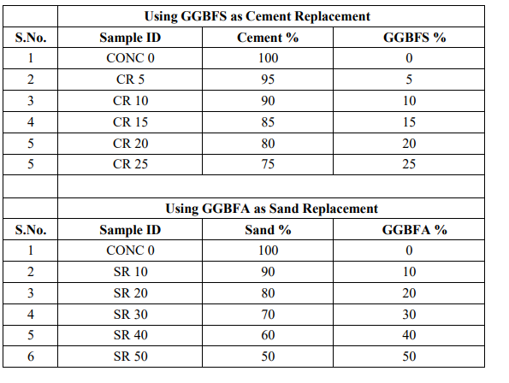

**4 Results**

The results got from tests directed on solid clearing blocks have been talked about in this part.

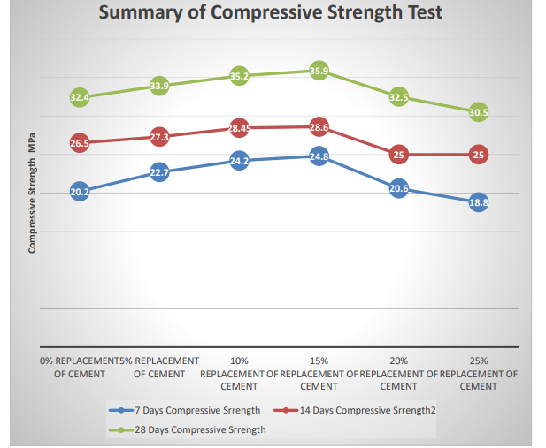

**Figure 1:** Comparative values of compressive strength at different age

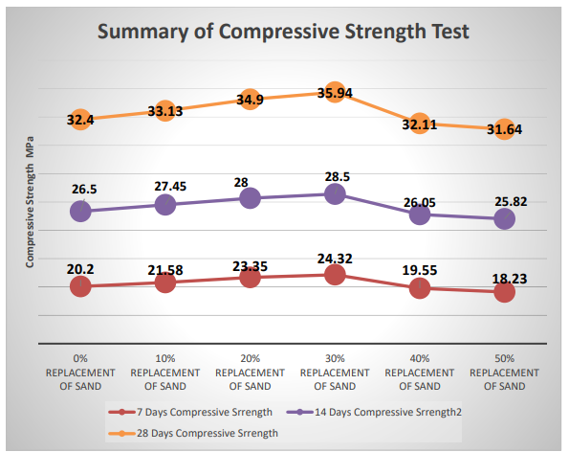

**Figure 2:** Comparative values of compressive strength at different age

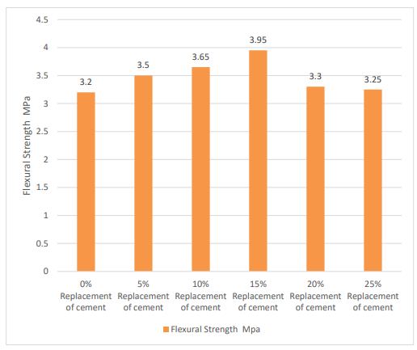

**Figure 3:** 28-days *Flexural* strength result MPa

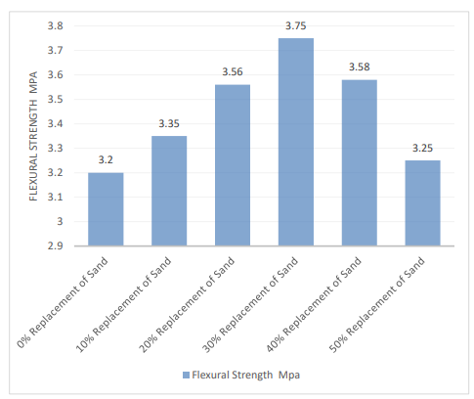

**Figure 4:** at 28 Days

**5 Conclusion**

From the above outcomes it can be seen that Compressive & flexural strength of concrete was initially increased with inclusion of GGBFA as partial replacement of natural sand. Concrete mix with 30% sand replacement level had maximum strength at all ages then after it decreases. The suitable level for the replacement (by weight) of GGBFS for severe exposure condition i.e. M 30 grade is found to 15% & for GGBFA as partial replacement of sand it is found 30%..

**Reference**

* *A. O. Olanike, “A Comparative Analysis of Modulus of Rupture and Splitting Tensile Strength of Recycled Aggregate Concrete”, American Journal of Engineering Research e-ISSN: 2320-0847, Volume-03, Issue-02, pp-141-147, 2014.*
* *Anju Ramesan, Shemy S. Babu, Aswathy Lal, “Performance of light weight concrete with plastic aggregate”, International Journal of Engineering Research and Applications, Vol. 5, Issue 8, August 2015, pp.105-110.*
* *Binaya Patnaik, Seshadri Sekhar.T, Srinivasa Rao, “Strength and Durability Properties Of Copper Slag Admixed Concrete” International Journal of Research in Engineering and Technology, e-ISSN: 2319-1163, p-ISSN: 2321-7308, Volume 4, Issue 1, Feb 2015.*
* *Chinmay buddhadev, Jayesh kumar pitroda, Prof. Chetna m. Vyas, “A review of innovative use of copper slag and foundry sand in design mix concrete” Journal Of International Academic Research For Multidisciplinary, Impact Factor 1.625, ISSN: 2320-5083, Volume 2, Issue 12, January 2015.*
* *Jeffrey W. Bullard , Hamlin M. Jennings, Richard A. Livingston, Andre Nonat, George W. Scherer, Jeffrey S. Schweitzer, Karen L. Scrivener, Jeffrey J. Thomas, “Mechanisms of cement hydration” , Elsevier 2011.*
* *Athanasia Soultana. Utilization of Upgraded Recycled Concrete Aggregates and Recycled Concrete Fines in Cement Mortars. Recent Progress in Materials 2021, volume 3, issue 3.*
* *Mônica Batista Leite. An Experimental Study of Self-Compacting Concrete Made with Filler from Construction and Demolition Waste. Open Journal of Civil Engineering, 2020, 10, 364-384.*
* *Jeyanth Baskaran. Feasibility of Construction Demolition waste in Concrete as a Coarse Aggregate. IOP Conf. Series: Materials Science and Engineering 955 (2020) 012045.*
* *Zahra Abdollahnejad. Construction and Demolition Waste as Recycled Aggregates in Alkali-Activated Concretes. Mdpi Materials 2019, 12, 4016; doi:10.3390/ma12234016.*
* *B. V. Venkatarama Reddy. Non-organic solid wastes – potential resource for construction materials. Current science, vol. 111, no. 12, 25 December 2019.*
* *Abdulsamee M. Halahla. Utilization of Demolished Waste as Coarse Aggregate in Concrete. Civil Engineering Journal Vol. 5, No. 3, March, 2019.*
* *Wayne Dodds. Corrosion risk assessment of structural concrete with coarse crushed concrete aggregate. Construction Materials Volume 173 Issue 2 2018.*
* *Dr. K.Srinivasu. A study on compressive strength properties and effects of copper slag as partial replacement of fine aggregate in concrete. ELK Asia Pacific Journals – Special Issue 2018.*
  + *Ayeni I. S. what's more, Akinlolu S. O. Execution of cow excrement debris on compressive strength of mixed cement. World Journal of Engineering Research and Technology wjert, (2018), Vol. 4, Issue 4, 117-124.*