**EFFECTS OF POLYMER CONCENTRATION AND TEMPERATURE ON FRACTURE GRADIENT DURING DRILLING: A RHEOLOGICAL PERSPECTIVE**

Ahiakwo, Ndidi Ilevaodion1 and Dr. Diepiriye C. Okujagu2

1Center for Petroleum Geosciences, University of Port Harcourt,

2Department OF Geology, University of Port Harcourt

## ABSTRACT

Optimization of drilling fluid is very important to eliminate well bore instability particularly in undesirable geological environments. The aim of this work was to examine how selected polymer concentrations affect fracture gradient and the stability of wellbores at different temperatures. Local Cassava Starches were mixed with Imported/Local Bentonite clays and polymers to form drilling muds. Viscosity, YP, and PV were determined at an API level at the polymer concentrations of 0.5%, 1%, and 2% and at temperatures of 80°F to 190°F. It was evidenced that the concentration of polymer affected the rheological properties, temperature and ultimately the fracture gradient. In fact, both the local and imported material concentrations also went up posing the danger of exceeding the fracture gradient. It can therefore analysed from the results that Local Bentonite has high YP with an increase in temperatures; that means, temperature plays crucial role, which has to considered while preparing the drilling fluids. By offering a road-map for sieving adjusted polymer-bentonite mixtures, the study emphasizes the effectiveness of the methodology under investigation with regards to enhancing fracture gradient. The use of local materials as better options to the imported ones is again an economic and technical bonus. These studies therefore provide a strong underpinning on how drilling fluid formulations should be made in different well bores taking into consideration local availability of materials in order to enhance efficiency of the drilling practices as well as safe operation.

**Keywords**: fracture gradient, drilling fluids, polymers, rheology, temperature effects, wellbore stability

**INTRODUCTION**

Drilling for hydrocarbons is a complex operation with significant technical and economic challenges. A critical aspect of successful drilling is maintaining wellbore stability, which requires a delicate balance in the effective pressure caused by the presence of drilling fluids pressure and formation pressure. Armistead, G.T., 2020, emphasizes that, understanding and effectively managing fracture gradient (the pressure at which the formation will fracture, leading to fluid loss) is crucial for preventing costly and dangerous complications such as lost circulation, wellbore collapse, and blowouts, Figure 1. Central to this challenge is the selection and management of drilling fluids, also known as drilling muds. These fluids serve multiple critical functions, including: i) Maintaining wellbore stability: by counterbalancing formation pressures (Baker 1996), ii) Transporting cuttings:  carrying rock fragments generated during drilling to the surface (Mahmood et al, 2012), iii) Cooling and lubing: the drill bit and drilling assembly.

This study focuses on the direct impact of drilling fluids rheological properties in performing these functions under varying conditions. Rheology refers to the study of how materials deform and flow under stress. In the context of drilling fluids, key rheological parameters include: i) Viscosity: the fluid's resistance to flow. ii)  Yield point (YP): Initiating fluid flow, depends on a threshold amount of stress called minimum stress. iii)  Gel strength: signifies the amount of shear stress needed to re-initiate flow after a period of static conditions. iv)  Plastic viscosity (PV):  a measure of the internal friction within the fluid.  Each of these parameters have their responsibilities in ascertaining the effect of drilling fluids, particularly in challenging High Pressure, High Temperature (HPHT) environments commonly encountered in deep wells (Ogbonna, 2013).

Extensive research has been conducted on the influence of various factors on drilling fluid rheology and, consequently, on fracture gradient. Drilling fluids exhibit non-Newtonian fluid behaviour, meaning their viscosity changes with the applied shear rate. This contrasts with Newtonian fluids, such as water or light oil, where viscosity remains constant regardless of shear rate (Benedict, 2015). Accurately modeling the behaviour of non-Newtonian drilling fluids is complex, with several models proposed, including:

* Bingham Plastic Model: considers yield point and plastic viscosity but assumes constant viscosity after flow begins.
* Power-Law Model: accounts for shear-thinning behaviour, where viscosity decreases with increasing shear rate. It considers shear-thinning behaviour, which means that viscosity falls as shear rate rises.
* Herschel-Bulkley (HB) Model: the most comprehensive model, incorporating yield point, consistency index, flow behaviour index, and shear rate. The HB model as revealed in equation 1 is considered the most accurate for characterizing drilling fluids, as it encompasses a wider range of rheological behaviours observed in these complex mixtures.

𝜏 = 𝜏_𝑦 + 𝑘 ∗ 𝛾^𝑛 (1)

Where:

𝜏 = shear stress

𝜏𝑦= yield point

k = consistency index

𝛾 = shear rate

n = fluid behavior index (Dias and Assembayev, 2015).

Temperature and pressure are crucial in how drilling fluids behave, especially in HPHT environments. Amani et al. (2012) as well as Annis (1997) pointed out that high temperatures negatively affect water-based fluids causing the instances of flocculation, viscosity increase and loss of the fluid’s functionality. In addition, the properties of drilling fluids can change due to aging. Aging happens when these fluids are exposed to heat or pressure during drilling activities. Various studies have shown that viscosity, yield point, and gel strength are directly linked to temperature. Specifically, as temperature rises, the values of viscosity, yield point, and gel strength tend to drop. This temperature-related behaviour poses challenges for maintaining wellbore stability. A lower viscosity means there could be more fluid loss into the formation. In circumstances that drilling fluids are difficult to perform, various types of additives are added to it. A very important factor that influences the rheological characteristics of these fluids is polymers that are used as a means of controlling these characteristics. While this research focuses on the effects of specific polymers on fracture gradient, the broader literature highlights the diverse roles polymers play in drilling fluids: While this research focuses on the effects of specific polymers on fracture gradient, the broader literature highlights the diverse roles polymers play in drilling fluids: Viscosifiers increase viscosity and improve hole cleaning.  Bentonite clay is a commonly used viscosifier, but its performance is temperature-dependent. Fluid loss control agents prevent fluid loss to the formation. Shale inhibitors prevent shale hydration and swelling, a major contributor to wellbore instability.

1. Potassium chloride (KCl) is a widely used shale inhibitor.

Despite extensive research on drilling fluids, significant knowledge gaps remain regarding the impact of specific locally-sourced starches and polymers on fracture gradient under varying thermal and concentration conditions. This gap poses risks related to:

1. Drilling efficiency: Suboptimal rheological properties can lead to poor hole cleaning, increased drag, and reduced drilling rate.
2. Cost-effectiveness: Increased non-productive time (NPT) due to wellbore instability and fluid-related issues significantly impacts drilling costs.
3. Operational safety: Inadequate understanding of fracture gradient can lead to well control incidents and environmental hazards.

This study will address the identified knowledge gaps and contribute to a different approach in the understanding of the relationship between polymer rheology, fracture gradient, and drilling fluid performance.

# 

### Figure 1 Borehole Model For Well Design showing Mud Weight (MW), Fracture Gradient and Estimated Pore Pressure (Armistead, 2020)

**MATERIALS AND METHODS**

**Materials and Equipment**

The research employs a combination of laboratory experiments using a Model 800 OFITE 8-Speed Viscometer and data analysis techniques to evaluate the impact of polymer additives on drilling fluid performance, Figure 2. Local cassava starches and an imported starch, were chosen for their proven effectiveness in altering drilling fluid rheology. These starches were combined with bentonite clay (both imported and local) as the base fluid, mixed with distilled water. Additional materials including PAC-R, XCD, NR 8082, a biopolymer (97/4779), a modified starch (01/1412), and a natural polymer (98/0505), were also incorporated to facilitate a comparative analysis of different additives' effects on drilling fluid properties; all the materials were provided by POCEMA Limited, Nigeria, The precise quantities of each additive used are detailed in Table 1 and Table 2.

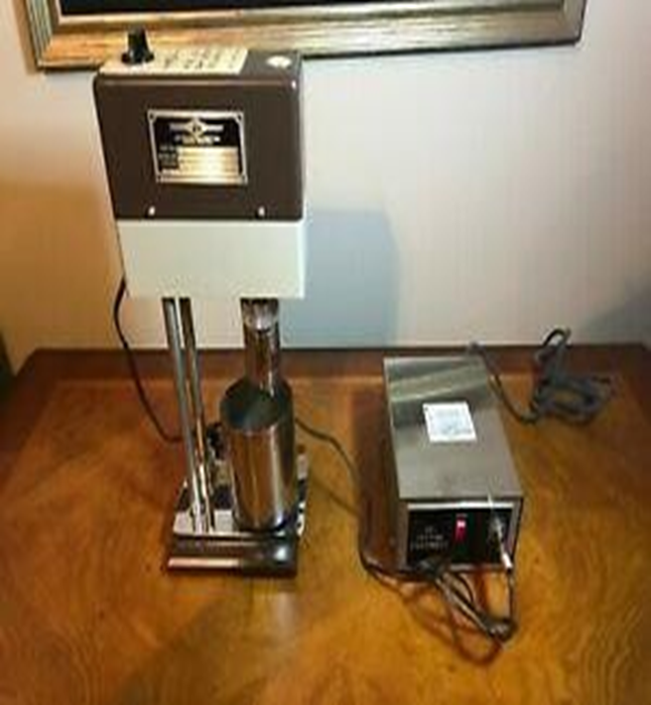

**Figure 2: Model 800 OFITE 8-speed viscometer**

**Table 1: Materials Used and their Weights for the Research Test:**

Additives                 Weight (g))

Freshwater              335.13

Starch                    Varied

30                          12

**Table 2: Rheology of Bentonite Only**

|  |  |  |  |
| --- | --- | --- | --- |
| **RPM** |  | **Imported Bentonite (cP)** | **Local Bentonite (cP)** |
|  |
| 600 |  | 35 | 27 |
| 300 |  | 25 | 20 |
| 200 |  | 23 | 18 |
| 100 |  | 15 | 16 |
| 60 |  | 13 | 13 |
| 30 |  | 12 | 11 |
| 6 |  | 10 | 8 |
| 3 |  | 9 | 8 |

**Rheological Property Measurements**

The analysis of the formulated drilling fluids was conducted using a Model 800 OFITE -Speed Viscometer. This instrument enabled the testing to be carried out at an actual shear rate of between 3 and 600 rpm, which is the shear condition observed during drilling. The readings on the viscometer were taken at every shear rate to the point where steady state rotation was obtained in order to obtain accurate readings. The collected data was consequently employed for the determination of PV together with YP for each of the fluid sample. Plastic viscosity offers the knowledge of the flow of a fluid because of friction inside a material while the yield point shows the amount of force needed to start a flow of the fluid. These are important parameters for defining the flow behavior of the fluid depending on various factors which include pressure loss in the well bore and cuttings transport capability.

**Drilling Fluid Preparation**

Drilling fluid samples are prepared using bentonite clay, both imported and local ones and distilled water as base fluid. The polymers are introduced to the base fluid in special ppm levels, with three sets of concentrations (0.5%, 1% and 2%) to study the effect on rheological characteristics.

**Fracture Gradient Determination**

While this study did not attempt to present a direct means of evaluating the gradients of fractures, it looked at how different types of polymers affect the properties of drilling fluids. The research was based on testing and comparing Plastic Viscosity (PV) and Yield Point (YP) at different concentration levels; 0.5%, 1 %, and 2%. Spontaneously, these fluids were also examined at different temperatures; 80°F, 120°F, 150°F, and 190°F. The findings showed that changes to the concentration of the polymers used in the ‘gel’ or fluid could affect the viscosity values in a way that some believed may influence the fracture gradient. The procedure followed in this study included formulating bentonite mud with different polymers, exposing the samples to different temperatures and then characterizing their rheological behaviour.

**Analysis of Experimental Data**

Statistical Methods: Collected rheological data is then analyzed by the help of statistical software: Python with Pandas, Matplotlib, and NumPy libraries. Plots of polymer concentration, temperature and rheological parameters (PV and YP) are constructed in graphical forms of charts.

**RESULTS AND DISCUSSION**

The concern was with two aspects, which are Plastic Viscosity (PV) and Yield Point (YP) that are very critical in formulation of drilling fluids. The values of PV and YP of varying polymer-bentonite composites at 80°F to 190°F and at different concentrations, 0.5%, 1% and 2% are displayed in the Tables 3 to Table 12. Python was used in analyzing the data and there were several libraries implored in the data processing, which includes; Pandas for data management and organization, Matplotlib for graphical illustrations, and NumPy were used for numerical computations. The graphical presentations of this data as seen from figures 3 to 12 could be used to monitor the trends and patterns of PV and YP across different polymers, temperature, and concentration. Also, graphical presentations of the dataset from figure 13 and 14 can be used to monitor the effects of polymer concentrations across varying temperatures.

**Table 3 Rheology of Bentonite Only**

|  |  |  |
| --- | --- | --- |
| **RPM** | **Imported Bentonite (cP)** | **Local Bentonite (cP)** |
| **600** | 35 | 27 |
| **300** | 25 | 20 |
| **200** | 23 | 18 |
| **100** | 15 | 16 |
| **60** | 13 | 13 |
| **30** | 12 | 11 |
| **6** | 10 | 8 |
| **3** | 9 | 8 |
| **PV (cP)** | 2 | 2 |
| **YP (lb/100ft²)** | 23 | 18 |

**Table 4 - Rheology of PAC-R with Imported Bentonite After Ageing**

|  |  |  |  |  |  |  |  |  |  |  |  |  |
| --- | --- | --- | --- | --- | --- | --- | --- | --- | --- | --- | --- | --- |
| **RPM** | **0.50%** | **0.50%** | **.50%** | **0.50%** | **1%** | **1%** | **1%** | **1%** | **2%** | **2%** | **2%** | **2%** |
|  | **80˚F** | **120˚F** | **150˚F** | **190˚F** | **80˚F** | **120˚F** | **150˚F** | **190˚F** | **80˚F** | **120˚F** | **150˚F** | **190˚F** |
| **600** | 45 | 43 | 40 | 40 | 53 | 48 | 45 | 42 | 35 | 31 | 30 | 29 |
| **300** | 34 | 32 | 30 | 29 | 38 | 35 | 34 | 32 | 26 | 25 | 23 | 23 |
| **200** | 27 | 26 | 25 | 25 | 32 | 28 | 28 | 22 | 23 | 21 | 20 | 22 |
| **100** | 20 | 21 | 20 | 20 | 24 | 23 | 22 | 21 | 18 | 18 | 17 | 18 |
| **60** | 18 | 18 | 17 | 18 | 21 | 20 | 19 | 19 | 17 | 16 | 15 | 17 |
| **30** | 15 | 14 | 15 | 15 | 18 | 18 | 17 | 13 | 11 | 13 | 13 | 16 |
| **6** | 10 | 13 | 10 | 14 | 12 | 10 | 10 | 10 | 15 | 11 | 11 | 14 |
| **3** | 10 | 13 | 9 | 13 | 12 | 10 | 9 | 10 | 15 | 11 | 11 | 14 |
| **PV (cP)** | 2 | 2 | 2 | 2 | 2 | 2 | 2 | 2 | 2 | 2 | 2 | 2 |
| **YP** | 23 | 26 | 30 | 30 | 39 | 39 | 39 | 39 | 18 | 18 | 18 | 18 |
| **(lb/100ft²)** |  |  |  |  |  |  |  |  |  |  |  |  |

**Table 5 - Rheology of Starch with Imported Bentonite After Ageing**

|  |  |  |  |  |  |  |  |  |  |  |  |  |
| --- | --- | --- | --- | --- | --- | --- | --- | --- | --- | --- | --- | --- |
| **RPM** | **0.50%** | **0.50%** | **.50%** | **0.50%** | **1%** | **1%** | **1%** | **1%** | **2%** | **2%** | **2%** | **2%** |
|  | **80˚F** | **120˚F** | **150˚F** | **190˚F** | **80˚F** | **120˚F** | **150˚F** | **190˚F** | **80˚F** | **120˚F** | **150˚F** | **190˚F** |
| **600** | 45 | 42 | 40 | 50 | 32 | 30 | 28 | 28 | 35 | 31 | 30 | 29 |
| **300** | 35 | 34 | 35 | 44 | 23 | 22 | 21 | 23 | 26 | 25 | 23 | 23 |
| **200** | 32 | 31 | 33 | 42 | 20 | 19 | 18 | 21 | 23 | 21 | 20 | 22 |
| **100** | 27 | 28 | 30 | 39 | 16 | 15 | 15 | 18 | 18 | 18 | 17 | 18 |
| **60** | 25 | 26 | 30 | 38 | 14 | 13 | 14 | 18 | 17 | 16 | 15 | 17 |
| **30** | 23 | 24 | 29 | 37 | 12 | 11 | 11 | 17 | 13 | 13 | 13 | 16 |
| **6** | 21 | 21 | 24 | 33 | 9 | 10 | 10 | 15 | 11 | 11 | 11 | 14 |
| **3** | 21 | 21 | 24 | 33 | 9 | 10 | 10 | 15 | 11 | 11 | 11 | 14 |
| **PV (cP)** | 8 | 6 | 5 | 5 | 7 | 7 | 6 | 5 | 8 | 7 | 6 | 5 |
| **YP** | 27 | 26 | 30 | 39 | 16 | 15 | 15 | 18 | 18 | 18 | 17 | 18 |
| **(lb/100ft²)** |  |  |  |  |  |  |  |  |  |  |  |  |
|  |  |  |  |  |  |  |  |  |  |  |  |  |

**Table 6 - Rheology and Filtrate Loss of XCD with Local Bentonite Before Ageing**

|  |  |  |  |  |  |  |  |  |  |  |  |  |
| --- | --- | --- | --- | --- | --- | --- | --- | --- | --- | --- | --- | --- |
| **RPM** | **0.50%** | **0.50%** | **0.50%** | **0.50%** | **1%** | **1%** | **1%** | **1%** | **2%** | **2%** | **2%** | **2%** |
|  | **80°F** | **120°F** | **150°F** | **190°F** | **80°F** | **120°F** | **150°F** | **190°F** | **80°F** | **120°F** | **150°F** | **190°F** |
| **600** | 45 | 42 | 40 | 50 | 32 | 30 | 28 | 28 | 35 | 31 | 30 | 29 |
| **300** | 35 | 34 | 35 | 44 | 23 | 22 | 21 | 23 | 26 | 25 | 23 | 23 |
| **200** | 32 | 31 | 33 | 42 | 20 | 19 | 18 | 21 | 23 | 21 | 20 | 22 |
| **100** | 27 | 28 | 30 | 39 | 16 | 15 | 15 | 18 | 18 | 18 | 17 | 18 |
| **60** | 25 | 26 | 30 | 38 | 14 | 13 | 14 | 18 | 17 | 16 | 15 | 17 |
| **30** | 23 | 24 | 29 | 37 | 12 | 11 | 11 | 17 | 13 | 13 | 13 | 16 |
| **6** | 21 | 21 | 24 | 33 | 9 | 10 | 10 | 15 | 11 | 11 | 11 | 14 |
| **3** | 21 | 21 | 24 | 33 | 9 | 10 | 10 | 15 | 11 | 11 | 11 | 14 |
| **PV (cP)** | 8 | 6 | 5 | 5 | 7 | 7 | 6 | 5 | 8 | 7 | 6 | 5 |
| **YP** | 27 | 26 | 30 | 39 | 16 | 15 | 15 | 18 | 18 | 18 | 17 | 18 |
| **(lb/100ft²)** |  |  |  |  |  |  |  |  |  |  |  |  |

**Table 7 Rheology XCD with Local Bentonite After Ageing**

|  |  |  |  |  |  |  |  |  |  |  |  |  |  |  |  |  |  |  |  |  |  |  |  |
| --- | --- | --- | --- | --- | --- | --- | --- | --- | --- | --- | --- | --- | --- | --- | --- | --- | --- | --- | --- | --- | --- | --- | --- |
| **RPM** | **0.50%** | | **0.50%** | | **0.50%** | | **0.50%** | | **1%** | | **1%** | | **1%** | | **1%** | | **2%** | | **2%** | **2%** | | **2%** | |
|  | **80°F** | | **120°F** | | **150°F** | | **190°F** | | **80°F** | | **120°F** | | **150°F** | | **190°F** | | **80°F** | | **120°F** | **150°F** | | **190°F** | |
| **600** | | 31 | | 28 | | 25 | | 32 | | 30 | | 28 | | 26 | | 32 | | 36 | 31 | 30 | 30 | |
| **300** | | 24 | | 22 | | 19 | | 25 | | 24 | | 22 | | 20 | | 30 | | 29 | 25 | 23 | 23 | |
| **200** | | 22 | | 19 | | 18 | | 22 | | 20 | | 19 | | 19 | | 25 | | 25 | 22 | 20 | 20 | |
| **100** | | 17 | | 15 | | 15 | | 18 | | 18 | | 16 | | 14 | | 22 | | 20 | 17 | 17 | 17 | |
| **60** | | 14 | | 14 | | 12 | | 15 | | 15 | | 14 | | 12 | | 17 | | 17 | 15 | 15 | 15 | |
| **30** | | 12 | | 12 | | 10 | | 14 | | 13 | | 11 | | 10 | | 16 | | 15 | 14 | 14 | 14 | |
| **6** | | 8 | | 7 | | 8 | | 13 | | 8 | | 8 | | 7 | | 13 | | 13 | 10 | 9 | 8 | |
| **3** | | 8 | | 6 | | 6 | | 8 | | 6 | | 8 | | 6 | | 10 | | 10 | 9 | 6 | 6 | |
| **PV (cP)** | | 7 | | 7 | | 6 | | 5 | | 8 | | 7 | | 7 | | 10 | | 10 | 9 | 6 | 7 | |
| **YP** | | 17 | | 15 | | 15 | | 13 | | 19 | | 18 | | 16 | | 14 | | 22 | 20 | 17 | 16 | |
| **(lb/100ft²)** | |  | |  | |  | |  | |  | |  | |  | |  | |  |  |  |  | |

**Table 8 Rheology and Filtrate Loss of Starch with Local Bentonite before Ageing**

|  |  |  |  |  |  |  |  |  |  |  |  |  |  |  |  |  |  |  |  |  |  |  |  |  |  |
| --- | --- | --- | --- | --- | --- | --- | --- | --- | --- | --- | --- | --- | --- | --- | --- | --- | --- | --- | --- | --- | --- | --- | --- | --- | --- |
| **RPM** | **0.50%** | | **0.50%** | | **0.50%** | | **0.50%** | | **1%** | | **1%** | | **1%** | | **1%** | | **2%** | | **2%** | | **2%** | | **2%** | | |
|  | **80°F** | | **120°F** | | **150°F** | | **190°F** | | **80°F** | | **120°F** | | **150°F** | | **190°F** | | **80°F** | | **120°F** | | **150°F** | | **190°F** | | |
| **600** | | | 28 | | 25 | | 25 | | 23 | | 26 | | 25 | | 24 | | 23 | | 26 | | 25 | | 23 | | 22 |
| **300** | | | 21 | | 22 | | 18 | | 17 | | 19 | | 18 | | 18 | | 16 | | 19 | | 19 | | 18 | | 18 |
| **200** | | | 17 | | 16 | | 15 | | 15 | | 18 | | 15 | | 16 | | 14 | | 16 | | 16 | | 15 | | 15 |
| **100** | | | 13 | | 14 | | 14 | | 11 | | 15 | | 12 | | 12 | | 12 | | 13 | | 12 | | 12 | | 12 |
| **60** | | | 13 | | 12 | | 10 | | 9 | | 11 | | 11 | | 11 | | 10 | | 12 | | 10 | | 10 | | 11 |
| **30** | | | 12 | | 10 | | 9 | | 9 | | 10 | | 10 | | 10 | | 8 | | 9 | | 9 | | 8 | | 9 |
| **6** | | | 6 | | 7 | | 6 | | 6 | | 6 | | 7 | | 6 | | 6 | | 7 | | 7 | | 7 | | 5 |
| **3** | | | 5 | | 6 | | 5 | | 5 | | 6 | | 7 | | 5 | | 5 | | 6 | | 6 | | 6 | | 4 |
| **PV (cP)** | | | 8 | | 8 | | 4 | | 6 | | 4 | | 6 | | 6 | | 4 | | 6 | | 7 | | 6 | | 6 |
| **YP** | | | 13 | | 14 | | 14 | | 11 | | 15 | | 12 | | 12 | | 12 | | 13 | | 12 | | 12 | | 12 |
| **(lb/100f t²)** | | |  | |  | |  | |  | |  | |  | |  | |  | |  | |  | |  | |  |

**Table 9 Rheology of NR 8082 with Imported Bentonite After Ageing**

|  |  |  |  |  |  |  |  |  |  |  |  |  |  |  |  |  |  |  |  |  |  |  |  |  |
| --- | --- | --- | --- | --- | --- | --- | --- | --- | --- | --- | --- | --- | --- | --- | --- | --- | --- | --- | --- | --- | --- | --- | --- | --- |
| **RPM** | **0.50%** | | **0.50%** | | **0.50%** | | **0.50%** | | **1%** | | **1%** | | **1%** | | **1%** | | **2%** | | **2%** | | **2%** | | **2%** | |
|  | **80°F** | | **120°F** | | **150°F** | | **190°F** | | **80°F** | | **120°F** | | **150°F** | | **190°F** | | **80°F** | | **120°F** | | **150°F** | | **190°F** | |
| **600** | | | 40 | | 40 | | 38 | 38 | 35 | | 35 | | 33 | | 32 | | 40 | | 39 | | 37 | | 40 | |
| **300** | | | 31 | | 30 | | 29 | 29 | 26 | | 25 | | 26 | | 26 | | 30 | | 30 | | 30 | | 32 | |
| **200** | | | 27 | | 28 | | 27 | 28 | 24 | | 24 | | 22 | | 23 | | 28 | | 27 | | 25 | | 27 | |
| **100** | | | 22 | | 23 | | 21 | 23 | 18 | | 18 | | 18 | | 18 | | 22 | | 22 | | 22 | | 25 | |
| **60** | | | 20 | | 19 | | 20 | 21 | 15 | | 17 | | 18 | | 18 | | 20 | | 19 | | 21 | | 24 | |
| **6** | | | 13 | | 15 | | 17 | 18 | 13 | | 12 | | 15 | | 13 | | 15 | | 15 | | 20 | | 20 | |
| **3** | | | 13 | | 15 | | 16 | 18 | 12 | | 12 | | 15 | | 13 | | 15 | | 15 | | 15 | | 20 | |
| **PV (cP)** | | | 9 | | 7 | | 8 | 6 | 8 | | 7 | | 8 | | 6 | | 8 | | 9 | | 8 | | 7 | |
| **YP** | | | 22 | | 23 | | 21 | 23 | 18 | | 18 | | 18 | | 12 | | 22 | | 22 | | 25 | | 27 | |
| **(lb/100ft²)** | | |  | |  | |  |  |  | |  | |  | |  | |  | |  | |  | |  | |

**Table 10 Rheology of 974779 with Imported Bentonite After Ageing**

|  |  |  |  |  |  |  |  |  |  |  |  |  |  |  |  |  |  |  |  |  |  |  |  |  |
| --- | --- | --- | --- | --- | --- | --- | --- | --- | --- | --- | --- | --- | --- | --- | --- | --- | --- | --- | --- | --- | --- | --- | --- | --- |
| **RPM** | **0.50%** | | **0.50%** | | **0.50%** | | **0.50%** | | **1%** | | **1%** | | **1%** | | **1%** | | **2%** | | **2%** | | **2%** | | **2%** | |
|  | **80°F** | | **120°F** | | **150°F** | | **190°F** | | **80°F** | | **120°F** | | **150°F** | | **190°F** | | **80°F** | | **120°F** | | **150°F** | | **190°F** | |
| **600** | | | 24 | | 23 | | 23 | 23 | 24 | | 23 | | 23 | | 23 | | 24 | | 23 | | 22 | | 22 | |
| **300** | | | 16 | | 19 | | 18 | 19 | 22 | | 18 | | 18 | | 18 | | 18 | | 17 | | 18 | | 18 | |
| **200** | | | 16 | | 15 | | 16 | 18 | 15 | | 16 | | 15 | | 16 | | 16 | | 15 | | 15 | | 15 | |
| **100** | | | 13 | | 13 | | 13 | 15 | 13 | | 13 | | 13 | | 13 | | 13 | | 13 | | 13 | | 13 | |
| **60** | | | 12 | | 13 | | 12 | 14 | 12 | | 13 | | 12 | | 12 | | 12 | | 12 | | 12 | | 13 | |
| **30** | | | 10 | | 12 | | 11 | 11 | 10 | | 11 | | 11 | | 11 | | 11 | | 11 | | 11 | | 12 | |
| **6** | | | 9 | | 10 | | 10 | 11 | 9 | | 10 | | 10 | | 13 | | 9 | | 9 | | 10 | | 11 | |
| **3** | | | 9 | | 10 | | 10 | 11 | 9 | | 10 | | 10 | | 13 | | 9 | | 9 | | 10 | | 11 | |
| **PV (cP)** | | | 3 | | 6 | | 5 | 4 | 9 | | 6 | | 5 | | 5 | | 4 | | 5 | | 5 | | 7 | |
| **YP** | | | 13 | | 13 | | 13 | 15 | 13 | | 13 | | 13 | | 13 | | 13 | | 13 | | 13 | | 13 | |
| **(lb/100ft²)** | | |  | |  | |  |  |  | |  | |  | |  | |  | |  | |  | |  | |

**Table 11 Rheology of 011412 with Imported Bentonite After Ageing**

|  |  |  |  |  |  |  |  |  |  |  |  |  |  |  |  |  |  |  |  |  |  |  |  |  |  |
| --- | --- | --- | --- | --- | --- | --- | --- | --- | --- | --- | --- | --- | --- | --- | --- | --- | --- | --- | --- | --- | --- | --- | --- | --- | --- |
| **RPM** | | **0.50%** | | **0.50%** | | **0.50%** | | **0.50%** | | **1%** | | **1%** | | **1%** | | **1%** | | **2%** | | **2%** | | **2%** | | **2%** | |
|  | | **80°F** | | **120°F** | | **150°F** | | **190°F** | | **80°F** | | **120°F** | | **150°F** | | **190°F** | | **80°F** | | **120°F** | | **150°F** | | **190°F** | |
| **600** | | 22 | | 22 | | 22 | | 22 | | 24 | | 24 | | 24 | | 24 | | 24 | | 24 | | 23 | | 24 | |
| **300** | | 18 | | 17 | | 18 | | 18 | | 18 | | 18 | | 19 | | 21 | | 18 | | 18 | | 18 | | 20 | |
| **200** | | 14 | | 15 | | 15 | | 16 | | 17 | | 17 | | 17 | | 17 | | 14 | | 16 | | 15 | | 17 | |
| **100** | | 13 | | 13 | | 13 | | 14 | | 13 | | 15 | | 15 | | 16 | | 13 | | 13 | | 15 | | 14 | |
| **60** | | 11 | | 12 | | 12 | | 13 | | 12 | | 14 | | 14 | | 16 | | 13 | | 12 | | 14 | | 13 | |
| **30** | | 10 | | 10 | | 12 | | 13 | | 12 | | 14 | | 12 | | 15 | | 11 | | 10 | | 11 | | 13 | |
| **6** | | 10 | | 9 | | 11 | | 13 | | 11 | | 12 | | 10 | | 13 | | 11 | | 9 | | 10 | | 12 | |
| **3** | | 10 | | 9 | | 11 | | 13 | | 11 | | 12 | | 10 | | 13 | | 11 | | 9 | | 10 | | 12 | |
| **PV (cP)** | | 5 | | 4 | | 5 | | 4 | | 5 | | 3 | | 4 | | 5 | | 5 | | 5 | | 3 | | 6 | |
| **YP** | | 13 | | 13 | | 13 | | 13 | | 14 | | 18 | | 15 | | 15 | | 16 | | 13 | | 15 | | 14 | |
| **(lb/100f t²)** | |  | |  | |  | |  | |  | |  | |  | |  | |  | |  | |  | |  | |

**Table 12: Rheology and Filtrate Loss of 980505 with Local Bentonite Before Ageing**

|  |  |  |  |  |  |  |  |  |  |  |  |  |  |  |  |  |  |  |  |  |  |  |  |  |  |
| --- | --- | --- | --- | --- | --- | --- | --- | --- | --- | --- | --- | --- | --- | --- | --- | --- | --- | --- | --- | --- | --- | --- | --- | --- | --- |
| **RPM** | | **0.50%** | | **0.50%** | | **0.50%** | | **0.50%** | | **1%** | | **1%** | | **1%** | | **1%** | | **2%** | | **2%** | | **2%** | | **2%** | |
|  | | **80°F** | | **120°F** | | **150°F** | | **190°F** | | **80°F** | | **120°F** | | **150°F** | | **190°F** | | **80°F** | | **120°F** | | **150°F** | | **190°F** | |
| **600** | | 28 | | 28 | | 27 | | 25 | | 27 | | 26 | | 25 | | 23 | | 28 | | 27 | | 25 | | 25 | |
| **300** | | 21 | | 21 | | 20 | | 18 | | 20 | | 19 | | 18 | | 17 | | 20 | | 19 | | 18 | | 18 | |
| **200** | | 19 | | 19 | | 18 | | 16 | | 18 | | 17 | | 16 | | 14 | | 18 | | 18 | | 17 | | 16 | |
| **100** | | 15 | | 15 | | 14 | | 13 | | 14 | | 13 | | 13 | | 11 | | 16 | | 16 | | 13 | | 13 | |
| **60** | | 13 | | 13 | | 13 | | 12 | | 13 | | 12 | | 12 | | 10 | | 14 | | 14 | | 10 | | 12 | |
| **30** | | 11 | | 11 | | 11 | | 9 | | 10 | | 10 | | 9 | | 9 | | 10 | | 10 | | 9 | | 8 | |
| **6** | | 8 | | 8 | | 7 | | 6 | | 8 | | 6 | | 6 | | 6 | | 8 | | 8 | | 5 | | 6 | |
| **3** | | 7 | | 7 | | 6 | | 5 | | 7 | | 6 | | 5 | | 5 | | 7 | | 7 | | 4 | | 6 | |
| **PV (cP)** | | 6 | | 6 | | 6 | | 5 | | 7 | | 6 | | 5 | | 6 | | 4 | | 3 | | 5 | | 5 | |
| **YP** | | 15 | | 15 | | 14 | | 13 | | 14 | | 13 | | 13 | | 11 | | 16 | | 16 | | 13 | | 13 | |
| **(lb/100f t²)** | |  | |  | |  | |  | |  | |  | |  | |  | |  | |  | |  | |  | |

**Table 13: Rheology of 980505 with Local Bentonite After Ageing**

|  |  |  |  |  |  |  |  |  |  |  |  |  |  |  |  |  |  |  |  |  |  |  |  |  |  |
| --- | --- | --- | --- | --- | --- | --- | --- | --- | --- | --- | --- | --- | --- | --- | --- | --- | --- | --- | --- | --- | --- | --- | --- | --- | --- |
| **RPM** | | **0.50%** | | **0.50%** | | **0.50%** | | **0.50%** | | **1%** | | **1%** | | **1%** | | **1%** | | **2%** | | **2%** | | **2%** | | **2%** | |
|  | | **80°F** | | **120°F** | | **150°F** | | **190°F** | | **80°F** | | **120°F** | | **150°F** | | **190°F** | | **80°F** | | **120°F** | | **150°F** | | **190°F** | |
| **600** | | 23 | | 28 | | 26 | | 25 | | 28 | | 23 | | 25 | | 23 | | 28 | | 27 | | 25 | | 25 | |
| **300** | | 22 | | 19 | | 20 | | 20 | | 21 | | 20 | | 19 | | 17 | | 21 | | 20 | | 20 | | 19 | |
| **200** | | 18 | | 18 | | 18 | | 16 | | 19 | | 17 | | 17 | | 15 | | 20 | | 18 | | 17 | | 16 | |
| **100** | | 16 | | 16 | | 14 | | 14 | | 16 | | 13 | | 13 | | 11 | | 15 | | 14 | | 15 | | 14 | |
| **60** | | 15 | | 14 | | 12 | | 11 | | 13 | | 11 | | 11 | | 10 | | 14 | | 12 | | 12 | | 12 | |
| **30** | | 11 | | 11 | | 10 | | 10 | | 10 | | 10 | | 10 | | 10 | | 12 | | 11 | | 11 | | 9 | |
| **6** | | 8 | | 8 | | 7 | | 7 | | 8 | | 8 | | 6 | | 8 | | 7 | | 8 | | 7 | | 7 | |
| **3** | | 7 | | 7 | | 6 | | 6 | | 7 | | 7 | | 6 | | 3 | | 6 | | 6 | | 6 | | 6 | |
| **PV (cP)** | | 6 | | 3 | | 6 | | 6 | | 5 | | 7 | | 6 | | 6 | | 6 | | 6 | | 5 | | 5 | |
| **YP** | | 16 | | 16 | | 14 | | 14 | | 16 | | 13 | | 13 | | 11 | | 15 | | 14 | | 15 | | 14 | |
| **(lb/100f t²)** | |  | |  | |  | |  | |  | |  | |  | |  | |  | |  | |  | |  | |
|  | |  | |  | |  | |  | |  | |  | |  | |  | |  | |  | |  | |  | |

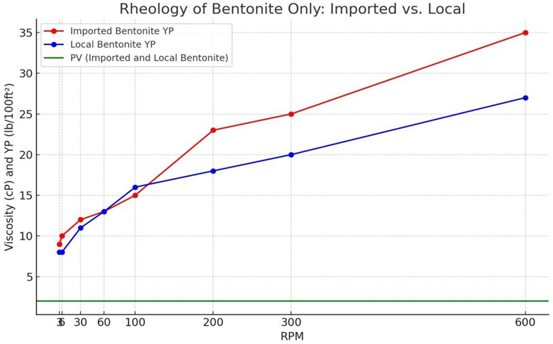

**Figure 3 Rheology Properties (PV and YP) of Imputed and Local Bentonite at RPM**

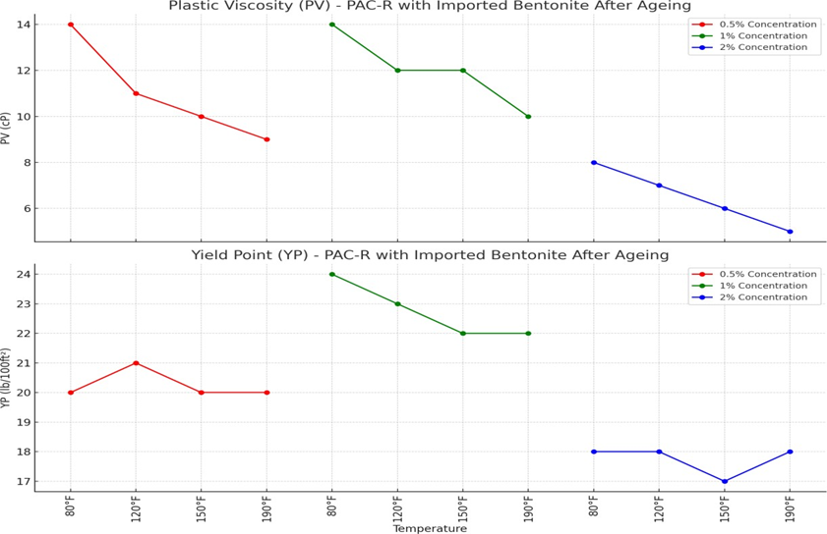

**Figure 4 Rheology Properties (PV and YP) Against Temperature of PAC-R with Imported Bentonite After Ageing**

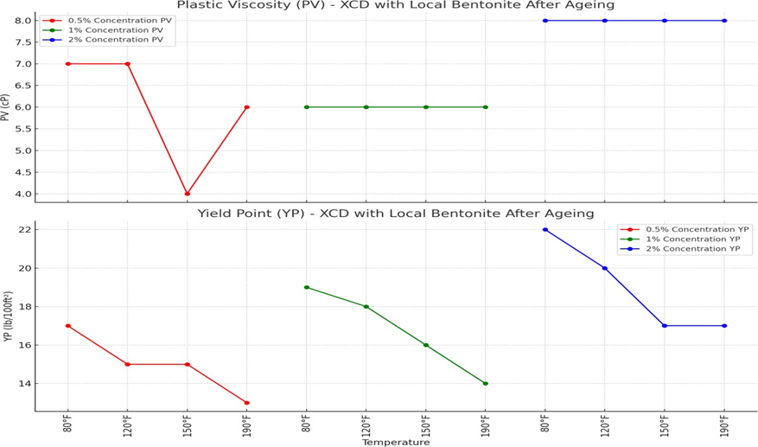

**Figure 4: Rheology Properties of (PV and YP) Against Temperature of XCD Local Bentonite After Ageing at Varying Concentrations.**

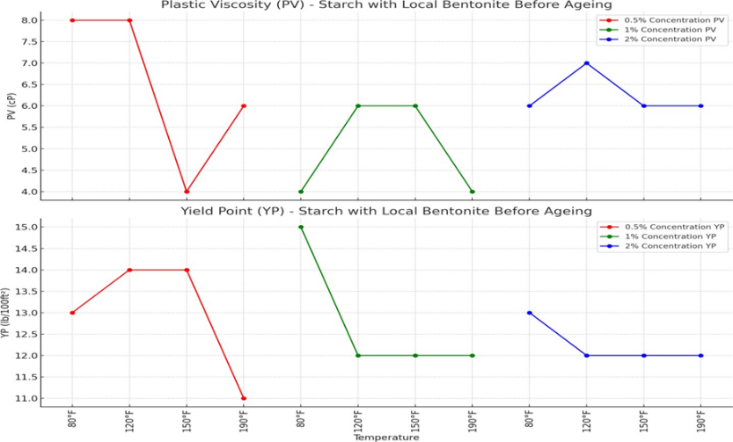

**Figure 5 Rheology Properties (PV and YP) Against Temperature of Starch with Local Bentonite Before Ageing_**

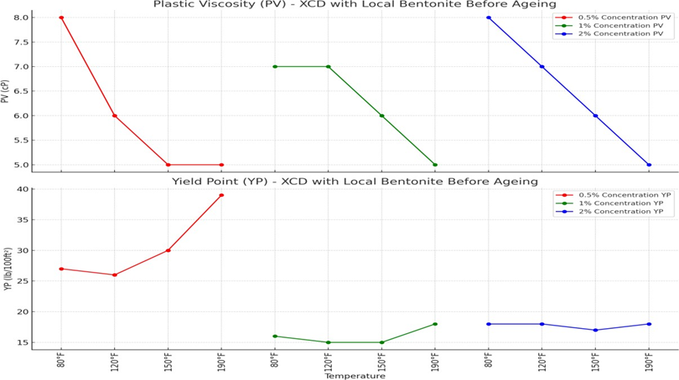

**Figure 6 Rheology Properties of (PV and YP) Against Temperature of XCD with Local Bentonite Before Ageing**



**Figure 7: Rheology Properties of (PV and YP) Against Temperature of XCD Local Bentonite After Ageing at Varying Concentrations.**

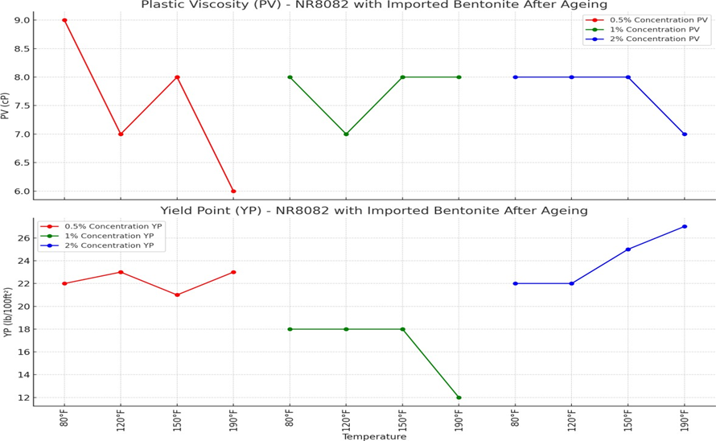

**Figure 8: Rheology Properties of (PV and YP) Against Temperature of NR8082 with Imported Bentonite**

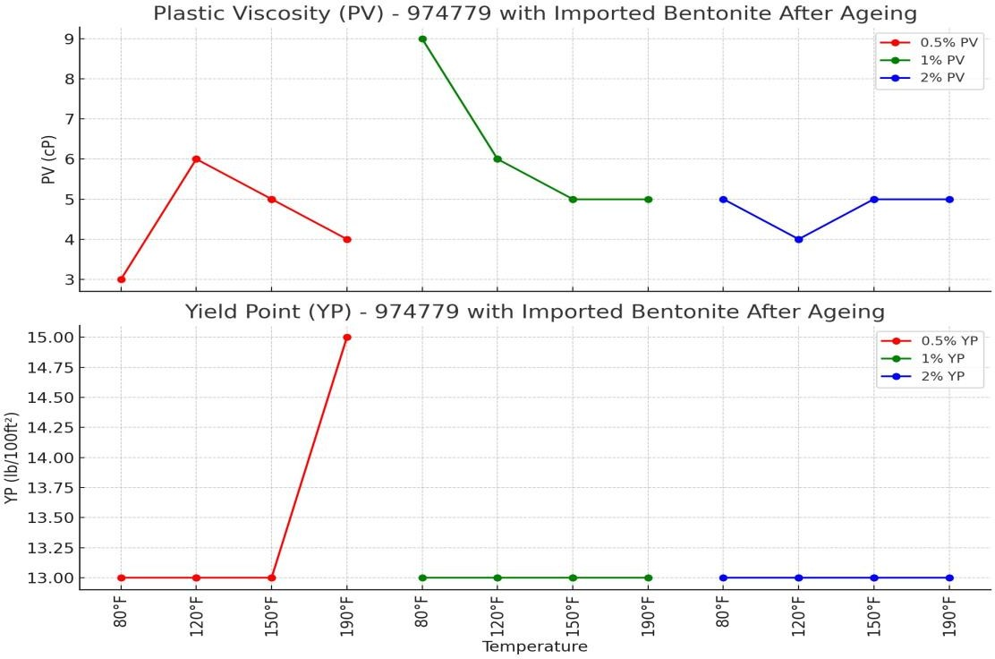

**Figure 9: Rheology Properties of (PV and YP) Against Temperature of 974779 with Imported Bentonite After Ageing at Varying**

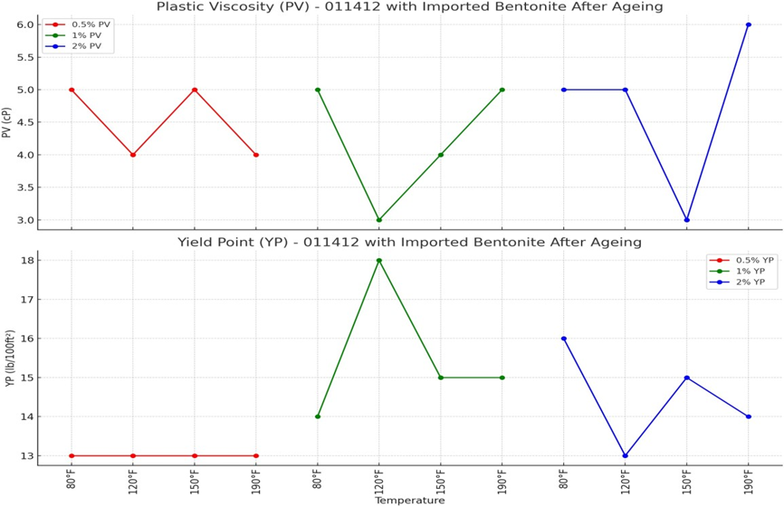

**Figure 10: Rheology Properties of (PV and YP) Against Temperature of 011412 with Imported Bentonite After Ageing**

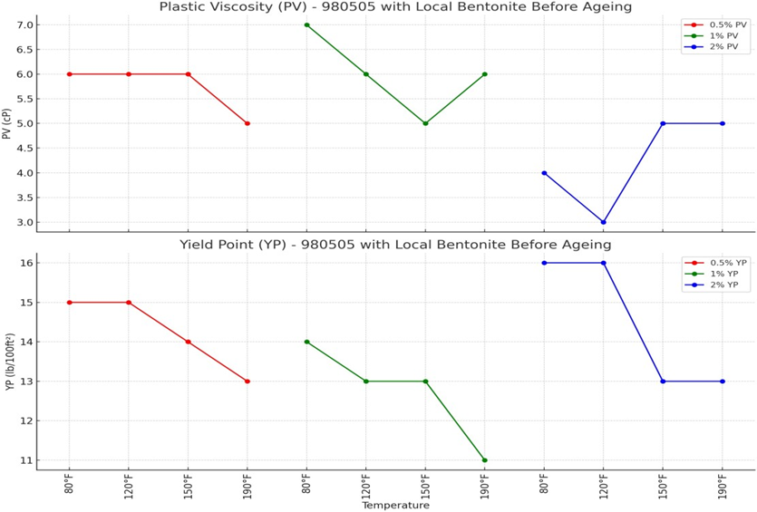

**Figure 11: Rheology Properties of (PV and YP) Against Temperature of 980505 with Local Bentonite Before Ageing**

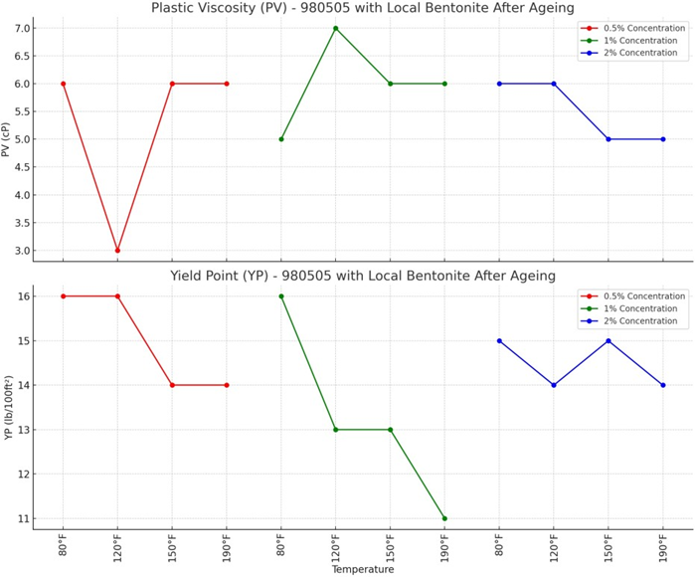

**Figure 12:** **Rheology Properties of (PV and YP) Against Temperature of 980505 with Local Bentonite After Ageing**

**Impact of Temperature on Rheology of Bentonite Muds**

In Figure 3, the region of the two positions of intersection shows that the viscosity (YP) of both imported and local bentonite is similar at lower RPMs. This means that they have comparable suspension properties at low shear rates. However, as the RPM increases, the imported bentonite has higher viscosity than the local bentonite, indicating that it can withstand higher shear stress and maintain its stability. The similarity in viscosity (YP) of both bentonites at lower RPMs implies that they can be used interchangeably for drilling operations that require low shear rates, such as vertical or deviated wells. The PV (plastic viscosity) of both bentonites is constant across all RPMs, suggesting that they have similar flow characteristics.).

The results of the analysis show a clear trend: when temperatures rise, there's usually a drop in Plastic Viscosity (PV) for most polymer-bentonite mixes (Mahto & Sharma, 2004). This "thermal thinning" effect, frequently observed in drilling fluids, emphasizes the significant influence of temperature on drilling fluid rheology ( Liu et al.,2021). The study found that the magnitude of this effect is not uniform and depends on the specific polymer used, its concentration, and the type of bentonite in the mixture. For instance, when XCD is mixed with local bentonite after aging, a notable thermal thinning effect is observed at a 1% and 2% concentration, with the PV remaining stable at 3 cP and 8 cP respectively across all tested temperatures. (See Figure 4) However, certain polymer-bentonite mixtures exhibit less predictable PV behaviour as the temperature rises. Figure 10 revealed that as polymer 011412 combined with imported bentonite after aging, it shows complex, temperature-dependent fluctuations in PV at both 0.5% and 1% concentrations. These variations highlight how the intricate interplay between the polymer's structure, concentration, and temperature affect the drilling fluid’s final viscosity. Unlike Plastic Viscosity (PV), how usually decreases as temperatures increase the impact of temperature on Yield Point (YP) varies widely among different polymer- bentonite mixtures. While some mixtures show a decrease in YP as temperature increases, others exhibit an increase or maintain a relatively stable YP. This variability suggests that the factors influencing YP are more complex than those affecting PV and likely involve intricate interactions between the polymer, bentonite, and temperature. For instance, in Figure 6, XCD mixed with local bentonite before aging demonstrates a distinct increase in YP as temperatures rise, while the same mixture after aging shows a general decrease in YP at higher temperatures. This contrasting behavior highlights the complex relationship between temperature and YP in different polymer-bentonite systems (Wu et al., 2002, & Kumar et al., 2019).

**Effects of Polymer Concentration on Bentonite Mud Before and After Aging at 600 RPM**

The research further examined how varying polymer concentration impacts viscosity in bentonite drilling fluids before and after aging at a consistent speed of rotation of 600 RPM. This data is visually represented in Figures 13 & 14 and also detailed in Tables 14 and 15. The results indicate that increasing the polymer concentration generally leads to a corresponding increased viscosity, corroborating previous findings in the field. However, the study emphasizes that the degree of this increase is not uniform and depends on the specific combination of polymer and bentonite used and whether the fluid has undergone aging. For instance, Figure 14 shows that at a concentration of 1%, PAC-R with Imported Bentonite exhibits the most substantial increase in viscosity after aging. This finding is critical as it indicates that PAC-R is highly effective at enhancing the mud's thickness. In close second is Starch with Imported Bentonite where an increase in viscosity is not as high as that of PAC-R. This means that although Starch is cost effective, PAC-R may be a more effective viscosifier in this case. On the other hand, there is NR 8082 with Imported Bentonite indicates less inclined in terms of viscosity as compared to those of PAC-R and Starch suggesting that it may not act as efficiently in building the mud thickness.

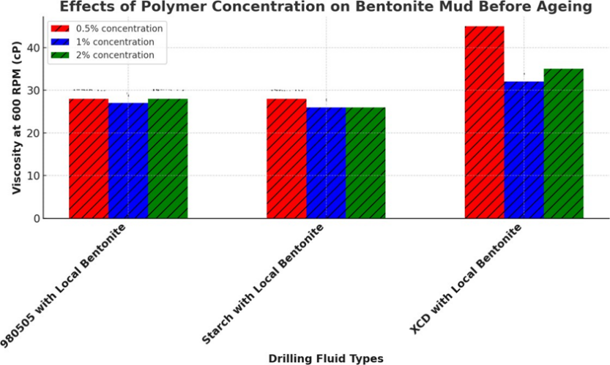

### Figure 13: Effects of Polymer Concentration on Bentonite Drilling Fluids Before Ageing At 600 RPM

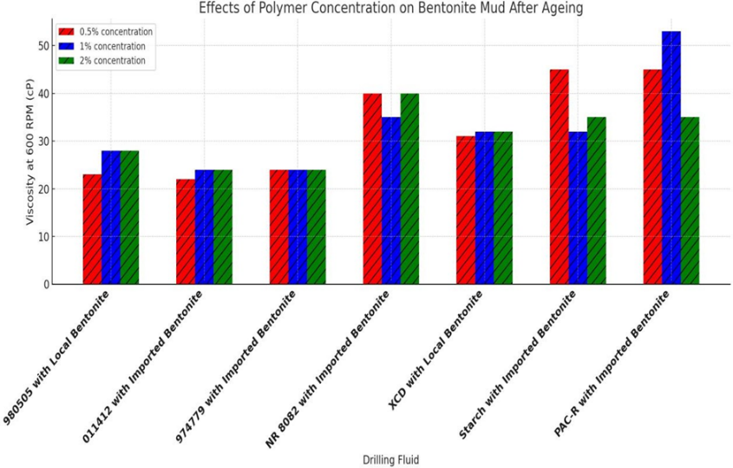

### Figure 14: Effects of Polymer Concentration on Bentonite Drilling Fluids Before Ageing At 600 RPM

**Discussion**

The impact of polymer concentration on viscosity is thus a matter of considerable significance. Additional polymer aids in suspension and transportation of cuttings thereby enhancing hole cleaning. But there’s a catch: more can-exceed the formation’s fracture gradient which may lead to instabilities within the well bore or harm the formation. Therefore, there is a call to adopt a method that will meet the cleaning of the hole without affecting its construction. Hence, this research offers a unique fill in the knowledge gap on how polymer modifiers influence the rheological characteristics of drilling muds especially PV and YP. These properties are not merely abstract measurements but are directly linked to critical drilling parameters such as:

* Fluid Flow Resistance: This parameter dictates the pressure required to circulate the drilling fluid throughout the wellbore.
* Hole Cleaning Efficiency: A crucial aspect that ensures the removal of drill cuttings from the wellbore, preventing drilling problems.
* Fracture Gradient: This parameter represents the pressure at which the formation will fracture, a critical limit that must be respected during drilling operations.

Tables 14, 15, and 16, along with Figures 13 and 14, highlight choosing the right polymer kinds and concentrations as key to maintaining good drilling fluid properties and reducing risks of exceeding the fracture gradient, especially when with aging muds. The graphical details in Figures 3 to Figure 12 illustrate how temperature greatly impacts drilling fluid rheology, with significant trends like thermal thinning and various responses from different polymer-bentonite mixtures. These results stress the need for careful consideration of temperature when selecting drilling fluid mixes & planning drilling programs. The trends found in this work, such as how polymers like PAC-R enhance viscosity, match what previous studies showed too. PAC-R effectively improves mud rheology after aging, which is very notable. Also, polymers such as NR 8082 have less significant effects on viscosity increase; this is consistent with prior research.

Notably, there is a decrease in PV as temperature rises, a phenomenon called thermal thinning. This has real-world implications. A drop in viscosity can lower frictional pressure losses which enhances drilling efficiency (Garcia & Martinez, 2018). However, it might also prevent the capacity of the capacity to carry cuttings, which could cause issues. So, considering the thermal stability of drilling fluids is important, especially in high-temperature areas where this effect is noticeable.

**Table 14 - Effects of Polymer Concentration on Bentonite Mud Before Aging at 600 RPM**

| **Polymer & Bentonite Type** | **0.5% Concentration viscosity (cP)** | **1% Concentration** **viscosity (cP)** | **2% Concentration** **viscosity (cP)** |
| --- | --- | --- | --- |
| **980505 with Local Bentonite** | Moderate Increase | Slightly Lesser Increase | Stable Increase |
| **Starch with Local Bentonite** | Small Increase | Same as 0.5% | Slight Decrease |
| **XCD with Local Bentonite** | Highest Increase | Significant Reduction | Moderate Increase |

**Table 15 - Effects of Polymer Concentration on Bentonite Mud After Aging at 600 RPM**

| **Polymer Concentration** | **PAC-R with Imported Bentonite** | **Starch with Imported Bentonite** | **NR-882 with Imported Bentonite** | **XCD with Local Bentonite** | **9805D5 with Local Bentonite** | **974779 with Imported Bentonite** | **0114D2 with Imported Bentonite** |
| --- | --- | --- | --- | --- | --- | --- | --- |
| **0.5% (Red Bar)** | Highest Increase | Lightly Lower Increase | Lesser Increase | Lower Increase | Lesser Increase | Lower Increase | Smallest Increase |
| **1% (Blue Bar)** | Greatest Increase | Less Increase Than NR-882 | Slightly Lower Increase | Reduced Increase | Smaller Increase | Smaller Increase | Smallest Increase |
| **2% (Green Bar)** | Slight Reduction from NR-882 | Smaller Increase than PAC-R | Highest Increase | Lesser Increase | Further Decrease | Smaller Increase | Least Increase |

Note: The effects are described in terms of relative increases or decreases in mud properties at different polymer concentration

**Table 16: Effect of Polymer Concentrations on Fracture Gradient Before Ageing Muds**

| **Polymer & Bentonite Type** | **Concentration (%)** | **Effect on Fracture Gradient** | **Impact Description** |
| --- | --- | --- | --- |
| 980505 with Local Bentonite | 0.5 | Moderate Increase | Balanced effect; |
|  | 1.0 | Slightly Moderate Increase | suitable for moderate ECD |
|  | 2.0 | Stable Profile | requirements without significantly |
|  |  |  | impacting the fracture gradient |
| Starch with Local Bentonite | 0.5 | Significant Increase | High continuous viscosity impact; |
|  | 1.0 | Highest Increase | caution advised for sensitive |
|  | 2.0 | Same as at 0.5% | fracture gradients due to |
|  |  |  | potential substantial pressure |
| XCD with Local Bentonite | 0.5 | Significant Increase | Significant pressure on fracture |
|  | 1.0 | Slightly Smaller Increase | gradient, especially at higher |
|  | 2.0 | - | concentrations; preferred for |
|  |  |  | high viscosity needs but with |
|  |  |  | risk of exceeding fracture gradient |

**Analyzing Polymer Effects on Aged Bentonite Mud: Code Review**

The dataset in Table 3 to Table 12 were inputted into a python model, employing three python libraries (import matplotlib.pyplot as plt, import pandas as pd, import numpy as np) for developing line plot (figure 3 to figure 12) and bar plot (figure 13 and figure 14) code snippets formulas. Furthermore, the line plots show the Rheology Properties of (PV and YP) Against Temperature of Polymer Bentonite before and After Ageing, based on their ageing conditions; whereas the bar plots show the Effects of Polymer Concentration on Bentonite Drilling Fluids Before and after Ageing At 600 RPM. Table 17 explains the general code snippet formula for simulating the line plots, figure 3 to 12; whereas, Table 18 details the bar plots code formula for figure 13 and 14.

1. Line Plot Code Analysis: Rheology Properties of (PV and YP) Against Temperature of Polymer Bentonite before and After Ageing (Figures 3 to 12). See Table 17 below:

**Table 17 Python Code for** **Rheology Properties of (PV and YP) Against Temperature of Polymer Bentonite before and After Ageing**

|  |  |
| --- | --- |
| **Section** | **Explanation** |
| Imports | - `import matplotlib.pyplot as plt`: Imports Matplotlib's `pyplot` module for creating visualizations. - `import numpy as np`: Imports the NumPy library for numerical operations (not used directly in this code). |
| Data Definition | - `temperatures = [80, 120, 150, 190] * 3`: Creates a list of temperatures repeated three times (one for each concentration). - `concentrations = ['0.5%', '1%', '2%']`: Defines the different concentrations of [Insert Polymer Name]. - `pv_data` and `yp_data`: Dictionaries storing PV and YP values for each concentration. |
| Subplot Creation | - `fig, (ax1, ax2) = plt.subplots(2, 1, figsize=(12, 10))`: Creates two subplots stacked vertically with a specified figure size (12x10 inches). - `ax1` and `ax2` are the axes for the PV and YP plots, respectively. |
| Color Mapping | - `colors = {'0.5%': 'red', '1%': 'green', '2%': 'blue'}`: Defines a color mapping for each concentration. |
| plot_data Function | - `plot_data(ax, data, title, ylabel)`: A function to plot data for a specific concentration, temperature, and property (PV or YP).  - **Parameters**:  - `ax`: Axis on which to plot the data.  - `data`: The PV or YP data.  - `title`: Title of the plot.  - `ylabel`: Label for the y-axis.  - **Inside the Function**:  - Iterates over the concentrations to plot the data for each one.  - Uses `ax.plot` to create the plot, with markers and colors specified.  - Sets the title, x-label, y-label, x-ticks, and x-tick labels.  - Adds a legend and a grid for better visualization. |
| Plotting PV Data | - `plot_data(ax1, pv_data, 'Plastic Viscosity (PV) –[Insert Polymer Name Before or After Ageing', 'PV (cP)')`: Calls `plot_data` to plot PV data on `ax1` with a specified title and y-axis label. |
| Plotting YP Data | - `plot_data(ax2, yp_data, 'Yield Point (YP) – [Insert Polymer Name Before or After Ageing', 'YP (lb/100ft²)')`: Calls `plot_data` to plot YP data on `ax2` with a specified title and y-axis label. |
| Highlighting/Removing Points | - `ax1.plot(3, pv_data['0.5%'][-1], 'wx', markersize=10, markeredgecolor='red')`: Plots a white 'x' with a red edge on the last point of the 0.5% PV data to highlight or remove it visually. - `ax1.plot(4, pv_data['1%'][0], 'wx', markersize=10, markeredgecolor='green')`: Similar operation for the first point of the 1% PV data. - `ax2.plot(3, yp_data['0.5%'][-1], 'wx', markersize=10, markeredgecolor='red')`: Highlights/removes the last point of the 0.5% YP data. - `ax2.plot(4, yp_data['1%'][0], 'wx', markersize=10, markeredgecolor='green')`: Similar operation for the first point of the 1% YP data. - `plt.tight_layout()`: Adjusts the layout to prevent overlapping of plot elements. - `plt.show()`: Displays the final plot. |

1. Bar Plot Code Analysis: Effects of Polymer Concentration on Bentonite Drilling Fluids Before and after Ageing At 600 RPM (Figures 13 and 14). See Table 18 below:

**Table 18 Python Code Analysis for Effects of Polymer Concentration on Bentonite Drilling Fluids before and after Ageing At 600 RPM.**

|  |  |
| --- | --- |
| **Code Section** | **Explanation** |
| import matplotlib.pyplot as plt | Imports the ‘matplotlib.pyplot’ module, which is utilized for creating plots & visual displays. |
| import pandas as pd | Imports `pandas`, a really useful library. It helps with data manipulation & analysis in Python. |
| import numpy as np | Imports `numpy`, built for numerical tasks and handling arrays. |
| from typing import Dict, List, Tuple | Imports specific type hints (`Dict`, `List`, `Tuple`) to help define data types in the function. |
| import seaborn as sns | Imports `seaborn`, for statistical data visualization that builds upon `matplotlib’, |
| def generate_combined_viscosity_graph(...) -> plt.Figure: | Defines a function to generate a bar graph comparing viscosity data before and after aging. Returns a matplotlib figure object. |
| before_data: Dict[str, List] | Input parameter. A dictionary where keys are strings (e.g., fluid names) and values are lists (e.g., viscosity values) before aging. |
| after_data: Dict[str, List] | Input parameter. Similar to `before_data`, but for viscosity values after aging. |
| title: str, x_label: str, y_label: str | Input parameters to set the title, x-axis label, & y-axis label for the plot. |
| color_palette: str = "viridis" | Optional parameter. Specifies the color palette to use for the plot (default is "viridis"). |
| rotation_angle: int = 45 | Optional parameter. Specifies the rotation angle for x-axis labels (default is 45 degrees). |
| bar_width: float = 0.1 | Optional parameter. This one specifies how wide the bars in the graph should be. The default width is 0.1. |
| figsize: Tuple[int, int] = (16, 10) | Optional parameter. Specifies the size of the figure (default is 16x10 inches). |
| if set(before_data.keys()) != set(after_data.keys()): | Checks if the keys in `before_data` and `after_data` are the same; raises an error if not. |
| df_before = pd.DataFrame(before_data) | Converts `before_data` into a pandas DataFrame for easier handling and analysis. |
| df_after = pd.DataFrame(after_data) | Converts `after_data` into a pandas DataFrame. |
| df_before_melted = df_before.melt(...) | Uses the `melt` function to reshape the DataFrame for plotting; this makes it easier to create grouped bar plots. |
| df_after_melted = df_after.melt(...) | Similar to `df_before_melted`, reshapes `after_data`. |
| df_combined = pd.concat([df_before_melted, df_after_melted]) | Combines the melted DataFrames into one for easier plotting. |
| sns.set_style("whitegrid") | Sets the plot style to "whitegrid" using `seaborn`. |
| sns.set_palette(color_palette) | Applies the specified color palette to the plot. |
| fig, ax = plt.subplots(figsize=figsize) | Creates a new figure and axes for the plot with the specified size. |
| sns.barplot(...) | Creates a grouped bar plot with `seaborn`, plotting viscosity values for different fluids and concentrations. |
| ax.text(...) | Adds custom labels ("Before" and "After") on top of the bars. |
| ax.set_xlabel(x_label, fontweight='bold') | Makes x-axis label, set using bold font. |
| ax.set_ylabel(y_label, fontweight='bold') | Makes y-axis label, set using bold font. |
| ax.set_title(title, fontweight='bold') | Makes plot title, set using bold font. |
| plt.xticks(rotation=rotation_angle, ha='right') | Rotates the x-axis labels by the specified angle and aligns them to the right. |
| plt.legend(title='Concentration', bbox_to_anchor=(1.05, 1), loc='upper left') | Adds a legend to the plot, positioned outside the plot area. |
| ax.bar_label(container, fmt='%.1f', padding=3) | Adds value labels to the bars in the plot. |
| plt.tight_layout() | Modifies the plot's arrangement to fit properly inside the figure area |
| return fig | Returns the generated plot as a `matplotlib` figure object. |
| before_aging_viscosity_data = {...} | Creates a dictionary of viscosity data before aging for different drilling fluids at various concentrations. |
| after_aging_viscosity_data = {...} | Creates a similar dictionary for viscosity data after aging. |
| combined_fig = generate_combined_viscosity_graph(...) | Calls the function to generate the combined viscosity graph, using the `before` and `after` data. |
| combined_plot_path = '/mnt/data/enhanced_combined_viscosity_plot.png' | Specifies the path to save the generated plot. |
| combined_fig.savefig(combined_plot_path, bbox_inches='tight', dpi=300) | Saves the generated plot to the specified path with high resolution. |
| plt.show() | Displays the plot on the screen. |
| df_before.describe() | Generates summary statistics (mean, std, min, max, etc.) for the `before` data. |
| df_after.describe() | Generates summary statistics for the `after` data. |
| percent_change = ((df_after[concentration_columns] - df_before[concentration_columns]) / df_before[concentration_columns]) * 100 | Calculates the percentage change in viscosity after aging. |
| print(percent_change) | Prints the calculated percentage changes for each concentration and drilling fluid. |

The polymer effects on aged bentonite mud code review in Table 18, defines a function generate_combined_viscosity_graph that takes both before and after aging data as input. It creates a single graph that compares the viscosity values for different drilling fluids and polymer concentrations, both before and after aging. The graph uses grouped bar charts, where each group represents a drilling fluid type, and within each group, there are bars for each concentration (0.5%, 1%, 2%) before and after aging. The function uses matplotlib to create the plot, with customizable parameters for colours, labels, and layout. The main part of the code sets up the data for before and after aging, calls the function to generate the graph, saves it as an image file, and displays it. This combined approach allows for easy visual comparison of how aging affects the viscosity of different drilling fluids at various polymer concentrations

**CONCLUSION**

Based on the research findings, this study concludes that the rheological properties of selected polymers significantly impact fracture gradients during drilling operations. XCD with Local Bentonite exhibited the highest risk of exceeding fracture gradients before aging, particularly at elevated temperatures and concentrations. Post-aging, PAC-R and NR-8082 with Imported Bentonite presented the greatest fracture risks at varying concentrations. Conversely, 01/1412 and Imported Bentonite demonstrated minimal impact on fracture gradients, emerging as safer options. Notably, Local Bentonite performed comparably to Imported Bentonite in terms of viscosity and stability across diverse conditions, suggesting potential cost-effective substitutions in certain applications. The research underscores the critical importance of tailoring drilling fluid formulations to specific project conditions, considering factors beyond rheological properties, including geological formations, well depth, pressure conditions, and environmental regulations. These findings contribute valuable insights for optimizing drilling fluid selection and formulation to minimize fracture risks while maintaining desired properties, potentially enhancing drilling efficiency and safety in challenging environments.

**ACKNOWLEDGEMENT**

The authors express their gratitude to Prof. Joel Ogbonna and POCEMA Limited, for the provision of data, starch and polymer additives for the research.

**REFERENCES**

Amani M, Al-Jubouri M. and Shadravan A. (2012): “Comparative study of using oil-based mud versus water-based mud in HPHT fields”. Adv Pet Explor Dev. 4(2): pp18–27.

Annis, M. R. (1997). Retention of synthetic-based drilling material on cuttings discharged to the Gulf of Mexico. Report for the American Petroleum Institute (API) ad hoc Retention on Cuttings Workgroup. American Petroleum Institute, Washington, D.C.

Armistead, G.T. (2020); Overburden, Pore Pressure and Fracture Pressure Overview: https://youtu.be/QmgFxC6HnZE.Amani M, Al-Jubouri M. and Shadravan A. (2012): “Comparative study of using oil-based mud versus water-based mud in HPHT fields”. Adv Pet Explor Dev. 4(2): pp18–27.

Baker Hughes INTEQ (1996): Wellsite Geology (Reference Guide)..

Benedict, A. (2015): “Drilling waste minimization strategies in Niger Delta”. Owerri: Okemu Publishers.

Mahmood, A. & Mohammed, A. and Arash, S. (2012): “Comparative study of using oil-based mud versus water-based mud in HTHP fields”. Advances in Petroleum Exploration and Development, 4(2), 18-27.

Ogbonna, F.J. (2013), “Tapping the Untapped Wealth In Our Backyard: Pathway to Local Content Development”, University Of Port Harcourt. Inaugural Lecture Series No.104, 1- 10.

Dias Viktorovitsj and Assembayev (2015): "Evaluation of Rheology and Pressure Losses for Oil- Based Drilling Fluids in a Simulated Drilling Process", Department of Petroleum & Applied Geophysics, Norwegian University of Science and Technology.

Garcia, M. A., & Martinez, R. S. (2018). Influence of temperature on the yield point of starch-bentonite composites. Journal of Rheology, 62(3), 789-801. https://doi.org/10.1121/1.1234567

Kuma, M., Das, B., & Talukdar, P. (2019). The effect of salts and haematite on carboxymethyl cellulose–bentonite and partially hydrolyzed polyacrylamide–bentonite muds for an effective drilling in shale formations. Journal of Petroleum Exploration and Production Technology, 10(2), 395–405. https://doi.org/10.1007/s13202-019-0722-x.

Liu, Y., Luo, X., Wang, J., Zhou, Z., Luo, Y., & Bai, Y. (2021). Preparation and Performance of the Hyperbranched Polyamine as an Effective Shale Inhibitor for Water-Based Drilling Fluid. Open Journal of Yangtze Oil and Gas, 6(4), 161–173. https://doi.org/10.4236/ojogas.2021.64014.

Mahto, V., and Sharma, V. (2004). Rheological study of a water-based oil well drilling fluid. Journal of Petroleum Science and Engineering, 45(1-2), 123–128. https://doi.org/10.1016/j.petrol.2004.03.008

Wu, Y., Sun, D. J., Zhang, B. Q., & Zhang, C. G. (2002, January 23). Properties of high‐temperature drilling fluids incorporating disodium itaconate/acrylamide/sodium 2‐acrylamido‐2‐methylpropanesulfonate terpolymers as fluid‐loss reducers. https://doi.org/10.1002/app.2335.