**IMPROVED HOLE DETECTION IN WIRELESS SENSOR NETWORK PRECISION AGRICULTURE USING ACO TECHNIQUE**

1*Onuzulike, V. C., 2Ebih, U. J, 3Obidike, A. I., 4Ekwunife, T. D. and 5Okafo, U. O.

1,2,3,4,5.Department of Electronic and Computer Engineering, Nnamdi Azikiwe University,

Awka, Nigeria.

*Email: vc.onuzulike@unizik.edu.ng

**ABSTRACT**

Integration of embedded wireless sensor networks in precision agriculture has impacted new, efficient, and well structured solutions for improving crop production. Typically, some of these sensors were integrated into the system to measure some parameters such as soil nutrients, humidity, temperature etc in real time and transmit data through wireless networks to the cloud. Wireless sensor networks (WSNs) face several challenges like coverage maintenance, improper node deployment, enabled wide connectivity, quality of service (QoS) provisions as well as resource allocation. To surmount these challenges, ant colony optimization (ACO) technique was applied in this study detect coverage holes caused as a result of improper node deployment. MATLAB and OPNET simulators were employed to simulate and evaluate the efficiency of the novel hole detection algorithm. The simulation result demonstrated an improvement in the system coverage performance when compared with other existing methods in terms of accuracy ratio, energy efficiency, reduction in resources demand and transmission range. Reduced number of ants were introduced through the virtual hole angles (VHAs) to accomplish efficient result. The result shows 10.1% reduction in the number of ants required to detect a hole in the network. As the number of holes increased, it was observed that the accuracy level of the developed algorithm increased. The performance evaluation also shows that more holes were discovered and efficiency ratio improved as the number of iterations increases. This result has effectively enhanced crop productivity with low energy consumption and in real time to ensure the sustainability of the sensor network.

**KEYWORDS**: Ant colony optimization (ACO), Coverage Hole Detection, Embedded Wireless

Sensor Networks (EWSNs), Node deployment, Precision Agriculture, Sensor nodes, Virtual Hole Angle (VHA),

**I. INTRODUCTION**

Evolution of Wireless Sensor Networks (WSNs) primarily received promoted in military operations suchlike battleground surveillance and subsequently developed in numerous applications such as healthcare monitoring, home automation, smart agriculture, traffic control, etc. Sensors can be scattered on equipments, farmlands, roads and walls for monitoring vehicular movements, tracing of holes in liquid flowing pipes and monitoring of supply chain in smart factories. Each piece of node in a sensor is equipped with diverse sensors, power source, a microcontroller and radio transceiver. A wireless sensor network (WSN) contains spatially distributed sensors having one or two sink nodes as shown in figure 1.1 [16]. Sensor node can perform two functions: as data source or data router. Sink node is attached for collection of data from sensors to the cloud [14].

In order to overcome the challenges of the existing WSN deployment, the swarm intelligence monitoring of holes using ant colony optimization was applied. This is a unique approach because of its ability to prolong the network lifespan and as well ensures complete coverage of the service region [10]. Ant colony optimization mechanism is among the most successful swarm intelligence techniques use in resolving combinatorial problems. However it takes in the behavioral manner of some ants species when in search of food. Besides, ants are simple and special creatures whichcan perform complicated functions with unique consistency and dependability, when acting as a group. For instance, some ant species may work together in invading particular fields for food, erecting and protecting their anthill, conveying bulk items and locating the shortest routes from the nest to a food source [6]. Indeed, ants use stimergy principle in coordinating its activities. In this work, ants were launched in the farmland through a special type of sensor nodes known as Virtual Hole Angles (VHAs). ACO based algorithm and mathematical model used for estimation of number of ants needed for efficient holes detection were developed. The proposed algorithm enhanced coverage quality of embedded WSNs used in the precision agricultural farmland.



Figure 1.1 A wireless sensor network (WSN) [16]

**II. REVIEW OF RELATED LITERATURE**

Recently, research on wireless sensor network (WSN) has improved and gained popularity. This section discussed some previous works on WSNs, coverage hole detection, improved coverage quality, node deployment and swarm intelligence. It highlights the challenges, methods, results and recommendations from most of the previous research in this area.

Challenges faced by embedded wireless sensor networks are presented in five major areas [5]. Firstly, energy consumption possesses frequent problems in sensor network design. Sensors usually operate with battery and are positioned in remote points for sensing activities. As a result, it depletes the sensor battery thereby causing the node out of energy. The second challenge is medium access control. It is of a great interest because of its role in controlling and regulating the power consumption when sharing physical resources to communicate. Thirdly, EWSNs is faced with resources allocation. Sensors should be applied in a distributed and honest manner to allow sensor nodes accomplishing their common aim which is event physical observations. Sustaining of the network coverage and connectivity is another big challenge in EWSNs. This involves detecting the presence of holes caused because of energy depletion of some of the nodes and restoring these holes by providing the adequate methodology to detect and amend holes. Finally, sensor networks are used in crucial applications like in military applications; but it needs maximum QoS provision. For instance in heterogeneous environment, different sensors communicate diverse types of traffic (data and multimedia). In this however, allocation of resources such like frequency spectrum or time slots should be carried out depending on the sensor node needed in terms of bandwidth.

According to [1], a proposed scheme was used to construct a Delaunay Triangle for node location information. They further proposed algorithm that based on characteristic of an empty circle to recognize coverage hole presence or absent in a particular Region of Interest (RoI). Experimental simulation ran to estimate the area of coverage hole based on computational geometry proved correct and effective. Generally, geometry-based or location-based techniques used geometrical tools to identify the boundary nodes and coverage holes with presumption that nodes have knowledge of their own locations. This infers that nodes are required to be furnished with a position identification means like Global Positioning System (GPS). It is highly cost effective in implementation and hard to perform in classical Wireless Sensor Networks. It is very vital to note that geometric schemes are deterministic and hence can correctly detect holes in wireless sensor networks using Voronoi diagram [2].

Authors in [18], concentrated on detecting boundary holes together with coverage hole. They used two algorithm called Distributed Sector Cover Scanning (DSCS) and Directional Walk (DW) to detect the nodes on the Region of Interest (RoI) of the network and to assign the identified holes. The experiment proved that the developed algorithm efficiently worked well in detecting holes of different shapes and sizes, healing coverage and enhances data forwarding efficiency. But the proposed algorithm utilized all the available nodes in the (RoI) which led to serious depletion or consumption of power during transmission of data to the base station and when finding the hole boundary.

[7] presented a distributed algorithm to distinguish the boundary nodes from the inner ones in a network based on their 1-hop neighbors. In this, a sensor first discovers if Hamitonian circle exists in its neighborhood and analyzes the features of the circle to determine if the circle is located around or beside depending on the methods neighborhood triangulation. The experimental results proved performance efficient of the technique in discovery boundary nodes in networks with scattered and irregular sensor deployment.

[15] introduced a hole boundary detection algorithm which finds out the nodes on a hole boundary based on the comparative geographic information of just 2-hop neighbors. This approach needs synchronization among the nodes. It took a local best-effort path and does not confirm if the nodes actually form a closed polygonal loop. That was a major setback. indeed.

[8] presented a distributed algorithm for enhancement of Distributed Least Polar- Angle Connected Node (DLPCN) by reducing the communication overhead. The developed technique detects boundary nodes similar to ad hoc networks with minimized power consumption. Simulation results proved power reduction of around 28% with high preserving accuracy acquired via DLPCN algorithm. All the aforesaid algorithms were proposed to recognize nodes. Though, few of them proffered clear technique on how coverage holes are identified.

[4] proposed an optimization models for determining the node density that varies in the objectives. Their first model yielded good detection fidelity while reducing the number of deployed sensors. The second applied model considered a case of constrained node count and determination of the position of the accessible node which led to maximization of the coverage. The third model tried to minimize the number of deployed nodes when the desire constancy is not maintained and some locations need higher coverage than others.

In [9], a description of monitoring system aimed at enhancing the efficiency and quality of agricultural environment based on Internet of Things using a low-cost wireless sensor known as Sun Spot was proposed. The system was programmed in Java running on the device itself and Arduino platform for internet connection. The brightness and temperature parameters were monitored in real time. Their result showed that conditions within greenhouses can vary from what is expected in certain cases. The proposed system was able to provide an effective tool to enhance the quality of agricultural output and energy efficiency.

Authors in [1] in their research firstly found the distance between Anchor Node (AN) and Unknown Node (UN) based on Received Signal Strength Indicator (RSSI) profiling. It also estimated the node location using Trilateration and constructed Delaunay Triangle based on the node location information. The property of empty circle was applied to detect whether coverage hole was present or not in the Region of Interest (RoI). Validation of the algorithm was performed based on the simulation result.

[12] introduced the in-network decision making features of WSN in Precision Agriculture (PA) by designing three layered wireless sensor network – cyber physical system (WSN-CPS) architecture. At layer1, proposed distributed mechanism for region demarcation was designed. It identifies nodes based on data values and location information that serve as the boundary of a sub region and data transmitters to the base station for final decision making. This novel scheme identifies network boundary nodes, coverage hole and sub region boundary nodes accurately.

[17] developed a novel scheme to measure soil moisture and temperature in heterogeneous farms called Adaptive Heterogeneous Precision Agriculture (AHPA). AHPA has two invented algorithm Optimally Sensor Selection Algorithm (OSSA) and Adaptive Sampling Interval Algorithm (ASIA). AHPA scheme firstly carry out the optimally sensors selection algorithm to select a group of sensor nodes that will be used to sense agricultural parameters. OSSA use the Genetic Algorithm (GA) as a population-based system to selects.

[4] developed algorithm to optimize coverage under radio irregularity using ACO based hole detection. Minimal cycles bonded with extra nodes were obtained when the algorithm was deployed due to uncontrollable variation on its radio sensing range. Consequently, additional algorithm was developed to get rid of those extra triangle nodes and obtain accurate minimal cycles. Employment of extra algorithm attracted swift system energy depletion, time consuming and more ants were needed. Those were the challenges this research is leveraging on.

**III. APPLIED METHODOLGY**

This research developed an improved ant colony optimization based algorithm for the detection of coverage holes in a precision agricultural farmland. The sensor detects and transmits the information direct to the online server.

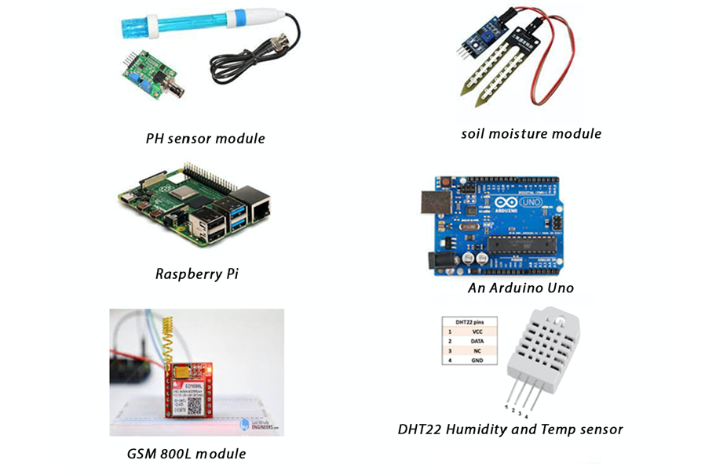

Figure 2: Devices used in this precision agricultural farmland WSN architecture

Figure 2 above shows all the sensors deployed in setting up of the agricultural farmland. The GSM module provides the wireless communications of sensor data (that is from humidity sensor, PH sensor, soil moisture sensor and temperature sensor) from the Arduino uno to the sink (Raspberry pi).

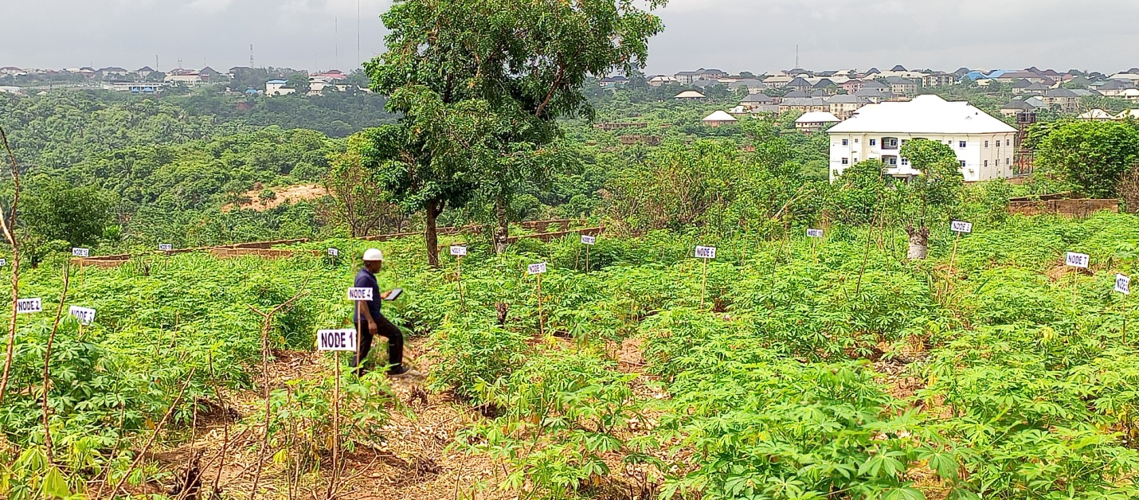

Figure 3: Node deployment on a precision agricultural farmland

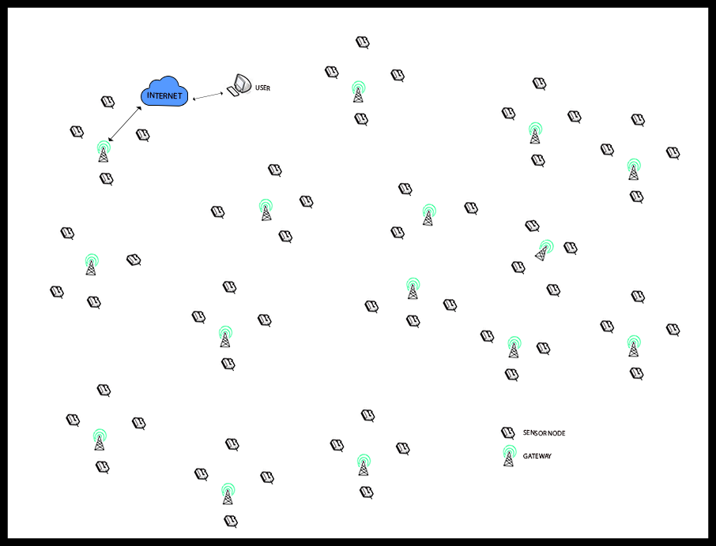Figure 4: WSN architecture model deployed over a farmland for precision agriculture.

After nodes deployment in figure 3, the sensors are static and remain fixed. In order to make proper assessments of the proposed method, it was required to create test environments as close to real-life conditions as possible. The performance of the developed algorithm was considered under diverse scenario. To validate the results obtained, the performance was compared with an already existing design by [3]. Architecture in figure 5 below shows the maximum sensing range of each sensor (Rs)with communication range $R_{c}= {2R}_{s}.$

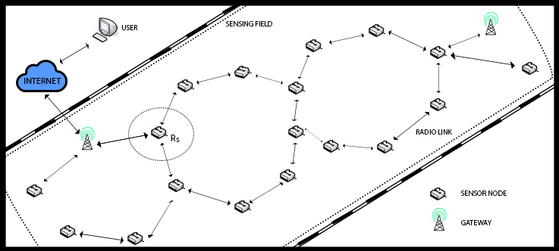Figure5: WSN architecture showing maximum sensing range [11]

Within the developed architecture, nodes are mapped with cycles as illustrated in figure 6 which represents a sequence of nodes $S_{1}, S_{2},…., S_{n}, where S_{i+1}$ is the neighbour of $S_{i}, S_{n}$ is the neighbour of $S_{1}, n ≥3$ and $∀ i ≠j, S_{1} ≠ S_{j}$. As a result, any cycle which does not bear any cycle within its interior is referred to as minimal cycle.

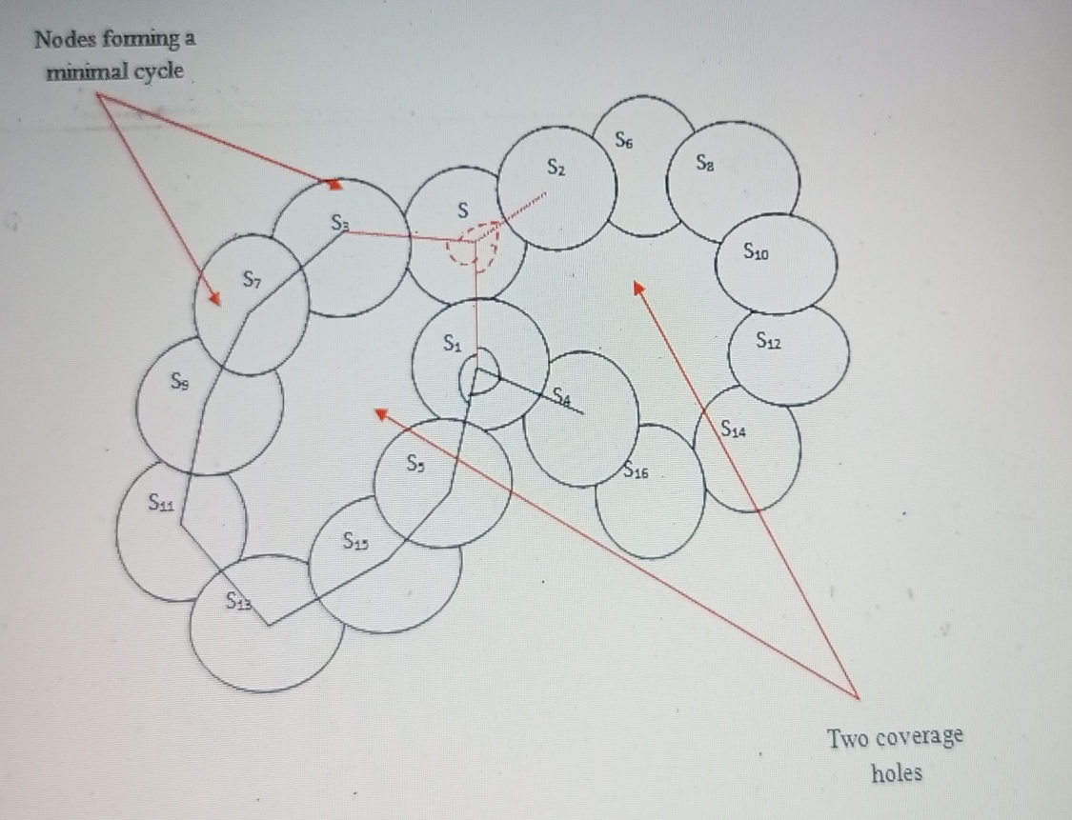

Figure 6: Cycle Illustration and Virtual Hole Angle

An algorithm is developed in this scheme to detect coverage holes in the WSN which may result from improper sensor deployment, obstacles, or energy depleted nodes. Coverage holes are set of points in the WSN that are surrounded by a minimal cycle. These points are not covered by any sensor forming this cycle as illustrated in figure 6. It is vital to note that all angles of minimal cycle are classified to as Virtual Hole Angle (VHA). VHA (angle in red verge) is an oriented angle ( $\hat{S_{1}, S, S_{2}) }$ as illustrated in figure 6. It is formed by two (2) edges ${SS}_{1}$ and ${SS}_{2}$, where $S_{1}$ and $S_{2}$ are two (2) neighbour nodes of node ${S, S}_{1}, and S_{2}$ are not themselves neighbours, and $S$ does not have any other neighbour between $S_{1} and S_{2}$

For detection of coverage hole, it is assumed a minimal cycle have at least a holeless angle taken as $\hat{S_{1}, S, S_{2} }$. This means that the summit $S$ has one neighbour s’, in the middle of its neighbour nodes $S_{1}$ and $S_{2}$. With this, two conditions can be deduced here. Firstly, $S_{1}$ or $S_{2}$ or both are neighbours of s’. It implies that the cycle contains another inner cycle which differs with minimal cycle definition. Second condition is that s’ is connected only to S. Consequently, the sequence of the node would not be regarded as a cycle because node $S$ will appear twice in the sequence. Thus, it is concluded that finding virtual hole angle can equally lead to identifying minimal cycles in the wireless sensor network. In order to prevent ants from loping boundlessly in the same route, ants were assumed to have indicated each visited nodes in the network field. Anytime an ant makes a tour, the intensity of pheromone deposit $τ_{ij}$ on every visited border (ij) is often updated with the formula:

$τ_{ij} \left(t+1\right)= τ_{ij}\left(t\right)+ ε$ (1)

Whenever an ant visits a node, it deposits a measure of pheromone at the node. The additional value of this pheromone is equivalent to $ε$. However, the pheromone on each node dissolves and disappears according to the rate P during every iteration. Due to the fact that ants select nodes with high labels or greater chances, it promotes nodes which are susceptible to form part of minimal cycles.

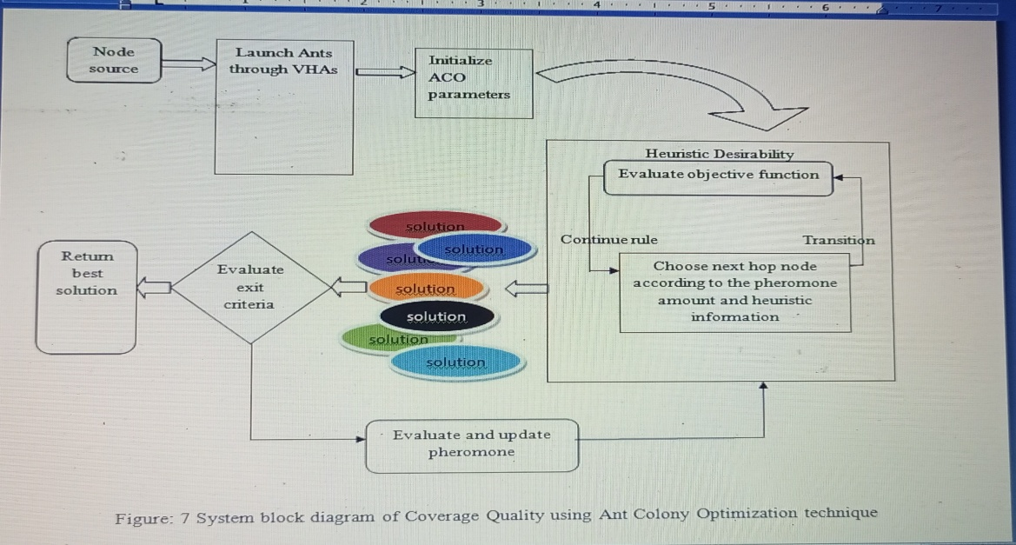

Figure7: System block diagram of coverage Quality using Ant Colony Optimization technique

**IV. SIMULATION, RESULTS AND ANALYSIS**

The communication range (rc) selected for each node in the WSN architecture is 15m. Performance evaluation of the proposed algorithm was done by artificially creating holes in the measured network area using uniform distribution on the sensing region. Boundaries formed by each created hole are taken note of. Both pheromone addition rate (ε) and pheromone evaporation rate (ρ) are adjusted to 0.2 respectively. Other parameters such as ∝, β and θ are generally set to 0.1 respectively. This ensures that pheromone quantities together with heuristic values evenly affect ants’ decision in making choice of the next hop node. The simulation was conducted using the OPNET Network simulator and MATLAB software. Table 1 below summarized the simulation parameters deployed in the research.

Table 1: Simulation Parameters used

|  |  |
| --- | --- |
| **PARAMETERS** | **VALUES** |
| Surface area | 1200m2 |
| Number of sensor Nodes | 120 |
| Adjustable weights (α,β,θ) | 0.1 |
| Pheromone addition/pheromone evaporation rate (ε,ρ) | 0.2 |
| Communication range (rc) | 15m |

**Scenario 1: Accuracy ratio test**

Here, simulations for accuracy ratio test were done to decide the accuracy performance of the developed algorithm. It indicates the ratio of the number of detected holes to the total number of holes in the wireless sensor network. The accuracy ratio result determines the efficacy of the hole detection approach used. The simulation network field was designed to vary the number of holes for each simulation as shown in Table 2, together with the amount of ants deployed to achieve a high accuracy level.

Table2: Simulation results of Accuracy ratio for developed algorithm.

|  |  |  |  |  |
| --- | --- | --- | --- | --- |
|  | Hole Number=2 | Hole Number=4 | Hole Number=6 | Hole Number=8 |
| 10 | 60 | 54 | 42 | 23 |
| 20 | 70 | 78 | 52 | 32 |
| 30 | 90 | 90 | 59 | 56 |
| 40 | 100 | 100 | 74 | 60 |
| 50 | 100 | 100 | 83 | 70 |
| 60 | 100 | 100 | 94 | 83 |
| 70 | 100 | 100 | 100 | 92 |
| 80 | 100 | 100 | 100 | 100 |
| 90 | 100 | 100 | 100 | 100 |
| 100 | 100 | 100 | 100 | 100 |

Figure 8: Simulation results of Accuracy ratio for developed algorithm

From figure 8 above, it was noticed that the accuracy ratio or efficiency of the algorithm increased as the number of ants deployed increased. As can be seen, the ratio is an increasing function of the number of ants and varies from 21% with only 10 ants to 100% with 80 ants for a total number of holes equal to 8. This also shows that as the complexity and irregularity of the WSN increases the more. The algorithm requires more ants to be deployed to increase the accuracy ratio. Comparison was also made with the algorithm developed by [3].

Figure 9: Accuracy ratio for the developed algorithm when compared with Dhouha, 2017.

From the simulation in figure 9, it was noticed that the accuracy ratio or efficiency of the algorithm increased as the number of ants deployed increased. As can be seen, the number of ants needed to achieve 100% accuracy when the number of holes is 8 for the algorithm by [3] is 89, while that required by the developed algorithm in this work is 80. This shows a 10.1% reduction in the number of ants required to detect a hole in the network. As the numbers of holes were increased, it was also observed that the accuracy level of the developed algorithm also increases.

**Scenario2: Iterations function test**

Simulations were done to observe the impact of the iterations to the accuracy ratio of the developed algorithm.

Figure10: Simulation results of Accuracy ratio for developed algorithm as a function of number of iteration.

Figure 10 shows the variation of the hole detection efficiency ratio as a function of the number of iterations for a number of effective holes that varies from 2 to 8 holes. The iteration is regarded as the number of times where each VHA node re-launches a set of ants to perform the proposed algorithm. Hence, as the number of iterations is increasing, the ants will perform additional work (through additional time) to detect holes. As a result additional pheromone quantities are deposited on the nodes experiencing these holes. Therefore, as the number of iterations gets increased, more holes are discovered and efficiency ratio is improved. It is important also to note that efficiency ratio works better with a smaller number of the entire holes. The reason is that the more holes are spread in the network; more time is required to detect all with the same amount of ants.

**V: CONCLUSION**

In wireless sensor networks, coverage quality serves as one of the important evaluations for quality of service provision. This research has established the importance of solving WSNs coverage hole problems in precision agriculture using Ant Colony Optimization (ACO). Firstly, the method deployed was distributive in nature which does not need exchange of neighborhood information and also gave room for adjustment of the number of ants required to detect holes regardless of the network environment. The simulation result is evident that the novel algorithm improved the system coverage performance when compared with other existing methods in terms of accuracy ratio, energy efficiency, reduction in resources demand and transmission range. Reduced number of ants were introduced through the virtual hole angles (VHAs) to accomplish efficient result. The result shows 10.1% reduction in the number of ants required to detect a hole in the network. Ants also travelled through the shortest route which conserved energy and time. As the numbers of holes were increased, it was also observed that the accuracy level of the developed algorithm also increases. Hence, as the number of iterations is increasing, the ants will perform additional work to detect holes.

In summary, as the number of iterations gets increased, more holes were discovered and efficiency ratio improved. This result in turn enhanced crop productivity with low energy consumption to ensure the sustainability of the sensor network.

**REFERENCES**

1. Das, S. and DebBarma, M. K. (2019), “Node position Estimation for Efficient Coverage Hole Detection in Wireless Sensor Network”.Computation Y Sistemas, Vol.23 No.1, 2019, pp.185-195, ISSN 1405-5546. DOI: 10.13053/CYS-23-1-2815
2. Deng, L., Ma, X., Gu, J. and Li, Y. (2018), “Detection and Repair of Coverage Holes in Mobile Sensor Networks using Sub-Voronoi Cells”. International Journal of Robotics and Automation, 33(6).
3. Dhouha, Krichen Cherif (2017), “Embedded and Cooperating Wireless Sensor Networks: Engineering Models and Protection Schemes” Communication Networks and Security Research LAB (CN &S), School of Communication Engineering of Tunis (SUP’Com), University of Carthage, Tunisia.
4. Fahad, A., Nouredine, L. and Mohamed Younis (2016), “Coverage-based Node Placement Optimization in Wireless Sensor Network with Linear Topology. 2016 IEEE International Conference on Communication (ICC), Kuala Lumpur, Malaysia 2016, pp 1-6. DOI: 10.1109/ICC.2016.7511421.
5. Gupta, S.M. and Deshpande, S. (2017). “Detecting Movements and Predicting the Future Path of a Moving Object in Wireless Sensor Networks”. 2017 International Conference on Trends in Electronics and Informatics (ICOEI). DOI:10.1109/ICOEI.2017.8300905.
6. Krichen, D., Abdallah, W. and Boudriga, N. (2017). “An Ant Colony Based Hole Detection in Wireless Sensor Networks” In the Proceeding of the 13th International Wireless Communication and Mobile Computing Conference (IWCMC).DOI: 10.1109/IWCMC.2017.7986558.
7. Linna, W. and Yuanxia, S. (2017), “Distributed Coordinate-free Boundary Nodes Identification in Wireless Sensor Networks”.Q2SWinet’17: Proceedings of the 13th ACM Symposium on QoS and Security for Wireless and Mobile Networks. Pages 97-104. https://doi.org/10.1145/3132114.3132122
8. Lhwani, A., Mosallam, A-A, Alawneh, A., Awad, A. and Othman, O.(2019) “A Low Power Boundary Nodes Detection Algorithm for Wireless Sensor Networks”. Proceedings of the 3rd International Conference on Future Networks and Distributed Systems. Article no.7, pages 1-8, July (2019).
9. Marques, G. and Pitarma (2018), “Agricultural Environment Monitoring System using Wireless Sensor Networks and IOT” 13th Iberian Conference on Information Systems and Technologies (CISTI), Caceres, Spain 2018. Pp 1-6. DOI:10.23919/CISTI.2018.8399320.
10. Onuzulike, V. C., Nwabueze, C. A., Akaneme S.A. and Iloh, J.P (2022), “Enhanced ACO Based Algorithm for Detection of Coverage Holes in Embedded Wireless Sensor Networks”. International Journal of Advances in Engineering and Management (IJAEM). Volume 4, Issue 9 2022. pp. 1257-1266. [www.ijaem.net](http://www.ijaem.net). ISSN: 2395-5252.
11. Onuzulike, V. C., Nwabueze, C. A., Obidike, A. I. and Ebih, U. (2023), “Coverage Hole Detection in Embedded Wireless Sensor Network Using ACO Based Technique: Comparative Architecture”. International Journal of Research in Engineering and Science (IJRES) ISSN (online): 2320-9364, ISSN (print): 2320-9356. [www.ijres.org](http://www.ijres.org) Volume 11 Issue 2, February 2023. pp.239-246.
12. Sapna, Pattanaik, K.K. and Trivedi, A. (2020), “A Dynamic Distributed Boundary Node Detection Algorithm for Management Zone Delineation in Precision Agriculture”. Journal of Networs and Computer Applications Vol.167 2020. https://doi.org/10.1016/j.jnca.2020.102712.
13. Se-Hang Cheong, Kim-Hou Ng and Yain-Whar Si (2022), “An Image Classification approach for Hole Detection in Wireless Sensor Networks”. The Journal of Supercomputing. Vol. 78, pp.8774-8809. https:doi.org/10.1007/s11227-02104276-4.
14. Senouci, M. R. and Mellou, A., (2016), “Deploying Wireless Sensors Networks: Theory and Practice”, ISBN: 978-1-78548-099-7, ISTE Press- Elsevier. DOI: <https://doi.org/10.1016/C2015-0-01311-9>.
15. Shirsat, A. and Bhargava, B. (2011), “Local Geometric Algorithm for Hole Boundary Detection in Sensor Networks”. Security and Communication Networks Vol.4 no.9, pp1003-1012. <https://doi.org/10.1002/sec.271>.
16. Vandana, J., (2018), “History and Architecture of Wireless Sensor Networks for Ubiquitous Computing”. International Journal of Advanced Research in Computer Engineering and Technology (IJARCET), Volume 7, Issue 2, 2018. ISSN: 2278-1323.
17. Yousef, E.M.Hamouda (2024), “Optimally Sensors Nodes Selection for Adaptive Heterogeneous Precision Agriculture using Wireless Sensor Networks Based on Genetic Algorithm and Extended Kalman Filter”. Physical Communication Vol.63. https://doi.org/10.1016/j.phycom.2024.102290.
18. Zhao, L. H., Liu, W. Lei, H., Zhang, R., and Tan, Q. (2016). “Detecting Boundary Nodes and Coverage Holes in Wireless Sensor Networks”. Mobile Information Systems 2016 Article ID8310296 Hindawi Publishing Corporation P.16.