Blockchain-e-Bhoomi integrated Transparent Real Estate Management system[BEBRMS]

Chandrashekar.G , Leelavathi.B , and Dr .M Dakshayini Dept of Computer Network Engineering, BMSCE, Bangalore

1

1 2 3

Chandrashekar.scn22@bmsce.ac.in1,leelavathi.scn22@bmsce.ac.in2

**Abstract.** In India and many other countries throughout the world, real estate management is an extremely ineffective and risky procedure that has been challenged by middlemen. This system is suffering with high mediation charges, third-party dependability, Legal Compliance, lack of ensured authorization, transparency and security. So Real estate system certailnly needs some technology based transparent solution to address these issues. We propose smart contract implemented on the Ethereum blockchain, enhancing transparency, trust and efficiency in property transactions. The work creates a safe environment by allowing customers to have genuene land information from governament website called e-boomi along with selling information. It also provides a platform for required negociation. As all the information and transactions are stored on a distributed blockchain, it make the entire system extremely secure and resistant from middlemen. The user will benefit from a more immersive, user-friendly, and visually appealing contracting procedure. Results proves the trust and transparency of the sytem proposed.

**Keywords:** Real Estate, Block Chain, Smart Contract, Etherum, Land Records.

# INTRODUCTION

Real estate is going through a significant evolution and transformation towards smart cities on a global scale. In previous times, we have relied on reliable third parties to register and transfer real estate and land rights. This model has a number of flaws. Documents are frequently not digitized, difficult to locate, even more difficult to update, and periodically disappear over time.

Blockchain technology is a cutting-edge method of digital record-keeping. By ensuring decentralization, blockchain hopes to lower the risk of record fraud

and corruption. Decentralization refers to the ability to maintain records within a blockchain without a centralized authority. In other words, since everyone maintains the information stored in the blockchain, it is virtually hard to manipulate. Property is also defined as a legal relationship in which the owner has the legal right to own, use, and dispose of a specific thing that forms the object itself. As cities have grown in importance, buying and selling, commonly known as "real estate," has become one of the most important marketplaces in a variety of countries in fact, this market is so important that it serves as an economic indicator for a country.

Another significant difficulty that we confront today is a lack of financial stability and security [1]. Although there are other types of security, this study focuses on the security of purchasing and selling "real estate" because the prevalence of fraud in this sector [2] could take away all or a large portion of the money that an individual accumulates in order to achieve their goal of owning a land . For the same reason, selling or buying a land may be more difficult and expensive than anticipated [3]. This includes the need to pay third parties such as attorneys for the legal aspects on buying land, technicians to evaluate the current condition of the property, and of course a mortgage evaluation to estimate the market value of a property. Many people choose to hire a business or "real estate broker" to provide mediation services in real estate purchasing, selling, or renting transactions, as well as other legal rights and duties [4,5]. Transaction costs and time increase with this type of intermediary, and government bureaucracy exacerbates the problem in many countries.

In the ideal world, everyone would be completely knowledgeable about the property they are buying or selling, including its commercial value and qualities. Furthermore, consumers should be able to view the entire history of the property as issue in real time, from its current point of purchase or sale. This is where the research takes off; By eliminating the need for third parties, brokers, and using smart contracts to make the system extremely safe and fraud resistant, the suggested system can be leveraging a tool like a blockchain, we can reduce or eliminate the complexities connected with buying or selling of real estate land. Block Chain, along with "smart contracts," is a crucial component of today's and tomorrow's cities. To achieve the sale of a land , our research employs decision-making approaches, including Authentication, Confidentiality, Integrity, Availability, Access Control and the non- interference of third parties in the transaction and providing transparency security. So, with evolution in Blockchain after cryptocurrency, the immutable, tamper proof technology started laying its roots in a wide range of applications. Real estate is unpredictable Previously, due to the privacy of land purchase agreements, and now that the technique is clear, other causes can benefit from

Blockchain technology.

Section two provides the related work.Section three provides a methodology used in this work to implement the proposed system.The section four come up with detailed proposed solution of real estate smart contract land record [BEBRMS]. Section five describes the system implementation and the coding process in depth. The results are discussed and evaluated in the sixth section. The final section concludes with future work recommendations.

## RELATED WORK

The utilization of block chain technology to enhance the security and efficiency of real estate smart contract land record [BEBRMS]. has captured significant attention in both academic and industry domains. This literature survey delves into key research studies, projects, and initiatives that explore the application of blockchain in secure real estate management.

Reurink,*J. Econ. Surv* [1] have provided a comprehensive overview of financial fraud blockchain applications, highlighting its fraud approach in.

*Koven, Felix, Siadati,Jakobsson, M.Bertini, E* [2], explores the potential of blockchain and smart contracts to revolutionize the way cities operate and regulate tasks, specifically in the context of property transactions in smart cities.

*Shepard,World* Econ[3]. the paper presents related works regarding blockchains, smart contracts, and real estate, and provides a background regarding the principal elements to their work.

*Ferreira, F.A.F.; Spahr, R.W.; Sunderman, M.A* [4] document explores the potential benefits of using blockchain to improve transparency, reduce fraud, and streamline transactions in the real estate industry.

*Nadel, M.S*.[5] The document also highlights the potential for blockchain to replace outdated paper deeds with digital sources and track changes on a permanent record.

Finally *Omar Cliff Uchani Gutierrez and Guangxia Xu* [6] concludes that with the help of blockchain and smart contracts, property transactions can be made more secure and efficient, leading to potential benefits such as reduced costs, increased transparency, and improved trust.

These studies show how blockchain has the potential to change real estate smart contract land record [BEBRMS].

## MOTIVATION AND OUR CONTRIBUTION.

Need for Blockchain Technology in Blockchain-e-Bhoomi integrated Transparent Real Estate Management system [BEBRMS].

Following an examination of similar studies, we decided that it is vital to design a completely blockchain-enabled real estate management system that addresses the following critical difficulties:

* Reducing third party Intermediaries: Blockchain eliminates the need for intermediaries. This lowers transaction costs and expedites the process.
* Ensuring Transparency and Trust: Blockchain creates a transparent and immutable ledger of property transactions, allowing all parties involved in a real estate transaction, including buyers, sellers, government agencies, and title companies, to access and verify the same set of data, increasing trust and lowering the risk of fraud and disputes.
* Providing Security: The cryptographic features of blockchain make it extremely safe. Blockchain-stored property records are resistant to tampering and unlawful alterations. This improves the accuracy of land records and decreases the possibility of fraudulent property transactions.
* Enhanching Efficiency and Cost Savings: Traditional land record management entails a great deal of paperwork and manual processes, which causes delays and increases expenses. Blockchain-based technologies save paperwork and administrative costs by automating the recording and verification of property transactions. Smart contracts can automate many elements of property deals, enhancing efficiency even further.
* Instant Verification through e-boomi: On a blockchain, property ownership and history can be quickly validated, eliminating the need for time-consuming searches and queries. This is especially useful when purchasing property or performing due diligence.
* Checking Immutable History: The blockchain preserves the historical record of property transfers. This is useful for historical research and establishing property ownership over time.

As a result, to address these real estate management difficulties, we suggest a Blockchain-e-Bhoomi integrated Transparent Real Estate Management system [BEBRMS]. Implement the same utilizing blockchain-enabled tools and technology.

## METHODOLOGY

This paper demonstrates how to use blockchain technology to create safe and transparent real estate smart contract land records.

Real estate smart contract land record is intended to reduce third-party dependence and provide transparency by boosting efficiency and cost savings by tracking property historical records and confirming property data via e- Bhoomi.

Our innovation in real estate smart contract land records involves the verification of the land record through the Government website called e Bhoomi, which means the history of the property will be verified whether he or she is the first or third owner of the property and checks legal compliance on the property. This eliminates the third party intermediary while using blockchain by lowering transaction costs and providing transparency and security.

Our efforts are focused on increasing openness and security in the real estate industry. Real estate smart contract land record address the danger of third- party intermediary by assuring a lower transaction cost and providing efficiency to property buyers.

Furthermore, we prioritize improving the user interface and experience by minimizing transaction time and effort.

These comprehensive initiatives seek to reform and improve the real estate sector for both buyers and sellers.

We applied the following approaches to improve the effectiveness of BEBRMS.

## Blockchain Framework

**Blockchain**

A blockchain is an unowned, time-stamped collection of immutable data records that are controlled by a group of computers. These data units (i.e., blocks) are each encrypted and linked to one another using cryptographic concepts (i.e., chains). It is a decentralized, distributed networking system made up of replicated state machines that take the shape of a data chain, with subsequent data blocks referencing a single ancestor block that is frequently identifiable by its hash.

**Remix:** Remix IDE is a no-setup tool with a GUI for developing smart contracts. Used by experts and beginners alike, Remix will get you going in double time. Remix plays well with other tools, and allows for a simple deployment process to the chain of your choice. Remix is famous for its visual debugger.

**Ethereum:**Using ether as a money for transactions, Ethereum is a framework for building a decentralized network of nodes with transparent transactions.It has two different kinds of accounts

**Ganache:**It is a personal blockchain for Ethereum development. It is used to deploy contracts, develop applications, and run tests. It is available as both a desktop application as well as a command-line tool (formerly known as the TestRPC). Ganache is available for Windows, Mac, and Linux.

**MetaMask:**MetaMask is a popular Ethereum wallet and browser extension that serves as a bridge between your web browser and the Ethereum blockchain. It provides users with a convenient way to manage Ethereum accounts, interact with decentralized applications (DApps), and securely store, send, and receive Ether (ETH) and other Ethereum-based tokens.

**Smart Contract:**A computer program with self-verifying, self-executing, and tamper-resistant features is called a smart contract.

A smart contract can be used in a variety of sectors to automate systems and do away with third-party transactions. A decision that is in the best interest of the group as a whole is developed and supported by the group through the process of consensus decision-making.

## THE PROPOSED BEBRMS SYSTEM

The proposed BEBRMS is formed up of numerous parties who want to access real estate transaction records, such as buyers, sellers, and land records.

Figure 1 depicts the proposed BEBRMS Architecture, including all modules and communication between these models with relevant functionalities.Buyer module

* Buyer module
* Seller module
* Property URL module

## Buyer Module

* Allows users to create an account by providing necessary details like name, contact information, and wallet address for Ethereum transactions.
* Enables buyers to search for properties listed on the platform based on criteria such as location, price range, property type, and features.
* Provides detailed information about each property listing, including descriptions, images, property history, and the current price.
* Allows buyers to view the transaction history of a property, including previous owners and prices, to assess its value.
* Enables buyers to submit offers for properties they are interested in. This module should include the option to attach any necessary documents or notes.
* Allows buyers to manage their Ethereum wallet, including checking balances, viewing transaction history, and topping up their wallet with Ether.
* Facilitates communication between buyers and sellers for price negotiations and other terms of the purchase.
* Provides a user-friendly interface for interacting with the RealEstateContract smart contract. Buyers can execute functions like agreeing to buy a property and updating the URL link.
* Displays a history of all transactions and interactions with the platform, allowing buyers to track their activity.

## Seller Module

* Allows sellers to create an account with the platform by providing personal information and their Ethereum wallet address.
* Enables sellers to create detailed property listings, including descriptions, images, pricing, and the initial URL link.
* Allows sellers to view and edit their existing property listings, adjust property prices, and update the URL link as needed.
* Provides a section for sellers to review and respond to purchase offers from potential buyers, including the ability to accept, counteroffer, or reject offers.
* Offers a user-friendly interface for interacting with the RealEstateContract smart contract. Sellers can update the URL link, adjust property prices, and initiate property sales.
* Facilitates communication with potential buyers for negotiating prices and discussing terms.
* Displays a history of all transactions and interactions related to the properties listed by the seller.
* Allows sellers to manage their Ethereum wallet, view balances, and monitor transaction history.

## Property URL Module

* Property URL Management module is responsible for handling and updating the URL link associated with a property listed on the platform.
* Initial URL Setup When a seller lists a property, this module allows the seller to provide an initial URL link related to the property. This URL link can point to property details, documents, images, or any relevant online resource.
* URL Update Functionality Sellers have the capability to update the URL link associated with their property listing at any time. They can provide a new link to updated property information or documents.
* URL Validation Before accepting and storing a new URL link, this module should include a validation process to ensure that the provided link is a valid URL format.
* Storage and Retrieval The module stores the URL link securely on the blockchain alongside the property details. When a user queries the property details, it retrieves and displays the URL link for access.
* Integration with Smart Contract This module should integrate seamlessly with the real estate smart contract, allowing sellers to update the URL link through the smart contract's functions.
* User-Friendly Interface To enhance user experience, provide an intuitive and user-friendly interface for sellers to manage and update the URL links associated with their property listings.

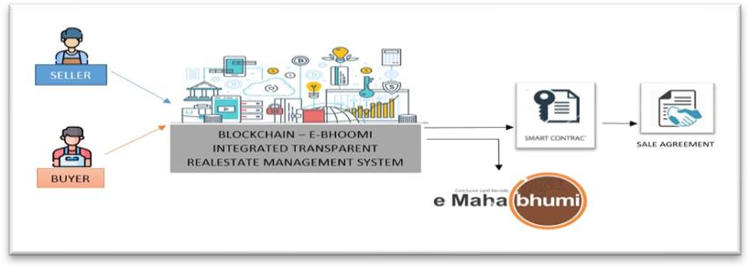

Figure 1: Shows the proposed Architecture of the RSSML

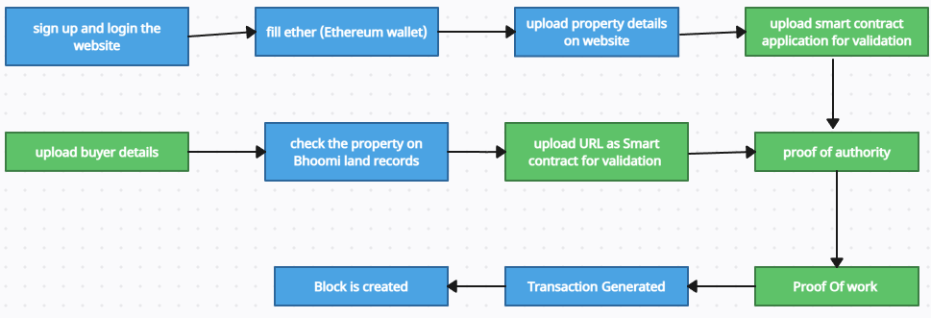

Figure 2: Work flow of RMSMLR

1. **ALGORITHM**

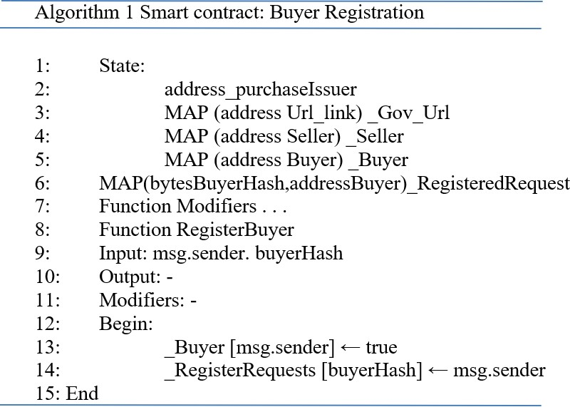

As mentioned in the above algorithm of buyer registration frist buyer need to address the purchase issue to the seller then the url_link of the land that buyer is going to buy. That particular land’s details will be verified by e- boomi land record website after verification of the land the buyer will send the register agreement to the seller.

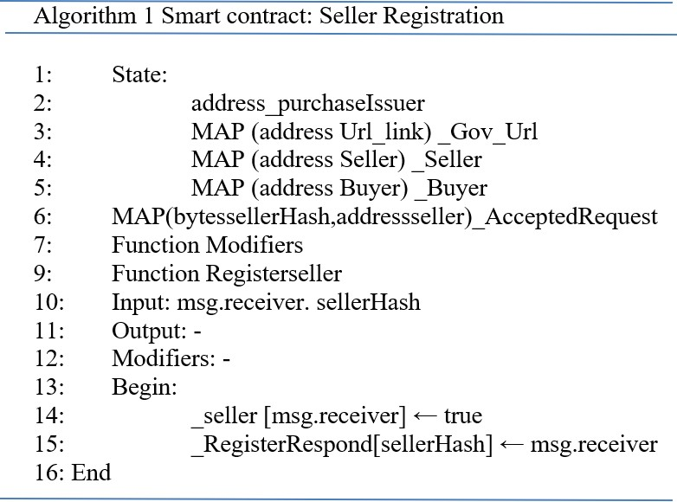

As mentioned the above algoritm of seller registration first seller raises the purchase issuer to the buyer then the purchase of the particular land will be updated the the link .The seller accept the regsitration agreement then the transaction will be held between the buyer and the seller.

# IMPEMENTATION

To execute the suggested blockchain-enabled BEBRMS model, the execution environment is equipped with all of the necessary tools such as Metamask, Remix, and Ganache.Remix IDE and MetaMask were used to create secure, transparent real estate smart contract land record management (BEBRMS) by first generating smart contracts in Solidity with Remix IDE, which is an online Ethereum smart contract development environment. The rules and logic for securely storing transaction records on the blockchain are specified in the contract. After the contracts have been constructed and tested, MetaMask, a cryptocurrency wallet and gateway to blockchain apps, is integrated into the user interface, allowing buyers and sellers to interact with the BEBRMS system through a web-based application.

On the Ethereum blockchain, MetaMask provides authentication and transaction processing, letting users to safely access and alter their property URL and transaction records while ensuring transparency and security.

## SNAPSHOTS & DISCUSSION

The BEBRMS implementation has been tested with the Remix IDE.The function

*property url* was executed as shown Figure 2. As the seller was a legal property

holder and the buyer allowed stakeholders such as the owner of the land and the transaction provider to view his/her property record profile. As a result, it emphasizes the significance of secure property transaction management.

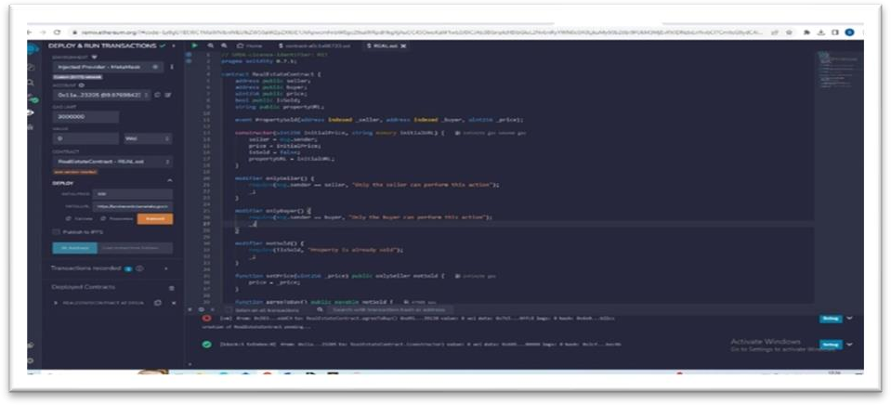

Figure 2 :intial property URL

Figure 3 update URL: After checking the property data via establishing e-Bhoomi, the buyer will learn if the seller is a valid owner or not. If the seller is legitimate, the propertyURL of the land will be updated on this function called update URL.

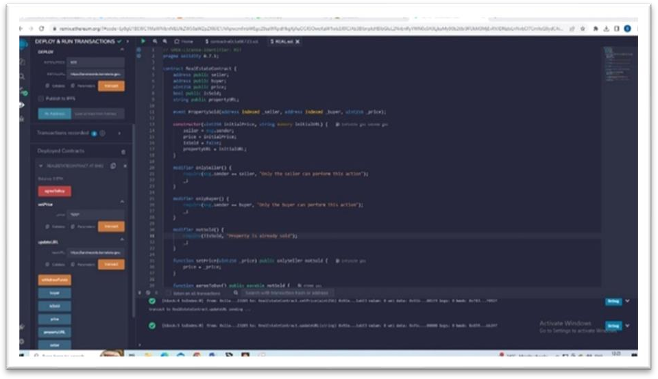

Figure 3 : update URL

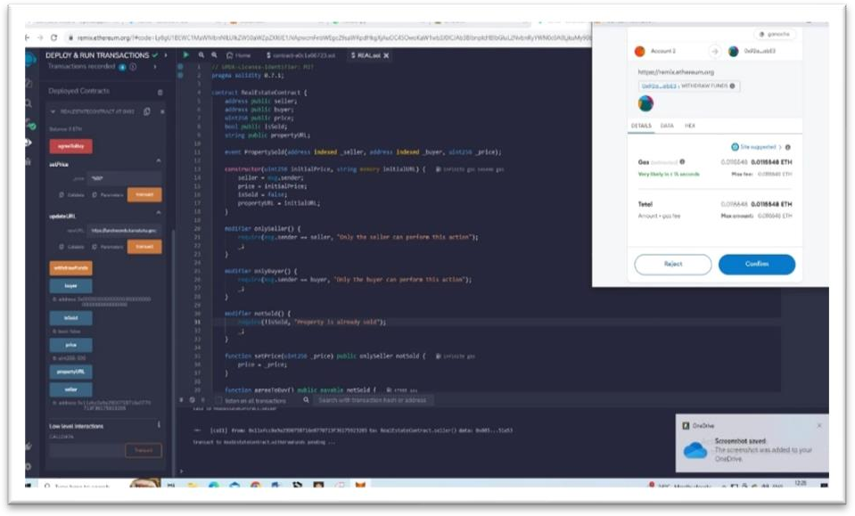

Figure 4: Metamask Transaction1

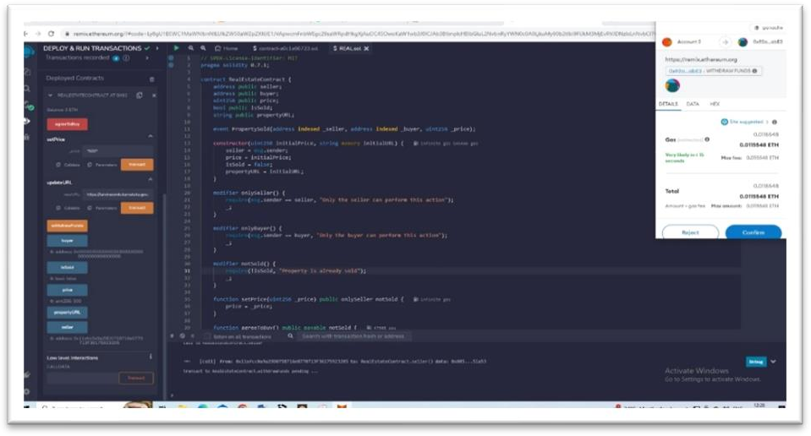

Figure 5: Metamask Transaction2

As shown in Figures 4 and 5, whenever any entity in the RMSMLR block chain attempts to make any type of transaction in order to access any transaction record, a Metamask transaction will appear, requesting the user to confirm or reject the

transaction. After clicking confirm, Metamask will load for 30 seconds to a minute before displaying a confirmation notice informing the user that the property record has been successfully created and stored on the blockchain.

So whenever any entity of BEBRMS tries to access the property records of any land owner , it can verify wheather the land owner(seller) is legitimate owner or not and access only if the concerned property is legitimate. Otherwise that buyer cannot buy the property*.*So our proposed BEBRMS successfuly achieved our objectives of providing the transparency ,security and no middlemen party.

The BEBRMS constructed with all of the mentioned entities has been run several times. The execution results demonstrated that there is no third-party dependability, secure transactions, low cost efficiency, and property verification in the government website known as e-bhoomi. Figure 5 depicts the level of security, tamper resistance, and access provided to the owner's property record data with blockchain deployment.

# CONCLUSION

In summary, the Blockchain-e-Bhoomi intigrated Transparent Real Estate Management system proposed provides a more straightforward platform for managing real estate transactions intigrating Blockchain with e-Bhoomi. It includes a number of crucial functions, such as ownership transfer, URL link storage, and price adjustment for real estate purchase agreements. Prposed work could successfully created a frindly, flexible, transparent and safe environment by allowing customers to access genuene land information from governament website e-boomi along with selling information without the interference of any middle man. It also has saved almost 90% of the cost for moneny for customers. Our proposed model successfuly created the

# REFERENCES

1. Reurink, A. Financial Fraud: A Literature Review. *J. Econ. Surv.* **2018**, *32*, 1292–1325.
2. Koven, J.; Felix, C.; Siadati, H.; Jakobsson, M.; Bertini, E. Lessons Learned Developing a Visual Analytics Solution for Investigative Analysis of Scamming Activities. *IEEE Trans. Vis. Comput. Graph.* **2019**, *25*, 225– 234.
3. Shepard, J. Digital Transactions in Real Estate Marketing. *J. World Econ. Res.* **2020**, *9*, 120–124.
4. Ferreira, F.A.F.; Spahr, R.W.; Sunderman, M.A.; Mark, A. A learning- oriented decision-making process for real estate brokerage service evaluation. *Serv. Bus.* **2017**, *11*, 453–474.
5. Nadel, M.S. Obstacles to Price Competition in the Residential Real Estate Brokerage Market. *Berkeley Bus. Law J.* **2020**, *18*, 1292–1325.
6. Omar Cliff Uchani Gutierrez 1 and Guangxia Xu 2 Blockchain and Smart Contracts to Secure Property Transactions

in Smart Cities 21 dec 2022

1. [https://www.researchgate.net/publication/357049783_The_U](https://www.researchgate.net/publication/357049783_The_Use_of_Blockchain_in_Real_Estate) [se_of_Blockchain_in_Real_Estate](https://www.researchgate.net/publication/357049783_The_Use_of_Blockchain_in_Real_Estate)
2. [https://papers.ssrn.com/sol3/papers.cfm?abstract_id=356549](https://papers.ssrn.com/sol3/papers.cfm?abstract_id=3565497) [7](https://papers.ssrn.com/sol3/papers.cfm?abstract_id=3565497)
3. [https://www.sciencedirect.com/science/article/pii/S02648377](https://www.sciencedirect.com/science/article/pii/S0264837722003611) [22003611](https://www.sciencedirect.com/science/article/pii/S0264837722003611)
4. [https://www.ijraset.com/research-paper/real-estate-land-](https://www.ijraset.com/research-paper/real-estate-land-transaction-system-with-blockchain) [transaction-system-with-blockchain](https://www.ijraset.com/research-paper/real-estate-land-transaction-system-with-blockchain)

11. <https://www.mdpi.com/2076-3417/13/1/66>