**TITLE:**

**“THE ACCURACY OF OPTION PRICING MODEL: A COMPARATIVE ANALYSIS OF BLACK SCHOLES AND MONTE CARLO SIMULATION WITH EMPIRICAL EVIDENCE”**

**AUTHOR:**

Ms. Sanjana

Masters of Business Administration

Sahyadri College of Engineering and Management

Adyar, Mangaluru-575007

Email ID: [sanjana.mba22@sahyadri.edu.in](mailto:sanjana.mba22@sahyadri.edu.in)

**GUIDE:**

Prof. Monisha Shetty

Assistant Professor

Department of Business Administration

Sahyadri College of Engineering and Management

Adyar, Mangaluru-575007

Email ID: [monisha.mba@sahyadri.edu.in](mailto:monisha.mba@sahyadri.edu.in)

**ABSTRACT:**

The Black-Scholes Model (BSM) is compared with the Monte Carlo Simulation (MCS), using Indian Stock Options for this study. This study seeks to assess the efficiency of models in price options across sectors and market capitalizations. We analysed data of 2 companies and across the top-15 industries using Power BI, correlation, regression, and paired-sample t-test. Larger capitalization options, BSM methods in general perform better than MCS when volatility is high. Based upon the assumptions of large-cap stock, BSM seemed more favourable as compared to MCS while in some cases like Tata Communications, with higher predictions. They also suffer from not representing market factors well in the real world. This advisor is statistically tested, which confirms the predictive power of BSM and reveals that options from this market conform significantly to model values. This paper finds BSM as relevant option pricing strategy for the historical dataset used, particularly with large-cap stocks. Nonetheless, additional research is necessary to investigate the MCS behavior under other market scenarios and stock types.

**Keywords:** Option pricing, Black-Scholes Model, Monte Carlo Simulation, Indian stock Market, Market Capitalization, Volatility, Model Comparison.

**INTRODUCTION:**

The concept of options trading has a colourful history that dates to 17 century Holland, when tulips were fashionable. Traders, intoxicated by the wild speculation, started to create contracts for future tulip prices that were so strikingly like modern puts and calls most people have never heard of such things before. Although formal option markets emerged in London during the late 17 century, it was not until economics and mathematics provided a theoretical foundation for the pricing of these contracts that progress was made. Traders were still dependent on intuition, experience and market feeling to assess values of options. Not until the 20th century did major breakthroughs in financial mathematics set the stage for modern option pricing.

To make sound financial decisions, accurately valuing options is vital. Options are contracts giving the buyer the right to buy or sell an asset at a specific price and time, but they do not have to. This paper compares two popular pricing methods: Black-Scholes, which is simple but has limitations, and Monte Carlo, which is more flexible. By analysing both, we aim to determine their effectiveness in real-world option pricing.

**Black Scholes Model:**

The Black-Scholes-Merton (BSM) model is a key tool for valuing options, contracts that give the right, but not the obligation, to buy or sell a security at a specific price. Despite its complexity, BSM remains essential in finance. Investors, traders, and risk managers use it to price options, gauge market sentiment, and create more complex models. BSM is mainly used for European options, exercisable only on the expiration date. It's employed by investors to check option prices, traders for hedging strategies, and banks for creating derivatives. The BSM formula for call options involves multiplying the stock price by a specific probability distribution function.

It is frequently used by:

1) Investors: To check discovery option prices for reasonableness before buying or selling them.

2) Option traders: For creation of hedging and pricing techniques for options.

3) Banks: For creating derivative products and pricing options within their portfolios.

The stock price is multiplied by the cumulative standard normal probability distribution function to get the Black-Scholes call option formula.

Notation used in mathematics for Call Option:

$$C=SN\left(d1\right)-Ke^{-rt}N(d2)$$

Where:

$$d1=\frac{In\left(\frac{S}{K}\right)+\left(r+0.5*σ^{2}\right)t}{σ√t}$$

And,

$$d2=d1-σ√t$$

Where:

*C* = Call option price

*S* = Current stock (or other underlying) price

*K* = Strike price

*r* = Risk-free interest rate

*t* = Time to maturity

*N* = A normal distribution​

e = constant = 2.71828

The BSM formula is a complex calculation that considers several inputs:

Spot Price (S): The present price of the underlying stock.

Strike Price (K): The price at which the holder of this option is eligible to sell (put) or purchase a certain number of shares.

Options Time to Maturity (T): The time remaining for an option to expire.

Risk-free interest rate (r): which is just the return on a no-risk investment, like government bonds.

Volatility(σ): How much the stock swings in price.

BSM’s simplicity and ease of use make it a valuable option pricing tool despite its flaws. While advanced models offer more realistic market conditions, they're often more complex. BSM provides a baseline price to understand factors affecting option value. However, it has limitations, such as being primarily for European options, requiring complex calculations, and making unrealistic assumptions about market conditions.

**Implied Volatility and Monte Carlo Simulation:**

Historically, volatility has been used in option pricing models like Black-Scholes. When we don't know the "true" volatility, Monte Carlo simulation and implied volatility (IV) come into play. IV is the volatility needed to match the market price of an option, reflecting market risk. Monte Carlo simulation is a powerful tool that doesn't need predetermined volatility. It simulates various price paths for the underlying asset. It can handle complex market conditions and helps calibrate models like Black-Scholes to better represent real markets. While Black-Scholes offers a quick and easy pricing method, Monte Carlo's implied volatility provides a more flexible and data-driven approach, leading to a better understanding of option values and risks.

**Stock Market Capitalization:**

The total value of a company's outstanding shares is its market capitalization (market cap). Large-cap stocks are issued by companies with the largest market caps. These are often well-established, financially sound companies, sometimes called "blue chips." They are usually more liquid and easier to trade. Mid-cap stocks fall between small-cap and large-cap. They offer growth potential but can be riskier. Small-cap stocks, issued by the smallest companies, have the most growth potential but are also the riskiest.

**CONCEPTUAL FRAMEWORK:**

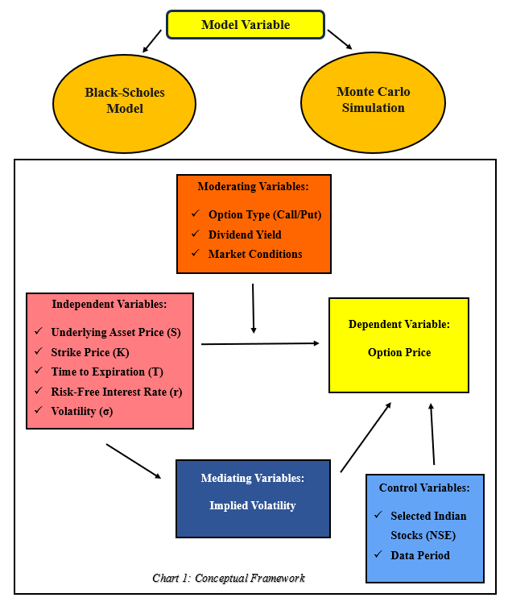

**LITERATURE REVIEW:**

(Shastri, 2020) The study examines the March 2018, 28-day expiry option prices for 30 NSE stocks across 10 industries, with the top 3 by market capitalization. Determines fair value using BSOPM, then uses a paired t-test to compare the outcome with market data. A thorough examination of 30 call options revealed notable differences between 23 options' market values and theoretical (BSOPM) prices. This implies that BSOPM has limitations when it comes to cheap stocks. The constraints of BSOPM may have an impact on other financial instrument and employee stock option valuations. It is advised to use different pricing models for increased accuracy.

(Jankova, 2018) Evaluated if Black-Scholes could value the security by comparing the Garman-Kohlhagen, Merton, and Black-Scholes models. Although it is widely used in option pricing, the Black-Scholes model is predicated on rigid assumptions. The most difficult task is precisely calculating volatility, which is a crucial component of option value. The Black Scholes model has undergone numerous revisions because of this constraint.

(Henri Berestycki, 2004) This study investigates the use of option prices to calculate stochastic volatility, or volatility in inconsistent markets. To estimate the implied volatility, the authors study European options (calls and puts). Based on their research, they developed a new technique that uses partial differential equations (PDEs). The topic of this study is option pricing close to expiration (short maturity). It examines implied volatility's behavior in this situation. Based on implied volatility, the Black-Scholes Model (BSM) is seen to be appropriate for option valuation.

(Muhammad Sheraza, 2013) A Black-Scholes model with GARCH volatility is suggested in this study to overcome the drawbacks of the lognormal assumption. It emphasizes that rather than coming from a perfectly normal distribution, real-world volatility patterns are caused by market inefficiencies. This work enhances stock option pricing by extending the Black-Scholes model to include GARCH, a more accurate volatility metric. Although GARCH considers variations in actual volatility, the model's traditional constant volatility is used. Investors may benefit from a more precise option price as a result.

(Amir Ahmad Dar, 2017) Using 13 years of daily closing data from McDonald's, the study compares the European option pricing Black-Scholes and Binomial models. To see if there were any discrepancies, they examined the models in Excel and computed option prices in MATLAB. We contrasted the Binomial and Black-Scholes models for pricing calls and puts on options. Both produced comparable findings, which MATLAB code further confirmed. This implies that our techniques were precise. Monte Carlo simulation takes market uncertainties into account, which sets it apart from deterministic models and may be useful in determining the applicability of the Black-Scholes Model.

(Monsurat Foluke Salami, 2024) This study uses paired t-tests on hundreds of calls and put options to compare actual stock option prices with estimates from the Black-Scholes Model. This aids in evaluating the accuracy of the model for the Indian market. Although the Black-Scholes model is a widely used method for option price estimation, it is vital to keep in mind that its accuracy is not always guaranteed. Numerous factors, such as supply and demand, interest rates, and economic conditions, might impact the actual market price of an option.

(Li, 2020) In this study, the Monte Carlo simulation of call options is performed using significance sampling, a variance reduction technique. It uses singular perturbation from a pricing equation to approximate the option price. Their technique, when compared to a simple Monte Carlo simulation, dramatically reduces variance. Compared to the Black-Scholes Model, Monte Carlo simulation can handle more complex models with features like fluctuating volatility, which makes it possibly more accurate for pricing call options. Because of this, it is useful for option pricing, particularly when attempting to lessen the effects of volatility variations.

**OBJECTIVES:**

1. To assess the Black-Scholes Model's on the selected Indian Stocks.
2. To evaluate options of selected stocks using Monte Carlo Simulation.
3. To compare the Effectiveness of Black-Scholes vs Monte Carlo Simulation.

**HYPOTHESIS:**

H0: There is no significant difference in the mean option prices calculated by Black-Scholes and Monte Carlo Simulation.

H1: There is a significant difference in the mean option prices calculated by Black-Scholes and Monte Carlo Simulation.

H0: There is no correlation between Black-Scholes predicted option prices and NSE observed option prices.

H2: There is a correlation between Black-Scholes predicted option prices and NSE observed option prices.

H0: The Black-Scholes model has no predictive power over NSE option prices.

H3: The Black-Scholes model has predictive power over NSE option prices.

**NEED OF THE STUDY:**

Despite its popularity, Black-Scholes has limitations, especially in emerging markets like India. Its assumptions of constant volatility and inability to handle American options or dividends can lead to pricing errors. This study compares Black-Scholes to Monte Carlo simulation in India to assess their effectiveness and provide insights for investors and financial institutions.

**SCOPE OF THE STUDY:**

The study compares Black-Scholes and Monte Carlo for option pricing on Indian stocks. Considering factors like price, strike, time, interest rate, and volatility, we evaluate their performance using NSE data from 15 sectors and 2 companies. The goal is to assess the models' strengths and weaknesses in the Indian market to mitigate risks associated with using Black-Scholes.

**RESEARCH METHODOLOGY:**

**a. Data Sample:** 2 Companies across 15 industries.

**b. Data source:** NSE website

**c. Rationale:** Includes Large and Mid-Cap Stocks that are categorised based on Market Capitalization.

**d. Option Pricing Techniques:** Black-Scholes model and Monte Carlo Simulations.

**e. Research tools:** Power BI (used to create visual aids that effectively communicate the simulation outcomes), correlation (significant relation between two variables), regression (significant predictor for option price) and paired-sample t-test (significant difference between the two valuation techniques).

**f. Software:** Power BI, Publish or Perish and VOS Viewer.

**g. Sample:**

Market Capital as on 31/03/2024 as per NSE:

1. Financial Services

* + HDFC Bank – Rs. 109,991,524.33 (in lakhs)
  + Federal Bank Ltd. – Rs. 3,658,946.70 (in lakhs)

2. Information Technology

* + TCS – Rs. 140,247,926.46 (in lakhs)
  + MphasiS Ltd. – Rs. 4,511,861.86 (in lakhs)

3. Capital Goods

* + ABB India Ltd. – Rs. 13,479,173.87 (in lakhs)
  + Polycab India Ltd. – Rs. 7,608,988.43 (in lakhs)

4. Oil, Gas & Consumable Fuels

* + Coal India Ltd. – Rs. 26,752,403.67 (in lakhs)
  + Indraprastha Gas Ltd. – Rs. 3,015,603.45 (in lakhs)

5. Automobile and Auto Components

* + Bajaj Auto – Rs. 25,905,708.85 (in lakhs)
  + MRF Ltd. – Rs. 5,657,148.26 (in lakhs)

6. Fast Moving Consumer Goods

* + ITC Ltd – Rs. 53,464,377.65 (in lakhs)
  + Britannia Industries Ltd. – Rs. 11,829,644.19 (in lakhs)

7. Healthcare

* + Apollo Hospitals Enterprise Ltd. – Rs. 9,140,103.08 (in lakhs)
  + Syngene International Ltd. – Rs. 2,824,356.38 (in lakhs)

8. Metals & Mining

* + Adani Enterprises Ltd. – Rs. 36,446,975.84 (in lakhs)
  + Steel Authority of India Ltd. – Rs. 5,545,230.20 (in lakhs)

9. Chemicals

* + Pidilite Industries Ltd. – Rs. 15,333,045.77 (in lakhs)
  + Tata Chemicals Ltd. – Rs. 2,753,660.61 (in lakhs)

10. Construction

* + Larsen & Toubro Ltd. – Rs. 51,739,685.70 (in lakhs)
  + ACC Ltd. – Rs. 4,679,095.23 (in lakhs)

11. Telecommunication

* + Bharti Airtel Ltd. – Rs. 69,478,399.83 (in lakhs)
  + Tata Communications Ltd. – Rs. 5,729,640 (in lakhs)

12. Services

* + Adani Ports and Special Economic Zone Ltd. – Rs. 28,985,824.43 (in lakhs)
  + Container Corporation of India Ltd. – Rs. 5,374,585.44 (in lakhs)

13. Realty

* + DLF Ltd. – Rs. 22,203,575.87 (in lakhs)
  + Godrej Properties Ltd. – Rs. 6,395,231.94 (in lakhs)

14. Consumer Services

* + Indian Railway Catering and Tourism Corporation Ltd. – Rs. 7,437,600.00 (in lakhs)
  + Aditya Birla Fashion and Retail Ltd. – Rs. 1,950,971.59 (in lakhs)

15. Consumer Durables

* + Havells India Ltd. – Rs. 9,494,247.90 (in lakhs)
  + Voltas Ltd. – Rs. 3,651,478.55 (in lakhs)

**h. Risk Free rate:**

Rf = 6.842 % (as on 30th May 2024)

**i. Time Period:** From 31st May to 27th June 2024

**LIMITATIONS:**

Small-cap stocks on the NSE often lack historical data, making research difficult. This is due to their shorter operating history, limited public interest, and inconsistent data collection. Any study relying on historical data to analyse small-cap stocks is inherently limited.

**DATA ANALYSIS AND INTERPRETATION:**

**Chart 1: Market Capital Distribution of the selected Large and Mid-Cap Stocks**

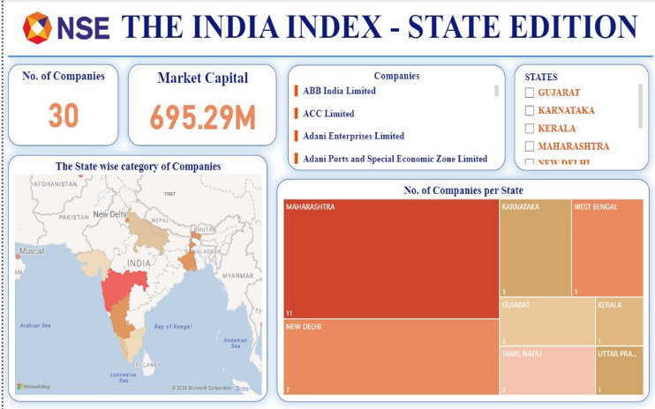

**Analysis:**

This visualization shows the distribution of market capitalization for major and mid-sized Indian companies. Maharashtra is a dominant state, with many companies concentrated there. Other key states include Karnataka and Gujarat. The map reveals uneven economic activity and financial resources across India, providing insights for investors, policymakers, and businesses seeking growth opportunities.

**Chart 2: Large Cap Stocks Leaderboard**



**Analysis:**

Many large-cap companies are in financial services on NSE. Other sectors like FMCG, auto, IT, and real estate have varying representation. Financial services and FMCG have more large-cap companies. Some sectors, like real estate and telecom, have fewer. Adani Group's dominance shows growing conglomerates in India's market.

**Chart 3: Mid Cap Stocks Leaderboard**



**Analysis:**

A detailed analysis of 101 mid-cap companies on NSE shows a diverse range across 19 industries, with financial services being dominant. While some sectors like healthcare and IT are well-represented, others like construction and media are less so. This suggests different growth trends and investment opportunities within mid-cap stocks.

**Comprehensive Table of all 30 Stocks:**

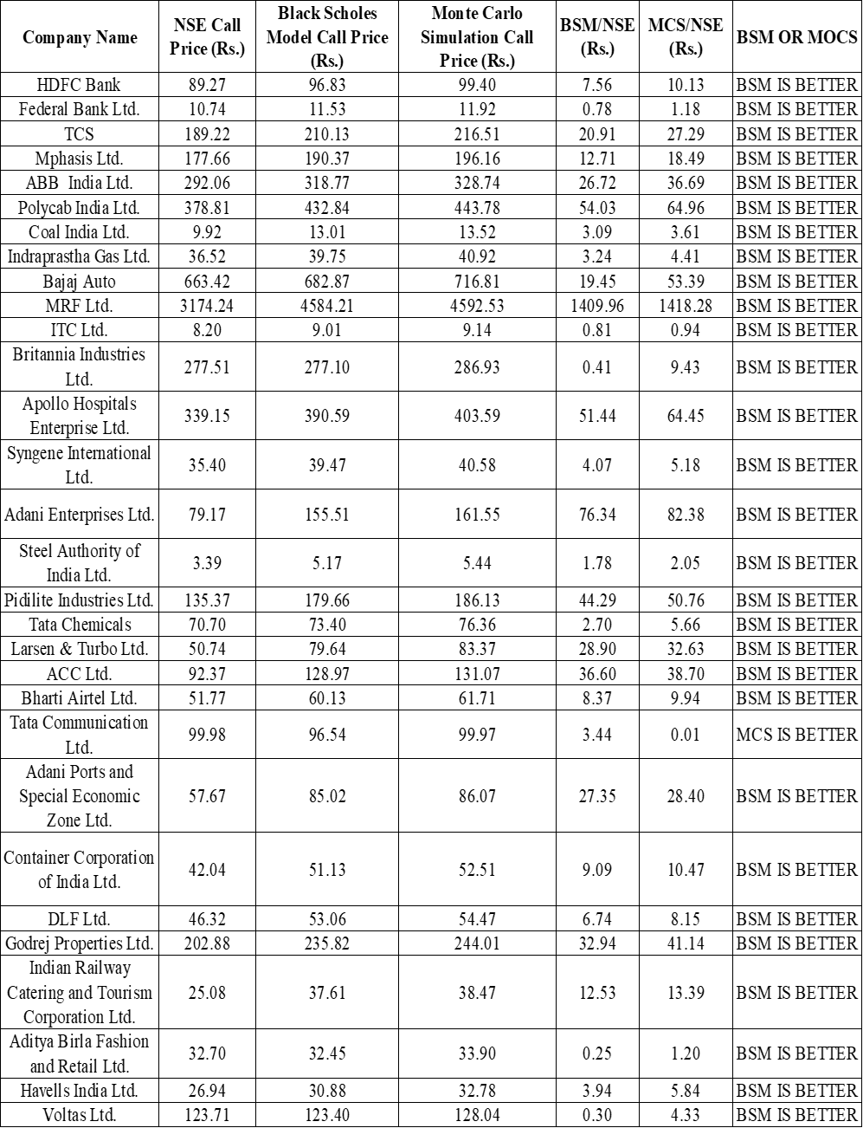

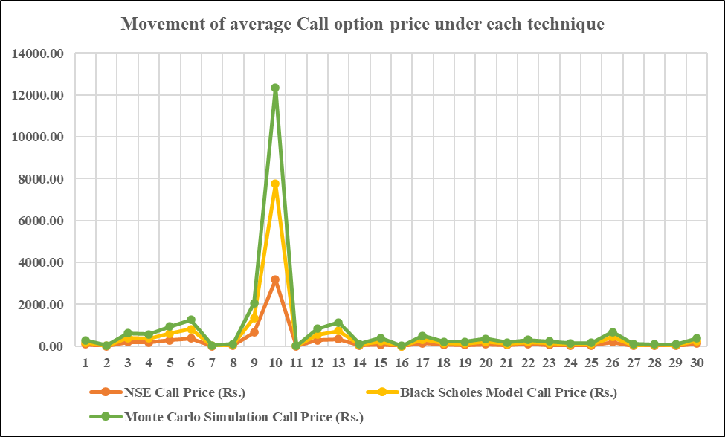

**Analysis:**

This study compares the Black-Scholes Model (BSM) and Monte Carlo Simulation (MCS) against actual NSE call option prices. We found that BSM generally predicts prices more accurately than MCS for most stocks. However, MCS can be better in specific cases, like Tata Communications Ltd. BSM's superiority is likely due to the high volatility of the stocks, which aligns with its assumptions. Therefore, BSM is a suitable option pricing strategy for large and mid-cap stocks.

**T – Test Interpretation:**

|  |  |  |
| --- | --- | --- |
| **Particulars** | **Monte Carlo** | **BSM** |
| Mean | 295.88 | 290.83 |
| Variance | 683630.47 | 680694.25 |
| Observations | 30 | 30 |
| Pearson Correlation | 0.999970862 |  |
| Hypothesized Mean Difference | 0 |  |
| df | 29 |  |
| t Stat | 4.2226 |  |
| P(T<=t) one-tail | 0.0001 |  |
| t Critical one-tail | 1.6991 |  |
| P(T<=t) two-tail | 0.0002 |  |
| t Critical two-tail | 2.0452 |  |

**Hypothesis Statement:**

H0: There is no significant difference in the mean option prices calculated by Black-Scholes and Monte Carlo Simulation.

H1: There is a significant difference in the mean option prices calculated by Black-Scholes and Monte Carlo Simulation.

**Analysis:**

The P value for a one-tailed test = 0.0001 and P value for a two tailed test = 0.002 which is less than 0.05, indicating a very strong statistical significance. This means that we reject H0 and accept H1, that is, there is a significant difference in the mean option prices calculated by Black-Scholes and Monte Carlo Simulation.

The positive t-statistics = 4.2226 suggests that the mean option price from Monte Carlo Simulation is likely higher than the mean price from the Black Scholes Model.

Therefore, Alternative hypothesis is accepted, stating there is a significant difference in the mean option prices calculated by Black Scholes and Monte Carlo Simulation.

**Correlation and Regression Testing for Black Scholes Model in comparison to NSE Call Option Price:**

|  |  |  |  |
| --- | --- | --- | --- |
| **Correlation Testing Results: -** | | | |
| **Particulars** | | **NSE Call Price** | **Black Scholes Model Call Price** |
| NSE Call Price | Pearson Correlation | 1 | 0.997 |
| Sig. (2-tailed) |  | 0.000 |
| N | 30 | 30 |
| Black Scholes Model Call Price | Pearson Correlation | 0.997 | 1 |
| Sig. (2-tailed) | 0.000 |  |
| N | 30 | 30 |

**Hypothesis Statement:**

H0: There is no correlation between Black-Scholes predicted option prices and NSE observed option prices.

H2: There is a correlation between Black-Scholes predicted option prices and NSE observed option prices.

**Analysis:**

The sig. value i.e., p value is 0.000 which is less than 0.05 hence we reject H0 and accept H2, therefore there is a correlation between Black-Scholes predicted option prices and NSE observed option prices.

R value = 0.997;

So, there exists a strong uphill positive correlation.

|  |  |  |  |
| --- | --- | --- | --- |
| **Regression Testing Results: -** | | | |
| **Model** | **Unstandardized Coefficients** | **Standardized Coefficients** | **Sig.** |
| **B** | **Beta** |
| (Constant) | 25.326 |  | 0.004 |
| Black Scholes Model Call Price | 0.695 | 0.997 | 0.000 |

For Large Cap as well as Mid Cap Stocks the Black Scholes Model predicted option prices do correlate with the NSE observed option prices.

**Hypothesis Statement:**

H0: The Black-Scholes model has no predictive power over NSE option prices.

H3: The Black-Scholes model has predictive power over NSE option prices.

**Analysis:**

$y=bx + a$

y (NSE Option Price) = b (Black Scholes Model Option Price) + a

The P value for Black Scholes Model Call price = 0.00, which is less than 0.05, hence we reject H0 and accept H3, the Black-Scholes model has predictive power over NSE option prices.

BSM Call Option Price P < 0.05

**Regression Equation:**

y = 0.695 x + 25.326

Therefore, Beta value = 0.695

For every 1-unit change in Black Scholes Model Call Price will lead to 69.5% change in NSE Option Price.

**FINDINGS:**

* Different regions hold market capitalization, but most is centred around Maharashtra; that close relationship supports its status as a major business and financial centre.
* Significant disparities exist in market capitalization across Indian states.
* Financial services are the largest sector for large-cap stocks. There are also major segments such as FMCGs, Automobiles, and IT that cannot be ignored.
* The prospect of commanding a large market capitalization attracts conglomerates.
* Mid-cap stocks can spread across the industries, but they are concentrated in financial services. Mid-cap stocks in different sectors offer different prospects for growth.
* The Black-Scholes model is often superior to the Monte Carlo simulation in pricing large-cap options.
* The models both have limitations in describing the market in practice.
* Higher volatility generally benefits the Black-Scholes Model.
* Large-cap stocks tend to align better with Black-Scholes Model assumptions.
* The Black-Scholes Model (BSM) generally provides more accurate option price predictions than the Monte Carlo Simulation (MCS) for the studied stocks.
* In certain cases, particularly for Tata Communications, the MCS produced closer predictions to actual NSE prices.
* BSM emerges as a suitable option pricing strategy for both large and mid-cap stocks in the analysed dataset.
* There is a statistically significant difference between the mean option prices calculated by the Black-Scholes and Monte Carlo models.
* The mean option price from the Monte Carlo Simulation is higher than that of the Black-Scholes Model.
* A strong positive correlation exists between Black-Scholes predicted option prices and NSE observed option prices.
* The Black-Scholes Model exhibits predictive power over NSE option prices.
* A one-unit change in the Black-Scholes Model call price leads to a 69.5% change in the NSE option price.

**SUGGESTIONS:**

* Explore the factors contributing to Maharashtra's dominance in market capitalization and investigate the potential for other regions to develop similar financial hubs.
* While financial services are prominent, a more in-depth study of other sectors like FMCG, Automobiles, and IT could reveal unique investment opportunities and risks.
* Conduct further research on the conditions under which the Monte Carlo Simulation might outperform the Black-Scholes Model, especially for mid-cap stocks and less volatile assets.
* Increase the sample size and include a wider range of stocks to strengthen the generalizability of the findings and improve model accuracy.
* Explore how the performance of both models varies under different market conditions (e.g., bull, bear, volatile) to assess their robustness.

**CONCLUSION:**

Analysing market capitalization and option pricing models in India reveals clear patterns. Maharashtra dominates market capitalization, but regional disparities persist. Financial services lead large-cap stocks, while mid-caps have a similar skew. For option pricing, the Black-Scholes Model consistently outperformed Monte Carlo Simulation, especially for volatile large and mid-cap stocks. Statistical analysis supports its accuracy. While BSM is generally superior, market conditions and individual stock characteristics can influence model performance. Further research with a broader dataset and controlled conditions is needed for a more comprehensive understanding.

**REFERENCES:**

1. A.S. Shinde, K. T. (2012). Retrieved from https://www.sciencedirect.com/science/article/pii/S1877705812019480
2. Ahmad Golbabai, O. N. (2019). Retrieved from chrome-extension://efaidnbmnnnibpcajpcglclefindmkaj/https://app.cafeprozhe.com/storage/files/project/ikqG82CUKzeWBW2hoBRe5pQWXLa2hOz56XVgHrMR.pdf
3. Amir Ahmad Dar, N. A. (2017). Retrieved from chrome-extension://efaidnbmnnnibpcajpcglclefindmkaj/https://www.researchgate.net/profile/AmirDar/publication/319643467_Option_Pricing_Using_Monte_Carlo_Simulation/links/5a2e112f0f7e9b63e53d3f64/Option-Pricing-Using-Monte-Carlo-Simulation.pdf
4. Anuradha, A. A. (2018). Retrieved from chrome-extension://efaidnbmnnnibpcajpcglclefindmkaj/https://www.aimspress.com/fileOther/PDF/QFE/QFE-02-01-230.pdf
5. Bill, 9. d. (n.d.). *Investopedia*. Retrieved from • https://www.investopedia.com/ask/answers/040915/how-riskfree-rate-determined-when-calculating-market-risk-premium.asp#:~:text=Since%20T%2Dbills%20are%20paid,form%20of%20zero%2Dcoupon%20bond.
6. Categories, M. C. (n.d.). *Economic Times*. Retrieved from • https://economictimes.indiatimes.com/mf/analysis/mid-smallcap-fund-do-we-need-a-new-category-targeting-both-mid-and-small-ap-stocks/articleshow/110268289.cms?from=mdr
7. Dr. R.Srinivasan, D. L. (2024). Retrieved from https://www.kuey.net/index.php/kuey/article/download/6230/4538
8. Henri Berestycki, J. B. (2004). Retrieved from chrome-extension://efaidnbmnnnibpcajpcglclefindmkaj/https://citeseerx.ist.psu.edu/document?repid=rep1&type=pdf&doi=feea0a57da4dc2ddb0248b7601e8205ea254e157
9. Interest, R. F. (n.d.). *ViewPoint*. Retrieved from • https://viewpoint.pwc.com/dt/us/en/pwc/accounting_guides/stockbased_compensat/stockbased_compensat__3_US/chapter_9_developing_US/95_riskfree_interest_US.html
10. Jankova, Z. (2018). Retrieved from chromeextension://efaidnbmnnnibpcajpcglclefindmkaj/https://ibimapublishing.com/articles/JFSR/2018/179814/179814.pdf
11. Kroese, R. Y. (2008). Retrieved from http://r-studio.ir/Download/Simulation%20_%20The%20Monte%20Carlo%20Method.pdf
12. Krznaric, M. J. (2016). Retrieved from chrome-extension://efaidnbmnnnibpcajpcglclefindmkaj/https://ideaexchange.uakron.edu/cgi/viewcontent.cgi?article=1410&context=honors_research_projects
13. Li, P. L. (2020). Retrieved from chrome-extension://efaidnbmnnnibpcajpcglclefindmkaj/https://otik.uk.zcu.cz/bitstream/11025/36975/1/EM_2_2020_10.pdf
14. Manjunatha, A. K. (2018). Retrieved from https://www.aimsinternational.org/aims16/16ACD/PDF/A-226-Final.pdf
15. Monsurat Foluke Salami. (2024). Retrieved from C:\Users\HP\Downloads\fams-10-1216386.pdf
16. Muhammad Sheraza, V. P. (2013). Retrieved from chrome-extension://efaidnbmnnnibpcajpcglclefindmkaj/https://core.ac.uk/download/pdf/82261152.pdf
17. Rate, G. B. (n.d.). *RBI*. Retrieved from https://www.rbi.org.in/
18. Rate, R. F. (n.d.). *Investopedia*. Retrieved from • https://www.investopedia.com/terms/r/riskfreerate.asp#:~:text=In%20practice%2C%20a%20truly%20risk,as%20their%20risk%2Dfree%20rate.
19. Seda Gulen, C. P. (2019). Retrieved from https://www.mdpi.com/2227-7390/7/8/760/pdf
20. Shastri, A. S. (2020). Retrieved from https://drive.google.com/file/d/1OG79BdYYD2V7xWgMyOmHGZJUr4UaqpFh/view?usp=drive_link
21. Teneng, D. (2011). Retrieved from chrome-extension://efaidnbmnnnibpcajpcglclefindmkaj/https://convention.vse.cz/media/Collection_2011_Volume_01.pdf
22. Vevek, A. M. (2015). Retrieved from http://www.pbr.co.in/2015/2015_month/Sep/12.pdf
23. Volatility, I. (n.d.). *Option Price*. Retrieved from https://www.option-price.com/implied-volatility.php
24. Westerlund, I. M. (2021). Retrieved from chrome-extension://efaidnbmnnnibpcajpcglclefindmkaj/https://gupea.ub.gu.se/bitstream/handle/2077/71238/21%2022%203.pdf?sequence=1&isAllowed=y
25. Yao Elikem Ayekple, C. K. (2018). Retrieved from https://ccsenet.org/journal/index.php/jmr/article/view/0/37663
26. Zetoun, M. (2013). Retrieved from C:\Users\HP\Downloads\DOC-20240509-WA0007_