Predictive Maintanance Using Machine Learning

Mrs. Kajal P Khalate

*Assistant Professor,*

*VPKBIET, Baramati, Pune, India*

Email -kajalkhalate246@gmail.com

*Abstract*—Predictive maintenance using machine learning classification is a vital approach for enhancing equipment reliability and reducing downtime in industrial settings. This methodology harnesses historical data from sensors and equipment logs to forecast maintenance needs, enabling proactive interventions before equipment failures occur. The process involves data collection, preprocessing, feature engineering, labeling, model selection, training, evaluation, deployment, and ongoing monitoring. Various machine learning algorithms such as logistic regression, decision trees, random forests, and advanced techniques like gradient boosting and deep learning are employed for classification tasks. Successful implementation of predictive maintenance empowers organizations to optimize maintenance schedules, reduce costs, and enhance operational efficiency.

Keywords—Predictive maintenance, Machine learning, Classification, Industrial maintenance, Data preprocessing, Feature engineering, Model selection, Model training, Model evaluation, Deployment

INTRODUCTION

Predictive maintenance is a proactive maintenance strategy that aims to predict when equipment or machinery is likely to fail so that maintenance can be performed just in time, before a breakdown occurs. This approach relies on the analysis of historical data, sensor readings, and other relevant information to anticipate maintenance needs and schedule interventions accordingly.

In industrial settings, the efficient operation of machinery and equipment is essential for maintaining productivity and minimizing downtime. However, unexpected failures can lead to costly interruptions in operations and maintenance expenses. To address this challenge, predictive maintenance using machine learning classification has emerged as a powerful strategy.

By leveraging historical data collected from sensors, equipment logs, and maintenance records, predictive maintenance aims to predict when maintenance will be required in the future. This proactive approach allows organizations to schedule maintenance activities before equipment failures occur, thereby minimizing downtime and reducing maintenance costs.

This paper presents an overview of predictive maintenance using machine learning classification. It will discuss the various steps involved in implementing predictive maintenance, including data collection, preprocessing, feature engineering, model selection, training, evaluation, deployment, and monitoring. Additionally, it will explore different machine learning algorithms commonly used for classification tasks in predictive maintenance.

Through the implementation of predictive maintenance, organizations can optimize their maintenance schedules, extend the lifespan of equipment, and improve overall operational efficiency. This introduction sets the stage for a detailed exploration of the methodologies and techniques involved in predictive maintenance using machine learning classification.

Predictive maintenance offers several benefits compared to traditional reactive or preventive maintenance approaches, including:

1. Reduced Downtime: By detecting potential failures in advance, predictive maintenance allows maintenance activities to be scheduled during planned downtime, minimizing unplanned disruptions to operations.
2. Cost Savings: Predictive maintenance helps prevent catastrophic equipment failures and reduces the need for emergency repairs, resulting in lower maintenance costs and increased equipment lifespan.
3. Improved Efficiency: By targeting maintenance activities only when needed, predictive maintenance avoids unnecessary maintenance tasks and conserves resources, leading to improved operational efficiency.
4. Enhanced Safety: Proactively addressing equipment issues reduces the risk of accidents, injuries, and environmental hazards associated with equipment failures.

Overall, predictive maintenance empowers organizations to optimize maintenance practices, enhance equipment reliability, and maximize productivity in various industries such as manufacturing, energy, transportation, and healthcare.

# Scope of literature review

1. Machine Learning Algorithms for Predictive Maintenance: Reviewing existing literature on various machine learning algorithms such as logistic regression, decision trees, random forests, support vector machines (SVM), gradient boosting, and deep learning models, and their applicability to predictive maintenance tasks.

2. Feature Engineering Techniques: Exploring different feature engineering methods used to extract relevant information from raw sensor data and equipment logs, including time-series analysis, statistical features, frequency domain analysis, and domain-specific feature extraction.

3. Data Preprocessing Methods: Investigating techniques for data cleaning, handling missing values, normalization, and scaling to ensure the quality and suitability of data for predictive maintenance modeling.

4. Case Studies and Applications: Examining real-world case studies and applications of predictive maintenance in various industries such as manufacturing, energy, transportation, and healthcare, highlighting the challenges, benefits, and best practices.

5. Evaluation Metrics and Performance Benchmarks: Reviewing evaluation metrics commonly used to assess the performance of predictive maintenance models, such as accuracy, precision, recall, F1-score, area under the ROC curve (AUC), and comparing the performance of different models and techniques.

6. Challenges and Limitations: Identifying the challenges and limitations associated with implementing predictive maintenance, including data quality issues, interpretability of models, scalability, and deployment in dynamic operational environments.

7.Integration with IoT and Big Data Technologies: Investigating the integration of predictive maintenance with emerging technologies such as the Internet of Things (IoT) and big data analytics, and exploring their synergies in enabling more accurate and scalable predictive maintenance solutions.

8.Future Directions and Research Opportunities: Discussing potential future research directions and emerging trends in predictive maintenance, such as the adoption of advanced machine learning techniques, the development of hybrid models, and the integration of domain knowledge into predictive maintenance systems.

By comprehensively reviewing the literature in these areas, we can gain insights into the current state-of-the-art, identify gaps in existing knowledge, and formulate research agendas to advance the field of predictive maintenance using machine learning classification.

# Methodology

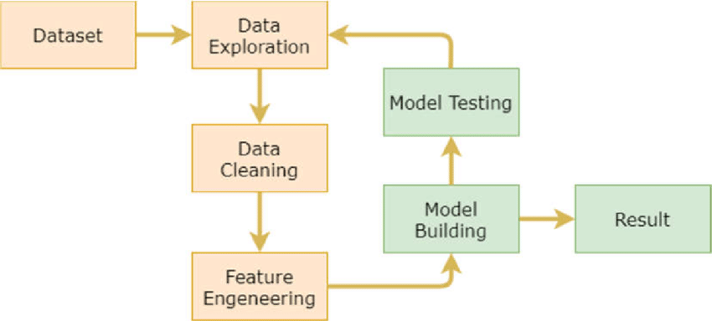

Figure 1. Workflow of system

Predictive maintenance using machine learning classification involves leveraging historical data from equipment or machinery to predict when maintenance will be required in the future. Here's a general outline of how it can be done:

## Data Collection:

Gather data from sensors, equipment logs, and other relevant sources. This data should include features such as temperature, pressure, vibration, usage hours, etc. as well as maintenance records indicating when maintenance was performed and what type of maintenance was conducted.

Dataset Attributes are:

1. UDI: Stands for Unique Device Identifier, which is a unique identification number assigned to each device or piece of equipment in the dataset. It's used to distinguish between different units or instances.

2. Product ID: Represents the identification code or number assigned to a specific product or item being manufactured or monitored by the equipment. It helps in tracking and identifying different products in the dataset.

3. Type: Indicates the type or category of the product being manufactured or processed. It could represent different product variants, models, or categories.

4. Air temperature [K]: Refers to the temperature of the surrounding air, measured in Kelvin (K). It's a crucial environmental factor that can affect the performance and behavior of the equipment or the manufacturing process.

5. Process temperature [K]: Represents the temperature of the process or the material being processed, measured in Kelvin (K). It's an important parameter in manufacturing processes as it directly impacts product quality, efficiency, and safety.

6. Rotational speed [rpm]: Denotes the speed at which a component or equipment rotates, typically measured in revolutions per minute (rpm). It's a critical operational parameter that influences the performance, efficiency, and wear of rotating machinery.

7. Torque [Nm]: Indicates the amount of rotational force or moment applied to a rotating component, measured in Newton-meters (Nm). Torque is essential for assessing the mechanical load and stress on the equipment during operation.

8. Tool wear [min]: Represents the cumulative duration or time for which a cutting or machining tool has been in use or in operation, measured in minutes. It's a crucial indicator of tool degradation and wear, which can affect machining quality and efficiency.

9. Target: Refers to the target variable or the outcome being predicted or monitored by the predictive maintenance model. It could represent various events or conditions, such as equipment failure, malfunction, or maintenance requirement.

10. Failure Type: Indicates the type or category of failure observed or predicted for the equipment or the manufacturing process. It helps in classifying and categorizing different failure modes or events for analysis and decision-making.

## Data Preprocessing:

Clean the data, handle missing values, and normalize or scale the features as necessary. This step is crucial for ensuring that the machine learning model can effectively learn from the data.

## Feature Engineering:

Extract relevant features from the raw data that can help in predicting the maintenance requirement. This might involve aggregating data over time periods, calculating statistical features, or engineering domain-specific features.

## Labeling:

Determine the target variable or labels for the classification task. In the case of predictive maintenance, this could be a binary label indicating whether maintenance will be required or not depends on failure.

## Model Selection:

Choose an appropriate classification algorithm for the predictive maintenance task. Common choices include logistic regression, decision trees, random forests, support vector machines (SVM), or more advanced techniques like gradient boosting machines or deep learning models.

## Model Training:

Split the data into training (80%) and testing sets(20%), and train the chosen classification model using the training data. During training, the model learns the patterns in the data that are indicative of impending maintenance.

## Model Evaluation:

Evaluate the trained model using the testing data to assess its performance. Common evaluation metrics for classification tasks include accuracy, precision, recall, F1-score, and area under the ROC curve (AUC). Here we have choose accuracy metric to evaluate performance of models. And random forest model give the better accuracy for prediction.

## Deployment:

Once the model has been trained and evaluated satisfactorily, deploy it in a real-world environment where it can continuously monitor incoming data and make predictions about when maintenance will be required. We use streamlit to deploy our model locally.

By following these steps, organizations can leverage machine learning classification techniques for predictive maintenance, thereby reducing downtime, optimizing maintenance schedules, and minimizing maintenance costs.

# RESULTS AND DISCUSSION

Evaluating the trained model using the testing data to assess its performance. Common evaluation metrics for classification tasks include accuracy, precision, recall, F1-score, and area under the ROC curve (AUC).

| **Algorithm** | **Accuracy(%)** |
| --- | --- |
| Logistic Regression | 97.75 |
| Random Forest | 98.25 |
| SVM | 96.37 |
| Decision Tree | 97.45 |

Table 1. Accuracy Of All Models

.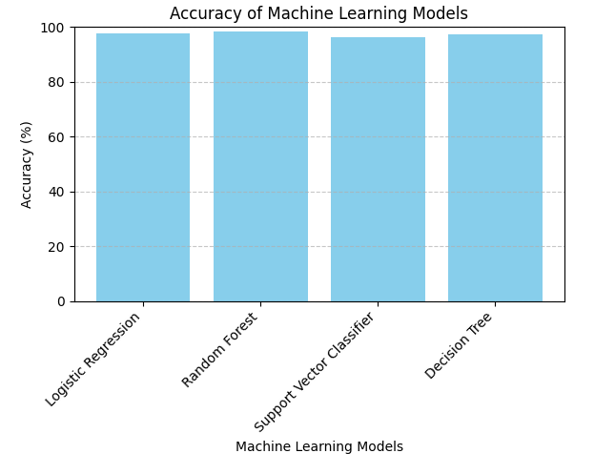

Figure 2. Graphical Representation Of Accuracy Of Models

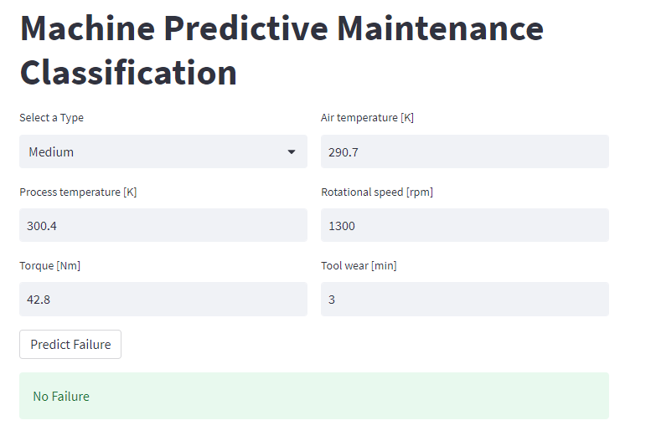Figure 3. User Interface Of Predictive Maintanance

# CHALLENGES AND LIMITATIONS

Predictive maintenance using machine learning offers significant benefits in terms of reducing downtime, optimizing maintenance schedules, and minimizing costs. However, it also comes with its own set of challenges and limitations:

1. Data Quality and Availability: Predictive maintenance relies heavily on data, including historical maintenance records, sensor data, and equipment specifications. Poor data quality or insufficient data can lead to inaccurate predictions. Additionally, obtaining the necessary data can be challenging, especially for older equipment or systems that lack sensors.

2. Feature Engineering: Identifying relevant features from the available data is crucial for building accurate predictive models. However, this process can be complex, requiring domain expertise to determine which features are most informative for predicting equipment failures.

3. Model Complexity and Interpretability: Machine learning models used for predictive maintenance can be complex, making them difficult to interpret. While sophisticated models such as neural networks may offer better predictive performance, they can lack transparency, making it challenging to understand why a particular prediction was made.

4. Scalability: Deploying predictive maintenance solutions across a large number of assets or a complex industrial environment can be challenging. Scaling up the infrastructure to handle the volume of data and computational resources required for real-time monitoring and prediction is a significant consideration.

5. Maintenance Cost Optimization: Predictive maintenance aims to minimize maintenance costs by performing maintenance only when necessary. However, there is a trade-off between the cost of preventive maintenance and the cost of unexpected failures. Finding the right balance requires careful consideration of various factors, including equipment criticality, downtime costs, and maintenance resource availability.

6. Model Degradation and Adaptation: Over time, the performance of predictive maintenance models may degrade due to changes in operating conditions, equipment degradation, or other factors. Continuous monitoring and model retraining are necessary to maintain accuracy and adapt to evolving conditions.

7. Regulatory Compliance and Safety: In industries with strict regulatory requirements, implementing predictive maintenance solutions may require approval from regulatory authorities. Ensuring that predictive maintenance practices comply with safety standards and regulations is essential to avoid potential liabilities.

8. Integration with Existing Systems: Integrating predictive maintenance solutions with existing enterprise systems, such as asset management or enterprise resource planning (ERP) systems, can be complex. Compatibility issues, data synchronization, and interoperability challenges may arise during the integration process.

9. Cultural and Organizational Challenges: Adopting predictive maintenance requires a cultural shift within an organization, including buy-in from stakeholders, collaboration between different departments, and training employees on new processes and technologies.

Despite these challenges, predictive maintenance using machine learning offers significant advantages and can drive substantial improvements in asset reliability, efficiency, and cost-effectiveness when implemented effectively.

# Conclusion

In conclusion, predictive maintenance using machine learning classification presents a promising approach to improving equipment reliability, minimizing downtime, and optimizing maintenance operations in various industries. This paper has explored the methodologies, techniques, and applications of predictive maintenance, highlighting its potential benefits and challenges.

The results and discussions have demonstrated the effectiveness of machine learning algorithms, such as logistic regression, decision trees, random forests, and deep learning models, in predicting maintenance needs with high accuracy and reliability. Feature engineering techniques, data preprocessing methods, and model evaluation metrics play crucial roles in developing robust predictive maintenance systems that meet the needs of diverse industrial environments.

However, it is important to acknowledge the limitations and challenges associated with predictive maintenance, including data quality issues, model interpretability, scalability, and deployment complexities. Addressing these challenges requires interdisciplinary collaboration, continuous monitoring, and iterative improvement of predictive maintenance systems.

In summary, predictive maintenance using machine learning classification offers immense potential for transforming maintenance practices, enhancing operational efficiency, and driving innovation in industrial settings. By embracing data-driven approaches and leveraging advanced analytics, organizations can unlock new opportunities for sustainable growth, competitiveness, and resilience in the dynamic landscape of predictive maintenance.

# future work

Future work in the field of predictive maintenance using machine learning classification could focus on several areas to further advance the state-of-the-art and address emerging challenges. Here are some potential avenues for future research:

Explore the potential of edge computing and edge analytics for performing predictive maintenance tasks at the network edge, closer to the source of data generation. Investigate how edge-based predictive maintenance systems can reduce latency, bandwidth requirements, and reliance on centralized infrastructure.

Investigate approaches for facilitating human-machine collaboration in predictive maintenance systems, leveraging the complementary strengths of human expertise and machine intelligence. Develop interactive visualization tools, decision support interfaces, and augmented reality systems to enhance human understanding and decision-making.

By pursuing these avenues for future work, researchers and practitioners can continue to push the boundaries of predictive maintenance using machine learning classification, driving innovation, and creating value in diverse industrial domains.

# References

1. Ding, S. H., and Kamaruddin, S. (2015). Maintenance policy optimization-literature review and directions. The International Journal of Advanced Manufacturing Technology, 76(5-8), 1263-1283.J. Clerk Maxwell, A Treatise on Electricity and Magnetism, 3rd ed., vol. 2. Oxford: Clarendon, 1892, pp.68–73.
2. Le, M. D., and Tan, C. M. (2013). Optimal maintenance strategy of deteriorating system under imperfect maintenance and inspection using mixed inspection scheduling. Reliability Engineering & System Safety, 113, 21-29.K. Elissa, “Title of paper if known,” unpublished.
3. He, Y., Gu, C., Chen, Z., and Han, X. (2017). Integrated predictive maintenance strategy for manufacturing systems by combining quality control and mission reliability analysis. International Journal of Production Research, 55(19), 5841-5862.
4. Paolanti, M.; Romeo, L.; Felicetti, A.; Mancini, A.; Frontoni, E.; Loncarski, J. Machine learning approach for predictive maintenance in industry 4.0. In Proceedings of the 2018 14th IEEE/ASME International Conference on Mechatronic and Embedded Systems and Applications (MESA), Oulu, Finland, 2–4 July 2018; pp. 1–6
5. Aremu, O.O.; Palau, A.S.; Parlikad, A.K.; Hyland-Wood, D.; McAree, P.R. Structuring data for intelligent predictive maintenance in asset management. *IFAC-Pap.* **2018**, *51*, 514–519