**Deep Learning-Based Prediction of Leaf Diseases**

***Mrs. Kajal Khalate1***

*Assistance Professor, VPKBIET Baramati, Pune, India1*

**ABSTRACT**:

This research addresses the challenge of leaf diseases in plants, which significantly affect global agriculture by reducing crop yield, quality, and food security. The study introduces an innovative method that integrates Convolutional Neural Networks (CNNs) for predicting leaf diseases with recommendations for preventative practices and fertilizer application. A diverse dataset of images, featuring both healthy and diseased leaves, is collected and processed for analysis using a custom-designed CNN model. This model is trained to accurately identify and predict leaf diseases. Additionally, the study offers recommendations for disease prevention, including cultural practices, biological controls, and chemical treatments, tailored to specific diseases and environmental conditions. The research also provides customized fertilizer strategies aimed at enhancing plant immunity and resilience against diseases. Experimental results show the CNN model's effectiveness in disease prediction, while the combined approach of preventative measures and tailored fertilizer use is intended to lower the incidence and severity of diseases. This comprehensive approach supports sustainable agriculture by providing farmers with tools for proactive disease management and promoting resilient crop production systems.

**Keywords:** Deep Learning, Convolutional neural Network, Accuracy

# I. INTRODUCTION

Leaf diseases pose a significant challenge in agriculture, negatively impacting crop productivity, quality, and global food security. As these diseases become more widespread and complex, the demand for effective and timely management strategies to minimize their effects is growing. Traditional approaches to disease identification and control often depend on manual inspection and reactive responses, which can be time-consuming, expensive, and inadequate for addressing new and emerging threats.

In recent years, the adoption of advanced technologies, especially in the fields of machine learning and computer vision, has transformed the way agricultural disease management is conducted. Convolutional Neural Networks (CNNs), in particular, have proven to be powerful tools for automating image analysis and classification. By utilizing large datasets of labeled images, CNNs can identify complex patterns and features, enabling precise and efficient detection of leaf diseases from visual data.

This paper introduces an innovative method for predicting leaf diseases by leveraging CNNs, alongside recommendations for preventative practices and fertilizer application. The main goal is to create an integrated framework that not only detects diseased plants but also offers proactive strategies to prevent the spread of disease and improve plant health. By combining predictive modeling with preventative measures and specific fertilization techniques, this approach seeks to provide farmers with actionable insights for sustainable disease management and enhanced crop production.

The structure of this paper is as follows: Section 2 reviews the current challenges and limitations in managing leaf diseases, emphasizing the need for new solutions. Section 3 outlines the methodology, including data collection, preprocessing, the CNN model architecture, and training procedures. Section 4 discusses preventative strategies, including cultural practices, biological controls, and chemical treatments, along with customized fertilizer recommendations to boost plant immunity. Section 5 presents experimental results that demonstrate the effectiveness of this integrated approach in predicting leaf diseases and reducing their impact. Finally, Section 6 concludes the paper and suggests future research directions in automated disease management and sustainable agriculture.

By integrating advanced technology with practical agricultural solutions, this interdisciplinary approach aims to strengthen farming systems and enhance global food security in the face of evolving disease challenges.

**Plant Disease Identification and Classification**

Computer vision, a branch of artificial intelligence (AI), allows machines to mimic the human visual system, enabling them to accurately extract, analyze, and recognize real-world images just as humans do. Machine learning (ML) techniques have been applied to detect and classify plant diseases, but with advancements in deep learning (DL), a subset of ML, this field of research shows significant promise in improving accuracy. Various deep learning architectures, combined with visualization techniques, have been used to detect and classify plant disease symptoms effectively. The benefits of computer vision-based technologies have already been demonstrated in rapidly growing fields such as medical diagnosis, surveillance, satellite imagery, and agriculture. In agriculture, computer vision-enabled systems can detect and classify plant diseases based on different features or symptoms that are extracted through a series of well-defined steps. These steps include image acquisition, followed by image processing tasks such as scaling, filtering, segmentation, feature extraction, and selection, culminating in the detection and classification of diseases using ML or DL techniques.

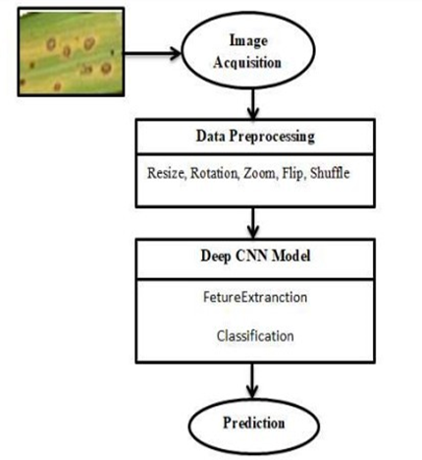

**Figure 1: Current Leaf Disease prediction Scenario**

**Factors Contributing to Plant Diseases**

Plant diseases can emerge at different stages of plant growth, potentially disrupting development and negatively affecting overall crop production. These diseases result from various factors that can be classified into two main categories: biotic and abiotic factors.

Biotic factors include organisms such as viruses, fungi, bacteria, mites, and slugs, which cause diseases through microbial infections in plants. On the other hand, abiotic factors refer to non-living elements like water availability, temperature fluctuations, radiation, and nutrient deficiencies, which can also impede plant growth.

This study includes images of plant leaves, both healthy and diseased, sourced from the Plant Village dataset and other datasets. These images illustrate the variety of diseases affecting plants, as detailed in previous research studies. Furthermore, the study outlines the computer vision-based techniques and processes used for detecting and classifying plant diseases. These processes encompass field crop analysis, image acquisition, the use of leaf image datasets, image preprocessing (including test, training, and validation sets), data splitting, and performance evaluation methods.

# 

# II. LITERATURE REVIEW

A literature review on the use of Convolutional Neural Networks (CNNs) for leaf disease prediction, combined with preventative measures and fertilizer strategies, would cover a wide array of studies across the fields of machine learning in agriculture, plant pathology, and agronomy. Here’s a summarized look at the existing research:

1. Machine Learning in Agriculture: Numerous studies have investigated the application of machine learning techniques, including CNNs, across various agricultural areas like crop yield forecasting, weed identification, and disease diagnosis. CNNs are particularly favored for their ability to effectively analyze visual data, making them highly suitable for tasks such as detecting plant diseases from images. Key research has shown that CNNs can accurately classify leaf diseases in different plant species under varying environmental conditions.

2. Leaf Disease Detection with CNNs: Research has concentrated on developing CNN-based models for the detection and classification of leaf diseases using image datasets. These studies typically involve compiling large datasets of images featuring both healthy and diseased leaves from various crop types. Custom CNN architectures are designed to extract pertinent features from these images, enabling precise disease prediction.

3. Preventative Measures and Fertilizer Use: Agronomic studies provide valuable insights into disease prevention strategies, including cultural practices (like crop rotation and sanitation), biological controls (such as biocontrol agents and resistant cultivars), and chemical treatments. Fertilizer application is also crucial in maintaining plant health and bolstering disease resistance. Research examines how nutrient deficiencies or imbalances can increase disease susceptibility and suggests fertilizer regimens to strengthen plant immunity.

4. Integrated Disease Management Approaches: Recent studies stress the importance of integrated pest management (IPM) strategies that combine various control methods—biological, cultural, and chemical—to reduce disease occurrence and severity. These integrated approaches merge traditional agronomic practices with modern technologies, including machine learning, to create comprehensive solutions for disease management.

5. Challenges and Future Prospects: Despite considerable advancements, challenges persist in applying machine learning models in real-world agricultural settings, such as issues with data collection, model interpretability, and scalability. Future research may focus on enhancing model robustness, incorporating remote sensing data for disease monitoring, and refining preventative strategies tailored to specific crop-disease scenarios.

Overall, the literature underscores the potential of CNN-based methods in predicting and managing leaf diseases while highlighting the importance of integrated strategies that include preventative practices and appropriate fertilizer use. Collaboration among researchers, agronomists, and farmers is critical to transforming these scientific advancements into practical, sustainable agricultural solutions.

# III. METHODOLOGY OF PROPOSED SYSTEM

Predicting leaf diseases using deep learning methodologies involves leveraging neural network architectures to analyze images of plant leaves and classify them into healthy or diseased categories. Here's a basic outline of steps you might take:

*1. Data Collection*: Gather a dataset of images of plant leaves, both healthy and diseased. Make sure the images cover a variety of plant species and diseases. Fot training Dataset has 61486 images . For testing we have taken images by **USB** Web Camera. Dataset link: <https://data.mendeley.com/datasets/tywbtsjrjv/1>

*2. Data Preprocessing*: Preprocess the images to ensure they are standardized and ready for input into the neural network. This may include resizing, normalization, and data augmentation techniques to increase the diversity of the dataset.

*3. Model Selection*: Choose a deep learning model architecture suitable for image classification tasks. Convolutional Neural Networks (CNNs) are commonly used for this purpose due to their ability to extract features from images effectively.*Deep learning (DL) techniques or algorithms:* The CNN Technique Deep feed-forward neural networks are used by the CNN to analyze multidimensional data. The CNN learns channels that are activated after it classifies a particular highlight at some spatial positioning information [[19](https://journalofbigdata.springeropen.com/articles/10.1186/s40537-023-00863-9#ref-CR19), [21](https://journalofbigdata.springeropen.com/articles/10.1186/s40537-023-00863-9#ref-CR21), [24](https://journalofbigdata.springeropen.com/articles/10.1186/s40537-023-00863-9#ref-CR24)]. The number of epochs utilized in the implementation of various convolution filters with dimensions of 2 × 2 and 3 × 3 determines their accuracy. This is contingent upon the filter’s dimensions. Several pre-trained architectures, including VGG16, VGG19, ResNet50, ResNet152, InceptionV3, InceptionNet, and DenseNet121, are available for use with the CNN approach.

*4. Model Training*: Split your dataset into training, validation, and testing sets. Use the training set to train the model and the validation set to tune hyperparameters and prevent overfitting. Monitor the model's performance on the validation set during training. Splitiing data into training and testing data.

Length of train size :36584

Length of test size :24902

Loss function: this project is multiclass classification type problem so we used categorical cross entropy (this include softmax + cross entropy loss)

optimizer : adam,

activation function=Relu

*5. Model Evaluation:* Evaluate the trained model on the testing set to assess its performance in classifying healthy and diseased leaves. Metrics such as accuracy, precision, recall, and F1 score can be used to evaluate the model's performance. Accuracy metric is used. Train Accuracy : 96.7 , Test Accuracy : 98.9, Validation Accuracy : 98.7

*6. Fine-tuning and Optimization:* Fine-tune the model and optimize hyperparameters to improve performance if necessary. This may involve adjusting learning rates, batch sizes, or exploring different architectures.

*7. Deployment:* Once satisfied with the model's performance, deploy it in a local server using flask.

*8. Monitoring and Maintenance:* Continuously monitor the model's performance in the deployed environment and update it as needed to adapt to changes in the data distribution or to improve performance over time.

Here are some popular deep learning frameworks and libraries that can be used for implementing leaf disease prediction models: TensorFlow, Keras, PyTorch, Caffe, MXNet

By following these steps and leveraging deep learning methodologies, you can develop an effective leaf disease prediction system that can help farmers detect and mitigate plant diseases early, thus improving crop yield and food security.

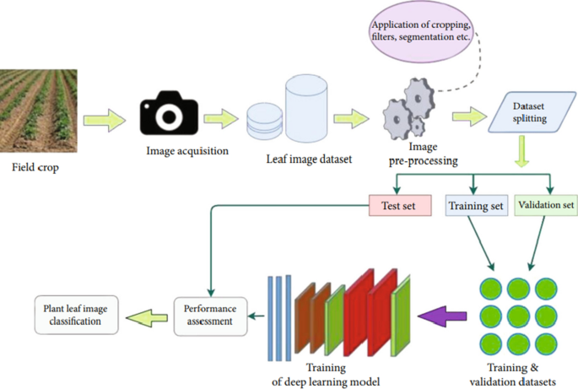

**Figure 2: Proposed System Architecture**

# IV. EXPERIMENTAL RESULT

Train Accuracy : 96.7

Test Accuracy : 98.9

Validation Accuracy : 98.7

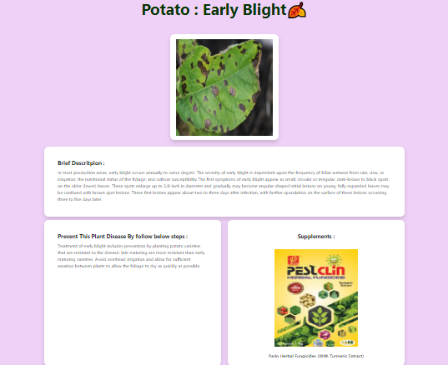

**Figure 3: Dashboard After Getting Result**

**V. CONCLUSION AND FUTURE WORK**

In conclusion, utilizing deep learning methodologies for leaf disease prediction presents a promising approach to addressing agricultural challenges, such as crop disease management and yield optimization. By leveraging neural network architectures, particularly Convolutional Neural Networks (CNNs), researchers and practitioners can develop robust models capable of accurately classifying plant leaves as healthy or diseased based on image data.

Through the outlined steps of data collection, preprocessing, model selection, training, evaluation, fine-tuning, deployment, and monitoring, a comprehensive framework for developing and deploying leaf disease prediction systems can be established. Leveraging popular deep learning frameworks and libraries facilitates the implementation process and enables scalability and flexibility in model development.

The deployment of such systems in real-world agricultural settings can empower farmers with timely and accurate information, allowing for proactive disease management strategies and ultimately leading to improved crop yield, reduced economic losses, and enhanced food security. Continuous monitoring and maintenance ensure the reliability and effectiveness of the deployed models over time, further contributing to their practical utility and impact.

**VI. REFERENCES**

1. Tirkey D, Singh KK, Tripathi S. Performance analysis of AI-based solutions for crop disease identification detection, and classification. Smart Agric Technol. 2023. <https://doi.org/10.1016/j.atech.2023.100238>.
2. Ramanjot, et al. Plant disease detection and classification: a systematic literature review”. Sensors. 2023. <https://doi.org/10.3390/s23104769>.
3. Krishnan VG, Deepa J, Rao PV, Divya V, Kaviarasan S. An automated segmentation and classification model for banana leaf disease detection. J Appl Biol Biotechnol. 2022;10(1):213–20. <https://doi.org/10.7324/JABB.2021.100126>.
4. S Mathulaprangsan K Lanthong S Patarapuwadol. 2020. Rice Diseases Recognition Using Effective Deep Learning Models. Telecommun. Eng Media Technol with ECTI North Sect Conf Electr Electron Jt Int Conf Digit Arts Comput. <https://doi.org/10.1109/ECTIDAMTNCON48261.2020.9090709>
5. Heltin Genitha C, Dhinesh E, Jagan A. Detection of leaf disease using principal component analysis and linear support vector machine. Adv Comput ICoAC Proc Int Conf. 2019. <https://doi.org/10.1109/ICoAC48765.2019.246866>.
6. P. S. Gupta, P. Hans, and S. Chand. 2020. Classification Of Plant Leaf Diseases Using Machine Learning And Image Preprocessing Techniques.
7. S. V. Militante, B. D. Gerardo, and N. V. Dionisio, “Plant Leaf Detection and Disease Recognition using Deep Learning,” 2019 IEEE Eurasia Conf. IOT, Commun. Eng., pp. 579–582, 2019.
8. Sardogan M, Tuncer A, Ozen Y. Plant leaf disease detection and classification based on CNN with LVQ algorithm. Comput Sci Eng Conf. 2018. <https://doi.org/10.1109/UBMK.2018.8566635>.
9. Sharma M, Kumar CJ, Deka A. Early diagnosis of rice plant disease using machine learning techniques. Arch Phytopathol Plant Prot. 2022;55(3):259–83. <https://doi.org/10.1080/03235408.2021.2015866>.
10. Sharath DM, Akhilesh S, Kumar A, Rohan MG, Prathap C. Image based plant disease detection in pomegranate plant for bacterial blight. Proc IEEE Int Conf Commun Signal Process ICCSP. 2019. <https://doi.org/10.1109/ICCSP.2019.8698007>.
11. Kumar S, Raghavendra BK. Diseases detection of various plant leaf using image processing techniques: a review” 2019 5th. Comput Commun Int Conf Adv. 2019. <https://doi.org/10.1109/ICACCS.2019.8728325>.
12. Rajasekaran C, Arul S, Devi S, Gowtham G, Jeyaram S. Turmeric plant diseases detection and classification using artificial intelligence. Int Conf Signal Process Commun. 2020. <https://doi.org/10.1109/ICCSP48568.2020.9182255>.
13. P. V., R. Das, and K. V. Identification of plant leaf diseases using image processing techniques. 2017 IEEE Int. Conf. Technol. Innov. ICT Agric. Rural Dev. (TIAR 2017), pp. 130–133, 2017.
14. Jasim MA, Al-Tuwaijari JM. Plant leaf diseases detection and classification using image processing and deep learning techniques. Int Comput Sci Soft Eng Conf. 2020. <https://doi.org/10.1109/CSASE48920.2020.9142097>.
15. Bedi P, Gole P. Plant disease detection using hybrid model based on convolutional autoencoder and convolutional neural network. Artif Intell Agric. 2021;5:90–101. <https://doi.org/10.1016/j.aiia.2021.05.002>.
16. Uchida S, Ide S, Iwana BK, Zhu A. A further step to perfect accuracy by training CNN with larger data. Int Conf Front Handwrit Recognit. 2016. <https://doi.org/10.1109/ICFHR.2016.0082>.
17. Hu Y, Liu G, Chen Z, Liu J, Guo J. Lightweight one-stage maize leaf disease detection model with knowledge distillation. Agriculture. 2023;13:1–22.
18. Ma L, Yu Q, Yu H, Zhang J. Maize leaf disease identification based on yolov5n algorithm incorporating attention mechanism. Agronomy. 2023. <https://doi.org/10.3390/agronomy13020521>.
19. Kumar R, Chug A, Singh AP, Singh D. A systematic analysis of machine learning and deep learning based approaches for plant leaf disease classification: a Review. J Sensors. 2022. <https://doi.org/10.1155/2022/3287561>.
20. Saleem MH, Potgieter J, Arif KM. Plant disease classification: a comparative evaluation of convolutional neural networks and deep learning optimizers. Plants. 2020;9(10):1–17. <https://doi.org/10.3390/plants9101319>.
21. Tiwari V, Joshi RC, Dutta MK. Dense convolutional neural networks based multiclass plant disease detection and classification using leaf images. Ecol Inform. 2021;63: 101289. <https://doi.org/10.1016/j.ecoinf.2021.101289>.
22. Vishnoi VK, Kumar K, Kumar B. Plant disease detection using computational intelligence and image processing. Berlin Heidelberg: Springer; 2021.
23. Faizal Azizi MM, Lau HY. Advanced diagnostic approaches developed for the global menace of rice diseases: a review. Can J Plant Pathol. 2022;44(5):627–51. <https://doi.org/10.1080/07060661.2022.2053588>.
24. Shoaib M, et al. An advanced deep learning models-based plant disease detection: a review of recent research. Front Plant Sci. 2023;14:1–22. <https://doi.org/10.3389/fpls.2023.1158933>.
25. Upadhyay SK, Kumar A. A novel approach for rice plant diseases classification with deep convolutional neural network. Int J Inf Technol. 2022;14(1):185–99. <https://doi.org/10.1007/s41870-021-00817-5>.
26. Guerrero-Ibañez A, Reyes-Muñoz A. Monitoring tomato leaf disease through convolutional neural networks. Electron. 2023;12(1):1–15. <https://doi.org/10.3390/electronics12010229>.
27. Picon A, Seitz M, Alvarez-Gila A, Mohnke P, Ortiz-Barredo A, Echazarra J. Crop conditional convolutional neural networks for massive multi-crop plant disease classification over cell phone acquired images taken on real field conditions. Comput Electron Agric. 2019;167:105093. <https://doi.org/10.1016/j.compag.2019.105093>.
28. Barbedo JGA. A review on the main challenges in automatic plant disease identification based on visible range images. Biosyst Eng. 2016;144:52–60. <https://doi.org/10.1016/j.biosystemseng.2016.01.017>.
29. Ahmed I, Yadav PK. A systematic analysis of machine learning and deep learning based approaches for identifying and diagnosing plant diseases. Sustain Oper Comput. 2023;4:96–104. <https://doi.org/10.1016/j.susoc.2023.03.001>.
30. Dhiman P, Kaur A, Balasaraswathi VR, Gulzar Y, Alwan AA, Hamid Y. Image acquisition, preprocessing and classification of citrus fruit diseases: a systematic literature review. Sustainability. 2023;15(12):9643. <https://doi.org/10.3390/su15129643>.