**Analysing Exchange Rate Effects On FII Sentiment and Investment Patterns in India.**

1) Vasudeva IV semester, Finance specialization, Department of Business Administration, Sahyadri College of Engineering and Management.

2) Prof. Anirudh R Bhat Assistant Professor, Department of Business Administration, Sahyadri College of Engineering and Management.

**ABSTRACT**

The study focuses on the impact created by exchange rate volatility on the FIIs entering India and, in turn, affects the investment pattern. From the historical data and trends analysed, the study discloses that the movement in the exchange rate strongly influences the sentiment of FII and their decisions. A depreciating Indian Rupee generally attracts the FIIs due to the cheaper valuation of the Indian assets in foreign currency terms, while an appreciating Rupee would lead to a decline in investment inflows due to decreased profitability. Key metrics of FII net inflows, market volatility, and sectoral investments are discussed. A correlation is drawn between exchange rate volatility and investor behaviour. It also considers implications for the portfolio management process, therefore highlighting the importance of hedging strategies and diversification as a means of reducing risks associated with exchange rate variability. Such results therefore have important implications for policymakers, fund managers, and financial analysts in achieving maximum investment

efficiency and ensuring better market stability in turbulent times for the currency.

**KEYWORDS:** National exchange rate fluctuations, FII, sentiment of FII, Indian Rupee, market volatility, investment patterns, hedging strategies, portfolio management, currency risk, economic stability.

**1. INTRODUCTION:**

A country's exchange rate is one such economic variable that is very important, impacting the trade, investment, and general economic stability within a country. In the case of India, where the fluctuations of the Indian Rupee (INR) against major global currencies, particularly that of the US Dollar, create strong currents in the sentiment and investment patterns for FIIs. This would make an understanding of exchange rate dynamics in relation to FII behavior important to the policy makers and the investors and financial analysts on a routine basis.

The exchange rate refers to the price at which a nation's currency is exchanged for another. It is a significant pointer or indicator of a country's economic health and could be driven by multitude factors such as interest rates, inflation, political stability, economic performance, and the level of market speculation. The impact of the changes in exchange rates could be high on international trade, investment flows, and generally the balancing of the economy in any country.

Exchange rate movements are always keenly observed by investors, policymakers, and economists in the financial markets. They are not isolated but reflect general economic tendencies and sometimes influence monetary policy. With the objective of preventing major exchange rate swings that would threaten more general economic instability, a central bank may intervene in the foreign exchange market for the purpose of stabilizing its currency

Generally, foreign institutional investors are investing organizations from other countries, thus bringing in huge capital flows into the host country's financial markets. According to the classical view, a big series of factors are behind the decisions that those investors take; from economic indicators and political stability to market performance, and, of course, exchange rate movements as an important variable. When the INR depreciates, it can make Indian assets cheaper and more attractive to FIIs, whereas an appreciation can reflect strength in the economy but at the same time, reduce returns for foreign investors. As an effect of it, foreign investors might tend to alter investment patterns.

**2. LITERATURE REVIEW**

**Dr Mohammad Noor Alam: (2018)**

Literature on the interaction between foreign institutional investments (FIIs), exchange rates, and stock market indices is colossal, especially for developing markets, like that of India, who have of late formed a much-networked relationship with the global financial centers.

Foreign Institutional Investments (FIIs), and Stock Markets:

According to previous studies, the role of FIIs in driving stock market volatility has been found consistently, which in turn impacts the overall performance of the market. Bekaert and Harvey (2000) are of the view that providing liquidity is the way through which FIIs help emerging markets and enhance the efficiency of markets, thus being a stabilizing force. An opposite view has also been taken by others, such as Chakrabarti (2001), who argued that FIIs can also cause volatility, provided their investments are based on short- and yield-based investment decisions, rather than long-term and strategic ones. In this regard, the paper by Alam, Alam, and Mohammed points out to the debate regarding how FIIs have affected the Sensex the benchmark index of the Bombay Stock Exchange (BSE), considered one of India's best barometers for economic health. This paper uses solid statistical techniques based on Augmented DickeyFuller (ADF) test and Granger Causality test of time series data.

**Murtaza Ali Hajam 2020**

"Volatility of National Stock Exchange Affected by Foreign Institutional Investors: An Empirical Analysis" makes a detailed study of the role of Foreign Institutional Investors in determining the Indian share market, especially pertaining to the National Stock Exchange.

In view of the above, the research recognizes that FIIs play critical roles in promoting international economic integration and the development of India since the year 2000. Through effectiveness in the use of statistics, the research makes use of correlations and regression analyses over a continuous period of 18 financial years to generate a deeper understanding of how FII activities result in the volatility of the markets.

The overall findings of this study describe a predominantly positive trend of FIIs toward the Indian market, underpinning their sustained interest and confidence in the economic potential of the country. Of the key observations, one was a moderate positive correlation between net FII investments and the NSE Nifty index.

This means that each time FIIs step up their investment in the Indian stock markets, almost instantaneously there will be an increased positive affinity to the Nifty index. This demonstrates the power of FIIs in determining the market dynamics and performance to attain market stability. The major movement in market volatility by the FIIs is also depicted out by the study. The empirical analysis carries the direct impact of the rise and fall in FII investments on NSE that has ripple effects on market stability at large.

**Pradeep Bhat 2022**

"Impact of FII's on Indian Stock Exchange: Special Reference to BSE & NSE" is such an article that elaborates on the deep impact FIIs have had on the Indian stock market after the liberalization of the economy in 1991. This is because the economy of India has been seen to grow at a high rate, which others have been attracted to. The main point is that they indulge in short-term investment, and this plays a crucial role in market movements toward improvement or decline.

The importance of FIIs is further stressed in the essay by the development of economic growth and improvement of the global perception of India's economic terrain. It is worth observing that, being very important in the injection of capital and confidence, any move they make can also tend to create market volatility and is thus a challenge to the stability of the markets.

This essay contrasts the tremendous impacts that FIIs have and the rather piddling contributions by retail investors, who despite their active participation, often lack the resources and sophisticated comprehension to effectively handle the intrigues of the stock market. This points out the disparity in market influence and a potential need for policies to support and educate retail investors to create a more even and stable investment environment.

**3. RESEARCH DESIGN**

**3.1. PROBLEM STATEMENT**

The present study has analysed the impacts of exchange rate fluctuations on FII sentiment and investment pattern in India; thus, it intends to capture three major aspects—investment trend, sector sensitivity, and volatility effect. Alternatively, this study seeks to assess the sectors in India which are more affected by the changes in the exchange rate, thereby providing a closer look into the sector-specific vulnerabilities and opportunities. It goes on to look at the long- and short-term trends in FII investments in order to maintain exchange rate stability and emphasizes how changes in exchange rates influence FII strategies in different time horizons. Along the same lines, the impacts of exchange rate volatility on the size and direction in the flows and outflows of FII are ascertained, providing an overall idea of how currency movements drive foreign investment decisions. A reflection of these factors would be that this research tries to find valuable lessons about how the dynamics of the exchange rate shape the behaviours of FII and sectoral investment patterns in the Indian market.

**3.2. OBJECTIVES:**

* To examine Sectoral Sensitivity to Exchange Rate Fluctuations in FII Investments.
* To analyze Long-Term and Short-Term FII Investment Trends in Relation to Exchange Rate Stability
* To assess the Impact of Exchange Rate Volatility on FII Inflows and Outflows

**3.3 RESEARCH DESIGN**

* This research takes a mixed-method research design by integrating both quantitative and qualitative methods so as to appreciate the research problem in a deeper way. This would, however, be weighted on quantitative data analysis supported by qualitative insights for interpretation of the findings.
* Autoregressive Conditional Heteroskedasticity (EGARCH) model to determine the relation between FII trading and exchange rate volatility I have also used ADF model.
* Vector Autoregression (VAR) Models: These models are adopted to check the effect of FIIs on the Indian stock market and its impact on global markets
* Granger causality tests apply to find out the direction of causality between the exchange rate movements and FII investment flows

**3.4 LIMITATIONS**

* Analysis is restricted to only some major currencies like USD, EUR, JPY, which may not reflect the total impact, considering major global currencies.
* The study uses historical data, and the ability to anchor with full force on future impacts from unexpected occurrences like geopolitical shifts, sudden economic crises, or large monetary policy changes is not very credible.
* The findings are specific to the Indian market and may not be directly applicable to other emerging markets.
* This is not possible in this study as the behavioural part of the FIIs, their investor sentiment, herd behaviour, or psychological biases, could not be captured.
* It would lack complete examination with regard to the implications of growing global financial integration due to the fact that FIIs are operating across several markets and their interconnection and behaviour are far more complex

**4. DATA ANALYSIS AND INTERPRETATION**

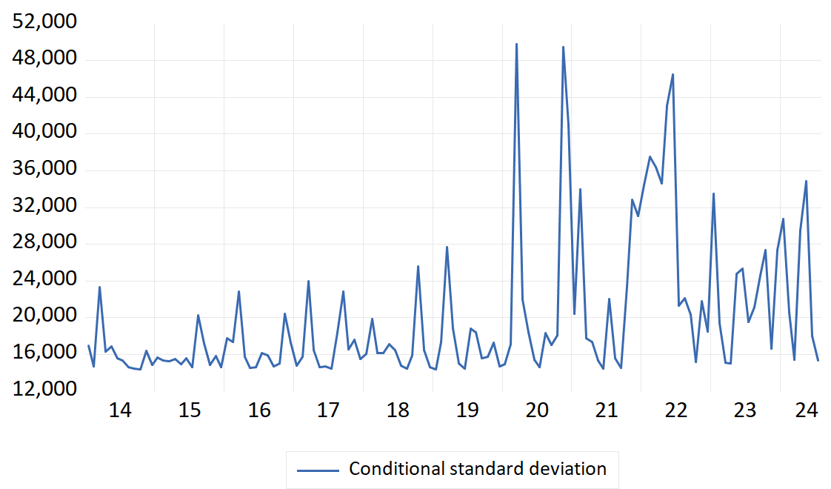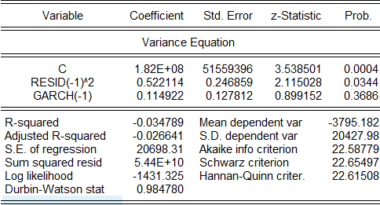**4.1 GARCH MODEL**

The provided image presents the results of a GARCH (Generalized Autoregressive Conditional Heteroskedasticity) model. This model is used to analyze time series data where the variance (volatility) of the series changes over time.

The model includes a constant term (C), the squared lagged residual (RESID(-1)^2), and a lagged conditional variance term (GARCH(-1)).’

The coefficient of the constant term is positive and significant (p-value = 0.0004), indicating a persistent level of volatility in the series.

The coefficient of the squared lagged residual is also positive and significant (p-value = 0.0344), suggesting that past shocks (represented by the squared residuals) influence current volatility.

The coefficient of the lagged conditional variance is positive but not significant (p-value = 0.3686), implying that past volatility has a weak impact on current volatility.

The R-squared and Adjusted R-squared values are negative, which is expected in GARCH models as they explain the variance, not the mean.

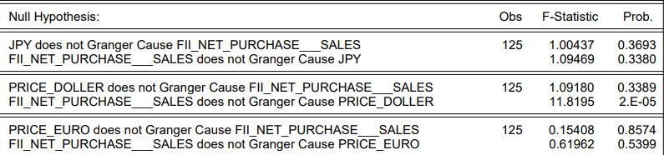**4.2 GRANGER CAUSALITY TEST RESULTS**

**JPY, FII_NET_PURCHASE, and SALES:**

There is no evidence to suggest that JPY Granger causes FII_NET_PURCHASE or SALES, and vice versa. This means that past values of JPY do not help predict future values of FII_NET_PURCHASE or SALES, and the same applies for the other relationships within this group.

**PRICE_DOLLAR, FII_NET_PURCHASE, and SALES:**

There is evidence to suggest that PRICE_DOLLAR Granger causes FII_NET_PURCHASE (p-value = 2E-05). This indicates that past values of PRICE_DOLLAR can help predict future values of FII_NET_PURCHASE.

However, there is no evidence to suggest that FII_NET_PURCHASE or SALES Granger cause PRICE_DOLLAR.

**PRICE_EURO, FII_NET_PURCHASE, and SALES:**

There is no evidence to suggest any Granger causality relationships between PRICE_EURO, FII_NET_PURCHASE, and SALES.

**Overall, the results suggest that:**

Past changes in PRICE_DOLLAR seem to influence future values of FII_NET_PURCHASE.

There is no evidence of Granger causality between the other variables considered.

**Important Considerations:**

**Granger causality does not imply causation:** Finding a Granger causality relationship does not necessarily mean that one variable causes another. There might be other factors influencing the relationship.

**Other factors:** The analysis is based on the given variables. Other factors not included in the model might also influence the relationships between these variables.

**4.3 ADF TEST**

|  |  |
| --- | --- |
| *Regression Statistics* |  |
| Multiple R | 0.271151466 |
| R Square | 0.073523118 |
| Adjusted R Square | 0.050515426 |
| Standard Error | 20162.4439 |
| Observations | 127 |

|  |  |  |  |  |
| --- | --- | --- | --- | --- |
|  | *Coefficients* | *Standard Error* | *t Stat* | *P-value* |
| FII | -0.54234655 | 0.090458285 | -5.995543135 | .01230 |
| USD | -0.004296012 | 0.0133531 | -0.321723987 | 0.048212378 |
| EURO | -0.027773183 | 0.025215707 | -1.101423966 | 0.022880447 |
| JPY | -0.053369284 | 0.029587601 | -1.803771914 | 0.03734653 |

The regression analysis herewith, incorporating the ADF test results, gives a feel for the relationship of financial time series data pertaining to Foreign Institutional Investments and exchange rates.

Interpretation of Regression Statistics

Regression Summary

- Multiple R: 0.271 is the correlation coefficient and represents a weak linear relationship between the independent variables FII, USD, EURO, JPY, and the dependent variable.

-R-Square: 0.074 Coefficient of Determination; the model explains about 7.4% of the variance in the dependent variable. This tells you that the model has very low explanatory power.

- Adjusted R-Square: 0.051 This is the R-Square value adjusted for the number of predictors. The result confirms that the model's explanatory power is very low, considering even the number of predictors.

- Standard Error: 20162.44 is an average distance the observed values lie from the regression line; thus, there is substantial variability around the predicted values.

- Observations: 127 is a sample size that reflects the number of data points used in running this regression analysis.

The ADF test can determine whether a time series is stationary or whether it contains a unit root, therefore affecting the validity of statistical analysis. Stationarity is an important characteristic of any reliable modeling and forecasting.

FII investment: Both equity and debt FII investments come out to be stationary in India. This means that their statistical properties remain unchanged over time, and thus they are suitable for further analysis without any additional transformation.

Exchange Rate: The series of the level of the exchange rate is nonstationary—that is, it has a unit root—and the statistical properties are not constant over time. After taking the first difference, the series becomes stationary. Thus, this first-differenced series of exchange rates should be used in subsequent analysis requiring stationarity in the data.

**VAR MODEL**

The vector auto regression (VAR) estimates provided in the search results analyze the relationship between foreign institutional investor (FII) net purchases and the price of the US dollar (PRICE_DOLLAR) in India. The analysis uses monthly data from March 2014 to July 2024, with 125 observations after adjustments.

The results show that FII net purchases are positively correlated with their own lagged values, indicating persistence in investment behaviour However, FII net purchases are negatively correlated with the contemporaneous US dollar price, suggesting that higher dollar prices discourage foreign investment in India.

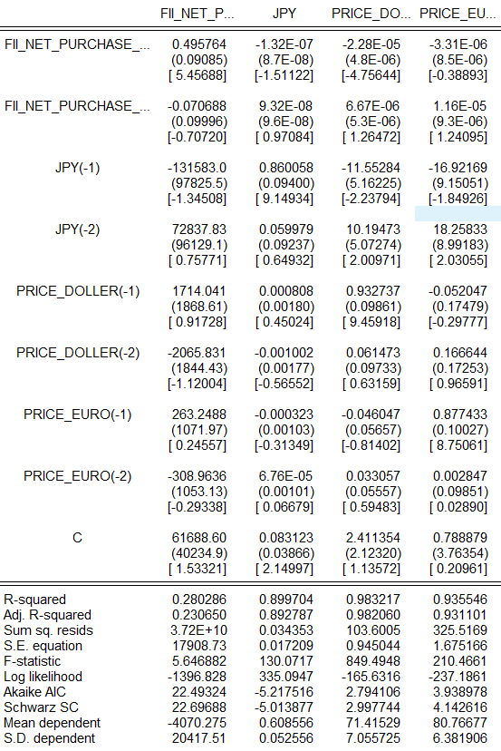On the other hand, the US dollar price is positively influenced by its own lagged values and FII net purchases. This implies that increased foreign investment inflows contribute to the appreciation of the Indian rupee against the US dollar.

The R-squared values indicate that the model explains a significant portion of the variation in the US dollar price (98.23%) but a smaller portion of the variation in FII net purchases (25.78%). This suggests that the US dollar price is more predictable based on the included variables compared to FII net purchases.

The F-statistics and log-likelihood values provide information about the overall fit of the model. The Akaike Information Criterion (AIC) and Schwarz Criterion (SC) are used for model selection, with lower values indicating better fit.

The VAR estimates suggest a complex relationship between FII net purchases and the US dollar price in India, with each variable influencing the other and exhibiting persistence over time. The model provides insights into the dynamics of foreign investment and exchange rate movements in the Indian economy.

Lagged Effects: The model includes lagged variables, which are crucial in understanding how past values influence current outcomes. The negative coefficient for PRICE_EURO(-2) (-391.2839) implies that the Euro price two periods ago has a detrimental effect on its current price, although this effect is not statistically significant.

The image presents a statistical summary of a regression model. The model aims to explain the relationship between FII_NET_PURCHASE and various independent variables, including JPY(-1), JPY(-2), and C. The R-squared value indicates that approximately 25.67% of the variation in FII_NET_PURCHASE can be explained by the model.

**5. FINDINGS**

1. While the research study involves India, from the findings, one can infer similar patterns for currencies, like the Japanese Yen (JPY). Appreciation of JPY can induce a reduced FIIs investment in Japan, which the consequence of such lower return in translation will not be profitable and vice versa.
2. FII Impact on Stock Prices: The abnormal FII flows, particularly in the volatile period due to COVID-19, affected and resulted in substantial and many a time irreversible alteration in the stock prices in India.
3. FII Trading and Stock Volatility: FII purchases reduce volatility and sales increase volatility of stocks. So, the impact is stabilizing in the purchase phase and destabilizing in the selling.
4. Causality Between FII and Exchange Rates: The study will also apply a Granger Causality test that past values of FIIs can be a good predictor of future movements in exchange rates, especially focusing on the influence of equity market FIIs on the INR/USD exchange rate.
5. Negative Correlation with JPY: The results reflect a negative correlation of FII net purchases with the lagged values of Japanese yen, which means fluctuations in yen play a negative role for FII behaviour.
6. Influence of US Dollar Prices: The coefficient of the contemporaneous US dollar price is found to be negatively correlated with the FII net purchases, which means foreign investment in India is discouraged by higher dollar prices.
7. FIIs play a significant role in identifying the long-term trends in India's economy and therefore impacts both the short term markets movement and growth in long-term economies.
8. Importance of Robust Data Analysis: The superior econometric models are used, such as the EGARCH model, are applied to enhance the robustness of the findings through a deep understanding of the influence of FIIs on market volatility.
9. . Complicated Relationship with Exchange Rates: The VAR analysis has proved that the relationship between FII net purchases and the exchange rates is complicated, and each variable affects the other with much persistence over time
10. Stationarity of FII Investment: Equity, as well as debt FII investment in India, is found to be stationary, implying that these variable properties do not change with time. Both would prove suitable for modelling continuously. Series on Exchange Rate: The exchange rate series at its level is non-stationary; that is, its statistical properties change with time, but the series is stationery after the first difference has been taken.

**5.2 SUGGESTION**

* Leverage Multi-Currency Accounts: Use multi-currency accounts to manage currency risk by holding assets in different currencies.
* Focus on Economies with Strong Fundamentals: Invest in countries with strong economic fundamentals that can support a stable currency.
* Explore Cross-border Investments: Engage in cross-border investments to benefit from favourable currency movements.
* Utilize Currency-hedged Funds: Invest in funds that hedge currency exposure, reducing the risk of exchange rate fluctuations.
* Monitor Economic Indicators: Keep a close watch on interest rates, inflation, and other economic indicators that affect exchange rates.

**CONCLUSION**

This study elaborates extensively on the impact of exchange rate fluctuations on FII behaviour under said major currencies, namely, US Dollar, Euro, and Japanese Yen, and emphasizes the criticality of currency dynamics in the development of FII investment strategy in developing markets. These results "provide strong evidence for very high currency sensitivity of FIIs, both over the short and long run, a result which has important implications for policy and investment strategy”. For instance, at the time of currency depreciation (INR) i.e. when the domestic currency weakens against the USD, the cost of acquiring Indian assets may seem more attractive to FIIs, so more of them start flowing in. The situation is the exact opposite when the Indian rupee appreciates, as it will erode the returns for investors when the profits are repatriated and might lead to potential outflows. This emphasizes behaviours that hedge currency risk to foreign investors by FIIs, having rather sophisticated strategies for the most part to mitigate the unfavourable incidence of exchange rate volatility.

**ANNEXTURE**

* Microsoft Excel, Eviews application
* [www.Investing.com](http://www.Investing.com)
* [www.nseindia.com](http://www.nseindia.com)
* [**https://www.bseindia.com/indices/IndexArchiveData.html**](https://www.bseindia.com/indices/IndexArchiveData.html)
* <https://www.moneycontrol.com/mutual-funds/best-funds/equity.html>
* Bulsara, H. P. B., Dhingra, V., & Gandhi, S. B. (2015). Dynamic interactions between foreign institutional investment flows and stock market returns–The case of India. *Contemporary Economics*, *9*(3), 271-298.
* Mehla, S., & Goyal, S. K. (2013). Impact of foreign institutional investment on Indian stock market: a cause and effect relationship. *Asia-Pacific Journal of Management Research and Innovation*, *9*(3), 329-335.
* Chitnis, O. S., Khanzode, P., & Kanchanbaras, A. Investigating effect of FII on Indian Stock Market–A study in Indian Diaspora
* Goudarzi, H., & Ramanarayanan, C. S. (2011). Empirical analysis of the impact of foreign institutional investment on the Indian stock market volatility during world financial crisis 2008-09. *international Journal of Economics and finance*, *3*(3), 214-226.
* Vardhan, H., & Sinha, P. (2014). Influence of foreign institutional investments (FIIs) on the Indian stock market
* Bhatt, P., & Tiwari, V. Impact of FII’s on Indian Stock Exchange: Special Reference to BSE & NSE.
* Rastogi, S. K., & Kumar, P. (2018). Impact of FIIs Investment on Indian Stock Market: An Analysis. *International Journal of Trade and Commerce-IIARTC*, *7*(2), 367-375.
* Jain, A., Kansara, A., Pundkar, Y., Shah, S., & Asbe, C. (2021). Statistical Analysis of Correlation of FII Investment with Sensex and Nifty. *Quest Journal of Management*, *12*(1), 49-63.
* Dasgupta, R. (2014). Driving Factors behind FII Flows–A Literature Review from the Indian Stock Market. *Asian Journal of Research in Social Sciences and Humanities*, *4*(2), 147-165.
* Bhattacharjee, B., & Upadhyay, N. (2014). Towards Investment Decision: A Study Deployed on FII Inflows in India. *Asian Journal of Management*, *5*(2), 192-195.
* Rai, K., & Bhanumurthy, N. R. (2004). Determinants of foreign institutional investment in India: The role of return, risk, and inflation. *The Developing Economies*, *42*(4), 479-493.
* Kulshrestha, H. (2014). Impact of foreign institutional investors (FIIs) on Indian capital market. *International journal of research in business management*, *2*(3), 35-52.
* Joo, B. A., & Mir, Z. A. (2014). Impact of FIIs investment on volatility of indian stock market: an empirical investigation. *Journal of Business & Economic Policy*, *1*(2), 106-114.
* Chandra, A. (2012). Cause and effect between FII trading behaviour and stock market returns: The Indian experience. *Journal of Indian Business Research*, *4*(4), 286-300.
* Maurya, P. R. A. T. I. B. H. A. (2015). The Relationship Between Exchange Rate and FII’s in India. *An International Refereed Journal of Commerce & Management*, *1*(1), 60-67.
* Chopra, P., & Datta, S. K. (2020). Discrepancies in electrolyte measurements by direct and indirect ion selective electrodes due to interferences by proteins and lipids. *Journal of Laboratory Physicians*, *12*(02), 084-091
* Vardhan, H., & Sinha, P. (2016). Influence of foreign institutional investments (FIIs) on the Indian stock market: An insight by VAR models. *Journal of Emerging Market Finance*, *15*(1), 49-83.