Performance evaluation of tea tree oil, eucalyptus oil & mint essential oil on cotton (knit) fabric as mosquito repellent finish.

Md Minhajul Abedin¹, Md. Redwanul Islam², Mohammad Rokon¹, Md Shahadad Hossain¹, Nasir Uddin¹, Tasfia Thasin¹, Nazmunnahar¹

¹Department of Textile Engineering, National Institute of Textile Engineering and Research, University of Dhaka, Dhaka-1000, Bangladesh.
²Department of Textile Engineering, Bangladesh University of Textiles, Dhaka, Bangladesh.
Corresponding Email: minhaj.niter.96@gmail.com.
Abstract
The evaluation focuses on enhancing mosquito repellency in 100% cotton fabric through the application of naturally extracted oils, prioritizing their advantages over synthetic alternatives due to concerns about human health and the environment. Tea tree oil, eucalyptus leaves, and mint were selected as key ingredients, applied using the exhaust method. Various tests, including air permeability, bursting strength, GSM, washing fastness, and mosquito repellency, were conducted to assess effectiveness. The study highlights the importance of fabric engineering in mosquito control and introduces a commercial repellent finish. While the treated fabric initially demonstrated strong repellency, efficacy waned after seven washes due to superficial application, especially evident in mint-treated fabric. Cotton fabric treated with tea tree oil showed most repellency. However, fabrics treated with eucalyptus oil or a combination of oils maintained partial repellency. Mint-treated fabric showed the most significant decline, emphasizing the importance of proper bonding between oils and fabric. The study underscores the need for continued research into effective mosquito repellent textiles, identifying the most successful repellent chemicals through comparative analysis.

Key Words: Mosquito repellency, mosquito repellent finish, cotton fabric, tea tree oil, eucalyptus oil, mint essential oil.

1 INTRODUCTION

Purpose and Significance of the study
A mosquito-repelling finish represents a specialized textile treatment engineered to ward off mosquitoes and other insects. This treatment is meticulously applied to various fabrics, ranging from clothing to bedding, with the primary objective of establishing a protective barrier that acts as a deterrent against mosquitoes attempting to land on or pierce through the material. The inherent repellent properties play a crucial role in thwarting mosquito bites, particularly in regions where these insects serve as vectors for debilitating diseases like malaria, dengue fever, Zika virus, and more. The global impact of insect-borne diseases cannot be overstated, underscoring the importance of effective preventive measures. In general, insect bites have a dual impact on human health – causing both irritation and potential illness. The milder consequences manifest as irritation, swelling, and pain resulting from bites inflicted by various insects, including mosquitoes, bees, certain spiders, and flies. Beyond the nuisance factor, these bites can lead to more severe repercussions, such as the transmission of diseases. Given the limited availability of vaccines for such diseases, a proactive approach to prevent their occurrence becomes paramount. While traditional methods such as insect repellent sprays, smokes, and chemical coils have been employed to deter insects, the widespread use of chemicals in these products raises concerns about potential risks to human health. Consequently, there is a pressing need to explore and develop natural alternatives for insect repellency that can mitigate the associated dangers stemming from chemical exposure.
In the pursuit of natural insect repellents, researchers and scientists are delving into innovative solutions that prioritize human safety and environmental sustainability. The development of natural repellents aims to provide an effective shield against insect bites without compromising health or contributing to environmental degradation. One promising avenue involves the exploration of plant-based repellents derived from botanical sources known for their insect-repelling properties. Essential oils extracted from plants such as citronella, eucalyptus, lavender, and peppermint have demonstrated efficacy in repelling mosquitoes and other insects. Integrating these natural extracts into textile finishes can offer a sustainable and non-toxic alternative to traditional chemical-laden repellents. Furthermore, the advancement of nanotechnology has paved the way for novel approaches in creating insect-repelling textiles. Nano-sized particles with inherent insect-repelling properties can be incorporated into fabric finishes, providing a durable and efficient barrier against mosquitoes. These nano-based solutions not only offer enhanced repellency but also address concerns related to the longevity of repellent effects on textiles.In the broader context of public health, the development and adoption of natural mosquito-repelling textiles have the potential to revolutionize preventative measures against insect-borne diseases. By reducing reliance on chemical-based repellents, these natural alternatives contribute to a safer and more sustainable approach to protecting individuals from the health risks associated with insect bites.In conclusion, the quest for natural mosquito-repelling finishes represents a significant stride towards safeguarding public health and environmental well-being. The exploration of plant-based extracts and innovative nanotechnological solutions underscores a commitment to developing effective, sustainable, and non-toxic alternatives to traditional insect repellents. As research in this field continues to evolve, the potential impact of natural repellent textiles on global health becomes increasingly evident, offering a promising path forward in the ongoing battle against insect-borne diseases.[1].
Creating protective textiles poses a formidable challenge for humanity, necessitating significant adaptations within the textile industry. Addressing this demand requires substantial transformations in manufacturing processes and product development. Particularly in tropical regions, the integration of insect repellent technology becomes crucial not only for personal comfort but also as a catalyst for innovation within the textile sector. This endeavor not only involves repelling insects effectively but also entails ushering in a new era of technological advancements in textile production. The textile industry must evolve to meet the diverse needs of consumers, fostering the development of cutting-edge solutions that go beyond conventional boundaries to enhance both functionality and protection [2]. The challenge of protective textiles necessitates substantial adaptations from the textile industry to address evolving human needs. In tropical regions, insect repellent plays a crucial role in warding off insects, prompting advancements in textile technology. The textile sector is thus compelled to undergo significant transformations to meet the demands of safeguarding individuals in diverse environmental conditions [3]. Utilizing plant and tree components such as stems, bark, leaves, and tubers serves as a preventive measure against potential skin issues caused by chemical treatments, offering a natural alternative that mitigates harm to human skin [4]. The crucial examinations involve evaluating repellent properties and assessing the durability of the product through washing tests [5].

Types of Mosquito Repellent Finish
Mosquito repellent finishes can be categorized based on their origin, distinguishing between synthetic or chemical-based repellents and natural or botanical-based repellents. Here are the main types based on origin:

Synthetic/Chemical-based Repellents:
  - Permethrin: A synthetic insecticide widely used in mosquito repellent finishes.[6]
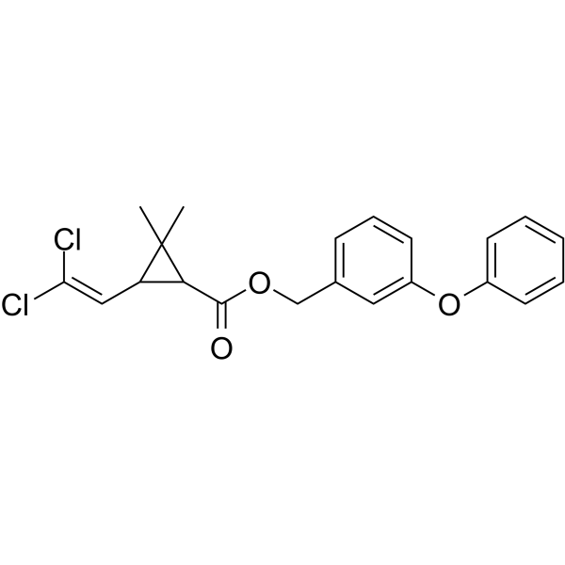
Figure 1: Permethrin
Textiles embedded with permethrin are now used to provide the most effective protection against mosquito-borne diseases, along with other repellents such as DEET.
  - DEET (N, N-Diethyl-meta-toluamide): Commonly used in topical insect repellents, and some attempts have been made to incorporate it into textile finishes.[7]
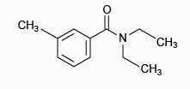
Figure 2: DEET (N, N-Diethyl-meta-toluamide)
  - Picaridin: Another synthetic compound found in some insect repellents, including those designed for textiles.[8]
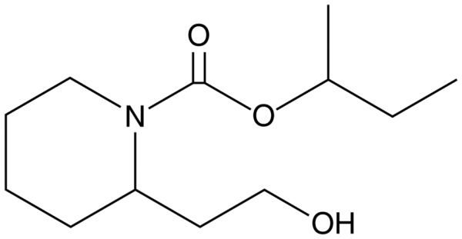
Figure 3: Picaridin

Natural/Botanical-based Repellents:
  - Citronella: Extracted from lemongrass, citronella oil is known for its mosquito-repelling properties and is used in some natural repellent finishes.
  - Eucalyptus: Eucalyptus oil, particularly lemon eucalyptus oil (OLE), is a natural ingredient with mosquito-repelling properties and is sometimes used in textile finishes.
  - Tea tree oil: Tea tree oil is an essential oil derived from the leaves of the Melaleuca alternifolia plant native to Australia. It is known for its potential antibacterial, antifungal, and anti-inflammatory properties. Tea tree oil is commonly used in skincare products, shampoos, and aromatherapy for its versatile and therapeutic qualities.
  - Mint essential: Mint essential oil is an aromatic extract obtained from mint plants, such as peppermint or spearmint. It is renowned for its refreshing scent and is often utilized in aromatherapy, skincare, and as a flavoring agent. Mint essential oil is prized for its potential benefits, including promoting relaxation and providing a cooling sensation.
  - Neem: Neem oil, derived from the neem tree, has insecticidal properties and is used in some natural repellent formulations.
The choice between synthetic and natural repellents often depends on individual preferences, potential allergies or sensitivities, and environmental considerations. Natural repellents are often favored by those seeking alternatives to synthetic chemicals, but it's essential to note that their efficacy and duration of protection may vary compared to synthetic counterparts. Additionally, users should follow product guidelines for application and reapplication to ensure optimal effectiveness.

Mosquito Repellent Textiles
Mosquito repellent textiles are fabrics treated with specialized finishes to repel mosquitoes and other insects. These finishes typically incorporate specific compounds, such as permethrin, DEET, or natural extracts like citronella or eucalyptus oil, known for their insect-repelling properties. The primary objective of these treated textiles is to create a protective barrier that deters mosquitoes from landing on or biting through the fabric. This is particularly beneficial in regions where mosquitoes transmit diseases such as malaria, dengue, or Zika virus. Mosquito repellent textiles are commonly used in the manufacturing of clothing, bedding, and outdoor gear to provide an additional layer of defense against mosquito bites. The effectiveness of these textiles can vary based on the active ingredient, concentration, and the specific formulation used in the repellent finish. Regular maintenance and reapplication may be necessary to ensure continued protection over time.

Performance of Mosquito Repellent Textiles
The performance of mosquito repellent textiles is generally assessed based on their ability to effectively deter mosquitoes and reduce the incidence of mosquito bites. The primary goal is to create a protective barrier between the fabric and mosquitoes, preventing them from landing on or penetrating the material. The effectiveness of these textiles is influenced by factors such as the type of repellent finish used (whether synthetic or natural), the concentration of the active ingredients, and the quality of application. Permethrin-based finishes, for example, are known for their durability through multiple washes, providing long-lasting protection. However, the performance can vary, and periodic reapplication may be necessary. Additionally, the comfort and breathability of the treated textiles, as well as any potential skin irritations or allergic reactions, are important considerations in evaluating their overall performance. While mosquito repellent textiles contribute significantly to personal protection against mosquito-borne diseases, users should follow care instructions and understand the limitations of these products for optimal performance.

Aim of the research
The aim of the research is to assess and compare the efficacy of tea tree oil, eucalyptus oil, and mint essential oil as mosquito repellent finishes on cotton fabric. The study will investigate the potential of these essential oils to provide a durable and effective mosquito repellent effect when applied to cotton fabric, contributing valuable insights into the development of natural and sustainable alternatives for mosquito protection in textiles.

Objectives

Assessing Mosquito Repellency:
Evaluate the effectiveness of tea tree oil, eucalyptus oil, and mint essential oil as mosquito repellents when applied to cotton fabric.

Comparison of Repellent Efficiency:
Compare the repellent efficiency of tea tree oil, eucalyptus oil, and mint essential oil on cotton fabric to identify which oil provides the most effective mosquito protection.

Durable Repellency:
Investigate the durability of the repellent finish by assessing the longevity of the mosquito repellent effect on treated cotton fabric over multiple wash cycles.

Fabric Compatibility:
Determine the impact of the repellent finish on the physical properties of the cotton fabric, such as color, texture, and airpermiability, to ensure it remains suitable for use.

Environmental Impact:
Assess the environmental impact of the mosquito repellent finishes by investigating any potential harm to the environment.

LITERATURE REVIEW
Ronali Rout and colleagues conducted research involving the application of naturally extracted mosquito repellent oils onto textile materials. The study aimed to explore the advantages of these natural oils in combating nuisance-biting insects, particularly mosquitoes, known for transmitting tropical diseases such as malaria, dengue, filariasis, zika, chikungunya, yellow fever, among others. The findings indicated that the natural repellent oils exhibited efficacy against these disease-carrying vectors. Moreover, the researchers underscored the safety profile of these natural oils in comparison to synthetic chemicals commonly used in mosquito repellents. The experimentation focused on the potential of these oils to serve as a protective barrier on textiles, providing a novel and environmentally friendly approach to warding off mosquitoes. The study's implications extend beyond basic mosquito protection, offering promise in the prevention of a range of tropical diseases. The emphasis on the safety of natural repellent oils contributes to the growing awareness and preference for sustainable and non-toxic alternatives in the ongoing efforts to address mosquito-borne health threats [9]. Another study explores the enhancement of traditional p control charts used in statistical process control (SPC) by incorporating fuzzy rule-based algorithms. The research aims to address the limitations of conventional p charts, which may not effectively handle process variability and uncertainty. By integrating fuzzy logic, the modified control charts provide a more flexible and accurate approach to monitoring and controlling process quality. The findings demonstrate that fuzzy rule-based p control charts can better detect shifts in the process, leading to improved decision-making and overall process performance. This approach offers a significant advancement for industries seeking to optimize quality control and maintain high standards in manufacturing processes and our future extension is this research for improvement [26,25,23].
For centuries, the persistent menace of mosquito-borne diseases such as malaria, dengue fever, and yellow fever has cast a shadow over human civilization, as astutely observed by Sandeep Kidile. The multifaceted world of mosquitoes, characterized by a myriad of species each with unique habitats, behaviors, and blood preferences, has compelled humanity to orchestrate concerted efforts in mosquito control. Approximately ten of these species, renowned for their abundant presence and aggressive biting proclivities, not only inflict nuisance through their bites but also wield the potential to act as vectors, periodically transmitting diseases to both humans and animals. The historical recognition of plants possessing repellent properties against mosquitoes and other pests predates the era of synthetic chemicals. However, in the contemporary landscape of insect repellents, the reliance on synthetic compounds has become prevalent, with DEET (N, N diethyl-3-methylbenzamide) emerging as a ubiquitous component. Despite DEET's proven effectiveness against a broad spectrum of insects, apprehensions have surfaced owing to its solvent activity on paints, varnishes, plastics, and synthetic fabrics, raising concerns about potential toxicity issues associated with this widely used chemical compound. The complex interplay between human endeavors to combat mosquito-borne diseases, the evolutionary adaptations of mosquitoes, and the ecological implications of synthetic repellents underscores a dynamic narrative that unfolds across centuries, shaping the delicate equilibrium between the relentless quest for public health and the intricate web of nature's interconnectedness. As the world grapples with the intricate challenges posed by mosquito-borne illnesses and endeavors to strike a balance between effective pest control and environmental stewardship, the discourse extends beyond the historical roots of plant-based remedies to the contemporary reliance on synthetic solutions, probing the intricate facets of human-animal-environment interactions in the ongoing battle against the relentless adversaries that are mosquitoes and the diseases they propagate [10].
Mynul Islam Sajib and his team conducted research aimed at creating an environmentally friendly mosquito repellent fabric by harnessing the properties of herbal extracts from neem, tulshi, and mint leaves. The methodology involved applying the extracted chemicals onto the fabric through processes such as pad-dry-cure and exhaust processes. Subsequently, the efficacy of the repellent was assessed through a comprehensive mosquito repellency activity test. To gauge the durability of the repellency, the researchers examined the fabric after washing at three distinct intervals—following the 5th, 7th, and 9th washes. Remarkably, the results indicated that the finished fabrics exhibited significant and enduring mosquito repellent activity, demonstrating effectiveness for both knit and woven fabric types. This innovative approach not only underscores the potential for utilizing herbal extracts in textile applications but also highlights the practicality of producing sustainable and effective solutions in the realm of mosquito repellency. The study thus contributes to the development of eco-friendly alternatives in the ongoing quest for solutions to mosquito-borne health challenges [4].
According to the research conducted by S. Sumathi et al., it has been established that the microencapsulation technique stands out as the most effective method, particularly in the context of mosquito repellent finishes. The approach employed in this study has been identified as a distinctive and optimal means for permanently infusing the bioactive components of the herbal composite into fabric materials. The study underscores the efficacy of microencapsulation in ensuring a lasting and efficient delivery of these bioactive compounds onto fabrics, providing a robust and enduring solution for mosquito repellency. The findings of the research highlight the uniqueness of the applied method, emphasizing its superiority in achieving a sustained and potent incorporation of herbal elements, thereby enhancing the overall effectiveness of mosquito repellent textile finishes [11].
Ghada A. Elsayed emphasizes that evaluating the effectiveness of insect repellent finished fabric in offering protection can be accomplished through established and standardized testing methods. In the forthcoming developments of insect repellent finishes, the primary emphasis will be on attaining not only highly effective and enduring insect repellent properties but also ensuring environmental sustainability. The focus lies in advancing formulations that strike a balance between efficacy and eco-friendliness. As the industry moves forward, the aim is to create insect repellent fabrics that not only meet high-performance standards but also align with the growing global commitment to sustainable and environmentally conscious practices. Ghada A. Elsayed envisions a future where insect repellent technologies seamlessly integrate effectiveness with long-lasting protection while upholding a commitment to environmental responsibility in the textile industry [12].
The production of both herbal extraction and herbal oil involves utilizing an assortment of natural herbs. Through the application of the cage method, tests were conducted to assess their efficacy. Ultimately, the findings revealed that herbal oil exhibited a commendable repellent effect. The process of crafting these formulations entails harnessing the inherent properties of diverse herbs, ensuring a comprehensive and effective outcome. The experimentation, conducted using the cage method, served as a pivotal means to gauge the performance of these herbal products. Notably, the results unequivocally highlighted the superior repellent qualities of the herbal oil. This underscores the significance of selecting and processing herbs in a manner that optimizes their repellent attributes, leading to the formulation of herbal oil as a potent solution in providing effective protection [22].
Mint leaves harvested from both domestic and forest areas, representing their native habitat, were cultivated under optimal environmental conditions devoid of diseases and contamination. Following sun-drying and grinding, genetic modifications were introduced to the fibers to facilitate the application of finishes. Cotton, known for its robust yield, underwent substantial genetic alterations, incorporating genes from mosquitoes and insects that pose threats to cultivated areas, thus instilling a repellent trait in the plant and enhancing overall productivity. This innovative approach reshapes the fibers, fostering a repellent action intrinsic to the plant and creating room for technological advancements. Additionally, there is a pivotal shift towards employing technology to administer finishes using natural extracts instead of conventional chemicals. This strategic move aligns with the preservation of ecological equilibrium, ensuring that goods are readily accessible to the general population. Notably, herbal mosquito repellents emerge as superior alternatives to traditional mosquito coils, exhibiting heightened efficacy. This comprehensive integration of genetic enhancements, sustainable agricultural practices, and technological advancements underscores a holistic approach to redefining fiber production, promoting ecological sustainability, and advancing technology for the benefit of a broader audience [14] .
Bano R investigated the potential application of the commercial mosquito repellent finish Sanitized AM 23-24, combined with a commercial binder and chitosan, on cotton knitted fabric using the pad-dry-bake method. The objective was to impart mosquito repellency to the fabric without compromising its air-permeability. Remarkably, the process not only achieved the desired repellent effect but also exhibited a noteworthy enhancement in the fabric's tensile strength. This fortification ultimately contributes to an increase in the overall durability of the fabric. The resulting treated fabric presents itself as a versatile solution suitable for various applications, including but not limited to furniture fabrics, garments, and military purposes. The combination of mosquito repellency retained air-permeability, and enhanced tensile strength positions the finished fabric as a viable option for sectors requiring durable and protective textiles. Bano R's findings offer a promising avenue for the development of textiles that can serve diverse needs, ranging from everyday domestic use in furniture and clothing to specialized applications in military contexts where durability and insect repellency are paramount considerations. This innovative approach to fabric enhancement not only addresses the challenge of mosquito protection but also opens up possibilities for multifunctional textiles with improved performance characteristics across different sectors [15].
Ebru Sahin and her research team have made a significant discovery regarding the efficacy of tea tree oil in mitigating nipple crack formation and alleviating nipple pain. Their findings suggest that the application of tea tree oil is a valuable intervention for addressing breast-related issues during the postpartum period in nursing care. Through their investigation, it was conclusively determined that the use of tea tree oil demonstrated a notable reduction in the occurrence of nipple cracks, providing relief to nursing mothers. This breakthrough underscores the potential benefits of incorporating tea tree oil into postpartum care routines, particularly in managing and preventing discomfort associated with nipple issues. The researchers strongly advocate for an increased utilization of tea tree oil in nursing care practices, emphasizing its positive impact on promoting maternal well-being. This recommendation signifies a promising development in the realm of postpartum care, as it offers a natural and potentially effective solution to a common challenge faced by breastfeeding mothers. As the medical community continues to explore alternative and complementary approaches, the inclusion of tea tree oil emerges as a viable and accessible option for enhancing the overall experience of breastfeeding women during the postpartum period [16].

Afaf Farag Shahba and colleagues conducted a study wherein they noted that curtain fabrics composed of a blend of cotton and linen exhibited superior mosquito repellent retention capacity, as well as enhanced resistance to washing when compared to fabrics made of 100% cotton or cotton/viscose blends. In contrast, curtain fabrics constructed from polyester demonstrated a reduced ability to retain insect repellents compared to fabrics derived from cellulosic sources. Importantly, the application of insect repellent treatments on the curtain fabrics did not have any adverse effects on the tensile strength or drapability index of the materials. This implies that the incorporation of insect repellent agents did not compromise the structural integrity or overall flexibility of the curtain fabrics, suggesting a promising compatibility between the insect repellent treatment and the physical attributes of the materials. The findings underscore the potential utility of cotton/linen blends for curtains as a means of achieving optimal mosquito repellency and durability. Moreover, the study contributes valuable insights into the nuanced performance variations observed across different fabric compositions, with implications for the design and selection of textiles for insect-repelling applications. Overall, the research highlights the effectiveness of certain fabric blends in serving as a resilient and insect-repelling barrier without sacrificing essential textile characteristics [17].
The assessments of dyed fabric revealed that the application of the synthesized dye did not bring about any noteworthy alterations in the fundamental structure of nylon. The results obtained from these examinations strongly suggested the creation of a durable functional nylon that withstands washing, presenting an innovative avenue to produce garments with dual properties: mosquito repellency and UV protection. The novel acid dye showcased compelling outcomes, paving the way for the development of textiles that serve as an effective shield against both mosquito bites and harmful ultraviolet rays. This breakthrough is particularly significant as it opens possibilities for enhancing human well-being by offering a practical solution for protection against disease-carrying mosquitoes and the adverse effects of prolonged sun exposure. Consequently, the synthesized dye's remarkable performance in maintaining the integrity of nylon while imbuing it with valuable properties positions it as a promising candidate for the fabrication of clothing dedicated to safeguarding individuals from two prevalent environmental threats. The synthesis of such wash-durable functional nylon represents a noteworthy advancement in textile technology, demonstrating its potential to contribute meaningfully to public health and safety in the ongoing battle against mosquito-borne illnesses and the hazards of UV radiation [18].
Zahra Sheikh and her colleagues conducted a study in which they arrived at the finding that nanoemulsions containing essential oils could present compelling alternatives for the management and prevention of mosquito-borne diseases. The research suggests that these specially formulated nanoemulsions, with their unique properties and composition, have the potential to be effective tools in controlling the spread of diseases transmitted by mosquitoes. The investigation delves into the intricate realm of essential oils, emphasizing their nanoemulsion form as a promising avenue for addressing the challenges associated with mosquito-related illnesses. The study underscores the significance of nanoemulsion technology in enhancing the efficacy of essential oils, potentially offering a novel approach to mosquito control strategies. Furthermore, the researchers highlight the importance of these findings in the broader context of public health, emphasizing the potential impact on disease prevention and vector control. The comprehensive nature of the study's conclusions suggests that nanoemulsions of essential oils may play a crucial role in future initiatives aimed at curbing the prevalence of mosquito-borne diseases, providing a nuanced understanding of the potential applications and implications of this innovative approach. Overall, Sheikh et al.'s research signifies a notable contribution to the field, shedding light on the promising role of nanoemulsions in the ongoing efforts to combat mosquito-related diseases and promote global health [19].

RESEARCH DESIGN

Methodology

Flowchart of methodology:

Selection of Fabric

Sample Preparation

Essential oils
M: L Preparation

Dyeing in IR Dyeing Machine

Drying at 100 ºC

Curing at 160 ºC

Selection of Fabric
Initially, the focus revolves around the careful selection of cotton (Knit) fabric to assess the performance of tea tree oil, eucalyptus oil, and mint essential oil. The subsequent evaluation aims to gauge the efficacy and impact of these oils on the chosen fabric, delving into their potential for enhancing performance in various aspects. Tarikuzzaman et. al. (2024) explores the potential of using human hair as a reinforcement material in regolith-based cement, which is relevant for construction applications in extraterrestrial environments like the Moon or Mars. The researchers investigated the effects of incorporating human hair on the tensile strength and porosity of the cement. Results showed that adding human hair improved the tensile strength and reduced the porosity of the cement, suggesting that it could enhance the material's durability and structural integrity. This approach could provide a sustainable and locally sourced reinforcement option for future space construction. The study contributes to advancing the understanding of novel construction materials for space habitats and we have considered for our fabric selection purposes [21,24].

Sample Preparation:
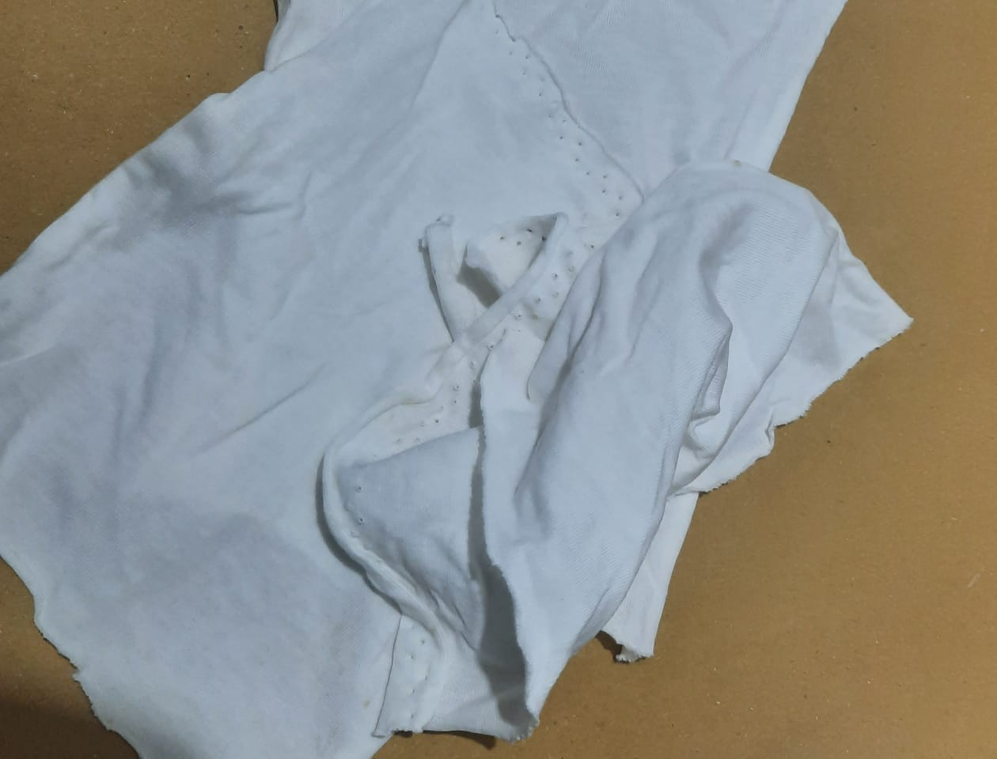
Figure 4: Sample Preparation
Afterward, we proceed to trim it into dimensions of 8 by 8 using a pair of scissors. The process involves carefully cutting the material to achieve a precise and uniform size, ensuring that each resulting piece conforms to the specified 8x8 measurements. This meticulous cutting step contributes to the overall precision and consistency of the final product. This study examines the use of direct contact membrane distillation (DCMD) to treat artificial urine for use in hydroponic systems aimed at growing sugar beets. By treating artificial urine, the process provides a sustainable method for nutrient recycling, which is essential for closed-loop agricultural systems. The findings suggest that the DCMD process effectively recovers water and nutrients from artificial urine, supporting the growth of sugar beets. This approach could be valuable for agricultural practices, particularly in controlled environments like space missions or urban farming [13]. The research investigates how temperature variations influence the physiochemical properties of sugar-based natural deep eutectic solvents (NADES). The study focuses on understanding how these solvents, which are eco-friendly alternatives to traditional organic solvents, behave under different thermal conditions. Results show that temperature changes significantly impact properties such as viscosity, density, and conductivity, affecting the solvents' potential applications. These insights are crucial for optimizing the use of NADES in various industrial and biochemical processes, including pharmaceuticals and bio-extraction which is greatly important for our research [20].

M: L Preparation:
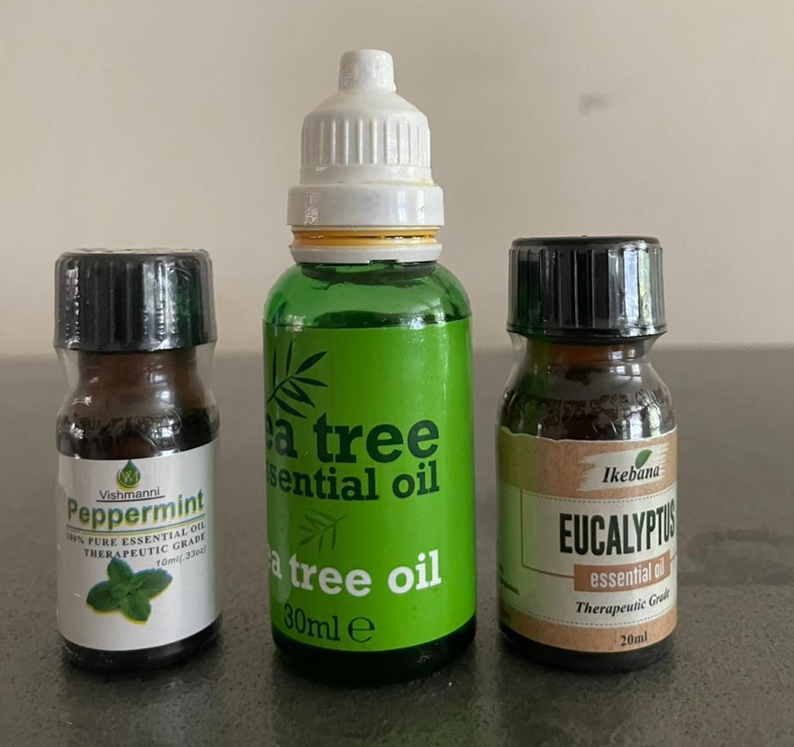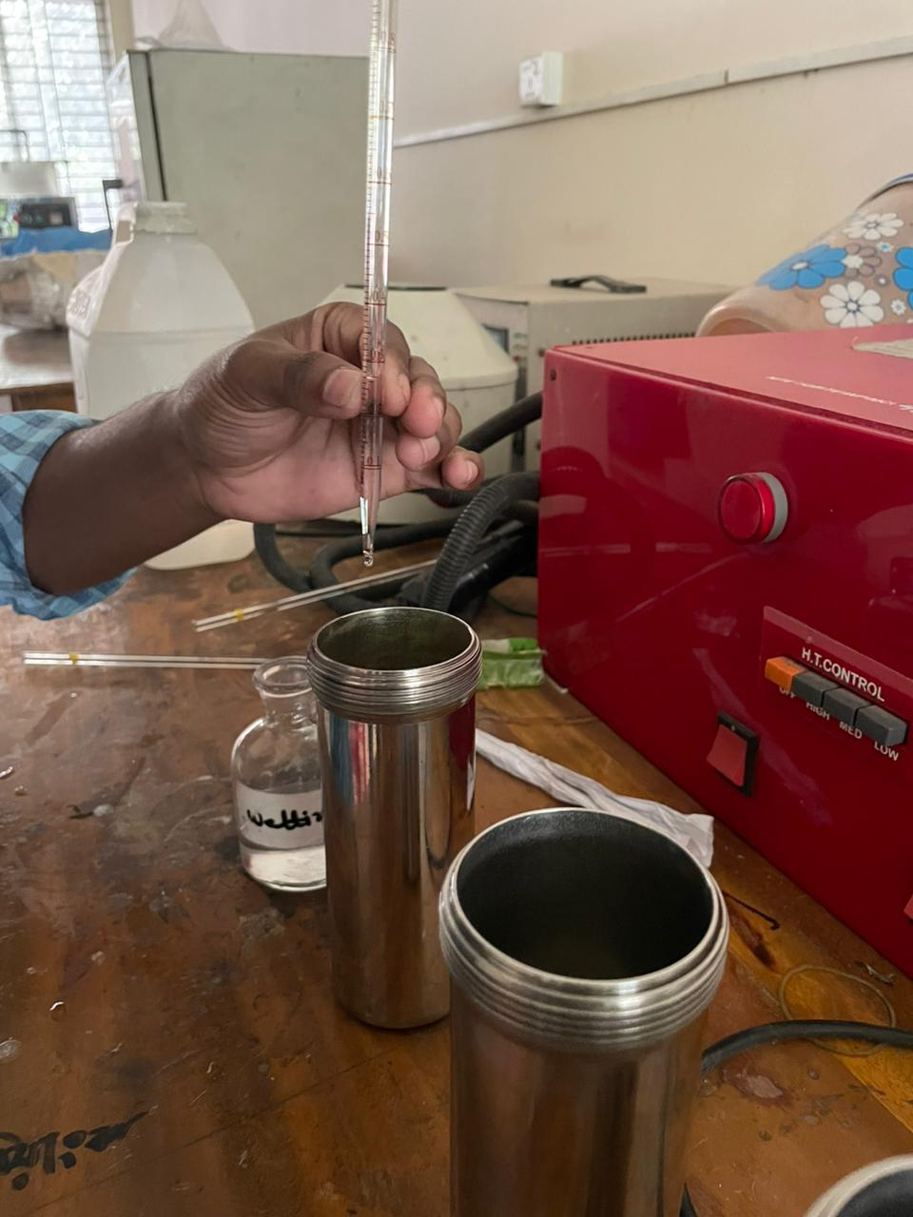
Figure 5: M:L Preparation
Then prepared M:L (Material:Liquor) ratio with essential oils (tea tree oil, eucalyptus oil & mint essential oil). Here it used M:L ration 1:10 and ingredients 3% of sample weight along with used 15gm sodium chloride and 1 cc/L citric acid for this M:L preparation.
Dyeing in IR Dyeing Machine:
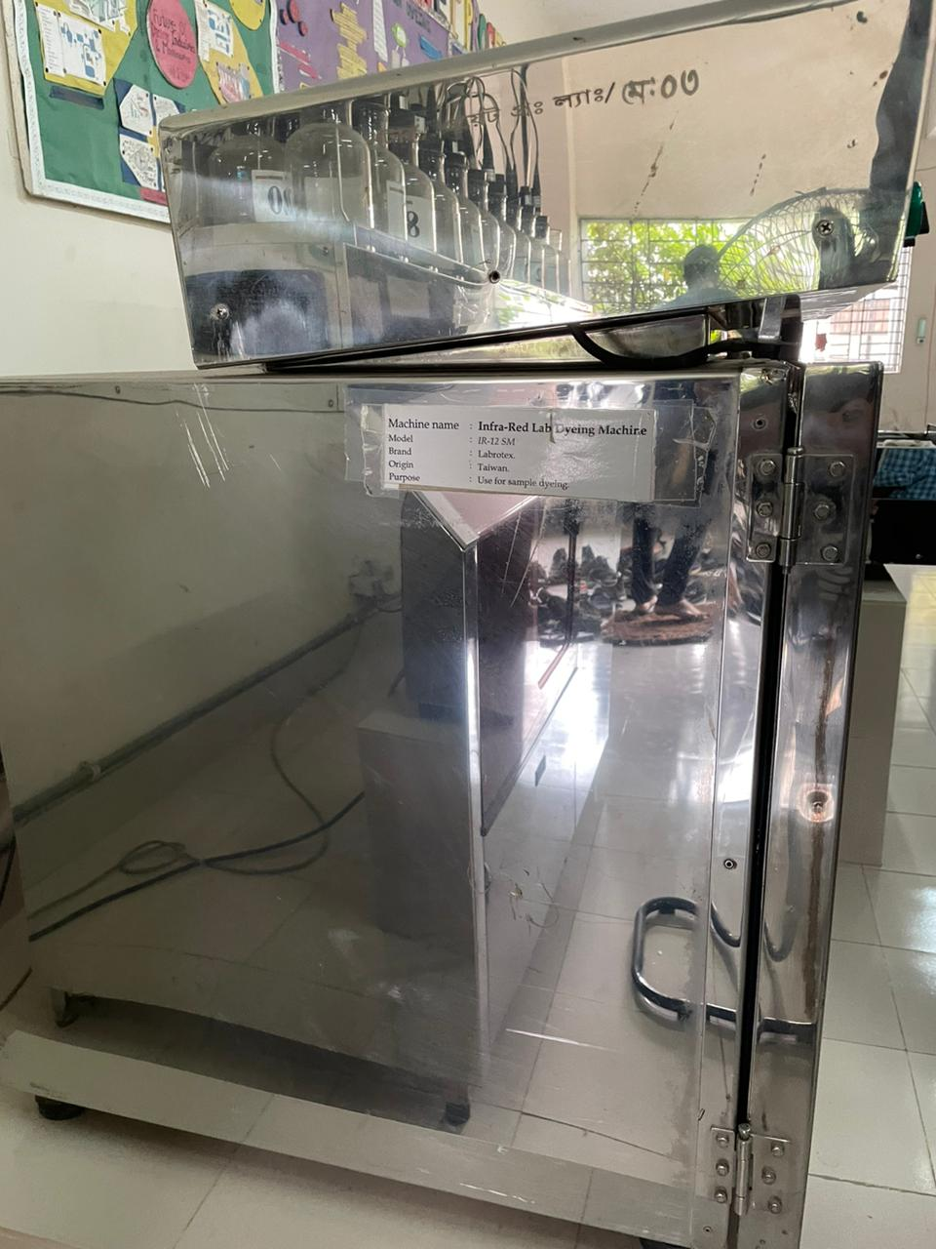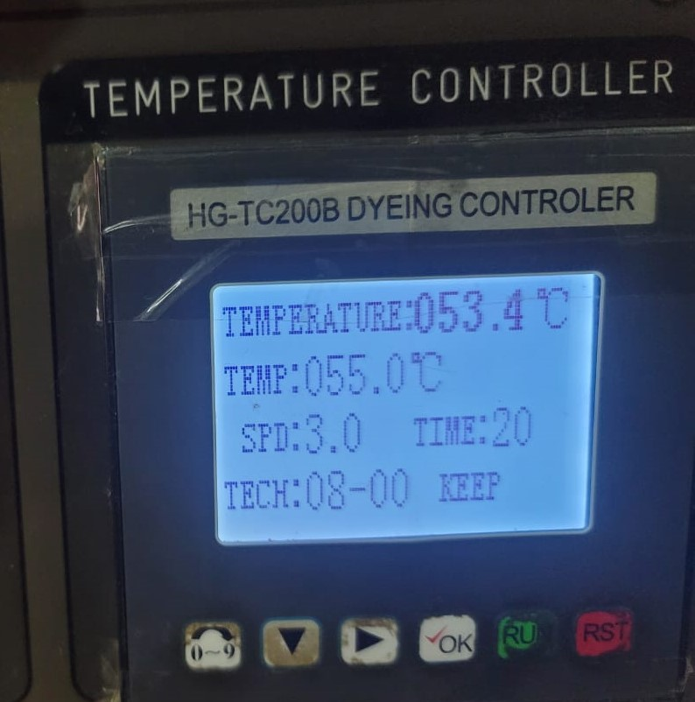
Figure 6: IR Dyeing Machine
Following the completion of M:L preparation, we initiated the dyeing process within an IR Dyeing Machine, maintaining a temperature of 55 ºC for a duration of 20 minutes.

Drying at 100 ºC:
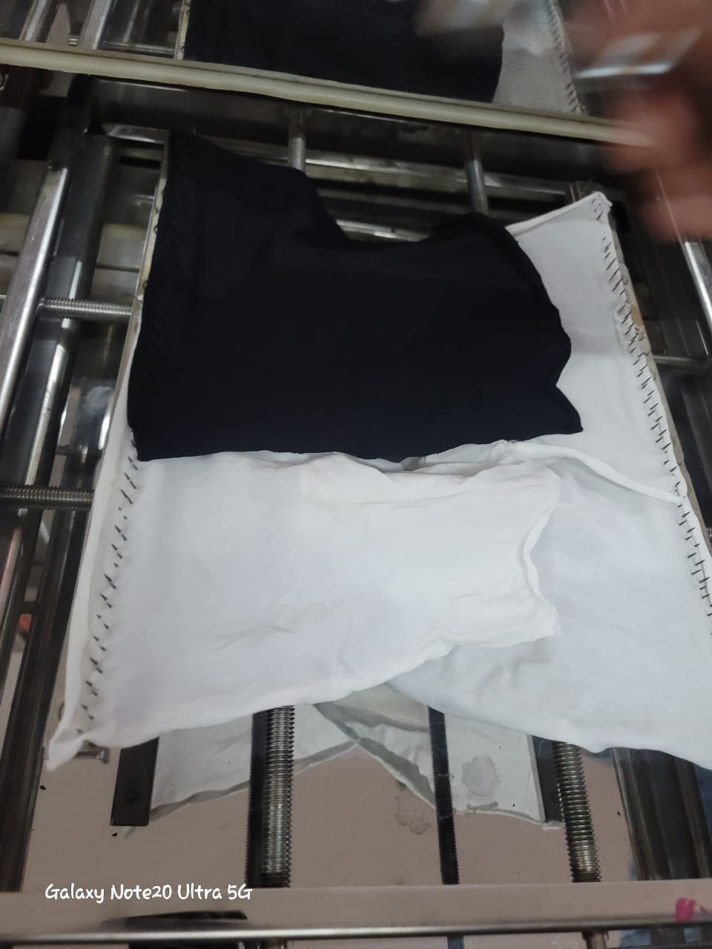
Figure 7: Drying at 100 ºC
Following the dyeing procedure, the fabric samples underwent a drying phase at a temperature of 100 ºC.
Curing at 160 ºC:
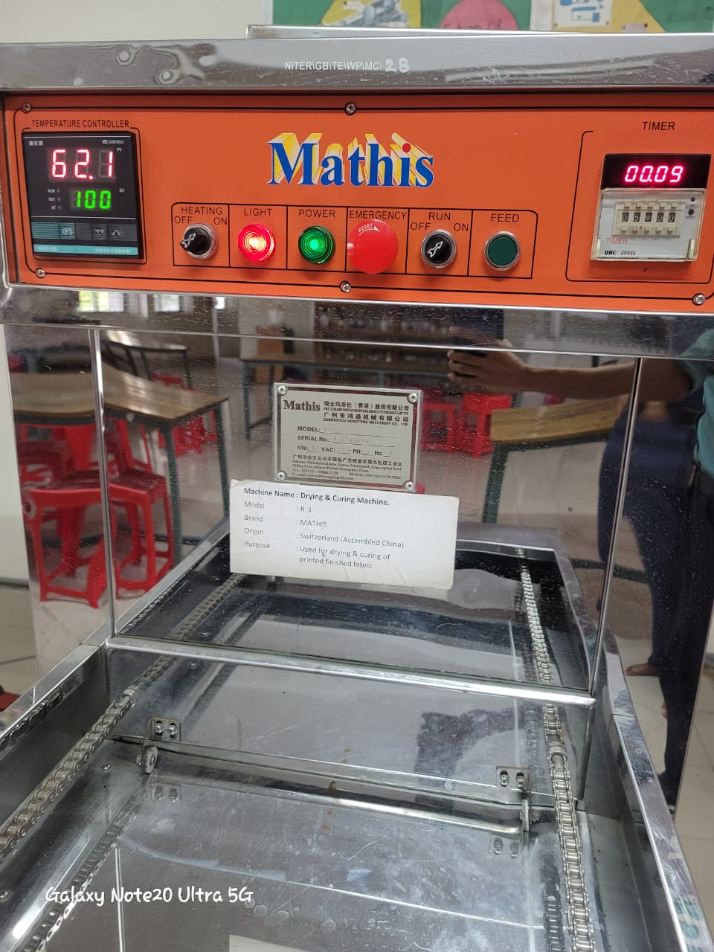
Figure 8: Curing

After curing that mosquito repellent finished fabric was prepared for test.

Methods
- The Exhaust Method was used to prepare the required finish sample.
- Following tests were done for the raw and finished fabric:

Box Test for mosquito repellency:

Prior to and after treating the fabric with mosquito repellent agents, fabric samples underwent testing using the box test method. Mosquitoes sourced from the NITER forest area were utilized for the experiment, with 15 mosquitoes introduced into the test box. A fabric sample was then placed over a hand inside the box. Given that mosquitoes are drawn to the warmth of human blood, their attraction to both untreated and treated fabric facilitated the evaluation process. The effectiveness of the treated fabric was assessed using a defined equation.:
(No. Of Specimen Escaped+ No. of Specimen Dead) *100
No. of Specimen Exposed

Mosquito Repellency % =

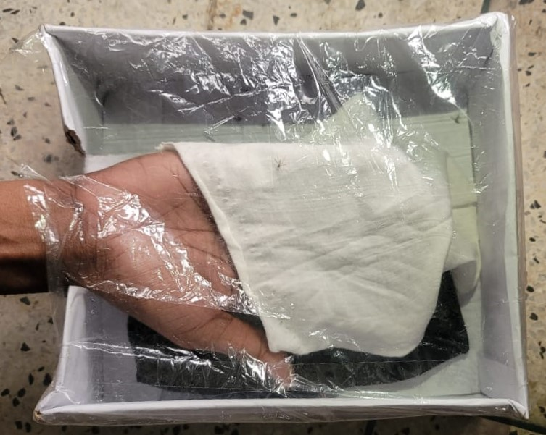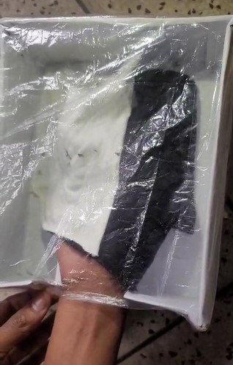
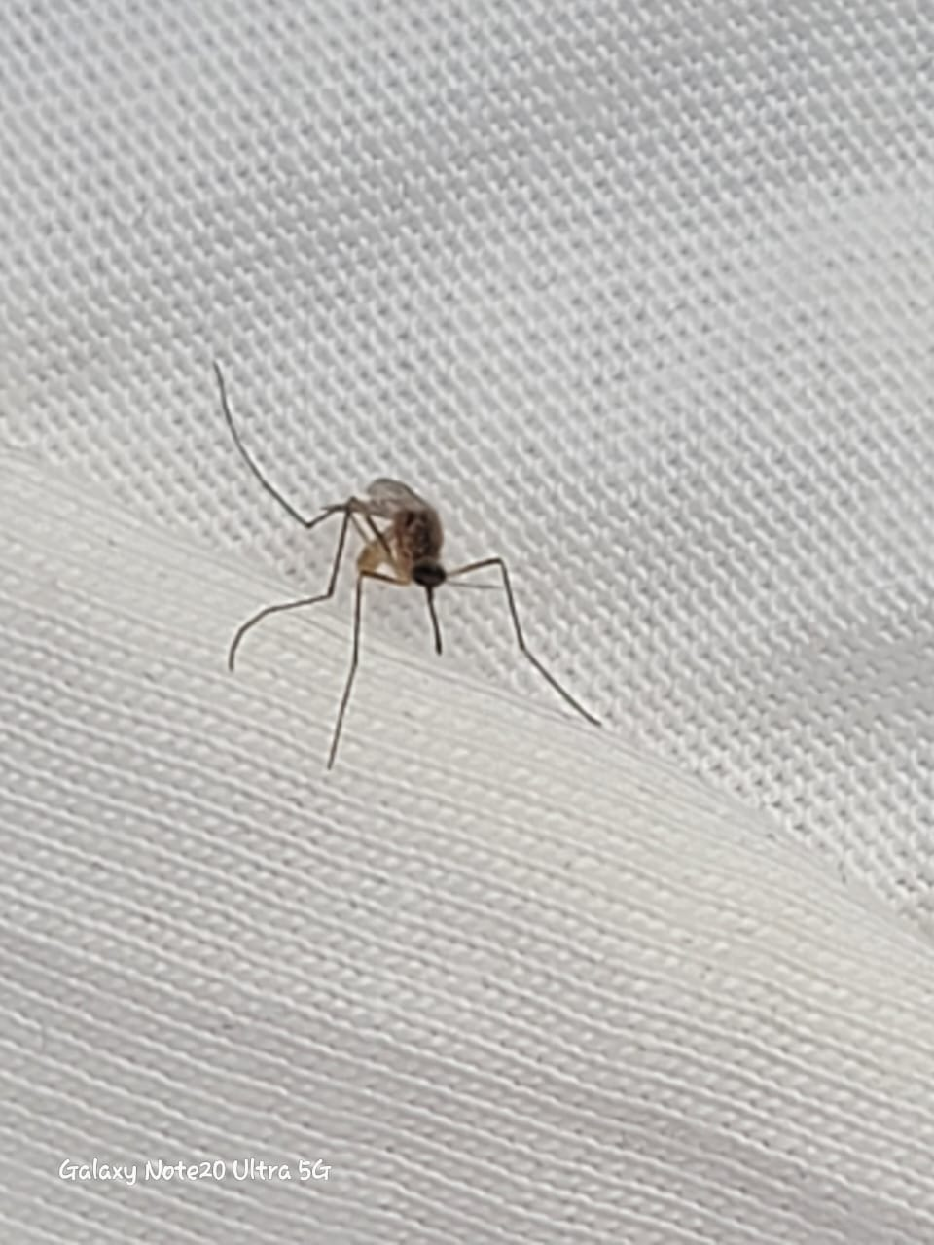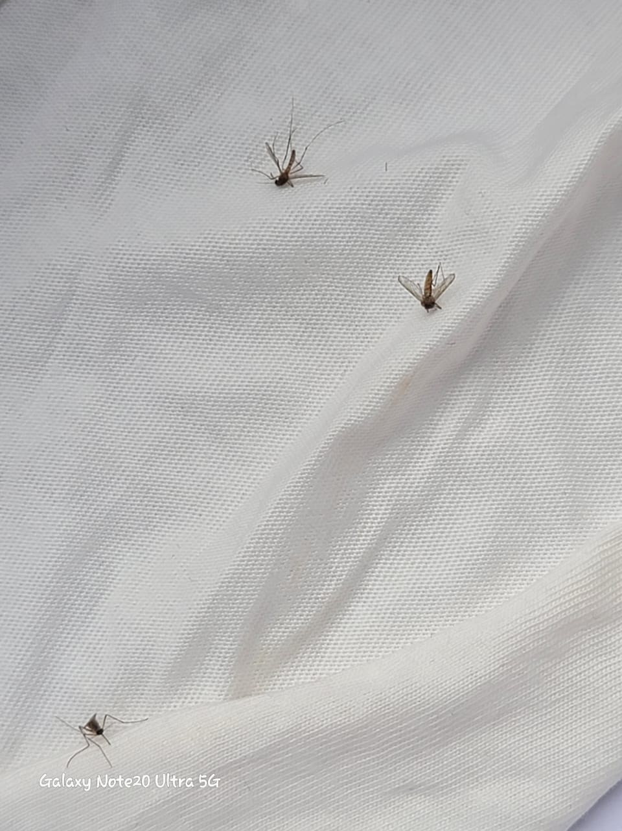
Figure 9: Box Test

GSM Test:


Figure 10: Fabric GSM Cutter

After mosquito repellency test, GSM test have been carried out for the finished fabric to show the weight variation for the sample before and after test. Before test GSM was 180, but after test it increased to 189.

Air Permiability Test:

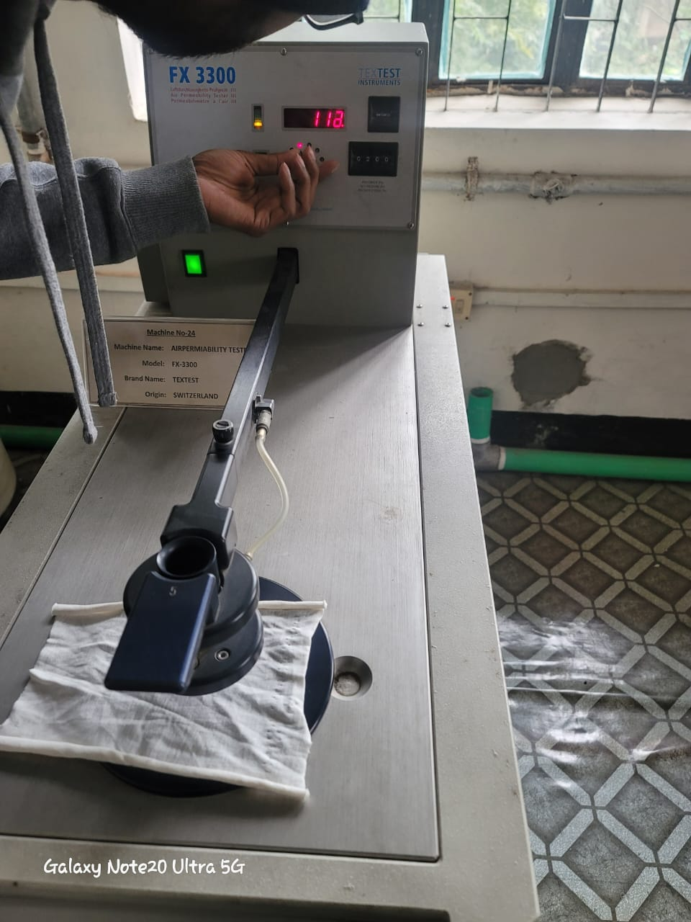
Figure 11: Air Permiability Tester

To assess the fabric's comfort level, an air permeability test was conducted on both untreated and treated samples at the NITER Quality Lab.
Machine Description:
Machine Name: Airpermiability.
Model: FX-3300.
Brand Name: TEXTEST.
Origin: Switzerland.

Bursting Strength Test:

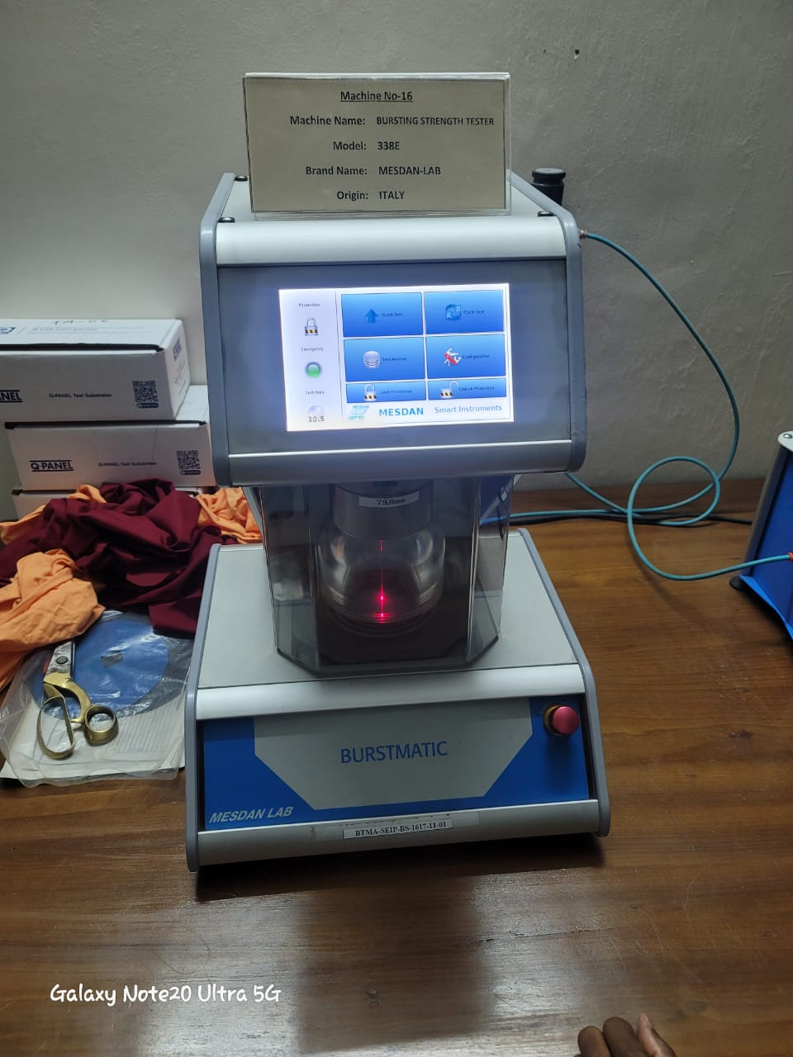
Figure 12: Bursting Strength Test
Also, for knitting fabric strength test i.e. bursting strength test was carried out in NITER quality lab to understand the strength variation of the sample due to repellent agent application.
Machine Description:
Machine Name: Bursting Strength Tester.
Mode: 338E.
Brand Name: MESDAN-LAB
Origin: Italy.

Color-fastness to wash (normal water and using detergent):

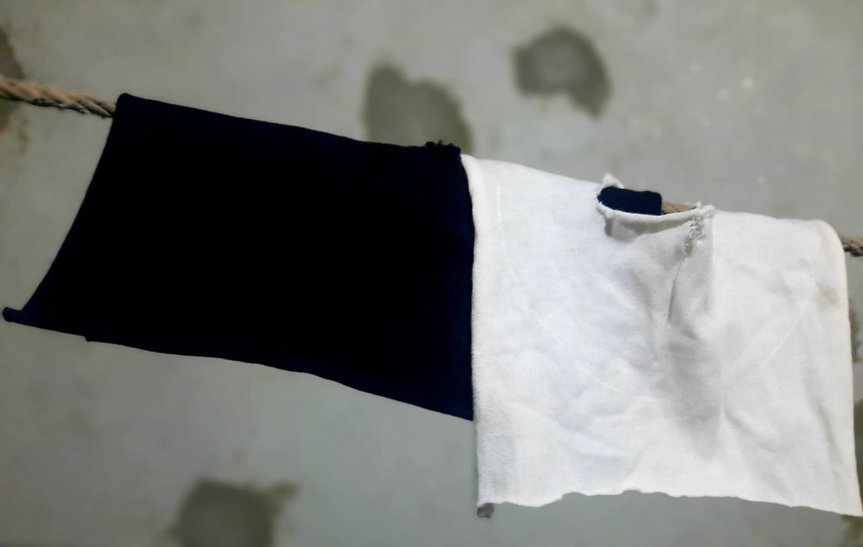
Figure 13: Washing Test
In the laboratory, an assessment was conducted to determine the durability of the finish and colorfastness to washing by employing a solution comprising normal distilled water and detergent. The detergent was applied at a ratio of 50% of the sample's weight, while the quantity of water used was adjusted accordingly. Color-fastness to wash denotes the capacity of a material to maintain its initial color following laundering with detergent in standard water. This evaluation gauges the fabric's resistance to fading or bleeding during washing, ensuring the enduring vibrancy and integrity of the color applied to the material.

Materials
Materials and Instruments:
Tea tree oil, eucalyptus oil & mint essential oil were used as natural ingredients, cotton fabric(knit) collected from Mitali Fashion Limited-Gazipur,
Measuring Cylinder, Distilled water, Weighting Balance, Glass-rode, IR Dyeing Machine was used for dying, Curing Machine for drying and curing.

RESULT AND DISCUSSION
The assessment of mosquito repellency involved the initial collection of Anopheles mosquitoes from a forested region, which were subsequently housed in a container equipped with air and oxygen ingress. Prior to conducting the experiments, the test mosquitoes underwent a fasting period, abstaining from both blood and sugar intake. The mosquitoes were gathered using a spacious flask to facilitate their preparation for the repellency behavior tests. It was essential to ensure the insects' physiological state before subjecting them to the repellency experiments [7].

Repellency test discussion:
The research introduced a novel approach to finishing cotton fabric by incorporating tea tree oil, eucalyptus oil, and mint essential oil as mosquito repellents. While the treated fabric demonstrated notable hygienic qualities, the efficacy varied across different finishes. Evaluation was conducted using a specified formula for each fabric and post-wash assessments. Despite initially robust results, the repellency of the finished fabric diminished after seven washes due to the superficial application of the extracts, lacking strong bonding to the fabric. Notably, the repellency of mint essential oil-treated fabric showed a more significant decline compared to tea tree oil and eucalyptus oil treatments for knit fabric. However, cotton fabric treated with eucalyptus oil and the combination of tea tree oil, eucalyptus oil, and mint essential oil exhibited similar repellency. Following seven washes, the repellency of mint essential oil-treated fabric substantially decreased, while other fabrics maintained partial repellency. Comparative analysis using a mosquito repellency percentage formula helped identify the most effective repellent chemicals.
Table 1: Comparison Table
S.  No. | Sample types | The total specimens exposed | No. of specimen escaped | Na, of specimen dead | Mosquito repellency in %
1 | Untreated -cotton fabric | 15 | 15 | 0 | 0
2 | Cotton fabric treated with tea tree oil | 15 | 8 | 5 | 86.67
3 | Cotton fabric treated with eucalyptus oil | 15 | 7 | 5 | 80
4 | Cotton fabric treated with mint essential oil | 15 | 7 | 4 | 73.34
5 | Cotton fabric treated with tea tree oil, eucalyptus oil & mint essential oil | 15 | 6 | 6 | 80

CONCLUSION
To sum up, our study concentrated on utilizing naturally derived mosquito repellent oils—such as tea tree oil, eucalyptus leaves, and mint—applied to 100% cotton fabric (knit) via the exhaust method. Our focus on natural elements was motivated by their effectiveness against disease-carrying insects, including those linked to malaria, dengue, filariasis, Zika, chikungunya, and yellow fever. We favored natural ingredients not only for their repellent qualities but also to minimize potential harm to humans and the environment, in line with the growing emphasis on eco-friendly and sustainable practices.

REFERENCES
[1] G. R. S.R. Affincy, “IRJET- Eco Friendly Fly Repellent Finish on Cotton Fabric using Vegetative Products,” Irjet, vol. 8, no. 7, pp. 4283–4287, 2021.
[2] N. Poonia and S. S. J. Singh, “Insect repellent fabric,” Pharma Innov. J., vol. 9, no. 5, pp. 65–71, 2020.
[3] A. Gupta, D. A. Singh, and A. Singh, “Eco-Friendly Mosquito Repelent Finish For Cotton Fabric,” Int. J. Curr. Res., vol. 9, no. 7, pp. 53434–53435, 2017.
[4] R. Mia et al., “Mosquito repellent finishes on textile fabrics (woven & knit) by using different medicinal natural plants,” J. Text. Eng. Fash. Technol., vol. 6, no. 4, pp. 164–167, 2020, doi: 10.15406/jteft.2020.06.00246.
[5] P. Kantheti, I. Rajitha, and A. Padma, “Natural finishes on textiles to combat the mosquitoes: A pilot study,” ~ 30 ~ J. Entomol. Zool. Stud., vol. 8, no. 2, pp. 30–33, 2020, [Online]. Available: http://www.entomoljournal.com
[6] B. Drago, N. S. Shah, and S. H. Shah, “Acute permethrin neurotoxicity: Variable presentations, high index of suspicion,” Toxicol. Reports, vol. 1, pp. 1026–1028, 2014, doi: 10.1016/j.toxrep.2014.09.007.
[7] G. B. Tseghai, “Mosquito Repellent Finish of Cotton Fabric by Extracting Castor Oil,” Int. J. Sci. Eng. Res., vol. 7, no. 5, pp. 873–878, 2016, [Online]. Available: http://www.ijser.org
[8] J. A. Klun, A. Khrimian, and M. Debboun, “Repellent and deterrent effects of SS220, picaridin, and deet suppress human blood feeding by Aedes aegypti, Anopheles stephensi, and Phlebotomus papatasi,” J. Med. Entomol., vol. 43, no. 1, pp. 34–39, 2006, doi: 10.1093/jmedent/43.1.34.
[9] R. Rout, “Mosquito Repellent Textile By Using,” vol. 5, no. 8, pp. 692–695, 2018.
[10] D. Of, M. Repellent, F. Using, B. Shoot, and N. Extract, “Journal of Engineering DEVELOPMENT OF MOSQUITO REPELLENT FABRIC USING,” vol. 8, no. 8, pp. 110–123, 2022.
[11] S. S and A. Thomas, “Microencapsulation of Herbal Composites for Mosquito Repellent Finishes in Bamboo and Modal Fabrics,” Int. J. Res. Ayurveda Pharm., vol. 9, no. 3, pp. 197–200, 2018, doi: 10.7897/2277-4343.09392.
[12] G. A. Elsayed and A. G. Hassabo, “Insect Repellent of Cellulosic Fabrics (A Review),” Lett. Appl. NanoBioScience, vol. 11, no. 1, pp. 3181–3190, 2022, doi: 10.33263/LIANBS111.31813190.
[13] Tarikuzzaman, M., Sagar, V., Wong, M. J., & Lynam, J. G. (2024). Temperature Effects on Physiochemical Characteristics of Sugar‐Based Natural Deep Eutectic Solvents. Advances in Materials Science and Engineering, 2024(1), 6641317.
[14] V. S. Shivankar, I. Shinde, A. Mulla, and P. P. Raichurkar, “Peer Reviewed: Eco-friendly mosquito repellent textiles,” Colourage, vol. 66, no. 4, 2019.
[15] R. Bano, “Use of Chitosan in Mosquito Repellent Finishing for Cotton Textiles,” J. Text. Sci. Eng., vol. 04, no. 05, pp. 4–6, 2014, doi: 10.4172/2165-8064.1000162.
[16] E. Sahin, F. Yildirim, and N. Büyükkayaci Duman, “Effect of Tea Tree Oil and Coconut Oil on Nipple Crack Formation in the Early Postpartum Period,” Breastfeed. Med., vol. 18, no. 3, pp. 226–232, 2023, doi: 10.1089/bfm.2022.0260.
[17] S. Afaf Farag, H. Osama, R. Mohamed, and H. Mohamed, “Development of Longer-Lasting Insect Repellence Cellulosic Based Curtain Fabrics,” Mater. Sci. Appl., vol. 02, no. 03, pp. 200–208, 2011, doi: 10.4236/msa.2011.23025.
[18] A. Singh and J. Sheikh, “Synthesis of a Novel Acid Dye to Impart Mosquito Repellency and UV Protection to Nylon,” Prog. Color. Color. Coatings, vol. 16, no. 2, pp. 207–219, 2023, doi: 10.30509/pccc.2022.167042.1190.
[19] Z. Sheikh et al., “Development of Mosquito Protective Textiles Using Nanoemulsion of Eucalyptus Globulus and Syzygium Aromaticum Essential Oils Against Malaria Vector, Anopheles Stephensi (Liston),” pp. 1–20, 2021, [Online]. Available: https://doi.org/10.21203/rs.3.rs-446207/v1.
[20] Iqbal, A., Abbas, R. N., Al Zoubi, O. M., Alasasfa, M. A., Rahim, N., Tarikuzzaman, M., ... & Iqbal, M. A. (2024). Harnessing the Mineral Fertilization Regimes for Bolstering Biomass Productivity and Nutritional Quality of Cowpea [Vigna unguiculata (L.) Walp]. Journal of Ecological Engineering, 25(7).
[21] Tarikuzzaman, M., Iqbal, M. A., & Lynam, J. G. (2024). Direct Contact Membrane Distillation of Artificial Urine for Sugar Beet Production in a Hydroponic System. Journal of Ecological Engineering, 25(10), 252-260.
[22] M. Ranasinghe, L. Arambewela, and S. S, “College of Chemical Sciences 1 , Institute of Chemistry Ceylon ,Adamantane House , No . 341 / 22 , Kotte INTRODUCTION : Mosquitoes are among the most disturbing blood sucking insects afflicting belonging to genera Anopheles , Culex and Aedes are vectors,” Int. J. Pharm. Siences Res., vol. 7 (9), no. May, pp. 3643-3648., 2018, doi: 10.13140/RG.2.2.17857.25443.
[23] Rabbi, F. (2018). Assessment of fuzzy failure mode and effect analysis (FMEA) for reach stacker crane (RST): A case study. International journal of research in industrial engineering, 7(3), 336-348.
[24] Tarikuzzaman, M., Shank, A. M., Agan, E. G., Sagar, V., Lynam, J. G., Gordon, I. I., ... & Alam, S. Tensile Strength and Porosity of Regolith-based Cement with Human Hair. Frontiers in Space Technologies, 5, 1448787.
[25] Rabbi, M. F. (2023). A novel approach for defect detection of wind turbine blade using virtual reality and deep learning (Master's thesis, The University of Texas at El Paso).
[26] Rabbi, M. F., Chakrabarty, N., & Shefa, J. (2018). Implementation of fuzzy rule-based algorithms in p control chart to improve the performance of statistical process control. International journal of research in industrial engineering, 7(4), 441-459.

