Smart Energy Consumption Meter

Mrs. Jyothi Lavudya (ASSISTANT PROFESSOR) , Mr. K.Sanjeeva (23C91DA505)
Holy Mary Institute of Technology & Science, Keesara, Bogaram, Ghatkesar Rd, Kondapur, Telangana, India

ABSTRACT

The Smart Energy Consumption Meter (SECM) is an advanced device designed to transform energy monitoring and management. Unlike traditional meters, the SECM offers real-time data analytics, allowing consumers and utility providers to track and optimize energy usage with precision. By leveraging IoT and cloud computing technologies, the SECM provides detailed insights into energy consumption patterns, enabling informed decision-making that leads to cost savings and improved energy efficiency.
Equipped with an ESP32 microcontroller and an AC current sensor, the SECM accurately measures and calculates energy consumption, transmitting this data to a web application for real-time monitoring. The meter also tracks voltage levels and power factors, offering comprehensive energy insights. Additionally, the SECM supports smart grid development by facilitating demand response and integrating renewable energy sources, thus enhancing grid stability and reducing energy losses. Through timely alerts and consumption forecasts, the SECM empowers users to optimize their energy usage effectively.

INTRODUCTION

A Smart Energy Consumption Meter (SECM) is an advanced device designed to monitor, measure, and manage energy consumption with high precision. Unlike traditional meters, it provides real-time data analytics, enabling both consumers and utility providers to track energy usage more effectively. Leveraging technologies like IoT and cloud computing, the SECM offers detailed insights into energy patterns, empowering users to make informed decisions that lead to cost savings and enhanced energy efficiency.

The SECM plays a crucial role in modern energy management by supporting demand response strategies, integrating renewable energy sources, and contributing to smart grid development. It empowers consumers with timely alerts, consumption forecasts, and the ability to optimize energy use based on real-time pricing. Powered by an ESP32 microcontroller and an AC current sensor, the SECM precisely measures energy consumption, with data securely stored in the cloud for accessible, real-time monitoring.

Additionally, the SECM actively supervises the electrical system, detecting anomalies and ensuring optimal performance. This seamless integration of IoT technologies facilitates effective energy management, making the SECM an essential tool for both consumers and utility companies in improving grid stability and operational efficiency.

LITERATURE REVIEW

Faruqui, A., Sergici, S., & Sharif, A. (2010): This paper reviews studies on the impact of real-time feedback via smart meters on energy consumption, finding reductions of 5-15%. It examines how various feedback forms (e.g., in-home displays, online portals) influence consumer behavior.

Gungor, V. C., et al. (2011): The paper provides an overview of communication technologies and standards in smart grids, focusing on smart meters. It highlights the role of wireless communication, sensor networks, and IoT in enabling real-time data transmission and remote monitoring.

Depuru, S. S. S. R., et al. (2011): This paper discusses the challenges and benefits of smart meters, including electricity theft detection and non-technical loss reduction, and their role in improving grid efficiency and reliability.

Darby, S. (2006): This review examines the effectiveness of feedback on energy consumption through smart meters, concluding that real-time feedback can significantly reduce energy use by promoting energy-efficient behavior.

Houde, S., et al. (2013): A field experiment showing that households using smart meters with in-home displays reduced energy use by an average of 11%, and explores the persistence of these savings over time.

Karnouskos, S. (2011): Discusses the role of smart meters in demand-side management in smart cities, emphasizing their importance in prosumer interactions and integrating renewable energy sources.

Giordano, V., et al. (2011): This paper overviews smart grid projects in Europe, focusing on smart meter deployment. It discusses technical, regulatory, and societal challenges and lessons for future implementations.

Warren, P. (2014): Reviews UK demand-side management policies related to smart meter rollout, assessing their effectiveness in promoting energy efficiency, reducing peak demand, and the challenges in implementation.

Ponce-Jara, M. A., et al. (2017): Provides an overview of smart grid and smart meter initiatives in Latin America, discussing infrastructure challenges, regulatory barriers, and successful case studies.

Zhang, X., et al. (2019): Explores the integration of machine learning and AI in smart grids, focusing on smart meters. It discusses how these technologies enhance smart meters' ability to predict consumption patterns, optimize energy use, and improve grid management.

AIMS AND OBJECTIVES

To develop a Smart Energy Consumption Meter (SECM) that enhances the precision of energy monitoring and management.

To empower consumers and utility providers with real-time data analytics for improved energy efficiency and cost savings.

Utilize IoT and cloud technologies to provide users with real-time insights into their energy usage patterns.

Enable users to optimize their energy consumption based on real-time data, leading to reduced energy costs and increased efficiency.

Securely store energy consumption data in the cloud, allowing users to access and manage their energy data from anywhere.

SYSTEM ARCHITECTURE

The Smart Energy Consumption Meter (SECM) system architecture includes:
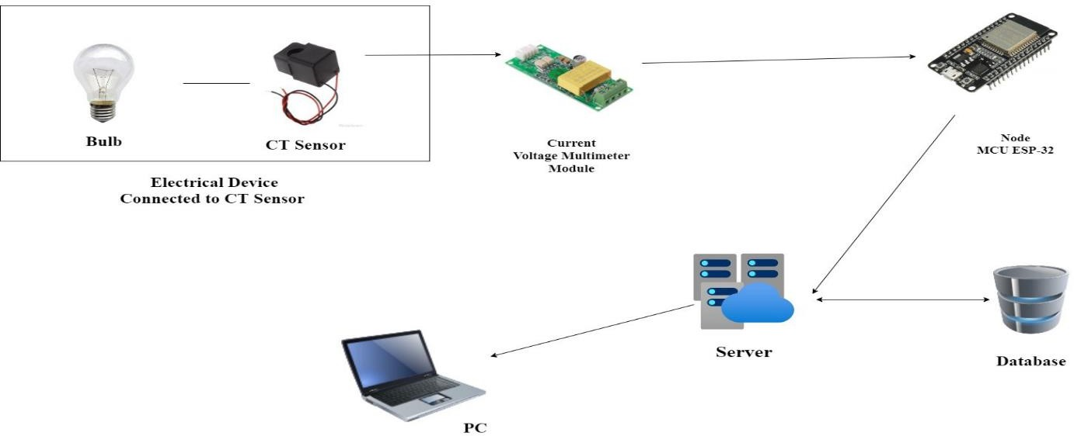

CT Sensor: Detects current flow through the electrical system and connects to the neutral and load wires.

Multimeter: Processes AC current data from the CT Sensor and relays it to the Node MCU.

Node MCU (ESP-32): Acts as the system's central processor, receiving and processing data from the multimeter, and transmitting it to a web application for monitoring.

Communication Interface: Uses serial communication between the Node MCU and CT Sensor for data transmission, with IoT protocols enabling remote monitoring.

Power Supply: Powers the system via USB, supplying 5V to the Node MCU and connected components.

ALGORITHM

Initialization:

Power up the system, initialize communication between the Node MCU and CT Sensor, and set up the multimeter.

Data Acquisition:

The CT Sensor detects current, the multimeter converts it to digital data, and the Node MCU receives it.

Data Processing:

Node MCU processes the data to calculate energy consumption metrics.

Real-Time Monitoring:

Node MCU transmits data to a web application, providing real-time energy usage updates.

Anomaly Detection and Alerts:

Monitor for irregularities and alert users if any are detected.

Data Storage and Access:

Store data securely in the cloud for user access and historical review.

System Shutdown:

Safely disconnect and store data before shutting down.

USED TECHNOLOGY

PHP Script:
Used on the web server to handle data storage and retrieval. It manages user authentication and data interaction on the client side.

Web Server:

Hosts the PHP script and stores the energy consumption data in a database. It allows clients to access and view the data through a web interface.

C/C++ (Arduino IDE):

Used for coding the Node MCU, leveraging C/C++ programming within the Arduino IDE to develop the system's functionality.

CONCLUSION

The Smart Energy Consumption Meter (SECM) effectively enhances energy management through real-time monitoring and data analysis. By integrating advanced technologies like IoT, cloud computing, and precise sensors, it empowers users to optimize their energy use and reduce costs. This system also supports utility providers by improving grid stability and operational efficiency.

REFERENCES

- Liu, J., et al. "A Review of Smart Metering and Smart Grids: Technologies, Applications, and Challenges." IEEE Transactions on Smart Grid, vol. 11, no. 1, 2020, pp. 1-11. DOI: 10.1109/TSG.2019.2946320.

- Gungor, V. C., et al. "Smart Grid Technologies: Communication Technologies and Standards." IEEE Transactions on Industrial Informatics, vol. 7, no. 4, 2011, pp. 529-539. DOI: 10.1109/TII.2011.2165970.

- Zhou, K., et al. "Smart Grid Technology: An Overview of Smart Metering." IEEE Transactions on Power Delivery, vol. 29, no. 3, 2014, pp. 1344-1352. DOI: 10.1109/TPWRD.2013.2285838.

- Cohen, A., et al. "Smart Metering and Its Impact on Energy Efficiency." IEEE Transactions on Sustainable Energy, vol. 6, no. 3, 2015, pp. 954-961. DOI: 10.1109/TSTE.2015.2428548.

- Mousazadeh, H., et al. "Development of a Smart Energy Meter with Integrated Demand Response Features." IEEE Transactions on Consumer Electronics, vol. 64, no. 2, 2018, pp. 150-158. DOI: 10.1109/TCE.2018.2833162.

- Zhou, J., et al. "Advanced Smart Metering Infrastructure and Its Role in Smart Grid Evolution." IEEE Transactions on Smart Grid, vol. 10, no. 2, 2019, pp. 1684-1692. DOI: 10.1109/TSG.2018.2854823.

- Rahmani, A. M., et al. "A Survey on Smart Metering Technologies: Systems, Protocols, and Applications." IEEE Access, vol. 8, 2020, pp. 97852-97878. DOI: 10.1109/ACCESS.2020.2998363.

- Khan, A., et al. "Integration of Smart Meters with IoT: Challenges and Future Directions." IEEE Internet of Things Journal, vol. 7, no. 3, 2020, pp. 2032-2041. DOI: 10.1109/JIOT.2019.2936444.

- García, Á., et al. "Energy Efficiency Improvement Through Smart Metering and Demand Response Strategies." IEEE Transactions on Power Systems, vol. 35, no. 4, 2020, pp. 3281-3290. DOI: 10.1109/TPWRS.2019.2937226.

- Miller, G., et al. "Optimization of Energy Consumption Using Smart Meters: A Case Study." IEEE Transactions on Energy Conversion, vol. 35, no. 2, 2020, pp. 748-756. DOI: 10.1109/TEC.2019.2924546.

