**FEASIBILITY STUDY OF THE WIND ENERGY HARVESTING POTENTIAL IN SAN ISIDRO, BACOLOR, MEGA DIKE ACCESS ROAD FOR SUSTAINABLE ROADWAY LIGHTING**

**Louise Anthony Apostol1, Jhon Rich Balingit2, Karl Enzo Bognot3, Roi Nino Manalo4, Allysson Ashlly Tanhueco5**

1Student of Electrical Engineering Department at Don Honorio Ventura State University,

Bacolor, Pampanga

2Faculty of Electrical Engineering Department at Don Honorio Ventura State University

2020100902@dhvsu.edu.ph1

2020100833@dhvsu.edu.ph2

2020100917@dhvsu.edu.ph3

2020101026@dhvsu.edu.ph4

2020101112@dhvsu.edu.ph5

**ABSTRACT**

This paper analyses the wind speed in San, Isidro, Bacolor Megadike Access Road. Also, the [feasibility study](https://www.sciencedirect.com/topics/engineering/feasibility-study) of implementing [wind turbines](https://www.sciencedirect.com/topics/engineering/wind-turbine) to take advantage of wind powered roadway lighting is reviewed and then the subject of wind speed and wind potential at different stations is considered. This energy can be harvested using vertical axis wind turbines (VAWT). This paper utilized wind speed data over a period of 2 months between January to February from 3 locations, the first location has a plus code of 2JHX+77H. The location one is located across the San Isidro approach and has an open area where no trees can obstruct the wind. Location two has a plus code of 2JGX+XFW and is 100 meters apart from the location one. The third location has a plus code of 2JGX+MMW, to assess the wind power potential at these sites. In this paper, the hourly measured wind speed data at 3 meters, 5 meters and 8 meters height for San, Isidro, Bacolor Megadike Access Road have been constantly analysed to determine the potential of [wind power generation](https://www.sciencedirect.com/topics/engineering/wind-power-generation). The results showed that most of the locations have an average wind speed of 5.83 m/s and 6.83 m/s which is considered as acceptable for installation of wind turbines. Location 1 has higher [wind energy potential](https://www.sciencedirect.com/topics/engineering/wind-energy-potential) with January and February wind speed average of 6.83 m/s, at height of 8 meters   above ground level. This site is a good candidate for remote area wind [energy applications](https://www.sciencedirect.com/topics/engineering/energy-application). This work presents a study of using a H Darrieus VAWT specially designed for applications where less power is needed. The designed turbine has a power output of 636.064W, a torque value of 88.797 N.m, and a tip speed ratio (TSR) of 1.2699. The findings of this feasibility study will provide valuable insights into the viability of wind energy harvesting for sustainable roadway lighting in San Isidro, Bacolor. Megadike Access Road.

**Keywords:** Vertical Axis Wind Turbine, H- Darrieus, Feasibility study, Wind energy harvesting, Wind speed, Power output and Wind potential

1. **INTRODUCTION**

Wind energy harvesting for electricity generation, which was initially introduced in 1970, has become increasingly popular as the world shifts towards a carbon neutral renewable energy focus. Wind energy plays a crucial role in addressing the issues related to the depletion of fossil fuels and the environmental problems they cause. It also helps meet the increasing energy demand resulting from population growth, economic development, urbanization, changes in lifestyles, and technological advancements. [1,2]

**1.1 Wind Turbine**

The rotor blades of a wind turbine, which function similarly to an airplane wing or a helicopter rotor blade, use aerodynamic force to convert wind energy into electrical power. The air pressure on one side of the blade drops as the wind blows across it. Both lift and drag are produced by the difference in air pressure on the two sides of the blade. The rotor rotates because the lift force is greater than the drag force. If the turbine is direct drive, the rotor is connected to the generator directly; otherwise, it is connected through a gearbox, which consists of a shaft and a set of gears that accelerate rotation and enable a smaller generator. Electricity is produced by this conversion of aerodynamic force to generator rotation. [3] Advancements in wind turbine technology continually enhance their efficiency, reduce noise levels, and enable them to harness energy from a broader spectrum of wind velocities. Wind power currently constitutes a significant proportion of the global energy blend and is crucial for reducing greenhouse gas emissions and stopping climate change. Due to its renewable nature, wind energy is being heavily invested in by numerous countries, with continuous advancements in technology to cater to the growing global energy demand.

**1.1.1 Horizontal Axis and Vertical Axis Wind Turbines**

The Horizontal Axis Wind Turbine (HAWT) is the prevailing configuration for turbines. The propellers and turbine mechanisms are elevated on a massive pedestal, situated well above the ground. Whether they improve the landscape is subjective and depends on personal preference. Nevertheless, it is undeniable that the elevated positioning of their mechanisms poses a drawback when maintenance is necessary. In addition, a mechanical yaw system is necessary to align them so that their horizontal axis is at a right angle to the wind and facing it directly. The potential power generation is directly proportional to the swept area (diameter) of the rotor. Therefore, a larger diameter is necessary to generate more power. The blades endure significant thrust and torque forces; thus, their size is constrained by the strength of the blades [4]

Figure 1 displays multiple conventional vertical-axis wind turbines. The vertical-axis wind turbines rotate around their vertical axes, which are perpendicular to the ground. One notable benefit of vertical-axis wind turbines is their ability to harness wind from any direction, eliminating the need for yaw control. By allowing the wind generator, gearbox, and other primary turbine components to be installed on the ground, the design and construction of the wind tower are significantly simplified, resulting in a reduction in the cost of the turbine. Nevertheless, vertical-axis wind turbines require an external energy source to initiate the rotation of the blades. The wind turbine's axis is supported solely at one end on the ground, which imposes a practical height limitation. [5]

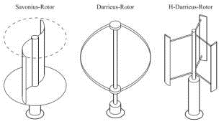.

**Figure 1:** Different types of vertical axis wind turbine

**1.1.2 Vertical Axis Wind Turbines**

VAWTs exhibit a diverse array of physical structures and possess intricate aerodynamic properties. Vertical axis wind turbines (VAWTs) were not only the initial wind turbines to be created, but they have also been constructed and operated on a scale comparable to some of the largest wind turbines ever manufactured. Vertical-axis wind turbines (VAWTs) have the potential to achieve coefficients of performance (Cp max) that are similar to those of horizontal-axis wind turbines (HAWTs). Additionally, VAWTs possess several notable advantages over HAWTs.

One advantage of Vertical Axis Wind Turbines (VAWTs) is their ability to accept wind from any direction due to their cross-flow design. Therefore, in theory, they do not require a yaw mechanism to ensure their alignment with the wind, unlike horizontal axis machines. Another significant benefit is the ability to directly connect the mechanical load to the VAWT rotor shaft, which can be positioned at ground level. This eliminates the necessity of a large tower to bear the load of equipment such as the gearbox, generator, and yaw mechanism.   
Small-scale turbines do not require slip rings or flexible cables to connect the generator to the load, eliminating the need for such components.

**1.1.3 VAWT Types**

Over the past few decades, numerous types of Vertical Axis Wind Turbines (VAWTs) have been suggested, and several comprehensive bibliographies have been released that provide an overview of the research and progress made in developing these devices. One notable survey on VAWTs is the one conducted by Abramovich [6].

**1.1.3.1 Savonius Turbines**

The Savonius turbine has gained popularity among wind turbine developers, both professional and amateur, due to its straightforward and sturdy design.

Several iterations of the Savonius rotor have been devised and evaluated. Nevertheless, the Savonius turbine has not been utilized for large-scale electricity generation due to its inherently high solidity and consequent high mass.

The Savonius rotor is mainly a device that generates drag, but it also benefits from improved performance due to the airflow across each vane and the interaction between the two halves of the rotor. All drag machines possess a low operating tip speed ratio. Devices with higher tip speeds are more suitable for electricity generation compared to this one. This is because a high shaft speed is generally preferred to reduce the need for a high step-up ratio in the gearbox that connects the rotor to a conventional electrical generator.

**1.1.3.2 Darrieus Turbines**

The invention of Darrieus in 1931 [7], which involved a rotor with a high tip speed ratio, created new possibilities for VAWTs in terms of generating electricity. Darrieus made a significant advancement by finding a way to increase the speed of the blades in a vertical axis wind turbine (VAWT) beyond the speed of the wind. This allowed for the use of lift forces to greatly enhance the performance of VAWTs, surpassing previous designs that relied mainly on drag. Darrieus also anticipated numerous realizations of his fundamental concept that would be tested on a large scale many decades later. These included the utilization of both curved-blade, as depicted in figure 1.2, and straight blade variations of his rotor. In addition, he suggested potential strategies for actively managing the pitch of the blades in relation to the entire rotor, with the aim of maximizing the wind's angle of attack on each blade as it moves around the circumference of the rotor.

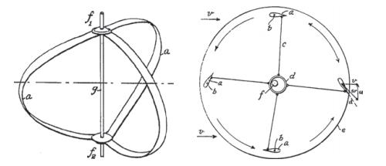

**1.1.3.3 Straight-blade VAWTS**

The name Darrieus is commonly linked to the variant of Darrieus' patent that features curved blades. Considerable effort over the last thirty years has been dedicated to the advancement and examination of the straight blade iteration of his initial creation, commonly referred to as the H-VAWT due to the shape of its blades and supporting spars.

The Darrieus family of turbines is known for having a restricted ability to start on their own due to inadequate torque to overcome initial friction. This is mainly due to the fact that at low rotational speeds, the lift forces on the blades are minimal. This is especially true for two-bladed machines, where the torque generated by each stationary blade during start-up is almost identical, regardless of the rotor's azimuth angle in relation to the direction of the incoming wind. In addition, the blades of a Darrieus rotor experience a condition called stall at low tip speed ratios for most azimuth angles. Consequently, in order for the rotor to gain speed in a specific wind velocity, it is typically necessary to operate large commercial machines at a sufficiently high tip speed. [8]

The self-starting capability of a rotor can be improved by implementing various strategies such as: increasing the solidity of the blades; using an odd number of blades; incorporating a blade pitch mechanism; and utilizing blades that are skewed, causing the blade azimuth angle to vary with axial distance along the rotor. Hill has recently reported a study on the self-starting characteristics of small Darrieus machines. [9]

The quantity of blades directly impacts the smoothness of rotor operation by providing the ability to counteract cyclic aerodynamic loads. The rotor torque fluctuation was higher for turbines with an even number of blades, such as two blades, compared to turbines with an odd number of blades, such as a three-blade turbine. This behavior could provide a significant benefit for three-bladed small VAWT architectures, where the higher costs of manufacturing and installation are less significant compared to larger rotors. [21]

Amidst a period characterized by the rise of cities and a greater dependence on renewable energy, there is a critical demand for creative approaches to improve road safety and advance sustainability. Highways, functioning as the primary means of transportation, frequently experience accidents, especially in situations with limited visibility. [10] The incidence of road accidents in the Philippines is experiencing a significant and swift rise. Road accidents in the Philippines commonly occur as a result of specific factors, including exceeding the speed limit through reckless driving, driving under the influence of alcohol, and using a phone while driving. Furthermore, an additional significant factor contributing to these road accidents is the absence of streetlights, resulting in poorly illuminated streets during nighttime. A significant proportion of nocturnal road accidents are attributed to limited visibility, inadequate streetlight design, or the absence of streetlights. According to global road crash statistics, approximately 3000 fatalities occur daily, resulting in a total of 1.3 million casualties from car accidents each year [11].

Due to the absence of streetlights in the current environment of Mega Dike, Bacolor Pampanga, drivers face an increased risk while driving, particularly at night. Nocturnal driving poses significant risks and presents more demanding circumstances for the majority of motorists. The nocturnal fatality rates are threefold higher than the diurnal fatality rates [12]. Mega Dike Road is a high-risk area for accidents, particularly at night, because it lacks streetlights. According to SunStar's report from 2014, a collision occurred between a motorcycle and a sports utility vehicle on the Eastern Mega Dike route in Barangay San Isidro, Bacolor, Pampanga. This accident resulted in the fatalities of both drivers and injuries to one passenger [13]. In 2017, a car accident occurred on Mega Dike Road, resulting in injuries to three passengers and the death of a Central Luzon police officer [14]. Road lighting is crucial for road users, as it helps illuminate dark areas and enhances safety while driving. It also facilitates efficient transportation by ensuring timely visibility [15]. Utilizing wind energy potential for sustainable roadway lighting is a significant step towards a safer and more energy-efficient future for the current generation. This innovative initiative seeks to transform conventional road lighting systems by utilizing the potential of wind energy, an inexhaustible and eco-friendly power source. Wind energy production can be sporadic due to its reliance on the presence of wind. The presence of substantial turbulence and the inherent difficulties in accurately forecasting wind speed pose considerable obstacles to wind harvesting [16].

The primary goal of this research is to assess the feasibility of the wind energy harvesting potential in San Isidro, Bacolor, Mega dike Access Road for sustainable roadway lighting. Additionally, the study seeks to accomplish the following objectives: to conduct a site suitability analysis to identify the locations for installing vertical axis wind turbines along the roadway for energy harvesting, and to evaluate the potential energy output of the wind turbines based on the assessed wind energy.

1. **METHODOLOGY**

The study was conducted using the Waterfall methodology, which prioritizes a sequential progression from the start to the completion of a project. This approach will achieve long-lasting roadway illumination in San Isidro, Bacolor, and Megadike access roads. The researchers have chosen the Waterfall development process due to its adherence to a sequential approach and its reliance on tangible results. Moreover, the implementation of the changes is straightforward during the initial stages of the development process.

**3.1 Data Gathering**

Data gathering is a crucial step in any research or analysis process. Having wind speed data in Mega dike access road is the first step in determining the feasibility of wind power potential. According to PAGASA Clark Synoptic/Airport weather station, there is no available wind speed data in Mega dike access road since their wind velocity measuring instrument can only measure up to a certain range where it is located. Since there is no available data, the researchers were advised to explore other sources or methods to obtain wind speed data for the Mega dike access road. The researchers used a handheld anemometer to measure wind speeds at different locations along the San Isidro, Bacolor, Mega dike access road. This direct measurement approach provided the researchers with on-site wind speed data, which was later used in their analysis of wind power potential in the area. The researchers measured wind speed hourly for a period of two months to gather sufficient data for analysis. The researchers measured wind speeds in three different locations along San Isidro, Bacolor, Mega dike access road to ensure a comprehensive understanding of wind patterns in the area. The locations are 100 meters apart and were strategically chosen to capture variations in wind speed along the Mega dike access road. The researchers also measured three different heights (3 meters, 5 meters, and 8 meters above ground level) to observe any variations in wind speed with height.

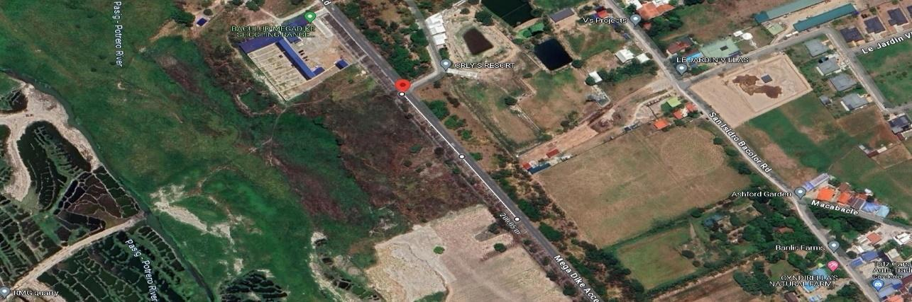

**Figure 3:** Locations of the measured wind speed

The Figure above shows the three locations where measuring of wind speed was conducted. The first location has a plus code of 2JHX+77H. The location one is located across the San Isidro approach and has an open area where no trees can obstruct the wind. Location two has a plus code of 2JGX+XFW and is 100 meters apart from the location one. The third location has a plus code of 2JGX+MMW and is 200 meters apart from the first location.

**3.2 Designing**

The designing phase of this study includes determining the applicable type and specification of the wind turbine, theoretical computations of the wind turbines output based on the available wind speeds in the area, and using Solid works application for the wind turbine CFD analysis.

**3.2.1 Wind turbine**

The design of the turbine was based on the development of the H-Darrieus vertical axis wind turbine by Ibrahim Gaber Abd. Based on the initial assessment of the available wind speeds in San Isidro, Mega dike access road, the H-Darrieus type of vertical axis wind turbine is the applicable wind turbine because it was designed for small scale and low wind speeds scenarios. The researchers may increase the swept area of the turbine to obtain higher power output from the wind.

|  |  |  |
| --- | --- | --- |
| Turbine swept area | 3 | m2 |
| Turbine diameter | 1.5 | m |
| Blade length | 2 | m |
| Number of blades | 3 | blades |
| Optimum Tip speed ratio | 2.5 | - |
| Airfoil | NACA 0020 | - |
| Fixed pitch angle | 6 | degree |

**Table 1:** Turbine main design data developed by Ibrahim Gaber [19].

Table 1 shows the configuration of the wind turbine developed by Ibrahim Gaber. It has a turbine diameter of 1.5 meters, blade length of 2 meters, and a turbine swept area of 3 square meters. It has 3 blades and uses NACA 0020 airfoil. The fixed pitch angle of the blades is 6 degrees.

**3.2.1.1 Optimum Tip Speed Ratio**

The angle of attack must be set to achieve a high lift coefficient (CL), a low drag coefficient (CD), and a high momentum coefficient (Cm). Then we select the AoA based on these concepts. The analysis computed the coefficient of lift-to-drag ratio (CL/CD) and the coefficient of lift (C).

**3.2.1.2 Airfoil**

The airfoil selection analysis will determine the most appropriate airfoil for a vertical axis wind turbine (VAWT) based on optimal values of angle of attack (AoA), lift and drag coefficient (CL/CD), torque, and coefficient of power (CP). We selected NACA [0012-0015-0018-0020-0021-4415] airfoils for our investigation. NACA airfoils refer to specific airfoil shapes designed for aircraft wings, which were developed by the National Advisory Committee for Aeronautics (NACA). The calculation of analysis will be performed using the XFOIL algorithm and DMST simulation. First, we analyze the impact of each parameter on all airfoil types and identify the optimal parameter values for each type. Then, we compare the optimal values and types of airfoils to select the most suitable airfoil.

**3.2.1.3 Fixed Pitch Angle**

The impact of pitch angle was examined using the Computational Fluid Dynamics (CFD) 6-DOF method, with a constant mass moment of inertia of 1.39 kg.m2. The turbine is designed to withstand forces at a wind speed of 6.83 m/s. Obtained from a Computational Fluid Dynamics (CFD) simulation, the data corresponds to a 6-degree pitch angle in a 6-degree-of-freedom (6-DOF) system. In this case, we opted for a rotational speed of 350 RPM as a precautionary measure.

**3.2.2 Computation**

The following formulas were used to compute the output values of the wind turbine and were incorporated in the simulation software to obtain output values.

**Sweep area of the turbine [17]**

For VAWT:

$A=D x H$

*where:*

*D = Diameter*

*H = Turbine height*

*A = Area*

**Calculate the available wind power [17]**

Once you know the swept area, you can find the available wind power according to this formula:

**Pout​= 0.5 ρ v3 A**

*where:*

*A = Sweep area (m2)*

*ρ = Air density (1.225 kg/m³)*

*v = Wind speed (m/s)*

*Pout​ = Available wind power (watts)*

**Calculating the torque [17]**

The torque (or the force causing the rotation of the blades) is calculated from the tip speed ratio (TSR) of the turbine.

$τ=\frac{p_{0}}{RPM}x\frac{30}{π}$

*where:*

*RPM = Revolutions per minute*

*τ = Torque (Nm)*

**Calculating the number of revolutions per minute [17]**

For VAWT:

$RPM=60 x v x\frac{TSR}{πxD}$

*where:*

*v = Wind speed (m/s)*

*TSR = Tip speed ratio*

*D = diameter of the rotor (m)*

**Tip Speed Ratio [17]**

$TSR=\frac{Rω}{V_{0}}$

*where:*

*R = radius of the rotor (m)*

$ω$*= angular velocity (rad/s)*

$V_{0}$*= wind velocity (m/s)*

**3.2.3 Pulley**

**d1​ n1= d2​ n2**

*where:*

*d1 = diameter of the driver pulley (m)*

*n1 = speed of the driver pulley (rpm)*

*d2 = diameter of the driven pulley (m)*

*n2 = speed of the driven pulley (rpm)*

**3.2.4 Simulation of the wind turbine**

After obtaining the output values of the wind turbine based on the gathered wind speed in the area, the researchers proceeded in computational fluid dynamics (CFD) analysis of the wind turbine using Solid works software. The simulation can give the power output, torque, angular speed, and tip speed ratio of the wind turbine on different wind speeds.

**3.2.5 Determining the size of the generator**

In determining the size of the generator, the torque output, angular velocity, and power output of the wind turbine must be considered. The ideal generator for the turbine should be able to efficiently convert the mechanical energy from the rotor into electrical energy while meeting the power requirements of the system. A low rated rpm generator with high torque capability would be suitable for a wind turbine operating at low rotational speeds.

**3.2.6 Determining the number of loads**

The capacity of the generator will determine the number of loads that can be powered. The size of the load will depend on the lamp wattage requirement on a specific road type according to the placement guide for roadway lighting given by the Department of Energy

**3.2.7 Design and specification of the roadway lights**

**3.2.7.1Structural System of the lighting**

**Pole Height**

The specified pole height must ensure that the illumination intensity and uniform brightness of the covered area align with the standards outlined in Table 2. To obtain information regarding height and illumination recommendations, please consult Table 2.

**Pole Placement**

The selection of pole placement shall be determined by considering the geometry, character of the roadway, physical features, environment, maintenance policy, economics, aesthetics, and overall lighting objectives. To determine the pole configuration, consult the limits specified on DOE manual page.

**Lighting Arrangement**

A unilateral arrangement, where all lighting fixtures are positioned on one side of the road, should be employed when the road width is equal to or less than the mounting height.

**Mounting Height**

The mounting height refers to the vertical distance between the center of the lamp and the surface of the ground

**Spacing**

Spacing is the measurement of the horizontal distance between poles that support the luminaire.

Since the Mega dike access road has a width of 7 meters and is classified as a minor road, the lighting poles are arranged in one-sided. The lamp wattage required for the road is 70 watts and a spacing of 10 to 40 meters apart. The mounting height of the lamp is 8 meters and has a mast arm length of 1.5 meters.

**3.2.7.2 Design Consideration for Road Lighting**

The primary factors that determine the lighting of roads for motorized traffic are the luminance level and uniformity of the carriageway, the illuminance level of the surrounding areas, the limitations of disability and discomfort glare, and the need for clear visual guidance. The lighting criteria employed include the maintained average road surface Luminance (Lav), the overall (Uo) and longitudinal (Ul) uniformity of the Luminance, the surround ratio (Rs), and the threshold increment (TI).   
The values mentioned are specifically applicable to roads that are of sufficient length to allow for the use of the luminance concept. The consideration of the surround ratio is only applicable to roads that have an adjacent footpath/cycle path, unless there are specific requirements stated [20].

**3.3 Implementation**

The gathered data for the wind speed will be used for the implementation and calculation of the required size of the rotor blades of the turbine. Calculating the size of this is necessary to maximize the speed output in reference to the wind speed tip ratio. This consists of the effectiveness of wind velocity in the context of a wind turbine designed to harness energy from the chosen area in a historical and real-time data. This approach enables the optimization of the wind turbine's orientation and design to capitalize on the specific wind patterns. The historical data, capturing the variability and trends in wind behavior over time, supplements the real-time measurements, providing valuable insights for refining the turbine's efficiency. This innovative implementation considers ensuring that the wind turbine is strategically positioned and configured for maximum energy capture.

1. **RESULTS AND DISCUSSION**

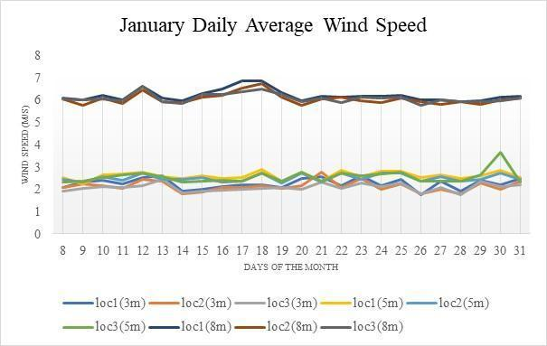

**Figure 4:** January daily average wind speed

As shown in figure 4, daily average wind speed varies on the location and height, as the height increases the daily average wind speed increases on a specific location with a 100 meters distance. The graph shows that location one (1) has the highest daily average wind speed than other locations ranging from 1.76 m/s to 6.83 m/s. Also, the wind speed peaks on location one (1) with the height of 8 meters.

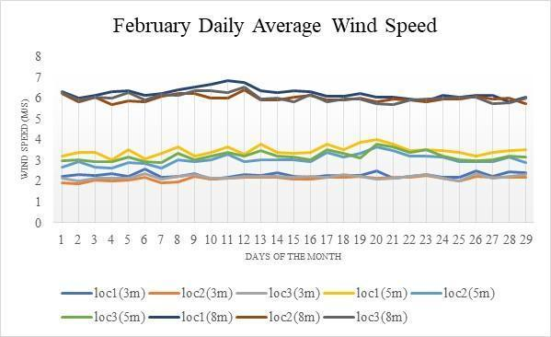

**Figure 4.1:** February daily average wind speed

Figure 4.1 presents the February daily average wind speed. Same as the month of January, the highest daily average wind speed is at location one (1) ranging from 5.83 m/s to 6.83 m/s and the peak wind speed was measured at the height of 8 meters high.

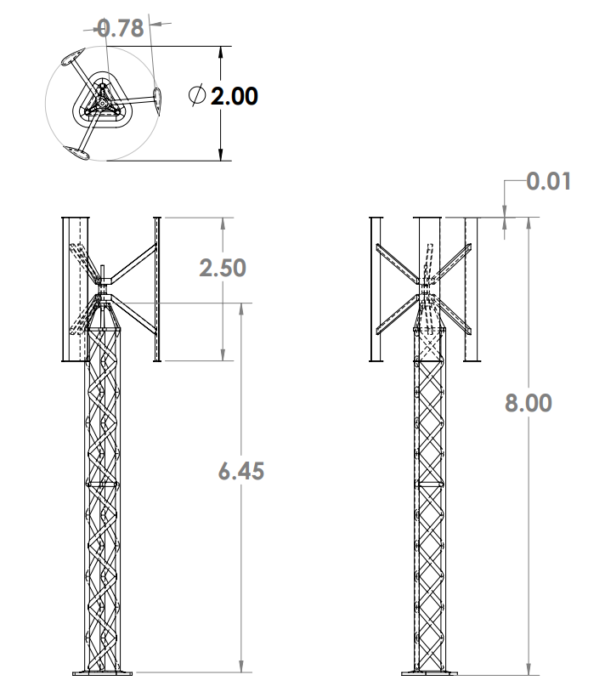

**Figure 5**: Dimension of the Darrieus Vertical Axis Wind Turbine

Figure 5 shows that the swept area of the vertical axis wind turbine was increased by simply increasing the diameter to 2 meters and the length of the blades to 2.5 meters. The height of the turbine is 8 meters high since the highest wind speeds in the area were obtained in the height of 8 meters.

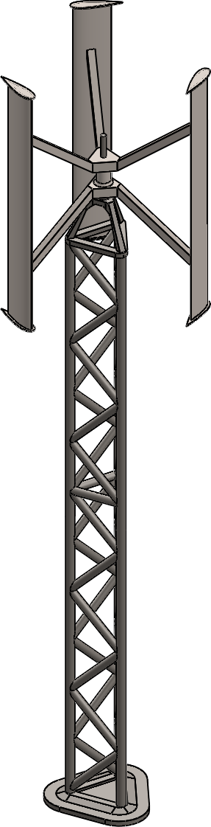

**Figure 5.1:** 3D Model of Darrieus Vertical Axis Wind Turbine

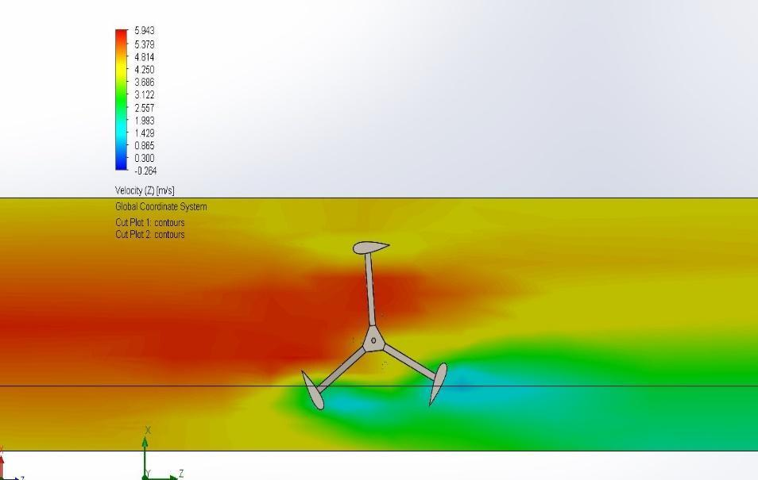

**Figure 6:** CFD Analysis using Solid works

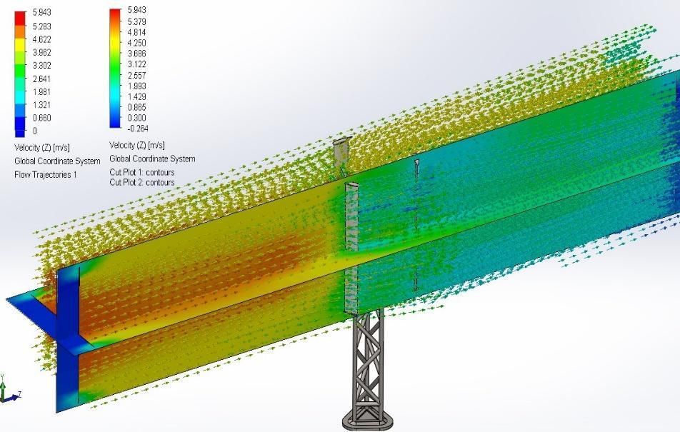

**Figure 6.1:** CFD Analysis using Solid works

**Table 3:** Results of the Wind turbine simulation using Solid works

|  |  |  |
| --- | --- | --- |
| **Name** | **Unit** | **Value** |
| Wind Velocity | m/s | 6.029 |
| Drag or Return Force | N | 6.475 |
| Lift or Forward Force | N | 66.428 |
| Torque | N*m | 88.797 |
| Power Output | W | 636.064 |
| Angular Velocity | Rad/s | 7.655 |
| Tip Speed Ratio |  | 1.2697751 |

The table shows the power output of the wind turbine with a value of 636.064W, a torque value of 88.797 Nm, angular velocity of 7.655 rad/s, and a tip speed ratio (TSR) of 1.2699. The output of the simulation will be used to determine the size of the generator based on its specification such as the rated speed and start-up torque.

**Generator**

Based on the outputs of the wind turbine simulation, the researchers will use the PMG-2000L single-phase permanent magnet generator which only requires a low rated speed to generate electricity.

**Table 4:** Single-phase generator specifications

|  |  |
| --- | --- |
| **Description** | **PMG-2000L** |
| Rated Power | 2000W |
| Max Power | 2200W |
| Rated Voltage | 24V-220V |
| Rated Speed(rpm) | 300rpm |
| Output Current | AC |
| Start Torque(<N*M) | 0.7Nm |
| Rated Torque(<N*M) | 32Nm |
| Generator | Single Phase Permanent Magnet |
| Shaft Material | Stainless Steel |
| Shell Material | Aluminium Alloy |
| Magnet Material | NdFeB |
| Protection Grade | IP54 |
| Lubrication | Lubrication Grease |
| Working Temperature | -40°C -80°C |

The generator has a rated power of 2000 watts and a maximum power of 2200 watts. The generator requires a speed of 300 rpm to generate a voltage output of 220 volts alternating current (AC). Starting torque of 0.7 Newton meter (Nm) and a torque of 32 Nm. The generator has a single-phase permanent magnet having a stainless-steel shaft and aluminum alloy shell. The magnet is Neodymium (DdFeb) with IP54 for its protection having a lubrication grease. The generator working temperature is ranging from -40°C -80° Celsius.

**Pulley**

The driver pulley which is attached to the shaft of the wind turbine has a diameter of 1 meter. The turbine shaft has an angular velocity of 73 rpm while the generator requires 300 rpm to produce 220v output. The driven pulley has a diameter of 0.25 meters. In this configuration, the wind turbine will be able to meet the required speed of the generator.

**Roadway Lights**

Since the rated power that the generator can produce is 2000 Watts, the total connected load must not exceed 1800 Watts and have an allowance of 200 Watts.

**Number of lamps**

Based on the table 4 placement guide for lighting parameters (DOE), the researcher must use a 70 watts lamp which will be used to determine the number of lamps that the generator can power. A total of 24 lamps can be powered by the generator.

**Simulation using Dialux Evo**

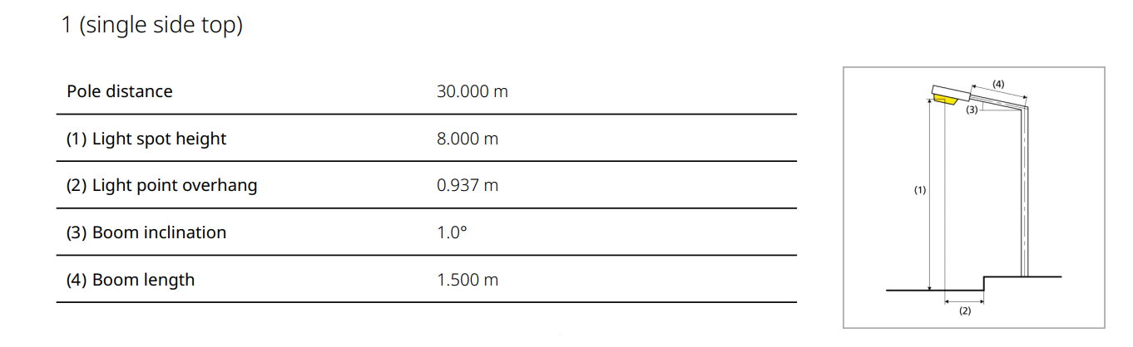**Table 5:** Roadway light specification

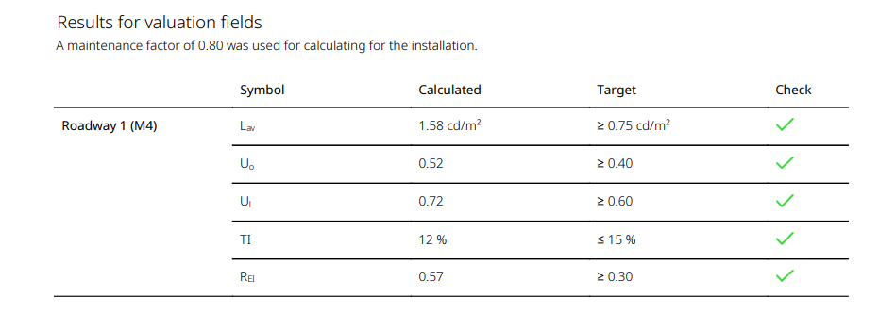**Table 6:** Dialux Evo simulation results

The table shows the results from the simulation of the roadway lights using Dialux Evo software. A maintenance factor of 0.80 was used for calculating for the installation. It shows that all of the parameters meet the standards shown in table 4.1 which is the minimum values for roadway lighting parameters. It only shows that the designed parameters meet the target illumination for the mega dike access road.

After designing the wind turbine, determining the size of the generator, and simulating the road lights, the final phase is the implementation. The researchers will combine all the designs in finalizing the study.

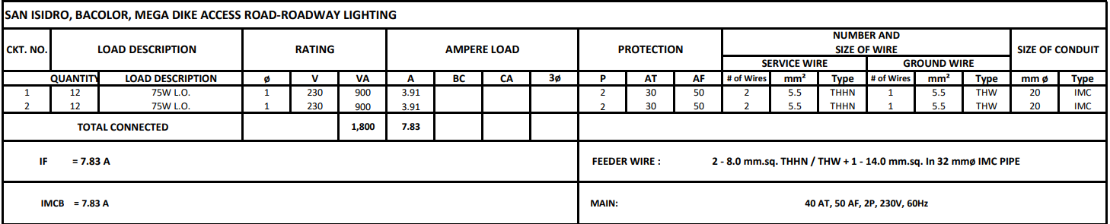

**Figure 7:** Load Schedule

Figure 7 presents the load schedule of the roadway lighting. It consists of two 15 amperes of circuit breaker for the roadway lights. Each branch has twelve 75 watts lamps. The total load of the circuit is 1800 VA while the total current is 7.83 amperes. The service wire and feeder wire size are 8.0 mm2. The main circuit breaker is rated 30 ampere trip, 50 ampere frame, two pole, 230 volts, 60 hertz.

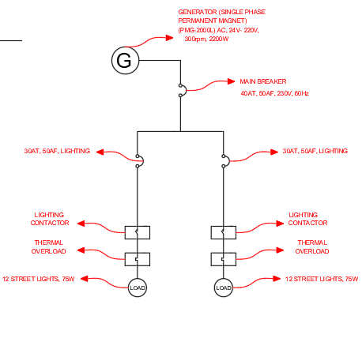

**Figure 7.1:** Single Line Diagram

This shows the single line diagram or the riser diagram of the system. Circuit number one and two are the roadway lights consisting of twelve 75 watts lamps. Circuit three and four are spare circuit breakers.

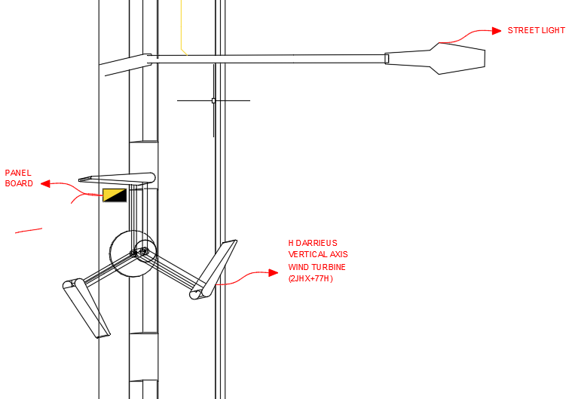

**Figure 7.2:** Lighting Layout using AutoCAD

This figure shows the lighting layout plan of the poles, wind turbine, generator and panel board. The PMG-2000L generator is placed under the H-Darrieus vertical axis wind turbine along with the panel board having two branches for roadway lights and two spares. The poles are placed 30 meters apart each on the open part of the road of 7 meters width.

**

**Figure 8:** Visual Representation using SketchUp

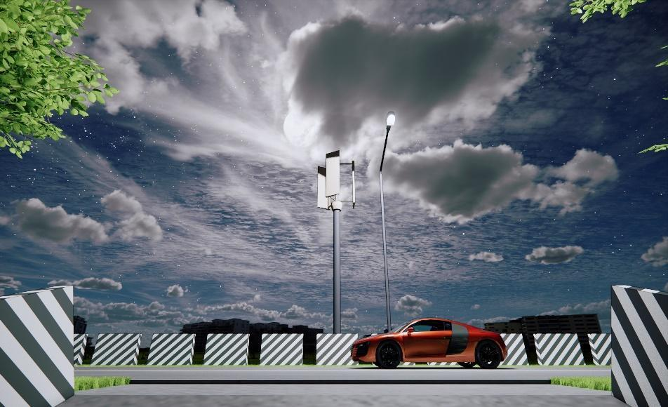

**Figure 8.1:** Visual Representation using SketchUp

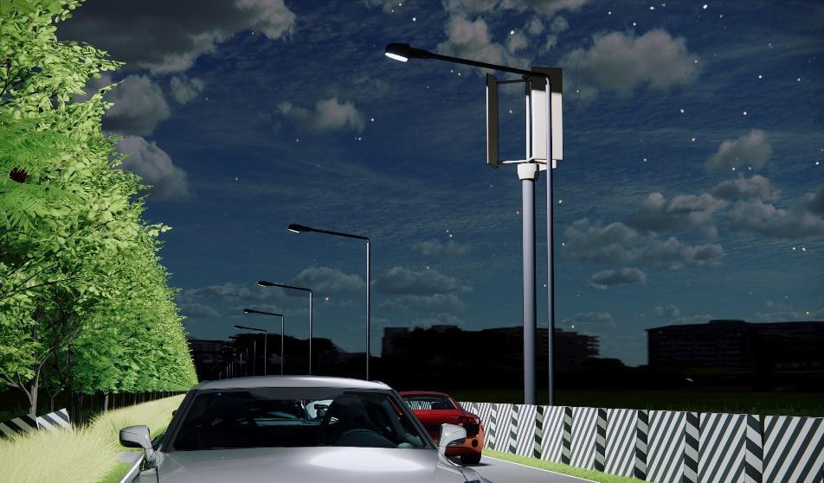

**Figure 8.2:** Visual Representation using SketchUp

1. **CONCLUSION**

After measuring the wind speeds in San Isidro, Bacolor, Mega dike access road, the researchers were able to determine the location where the wind turbine must be placed. The wind turbine must be placed on the location one which has a plus code of 2JGX+XFW and a height of 8 meters from the ground. The area has an average wind speed of 6 m/s. A H-Darrieus vertical axis wind turbine was used in the study to determine the wind energy harvesting potential in the area since the turbine was designed to have enough angular velocity and torque at low wind speeds. The swept area of the wind turbine is 5 m2 which has an output power of 636.064 watts and torque of 88.797 N.m enough to drive a generator. A 2000 watts generator was used in the design to power 24 pieces of 75 watts roadway lights. With this output of the study, the researchers conclude that wind energy harvesting in San Isidro, Bacolor, Mega dike access road for roadway lights is feasible.

**4.1 Recommendations**

The study in wind energy harvesting in San Isidro, Bacolor, Mega dike access road is not yet finished. For the purpose of the future researchers, the researchers have the following recommendations:

* A thorough analysis of the wind velocity in the area with its wind direction since the researchers were not able to determine the direction due to limited capability of measuring tools being used.
* An integration of power banks in the system to prevent any waste from the harvested wind energy.
* A structural analysis of the base of the turbine since the area has limited space.
* A thorough study and integration of gearbox in the system.

1. **REFERENCES**
2. Gönül, Ö.; Duman, A.C.; Deveci, K.; Güler, Ö. An Assessment of Wind Energy Status, Incentive Mechanisms and Market in Turkey. Eng. Sci. Technol. Int. J. 2021, 24, 1383–1395.
3. Dehghani-Sanij, A.R.; Al-Haq, A.; Bastian, J.; Luehr, G.; Nathwani, J.; Dusseault, M.B.; Leonenko, Y. Assessment of Current Developments and Future Prospects of Wind Energy in Canada. Sustain. Energy Technol. Assess. 2022, 50, 101819.
4. DOE (2019), Wind Turbine Energy.
5. MECH 4010 Design Project Vertical Axis Wind Turbine. Dalhousie: Department of Mechanical Engineering  
   Dalhousie university. December 05, 2005. from <https://www.academia.edu/5926298/MECH_4010_Design_Project_Vertical_Axis_Wind_Turbine>
6. WIT Press, Ashurst Lodge, Ashurst, Southampton SO40 7AA, UK. Registered in England as a limited company No. 4741634 from <https://www.witpress.com/books/978-1-84564-205-1>
7. Abramovich, H. Vertical axis wind turbines: a survey and bibliography. United Kingdom: N. p.334-343, 1987
8. 1931- G. .1. M. Darrieus Turbine Having its rotating shaft Transverse to the flow of the current. Filed on 1 1926 Inventor 25, US Patent, December 08, 1931.
9. Darrieus turbines: the physics of self starting. jpurnal ofpower and energy, 21-29
10. S. Srivastava (2013). Automatic street lights. advance in electronic and electric engineering, 3(5), 539-342.
11. Republic of the Philippines DEPARTMENT OF ENERGY Energy Center, Merritt Rd., Fort Bonifacio, Taguig
12. SunStar Publishing Inc. (2014). 2 Killed In Megadike Mishap. Retrieved from <https://www.sunstar.com.ph/article/341437/2-killed-in-megadike-mishap>
13. INQUIRER.net (2017). DPWH checks safety of dike road after crash killed cop, hurt Mikey. Retrieved from <https://newsinfo.inquirer.net/865142/dpwh-checks-safety-of-dike-road-after-crash-killed-cop-hurt-mikey>
14. [Solar Energy](https://www.sciencedirect.com/journal/solar-energy)[Volume 208](https://www.sciencedirect.com/journal/solar-energy/vol/208/suppl/C), 15 September 2020, Pages 368-378
15. J. Sol. Energy Eng. Apr 2016, 138(2): 024503
16. Omni Calculator sp. z o.o. from: <https://www.omnicalculator.com/ecology/wind-turbine>
17. Development of the helical reaction hydraulic turbine. Final technical report, July 1, 1996--June 30, 1998
18. Darrieus turbines: the physics of self starting. jpurnal ofpower and energy, 21-29
19. PERFORMANCE ANALYSIS, DESIGN AND MANUFACTURING OF  
    VERTICAL AXIS WIND TURBINE A B.SC. SENIOR PROJECT from [Vertical Axis Wind Turbine (researchgate.net)](https://www.researchgate.net/publication/328382128_Vertical_Axis_Wind_Turbine?enrichId=rgreq-6ddd3874294cbac5c3f89eff1a577a99-XXX&enrichSource=Y292ZXJQYWdlOzMyODM4MjEyODtBUzo2ODMzNTc0OTA5MTczODRAMTUzOTkzNjUzMDkxNg%3D%3D&el=1_x_2&_esc=publicationCoverPdf)
20. Battisti, L. (2016). Analysis of different blade architechtures on small VAWT performance. Journal of physics conference series
21. https://www.desertcart.ph/ copyright © 2024 Desertcart Holdings Limited