

# Amity Institute of Organic Agriculture

**Report on**

# Rural Agricultural Work Experience (RAWE) and Agro-Industrial Attachment (AIA)

**Title of Project**

# Plant protection and development.

**Faculty Guide – Dr. Ajay Tomar**

# Name – Sanu Kumar Enrollment no. – A014119120114 Course – B.Sc Agriculture (hons) Semester -08

**Section-B**

# Declaration

I Sanu Kumar hereby declare that the project work entitled “Plant Protection and Development ” submitted to Amity Institute of Organic Agriculture, (Amity University) Noida is a record of an original work done by me under the guidance of Dr. Ajay Tomar, Assistant professor of Amity institute of Organic Agriculture, and this project work is submitted in the partial fulfillment of the requirements for the award of the degree of Bachelor of Science in Organic Agriculture. The results embodied in this thesis have not been submitted to any other University or Institute for the award of any degree or diploma.

# Acknowledgment

First of all, thank you to everyone who gave me the opportunity to be a part of this project and helped me at every stage of this project. During the project, I learned a lot about my work as a technical assistant intern. I have improved my communication skills, teamwork and collaboration skills and critical thinking skills, and I have learnt about Plant protection and development techniques and its various components and how to establish the system Moreover, I would like to thank those who directly or indirectly supported me in the internship and in the preparation of this report.

Lastly, I am much thankful to respected (H. O. D.) Dr. Sangeeta Pandey and

“Faculty Guide” Dr. Ajay Tomar who supported me for this work.

THANK YOU

Your Sincerely Sanu Kumar

# List of contents

1. **Introduction**

# Brief about KVK

1. **Designation and Role**

# Objective

1. **Strategies followed during Internship**

# Conclusion

1. **Reference**

# Certification

On the basis of declaration submitted by Sanu Kumar,, Student of B.Sc. (Hons) Agriculture. I hereby certify that the project titled “Plant Protection and development ” which is submitted to Amity Institute of Organic Agriculture, Amity University, Uttar Pradesh, Noida, in partial fulfillment of the requirement for the award of the degree of B.Sc. (Hons) Agriculture is an original contribution with exiting knowledge and faithful record of work carried out by him under my guidance and supervision. To the best of my knowledge this work has not been submitted in part or full for any degree to this University or elsewhere.

# Abstract

Plant protection and development are critical components of sustainable agriculture and environmental stewardship. This abstract presents an overview of strategies aimed at safeguarding plant health and promoting robust growth in agricultural and natural ecosystems. Key aspects include integrated pest management (IPM), which integrates multiple tactics to manage pests while minimizing environmental impact. Additionally, advancements in biotechnology have led to the development of genetically modified crops with enhanced resistance to pests and diseases.

Furthermore, the importance of soil health and nutrient management in promoting plant growth and resilience is emphasized. The abstract also discusses the role of climate-smart agriculture practices in mitigating the impact of climate change on plant health and productivity. Overall, a holistic and integrated approach to plant protection and development is essential for ensuring food security, environmental sustainability, and economic prosperity.

**Introduction**

Plant protection and development play a vital role in ensuring global food security, environmental sustainability, and economic prosperity. This report aims to provide an overview of the objectives, strategies, and importance of plant protection and development in modern agriculture. Plant protection and development is a comprehensive discipline aimed at safeguarding the health and vitality of plants while fostering their growth and productivity. It encompasses a diverse array of strategies and practices designed to combat threats such as pests, diseases, weeds, and environmental stressors. By employing integrated approaches that combine biological, cultural, and chemical methods, plant protection seeks to minimize the use of harmful pesticides while maximizing sustainable outcomes. From implementing crop rotation and utilizing resistant varieties to deploying biological control agents and adopting precision agriculture techniques, this field is dedicated to optimizing plant health, ensuring food security, and preserving natural

ecosystems. Through ongoing research, innovation, and collaboration, plant protection and development contribute significantly to the resilience and sustainability of agricultural systems worldwide. Plant protection and development is a multifaceted field dedicated to safeguarding plants from pests, diseases, and environmental stresses while promoting their growth and productivity. This discipline encompasses various strategies, including integrated pest management (IPM), biological control, cultural practices, and the use of pesticides when necessary. Additionally, plant development focuses on enhancing plant growth, yield, and quality through techniques such as breeding, genetic engineering, nutrient management, and agronomic practices. The ultimate goal of plant protection and development is to ensure global food security, preserve natural ecosystems, and sustainably manage agricultural resources for future generations.

# Brief about KVK

Krishi Vigyan Kendra (KVK) translates to "Farm Science Center" . It's a program initiated by the Indian Council of Agricultural Research (ICAR) to serve as an interface between research institutions and farmers.

KVKs aim to accelerate agricultural growth by providing access to practical knowledge, technologies, and training to farmers at the grassroots level. These centers are established in different agro-climatic zones across India, focusing on location-specific agricultural challenges and solutions. They play a pivotal role in technology dissemination, capacity building, and empowering farmers with the latest agricultural practices to enhance productivity and sustainability.



# Designation

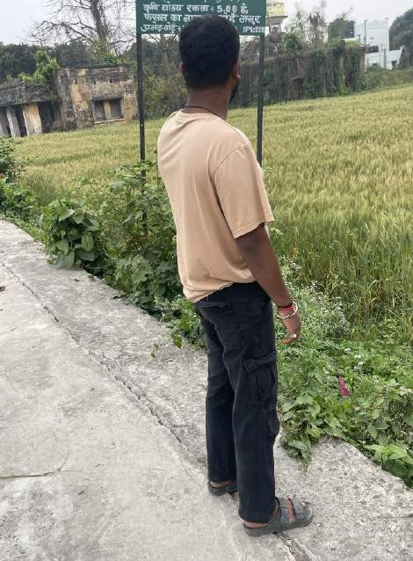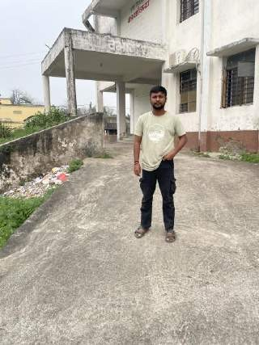I have worked as a intern in this company and my role was to techincally support the farmers with the guidance of the faculty provided during the internship who are willing to help the farmers for the proper growth and development of the plants and also help them with their problems to make them more profitable and to protect their agricultural land for better productivity.

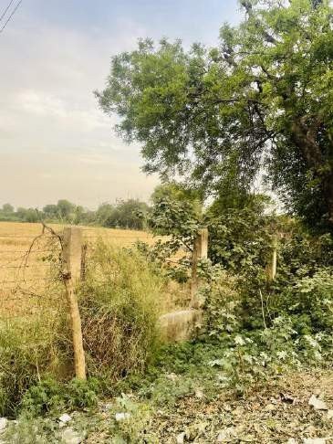

# Objective

The objective of plant protection and development is multifaceted:

1. Ensure Crop Health: Protect plants from pests, diseases, and weeds that can threaten their health and reduce yield.
2. Promote Growth and Productivity: Create conditions conducive to optimal growth and development of plants, leading to higher yields and quality produce.
3. Environmental Conservation: Implement practices that minimize the negative impact of agriculture on the environment, such as reducing chemical pesticide use and preserving biodiversity.
4. Sustainable Agriculture: Adopt methods that sustainably manage natural resources like soil, water, and air to ensure long-term viability of agricultural production systems.
5. Food Security: Contribute to global food security by safeguarding crops against threats and maximizing their productivity to meet the demands of a growing population.
6. Economic Viability: Support the economic viability of farming operations by reducing losses due to pests and diseases, thereby increasing profitability for farmers.
7. Research and Innovation: Continuously research and innovate new techniques, technologies, and crop varieties to improve plant protection and development practices.

Overall, the objective is to foster a balance between protecting plants from threats and fostering their growth and development in a sustainable and environmentally responsible manner to ensure food security and economic prosperity.

# Strategies For Plant Protection and Development

**Cultural methods for disease control**

1. Crop Rotation:

* Planting different crops in a specific sequence or rotation can help break the life cycle of pathogens that are specific to particular plant species. This reduces the build-up of pathogens in the soil.

1. Polyculture and Companion Planting:

* Planting a variety of crops in close proximity (polyculture) or strategically placing companion plants can disrupt the habitat for pests and diseases. Some plants release substances that repel or inhibit the growth of pathogens.

1. Selection of Resistant Varieties:

* Planting crop varieties that are naturally resistant or tolerant to specific diseases can be an effective cultural method. Breeding programs often develop and promote resistant varieties.

1. Proper Plant Spacing:

* Adequate spacing between plants enhances air circulation, reducing humidity and creating an environment less conducive to fungal and bacterial diseases.

1. Sanitation Practices:

* Removing and destroying infected plant debris, fallen leaves, and other plant residues can help eliminate sources of pathogens. This reduces the likelihood of diseases overwintering and spreading.

1. Proper Irrigation:

* Watering plants at the base and avoiding overhead irrigation can help minimize the moisture on plant surfaces, which is crucial for the development of many fungal diseases.

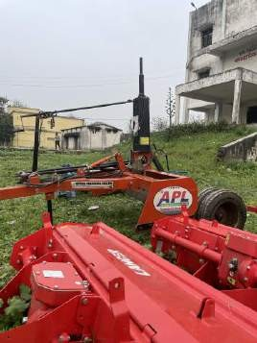

1. Soil Management:

* Well-draining soil, proper pH levels, and appropriate nutrient levels contribute to plant health. Healthy plants are generally more resistant to diseases.

1. Timely Planting:

* Planting at the right time, considering seasonal factors and the life cycle of pests and pathogens, can help reduce the risk of diseases.

1. Intercropping:

* 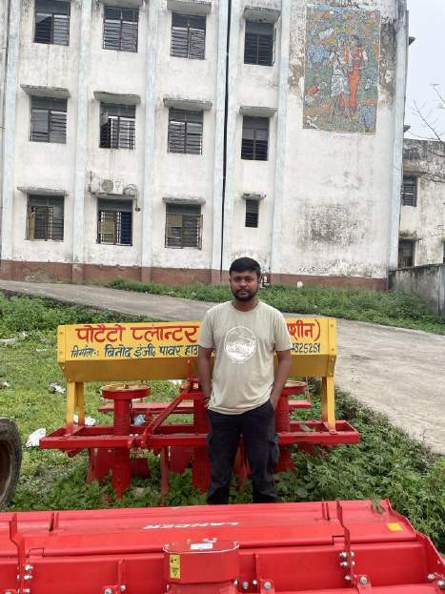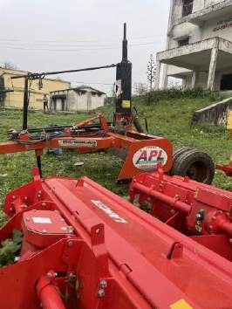Planting different crops in close proximity can disrupt the life cycles of pests and pathogens, making it more challenging for them to establish and spread.

# Mechanical method for disease control

1. Handpicking: This simple method involves manually removing pests from plants. It is particularly effective for larger pests like caterpillars, beetles, or snails.

Regular inspection of plants and picking off pests can help control their populations.

1. Traps: Various traps can be used to catch and control pests. Examples include sticky traps for flying insects, pheromone traps to attract and trap specific insect species, and pitfall traps for ground-dwelling pests.
2. Barriers: Physical barriers can be employed to prevent pests from reaching plants. Examples include row covers, netting, or screens that block insects or larger animals from accessing crops. Mulches can also act as barriers to prevent soil- borne diseases.
3. Cultivation practices: Modifying the way crops are planted or arranged can help control pests. For example, companion planting involves growing certain plants together to repel pests or attract beneficial insects.
4. Tillage: Regular plowing or cultivating the soil can disrupt the life cycle of some pests, such as soil-dwelling insects and weed seeds. This method can be effective in reducing pest populations.

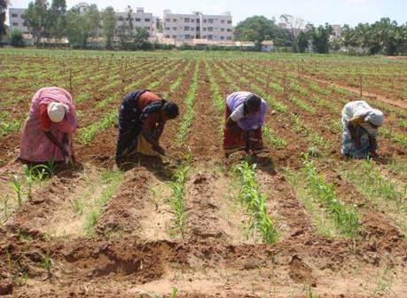

# Chemical method for plant protection and development

1. Fertilizers:

* Nitrogen (N), Phosphorus (P), and Potassium (K): Essential nutrients for plant growth. Fertilizers are used to supplement soil nutrients and promote healthy plant development.
* Micronutrients: Trace elements like iron, zinc, copper, manganese, and boron are crucial for plant growth. Micronutrient fertilizers are applied when there are deficiencies.

1. Plant Growth Regulators (PGRs):

* Auxins, Gibberellins, and Cytokinins: PGRs influence plant growth and development. They are used to regulate flowering, fruiting, and overall plant structure.
* Abscisic Acid (ABA): Regulates seed dormancy, bud dormancy, and stress

responses.

1. Pesticides:

* Insecticides: Control insect pests that can damage crops. Examples include neonicotinoids, pyrethroids, and organophosphates.
* Herbicides: Control unwanted weeds. Glyphosate is a widely used herbicide.
* Fungicides: Manage fungal diseases. Copper-based fungicides and systemic fungicides like triazoles are common.

# Condition required for proper plant growth and development

1. Light: Most plants require light for photosynthesis, the process by which they convert light energy into chemical energy to fuel growth. The intensity, duration, and quality of light all play roles in plant growth. Different plants have different light requirements; some need full sun, while others thrive in partial shade.
2. Water: Adequate water is essential for plant growth as it is a vital component of photosynthesis and various metabolic processes. However, the water needs of plants vary greatly depending on species, climate, and soil type. Overwatering or underwatering can both negatively impact plant health.

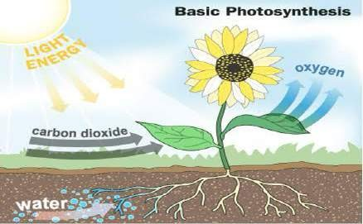

1. Temperature: Plants have specific temperature ranges within which they grow best. Extreme temperatures, whether too hot or too cold, can stress plants and inhibit growth. Different plants have different temperature preferences, so it's essential to match the plant to the appropriate climate conditions.
2. Air Circulation: Good air circulation is crucial for plants as it helps prevent the buildup of humidity and reduces the risk of diseases. It also aids in the exchange of gases necessary for photosynthesis and respiration.
3. Soil: Soil provides plants with essential nutrients, anchorage, and water. The ideal soil type and composition vary depending on the plant species. Some plants

thrive in well-draining sandy soils, while others prefer nutrient-rich loam or clay soils

1. Nutrients: Plants require various nutrients for healthy growth, including macronutrients such as nitrogen, phosphorus, and potassium, as well as micronutrients like iron, magnesium, and zinc. These nutrients are typically obtained from the soil or through fertilization.
2. pH Level: The pH level of the soil affects nutrient availability to plants. Most plants prefer a slightly acidic to neutral pH range, although some species have specific pH requirements.

.

# Herbicides selection for Plants

1. Selective Herbicides: Selective herbicides are formulated to target specific types of plants while leaving desirable plants relatively unharmed. They are commonly used in agriculture to control weeds without harming crops. For example, herbicides targeting broadleaf weeds in grassy crops or grassy weeds in broadleaf crops.
2. Non-Selective Herbicides: Non-selective herbicides are designed to kill a wide range of plant species, including both weeds and desirable plants. They are often used in areas where complete vegetation control is necessary, such as along roadsides, sidewalks, and industrial sites.
3. Pre-Emergent Herbicides: Pre-emergent herbicides are applied to soil to prevent weed seeds from germinating. They create a barrier in the soil that inhibits weed seed germination, effectively controlling weeds before they emerge from the ground. These are often used as a proactive measure to prevent weed infestations.
4. Post-Emergent Herbicides: Post-emergent herbicides are applied to weeds that have already emerged from the soil. They work by targeting and killing existing weeds, either through contact or systemic action. Post-emergent herbicides are

commonly used in agriculture, landscaping, and gardening to control established weed populations.

1. Contact Herbicides: Contact herbicides kill plants upon direct contact with their foliage. They are fast-acting but may not effectively control perennial weeds with extensive root systems. These herbicides are often used for spot treatments or in situations where rapid control is needed.
2. Systemic Herbicides: Systemic herbicides are absorbed by plants and then translocated throughout the plant's vascular system, ultimately leading to the plant's death. They are effective against a wide range of weed species, including perennial weeds, as they target both the foliage and root system of the plant.
3. Residual Herbicides: Residual herbicides remain active in the soil for an extended period, providing long-term weed control. They are often used in agriculture to manage weed populations throughout the growing season. Residual herbicides can help reduce the need for multiple herbicide applications and can be particularly effective in no-till or minimum-tillage systems.

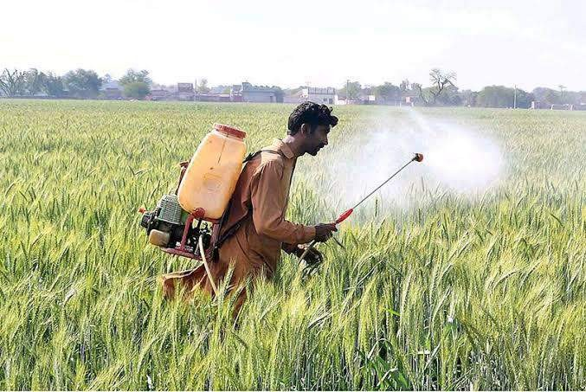

# Types of sprayer used for plant development

1. Knapsack Sprayer:

* Description: A portable sprayer carried on the back with shoulder straps. It consists of a tank, pump, lance (spray gun), and nozzles.
* Application: Suitable for small-scale applications, horticulture, and field edges.
* Advantages: Easy to use, maneuverable in tight spaces.

1. Tractor-Mounted Sprayer:

* Description: Mounted on a tractor, these sprayers consist of a tank, pump, nozzles, and boom. They can be either towed or attached to the three-point hitch.
* Application: Suitable for larger fields and row crops.
* Advantages: Allows for faster application over larger areas, reduces operator fatigue.

1. Boom Sprayer:

* Description: Boom sprayers have long arms with multiple nozzles that are mounted on a tractor or a specialized vehicle.
* Application: Ideal for broad-acre crops, such as wheat, corn, soybeans, and cotton.
* Advantages: Provides uniform coverage over a large area.

1. Drip Sprayer (Drip Irrigation):

* Description: Drip irrigation systems apply water and nutrients directly to the plant's roots, usually from a network of pipes and tubing.
* Application: Commonly used in areas with limited water availability or where water is expensive.

# Houses for Plant protection

1. Greenhouses: Greenhouses are structures primarily made of glass or plastic where plants are grown. They provide controlled environments with regulated temperature, humidity, and light, protecting plants from harsh weather conditions and pests while extending the growing season.
2. Cold Frames: Cold frames are simple structures with transparent roofs, often made of glass or plastic, and solid sides, usually made of wood or metal. They provide protection from cold temperatures, frost, and wind, allowing gardeners to extend the growing season in cooler climates.
3. Polytunnels: Polytunnels are similar to greenhouses but typically use polyethylene plastic for covering instead of glass. They offer protection from weather elements such as wind, rain, and excessive sunlight while also creating a microclimate conducive to plant growth.
4. Row Covers: Row covers are lightweight, translucent fabrics placed directly over rows of plants in the garden. They provide protection from frost, pests, and harsh sunlight while allowing air, water, and light to penetrate.
5. Cloches: Cloches are small, bell-shaped covers made of glass, plastic, or other transparent materials placed over individual plants to protect them from cold temperatures and pests. They create a mini greenhouse effect, trapping heat and moisture around the plant.

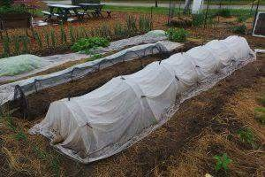

# Conclusion

In conclusion, plant protection and development are essential components of modern agriculture, contributing to food security, environmental sustainability, and economic prosperity. By adopting integrated and sustainable approaches, stakeholders can effectively manage plant health, optimize crop productivity, and ensure the long-term viability of agricultural systems. Continued research, innovation, and collaboration are necessary to address emerging challenges and achieve the goals of plant protection and development in the future.

# References

**https://eos.com/blog/crop-protection/****https://www.sciencedirect.com/science/article/abs/pii/S0958166910002351****https://www.upl-ltd.com/agricultural-solutions/crop-protection/herbicides**