**A Review Paper on Study the effect of Process Parameters on Weld Quality and Perform Formability Test along with Uniaxial Tensile test and Microhardness Test**

Sumer Singh

College Of Technology and Engineering, Udaipur

sumerrock1993@gmail.com

Introduction

With the changing attitude of society towards the environment, the use of laser welded blanks could be very beneficial to the automotive industries. This includes reducing scrap from manufacturing and making their product more energy efficient. Along with the reduction of scrap, the automotive industry is subjected to more and more stringent government regulation for fuel efficiency. There is currently a large interest in developing lightweight alloys that can be used in an automobile to replace heavier steel parts, resulting in weight reductions of the vehicle without sacrificing strength. Metallic material such as aluminium and magnesium, high-strength steels, carbon-carbon composites as well as a number of novel metallic composites is all under investigation in terms of viability and practicality for use in high production in automobile

**1.1 Tailor Welded Blanks and their Applications:**

In order to reduce energy consumption, the automotive industry keeps a strong interest the development of lightweight component by using the concept of tailor welded blanks. A Tailor welded blank is a blank that is composed of two or more different sheet materials. Typically, two different thicknesses or alloys are butt welded together to form a multi-gauge and/or multi-alloy blank prior to the stamping operations. Currently TWBs are used for manufacturing auto body parts such as front door inner, floor pan, a pillar, centre pillar, body sides frames etc.

**1.2 Benefits of TWBs:**

* Weight reduction due to the combining of parts into a single component.
* Because each welded piece can have a different thickness, grade of sheet metal or coating, these blanks posses the needed characteristics in the desired locations of the formed part.
* Manufacturing cost is reduced because scrap is very less.
* More dimensional stable since it is a single stamping, eliminating the stacking of tolerances

**Formability**

The formability of TWBs specimen and base metal specimen were examined by means of the measured dome height from limiting dome height tests.

**1.3. Limiting Dome Height in Biaxial Stretching:**

The biaxial stretched samples of TWBs are shown in fig 4.4. For each set of parameters two samples were tested. Limiting dome height of those samples is given in table

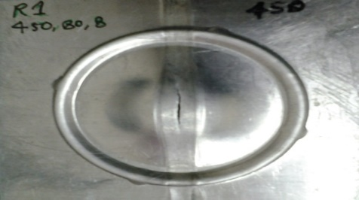 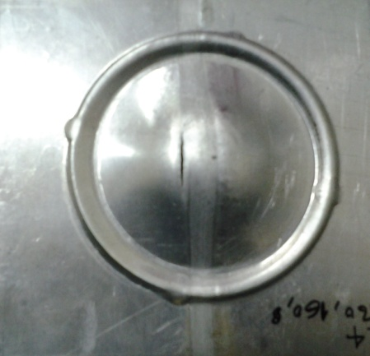

(a) R1 (450/80/8)

(b) R4 (560/160/8

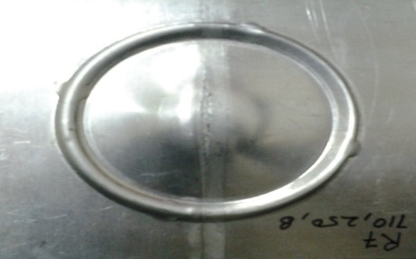

(c) R7 (710/250/8)

**Fig 1.1** Limiting Dome Height Tests specimen after stretching for different set of parameters

**Table 1.1** Limiting Dome Height for different set parameters

|  |  |  |  |  |  |  |
| --- | --- | --- | --- | --- | --- | --- |
|  | **R1(450/80/8)** | | **R4 (560/160/8)** | | **R7 (710/250/8)** | |
| Sample 1 | Sample 2 | Sample 1 | Sample 2 | Sample 1 | Sample 2 |
| LDH (mm) | **11.04** | **12.06** | **12.02** | **11.32** | **12.04** | **12.5** |

As from the above result it is concluded that with increase in rpm ductility increases. This can also be verified by the Limiting Dome Height tests (LDH), with increase in ductility limiting dome height increases.

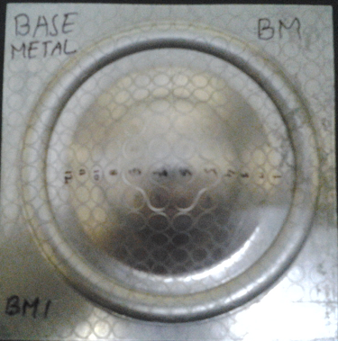 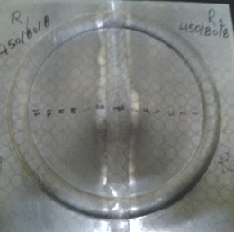**\**

Fracture

Base metal

1. (b)

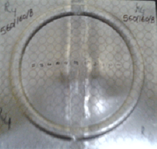 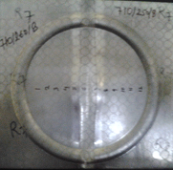

Weldment

560/160/8

(c) (d)

**Fig 1.5** Deformed TWBs of different set of parameters (with grid marking) in biaxial stretching

**Table 1.4** Limiting dome height of TWBs specimen for different set of parameters and base metal specimen in biaxial stretch forming

|  |  |  |  |  |
| --- | --- | --- | --- | --- |
| **Specimen** | **Base metal** | **R1 (450/80/8)** | **R4 (560/160/8)** | **R7(710/250/8)** |
| **LDH (mm)** | 18.04 |  | 11.32 | 11.98 |

**1.3.2 Strain distribution in Biaxial Stretching**

The ability of a material to distribute strains is centre to the understanding of formability, not only to the description of maximum punch height but also to the understanding of spring back and shape fixation. A typical strain distribution profile of a stretched formed sample of different set of parameters was used in study as shown in fig 4.6. Strain distributions of stretch formed sample of AA base metal have two peaks symmetrically located on either side of the pole. Higher of the two peaks is the limiting strain. Pole region has undergone minimum amount of deformation due to friction between the punch and the sheet. At the peaks major strains are significant larger than minor strains due to geometrical constraints.

**Fig 1.5** A typical strain distribution profile of a stretch formed sample of AA base metal of thickness 1.7.

The strain distribution profile of major and minor strain variations on the stretch formed samples of the TWBs with different set of parameters are shown in fig 4.6 (a,b and c).

(a) R1(450/80/8)

(b) R4 (560/160/8)

(c) R7(710/250/8)

**Fig 1.6** Major strain and minor strain distribution in a stretched formed specimen of R1, R4 and R7

In case of base metal specimen (fig 4.5), strain (major and minor) is less at the pole and strain is more in the pole surrounding region. But from the above curve (a, b and c) obtained from weld specimen, it is observed that at the pole strain is more as compare to the base metal region (weld region), because of high ductility, low weld strength and low thickness at pole.

During FSW, heat is generated by friction between the tool and the work piece and via plastic deformation.

Where RS-Retreating side , AS- Advancing side, The axis of the pin forms the work angle ** and the travel /tilting angle θ with the normal direction of the blanks schematically shown in Fig2.2

**Table 2.1 Main process parameters in friction stir welding [1]**

|  |  |
| --- | --- |
| Parameter | Effects |
| Rotation Speed | Friction heat, “Stirring”, oxide layer breaking and mixing |
| Welding speed | Heat control |
| Shoulder Diameter | Heat control |
| Depth of plunging | Heat control |
| Down force | Friction heat |
| Tilting angle | The appearance of the weld thinning |

**W**elding parameters, including tool rotation rate, traverse speed, spindle tilt angle, and target depth, are crucial to produce sound and defect-free weld [6]. FSW results in significant temperature rise within and around the weld. A temperature rise of 400–500 oC has been recorded within the weld for aluminum alloys. Intense plastic deformation and temperature rise result in significant microstructural evolution within the weld, i.e., fine recrystallized grains of 0.1–18 mm, texture, precipitate dissolution and coarsening, and residual stress with a magnitude much lower than that in traditional fusion welding. It has been widely accepted that the softening effect of FSW is due to dissolution and/or coarsening of the precipitates [3]. Furthermore, the hardness profile is asymmetric for all configurations. experiencing medium temperature and deformation and characterized by deformed and un-recrystallized grains, and heat-affected region experiencing only temperature and characterized by precipitate coarsening. Compared to the traditional fusion welding, friction stir welding exhibits a considerable improvement in strength, ductility and fatigue and fracture toughness. Moreover, 80% of yield stress of the base material has been achieved in friction stir welded aluminum alloys with failure usually occurring within the heat-affected region.

**1.4 Challenges in application of tailor welded blanks**

Tailor welded blank are tailor made for different complex component design by welding multiple metal sheets with different thickness, shape or grades prior to forming. The challenges in adopting this technology lie in the weld zone itself. These manufacturing issues can be segregated into two categories.

1. **Joining issues:**
2. Identification of proper welding techniques of the materials of different grades, thickness and coatings.
3. Weld length, orientation, shape and automation of the welding process to get the desired weld geometry.
4. Optimization of the weld parameters for getting a sound weld.
5. **Forming issues:**
6. Formability changes due to difference in thickness, strength and tool- blank interface friction.
7. Effect of properties of weld and heat affected zones on formability.
8. Effect of weld orientation and weld line movement on formability.

**1.4 Limiting Dom Height Test (LDH):**

Fundamental mechanical properties like hardness, yield strength, ultimate tensile strength and total elongation were initially used as a rough indication of formability of sheet metals. Formability does not always correlate well with ductility, particularly when cracking initiates at free surfaces. For these reasons other formability tests are used. In order to evaluate the formability performance of automotive friction stir welded TWB sheets, experiments were performed for the limit dome height (LDH) using the hemispherical dome stretching test.

**3.1 Biaxial Stretch Forming**

The biaxial forming tests were done by using a hemispherical punch of 50 mm diameter on a double action 100 ton hydraulic press as shown in fig 3.9.

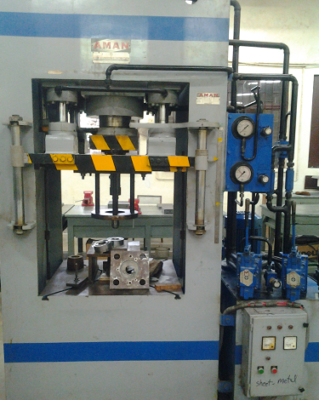

Upper and Lower Die

Leaver

Punch

Pressure gauge

Blank Holder

**Fig 3.0** Experimental setup on 100 tonne hydraulic press for stretch forming tests

The schematic diagram of the tool arrangement (punch, lower die and upper die) is shown in fig. 3.9. For LDH tests square specimen of 1100 Al Alloy of size 100 mm X 100 mm as shown in fig. 3.11 (a) were cut from the FSW welded specimen. A circular drawbead as shown in fig 3.10 and fig 3.12 was provided on the dies with 80mm diameter to restrict the flow of metal from the flange region into the die to ensure complete clamping of the blank at the drawbead. Since the specimen thickness is greater than the drawbead diameter, so this is the case of biaxial stretching. All the tests were conducted in dry condition at punch speed of 20 mm/min. An optimum blank holding fore in the range of 5 to 6 tons was applied on the upper die. The experiments were stopped when a visible neck of initiation of fracture was observed on the specimen as shown in fig 3.9 (b). The dome height of the specimen was measured by a height gauge of least count of 0.02 mm.

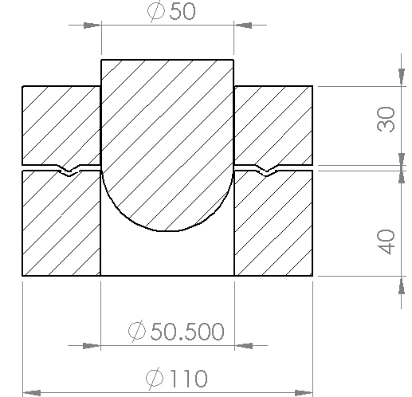

**Fig 3.1** Schematic diagram of the tools used in stretch forming experiments

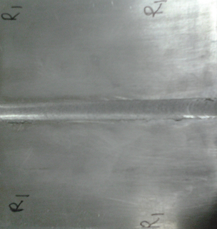 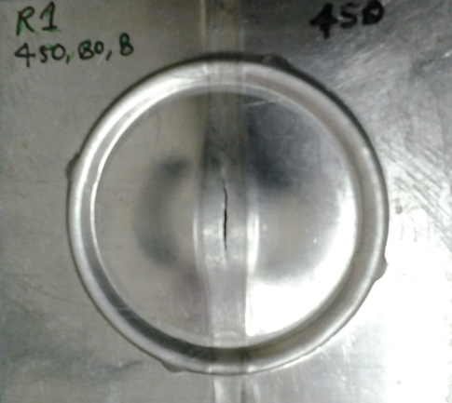



**Fig 1.4** (a) LDH tests specimen before testing (b) LDH tests specimen after testing (Splitting of the weld line observed during stretch forming)

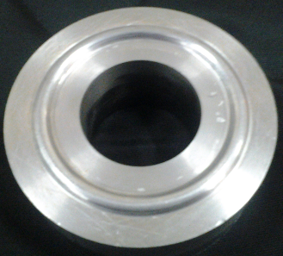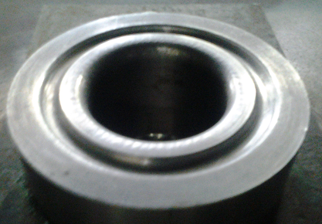

Lower Die

**Fig 2.6** Upper die and lower die for stretch forming

**2.6 Forming limit diagram:**

A forming limit diagram (FLD) is a plot of major *v/s* minor strain in the plane of the sheet, for different strain ratios. At each minor strain there is a limiting major strain that can be achieved before failure [11]. The locus of points for different ratios of limiting major strain/minor strain is the forming limit diagram (FLD), and represents a boundary below which “safe” ratios of major-to-minor strain exist. For FLD tests square specimen of 1100 Al Alloy of size 100 mm X 100 mm as shown in fig. 3.13 (a) were cut from the FSW welded specimen. In order to measure surface strains, grid circles were engraved by laser on the specimen, with diameters 5.0 mm as shown in fig 3.13. The circles used for plotting the FLD. The base metal sheets were used to obtain baseline FLD data for each set of parameters.

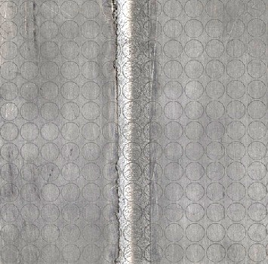 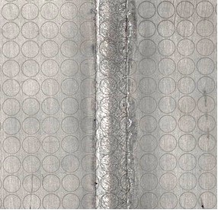 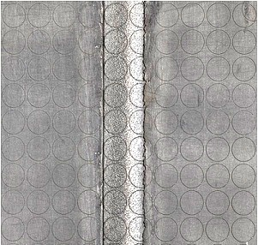

R1 (450-80-8) R4 (560-160-8)

R7 (710-250-8)

**Fig 2.7** FLD tests specimen (size 100mm X 100mm)

**2.8 Measurement of LDH, Strain Distribution and Weld Line Movement**

The limiting dome height of the entire deformed specimen in stretch forming was measured by a vernier height gauge of least count of 0.02 mm. The major and minor diameters of deformed ellipse were measured by a travelling microscope with least count of 0.001 mm to obtain major and minor strains. The variations of major and minor strains along and across the weld in all combinations were measured to plot the strain distribution profiles. The weld line movement was measured by finding out the coordinates of about 11 points on the weld line of the deformed specimen.

**2.5 Motivation and scope**

The application of aluminum and its alloy for automotive application have increased significantly in the last decade. Though the concept of TWBs has been developed several years ago, there have been very limited attempts of using aluminum alloys for TWBs. Many studies [9] on FSW based on experiments and simulations are mainly focused to understand the process itself, especially the effect of process parameters (tool geometry, tool materials, rotation speed, moving speed, tool angle, base materials and their arrangement in the advancing or retreating sides, base material thickness) on the quality of welding (temperature distribution, material flow or deformation, microstructure, mechanical properties in the welded area, hardness, residual stress, defects, texture). Studies on the macroscopic behavior of friction stir welded aluminium alloy 5XXX/6XXX tailor welded blank of thin sheets are rare except for a few recent works. However, AA 5XXX/6XXX series are having very good formability and used in various automotive application.

**2.6 Objectives**

1. To prepare the aluminium alloy TWBs using Friction Stir Welding (FSW) process
2. To study the influence of process parameters on weld quality.
3. To investigate the metallurgical characteristics of FSW fabricated tailor welded blank.

**CONCLUSION AND SCOPE FOR FUTURE WORK**

The following conclusions can be drawn from the results:

1. Friction stir welding process was used to join the AA-1100 sheets. It is concluded from above result the optimum range of tool rotation (rpm) is 450 rpm to 710 rpm. If it is less than 450rpm, due to less heat generation joint produced by FSW is not good but if it is more than 710 rpm flushing takes place.
2. At a constant rotational speed, an increase in the travel speed leads to wormhole initiation near the bottom of the weld. Furthermore, the size of the wormholes increases with the travel speed because of inadequate material flow towards the bottom of the weld.
3. Tensile tests were performed to find out the mechanical properties of the AA 1100 sheets as well as weld region (i.e. longitudinal and transverse direction) of TWBs. It was observed that the % elongation of weld in longitudinal direction is very high as compare to base metal.
4. Hardness in advancing side is more than the retreating side in HAZ because the grain refinement is more in advancing side than retreating side.

**SCOPE FOR FUTURE WORK**

1. FSW tool with pin can also be used for further study.
2. Microstructure of the weld can also be seen for better understanding and analyzed them for better welding characteristics.

**REFERENCES**

1. R. Nandan ,T. DebRoy ,H.K.D.H. Bhadeshia, Recent advances in friction-stir welding – Process, weldment structure and properties, Progress in Materials Science 53 (2008) 980–1023.
2. J. Jeswiet, M. Geiger, U. Engel, M. Kleiner, M. Schikorra, J. Duflou, R. Neugebauer, P. Bariani, S. Bruschi, Metal forming progress since 2000, CIRP Journal of Manufacturing Science and Technology 1 (2008) 2–17.
3. Amir Abbas Zadpoor, Jos Sinke, Rinze Benedictus, Raph Pieters, Mechanical properties and microstructure of friction stir welded tailor-made blanks, Materials Science and Engineering A 494 (2008) 281290.
4. Sushanta Kumar Panda, D. Ravi Kumar, Improvement in formability of tailor welded blanks by application of counter pressure in biaxial stretch forming, journal of materials processing technology 2 0 4 ( 2 0 0 8 ) 70–79.
5. R Ganesh Narayanan1 and K Narasimhan, Predicting the forming limit strains of tailor-welded blanks, The manuscript was received on 17 April 2008 and was accepted after revision for publication on 20 June 2008.
6. M.Sivashanmugam, S.Ravikumar, T.Kumar, V.Seshagiri Rao, D.MuruganandamA Review on Friction Stir Welding for Aluminium Alloys, 978-1-4244-9082-0/10/$26.00 ©2010 IEEE
7. D.M. Rodrigues, A. Loureiro, C. Leitao, R.M. Leal, B.M. Chaparro, P. Vilaça, Influence of friction stir welding parameters on the microstructural and mechanical properties of AA 6016-T4 thin welds, Materials and Design 30 (2009) 1913–1921.
8. Wonoh Lee, Kyung-Hwan Chung, Daeyong Ki, Junehyung Kim, Chongmin Kim, Kazutaka Okamoto, R.H. Wagoner, Kwansoo Chung,