**Study The effect of Process Parameters on Weld Quality and Perform Microhardness Test.**

Sumer Singh

College Of Technology and Engineering, Udaipur

sumerrock1993@gmail.com

Abstract - Given the changing cultural attitudes on the environment, the automotive industry stands to gain a great deal from the use of laser welded blanks. Improving their product's energy efficiency and reducing production waste are necessary for this. Requirements for fuel economy in the automotive sector are becoming more stringent as scrap is declining. In order to lighten automobiles without sacrificing strength, there is now a lot of interest in developing lightweight alloys to replace bulky steel parts. High-strength steels, carbon-carbon composites, magnesium and aluminium, as well as a number of novel metallic composites, are all being studied for their potential and viability in large-scale production.

Aluminium and its alloys are among our most versatile engineering and building materials because of their special mix of qualities. While all alloys are lightweight, some of them have strengths higher than structural steel. The benefits of aluminium alloy sheets for automotive applications include excellent strength to weight ratio, recyclability, and resistance to corrosion.

Laser, electron beam, tungsten inert gas, metal inert gas, and friction stir welding techniques have all been used to create tailored welded blanks. However, due of their small heat affected zone (HAZ) and fusion zone, laser and electron beam welding technologies have less of an impact on material properties than conventional welding methods. Laser welding has become the most popular method for making TWBs since it is less costly and more versatile than electron beam welding. However, alloys made of magnesium and aluminium provide a lot of difficulties in the creation of TWB because of their intrinsic oxide layer, low molten viscosity, and high reflectivity.

For instance, heated cracking in the fusion zone and poor coupling throughout the welding process are the outcomes of conventional laser welding.   
Thus, friction stir welding (FSW) was created mainly for aluminium alloys as a rapidly developing TWB welding process. Wayne Thomas of TWI (The Welding Institute) devised friction stir welding, and in December 1991 the first patent applications for the technique were submitted in the UK. Although the technique was once thought to be a "laboratory" curiosity, it quickly became apparent that FSW had several advantages when it comes to the manufacture of aluminium goods.

A spinning tool with a shoulder and a pin travels over the butting surfaces of two tightly clamped plates set on a backing plate during friction stir welding (FSW), a solid-state, hot-shear joining technique, as illustrated in Fig. 1.1. The shoulder comes into touch with the workpiece's upper surface. The material being welded becomes softer due to heat produced by friction at the shoulder surface. The tool experiences significant plastic deformation and flows of this plasticised metal as it is moved in the direction of welding. The material is moved from the tool's front edge to its rear edge, where it is fused forming a junction. While a butt joint is used as an example in Fig. 1.1, additional joint types such fillet joints and lap joints

For tailor-welded blanks, the welding technology is well-established. What remains unclear are the TWBs' forming properties. The challenge is in forecasting the effects of process factors on weld quality and the position of welds on formability and mechanical qualities. In order to produce customised welded blanks for this project, I will use the friction stir welding technique. I will also conduct formability testing, uniaxial tensile testing, and microhardness testing, as well as research the effects of process parameters on the quality of the welded product. Additional thorough explanation provided in the chapter's literature review

**EXPERIMENTAL INVESTIGATION**

In the present work the TWBs made by FSW process and study the effect of process parameter on weld quality.

**1.1 Friction Stir Welding Setup:**

The following were used for the Friction Stir Welding Process of Aluminium alloy sheets.

1. Vertical Milling machine
2. Fixture
3. Backing Plate
4. Tool
5. Specimen
6. Fixture A fixture is a support or work-holding tool used in a variety of industrial processes. Fixtures are primarily used to identify and, in some situations, retain workpieces during machining operations.

2. Every weld sample is displayed in fig. 3.5 above. Equation 2.1 indicates that heat generation is greater at higher rotational speeds, as seen in the above figure 3.5c, d. When welding, more material flashes out when there is high heat output, and incorrect strip bonding results from low heat generation, both of which are undesirable. Hence, the ideal speed range, which was employed in this experiment, is between 450 and 710 rpm. Porosity and surface flaws are frequent flaws in friction stir welds [1].

3. Surface flaws and porosity are frequent flaws in friction stir welds [1]. Wormhole initiation occurs close to the bottom of the weld when the travel speed increases while the rotating speed remains constant. Furthermore, because there is insufficient material flow towards the bottom of the weld, the size of the wormholes rises with the travel speed. There are hints that a key factor in the creation of the wormhole defect is the ratio of rotating speed to transit speed. A high ratio often encourages the production of wormhole flaws for the same material and tool geometry.

4. For this reason, it was limited. The interface between the tool shoulder and the work-piece is where the majority of heat generation takes place. Surface overheating can cause defect development in the form of surplus flash if there is significant variability in the heat production at that contact.

**1.2 Selection of process parameters**

The choice of process parameters, such as rotation speed (rpm), welding speed (mm/min), and tool diameter, has a significant impact on the quality of FSW welds. Since the mechanical characteristics of the weld are significantly influenced by the heat generated [eq. 2.1] in the weld nugget zone. As a result, choosing the welding process parameters carefully is crucial to getting the ideal heat in the weld nugget zone. Using the chosen parameter changes as indicated in Table 1, which were acquired using Taguchi's orthogonal array approach, the welding was completed. The goal of the Taguchi approach is to minimise process variation by using a strong experimental design.

Taguchi's proposed experimental design uses orthogonal arrays to arrange the process-affecting factors and the levels at which they should be varied. The Taguchi approach evaluates pairs of possibilities as opposed to needing to test every conceivable combination, as in the case of the factorial design. This saves time and money by enabling the gathering of the data required to identify the variables that most influence product quality with the least amount of trial. Visual examination is the primary method used to assess the high quality of the welds that FSW obtained. Every set of parameters showed the development of four welds.

**Table 1.2 Process parameters**

|  |  |  |  |  |  |
| --- | --- | --- | --- | --- | --- |
| Welding Run No. | Rotational speed (rpm) | Welding speed (mm/min) | Tool diameter (mm) | Depth of plunging (mm) | Result |
| 1 | 450 | 80 | 8 | 0.35 | Good |
| 2 | 450 | 160 | 12 | 0.35 | Poor/ over heating |
| 3 | 450 | 250 | 16 | 0.35 | Not possible due to over heating |
| 4 | 560 | 160 | 8 | 0.35 | Good |
| 5 | 560 | 250 | 12 | 0.35 | Poor/ over heating |
| 6 | 560 | 80 | 16 | 0.35 | Not possible due to over heating |
| 7 | 710 | 250 | 8 | 0.35 | Good |
| 8 | 710 | 80 | 12 | 0.35 | Poor/ over heating |
| 9 | 710 | 160 | 16 | 0.35 | Not possible due to over heating |

After performing the welding, only three welding runs [i.e.R1( 450-80-8), R4( 560-160-8) and R7 (710-225-8)] were produce good quality weld and other then these run generating more heat which causes sticking between specimen and backing plate which is undesirable and shown in figer.3.5 .

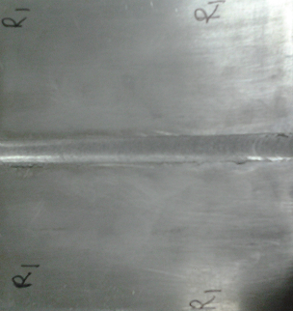 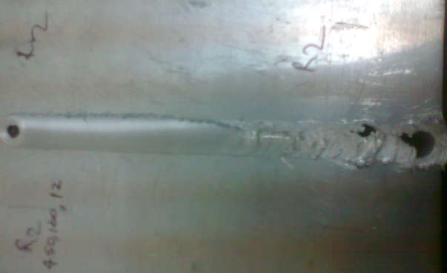

R1 (450 -80 - 8) R2 (450 -160 - 12) R3 (450 -225 – 16)

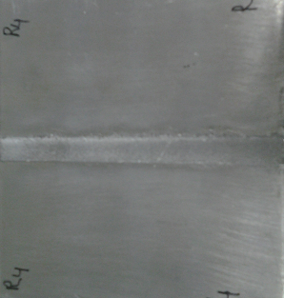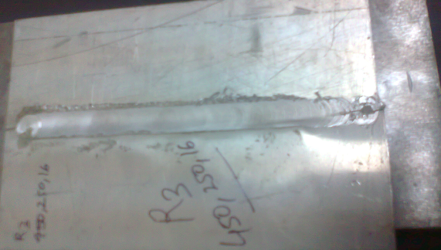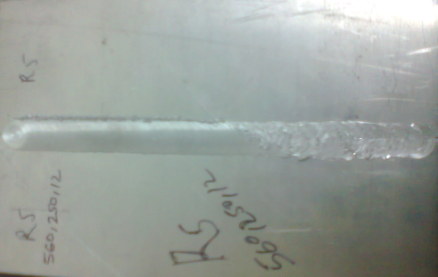 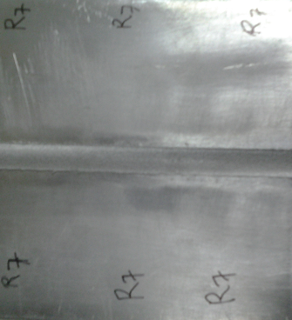

R4 (450 -160 - 8) R5 (560 -250 - 12) R7 (560 -80 - 16)

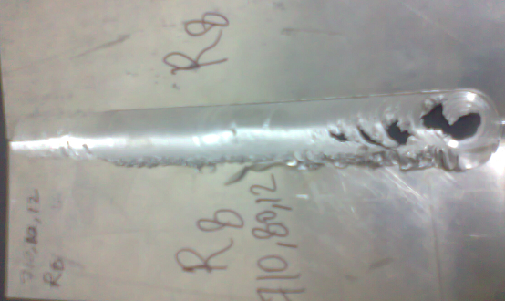

R8 (710 -80 - 12))

Fig. 3.5 Weld samples with different process parameters (R1, R2, R3, R4, R5, R7 and R8)

The weld samples are all displayed in fig. 3.6 above. Equation 2.1 indicates that increased tool pin diameter, increased tool rotation, and decreased welding speed result in increased heat generation, as the above figure 3.6 (R2, R3, R5, and R8) clearly illustrates. Increased heat generated during welding results in an unwanted quantity of material flashing out and adhering between the backing plate and the strips. R6 (560 - 80 - 16) and R9 (710 - 160 - 16) are not achievable due to decreased welding speed and a larger tool diameter. As seen in figure 3.6, R1 (450 - 80 - 8), R4 (560 - 160 - 8), and R7 (710 - 250 - 8) produced high-quality welds.

**1.4 Mechanical Properties**

Various tests will be performed on base material as well as weld material such as...

**1.4.1 Microhardness tests**

The transverse direction of the weld was used to cut the metallographic sample, and epoxy resignation was used to prepare the mounting. Samples were polished using emery paper ranging in grade from 200 to 2000. Following this, they were softly polished using alumina powder (Al2O3) of grades I, II, and III, which had particle sizes of 5, 3, and 1 µm, respectively. Samples were then etched using Killer's reagent, which included 95% water and 2.5% each of HNO3, HCl, and HF. Each sample was subjected to a Vicker's hardness test in the transverse direction, covering the advancing, retreating, and weld sides. A material's hardness is often measured by its ability to withstand long-term indentation. 100 grammes of indentation load were used, and the dwell period was 10 seconds.

As seen in fig. 3.6, microhardness test samples will be created for every weld run, derived from weld specimens spanning the whole weld area (i.e., weld nugget zone and heat impacted zone).

Indentation

Mark

Weld nugget zone

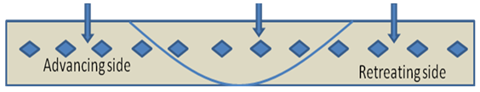

HAZ

HAZ

Fig 3.6 Top view of micro hardness sample

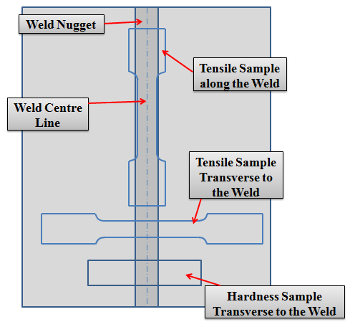

**Fig.1.5** Tensile tests and microhardness test samples

**RESULTS AND DISCUTIONS**

The findings and observations from a range of experiments, including formability testing on parents and tailor-welded blanks, microhardness tests, and uniaxial tensile tests.

**2.1 Microhardness**

The microhardness analysis revealed that the average width of weld zone (weld nugget zone and heat affected zone) is approximately 3 to 4 mm both side higher than the weld nugget zone (i.e. 14 mm for 8mm diameter tool). The hardness profiles of all weld configurations are as seen in Figure 4.1. It is evident that welding produced a very uneven distribution of hardness. It is generally acknowledged from the literature that the precipitates' dissolving and/or coarsening is what causes the softening effect of FSW. Moreover, for every arrangement, the hardness profile is asymmetric. Due to distinct deformations on both sides, the sheet at the advancing side often has a higher hardness than the one at the retreating side. This has also been seen in other research. Because they have distinct directions on the retreating side but the same direction on the advancing side, the material at the advancing side is impacted by the vortex velocity field more intensely and for a longer period of time. Thus, the process of straining and refining grain

**Table 1.1** Vickers Hardness values of all samples with respect to weld region

|  |  |  |  |
| --- | --- | --- | --- |
| Distance from Centre Line  Sample no. | R1 (450/80 /8) | R4 (560/160/8) | R7 (710/250/8) |
| -25 | 48.7 | 47.4 | 47.9 |
| -24 | 47.6 | 47.2 | 45.7 |
| -23 | 44.3 | 46.2 | 46.2 |
| -22 | 46.2 | 44.2 | 46.8 |
| -21 | 46.7 | 45.3 | 47.1 |
| -20 | 45.8 | 46.6 | 45.5 |
|  |  |  |  |
| -19 | 45.2 | 43.8 | 43.9 |
| -18 | 44.1 | 43.6 | 42.8 |
| -17 | 45.1 | 42.1 | 42.4 |
| -16 | 45.6 | 41.3 | 42.2 |
| -15 | 43.6 | 41.9 | 43.1 |
| -14 | 44.1 | 42.1 | 43.2 |
| -13 | 44.7 | 42.7 | 41.9 |
| -12 | 43.6 | 41.8 | 43.6 |
| -11 | 44.2 | 42.2 | 40.6 |
| -10 | 45.5 | 41.5 | 42.5 |
| -9 | 43.5 | 39.8 | 41.9 |
| -8 | 42.7 | 41.5 | 41.8 |
| -7 | 44.9 | 39.5 | 43 |
| -6 | 40.8 | 41.2 | 40.8 |
| -5 | 41.5 | 38.8 | 40.1 |
| -4 | 40.5 | 38.7 | 39 |
| -3 | 39.5 | 37.5 | 38 |
| -2 | 40.2 | 37.4 | 37.4 |
| -1 | 38.5 | 35.7 | 37.8 |
| 1 | 39.3 | 36.6 | 37.7 |
| 2 | 39.9 | 38.1 | 39 |
| 3 | 40.5 | 36.5 | 36.5 |
| 4 | 42.3 | 37.8 | 35.7 |
| 5 | 40.3 | 36.5 | 37.6 |
| 6 | 41.8 | 36.7 | 37.5 |
| 7 | 43.3 | 37.4 | 38.3 |
| 8 | 44.9 | 36.8 | 41.5 |
| 9 | 46.6 | 38.9 | 43.4 |
| 10 | 45.6 | 39.6 | 43.8 |
| 11 | 44.9 | 42.4 | 42.1 |
| 12 | 46.9 | 44.2 | 44.2 |
| 13 | 46.5 | 44.2 | 43.4 |
| 14 | 44.1 | 43.2 | 42.6 |
| 15 | 45.7 | 44.3 | 43.4 |
| 16 | 45.7 | 43.7 | 43.6 |
| 17 | 46.2 | 43.4 | 42.5 |
| 18 | 47.6 | 42.5 | 44.3 |
| 19 | 47 | 43.2 | 44.7 |
| 20 | 45.7 | 43.2 | 44.1 |
| 21 | 46.4 | 41.3 | 43.2 |
| 22 | 48.4 | 44.2 | 42.2 |
| 23 | 47.7 | 46.1 | 45.4 |
| 24 | 47.4 | 48.6 | 45.8 |
| 25 | 48.3 | 47.4 | 48.8 |

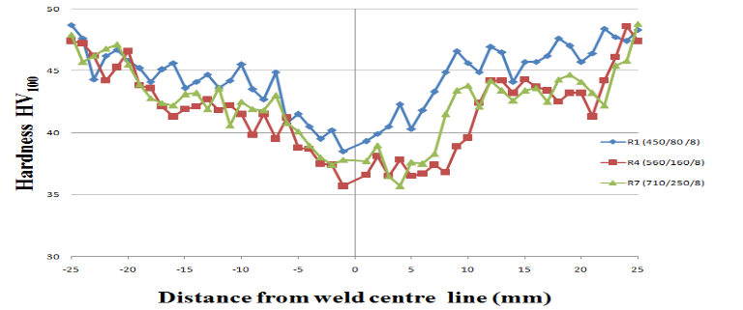

**Fig. 2.1** Microhardness profile across the weld in TWBs samples

metal, transverse to the weld and longitudinal to the weld for each run determined from tensile tests are given in table 4.2.

**Table 4.2** Mechanical properties of base metal and weld metal.

|  |  |  |  |
| --- | --- | --- | --- |
| **Welding Run** | **YS (MPa)** | **UTS (MPa)** | **% Elongation** |
| Base metal | 110.512 | 118.078 | 8.03 |
| R1 TW | 82.872 | 92.776 | 12.06 |
| R4 TW | 83.503 | 93.431 | 9.56 |
| R7 TW | 82.870 | 89.645 | 10.53 |
| R1 LW | 83.047 | 91.505 | 23.69 |
| R4 LW | 84.751 | 93.627 | 33.21 |
| R7 LW | 80.281 | 91.812 | 27.4 |

According to the above table, the percentage elongation of the weld metal is greater than the base metal in both cases (i.e. longitudinal and transverse direction), but the yield strength and ultimate tensile strength of the weld (i.e. longitudinal direction / along the weld (LW) and transverse direction / across the weld (TW)) are less than the base metal. Additionally, it can be seen that when two welds are transverse and longitudinal, the longitudinal weld exhibits a higher percentage of elongation than the transverse weld, although both the longitudinal and transverse directions of the weld's yield strength and ultimate tensile strength are almost comparable.

**Fig 2.3** **(b)** Stress *v/s* strain diagram of transverse direction for each run along with base metal

The stress-strain curve displayed in Figure 4.3(a) and (b) can be used to confirm the above findings. From the curve, it is also possible to see that R1 (450/80/8) provides more strength and a lower percentage of elongation; nevertheless, the percentage of elongation grows as tool rotation (rpm) increases. In comparison to the other curves, R7 (710/250/8) has good strength and ductility.

**CONCLUSION AND SCOPE FOR FUTURE WORK**

The following conclusions can be drawn from the results:

Using a friction stir welding procedure, the AA-1100 sheets were joined. The aforementioned result indicates that the ideal tool rotation speed range is between 450 and 710 rpm. If it is less than 450 rpm, the FSW-produced joint is not as excellent since there is less heat generation; nevertheless, flushing occurs if it is higher than 710 rpm.

Wormhole initiation occurs close to the bottom of the weld when the travel speed increases at a constant rotating speed. Furthermore, because there is insufficient material flow towards the bottom of the weld, the size of the wormholes rises with the travel speed.

Tensile tests were carried out to determine the mechanical characteristics of the TWBs' weld area, or the longitudinal and transverse directions, as well as the AA 1100 sheets. The longitudinal % elongation of the weld was found to be much higher than that of the base metal.

Because the advancing side of the HAZ has more refined grain than the retreating side, the advancing side is harder than the receding side.

**SCOPE FOR FUTURE WORK**

1. For more research, the FSW instrument with pin can also be utilised.
2. The weld's microstructure may also be observed for a clearer comprehension and examined for improved welding properties.

**REFERENCES**

1. R. Nandan ,T. DebRoy ,H.K.D.H. Bhadeshia, Recent advances in friction-stir welding – Process, weldment structure and properties, Progress in Materials Science 53 (2008) 980–1023.
2. J. Jeswiet, M. Geiger, U. Engel, M. Kleiner, M. Schikorra, J. Duflou, R. Neugebauer, P. Bariani, S. Bruschi, Metal forming progress since 2000, CIRP Journal of Manufacturing Science and Technology 1 (2008) 2–17.
3. Amir Abbas Zadpoor, Jos Sinke, Rinze Benedictus, Raph Pieters, Mechanical properties and microstructure of friction stir welded tailor-made blanks, Materials Science and Engineering A 494 (2008) 281290.
4. Sushanta Kumar Panda, D. Ravi Kumar, Improvement in formability of tailor welded blanks by application of counter pressure in biaxial stretch forming, journal of materials processing technology 2 0 4 ( 2 0 0 8 ) 70–79.
5. R Ganesh Narayanan1 and K Narasimhan, Predicting the forming limit strains of tailor-welded blanks, The manuscript was received on 17 April 2008 and was accepted after revision for publication on 20 June 2008.
6. M.Sivashanmugam, S.Ravikumar, T.Kumar, V.Seshagiri Rao, D.MuruganandamA Review on Friction Stir Welding for Aluminium Alloys, 978-1-4244-9082-0/10/$26.00 ©2010 IEEE
7. D.M. Rodrigues, A. Loureiro, C. Leitao, R.M. Leal, B.M. Chaparro, P. Vilaça, Influence of friction stir welding parameters on the microstructural and mechanical properties of AA 6016-T4 thin welds, Materials and Design 30 (2009) 1913–1921.
8. Wonoh Lee, Kyung-Hwan Chung, Daeyong Ki, Junehyung Kim, Chongmin Kim, Kazutaka Okamoto, R.H. Wagoner, Kwansoo Chung, Experimental and numerical study on formability of friction stir welded TWB sheets based on hemispherical dome stretch tests, International Journal of Plasticity 25 (2009) 1626–1654.