**Influence of Reskilling And Upskilling on Promotion of Employees**

**1. Rashmi V K**

IV semester, Human resources specialization, Department of business administration, Sahyadri college of Engineering and Management, Mangalore

**2. Dr. Vishal Samartha**

Director, Department of business administration, Sahyadri college of Engineering and Management, Mangalore

**Abstract**

Reskilling and upskilling play a crucial role in the promotion and career advancement of employees in today’s dynamic work environment. As industries evolve, the demand for new skills emerges, making it essential for employees to continually update their knowledge and capabilities. Organizations that invest in reskilling and upskilling initiatives not only empower their workforce to meet these changing demands but also enhance employee engagement and loyalty. This proactive approach to skill development fosters a culture of continuous learning, which in turn creates a pipeline of qualified internal candidates for promotions. By aligning employee skills with organizational needs, companies can better address skill gaps, reduce turnover, and maintain a competitive edge in the market. Thus, reskilling and upskilling are pivotal in ensuring employees are well-prepared for higher responsibilities and leadership roles, ultimately driving both individual and organizational growth.

**1. INTRODUCTION**

In today's rapidly evolving technological and business landscapes, the urgency for workforce reskilling and upskilling initiatives has become paramount. the necessity to adapt to these changes to maintain competitiveness and relevance. As traditional job roles evolve and new ones emerge, the capacity to efficiently reskill and upskill employees is now a strategic necessity. This introduction outlines the significance of these initiatives, their impact on both employees and organizations, and key strategies for successful implementation. Technological advancements in areas such as artificial intelligence, automation, and digital transformation are dramatically changing the nature of work. Many roles that once required manual intervention are being automated, while new positions necessitating advanced technical skills are being created. The widening skills gap—where the skills required for modern jobs are not matched by those possessed by the current workforce—presents a significant challenge to growth and innovation. For employees, reskilling and upskilling initiatives offer pathways to career advancement and job security. By acquiring new skills, employees can transition into new roles, avoid redundancy, and enhance their professional growth, leading to higher job satisfaction and engagement. For organizations, investing in workforce development results in a more agile and adaptable team, better equipped to handle modern business complexities, driving innovation and productivity. Additionally, companies that prioritize employee development attract top talent, gaining a competitive edge in talent acquisition and retention.

Successful reskilling and upskilling programs require strategic approaches aligned with organizational goals and workforce needs. Key strategies include fostering a culture of continuous learning, developing personalized learning paths, leveraging technology for flexible learning, creating collaborative learning environments, partnering with educational institutions for advanced training, and establishing leadership development programs. These strategies ensure a resilient and future-ready workforce, capable of navigating the challenges and opportunities of the modern business environment. By adopting these approaches, organizations can secure long-term success and employee fulfillment, solidifying reskilling and upskilling as cornerstones of strategic human resource management. workforce reskilling and upskilling initiatives are indispensable for organizations navigating the complexities of today's rapidly changing business landscape.

**2. Literature review**

**Sahana G N (2023)** The In addition to identifying solutions to the problems that arise, the paper looks into the most recent advances in research and practice of reskilling and upskilling programs for the benefit of employees receiving a promotion by offering the employees various programs focusing on different types of skill programs. This study contributes to the understanding that most employees did not receive promotions after participating in upskilling and reskilling programs, even after taking into account all of the skill trainings offered. Additionally, most employees received pay increases after doing this, but neither were they promoted to a better or higher position within the company, nor were they deemed eligible for promotions currently underway. Finding out what skills the organization currently has is the study's goal. to determine the obstacles to upskilling and reskilling. to determine which reskilling and upskilling programs' best practices are. The purpose of the study is to assess how employee promotion rates are affected by reskilling and upskilling initiatives. evaluating the differences in training program kinds' efficacy.

**Dr K Samuvel (2023)** The study mainly focus on the IT services industry is constantly evolving, with new technologies and trends emerging all the time. this study is done through online. To measure the effectiveness of upskilling and reskilling programs to improve employee performance and productivity. This study was carried out by a primary data with sample size 150 of IT employees which were chosen by simple random sampling method. To evaluate the impact of retention. To assess and potential barriers to develop strategies to overcome them. Statistical tools used for this data are factor analysis, Anova, chi-square, correlation. There are number of different ways that IT organization can upskill and reskill their employees. Some organization offer formal training programs, while other provide some informal opportunities for employees to learn new skills. some organizations also offer tuition reimbursement programs to help employees pay for their own training.

**Rosalind Marie Evans (2022)** The aim of the study is to perceived influence, This study seeks to explore whether the benefits of reskilling and upskilling include moving above poverty line. this indicate the participants perceive upskilling and reskilling to be an option that is available but only for few. It further highlights several themes that participants perceived as barriers. This theme includes such barriers as mental health, lack of education, lack of technology skills. The implications from the research include more community awareness of employment barriers. And need for social work on education on the micro and macro levels to assist individuals experiencing that lead to barriers to employment for the underserved and overlooked population. In this paper we can say that young and the old are experiencing barriers to employment. Two common frustrations felt by young job seekers are the employer’s expectation of work experience. Another barrier present is federal programs to employment.

**3. Research design**

**3.1 Problem statement**

Concerning the examination of the impact of reskilling and upskilling on employee promotions, the problem statement highlights the crucial necessity to determine whether and how career advancement within businesses is impacted by participation in skill development programs. The efficacy of employee development activities in promoting employees is poorly supported by empirical data, despite substantial spending in this area. In the end, this research aims to provide insights for optimizing talent management strategies by examining the degree to which reskilling and upskilling contribute to employee promotions, identifying the most impactful types of training, and investigating any variations in effectiveness across different roles and departments.

**Objectives**

* To analyze the relationship between reskilling and upskilling and promotion of employees.
* To evaluate the predicting power of reskilling and upskilling on promotion of employees.
* To assess the influence of demographic factors on promotion of employees.

**3.3 Research Methodology**

The present study has been done considering Mangalore region and employees working in IT Company. A sample size of 120 has been taken up for the study and the questionnaire has been used as a primary methodology.

**3.3.1 Variables:**

**Dependent variable:** promotion of employees

**Independent variable:** reskilling and upskilling

**3.3.2 Model Diagram**

**3.3.3 Statistical Tool**

|  |  |  |
| --- | --- | --- |
| SI No | objectives | Statistical tool |
| 1 | To analyze the relationship between reskilling and upskilling and promotion of employees | Correlation |
| 2 | To evaluate the predicting power of reskilling and upskilling on promotion of employees | Regression |
| 3 | To assess the influence of demographic factors on promotion of employees | Chi-Square |

**3.3.4 Hypothesis**

H1: There is a significant relationship between reskilling and upskilling and promotion of employees.

H1: There is a significant predictor in the power of reskilling and upskilling on promotion of employees.

H1: Age has a significant association that influence factors on promotion of employees.

H1: Gender has a significant association that influence factors on promotion of employees.

H1: Qualification has a significant association that influence factors on promotion of employees.

**4. Test and Interpretation**

**4.1 Correlation**

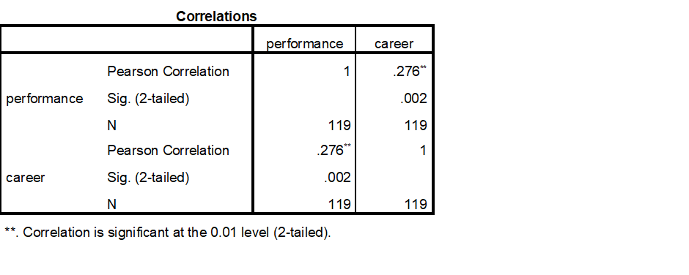

A p-value of less than 0.05 was obtained from the statistical analysis that was done. This low p-value suggests that there is extremely little possibility that the observed link is the result of random chance. As a result, we find that there is a substantial correlation between employee advancement and reskilling and upskilling, rejecting the null hypothesis and accepting the alternative. This research suggests that reskilling learning new skills for tasks that require them and upskilling improving existing skills increase an employee's chances of getting promoted. Employees gain from investments in ongoing learning and development because it increases their competitiveness and adaptability and helps the company achieve its strategic goals by developing a highly trained and motivated workforce. Consequently, encouraging a reskilling and upskilling culture. The importance that companies focus on ongoing staff development is demonstrated by this noteworthy relationship.

**4.2 Regression**

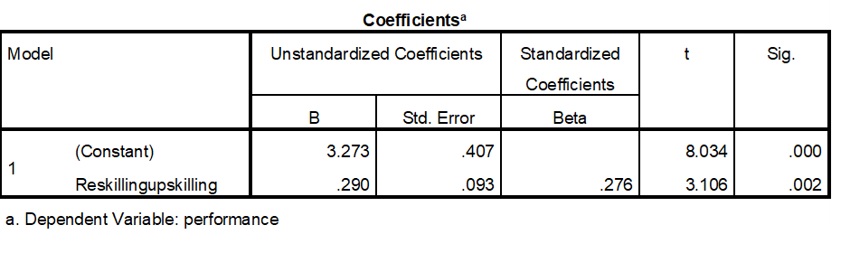

This result suggests that there is a significant correlation between employees' likelihood of receiving promotions and their involvement in these learning opportunities. In essence, the evidence backs up the hypothesis that better promotional outcomes are associated with investments made in skill development. Organizations are urged to make reskilling and upskilling initiatives a top priority as a fundamental part of their staff development plans in light of these findings. Employers can increase their employees' prospects of promotion and professional advancement by emphasizing skill development. By placing a deliberate focus on professional development, the business may eventually gain from a more capable and driven staff that will improve employee performance and retention. Building on these results, more research might examine the precise categories of reskilling and upskilling that lead to promotions. It would be beneficial to investigate the effects that distinct programs have on different departments or functions within an organization. Furthermore, by comprehending the elements that influence these developmental activities' efficacy, firms can modify their approaches to optimize the advantages of employee promotions and overall career advancement.

**4.3 Chi-Square Test**

**(1) For the influence of age on reskilling and upskilling on promotion of employees**

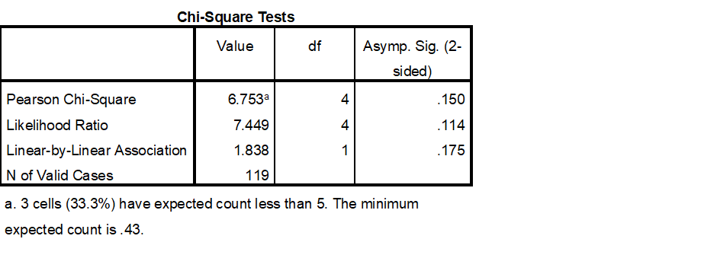

The claim that "Age has no significant influence on the promotion of employees" implies that age shouldn't be taken into account when deciding whether to promote an employee in a fair and efficient work environment. Promotions ought to be determined more by potential, performance, abilities, and merit than by years of service. This viewpoint is consistent with the ideals of non-discrimination and equal opportunity, wherein each employee is assessed according to their contributions and abilities rather than their age. If a company truly adheres to this philosophy, then all employees, regardless of age, will have equal opportunities for growth as long as they fulfil the performance and competency standards established by the business. This strategy guarantees that promotions are given out based on the value that employees provide to the company rather than on age-related biases or stereotypes, in addition to fostering a more diverse and inclusive workplace. In addition, a meritocratic workplace culture where people are inspired to succeed based on their own accomplishments and potential is fostered when age is disregarded in promotion decisions.

**(2) For the influence of gender on reskilling and upskilling on promotion of employees**

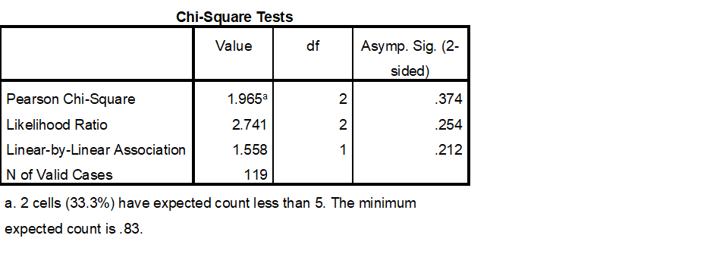

Promotions within a company should not be impacted by an employee's gender, as the statement "Gender has no significant influence on the promotion of employees" highlights. In an ideal workplace, gender is not taken into account when making decisions about career advancement; instead, qualifications, performance, and potential are the only factors taken into account. By guaranteeing that every employee, regardless of gender, has equal opportunity for growth and promotion, this principle promotes a culture of fairness and equality. Organizations must actively seek to eradicate prejudices from their promotion procedures in order to put this principle into practice. This entails defining precise promotion standards that prioritize abilities, accomplishments, and contributions over presumptions based on gender. By doing this, businesses can make sure that employee promotions are merit-based and accurately represent their abilities and accomplishments.

**(3) For the influence of education on reskilling and upskilling on promotion of employees**

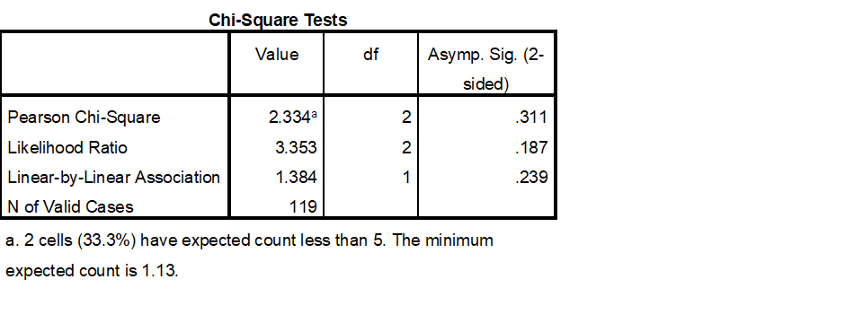

An employee's ability to develop within a company shouldn't be only based on their formal educational history, as the statement "Educational qualification has no significant influence on the promotion of employees" emphasizes. Promotions should instead be determined on an employee's experience, performance on the job, and the abilities they bring to the table. This methodology recognizes that although academic credentials might furnish a basis of understanding, they do not constitute the exclusive markers of an individual's capacity for achievement and advancement to more senior positions within the company. In order to properly implement this idea, firms must prioritize evaluating individuals not only on the basis of their educational qualifications but also on their demonstrated capabilities and accomplishments. This implies that there should be equal opportunity for promotion for workers who have great performance, leadership potential, and problem-solving skills but do not hold advanced degrees. This method assists in identifying and rewarding skill and ability regardless of formal educational background. Additionally, employers can encourage a more dynamic and diverse workforce by not placing an undue emphasis on educational requirements when making promotions.

**5. Findings**

**5.1 Correlation**

**H0:** There is no significant relationship between reskilling and upskilling and the promotion of employees.

**H1:** There is a significant relationship between reskilling and upskilling and the promotion of employees.

**Here p value is 0.02, Since the value is less than 0.05 we reject null hypothesis and accept alternative hypothesis**

Therefore, There is a significant relationship between reskilling and upskilling and the promotion of employees.

**5.2 Regression**

**H0:** Reskilling and upskilling have no predictive power on the promotion of employees.

**H1**: Reskilling and upskilling have predictive power on the promotion of employees.

**Here p value is 0.02, Since the value is less than 0.05 we reject null hypothesis and accept alternative hypothesis**

Reskilling and upskilling have predictive power on the promotion of employees.

**PROMOTION OF EMPLOYEES= 0.276* Reskilling and Upskilling + 3.273**

Beta value is 0.276which means,

**1 unit of change in Reskilling and upskilling leads to 27% change in promotion of employees**

**5.3 Chi-Square**

1. Demographic factor: Age

Dependent variable: Promotion of employees

**H0:** Age has no significant influence on the promotion of employees.

**H1:** Age has a significant influence on the promotion of employees.

**Since p value>0.05 we accept null hypothesis and reject alternative hypothesis**

Age has no significant influence on promotion of employees

2. Demographic factor: gender

Dependent variable: Promotion of employees

**H0:** Gender has no significant influence on the promotion of employees.

**H1:** Gender has a significant influence on the promotion of employees.

**Since p value>0.05 we accept null hypothesis and reject alternative hypothesis**

Gender has no significant influence on the promotion of employees

3. Demographic factor: Educational Qualification

Dependent variable: Promotion of employees

**H0:** Educational qualification has no significant influence on the promotion of employees.

**H1:** Educational qualification has a significant influence on the promotion of employees.

**Since the p value >0.05 we accept null hypothesis and reject alternative hypothesis**

Educational qualification has no significant influence on the promotion of employees.

**6. Conclusion**

Enhancing employee productivity and competency is one important way that reskilling and upskilling affect promotions. Workers with continuous learning and skill development are better able to manage challenging jobs and adjust to emerging technologies. Promotional decisions heavily weigh performance, which is generally correlated with this enhanced proficiency. Employees that regularly update their skill sets show that they are prepared for more advanced jobs and that they are committed to excellence. Additionally, retraining and upskilling support increased job retention and satisfaction. Workers are more likely to stick with the organization and be motivated at work if they perceive chances for both personal and professional development.

**BIBLIOGRAPHY**

Sahana, G. (2023) A study on impact of reskilling and upskilling on promotion of employees in the organization. Journal of emerging technologies and innovative research, 258-274 doi: 10.5467/jetir12.1086

Dr, K Samvuel. A study on impact of upskilling or reskilling of employees in IT services. International journal of advanced research in science, communication and technology, 359-363 doi:10.48175/IJARSCT-11457

Evans, Rosalind Marie, "Perceived Benefits of Upskilling and Reskilling by Persons who Are Among the Employed, Underemployed, and Unemployed" (2022). Digital Commons @ ACU, Electronic Theses and Dissertations. 482.

Dr shiny colaco, The impact of upskilling and reskilling programs on job satisfaction and employee retention (2023). Rabindra Bharathi journal of philosophy.55-64

Li, L. Reskilling and Upskilling the Future-ready Workforce for Industry 4.0 and Beyond. *Inf Syst Front* (2022). doi:10.1007/s10796-022-10308-y

Vallor, S. Moral Deskilling and Upskilling in a New Machine Age: Reflections on the Ambiguous Future of Character. *Philos. Technol.* 28, 107–124 (2015). doi:10.1007/s13347-014-0156-9

Sawant, Rhea, Bryan Thomas, and Swati Kadlag. "Reskilling and upskilling: To stay relevant in today’s industry." *International Review of Business and Economics* 7.1 (2022): 4.

Lang, Guido, and Tamilla Triantoro. "Upskilling and Reskilling for the Future of Work: A Typology of Digital Skills Initiatives." *Information Systems Education Journal* 20.4 (2022): 97-106.

Ajayi, Funmilayo Aribidesi, and Chioma Ann Udeh. "Review of workforce upskilling initiatives for emerging technologies in it." *International Journal of Management & Entrepreneurship Research* 6.4 (2024): 1119-1137.

# Vanda. "Reskilling and Upskilling of Managers: People Management in the Digital Era."  International Journal of Management & Entrepreneurship Research 6.4 (2022): 1229-1320

# Sukarna Chakma. "Importance of reskilling and upskilling in workplace."  Interdisciplinary Sripatum Chonburi Journal Vol. 6(2), May-August (2020)

Andreas Fraefel.” Slot Filling for Extracting Reskilling and Upskilling Options from the Web.” International Journal of Management & Entrepreneurship Research 6.4 (2022) DOI: [10.1007/978-3-031-08473-7_25](http://dx.doi.org/10.1007/978-3-031-08473-7_25)

Paula Cristina Nunes “Reskilling and upskilling in artificial intelligence era.” International Journal of Management & Entrepreneurship Research (2024)

# Sultana Ph, Dr. “THE IMPORTANCE OF RESKILLING AND UPSKILLING IN POST COVID ECONOMY” Journal of Tianjin University Science and Technology. 10.17605/OSF.IO/U26BW.

Allen “importance of reskilling and upskilling in workforce” International Journal of Management & Entrepreneurship Research (2022)

Kakul Agha “Training and Upgrading Skills of Employees Towards Building Resilience Among the Workforce.” International Journal of Management & Entrepreneurship Research (2022) DOI: 10.4018/978-1-7998-9506-0.ch012

Hari Krishnan Andi “upskilling and reskilling of artificial intelligence trends in knowledge management for enterprise search.” International Journal of Management & Entrepreneurship Research (2023)

Leon, Ramona Diana, 2023. "[Employees’ reskilling and upskilling for industry 5.0: Selecting the best professional development programmes](https://ideas.repec.org/a/eee/teinso/v75y2023ics0160791x23001987.html)," [Technology in Society](https://ideas.repec.org/s/eee/teinso.html), Elsevier, vol. 75(C).

Gichobi, Dennis. (2022). SKILLING, RESKILLING, AND UPSKILLING A WORKFORCE: A PERSPECTIVE FROM KENYAN ENTERPRISES SKILLING, RESKILLING, AND UPSKILLING A WORKFORCE: A PERSPECTIVE FROM KENYAN ENTERPRISES.

H. Bikas (2022). “Reskilling and upskilling in industry.” International Journal of Management & Entrepreneurship Research