“PARTIAL REPLACEMENT OF COARSE AGGREGATE WITH RUBBER TYRE CHIPS & CEMENT WITH RICE HUSK ASH IN CONCRETE

Manish Kumar1, Prof. Deepak Garg2, Dr. Rakesh Patel3

Department of Civil Engineering, OIST Bhopal, India

Abstract

The objective of this research is to determine the fresh and hardened properties of concrete under the influence of rubber and mineral admixtures. The results of the experiments showed a reduction in compressive strength as tire rubber content increased when compared to control mix. However, the tire rubber treated in NaOH solution yielded slightly better compressive strength results overall. Furthermore, as the tire rubber content increased a reduction in the workability and weight of the concrete was observed and recorded. The results revealed that the optimal replacement ratio is 8% rice husk ash + 10% tire rubber, yielding the highest compressive strength among all specimens tested irrespective of the rubber tire.

Keywords Cement Concrete, flexural strength, Strength parameters, water absorption, Workability.

1 Introduction

Rubber concrete has been researched for over twenty years. Rubber aggregate is mainly sourced from the increasingly discarded end-of-life tyres, which is known as black pollution because they are not readily degradable, posing a potential fire hazards to the environment and providing breeding grounds for mosquitoes . They are usually used to substitute part of natural aggregates or as additive of concrete mixture. A general consensus is that the ductility, impact resistance and dynamic energy dissipation capacity increase and compressive strength decreases with a rising proportion of rubber phase in concrete due to the elastic and soft nature of rubber material. However, conclusions on some other properties such as workability, flexural strength, freeze-thaw resistance do not come to an agreement and even the same property reported by different researchers varies significantly. From the aspect of rubber aggregate itself, this is attributed to the various rubber aggregate used by different researchers. It is stated that research is required to optimize the size, shape, grading, density, amount, and methods of pre-treatment of rubber particles on the properties of rubber concrete. The waste problem considered as one of the most crucial problems facing the world as a source of the environmental pollution. It is contributing as a direct form in pollution that includes the negative effects on the health by increasing the diseases, diseases vector, percentage of mortality and lowering the standard of living. The waste usually defined as the all remains things resulted from production, transfer and uses processes, and in general all transmitted things and resources that the owner or the producer wants to dispose or must dispose to prevent the risk on the health of the human and save the environment in general

**2 Objectives**

Following are the objectives of this work

* To Design a mix for M 30 grade of concrete as per the is code 10262:2019 having cement replacement 8%,16%, 24%& 32% with rice husk ash & coarse aggregate replacement 5%,10%, 15% & 20% with Rubber Tire Chips.
* To evaluate strength parameters like compressive strength and flexural strength of concrete with different configurations.
* To study the workability of concrete with rice husk ash & Rubber Tire Chips.
* To study the effect of dose of super plasticizer on slump values of mix.
* To obtain suitable percentage of replacement of cement with rice husk ash & coarse aggregate with recycled aggregate for the production of concrete.

**3 Methodology Adopted**

As stated earlier concrete mix design is required to be done if admixtures or additional cementing materials are added with partial replacement of cement in concrete is done. The behaviour and properties of green and hardened concrete totally depends on its ingredients ie. Cement, aggregates, cementing material and water to cement ratio. Properties of green concrete like workability and of hardened concrete like compressive strength, flexural strength, weight density etc. totally depends on the proportion of ingredients used in mix design, apart from this ratios of fine aggregate to coarse aggregate, water to cement, admixture to cement also plays and important role in different properties of concrete. For concrete mix design initially the lab tests on all the ingredients need to done and based on the lab results weather the ingredients are suitable to use or need to be changed need to be checked. Also properties like specific gravity, fine ness modulus, cement grade and required grade of concrete with have impact on proportions of ingredients in final concrete matrix. Concrete mix design is done based on the requirement of designer stating the requirement compressive strength, workability, which need be achieved based on the raw material available at site for concreting. Alteration in the materials tested in laboratory and material available on site may lead to concrete of undesirable properties. If ingredients are changed due to non-availability at site or it change due to source of excavation, concrete mix design need to be rechecked from time to time. Concrete mix design is a trial and error process and its results totally depends on the lab results of its constituents thus a through and detailed lab test need to be done on ingredients before proceeding for mix design.

**4 Test Results**

Table- slump value on varying cement replacement

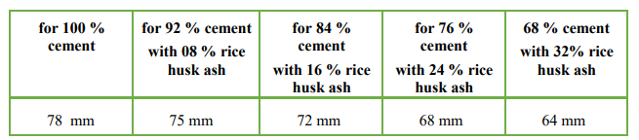

Table- slump value on varying aggregate replacement

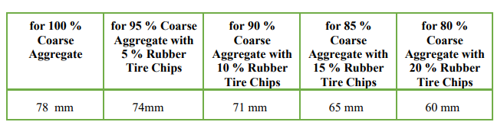

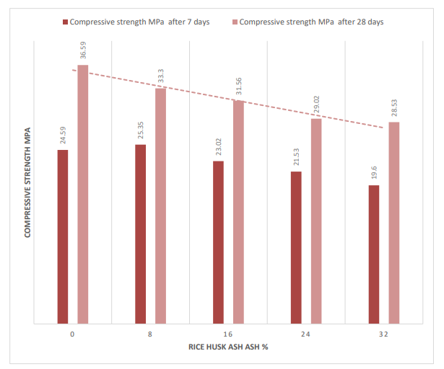

Figure - Compressive Strength Contain of RHA

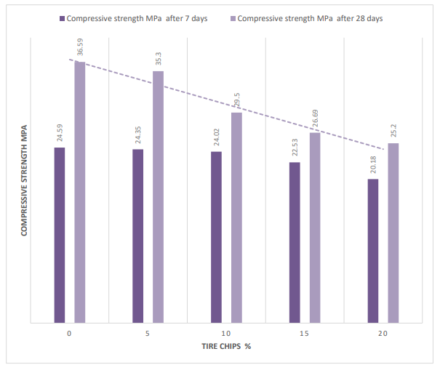

Figure -Compressive Strength Contain of Rubber Tire Chips

**5 Conclusion**

On the basis of experimental investigation of the present research study, the following conclusions have been drawn.

* Slump shows that the Workability of concrete was decreased as the percentage replacement of coarse aggregate with Waste Rubber Tire Chips was increased.it may be due increase in water demand on increase in specific surface area of aggregate. However, workability of all concrete mixes up to 20% replacement was suitable in structural uses.
* When the replacement of cement is increased up to 32% by rice husk ash in concrete mix there is decrease in slump value, which shows the workability of the concrete is reduced. rice husk ash is considered as a pozzolanic material which provides an increased cohesiveness in concrete due to its high fineness modulus which consequently results into a high amount of water requirement to maintain the desired workability
* If Single-doped rice husk ash replaces part of the cement, then for the same curing time, the compressive strength increases in the early level and at higher percentages it is relatively less. When the content of rice husk ash 8 %, the performance of concrete reaches the best.

**Reference**

GUO Yin-le1 LIU Xue-ying, and HU Yue-ping (2021) Study on the influence of fly ash and silica fume with different dosage on concrete strength. E3S Web of Conferences 237, 03038 (2021).

G.V.V. Raj Kishore. (2021) Experimental study on Strength Attainment of concrete containing silica fume and fly ash. International Conference on Advances in Civil Engineering, IOP Conf. Series: Materials Science and Engineering.

Priyanka lohiya & Dr. Suprakash Biswa (2020) “A literature review on study of silica fume as a partial replacement material of cement in concrete” Journal of Xi'an University of Architecture & Technology.

Judita Gražulytė, Audrius Vaitkus, Ovidijus Šernas, Donatas Čygas (2020) “Effect of Silica Fume on High-strength Concrete Performance. 5th World Congress on Civil, Structural, and Environmental Engineering (CSEE'20).

Mazin Rahal1 &Cornelius kanmalai Williams (2019) Study on Utilization of Waste Tire Rubber Chip as Coarse Aggregate with Mineral Admixture in Concrete. Saudi Journal of Civil Engineering Abbreviated Key Title: Saudi J Civ Eng ISSN 2523-2657 (Print) |ISSN 2523-2231 (Online)

M.Harikaran & N Balasundaram (2019) “Evaluation of Concrete Using Reshaped Waste Tyre Rubber as Partial Replacement of Coarse Aggregate”. International Journal of Recent Technology and Engineering (IJRTE) ISSN: 2277-3878, Volume-7, Issue-6S5

Ashhad Imam, Vikash Kumar and Vikas Srivastava (2018) Review study towards effect of Silica Fume on the fresh and hardened properties of concrete. Advances in Concrete Construction, Vol. 6, No. 2 145-157.

Rahul Dogra & Ankit (2014) Effect of silica fume on various properties of fibre reinforced concrete . International Journal of Civil Engineering and Technology (IJCIET) Volume 7, Issue 4, July-August , pp. 542–54

Dr ,P.Velumani, C.Lakshmipriya, N.Poovitha & R.Jeevanram (2018) “Feasibility study on addition of Hypo Sludge in concrete “.IJESRT, Volume 7, Issue 2, Page 463-467

MehtabAlam ,Vebhav Berera(2016) ” Experimental study of use of hypo sludge in cement concrete”. IJSRD, Volume 6, Issue 9, Page 135-139.

Ranjeet Kumar, Dr. Krishna Murari (2018) “ Influence of Polypropylene Fibers on recycled aggregate concrete”IJREAM, Volume 4, Issue 6, Page 477- 482.

R.Aravind Raj , Selvamuthumani (2018) “Experimental Studies on Strength of Hypo sludge Concrete with Polypropylene Fiber” IJIRSET, Volume 7, Issue 5, Page 49-52 56

IS 1489-1991 (Part-I). 1991. Specification Portland Pozzolana cement. New Delhi : Bureau of Indian standards, 1991. IS:10262-2019, 2000. Specifications for concrete mix design. New Delhi : Bureau of Indian Standards, 2000.

IS 383-1970 (reaffirmed. 2002. Specification for coarse and fine aggregates from natural sources for concrete. New Delhi : Bureau of Indian standards, 2002.

SP23-1982,. 1982. Hand book on concrete mixes (based on Indian standards). New Delhi : Bureau of Indian standards, 1982.

IS:456-2000,. Plain and Reinforced Concrete. New Delhi : Burea of Indian Standards, 2000.