**Low-Power Smart Vehicle Tracking Monitoring Collision Avoidance and Antitheft System**

**M. Ramesh Babu1, A. Vinoth Kumar2, R. Ganesh3, and B. Maheswari4**

1,2,3,4 Student, Department of Computer Science Engineering, ABR College of Engineering and Technology, Kanigiri, Andhra Pradesh -523254

**\* Correspondence:** R. Ganesh (ganeshrajan2810@gmail.com)

**ABSTRACT**

The “Low Power Smart Vehicle Tracking, Monitoring, Collision Avoidance, and Anti-theft System” proposed here integrates a suite of sensors including gas, fire, and MEMS (Micro-Electro-Mechanical Systems) to enhance vehicle safety and security. This system employs a microcontroller to process sensor data and control output devices such as a DC motor and buzzer. Additionally, an IOT platform facilitates remote monitoring and tracking of the vehicle’s status via GPS. In the event of gas or fire detection, the system triggers an alert through the buzzer while preventing the DC motor from operating to ensure safety. The MEMS sensor provides insights into the vehicle’s orientation, enabling accident detection and anti-theft measures. All sensor data is logged and accessible through an IOT platform for real-time monitoring and analysis.

**Keywords:** IOT, MEMS accelerometer, GPS tracking, Collision avoidance.

1. **INTRODUCTION**

Modern vehicles are equipped with various safety and security features, but there is always room for improvement, especially concerning real-time monitoring and proactive hazard detection. The Low Power Smart Vehicle Tracking, Monitoring, Collision Avoidance, and Anti-theft System presented in this project address these concerns by leveraging advanced sensor technologies and IoT connectivity.

The system comprises gas, fire, and MEMS sensors strategically placed within the vehicle to detect potential hazards and monitor its operational status. A microcontroller acts as the central processing unit, collecting data from these sensors and controlling output devices such as a DC motor and buzzer. The integration of GPS enables remote tracking and location-based functionalities.

In the event of a gas leak or fire detection, the system triggers an alert through the buzzer while preventing the DC motor from operating to avoid exacerbating the situation. The MEMS sensor provides crucial information about the vehicle’s orientation, aiding in accident detection and anti-theft measures. Furthermore, all sensor data is transmitted to an IoT platform, such as Thingspeak, allowing for remote monitoring and analysis by vehicle owners or authorized personnel.

1. **LITERATURE SURVEY** 
   1. **Existing System**

The existing vehicle tracking and safety systems lacked comprehensive integration of multiple sensors for hazard detection and prevention. Typically, vehicle tracking systems relied primarily on GPS technology for location monitoring, with limited capabilities for real-time monitoring of internal vehicle conditions such as gas leaks, fires, or accidents. Anti-theft systems primarily focused on immobilization techniques rather than proactive detection and prevention measures. Additionally, the integration of IoT platforms for remote monitoring and analysis was not widespread, limiting the accessibility and usability of vehicle data. Overall, the existing systems lacked the sophistication and integration necessary to provide comprehensive safety, security, and tracking functionalities for vehicles, leaving significant gaps in hazard detection and prevention.

**Disadvantages:**

* Limited sensor integration: Existing systems often lacked the integration of multiple sensors such as gas, fire, and MEMS, resulting in limited capability to detect various hazards comprehensively.
* Lack of real-time monitoring: Systems primarily relied on GPS for location tracking, with limited ability to monitor internal vehicle conditions in real-time, leaving occupants vulnerable to unforeseen hazards.
* Reactive anti-theft measures: Anti-theft systems mainly focused on immobilization after unauthorized access, rather than proactive measures to prevent theft or unauthorized use.
* Insufficient data accessibility: Data collected by these systems were often stored locally, limiting accessibility and usability for vehicle owners and authorities, hindering timely decision-making and response to emergencies.
* Inadequate hazard prevention: Without comprehensive sensor integration and real-time monitoring, existing systems were unable to proactively prevent hazards such as gas leaks, fires, or accidents, potentially leading to safety risks for occupants and damage to the vehicle.
* Limited remote monitoring capabilities: The absence of robust IoT platforms restricted remote monitoring and analysis of vehicle data, diminishing the effectiveness of tracking and safety measures, particularly in situations requiring immediate attention.
  1. **Proposed System**

The proposed system aims to revolutionize vehicle safety and tracking by integrating gas, fire, and MEMS sensors with a microcontroller and IoT platform. Through this integration, the system offers real-time monitoring of internal vehicle conditions, enabling proactive detection and prevention of hazards such as gas leaks, fires, accidents, and theft. In case of a hazard detection, alerts are triggered via a buzzer while simultaneously preventing the DC motor from operating to mitigate risks. The MEMS sensor provides crucial orientation data, aiding in accident detection and anti-theft measures. Additionally, GPS integration facilitates remote tracking and location-based functionalities, ensuring comprehensive safety, security, and tracking capabilities for vehicle owners and authorities. With seamless integration into an IoT platform, such as Thingspeak, the system allows for remote monitoring, analysis, and swift response to emergencies, enhancing overall vehicle safety and security.

**Advantages:**

* Comprehensive hazard detection: Integration of gas, fire, and MEMS sensors enables the system to detect various hazards such as gas leaks, fires, accidents, and unauthorized vehicle movement comprehensively.
* Real-time monitoring: The system offers real-time monitoring of internal vehicle conditions, allowing for proactive detection and prevention of potential hazards, ensuring timely intervention to mitigate risks.
* Proactive safety measures: Upon hazard detection, the system triggers alerts via a buzzer and prevents the DC motor from operating, thereby proactively minimizing risks and ensuring the safety of vehicle occupants and bystanders.
* Enhanced anti-theft measures: The MEMS sensor provides crucial orientation data, aiding in accident detection and anti-theft measures, enhancing the security of the vehicle against unauthorized access or theft.
* Remote tracking and monitoring: Integration with GPS enables remote tracking and location-based functionalities, facilitating easy monitoring of vehicle whereabouts and status in real-time, even from a distance.
* Swift response to emergencies: Seamless integration with an IoT platform allows for remote monitoring, analysis, and swift response to emergencies, enabling timely assistance and intervention during critical situations.
  1. **Technologies used in the proposed system:**
* Microcontroller: A microcontroller, serves as the central processing unit to manage sensor inputs, process data, and control output devices.
* Sensors:
* Gas Sensor: Detects gas leaks within the vehicle, providing early warning and preventing potential hazards.
* Fire Sensor: Identifies the presence of fire or high temperatures, triggering appropriate responses to mitigate risks.
* MEMS Sensor: Measures vehicle orientation, acceleration, and detects sudden changes, aiding in accident detection and anti-theft measures.
* GPS (Global Positioning System): Enables accurate tracking of the vehicle’s location, facilitating real-time monitoring and location-based functionalities.
* IoT (Internet of Things) Platform: Utilizes cloud-based services or platforms like Thingspeak or AWS IoT to establish connectivity, enabling remote monitoring, data logging, and analysis.
* Buzzer: Provides audible alerts in response to detected hazards or emergencies.
* DC Motor: Controlled by the microcontroller to implement safety interventions, such as preventing vehicle movement in hazardous situations.
  1. **Software requirements:**
* Arduino ide
* Embedded C
  1. **Hardware requirements :**
* Microcontroller
* Gas sensor
* Fire sensor
* MEMS Sensor
* GPS
* DC motor
* Buzzer

1. **METHODOLOGY**
   1. **Hardware Analysis**

The methodology for the proposed solution illustrates a coherent integration of components to ensure comprehensive vehicle safety and tracking capabilities. At the heart of the system lies a microcontroller, serving as the central processing unit. Input signals from gas, fire, and MEMS sensors are received by the microcontroller, which processes the data and triggers appropriate actions. Outputs from the microcontroller control the operation of a buzzer for alert notifications and a DC motor for safety interventions. Additionally, the system incorporates GPS technology for location tracking and an IoT platform for remote monitoring and data analysis. This platform enables real-time access to sensor data and facilitates seamless communication with vehicle owners and authorities. The integration of these components forms a robust framework for proactive hazard detection, prevention, and remote management, ensuring enhanced safety, security, and tracking capabilities for vehicles.

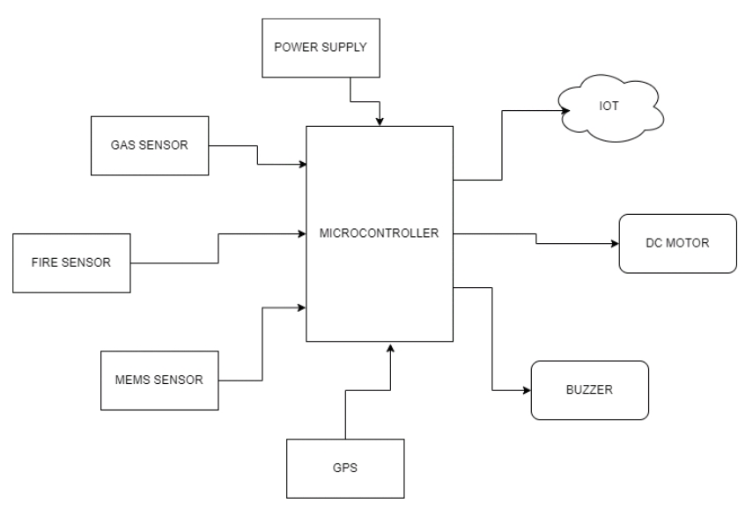

Fig. 1: Proposed System Model.

* 1. **Software Analysis**

The UML diagram illustrates the proposed system's architecture, focusing on the key components and their interactions. At the center of the diagram is the System Controller class, which orchestrates the flow of operations within the system. It interacts with two main subsystems: the Lane Detection System and the Motor Control System.

The Lane Detection System comprises several classes responsible for real-time lane detection using a Raspberry Pi camera with Open CV. The Camera class represents the Raspberry Pi camera module, capturing video frames. These frames are then processed by the Image Processor class, utilizing Open CV algorithms for lane detection. Detected lane positions are extracted and communicated to the System Controller. On the other hand, the Motor Control System includes classes responsible for adjusting robot movement based on detected lane positions. The Motor Driver class represents the L293D motor driver, enabling immediate adjustments in robot movement. The Movement Controller class interprets lane position data received from the System Controller and generates appropriate motor commands to ensure continuous adherence to the designated path. The System Controller acts as a mediator between the Lane Detection System and the Motor Control System. It receives lane position data from the Image Processor and forwards it to the Movement Controller for motor adjustments. Additionally, the System Controller monitors the system's overall operation and ensures coordination between the two subsystems. A use case diagram outlines the interactions between users and the proposed system, showcasing the various functionalities provided by the system. In this scenario, the actors interact with the system to achieve specific goals or tasks.

User: Represents any individual or entity interacting with the system.

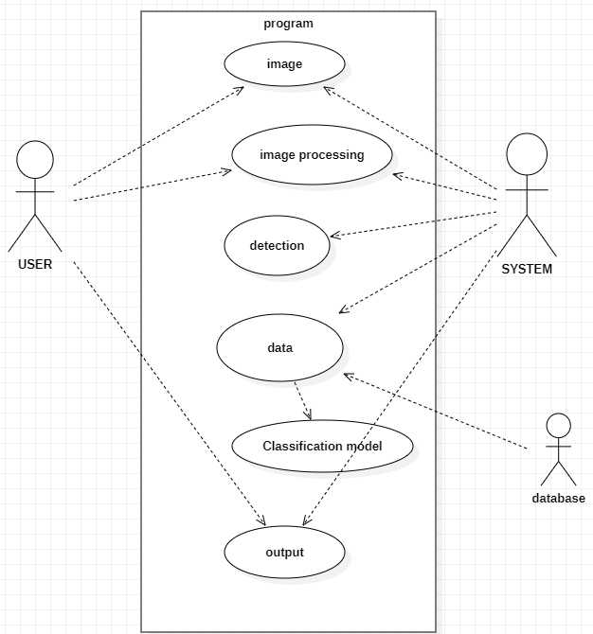

Fig. 2: User case diagram

**Use Cases:**

* Real-time Lane Detection:
* The user initiates real-time lane detection functionality.
* Adjust Robot Movement:
* The user triggers adjustments in robot movement based on detected lane positions.
* Ensure Continuous Adherence to Designated Path:
* The system ensures continuous adherence to the designated path by making immediate adjustments in robot movement.
* Enhance Accuracy in Lane Tracking:
* The system enhances accuracy in lane tracking by utilizing the Raspberry Pi camera with Open CV.
* Enable Autonomous Navigation:
* The system enables autonomous navigation, minimizing the risk of deviation from the intended path.

**Relationships**:

* User interacts with all the mentioned use cases.
* Use cases such as "Adjust Robot Movement" and "Ensure Continuous Adherence to Designated Path" depend on "Real-time Lane Detection" for obtaining lane position data.
* "Real-time Lane Detection" relies on "Enhance Accuracy in Lane Tracking" for precise lane detection using the Raspberry Pi camera with Open CV.
* "Enable Autonomous Navigation" builds upon the capabilities of "Real-time Lane Detection" and "Adjust Robot Movement" to ensure continuous navigation without deviation.

**System Boundary:**

* The system boundary encapsulates all the mentioned use cases and actors, representing the scope of the proposed system.

1. **RESULTS AND DISCUSSION**

The proposed system represents an innovative integration of hardware and software components aimed at achieving enhanced accuracy in lane tracking and enabling autonomous navigation for robotic systems. Here's a detailed explanation of each aspect:

* Existing vehicle tracking and safety systems lack comprehensive integration of multiple sensors, limiting their ability to detect various hazards effectively.
* Current systems primarily rely on GPS for location tracking, with limited capability to monitor internal vehicle conditions in real-time, leaving occupants vulnerable to unforeseen hazards.
* Anti-theft measures focus on immobilization after unauthorized access, rather than proactive prevention methods, leading to potential security breaches.
* Data accessibility and remote monitoring are often limited, hindering timely decision-making and response to emergencies.
* Without proactive hazard detection and prevention measures, vehicle safety and security remain compromised, posing risks to occupants and assets.

1. **CONCLUSION**

In conclusion, the Low Power Smart Vehicle Tracking, Monitoring, Collision Avoidance, and Anti-theft System offers a cutting-edge solution to address the pressing challenges in vehicle safety and security. Through the integration of gas, fire, and MEMS sensors with a microcontroller and IoT platform, the system achieves unparalleled levels of hazard detection, prevention, and remote monitoring capabilities. By proactively alerting and intervening in potential hazards such as gas leaks, fires, accidents, and theft, the system ensures the safety of vehicle occupants and bystanders. Furthermore, the seamless integration with GPS technology enables precise location tracking, while the IoT platform facilitates real-time access to vehicle data for informed decision-making. With its robust framework and comprehensive functionalities, the proposed system sets a new standard for enhancing vehicle safety, security, and tracking capabilities, ultimately contributing to safer roads and peace of mind for vehicle owners worldwide.

1. **REFERENCES**
2. W. U. Wen-Jing, C. H. E. N. Run-Chao, M. A. Fang-Wu, and L. I. A. N. G. Zhi-Kang, ‘‘Identify risks of pedestrian crossing based on sequence alignment method,’’ J. Transp. Syst. Eng. Inf. Technol., vol. 18, no. 3, pp. 101–107, 2018.
3. Reddy, N.U., Kumar, P.V., Kapileswar, N., Simon, J. and Kumar, P.P., 2022, November. A Prediction Model for Minimization of Flood Effects using Machine Learning Algorithms. In 2022 Sixth International Conference on I-SMAC (IoT in Social, Mobile, Analytics and Cloud)(I-SMAC) (pp. 593-597). IEEE.
4. Kapileswar, N. and Phani Kumar, P., 2024. Optimized deep learning driven signal detection and adaptive channel estimation in underwater acoustic IoT networks. International Journal of Communication Systems, 37(4), p.e5673.
5. Kumar, P.P., Simon, J., Devi, K.D., Elaveini, M.A. and Kapileswar, N., 2023. Enhanced Traffic Management for Emergency Vehicle Information Transmission using Wireless Sensor Networks. Procedia Computer Science, 230, pp.798-807.
6. Prabu, R.T., Simon, J., Kapileswar, N., Vinod, D.N., Polasi, P.K. and Emam, H.H.A., 2024. Four wave mixing, average amplified spontaneous emission, and channel spacing effects on the optical transceiver systems based on multi pumped Raman amplifiers. Journal of Optical Communications.
7. Simon, J., Kapileswar, N., Datchinamoorthi, M., Devi, G.K. and Muthukumar, S., 2024, May. DBQA: A Comprehensive Query Performance Analyzer with Django Framework. In 2024 International Conference on Advances in Computing, Communication and Applied Informatics (ACCAI) (pp. 1-6). IEEE.
8. Pandey, S., Barik, R.K., Karan, A., Phani Kumar, P., Haripriya, D. and Kapileswar, N., 2020. Socio-medic drone with integrated defibrillator. In Micro-Electronics and Telecommunication Engineering: Proceedings of 3rd ICMETE 2019 (pp. 659-668). Springer Singapore.
9. Kapileswar, N., Sankeetha, B., Mamta, M., Harini, V., Abinaya, S.K. and Kumar, P.P., 2022, April. Linear discriminant analysis based stage wise breast cancer identification. In AIP Conference Proceedings (Vol. 2405, No. 1). AIP Publishing.
10. Simon, J., Kapileswar, N., Reddy, J.V.G., Reddy, V.N. and Lakshmi, J.N., 2023, May. Internet of Things Assisted Road Traffic and Safety Monitoring Scheme using Sensitive Alcohol Detectors with Speed Analyzing Protocol. In 2023 International Conference on Advances in Computing, Communication and Applied Informatics (ACCAI) (pp. 1-8). IEEE.
11. Simon, J., Kapileswar, N., Phani Kumar, P. and Aarthi Elaveini, M., 2024. Improved geographic opportunistic routing protocol for void hole elimination in underwater IoTs: Parameter tuning by TSA optimization. International Journal of Communication Systems, 37(3), p.e5659.
12. M. R. D. Palepu, V.K. R. Chenchela, N. Kapileswar and P. Vijayasanthi, "Design of High Speed Fir Filter on FPGA by using Multiplexer Array Optimization in DA-OBC Algorithm", Int. J. Eng. Sci. Res. Technol., vol. 5, pp. 715-722, 2016.
13. Simon, J., Shyni, S.M., Jebaseeli, E.A.E. and Janakiraman, G., 2020, November. Design of massive MIMO dual band antenna for 5G cellular mobile communication. In 2020 4th International Conference on Electronics, Communication and Aerospace Technology (ICECA) (pp. 586-591). IEEE.
14. Simon, J., Priyan, T. and Prasanth, P.P., Audio Transmission in Visible Light Using Li-Fi Technology.
15. Simon, J., Kumar, U.S., Aarthi Elaveini, M., Vengaloor, R.P. and Phani Kumar, P., 2022. ATM Security Using Iris Recognition. In Mobile Computing and Sustainable Informatics: Proceedings of ICMCSI 2022 (pp. 97-108). Singapore: Springer Nature Singapore.
16. Simon, J., 2022. An Energy Efficient Routing Protocol based on Reinforcement Learning for WSN.
17. Shyni, S.M., Memala, A., Bhuvaneswari, C. and Simon, J., Efficient Energy Management System using Zigbee for Residential Application.
18. Polasi, P.K., Vellela, S.S., Narayana, J.L., Simon, J., Kapileswar, N., Prabu, R.T. and Rashed, A.N.Z., 2024. Data rates transmission, operation performance speed and figure of merit signature for various quadurature light sources under spectral and thermal effects. Journal of Optics, pp.1-11.
19. Reddy, B.A., Reddy, N.U., Teja, D.P.S., Rajam, V.S. and Kapileswar, N., 2020. A smartphone controlled fertilizing and plant watering garduino. International Journal of Applied Mathematics Electronics and Computers, 8(4), pp.173-178.
20. Z. H. U. Xichan, L. I. U. Zhichao, and L. I. Lin, ‘‘Evasive manoeuvre for emergency steering based on typical vehicle-pedestrian use case,’’ J. Automot. Saf. Energy, vol. 6, no. 3, pp. 217–223, 2015.
21. Kapileswar, N. and Santhi, P.V., 2012. Fault Secure Encoder and Decoder with Clock Gating. International Journal of VLSI Design & Communication Systems, 3(2), p.133.
22. Chenchela, V.K., Palepu, V.S., Nellore, K. and Palepu, M.R.D., 2016. Improving the quality of Service (QOS) of Connection Admission control Mechanism (CAC) using two dimensional queuing model. IOSR J. Electr. Electron. Eng, 11, pp.17-27.
23. Simon, J., Elaveini, M.A., Kapileswar, N. and Kumar, P.P., 2024. ARO-RTP: Performance analysis of an energy efficient opportunistic routing for underwater IoT networks. Peer-to-Peer Networking and Applications, 17(1), pp.1-17.
24. Kapileswar, N., Kumar, P.P., Reddy, N.U., Teja, D.P.S., Rajam, V.S. and Reddy, B.A.J., 2020, October. Adaptive OFDM non-uniform modulation for underwater acoustic communication. In 2020 5th International Conference on Computing, Communication and Security (ICCCS) (pp. 1-7). IEEE.
25. Nellore, K. and Polasi, P.K., 2022. An improved underwater wireless sensor network communication using Internet of Things and signal to noise ratio analysis. Transactions on Emerging Telecommunications Technologies, 33(9), p.e4560.
26. Gottapu, S.K., Kapileswar, N., Santhi, P.V. and Chenchela, V.K., 2018. Maximizing cognitive radio networks throughput using limited historical behavior of primary users. IEEE Access, 6, pp.12252-12259.
27. Kapileswar, N. and Phani Kumar, P., 2022. Energy efficient routing in IOT based UWSN using bald eagle search algorithm. Transactions on Emerging Telecommunications Technologies, 33(1), p.e4399.
28. Simon, J., Kapileswar, N., Polasi, P.K. and Elaveini, M.A., 2022. Hybrid intrusion detection system for wireless IoT networks using deep learning algorithm. Computers and Electrical Engineering, 102, p.108190.
29. Simon, J. and Kumar, A.N., 2021. A novel signal processing based driver drowsiness detection system. Journal of IoT in Social, Mobile, Analytics, and Cloud, 3(3), pp.176-190.
30. S. Cheng, Z. Wang, B. Yang, and K. Nakano, ‘‘Convolutional neural network- based lane-change strategy via motion image representation for automated and connected vehicles,’’ IEEE Trans. Neural Netw. Learn. Syst., early access, Apr. 18, 2023, doi: 10.1109/TNNLS.2023.3265662.
31. Kapileswar, N., Santhi, P.V., Chenchela, V.K. and Prasad, C.V.S., 2017, August. A fast information dissemination system for emergency services over vehicular ad hoc networks. In 2017 International Conference on Energy, Communication, Data Analytics and Soft Computing (ICECDS) (pp. 236-241). IEEE.
32. Nellore, K.; Palepu, V.S.; Palepu, M.R.D.; Chenchela, V.K. Improving the lifespan of wireless sensor network via efficient carrier sensing scheme-CSMA/SDF. Int. J. Eng. Sci. Res. Technol. 2016, 5, 723–732.
33. Menon, N.G., Shrivastava, A., Bhavana, N.D. and Simon, J., 2021, November. Deep learning based transcribing and summarizing clinical conversations. In 2021 Fifth International Conference on I-SMAC (IoT in Social, Mobile, Analytics and Cloud)(I-SMAC) (pp. 358-365). IEEE.
34. S. Cheng, Z. Wang, B. Yang, L. Li, and K. Nakano, ‘‘Quantitative evaluation methodology for chassis-domain dynamics performance of automated vehicles,’’ IEEE Trans. Cybern., early access, Nov. 14, 2022, doi: 10.1109/TCYB.2022.3219142. 66726 VOLUME 11, 2023 C. Yuan et al.: Vehicle Path Planning Based on Pedestrian Collision Avoidance Action.
35. Velmurugan, L., Raghuraj, G. and Simon, J., 2017, December. Google glass based GPS navigation using smartwatch. In 2017 IEEE International Conference on Computational Intelligence and Computing Research (ICCIC) (pp. 1-5). IEEE.
36. Shyni, S.M., Simon, J., Memala, W.A. and Bhuvaneswari, C., 2020, November. Implementation of integrated SEPIC-Flyback converter for LED drive with efficient power factor. In 2020 4th International Conference on Electronics, Communication and Aerospace Technology (ICECA) (pp. 385-389). IEEE.
37. Kumar, U.S., Simon, J., Vengaloor, R.P. and Elaveini, M.A., 2022. Image Processing Techniques in Thermal and Non-thermal Images. In Second International Conference on Image Processing and Capsule Networks: ICIPCN 2021 2 (pp. 533-544). Springer International Publishing.
38. Simon, J., 2021. A Performance Analysis of Wavelet based LTE-OFDM with Multi-equalizers. Turkish Journal of Computer and Mathematics Education (TURCOMAT), 12(6), pp.108-116.
39. Simon, J. and Prabakaran, N., 2021. Optimal wavelets with Binary Phase Shift Keying modulator utilized simulation analysis of 4G/5G OFDM systems. International Journal of Communication Systems, 34(9), p.e4775.
40. Simon, J., Monika, V., Santhiya, V.N.S. and Evangeline, E.S., 2017, September. Multisource energy harvesting architecture for electrical applications. In 2017 IEEE International Conference on Power, Control, Signals and Instrumentation Engineering (ICPCSI) (pp. 1812-1816). IEEE.
41. C. Yuan, Y. Wei, J. Shen, L. Chen, Y. He, S. Weng, and T. Wang, ‘‘Research on path planning based on new fusion algorithm for autonomous vehicle,’’ Int. J. Adv. Robot. Syst., vol. 17, no. 3, May 2020, Art. No. 172988142091123, doi: 10.1177/1729881420911235.
42. Vinod, D.N., Kapileswar, N. and Simon, J., 2024. Prognosis of COVID-19 Using Ultrasound Scans Augmented by Generative Adversarial Networks. International Journal of Intelligent Engineering & Systems, 17(4).
43. Kapileswar, N., Raj, P.P., Kanth, M.K., Upendra, D. and Kumar, P.P., 2022, April. Deep learning algorithm for classification and prediction of COVID-19 Pneumonia using CT scan images. In AIP Conference Proceedings (Vol. 2405, No. 1). AIP Publishing.
44. Kapileswar, N. and Kumar, P.P., 2022, September. Self-configured energy efficient protocol for IoT enabled underwater WSNs. In 2022 4th International Conference on Inventive Research in Computing Applications (ICIRCA) (pp. 398-403). IEEE.
45. Q. Liu, L. Zhao, Z. Tan, and W. Chen., ‘‘Global path planning for autonomous vehicles in off-road environment via an A-star algorithm,’’ Int. J. Vehicle Auto. Syst., vol. 13, no. 4, p. 300, 2017, doi: 10.1504/IJVAS.2017.087148.
46. Kapileswar, N. and Phani Kumar, P., 2023, June. Energy-Efficient Reliable Communication Routing Using Forward Relay Selection Algorithm for IoT-Based Underwater Networks. In International Conference on IoT Based Control Networks and Intelligent Systems (pp. 45-63). Singapore: Springer Nature Singapore.
47. Simon, J., Kapileswar, N., Datchinamoorthi, M. and Muthukumar, S., 2024, January. Gaze-Assisted Autism Spectrum Disorder Identification: A Fusion of Machine Learning and Deep Learning Approaches for Preemptive Identification. In 2024 5th International Conference on Mobile Computing and Sustainable Informatics (ICMCSI) (pp. 525-529). IEEE.
48. Simon, J., 2021. Image Augmentation based on GAN deep learning approach with Textual Content Descriptors. Journal of Information Technology and Digital World, 3(3), pp.210-225.
49. Simon, J. and Prabakaran, N., 2021, June. An Amplified Multi Equalizer Model in LTE-OFDM System for BER Performance. In 2021 5th International Conference on Trends in Electronics and Informatics (ICOEI) (pp. 318-323). IEEE.
50. Simon, J., Shyni, S.M., Mayuri, M. and Rajam, R.S., Tracking of Potholes and Measurement of Noise and Illumination Level in Roadways.
51. K. G. Jolly, R. S. Kumar, and R. Vijayakumar, ‘‘A Bezier curve based path planning in a multi-agent robot soccer system without violating the acceleration limits,’’ Robot. Auto. Syst., vol. 57, no. 1, pp. 23–33, 2009, doi: 10.1016/jrobot.2008.03.009.