**Performance Comparison of Electrically and Mechanically Operated 3/2 Pneumatic Directional Control Valves Using Artificial Neural Networks and Regression Models**

**1Oshundairo M.I, 2Ologe S.O., 3Anaidhuno, U.P.**

[oshundairo.mushafau@fupre.edu.ng](mailto:oshundairo.mushafau@fupre.edu.ng), ologe.solomon@upc.edu, & anaidhuno.ufuoma@fupre.edu.ng.

**1,3 Department of Mechanical Engineering, Federal University of Petroleum Resources, Effurun,**

**Delta State, Nigeria.**

**2Department of Mechanical Engineering, Acoustic and Vibration, University Polytechnic of**

**Catalonia, Barcelona, Spain**

**Abstract**

This research presents a comparative analysis of a 3/2 pneumatic directional control valve in electrically and mechanically operated systems, using both Artificial Neural Network (ANN) and regression models. The study involved an experimental set-up where air pressure was varied between 10 and 60 psi to measure piston travel time and distance, allowing for the calculation of piston travelling speeds through a mathematical relationship. ANN and regression modelling (RM) were employed to analyse and predict performance outcomes. The ANN produced adjusted coefficients of determination of 0.96422 for the electrically operated (EO) system and 0.93072 for the mechanically operated (PMO) system, outperforming the regression model’s results of 0.7037 and 0.8620, respectively. Results indicate that the actuator (piston) exhibits faster response times and generates higher power output in the purely mechanically operated system (PMO), achieving a piston travelling speed of 622.43 mm/sec, compared to 580 mm/sec in the electrically operated (EO) system. These findings provide valuable guidance for industries such as maritime, aerospace, and robotics, where the selection of pneumatic systems is crucial.

**Keywords:** Pneumatic valve, Comparative analysis, Electrically operated, Mechanically operated, Piston speed.

**1.0 Introduction**

The origins of pneumatic systems trace back to ancient Greece, where the term "pneuma," meaning breath or wind, was first coined. The study of pneumatics focuses on understanding the properties of air and gas. The ancient Greek engineer Hero of Alexandria (circa 10–70 AD) made significant early contributions to this field (Berryman & Sylvia, 2020). Over time, various inventors and engineers have further refined pneumatic technology. The 19th century marked the widespread industrial adoption of pneumatics, driven by advancements in steam power and gas properties (Amirit, 2022). Today, pneumatic systems are integral to automation, manufacturing, and numerous other applications due to their simplicity, reliability, and efficiency (Akers, Gassman & Smith, 2006). A pneumatic system utilizes compressed air to transmit and control power. It typically includes components such as compressors, valves, cylinders, and air motors to perform mechanical tasks (Amirit, 2022). These systems are extensively used in industries and machinery that depend on pressurized air. Applications of pneumatic systems extend across modern aerospace, robotics, mining, manufacturing, and machinery automation (Vishal et al., 2015).

The popularity of pneumatic systems is largely attributed to their high power-to-weight ratio. They also offer rapid response times, exceptional positioning capabilities, and durability (Bird, 1985). Their simplicity, cost-effectiveness, cleanliness, and environmental friendliness further contribute to their widespread adoption. Common components of pneumatic systems include cylinders, compressors, valves, and air-conveying hoses or tubes (Akers, Gassman & Smith, 2006).

Pneumatic systems are categorized into three types based on their mode of operation: computerized pneumatics, pure pneumatics, and electro-pneumatic systems:

* **Computerized pneumatic systems**: These advanced electro-pneumatic systems are controlled by a Programmable Logic Controller (PLC) and feature computerized control units, such as switches, sensors, and solenoid valves (Nguyen et al., 2021).
* **Pure pneumatic systems**: These systems consist solely of mechanical pneumatic components like cylinders, valves, pneumatic control components, and pneumatic motors (Vishal et al., 2015).
* **Electro-pneumatic systems**: These systems integrate electrical components with purely mechanical pneumatic components, including solenoid valves, limit switches, push-buttons, relays, and electrical control panels (Wu et al., 2014).

This research conducted a comparative analysis of a 3/2 pneumatic directional control valve in both electrically and mechanically operated systems using an Artificial Neural Network (ANN) and a regression model.

**2.0 Methodology**

The study conducted a comparative analysis of pure mechanical pneumatic systems and electro-pneumatic systems using artificial intelligence (AI) software. The focus was on the performance of 3/2 push-button and 3/2 solenoid valve control systems operated by a push-button. While electro-pneumatic systems are often preferred for applications requiring precise positioning and efficient power generation, they also exhibit inherent challenges. These challenges include throttling, overflowing, low efficiency, increased complexity, non-linearity, uncertainty, and vulnerability to external disturbances (Nguyen et al., 2021; Tivay et al., 2014).

To validate these observations, this project employed a critical analysis of both system types, utilizing practical data obtained from a model laboratory pneumatic trainer system. The trainer system, provided by Scientific Educational Systems (SES), facilitated a detailed examination of the effectiveness of electro-pneumatic versus mechanical pneumatic systems under controlled conditions. The AI software analyzed the system's responses to various inputs, allowing for a thorough evaluation of each system's performance and reliability under simulated real-world scenarios.

**2.1 System Description and Design Calculation**

**2.1.1 Piston area** **:** The piston area, calculated from the piston’s external and internal diameters, is essential for determining the force exerted in a pneumatic system.

 (1)

**2.1.2 Piston force** **:** The piston force in a pneumatic system is generated by the pressure applied to the fluid or gas and is calculated by multiplying the pressure (p) by the piston area (Ap), as described in Equation 2.

 (2)

**2.1.3 Piston travelling speed**

The piston’s velocity, a key determinant of system performance, is calculated by dividing the piston traveling distance (dp) by the traveling time (tp) (Amirit, 2022), as shown in Equation 3.

(3)

**2.2 Essential Equipment for a Purely Mechanical Pneumatic System**

1. Pneumatics Metal Base: A metal frame with a panel that has specialized holes for mounting small pneumatic components according to the experimental procedure guidelines.
2. Single Acting Cylinder (80mm) with Flow Control Valve Module
3. 3/2 Way Valve with Push-button Switch
4. Air Pressure Filter Regulator
5. Compressor
6. 4mm Flexible Tubing
7. 10mm Flexible Tubing

**2.3 Experimental Procedure**

Various components were identified and installed on the pneumatic metal board (TPS-3810/B) as shown in Figure 3. A 4mm tube was connected between the output of the air supply regulator and the input of the 3/2 push-button spring-loaded directional control valve (Vishal et al., 2015). Another 4mm tube was connected between the output of the 3/2 push-button valve and the input of the single-acting cylinder. A 10mm tube was then connected from the output of the compressor gate valve to the input of the air supply regulator .The compressor was switched on to fill the air storage tank, and the air supply regulator was adjusted to vary the air pressure supplied to the 3/2 push-button spring-loaded directional control valve. When the push-button was pressed, it forcefully extended the piston from the spring-loaded 80mm single-acting cylinder( Bird,1985). At various pressure levels (10, 20, 25, 30, 35, 40, 55, and 60 psi), each press of the 3/2 push-button recorded the distance traveled by the piston and the traveling time for further analysis.

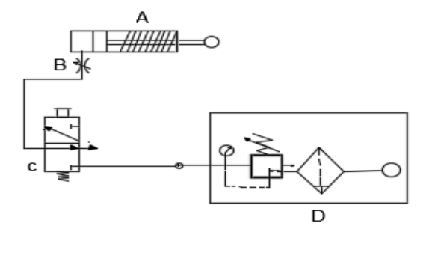

**Fig 1**: Fig 1: Schematic of the purely mechanical pneumatic system, including an 80mm cylinder (A), flow control valve (B), 3/2-way directional control valve (C), and pressure regulator (D).

**2.4 Experimental Equipment Required for Electro-Pneumatic System:**

1. Pneumatics Metal Base: A metal frame with mounting holes for pneumatic components
2. Single Acting Cylinder (80mm) with Flow Control Valve Module
3. 3/2 Way Solenoid Valve, Normally Closed, Spring Return
4. Air Pressure Filter Regulator
5. Compressor
6. 4mm Flexible Tubing
7. 10mm Flexible Tubing
8. Electronic Board: Includes 3 push-buttons, 3 switches, and 4 relays.
9. 12V Power Supply
10. Banner Cables

**2.5 Experimental Procedure**

Various components were installed on the pneumatic metal board as shown in Figure 4 (Vishal et al., 2015). A 4mm tube connected the air supply regulator to the 3/2-way solenoid valve, and another 4mm tube connected the solenoid valve to the single-acting cylinder. A 10mm tube linked the compressor gate valve to the air supply regulator Electrical power was supplied to the solenoid valves using Banner cables and a 12V adapter from the main power source The compressor filled the air tank, and the air supply regulator adjusted the pressure to the solenoid valve, which controlled the 80mm single-acting cylinder at various pressures. The piston distance and traveling time were recorded for analysis (Jan et al., 2023).

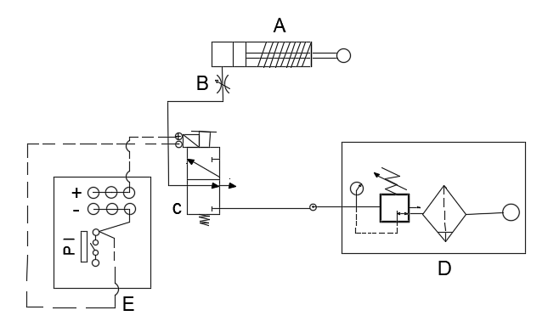

**Fig 2**: Schematic of the electro-pneumatic system, showing an 80mm cylinder (A), flow control valve (B), 3/2-way directional valve (C), pressure regulator (D), and electronic board with controls (E).

**2.6 Model Equation**

The resultant predictive model equations for piston travelling speed are expressed in Equations 5 and 6. Equation 5 predicts piston travelling speed under purely mechanically operated (PMO) conditions. In this equation, as the coefficient term increases, piston travelling distance decreases, piston travelling time decreases, and applied force increases, leading to an increase in piston travelling speed (Nguyen et al., 2021) .

RSM-Predicted Piston Travel Speed ( ) PMO *= 113.13 –1.1144* *- 162.296* *+ 0.09858*(5)

Equation 6 predicts piston travelling speed under electrically operated (EO) conditions. Here, an increase in the coefficient term, piston travelling distance, and applied force, combined with a decrease in piston travelling time, results in an increase in piston travelling speed (Chen et al., 2012) .

RSM-Predicted Piston Travel Speed ( ) EO *= 41.382+ 1.8156* *- 283.109* *+*

*0.0643*(6)

**3.6 ANN Model Equations for Piston Travel Speed in Purely Mechanical (PMO) and Electrically Operated (EO) Systems**

Artificial Neural Networks (ANNs) are machine learning models designed to recognize patterns and predict system performance based on input data. ANNs jn MATLAB, were used to predict piston traveling speed using experimental data, with 70% of data for training, 15% for testing, and 15% for validation(Wu et al., 2014). The model evaluated factors like air pressure and piston traveling distance, and results showed high accuracy, with strong correlations between actual and predicted values, as reflected in Table 5 and Fig. 6.

**3.0 Results and Discussion**.

This section of the research presents the data recorded from the experimental set-up, as shown in Tables 1 and 2. The data were analysed using statistical tools to generate a predictive model for piston travelling speed and to conduct a comparative analysis between purely mechanical and electro-pneumatic systems (Zhao et al., 2023). This analysis aims to provide a comprehensive understanding of piston travelling speed, distance travelled by the piston, and the applied force.

**Table 1: Experimental Measurements and Calculations of Key Parameters for a Mechanically Operated Pneumatic System**

**Table 2: Recorded Pressure, Piston Distance, Time, Piston Speed, and Applied Force for an Electrically Operated Pneumatic System**

**3.1 RSM Model Equations for Piston Travel Speed in Purely Mechanical (PMO) and Electrically Operated (EO) Systems**

The linear regression model, evaluated with four factors and represented by coefficients, estimates the change in piston travel speed per unit change in factors. For the PMO system, the model has an R² of 0.9736 and an adjusted R² of 0.7037, with a significant P-value of 0.0457 and an F-value of 49.09, indicating high accuracy (Table 3, Figure 5(a)). In comparison, the EO system's model, shown in Table 4 and Figure 5(b), has a higher R² of 0.9085 and an adjusted R² of 0.8720 with a significant P-value of 0.00253 and an F-value of 24.8485, demonstrating better prediction accuracy than the PMO model.,

**Table 3: ANOVA Results for Piston Travel Speed under Purely Mechanical Operation (PMO)**

|  |  |  |  |  |  |
| --- | --- | --- | --- | --- | --- |
| **R square** | **Adjusted R square** | **observations** | **P-value** | **F-value** | **Standard error** |
| **0.9736** | 0.7037 | 8 | 0.00457 | 49.099403 | 41.6463 |

**Table 4: ANOVA Results for Piston Travel Speed in Electrically Operated (EO) Conditions**

|  |  |  |  |  |  |
| --- | --- | --- | --- | --- | --- |
| **R square** | **Adjusted R square** | **observations** | **P-value** | **F-value** | **Standard error** |
| **0.921167** | 0.8620 | 8 | 0.01134 | 15.57995 | 84.2197 |

(a)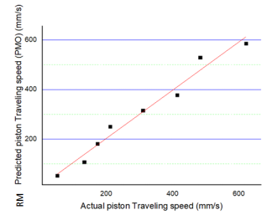 (b) 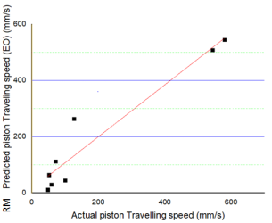

**Fig. 3:** RM Regression Correlation of Piston Travel Speed for (a) Mechanically Operated and (b) Electrically Operated (EO) Conditions

**Table 5**: ANN R2 and Adjusted R2 values under PMO and EO conditions

|  |  |  |
| --- | --- | --- |
|  | **Coefficient of determinant R2** | **Adjusted R2** |
| **PMO** | 0.96933 | 0.96422 |
| **EO** | 0.94062 | 0.93072 |

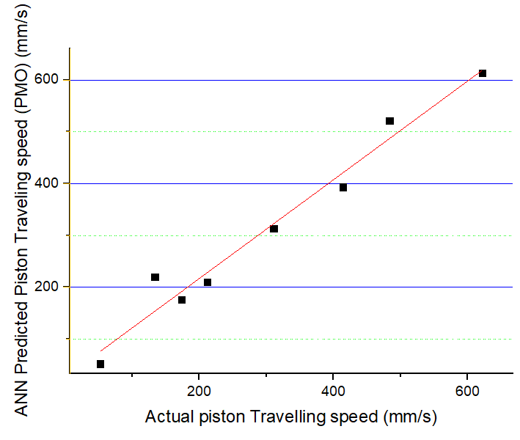 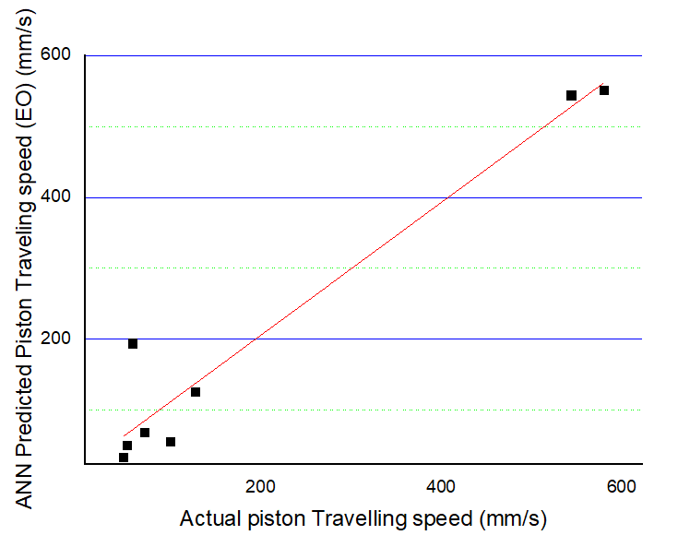

**Fig. 4:** ANN Regression Correlation of Piston Travel Speed for (a) Mechanically Operated and (b) Electrically Operated Systems

**3.2 Influence of Applied Force on Piston Speed: Mechanical vs. Electrical Systems**

Under purely mechanical operation, piston speed remains under 200 mm/s at 4000 N of applied force but rapidly increases to over 500 mm/s between 5000 N and 6000 N (Fig. 5a). Conversely, the electrically operated system shows a steady increase in piston speed up to 600 mm/s as force gradually rises from 1000 N to 6000 N (Amirit, 2022)., indicating a more gradual response (Fig. 5b).

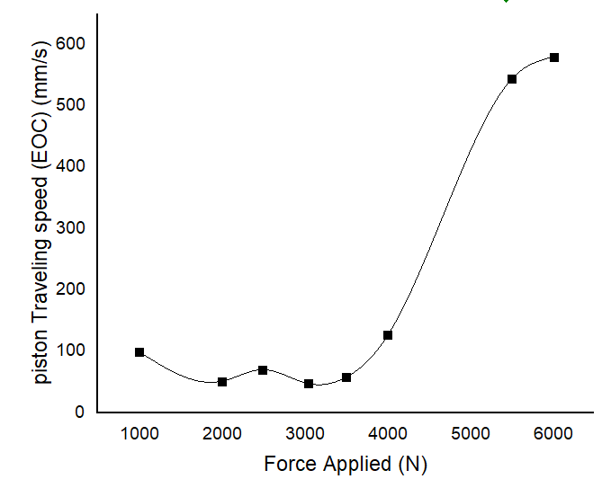 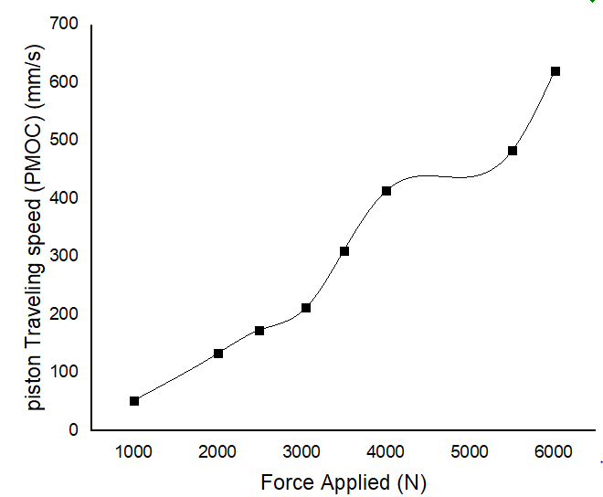

(a) (b)

**Fig. 5:** Applied Force vs. Speed for (a) Purely Mechanical Operation and (b) Electrically Operated System

**3.3 Impact of Piston Travel Time on Distance: Mechanical vs. Electrical Operation**

The piston travel time is directly related to the applied force and inversely related to the travel distance. As force decreases, travel distance decreases and time increases, while increasing force slightly reduces distance and varies travel time (Zhao,et.,al 2023). This shows that a purely mechanical operated (PMO) system responds more quickly to force compared to an electrically operated (EO) system.

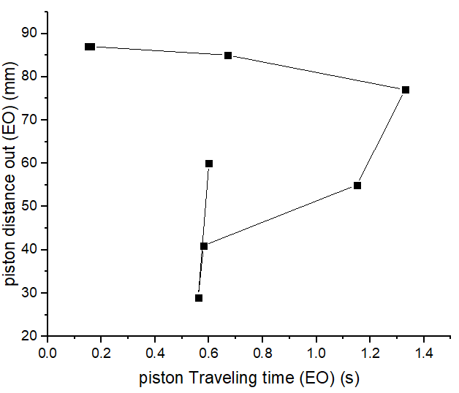 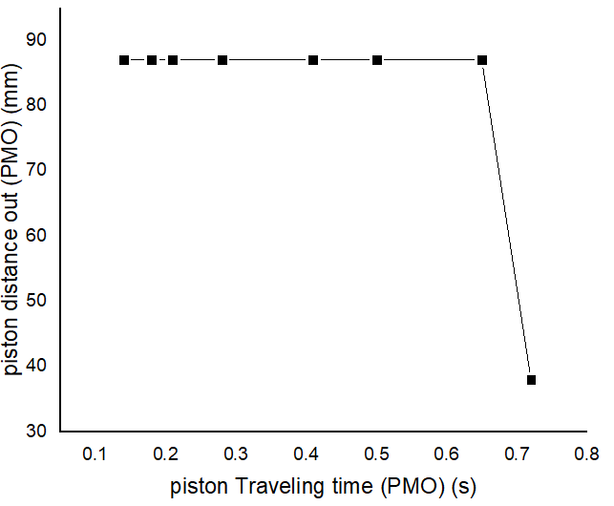

1. (b)

**Fig 6**: Piston travelling distance against time for (a) electrically operated and (b) Mechanically operated (PMO)

**3.4 Impact of Piston Travel Speed on Piston Travel Distance and Response Time**

The piston travel distance increases with speed but decreases as applied force is reduced in purely mechanical operation, while the electrically operated system shows slight distance variations with a sharp decline as speed drops, highlighting the PMO system's faster response to force.

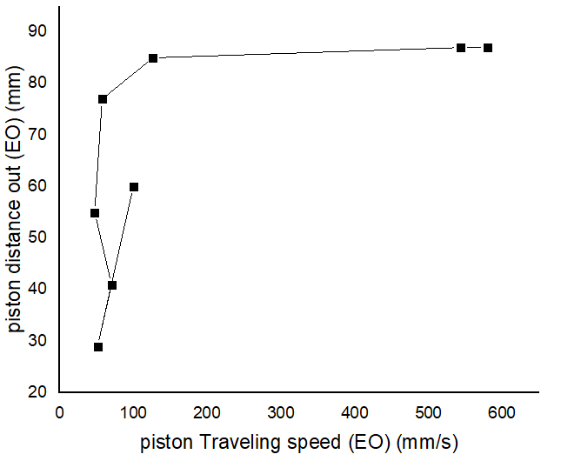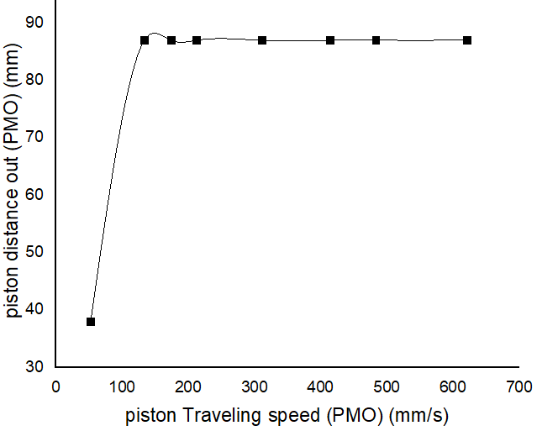

**(a) (b)**

**Fig. 7:** Piston Travel Distance vs. Speed for (a) Electrically Operated and (b) Mechanically Operated Systems*.*

**3.5 Correlation Between Applied Force and Piston Travel Speed**

The applied fluid pressure significantly impacts piston speed, with the PMO system outperforming the EO system at higher forces, while the EO system achieves greater speed at lower forces due to its transient pneumatic setup.

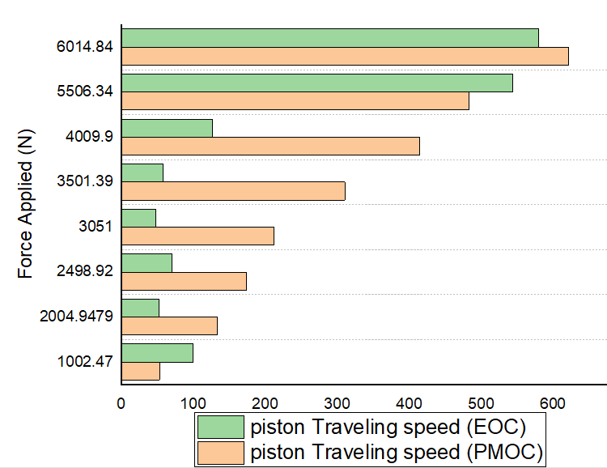

**Fig 8:** Piston Travel Speed versus Applied Force for EO and PMO Pneumatic Systems"

**3.6 3D Interactive Plots of Factors Influencing Piston Travel Speed**

The 3D plots show that piston travel speed is highest at high forces and low times for both EO and PMO systems, with the PMO system delivering greater speeds and power at lower forces compared to the more gradual speed reduction in the EO system.

(a)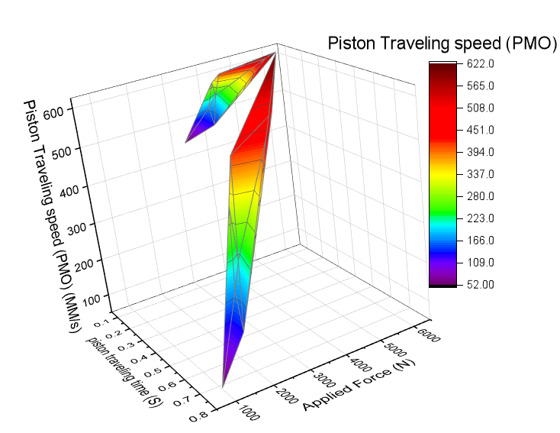 (b) 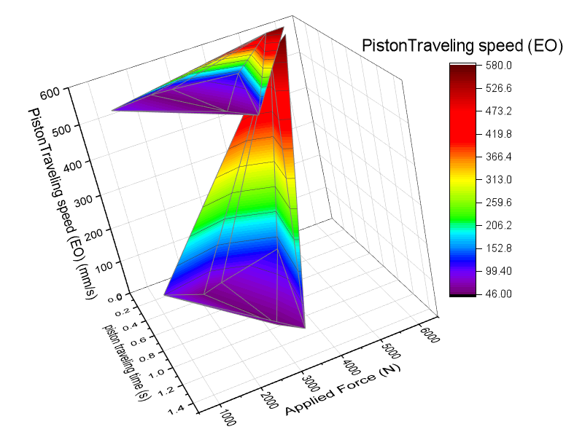

**Fig 9**: 3D Plots of Applied Force, Piston Travel Time, and Piston Travel Speed for (a) PMO and (b) EO Systems

**4.0 Conclusion**

This research provides a compelling comparison between purely mechanical operated (PMO) and electrically operated (EO) pneumatic systems, revealing distinct advantages for each. The PMO system demonstrates superior power output, achieving a peak piston travel speed of 622 mm/s compared to 560 mm/s in the EO system. Conversely, the EO system offers a more gradual and consistent increase in piston speed. These insights highlight how each system’s unique characteristics can be leveraged to optimize process design across different industrial applications, offering valuable guidance for selecting the right technology to meet specific operational needs.

**References**

1. Akers, A., Gassman, M., & Smith, R. (2006). Hydraulic Power System Analysis. CRC Press. doi:10.1201/9781420014587.

2. Amirit, K. (2022). "Pneumatic System: Definition, Components, Working, Advantage." The Mechanical Engineering. Retrieved from

3. Berryman, & Sylvia. (2020). "Ancient Greek Mechanics and the Mechanical Hypothesis." Generic.

4. Bird, P. J. (1985). "Development in the Design and Control of Pneumatic Linear Actuators." In European Conference on Electrics versus Hydraulics versus Pneumatics (pp. 77-83). Inst. of Mechanical Engineers, London.

5. Hasiaoqier, H., et al. (2017). "Numerical Investigation on Suppressing High Frequency Self-Excited Noises of Armature Assembly in a Torque Motor Using Ferrofluid." Shock and Vibration, 2017, 1–10.

6. Jan, P., Marko, H., Primož, P., Ana, T., & Franc, M. (2023). "Comparative Study of Hydraulic, Pneumatic, and Electric Linear Actuator Systems." Research Square.

7. Marciniak, Z., Duncan, J. L., & Hu, S. J. (2002). Mechanics of Sheet Metal Forming (2nd ed.). Butterworth-Heinemann Press.

8. Nguyen, M., Dao, H., & Ahn, K. (2021). "Active Disturbance Rejection Control for Position Tracking of Electro-Hydraulic Servo Systems under Modelling Uncertainty and External Load." MDPI, 10.20.

9. Qi, H., Bone, G., & Zhang, Y. (2019). "Position Control of Pneumatic Actuators Using Three-Mode Discrete-Valued Model Predictive Control." Actuators, 8.

10. Skarpetis, M. G., & Koumboulis, F. N. (2013). "Robust PID Controller for Electro-Hydraulic Actuators." In Proceedings of the 2013 IEEE 18th Conference on Emerging Technologies & Factory Automation (ETFA), Cagliari, Italy (pp. 1–5). IEEE: Piscataway, NJ, USA.

11. Tivay, A., Zareinejad, M., Rezaei, S. M., & Baghestan, K. (2014). "Switched Energy Saving Position Controller for Variable-Pressure Electrohydraulic Servo Systems." ISA Transactions, 53(4), 1297–1306.

12. Vishal, T., Nilkanth, R., Omkar, S., & Pankaj, Y. (2015). "Pneumatic Shearing and Bending Machine." International Journal of Recent Research in Civil and Mechanical Engineering (IJRRCME), 1(2), 9-18.

13. Wu, S., et al. (2014). "Development of a Direct-Drive Servo Valve with High-Frequency Voice Coil Motor and Advanced Digital Controller." IEEE/ASME Transactions on Mechatronics, 19(3), 932–942.

14. Zhao, P., Xie, A., Zhu, S., & Kong, L. (2023). "Pressure Optimization for Hydraulic-Electric Hybrid Biped Robot Power Unit Based on Genetic Algorithm." Scientific Reports, 13, 60.