**FORMULATION OF GLUTEN FREE BLACK RICE CAKE**

**1B Dharani Raja Sree**, **2Dr. Sindhu S**

1Research Scholar1 Department of Foods and Nutrition, PSG College of Arts and Science, Coimbatore, Tamil Nadu, India

2Assistant Professor,2Department of Food Processing Technology, PSG College of Arts and Science, Coimbatore, Tamil Nadu, India

**ABSTRACT**

Black rice is an aromatic and pigmented rice popular in Asia, whose demand is increasing steadily due to numerous health benefits, including antioxidant activity, anti-inflammatory, anti-diabetic, anti-aging and anti-cancer properties. Black rice is a better source of protein, iron, fiber and antioxidants than refined flour. Despite the influence of processed convenience foods, the preference of people has shifted towards healthy alternative bakery products made using refined flour. Considering this aspect, a study was designed to develop black rice flour-incorporated cake and assess its sensory acceptability. Black rice cake was made using 100% black rice flour with egg (variation 1) and without egg (variation 2). Control cakes were also made using 100% refined flour with and without eggs respectively. The prepared products were subjected to sensory evaluation using a 9-point hedonic scale. The results revealed that variation 1 had excelled volume and texture and was highly acceptable by the panel members. Hence, the study claims that black rice flour, high-fiber, gluten-free ingredient is well suited for baking.

**Keywords:** black rice, cakes, gluten free, high fiber, eggless cakes, bakery product.

**INTRODUCTION**

Bakery products are consumed worldwide owing to their wide availability, convenience, distinct flavour and longer shelf life and are affordably priced in the market as ready-to-eat biscuits, buns, bread, cookies and cakes. The production of bakery products has been rising steadily; however, consumers are more concerned about the healthy ingredients and nutrient content of the bakery products. To meet the ever-increasing demand for healthy bakery products, one of the solutions is the replacement of refined flour with gluten-free, indigenous black rice.

Over half of the world's population relies on rice *(Oryza sativa L.)* as their staple diet. (Das et al.) [1] Black rice is also referred to as purple rice, heaven rice, imperial rice, King’s rice, forbidden rice, and prized rice. (Thanuja et al.) [2] The richest country in terms of black rice resources is China followed by Sri Lanka, Indonesia, India, Philippines and Bangladesh (Sompong et al.) [3] Black rice dispenses the richest nutritional value with a greater quantity of fiber (Cherik et al.)[4]. It contains approximately 160 kcal of energy, 1.5 g of fat, 34 g of carbohydrate, 2 g of fiber, 7.5 g of protein, no saturated fat and no cholesterol.(Kumari et al.)[5] It is also rich in vitamins, amino acids and bioactive substances such as minerals, α-oryzanols, γ-tocopherol, γ-phenolic compounds and flavonoids.(Prasad et al.)[6]Consumption of black rice has been associated with a lower risk of diseases such as diabetes, atherosclerosis, obesity, osteoporosis, asthma, hypertension and cancer(Kumari et al.) [5]. The demand for black rice is increasing due to its promising health benefits.

In order to get consumer acceptance, a product must have the necessary quality characteristics similar to those of baked products made with refined flour or wheat. With this view, the research study was planned to develop black rice flour-incorporated cake with egg and eggless variations and to assess its organoleptic qualities and consumer acceptance.

**2. METHODOLOGY**

**2.1 Selection of Ingredients**

The ingredients required for the present study including black rice, refined flour, table sugar, eggs, baking powder, salt, milk and oil were brought from the local shops of Coimbatore.

**2.2 Preparation of Control Cake**

The method adopted for cake making is creaming method. The control cake control 1 was prepared using refined flour, baking powder, salt and table sugar. All the ingredients were sieved together to prevent lumps. The liquid mixture (milk and oil) was gradually added to the dry ingredients to form a batter to a thick ribbon consistency and vanilla essence was added for flavour. The batter was poured into a foil cup and baked at 180ºC for 25 to 30 minutes, followed by cooling to room temperature and packed. A control cake (control 2) was also made using similar method with 100% refined flour except the addition of egg.

**2.3 Preparation of black rice flour cake**

The black rice was cleaned, weighed and dry roasted in a pan until the flavour evolved. The roasted grains were cooled to room temperature, ground to a fine powder and cooled. Black rice cake was made by substituting the prepared black rice flour at 100% in the control cake (variation 1 & 2) and similar procedure of control cake making was adopted.

**2.5 Acceptability Test**

Acceptability of the product was assessed using sensory evaluation which is the scientific measurement of food quality based on sensory characteristics as perceived by the five senses (Choi et al.) [7]. The sensory evaluation was carried out by 20 semi-trained panel members using a 9-point hedonic scale ranging from like extremely to dislike extremely. The scores of the sensory evaluation were calculated for mean and standard deviation. The prepared products were presented in Plate I

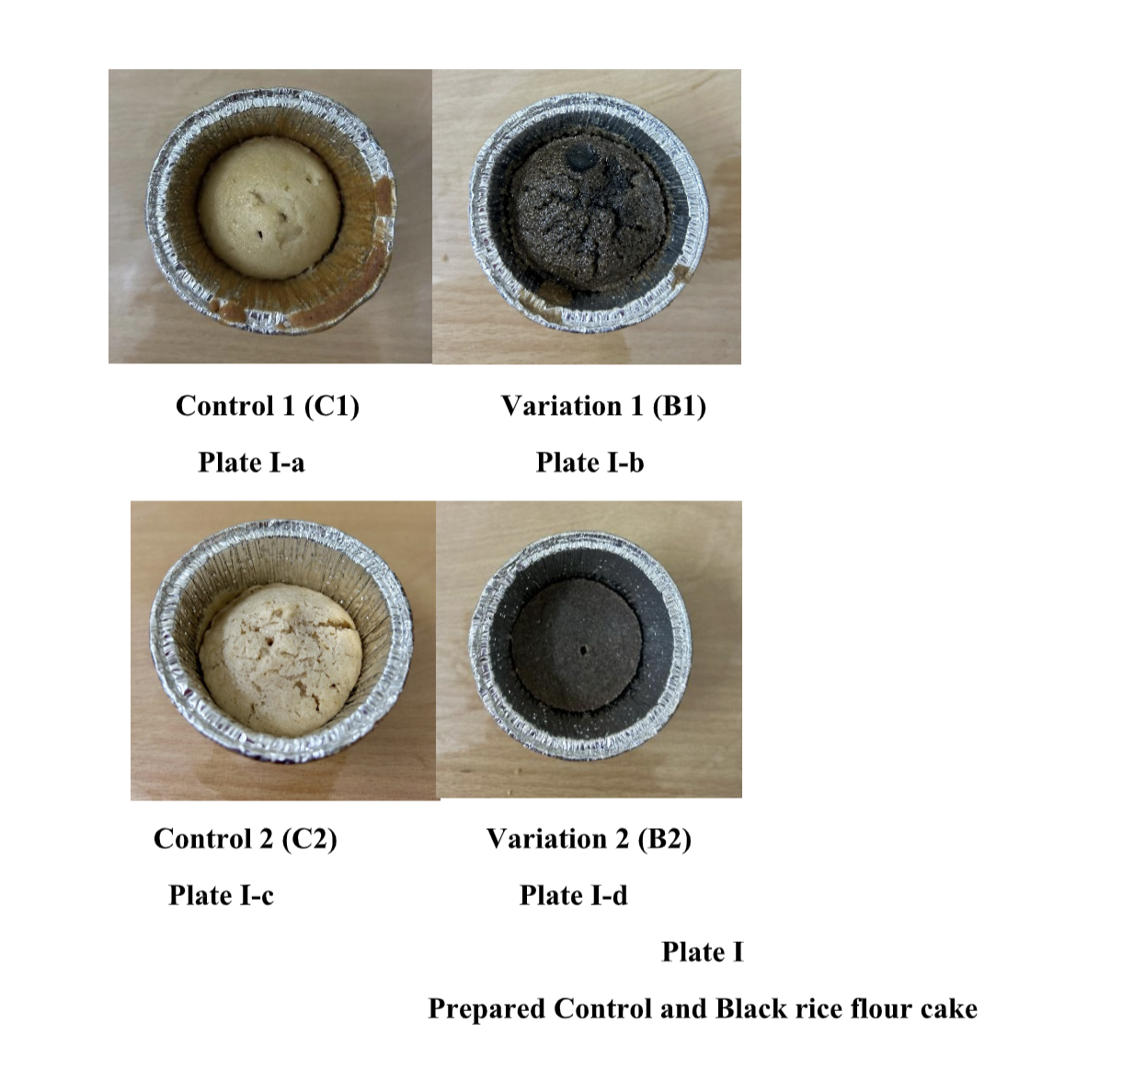

**3.RESULTS AND DISCUSSION**

**3.1 Mean scores of Sensory evaluation**

The mean scores of sensory evaluation of the prepared cakes are presented in Table I

**Table I**

Mean scores of sensory evaluation of the prepared cakes

|  |  |  |  |  |
| --- | --- | --- | --- | --- |
| **Parameters** | **C1** | **V1** | **C1** | **V2** |
| Colour and Appearance | 7.70 ± 1.59 | **7.90 ± 1.48** | 7.30 ± 1.12 | 6.95 ± 1.43 |
| Flavour | 7.50 ± 1.30 | **7.15 ± 1.38** | 7.05 ± 1.14 | 6.45 ± 1.27 |
| Texture | 7.65 ± 1.56 | **7.15 ± 1.63** | 6.90 ± 1.58 | 6.20 ± 1.73 |
| Taste | 7.50 ± 1.63 | **6.95 ± 1.73** | 7.30 ± 1.03 | 6.30 ± 1.34 |
| Overall acceptability | 7.50 ± 1.36 | **7.23 ± 1.31** | 7.10 ± 0.95 | 6.40 ± 1.17 |

C1- Control 1 with egg; C2- Control 2 without egg; V1-Variation 1 100% Black rice flour cake with egg; V2-Variation 2 100% Black rice flour cake without egg. The values in the table represents Mean ±Standard Deviation of the formulated cake.

The colour and appearance of variation 1 was liked moderately with a mean score of 7.90 ± 1.48, whereas variation 2 was liked slightly with a mean score of 6.95 ± 1.43.Hence, with respect to the mean score of colour and appearance, variation 1 was better accepted than variation 2. Similarly, Cañizare et al. [8] observed that the colour of the cake was black due to the presence of anthocyanin and primary flavonoid found in black rice which is predominantly located in the aleurone layer. The outer layer of the black rice has a higher concentration of phenolic compounds, flavonoids and anthocyanins compared to the inner layers.

Roasting the black rice improved the flavour in variations 1 and 2. The flavour of variation-1 was liked moderately, with a mean score of 7.15 ± 1.38, whereas the flavour of variation 2 was liked slightly, with a mean score of 6.45 ± 1.27. As a result, with respect to the mean score of flavour, variation-1 was better acceptable than variation 2. Arora et al. [9] examined that roasting results in the degradation of amino acids and increases the total phenolic content, while the flavonoid and anthocyanin content were reduced significantly with roasting. Over all, roasting led to significant improvements in the various properties of black rice

On assessing the textural properties after baking, variation 1 had a spongy texture and high volume similar to control 1 whereas, variation 2 had no springiness and had a dense crumb and low volume due to the absence of gluten proteins unlike control 2. The texture of variation 1 was liked moderately with a mean score of 7.15 ± 1.63, whereas variation 2 was liked slightly with a mean score of 6.20 ± 1.73. Therefore, the mean score of texture, variation 1 was more favorable than variation 2. The study is in par with the result of the study conducted by Lee et al. [10] which observed a decrease in volume of black rice cake on increasing the quantity of black rice flour. Similarly, the hardness, chewiness and gumminess of the black rice cake were found to be directly proportional to the amount of black rice flour used.

The sensory evaluation recorded that cakes baked with black rice had a good taste. The taste of variation 1 & 2 was liked slightly with a mean score of 6.95 ± 1.73 and 6.30 ± 1.34 respectively. The results of the present study was found to be contradictory to the study done by Murali et al. [11], where several variations of black rice flour cake were developed by substituting black rice flour at different levels (0, 10, 20, 30, 40, 50, 60, 70, 80, and 90) against 100% wheat flour in chiffon cakes. It was found that black rice flour substituted at 10–60% was more appreciable than cake with 70–100%.

Cañizare et al. [8] pointed out that baking directly influences the texture, flavour, aroma, appearance and taste of the cakes, as well as altering their nutritional composition and bioactive compounds. The author compared the formulated black rice cake with traditional white rice, which showed higher contents of phenolic acid (12-fold) and antioxidant activity (44-fold). Furthermore,the study observed an increase in hydroxybenzoic acid (205.2%), caffeic acid (99.5%), caftaric acid (318.1%), protocatechuic acid (26.6%) and quercetin (0.8%) in the cakes compared to whole flour.

The overall acceptability of variation 1 was 7.23 ± 1.31 which was highly acceptable than variation 2 with a mean score of 6.40 ± 1.10. Iva et al. [12] reported that black rice exhibits high protein and fiber content with low starch content, which results in nutritional benefits in gluten-free baking.

**4. CONCLUSION**

From the result of the present study, it is evident that black rice can be utilized for the preparation of cakes, as it exhibits highly acceptable organoleptic characteristics when prepared with eggs. The study also proved that this magnificent ingredient offers numerous health benefits owing to its nutrient content and gluten-free nature. Hence, the study states that black rice, a gluten free alternative, shall be included in the diet to improve the nutritional status. Furthermore, the utilization of black rice creates a demand, which will reflect positively on the cultivation and production of the rice. This trend may contribute significantly to a farmer's income, the country's grain production and its economic status.

**5.REFERENCES**

[1] Maitrayee Das, Uma Dash, Sudhansu Shekhar Mahanand, Prakash Kumar Nayak, Radha Krishnan Kesavan,Black rice: A comprehensive review on its bioactive compounds, potential health benefits and food applications,Food 1Chemistry Advances,Volume3,2023,100462,ISSN2772753X,https://doi.org/10.1016/j.focha.2023.100462.

[2] B. Thanuja, R. Parimalavalli, Role of Black Rice in Health and Diseases, Dept. of Food Science & Nutrition, Periyar University, Salem, Tamilnadu, India, ISSN: 2249-9571, www.ijhsr.org

[3] R. Sompong, S. Siebenhandl-Ehn, G. Linsberger-Martin, E. Berghofer,Physicochemical and antioxidative properties of red and black rice varieties from Thailand, China and Sri Lanka,FoodChemistry,Volume124,Issue1,2011,Pages132140,ISSN03088146,https://doi.org/10.1016/j.foodchem.2010.05.115.

[4] Cherik R. Sangma, H., & Parameshwari, S. (2021). *Health benefits of black rice(Zizaniaaqatica)areview.MaterialsToday:Proceedings.* doi:10.1016/j.matpr.2021.07.25710.1016/j.matpr.2021.07.257

[5] Kumari, Shivani. (2020). Black Rice: An emerging 'super food

[6] Prasad, B. J., Sharavanan, P. S., & Sivaraj, R. (2019). *Health benefits of black riceAreview.Grain&OilScienceandTechnology.* doi: 10.1016/j.gaost.2019.09.00510.1016/j.gaost.2019.09.005

[7]Choi, Sungeun. (2013). Sensory Evaluation.

[8]Cañizares L, Meza S, Peres B, Rodrigues L, Jappe SN, Coradi PC, Oliveira M. Functional Foods from Black Rice (*Oryza sativa* L.): An Overview of the Influence of Drying, Storage, and Processing on Bioactive Molecules and Health-Promoting Effects. Foods. 2024 Apr 2;13(7):1088. doi: 10.3390/foods13071088. PMID: 38611392; PMCID: PMC11011668.

[9]Arora, S., Virdi, I.K., Sharanagat, V.S. *et al.* Roasting of black rice (*Oryza Sativa* L.): change in physico-functional, thermo-pasting, antioxidant and anthocyanin content. *Food Measure* **15**, 2240–2250 (2021). <https://doi.org/10.1007/s11694-021-00828-7>

[10]Lee, J.-C., Kim, J.-D., Hsieh, F., & Eun, J.-B. (2008). Production of black rice cake using ground black rice and medium-grain brown rice. International Journal of Food Science & Technology, 43(6), 1078–1082. doi:10.1111/j.1365-2621.2007.01569.x

10.1111/j.1365-2621.2007.01569.x

[11]Murali RD, Kumar N (2020) Black Rice: A Novel Ingredient in Food Processing. J Nutr Food Sci 10:771. doi: 10.35248/2155-9600.20.10.771.

[12] Iva Burešová,Libor Červenka,Romana Šebestíková,Monika Augustová,Alžbeta Jarošová, Applicability of Flours from Pigmented and Glutinous Rice in Gluten-Free Bread Baking,Volume 12, Issue 6, 10.3390/foods12061324