**Innovations and Updates in Pharmaceutical Regulatory Submissions: CTD Module Advancements**

**R.Kabilan*,Dr.B.Senthil Kumar,Dr.N.Senthil Kumar**

Department of Pharmaceutical Regulatory Affairs,JKKMRF’s Annai JKK Sampoorani Ammal College Of Pharmacy, Komarapalayam,Nammakkal – 638183,Tamil Nadu,India

**Abstract;**

Regulatory affairs refers to a profession or department within industries such as pharmaceuticals, medical devices, biotechnology, and other sectors regulated by government agencies. This field involves ensuring that companies comply with all the regulations and laws pertaining to their business, particularly in the development, manufacturing, and marketing of products. The goal of regulatory affairs is to protect public health by ensuring that products are safe, effective, and meet all necessary standards set by regulatory bodies like the FDA in the United States. All regulatory elements and guidelines connected to product filing are summarized in this evaluation. This study covers the whole CTD and eCTD submission process, as well as the modules that go with it. It also focuses on the key regulatory bodies across the world. . Detailed guidelines are provided describing the content of each module and the majority of submissions must now follow the CTD format for submission dossiers .The regulatory procedure through which an individual, organization, sponsor, or innovator obtains approval to introduce a drug to the market is referred to as the **approval process**. This process involves the submission of technical documentation to the relevant authority.

**Key Words:** Regulatory affairs; Regulatory Agencies; FDA; eCTD; Regulatory market

**\*Corresponding Author: Dr.B.Senthil Kumar M.Pharm,Ph.D**

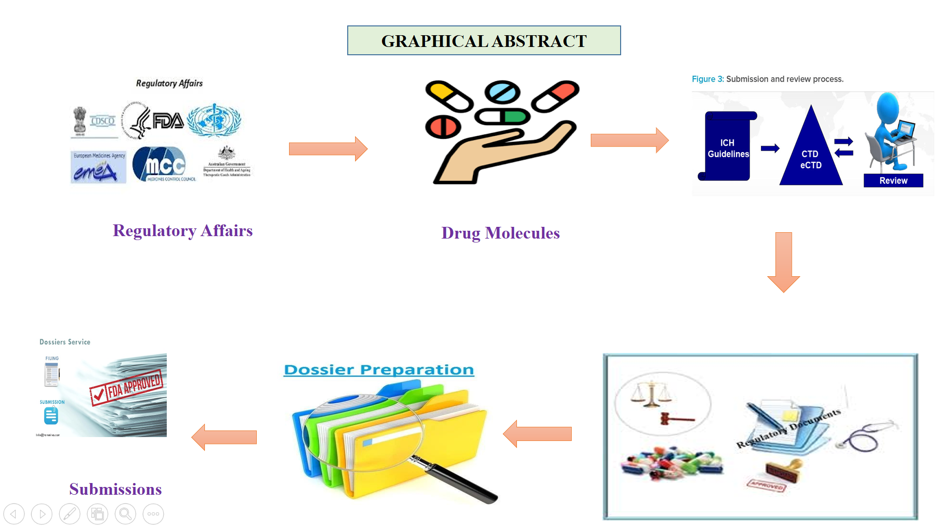

**Introduction**

Regulatory affairs is a vital field within the pharmaceutical, biotechnology, and medical device industries that ensures products comply with all relevant regulations and laws throughout their lifecycle. Professionals in regulatory affairs are tasked with maintaining compliance with global regulatory standards set by agencies such as the FDA (U.S. Food and Drug Administration), EMA (European Medicines Agency), and other regulatory bodies worldwide. Their responsibilities include preparing and submitting detailed documentation for regulatory approvals, such as Investigational New Drug (IND) applications, New Drug Applications (NDAs), Biologics License Applications (BLAs), and Marketing Authorization Applications (MAAs). Additionally, they act as liaisons between their companies and regulatory agencies, facilitating effective communication and negotiation. Furthermore, regulatory affairs specialists manage the regulatory lifecycle of products, which encompasses handling post-approval changes, updating labeling, and ensuring adherence to new and evolving regulations. This field plays a crucial role in bringing safe and effective products to market and maintaining their compliance throughout their commercial life. This study comprehensively examines the entire CTD and eCTD submission process, including the associated modules. Additionally, it highlights the primary regulatory authorities globally.

**Regulatory Affairs Updates:**

**Digitalization and Automation**:

Increased use of artificial intelligence (AI) and machine learning (ML) in drug development and regulatory submissions.

Implementation of advanced software tools for eCTD submission and management.

Enhanced use of electronic submission gateways by regulatory authorities for faster and more efficient submission processing.

**Global Harmonization**:

Continued efforts by the International Council for Harmonisation of Technical Requirements for Pharmaceuticals for Human Use (ICH) to harmonize global regulatory requirements. Updated ICH guidelines such as ICH E8 (R1) on general considerations for clinical studies and ICH Q12 on lifecycle management.

**COVID-19 Impact**:

Acceleration of regulatory processes for COVID-19 vaccines

**Role of Regulatory Affairs**

The Regulatory Affairs (RA) department plays a crucial role in the pharmaceutical, biotechnology, and medical device industries. Its primary function is to ensure that products comply with all relevant regulations and laws throughout their lifecycle, from development to market. Here are the key responsibilities and roles of the Regulatory Affairs department:

**Regulatory Strategy and Compliance**

**Develop Regulatory Strategies**: Formulate strategies for regulatory approval that align with business goals and market requirements.

**Ensure Compliance**: Monitor and ensure adherence to regulations and guidelines set by regulatory authorities such as the FDA, EMA, and other global bodies.

**Submission Management**

**Prepare and Submit Applications**: Prepare, compile, and submit regulatory documents for new drug applications, marketing authorizations, and other approvals.

**Manage Submissions**: Track the progress of submissions, address regulatory queries, and provide additional information as needed.

**Liaison with Regulatory Authorities**

**Communication**: Act as the primary contact between the company and regulatory agencies, facilitating communication and negotiations.

**Representation**: Represent the company in meetings with regulatory agencies, ensuring that the company's interests are effectively communicated.

**Documentation and Reporting**

**Maintain Documentation**: Ensure that all regulatory documents are accurately prepared, maintained, and updated in compliance with regulatory requirements.

**Regulatory Reporting**: Prepare and submit periodic reports and updates on the product's status, including post-market surveillance and adverse event reports.

**Regulatory Intelligence**

**Monitor Regulations**: Stay informed about changes in regulations, guidelines, and industry standards.

**Provide Insights**: Offer insights and recommendations on regulatory trends and their potential impact on the company's products and strategies.

**Product Development Support**

**Guidance**: Provide regulatory guidance during product development to ensure that clinical trials, manufacturing processes, and labeling meet regulatory requirements.

**Risk Management**: Identify and mitigate regulatory risks throughout the product lifecycle.

**Lifecycle Management**

**Post-Market Surveillance**: Oversee post-market activities, including monitoring product safety and effectiveness.

**Regulatory Updates**: Manage updates and modifications to product labels, packaging, and marketing materials in response to regulatory changes or new findings.

**Role of Regulatory Affairs in R and D**

In the research and development (R&D) phase of drug and medical device development, the Regulatory Affairs (RA) department plays a pivotal role in ensuring that the process adheres to regulatory requirements and facilitates a smooth transition from discovery to market. RA professionals develop strategic plans to align R&D activities with regulatory guidelines, engage with regulatory agencies early to address potential issues, and prepare necessary submissions for clinical trials and other regulatory approvals. They ensure compliance with Good Clinical Practice (GCP) and Good Laboratory Practice (GLP), review clinical trial protocols, and maintain accurate documentation of all research activities. By staying informed about regulatory updates and assessing potential risks, RA helps guide the development process, supports internal collaboration, and prepares regulatory dossiers for future submissions. Their role includes facilitating communication with regulatory agencies, providing regulatory guidance to R&D teams, and ensuring that all activities meet regulatory standards, ultimately contributing to the successful development and commercialization of new products.

**Regulatory affairs in Clinical Trials**

In clinical trials, the Regulatory Affairs (RA) department plays a crucial role in ensuring that the study is conducted in compliance with all relevant regulations and guidelines. RA professionals are responsible for preparing and submitting Investigational New Drug (IND) applications or Clinical Trial Applications (CTAs) to obtain regulatory approval to initiate trials. They ensure that trial protocols, informed consent forms, and investigator brochures meet regulatory standards and provide accurate and comprehensive documentation throughout the trial process. RA also manages communications with regulatory agencies, addressing queries, providing updates, and ensuring timely submission of safety reports and adverse event notifications. By staying informed about evolving regulations and maintaining rigorous documentation practices, the RA department helps to navigate the complex regulatory landscape, facilitating the successful conduct of clinical trials and ultimately supporting the advancement of new therapies to market.

**The global pharmaceutical market is generally categorized into two main segments: the Regulated Market and the Semi-Regulated Market.**

**Regulated Market**

EU (UK, Germany, France, Ireland, Sweden etc.), US, Japan, Canada, Australia, New Zealand, South Africa.

**Semi-regulated Market (ROW Countries)**

African Countries: Algeria, Zambia, Ethiopia, Ghana, Kenya, Mozambique, Malawi, Nigeria, Namibia, Sierra, Leone, Tanzania, Zimbabwe etc.

Asia: Sri Lanka, India, Bangladesh, And And ASEAN: having groups of 10 Countries – Vietnam, Malaysia, Philippines, Singapore, Thailand, Indonesia, Laos, Cambodia, Brunei Darussalam, Myanmar.

Latin America: Brazil, Panama, Peru, Mexico, Argentina, Guatemala, Chile, Dominican Republic.

Middle East countries: also called Gulf Co-operation Council countries i. e. Kuwait, Bahrain, Qatar, Oman, Saudi Arabia, and UAE.

Common Wealth of independent States (CIS): Ukraine, Russia, OFSU (America, Azerbaijan, Belarus, Georgia, Kazakhstan, Kirghizstan, Turkmenistan etc

**CDSCO’s Key Responsibilities include**

The CDSCO headquarters is responsible for overseeing drug imports, approving new products and clinical trials, organizing meetings of the Drugs Consultative Committee (DCC) and the Drug Technical Advisory Board (DTAB), and issuing licenses as the central licensing authority.

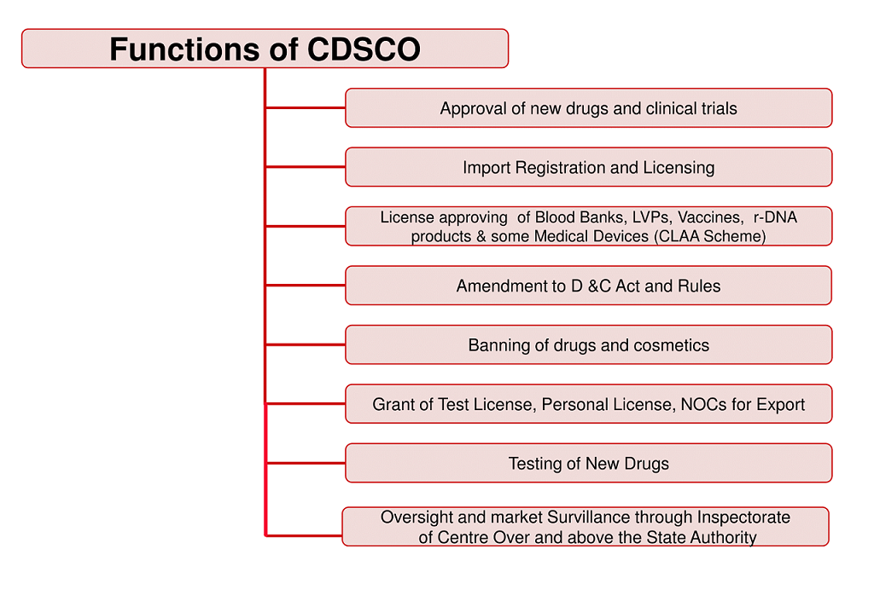

**Fig.1 Functions of CDSCO**

**Drug approval process in India**

The Drug and Cosmetic Act of 1940 and its associated Rules of 1945 were enacted by the Indian Parliament to regulate the import, manufacture, transport, and sale of pharmaceuticals and cosmetics. The Central Drugs Standard Control Organization (CDSCO), led by the Drugs Controller General of India (DCGI), oversees these regulations. In 1988, the Indian government updated the Drug and Cosmetics Rules by introducing Schedule Y. For a business in India to develop or import a new drug, it must complete Form 44 and submit the required data according to Schedule Y. Clinical trials must be conducted in compliance with Schedule Y, and the results must demonstrate the drug's safety and efficacy for the Indian population as outlined in the schedule.

**The below are the provisions of the 1945 Drugs and Cosmetics Rules:**

• Rule 122 - A: Request for New Drug Import Approval

• Rule 122-B: application for permission to import a new medication that is not on Schedule C or C. (1).

• Permission to import or export fixed dosage combinations (Rule 122-D).

• Rule 122 - DA: Request for approval to perform clinical trials for a new drug or an investigational new drug.

• DAB: Compensation in the event of injuries or death during clinical trials (Rule 122).

**Stages of Approval**

**Clinical Trial Proposal Submission**: Submission of a proposal for clinical trials to assess the safety and efficacy of a new product.

**New Medicine Clearance**: Meeting specific conditions required for the approval of new medicines.

**Post-Approval Enhancements**: Updates and improvements to biological products after approval, focusing on cost, safety, and effectiveness records.

**New Drug Application (NDA)**

A New Drug Application (NDA) is a comprehensive request submitted to regulatory authorities, such as the U.S. Food and Drug Administration (FDA), seeking approval to market a new pharmaceutical drug. The NDA includes extensive clinical data demonstrating the drug's safety and efficacy from trials conducted in various phases. It also provides detailed information on the drug's formulation, including its active ingredients and dosage form, as well as manufacturing processes to ensure compliance with Good Manufacturing Practices (GMP). Additionally, the NDA includes preclinical data from animal studies, proposed labeling with usage instructions and warnings, and pharmacology and toxicology information. It also outlines risk management strategies for handling potential adverse effects and confirms adherence to all regulatory requirements. The NDA process is crucial for ensuring that a new drug meets stringent safety, efficacy, and quality standards before it is approved for commercial distribution.

**Abbreviated New Drug Application (ANDA)**

An Abbreviated New Drug Application (ANDA) is a submission to the U.S. Food and Drug Administration (FDA) for approval of a generic drug. The ANDA process allows a company to obtain approval to market a generic version of an already approved brand-name drug. Unlike a New Drug Application (NDA), an ANDA does not require the submission of clinical trial data to demonstrate safety and efficacy. Instead, the applicant must show that the generic drug is bioequivalent to the reference listed drug, meaning it delivers the same therapeutic effect at the same dosage. The ANDA must include information on the drug’s formulation, manufacturing process, and labeling, ensuring that it meets the same quality standards as the original drug. This streamlined process facilitates the availability of lower-cost generic medications while maintaining high standards for safety and effectiveness.

**Overall organisation of the CTD**

The structure of the Common Technical Document (CTD) is outlined in the ICH M4 guidelines, which include detailed instructions on organizing and paginating the CTD dossier. This guidance is especially valuable for dossiers that involve multiple indications or components of the investigational medicinal product (IMP). Additionally, the guidelines are supplemented with a series of questions and answers that address frequently encountered issues.

The CTD dossier is divided into five main modules (see Figure 2):

Module 1: Administrative information and prescribing information

Module 2: Overviews and Summaries of Modules 3–5

Module 3: Quality (pharmaceutical documentation)

Module 4: Non-clinical reports (pharmacology/ toxicology)

Module 5: Clinical study reports (clinical trials).

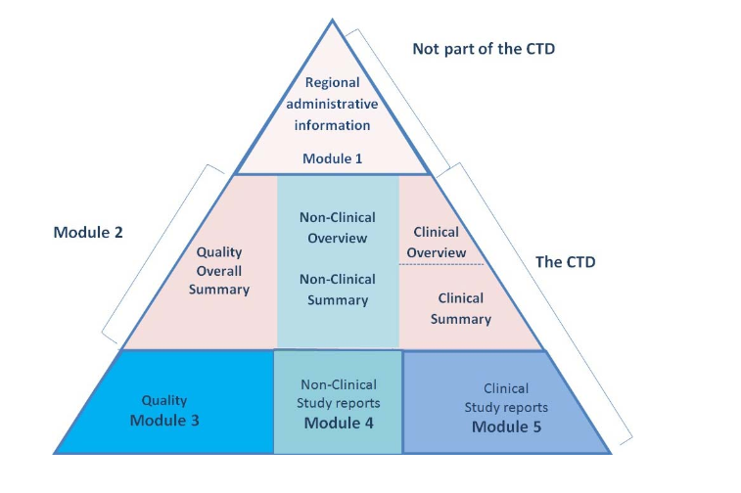

**Fig.2 CTD dossier**

Module 1 of the Common Technical Document (CTD) focuses on administrative information and prescribing details. It includes essential regional documents required by regulatory authorities, such as application forms, cover letters, and detailed labeling information for the pharmaceutical product. This module serves as the introductory section of the CTD, providing the regulatory authority with the necessary administrative and regulatory context for the submission. It outlines the product's intended use, proposed indications, and labeling instructions, ensuring that all required administrative and legal information is readily accessible and organized in a clear and concise manner. This facilitates an efficient review process by presenting all essential documentation in a standardized format.

**Module 2: Overviews and Summaries of Modules 3–5**

Module 2 of the Common Technical Document (CTD) serves as a critical summary section, providing an overview of the detailed information presented in Modules 3, 4, and 5. It includes a comprehensive summary of the drug's quality attributes, preclinical data, and clinical study results. The Quality Summary offers an overview of the drug substance and product, including formulation, manufacturing processes, and quality control measures. The Non-Clinical Summary highlights key findings from preclinical studies on pharmacology, toxicology, and pharmacokinetics, summarizing the drug’s safety and biological activity. The Clinical Summary presents a concise review of clinical trial outcomes, focusing on efficacy, safety, and adverse effects. By integrating these summaries, Module 2 provides regulatory reviewers with a clear and organized snapshot of the essential data, facilitating an efficient and effective review process.

**Module 3: Quality (pharmaceutical documentation)**

Module 3 of the Common Technical Document (CTD) is dedicated to the quality documentation of the pharmaceutical product, encompassing both the drug substance and the drug product. It provides detailed information on the drug substance, including its chemical properties, manufacturing process, and quality control measures to ensure its purity and potency. For the drug product, Module 3 includes details on the formulation, including the composition and excipients, as well as the manufacturing process and quality control procedures. Additionally, it covers stability studies that assess how the drug maintains its quality over time under various storage conditions, supporting proposed shelf life and storage recommendations. This module is essential for demonstrating that the drug product is consistently manufactured and meets all quality standards throughout its shelf life, providing regulatory authorities with comprehensive data to evaluate the product’s suitability for market approval.

**Module 4: Non-clinical reports (pharmacology/ toxicology)**

Module 4 of the Common Technical Document (CTD) encompasses non-clinical study reports, focusing on pharmacology and toxicology. This module provides comprehensive data on the safety and biological activity of the investigational drug derived from preclinical studies. It includes detailed reports on pharmacological studies, which assess the drug's mechanism of action, therapeutic potential, and interaction with biological systems. Toxicological studies are also covered, detailing the drug’s safety profile through various tests, such as acute, sub-chronic, and chronic toxicity evaluations, as well as genotoxicity and carcinogenicity assessments. The data presented in Module 4 is crucial for understanding the potential risks and benefits of the drug before it proceeds to clinical trials, helping regulatory authorities evaluate the product's safety and efficacy in humans based on preclinical evidence.

**Module 5: Clinical study reports (clinical trials)**

Module 5 of the Common Technical Document (CTD) focuses on clinical study reports, providing detailed accounts of clinical trials conducted to evaluate the safety and efficacy of the investigational drug. This module includes comprehensive data from various phases of clinical trials, detailing the study design, methodology, and results. It encompasses efficacy data, which demonstrates the drug's therapeutic benefits and its impact on the targeted condition, as well as safety data, including information on adverse effects and any observed safety issues. Module 5 also includes statistical analyses and interpretations of the trial outcomes, along with any relevant discussions on trial limitations and implications for the drug’s use. By presenting a thorough and structured overview of clinical trial findings, Module 5 helps regulatory authorities assess the drug’s overall benefit-risk profile and supports informed decision-making regarding its potential approval for market use.

**Electronic Common Technical Documents (eCTD)**

The Electronic Common Technical Document (eCTD) is a digital format used by the pharmaceutical industry to submit regulatory data to authorities. Developed by the Multidisciplinary Group 2 Expert Working Group of the International Conference on Harmonization (ICH) and based on the Common Technical Document (CTD) framework, the eCTD facilitates electronic submissions by providing a standardized format that can be seamlessly integrated into regulatory agencies' review systems. This format streamlines the process of producing, reviewing, managing, and archiving submissions. The eCTD specifications ensure that electronic submissions meet technical standards and improve the efficiency of the drug approval process. Looking ahead, this technology may enable companies to submit applications to multiple regulatory bodies with a single submission, further simplifying and accelerating the approval process.

**Advantages of eCTD**

1. Improved submission handling and storage Benefits of electronic prescription drugs

2. Enhanced data organization

3. Assistance in managing the life cycle

4. Instant access to comprehensive and current details

5. Reviewers' enhanced search tools and tracking skills

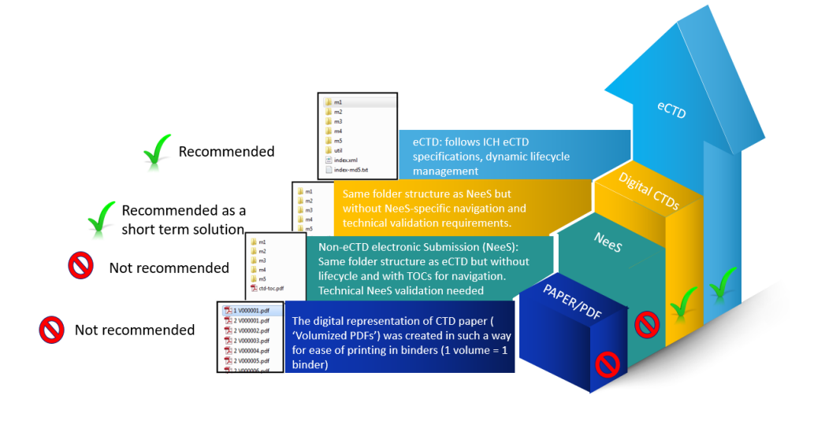

**Fig.3 Transitional Formats towards eCTD adoption**

**Common format for eCTD**

• Narrative: Portable Document Format (PDF) [Calibri 12].

• Structure: Extensible Markup Language (XML).

• Graphic: Use PDF, whenever PDF is not supporting, use Joint Photographic Experts Group (JPEG), Portable Network Graphics (PNG), Scalable Vector Graphics (SVG) and Graphic Interchange Format (GIF).

• Font size 9 and 10 are suggested for tables

**The regulatory content information**

|  |  |
| --- | --- |
| **Region** | **Internet address** |
| European Union | http://WWW.Emea.europa.eu |
| Food and drug administration USA | WWW.fda.gov/cber |
| Ministry of Health, Labour and Welfare, Japan | http://weww.mhlw.go.jp |
| Health Canada | http://WWW.hc-sc.gc.ca |

eCTDXPress-Image solution-http://www.imagesolutions.com

eCTDXPress-Image solution-http://www.imagesolutions.com

Data farm, http://www.datafarminc.com

Take solution : www.PharmaReady.com 5

MasterControl submission GatewayTM-Master Control, http://www.mastersolution.com

Lorenz Life Science: [www.lorenz.com](http://www.lorenz.com)

**Recent updates:**

### Digital Transformation

**AI and Machine Learning**: Regulatory agencies and companies are increasingly using AI and ML to analyze data, predict outcomes, and streamline submissions. These technologies help in identifying potential issues and accelerating the review process.Some **Blockchain** organizations are exploring blockchain technology for secure and transparent tracking of drug development and regulatory submission processes.

### Regulatory Harmonization and International Collaboration

**Global Submission Portals**: The rise of global electronic submission portals, like the Common Electronic Submission Gateway (CESG) in the EU, facilitates more unified and efficient submission processes across different regions.

### Enhanced Focus on Patient-Centricity

**Real-World Evidence (RWE)**: Regulatory bodies are increasingly valuing RWE for drug approvals and post-market surveillance. This involves the use of data from real-world settings to complement clinical trial data.

**Regulatory Science Advancements**

**Adaptive Pathways**: Regulatory agencies are developing more flexible approval pathways, such as the FDA's Breakthrough Therapy Designation and the EMA's PRIME scheme, to expedite the development of promising therapies.

**Advanced Therapy Medicinal Products (ATMPs)**: There is an increasing focus on the regulation of ATMPs, including gene therapies, cell therapies, and tissue-engineered products.

### Post-Market Surveillance and Pharmacovigilance

**Risk Management Plans (RMPs)**: Enhanced requirements for RMPs and post-marketing commitments ensure ongoing safety monitoring and risk mitigation.

**Digital Tools for Pharmacovigilance**: Adoption of digital tools and big data analytics for more effective adverse event monitoring and reporting.

### Regulatory Affairs and COVID-19

**Emergency Use Authorizations (EUAs)**: Regulatory frameworks have been adapted to allow for rapid approval of COVID-19 vaccines, treatments, and diagnostics.

**Remote Inspections**: Due to travel restrictions, regulatory bodies have adopted remote inspections and virtual audits to ensure compliance with Good Manufacturing Practices (GMP).

### Evolving Regulatory Requirements

**Data Integrity**: Increased scrutiny on data integrity and transparency in clinical trials and manufacturing processes.

**Environmental Sustainability**: Regulatory bodies are introducing guidelines to address the environmental impact of pharmaceutical manufacturing and packaging.

### Professional Development and Education

**Regulatory Affairs Certification**: Professional certification programs, such as those offered by the Regulatory Affairs Professionals Society (RAPS), are becoming more popular and essential for career advancement in regulatory affairs.

**Continuous Learning**: Ongoing education and training in regulatory updates, new technologies, and evolving guidelines are critical for regulatory affairs professionals to stay current in their field. These updates reflect the dynamic nature of regulatory affairs, highlighting the importance of staying informed about the latest trends, technologies, and guidelines to ensure compliance and successful product development.

**Conclusions:**

The pharmaceutical industry is among the most stringently regulated sectors worldwide. Various regulatory authorities have been established globally to ensure that medicines meet international standards for quality, efficacy, and safety. Examples of these governing bodies include the FDA (U.S. Food and Drug Administration), TGA (Therapeutic Goods Administration), CDSCO (Central Drugs Standard Control Organization), and EMEA (European Medicines Agency), among others. The adoption of CTD and eCTD formats streamlines the registration process and minimizes the time and resources needed for submissions. This efficiency is crucial for accelerating a product's market entry, which is vital for its success and the company’s growth. Efficient approval procedures are key to ensuring access to safe and effective treatments. This approach ensures timely and safe healthcare advancements.

**Reference**

1. Guideline ICH. Organisation of the Common Technical Document for the Registration of Pharmaceuticals for Human Use M4. Geneva: ICH. 2004.
2. Jordan D. An overview of the Common Technical Document (CTD) regulatory dossier. Medical Writing. 2014 Jun 1;23(2):101-5.
3. International Committee of Medical Journal Editors. Recommendations for the conduct, reporting, editing and publication of scholarly work in medical journals. International Committee of Medical Journal Editors; 2015.
4. Praneeth P. Regulatory affairs and its role in pharmaceutical industry. Int J Pharm Biomed Eng. 2016 Jan;3(1):1-2.
5. Mahaparale S, Desai B. Role and overview of drug regulatory affairs in pharmaceutical industry with implementation of CTD and ECTD. Sonali al World J Pharm Res [Internet]. 2018 Feb 7; 7
6. Roshan K. (GJRA) JA-GJFRA, 2018 undefined. ROLE OF REGULATORY AFFAIRS IN PHARMACEUTICAL COMPANY: AN OVERVIEW. wwjournals.org [Internet].2018.
7. Drago D, Yap M. Regulatory OE-CR and, undefined. Increasing the odds of effective drug development: Elevating regulatory affairs professionals to strategic partners. Taylor Fr [Internet]. 2016.
8. Affairs BK-IJ of DR, 2013 undefined. Overview of Drug Regulatory Affairs and Regulatory Profession. researchgate.net [Internet]. 2013; 2013(1): 1–4.
9. Information MX-CMD. undefined. Overview of Medical Device Regulatory Affair Professional’s Training Abroad and its Implication for China. en.cnki.com.cn [Internet]. 2009.
10. Mahaparale S, Desai B. Role and overview of drug regulatory affairs in pharmaceutical industry with implementation of CTD and ECTD. Sonali al World J Pharm Res [Internet]. 2018; 7.
11. ICH M4E Guideline: Clinical Overview and Clinical Summary of Module 2 and Module 5: Clinical Study Reports (R1) [cited 2002 Sep 12]. Available from: http://www.ich.org/fileadmin/Public_Web_Site/ICH_ Products/CTD/M4__R1__Efficacy/M4E__R1_.pdf.
12. ICH M4E Guideline: General Questions & Answers Document (R4) [cited 2004 Jun 10]. Available from: http://www.ich.org/fileadmin/Public_Web_Site/ICH_ Products/CTD/M4__R1__Efficacy/The_M4_Efficacy_ Questions___Answers__R4_.pdf.