**Study on Reverse Mentoring and its influence on employee performance**

1. **K Priyanka Prabhu**

IV semester, Human resources specialization, Department of business administration, Sahyadri college of Engineering and Management, Mangalore

1. **Dr. Vishal Samartha**

Director, Department of business administration, Sahyadri college of Engineering and Management, Mangalore.

**Abstract:**

This study investigates the concept of reverse mentoring, an innovative practice where younger employees mentor senior colleagues, particularly in areas like technology and modern trends. The research aims to understand how reverse mentoring impacts various aspects of employee performance, including skill development, job satisfaction, and career growth. Utilizing a descriptive research design, the study combines primary data from structured questionnaires with secondary literature. Findings indicate that reverse mentoring significantly enhances learning for senior employees, enabling them to adapt to technological changes, while also benefiting younger mentors by developing their leadership and communication skills. However, challenges such as resistance from senior employees and generational friction are identified. The study concludes that reverse mentoring, when effectively implemented with clear goals and supportive organizational culture, can foster continuous learning, bridge generational gaps, and improve overall organizational performance and employee satisfaction.

**Key words:** Reverse mentoring, Employee performance,Skill development ,Job satisfaction,Career growth, Generational gap, Technological adaptation, Leadership skills, Organizational culture, Continuous learning.

1. **Introduction:**

Understanding Reverse Mentoring: Reverse mentoring flips traditional mentorship by having younger employees mentor their senior colleagues, typically in areas like technology and contemporary trends. It's a two-way street where mentors and mentees learn from each other. This approach fosters collaboration and understanding across different generations in the workplace, breaking down age-related barriers. For older employees, reverse mentoring offers a valuable opportunity to stay updated on the latest technological advancements and market trends, benefiting from the expertise of their younger counterparts. Meanwhile, younger employees gain leadership experience and the chance to share their knowledge and insights with senior colleagues. Beyond just skills, reverse mentoring cultivates a culture of inclusivity and mutual respect, where everyone's contributions are valued. By embracing reverse mentoring, organizations can enhance employee engagement, drive innovation, and foster a dynamic learning environment. It's not just about transferring knowledge—building bridges between generations and creating a workplace culture that values continuous learning and collaboration.

Reverse Mentoring and Its Influence on Employee Performance: Reverse mentoring, where younger employees mentor their senior counterparts, profoundly influences employee performance. This innovative approach fosters a dynamic exchange of knowledge, skills, and perspectives between different generations in the workplace. For senior employees, reverse mentoring provides an invaluable opportunity to stay abreast of technological advancements, emerging trends, and changing market dynamics. By learning from their younger colleagues, senior employees can enhance their efficiency, adaptability, and decision-making abilities, ultimately leading to improved performance. Simultaneously, younger employees benefit from the mentorship experience by developing leadership skills, enhancing communication abilities, and gaining exposure to senior-level decision-making processes. This reciprocal learning dynamic not only boosts the confidence and professional development of younger employees but also contributes to a more inclusive and collaborative work environment. Reverse mentoring fosters innovation by bringing fresh perspectives and ideas into the organization, driving creativity and problem-solving. Additionally, it strengthens employee engagement and job satisfaction, as mentors and mentees feel valued and empowered through their participation in the program.

Overall, reverse mentoring catalyzes enhancing employee performance by promoting knowledge sharing, skill development, and collaboration across different levels of the organization. Embracing reverse mentoring can lead to tangible improvements in organizational productivity, innovation, and employee satisfaction. . Additionally, it fosters a culture of inclusivity and continuous learning, bridging generational gaps and empowering employees to leverage diverse perspectives. By investing in reverse mentoring, companies can build a more agile and adaptable workforce, better equipped to navigate the complexities of the modern business environment. This strategic initiative not only boosts individual growth but also drives long-term organizational success and resilience.

1. **Literature Review:**

**(Khattak, Rahman, Saleem, Fayaz, & Iqbal, 2021)** A significant field of study in psychology and management is reverse mentoring. Our research focused on the impact of younger employees' knowledge transfer to senior employees on skill development. We discovered that older learners require intrinsic incentives to acquire tech skills, whereas younger mentors are motivated by extrinsic rewards. This information was gathered over three months using data from 345 older learners and 310 younger mentors. This process is aided by individual characteristics such as trust, pleasant emotions, sharing of knowledge, and confidence. According to our research, reverse mentoring helps both younger staff members by developing their mentoring abilities and older staff members by boosting their tech skills. To encourage knowledge exchange throughout generations, organizations ought to implement reverse mentoring

(**Karunaratne, 2022**)This review paper examines how reverse mentoring was used during the COVID-19 pandemic to address challenges caused by the crisis. The pandemic led to widespread changes in people's attitudes and behaviors due to measures like social distancing and travel restrictions imposed by governments worldwide. These changes significantly affected daily life and work. To adapt, people and organizations turned to new technologies. Reverse mentoring, where younger people mentor older ones, became an important tool to help with technology-related issues. The paper highlights how reverse mentoring helped bridge gaps in education, healthcare, business, and other sectors, providing evidence from various studies to show its benefits.

(**Dafna Schwartz, 2022**)Reverse Mentoring (RM), where junior employees mentor senior ones, is popular in large companies but not in SMEs due to resource constraints and a lack of skilled junior employees. A new RM model for SMEs involves a trusted professional entity initiating and supporting the program across multiple companies and using external graduate students as mentors. A pilot in Ceara, Brazil, showed this model is feasible and effective, stimulating innovative ideas, creative thinking, and identifying opportunities, thus promoting an open innovation approach essential for resource-limited SMEs. This study provides a practical RM model for SMEs, validated by empirical testing.

1. **Research Design:**

**3.1 Problem Statement:** In today's fast-changing workplace, more organizations are using reverse mentoring programs to improve employee performance and encourage ongoing learning. However, there's not much research on how effective these programs are and what factors make them successful. This study aims to fill that gap by looking at how reverse mentoring affects employee performance, how well it can predict improvements in performance, and how different demographic factors (like age, gender, and experience) influence performance. The goal is to give organizations useful information to better implement and improve reverse mentoring programs for better employee development.

**3.2 Objective:**

* To understand the relationship between reverse mentoring and Employee performance.
* To assess the predicting power of reverse mentoring on Employee performance.

To assess the influence of demographic factors on Employee performance.

**3.3 Research Methodologies:**

The study is based on primary data. The primary data is collected through a structured questionnaire through Google cal forms from the respondents. The responses I have been collected from 113 respondents. The respondents are Employees of the various organizations

**3.3.1 Dependent Variable:**

Employee performance

**Independent Variable:**

Reverse mentoring

**3.3.2 Model Diagram:**



**3.3.3**

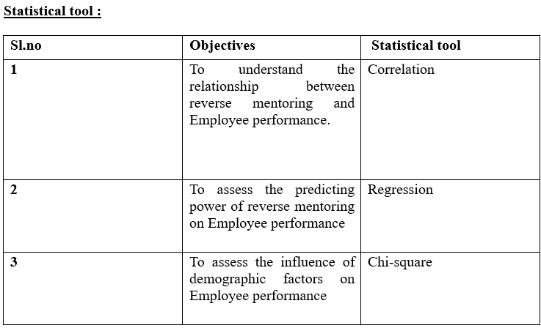

**3.3.4 Hypothesis:**

H1: There is a significant relationship between reverse mentoring and employee performance.

H2: Reverse mentoring significantly predicts employee performance.

H3: Age has a significant association that influences factors on employee performance.

H4: Gender has a significant association that influences factors on employee performance.

H5: Qualification has a significant association that influences factors on employee performance.

H6: Year of experience has a significant association that influences factors on employee performance.

1. **Test and Interpretation**

**4.1 Correlations:**

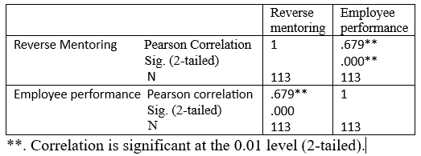

The results of the study showed a substantial relationship between employee performance and reverse mentoring. The somewhat positive association between reverse mentoring and employee performance is indicated by the correlation coefficient of 0.679, which indicates an increase in reverse mentoring. This bolsters the notion that reverse mentorship schemes can help companies by improving workers' job performance.

**4.2 Regression**

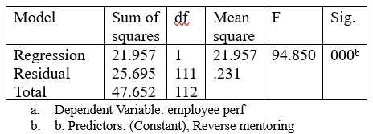

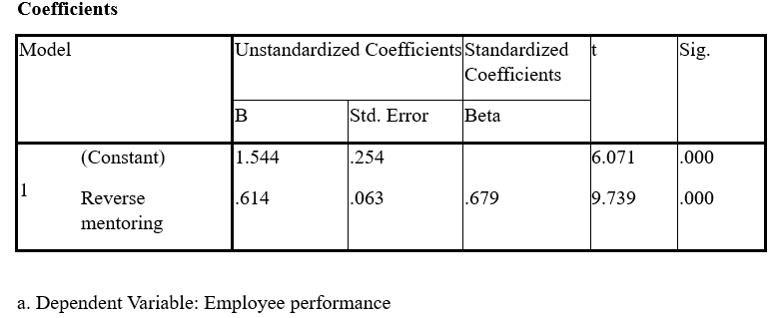According to the study, employee performance can be significantly predicted by reverse mentoring. Since the p-value is less than 0.05 according to the analysis, we can accept the alternative hypothesis.

The following Regression equation: Employee outcomes = 1.544 + 0.614 * Reverse mentoring Employee performance in Reverse mentoring = 1.544 + 0.614.

This indicates that employee performance rises by 0.614 units for every unit increase in reverse mentoring. Reverse mentorship explains 67.9% of the changes in employee performance, according to the beta value of 0.679. Reverse mentoring hence has a beneficial effect on and can forecast employee performance.

**4.3 Chi – Square Test:**

**1. Age :**

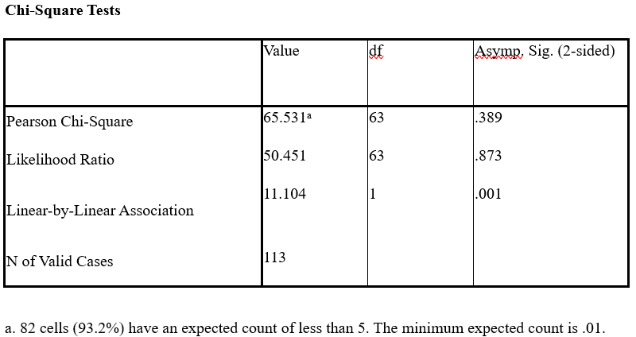

Age and variable under test do not significantly correlate (p-values of 0.389 and 0.873 are greater than 0.05 ). On the other hand, a substantial linear association (p-value of 0.001) indicates that age has a linear pattern of influence. Many cells have low expected counts, which can affect the reliability of the results.

**2. Gender :**

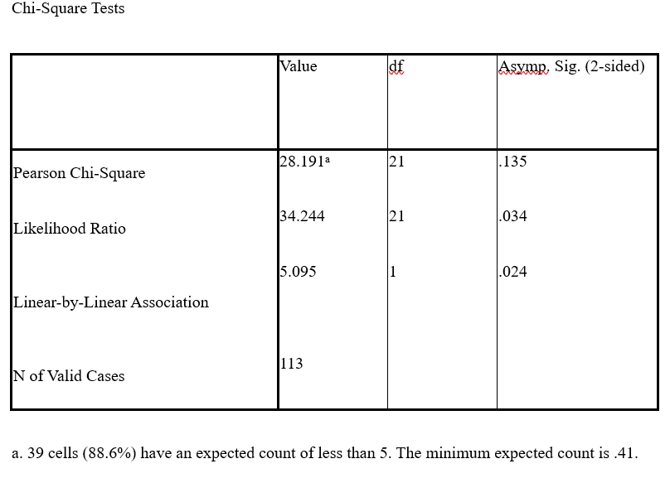

Gender did not significantly correlate with the variable under test (Pearson's Chi-Square p-value of 0.135). The likelihood ratio indicates a significant relationship (p-value of 0.034). a p-value of 0.024 indicates a significant linear association. The results may not be trustworthy because many cells have lower-than-expected numbers.

**3. Qualification:**

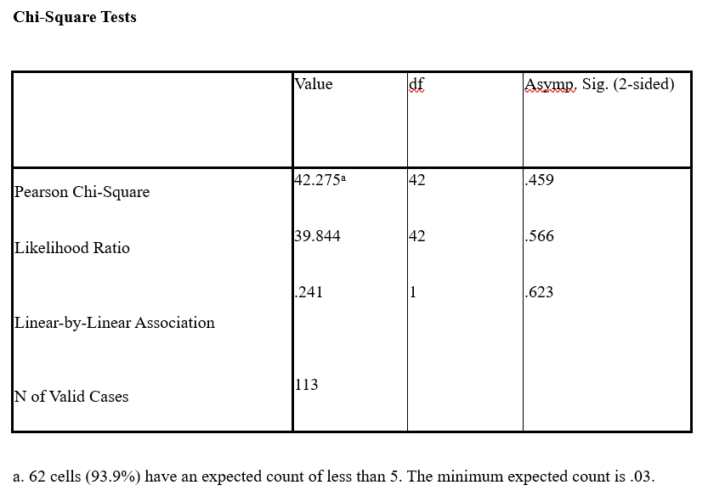

Qualification and the variable under test did not significantly correlate (Pearson Chi-Square p-value of 0.459 and likelihood ratio p-value of 0.566, both more than 0.05). there isn't a significant linear relationship (p-value of 0.623 for linear-by-linear association). The low anticipated numbers of many cells (93.9%) could compromise the validity of our findings.

1. **Year of experience:**

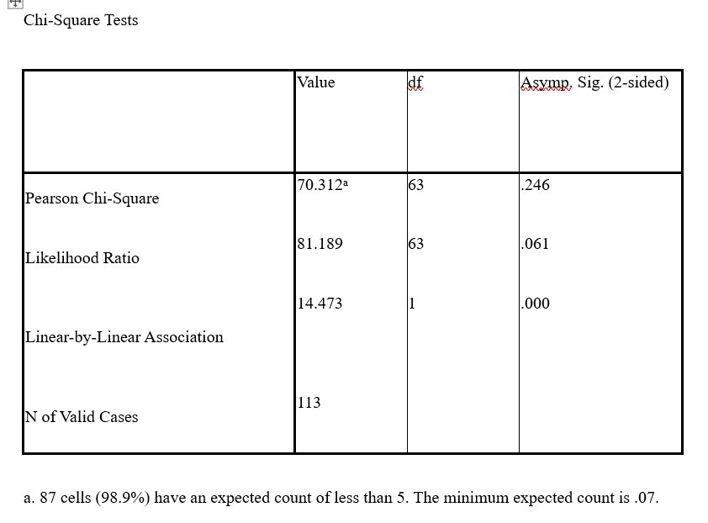

Years of experience did not significantly correlate with the variable under study (Pearson Chi-Square p-value of 0.246, larger than 0.05). A p-value of 0.061, slightly over 0.05, indicates a borderline significant link based on the likelihood ratio. A 0.000 p-value indicates a substantial linear link (Linear-by-linear association). The credibility of these data may be impacted by the low predicted numbers of many cells (98.9%).

1. **Findings**

* Reverse mentoring allows younger employees to share new ideas and tech skills with older employees, who in turn share their experience and knowledge about the company**.**
* Employees in reverse mentoring programs tend to perform better. Younger employees gain confidence and leadership skills, while older employees stay updated with new trends.
* Both mentors and mentees feel more satisfied with their jobs because they learn from each other and build better relationships.
* Companies with reverse mentoring programs keep their employees longer because they feel valued and engaged.
* The exchange of ideas between different generations leads to more creativity and new solutions.
* Reverse mentoring brings different viewpoints together, making the workplace more inclusive and improving decision-making.
* Employees become more flexible and open to change, helping each other navigate new technologies and work practices.
* Older employees in reverse mentoring programs often become more tech-savvy, which can improve their efficiency and productivity.
* Companies with successful reverse mentoring programs can enhance their corporate image, attracting top talent who value learning and development opportunities.
* Reverse mentoring helps in identifying and grooming potential leaders, ensuring a smooth succession planning process for the organization

1. **Suggestions :**

* Set up reverse mentoring programs with clear goals and timelines. Ensure both mentors and mentees understand the benefits and are committed.
* Offer training to help both mentors and mentees develop the necessary skills and understand their roles.
* Promote a workplace culture where sharing knowledge is encouraged and appreciated.
* Track how well the program is working by measuring improvements in performance, job satisfaction, retention, and innovation.
* Get company leaders to support and participate in the program to encourage more employees to join.
* Offer continuous support and resources for mentors and mentees to address any challenges and keep the program running smoothly.
* Pair mentors and mentees thoughtfully based on their skills, interests, and goals to ensure a good fit and productive relationship.
* Recognize and celebrate the achievements and progress of participants in the reverse mentoring program to motivate and encourage ongoing participation**.**
* Utilize digital tools and platforms to facilitate communication, track progress, and provide resources. This is particularly useful for remote or geographically dispersed teams.
* Organize events or forums where participants can share their experiences and insights with a broader audience. This not only reinforces learning but also fosters a sense of community and broader collaboration across the organization.

1. **CONCLUSION :**

Reverse mentoring is a powerful approach to boost employee performance and satisfaction by promoting knowledge exchange and innovation. It enables younger employees to share new ideas and tech skills with senior colleagues, who, in turn, provide valuable experience and insights. For maximum benefit, organizations should implement well-structured reverse mentoring programs with clear goals and timelines, offering necessary training and continuous support. A culture of openness and knowledge sharing should be encouraged. Careful pairing of mentors and mentees, along with active leadership involvement, is essential for the program's success. Evaluating the program's impact on performance, job satisfaction, retention, and innovation helps refine and sustain it. Celebrating participants' achievements can further motivate them. By adopting these strategies, reverse mentoring can lead to significant and lasting improvements in employee engagement and overall organizational performance

**Bibliography :**

Balu.L, D. L. (2016). Facilitating Employees Career through Mentoring Methods. *European Journal of Business and Management*, 1 - 8.

Bethany M. Breck, C. B. (2018). Implementing reverse mentoring to address social isolation among older adults. *JOURNAL OF GERONTOLOGICAL SOCIAL WORK*, 1 - 14.

Browne, I. (2021). Exploring Reverse Mentoring; “Win-Win”Relationships in The Multi-Generational Workplace. *International Journal of Evidence Based Coaching and Mentoring*. doi:https://doi.org/10.24384/jkc9-2r51

Chaudhuri, S. (2019). Perspectives in HRD Reverse mentoring:Hallmarks for implementing an intergenerational intervention. 1 - 7.

Dafna Schwartz, R. B.-E. (2022). Adapting Reverse Mentoring Strategy to SMEs: A New Pilot Model Implemented in Brazil. 1 - 15. doi: https://doi.org/10.3390/su14159515

Darren B. Whitehead, D. (2018). THE IMPACT OF MENTORING AND REVERSE-MENTORING WITH BABY BOOMERS AND MILLENNIALS ON CHURCH ENGAGEMENT. 1 - 24.

Estepan, T. (2019). Exploring the Reverse Mentoring – Engagement Relationship: Mediated by Emotional Intelligence. 1 - 108.

Gugercin, u. (2017, november). Leveraging the differences : A case of reverse mentoring. *The Role of Management in the Economic Paradigm of the XXIst Century*, 1 - 16.

Harrison, A. E. (2017, 2). Exploring Millennial Leadership Development: An Evidence Assessment of Information Communication . doi:10.5296/csbm.v4i1.10615

Hechl, C. (2017). Affective Commitment to Organizations:A Comparative Study of Reverse Mentoring Versus Traditional Mentoring among Millennials. 1 - 9. doi:DOI: 10.21512/bbr.v8i2.3666

Karunaratne, M. W. (2022). Review on Application of Reverse Mentoring during COVID-19 Pandemic. *International Journal of Research in Engineering, Science and Management*, 1 - 6.

Khattak, R. S., Rahman, U. S., Saleem, Z., Fayaz, M., & Iqbal, K. h. (2021). Reverse Mentoring: Improving Technological Skills of Older Peers: A Moderated Mediation Approach. *Volume 7*, 1 - 13. doi:10.5281/zenodo.4718684

LINAH, M. T. (2018). THE IMPACT OF TALENT MANAGEMENT ON EMPLOYEE PERFORMANCE AND RETENTION STRATEGIES:A CASE STUDY OF MASVINGO CITY COUNCIL IN ZIMBABWE. *DURBAN UNIVERSITY OF TECHNOLOGY*, 1 - 175.

Nagi, M. (2019). Reverse mentoring a social supportive and bidirectional exchange tool .

Poornima, S. (2016, June). Reverse Mentoring at Workplace- Nurturing cross- generational Learning. *PIBM MANAGEMENT JOURNAL*, 1 - 13.

Robert Kase, T. S. (2018). Skill development in reverse mentoring: Motivational processes of mentors and learners. 1 - 13. doi:DOI: 10.1002/hrm.21932

sahar, R. L. (2021). Organizational Commitment and Turnover Intentions of Millennials: Using Reverse Mentoring as a Social Exchange Tool. *Leadership and Organizational Behavior Journal*, 1 - 18.

Sharma, k. M., & Nagi, M. (2018, August). Factors Affecting Prevalence of Reverse Mentoring in India. *International Journal of Business Marketing and Management (IJBMM)*, 1 - 6.

Sonika, & shivani, N. (2021, 4). A Study on Dynamic Model of Reverse Mentoring at Workplace–Conceptual Study. *nternational Journal of Intellectual Human Resource Management (IJIHRM)*. doi:DOI: 10.4698

Tomlinson, A. S. (2020). The Role of Reverse Mentoring in Organizational Knowledge Transfer between Generations: A Generic Qualitative Study.

Vallesteros, R. (2019). Reverse mentoring by Millenials in the United States : A PHENOMENOLOGICAL STUDY. 1 - 271.

von Preußen, W. p., & Daniel, B. (2019). Turning Mentoring Around –A Case-based Analysis of the Outcomes of Digital Reverse Mentoring. *Twenty-fifth Americas Conference on Information Systems, Cancun, 2019*, 1 - 10.