Histopathological Changes in the Kidney of Rats Exposed to Aluminum : A Review

G. Kondaiah^{1*}, Dr. U. Srineetha², Dr. D. Veera Nagendra Kumar³, Dr. C. Narasimha Rao⁴
¹Ph.D Scholar, Department of Zoology, Yogi Vemana University, Kadapa, Andhra Pradesh, India.
²Lecturer in Zoology, Government Degree college for Women, Pulivendula, (Affiliated to Yogi Vemana University, Kadapa), Andhra Pradesh, India.
³Lecturer in Zoology, Government Degree college for Men (A), Kadapa, (Affiliated to Yogi Vemana University, Kadapa), Andhra Pradesh, India.
⁴Lecturer in Zoology, Government Degree college, Mydukur, (Affiliated to Yogi Vemana University, Kadapa), Andhra Pradesh, India.

Address of Correspondence
G.Kondaiah
Ph.D Scholar,
Yogi Vemana University, Kadapa,
Andhra Pradesh, India.
Email: kondumsc@gmail.com

ABSTRACT
The kidney is a urinary organ that eliminates most toxic substances that are either ingested or produced by the body. The nephrotoxic actions are raised by aluminium (Al) metal and its accumulation in the kidneys. However, Al generates reactive oxygen species with the resultant degeneration of the renal tubular cells, the oxidative deterioration of cellular lipids, proteins, and DNA. The histopathological examination of the kidneys of aluminium- treated group rats revealed kidney injury with enlargement of many glomeruli, tubular dilatation, necrotic changes, and leukocytic infiltration. Several reports show that aluminium toxicity on kidneys occurs through dietary sources, even though it’s association with adverse effects such as dementia, osteomalacia, encephalopathy, and fractures. More recent ingestion of aluminium showed obvious signs of focal segmental thickening, renal corpuscle injury, podocyte changes, and mesangial cells appearing highly deteriorated. For the above reasons, this review was written to contribute to the role of aluminium metal toxicity, toxic mechanisms and toxic effects in the kidneys of rats.
Keywords: Aluminium, histopathological examination, kidney, mesangial cells.

- INTRODUCTION:

Exley et al. [1] reported that, aluminium is a pro-oxidant, a non-redox active metal, and will promote biological oxidation both in vitro and in vivo. Berthon et al.[2] noted that, aluminium is the most plentiful and the third most prevalent metallic element in the earth’s crust. It gets into human and animals’ bodies through the gastrointestinal and respiratory tracts. [3].

Ochmanski et al. [4] stated that, it binds to DNA and RNA and inhibits enzymes such as hexokinase, acid and phosphodiesterase, phosphooxydase, and alkaline phosphatases.

Chappard et al. and Kawahara et al. [5] repoted, that chronic exposure to aluminium can have adverse effects on bone mineralization, bone health as aluminium interferes, and bone demineralization, potentially contributing to conditions such as osteomalacia and osteoporosis.

Pocsi et al.[6] stated that, kidneys are major organs that filters nearly 200 liters of blood per day, produce up to 2 liters of urine, and are particularly susceptible to the adverse effects of chemical pollutants. As a result, pollutants have a strong impact on the kidneys.

Hill et al.[7] repoterd that, kidney diseases are widespread throughout the world. Chronic kidney disease has been estimated to affect 9% to 15% of the population in different regions of the world. Nephropathies often have a long asymptomatic latency period because the kidneys have enormous compensatory capabilities and can maintain homeostasis for years.[8]

Fatima et al.[9] noted that, humans are highly sensitive to Al toxicity, and it may accumulate in the kidney, causing nephrotoxicity due to its high availability. Lentini et al.[10] reported that, correlation between acute and chronic kidney diseases and environmental levels of heavy metals and other risk factors.

This review aimed to provide data about aluminium metal toxicity in kidney health with reference to health effects on rats.

- METHODOLOGY
This review summarizes and analyses primary information created and provided by other academic and professional researchers who studied aluminium metal and its toxic effects on different living organisms. A literature review was conducted using search terms such as kidney, rat, histopathological studies, aluminium metals, aluminium toxicity, toxicity measurement, sources, and organ diseases on organisms in relevant studies on EMBASE, Google Scholar, Medline, NCBI, PubMed, Science Direct, Scopus, and Web of Science databases. This review paper analyzed a total of 20 research articles published in reputed journals.

- Aluminium toxicity effects on the kidneys of rats:

Ajibade et al.[11] stated that, exposure to aluminium chloride in the kidneys of Wistar rats causes mild disarrangement of kidney architecture with decreased capsular space (DCS) and mild degeneration of glomerulus; severe degeneration of the glomerulus. The renal corpuscles (RC) appeared degenerated, and dilatation of the collecting tubules with inflammatory cell infiltration (ICI) was prominent. (Fig. 1).

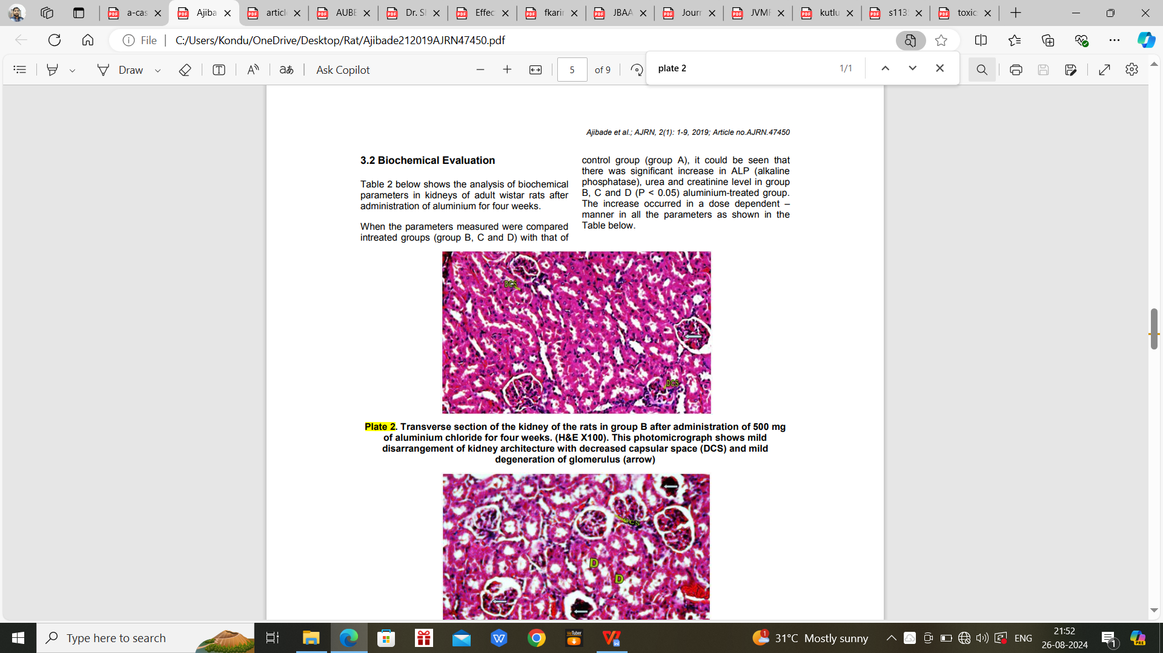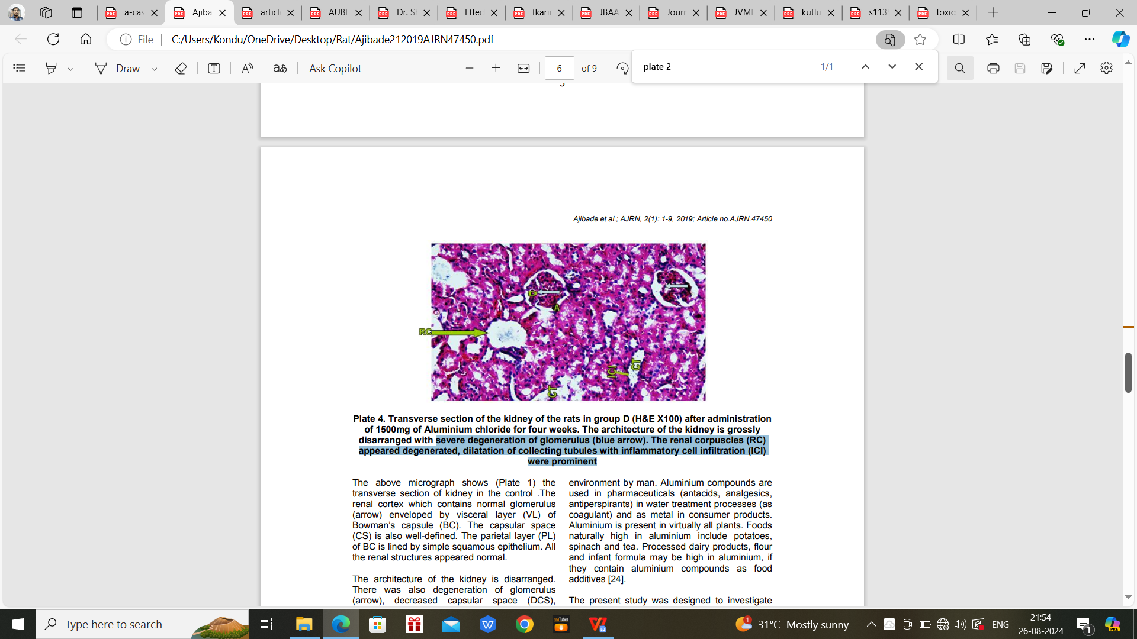
B
A
Fig. 1. A. mild disarrangement of kidney architecture with decreased capsular space (DCS) and mild degeneration of glomerulus (arrow), (H&E X100); B. grossly disarranged with severe degeneration of glomerulus (blue arrow). The renal corpuscles (RC) appeared degenerated, dilatation of collecting tubules with inflammatory cell infiltration (ICI) (H&E X100).

Shilpi Jain et al.[12] reported that, exposure to aluminium in the kidneys of albino rats causes swelling of tubules, obliterated Bowman’s space, increased cellularity of glomeruli, inflammatory cell infiltratioin, and partial sclerosis of glomeruli in the experimental group. In contrast, 70% of animals in the control group showed only congestion. (Fig. 2).

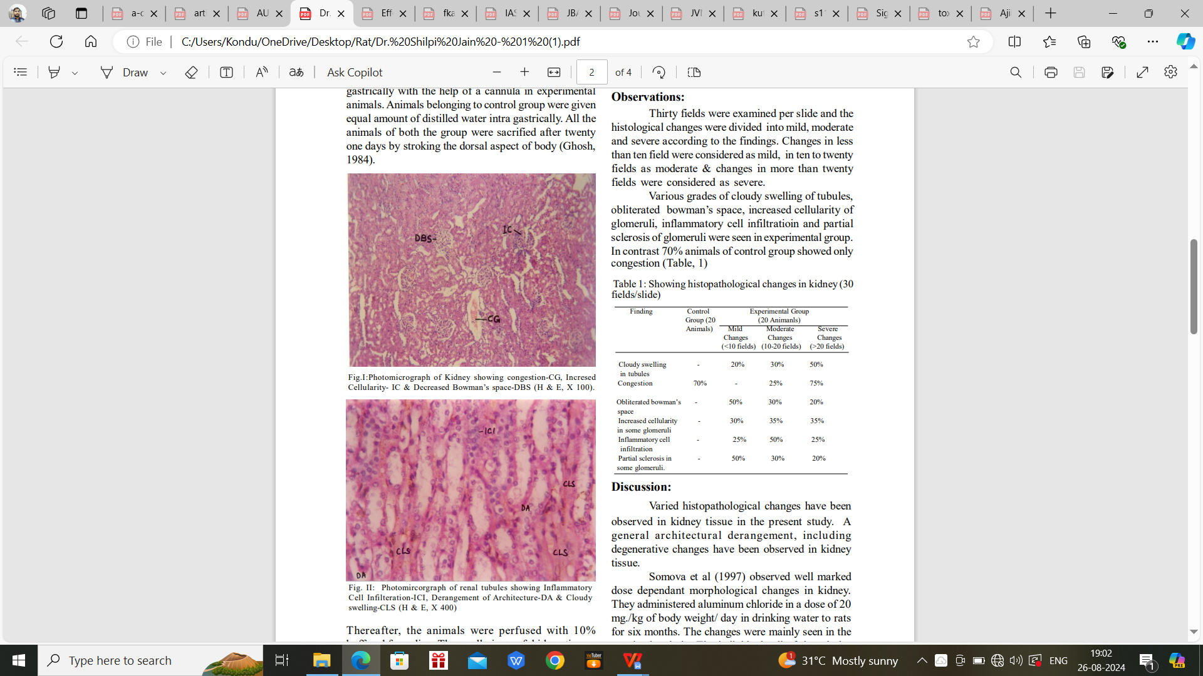
B
A
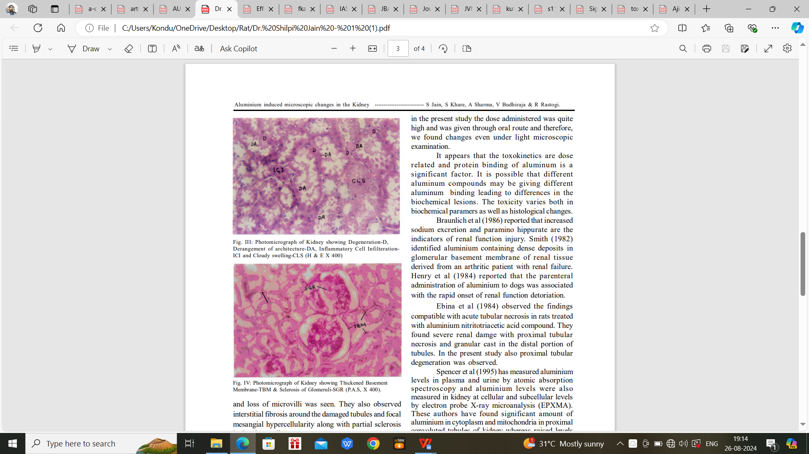
D
C
Fig: 2. A. Kidney showing congestion-CG, Incresed Cellularity- IC & Decreased Bowman’s space-DBS (H & E, X 100); B. renal tubules showing Inflammatory Cell Infilteration-ICI, Derangement of Architecture-DA & Cloudy swelling-CLS (H & E, X 400). C. Kidney showing Degeneration-D, Derangement of architecture-DA, Inflammatory Cell InfilterationICI and Cloudy swelling-CLS (H & E X 40). D. Kidney showing Thickened Basement Membrane-TBM & Sclerosis of Glomeruli-SGR (P.A.S, X 400).

Kadhim et al.[13] stated that, exposure to aluminium chloride in the kidneys of Wistar rats causes congestion in the capillary tuft of the glomeruli, diffuse vacuolar degeneration in epithelial cells, and focal cystic changes suggest kidney damage. Aluminium exposure can lead to glomerular changes, such as glomerulosclerosis, characterized by thickening and scarring of glomerular basement membranes. (Fig. 3).
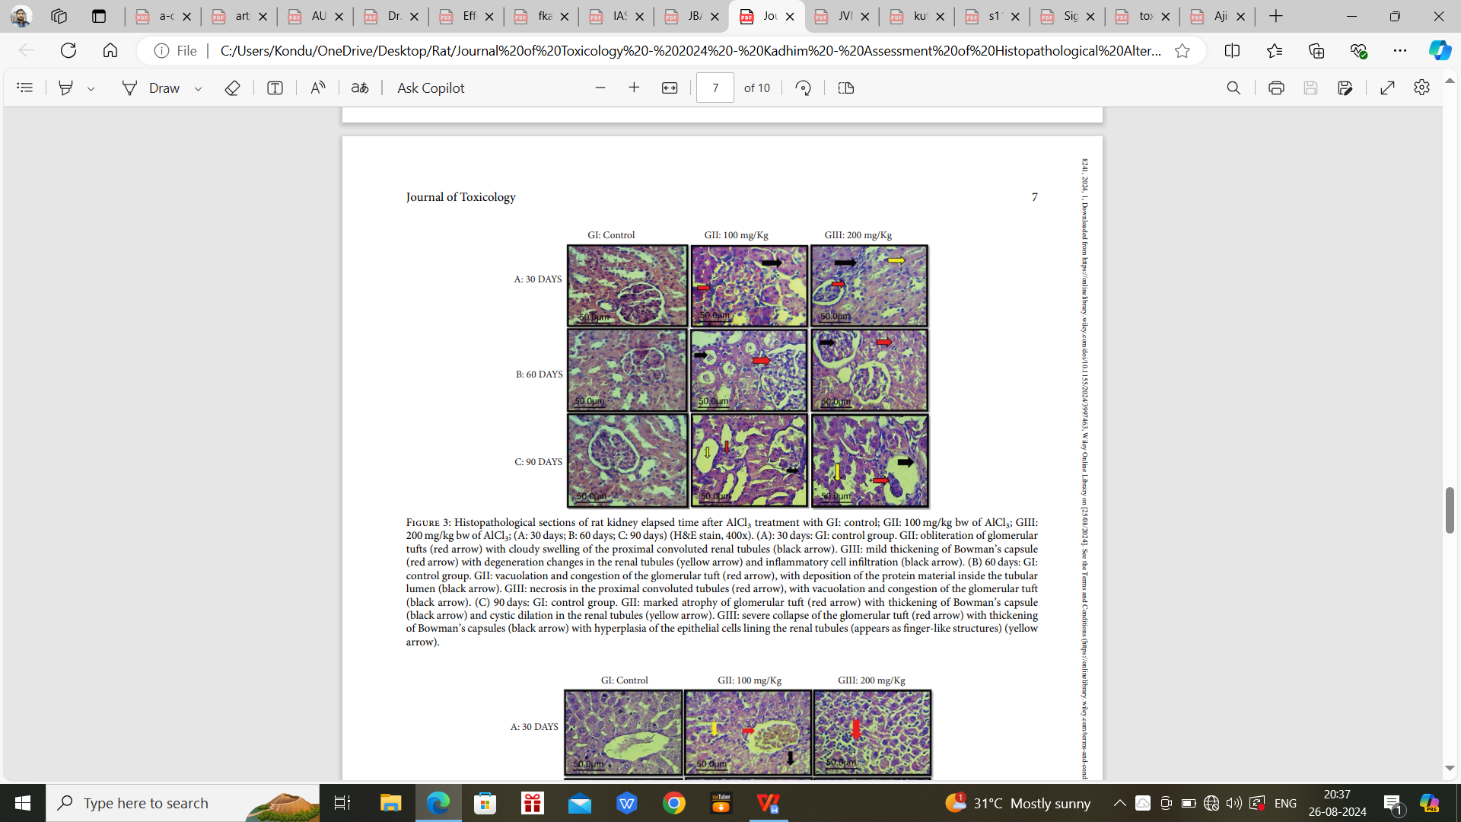
Fig. 3. kidney elapsed time after AlCl3 treatment (H&E stain, 400x).
GI: 30 days: control; 60 days: control; 90 days: control.
GII: obliteration of glomerular tufts (red arrow) with cloudy swelling of the proximal convoluted renal tubules (black arrow); vacuolation and congestion of the glomerular tuft (red arrow), with deposition of the protein material inside the tubular lumen (black arrow); marked atrophy of glomerular tuft (red arrow) with thickening of Bowman’s capsule (black arrow) and cystic dilation in the renal tubules (yellow arrow).
GIII: mild thickening of Bowman’s capsule (red arrow) with degeneration changes in the renal tubules (yellow arrow) and infammatory cell infltration (black arrow); necrosis in the proximal convoluted tubules (red arrow), with vacuolation and congestion of the glomerular tuft (black arrow); severe collapse of the glomerular tuft (red arrow) with thickening of Bowman’s capsules (black arrow) with hyperplasia of the epithelial cells lining the renal tubules (appears as fnger-like structures) (yellow arrow).

Amira et al.[14] stated that, exposure to aluminium chloride in the kidneys of Sprague-Dawley pregnant female rats showed pregnancy, and during the lactation period, feeding time and drinking frequency increased significantly while standing time decreased gradually. They exhibited more lying time during the last two weeks of pregnancy than during the lactation period, with a gradual decrease during the lactation period. (Table 1).

Table. 1. aluminium chloride exposure in the kidneys of Sprague-Dawley female rats.
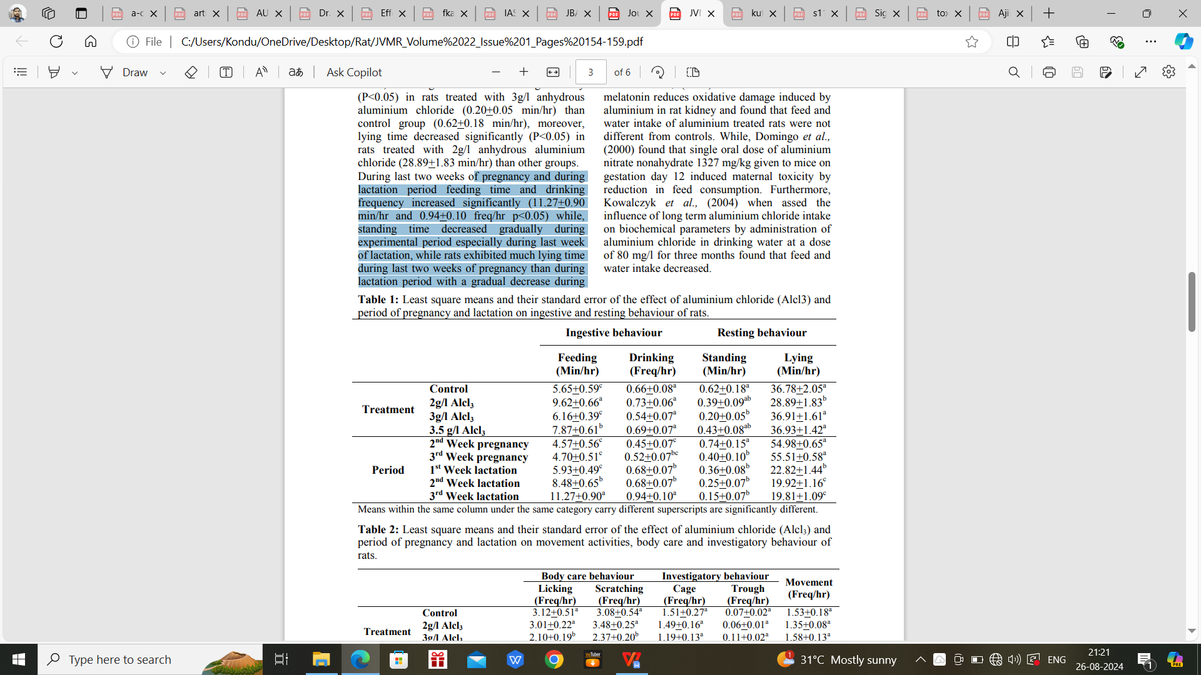
Shrivastava.[15] reported that, exposure to aluminium in the kidneys of female albino rats causes a higher degree of degeneration in the cortex and medullary region. Bowman’s capsules showed hypertrophy. Disturbed endothelial lining was observed. Epithelial cells showed darkly stained nuclei. Cytoplasmic vacuolation in the renal tubules. The lumen of the tubules was filled with debris. Bowman’s capsules and the glomeruli were also recouped. In some regions, the epithelial cells of the uriniferous tubules showed the apical position of the nuclei. (Fig. 4).
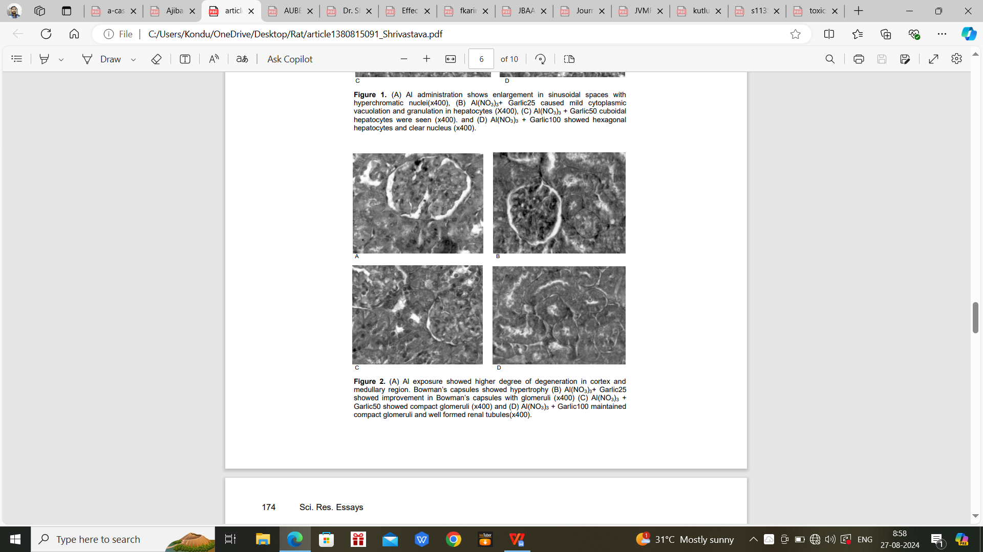
Fig. 4. A. higher degree of degeneration in cortex and medullary region. Bowman’s capsules showed hypertrophy; B. improvement in Bowman’s capsules with glomeruli (x400); C. compact glomeruli (x400); D. compact glomeruli and well formed renal tubules(x400).

Omar et al.[16] stated that, exposure to aluminium in the kidneys of male Sprague-Dawely rats causes swelling of the glomerular tuft with an increase in their cellularity and small focal areas of tubular nephrosis in the renal medulla. In the aluminium/tannic acid-treated rats, there was a slight cellular proliferation in the glomerular tuft as well as congestion of interstitial capillaries in the renal medulla. (Fig. 5).
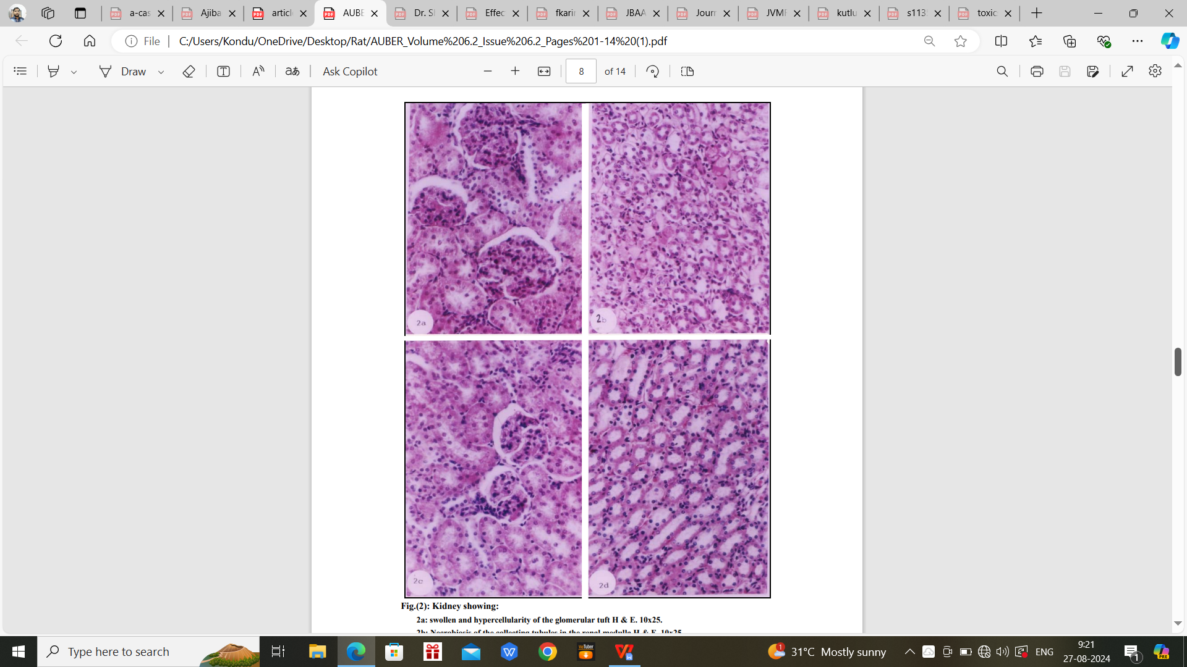
D
C
B
A
Fig. 5. A: swollen and hypercellularity of the glomerular tuft H & E. 10x25; B: Necrobiosis of the collecting tubules in the renal medulla H & E. 10x25; C: More or less normal histology of the renal cortex H & E.10x25; D: Only slight congestion in the interstatium of the renal medulla.H &E. 10x25.

Gerbed.[17] reported that, exposure to aluminium phosphide in the kidneys of albino rats causes a double-walled capsule, tubular epithelium, and interstitial tissue. The proximal and distal convoluted tubules (PCT and DCT) are composed of a single layer of a simple cuboidal type of epithelium; distal tubules had wider lumina compared with proximal tubules, no brush border, less eosinophilic cytoplasm, and smaller and flatter cells. (Fig. 6).
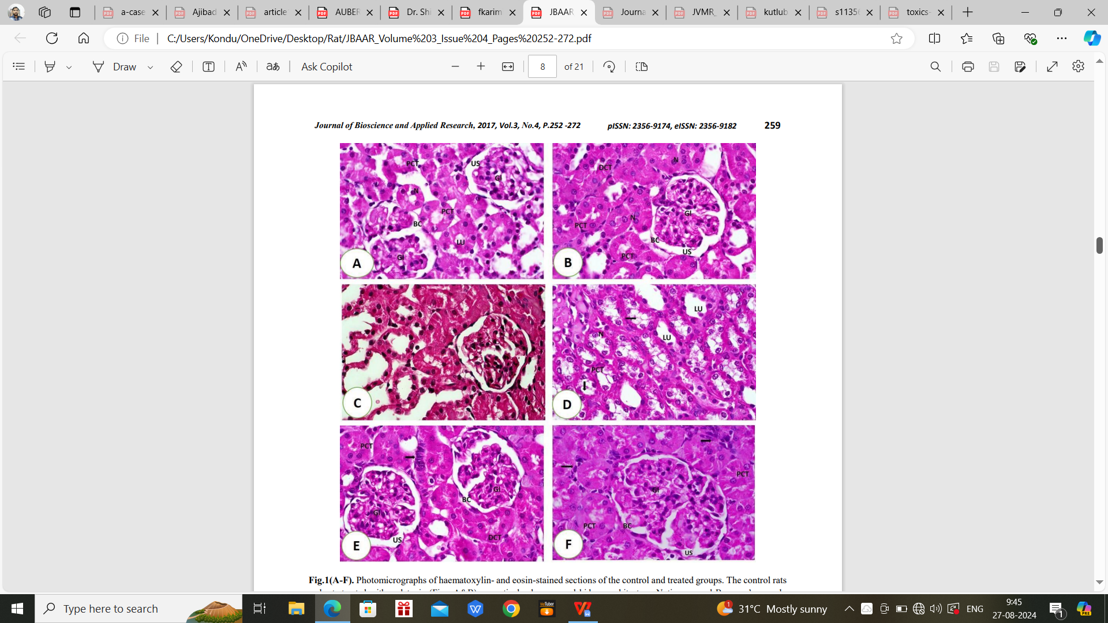
Fig. 6. A&B. show normal kidney architecture. Bowman’s capsule (Bc), glomerulus tufts (Gl), narrow urinary space (US), proximal convoluted tubules (PCT) with typical cuboidal cells and central round nuclei (N) and narrow lumen (Lu) were observed; C&D rats received aluminum phosphide demonstrating, kidney tissue with cellular abnormalities, hypertrophied and congested glomerulus (Gl) and dilated urinary space (US). Tubular necrosis, epithelial lining degeneration, swelling proximal (PCT) and distal (DCT) convoluted tubules with segregated nuclei (N), the dilated lumen (Lu); E&F rats receiving aluminum phosphide and melatonin, showing, kidney tissue with typical architecture, normal Bowman’s capsule (Bc), glomerulus (Gl), regular urinary space (US). Notice: proximal convoluted tubules (PCT), a narrow lumen (Lu), central rounded nuclei (N), inflammatory cell infiltrates (arrow) were seen.

Kutlubay et al.[18] noted that, exposure to aluminium in the kidneys of albino Wistar rats causes the glomeruli and proximal tubuli to be swollen and the Bowman capsules to adhere to the glomeruli. There was also an increase in the mesangial matrix. crescent formation, dilatation in the Bowman space, and the exudation of erythrocytes. Slight swellings, considerable damage, and degeneration, with shape, position, and volume disturbances of the nuclei. Numerous renal tubule cells have very dense and obscure cytoplasmic. Some of the tubuli were critically dilated. Marked interstitial tissue fibrosis was seen among the damaged tubuli, with marked destruction of the tubule epithelial cells also evident. However, a slight stenosis was seen in the capsular area of the Malpighi corpuscules. The tubular organization and the cytoplasmic basophilia were also similar to the control group, with the lumen clearly visible in most of the cortical tubuli. (Fig. 7).
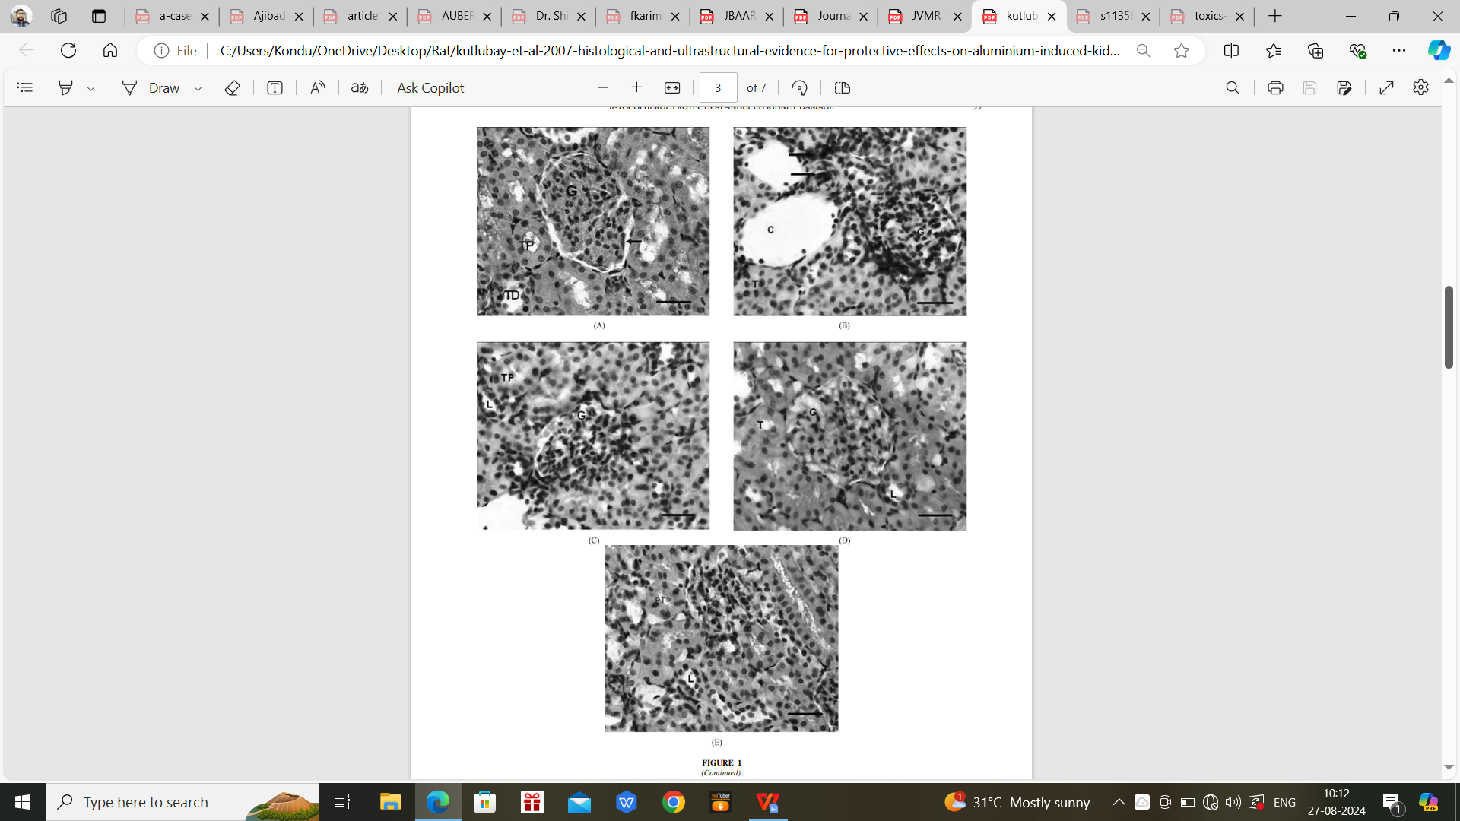
Fig. 7. A. a normal appearance; B. increase in the mesangial matrix; C. dilatation in the Bowman space, and exudation of erythrocytes; D. a slight stenosis was seen in the capsular area in the Malpighi corpuscules; E. lumen clearly visible in most of the cortical tubuli.

Hassan et al.[19] stated that, exposure to aluminium chloride in the kidneys of Wistar rats causes faint positive reactions in the cytoplasm of tubular cells, strong positive reactions in the cytoplasm of degenerated tubular cells, and weak positive reactions in the cytoplasm of most tubular cells compared with the treated group. (Fig. 8).
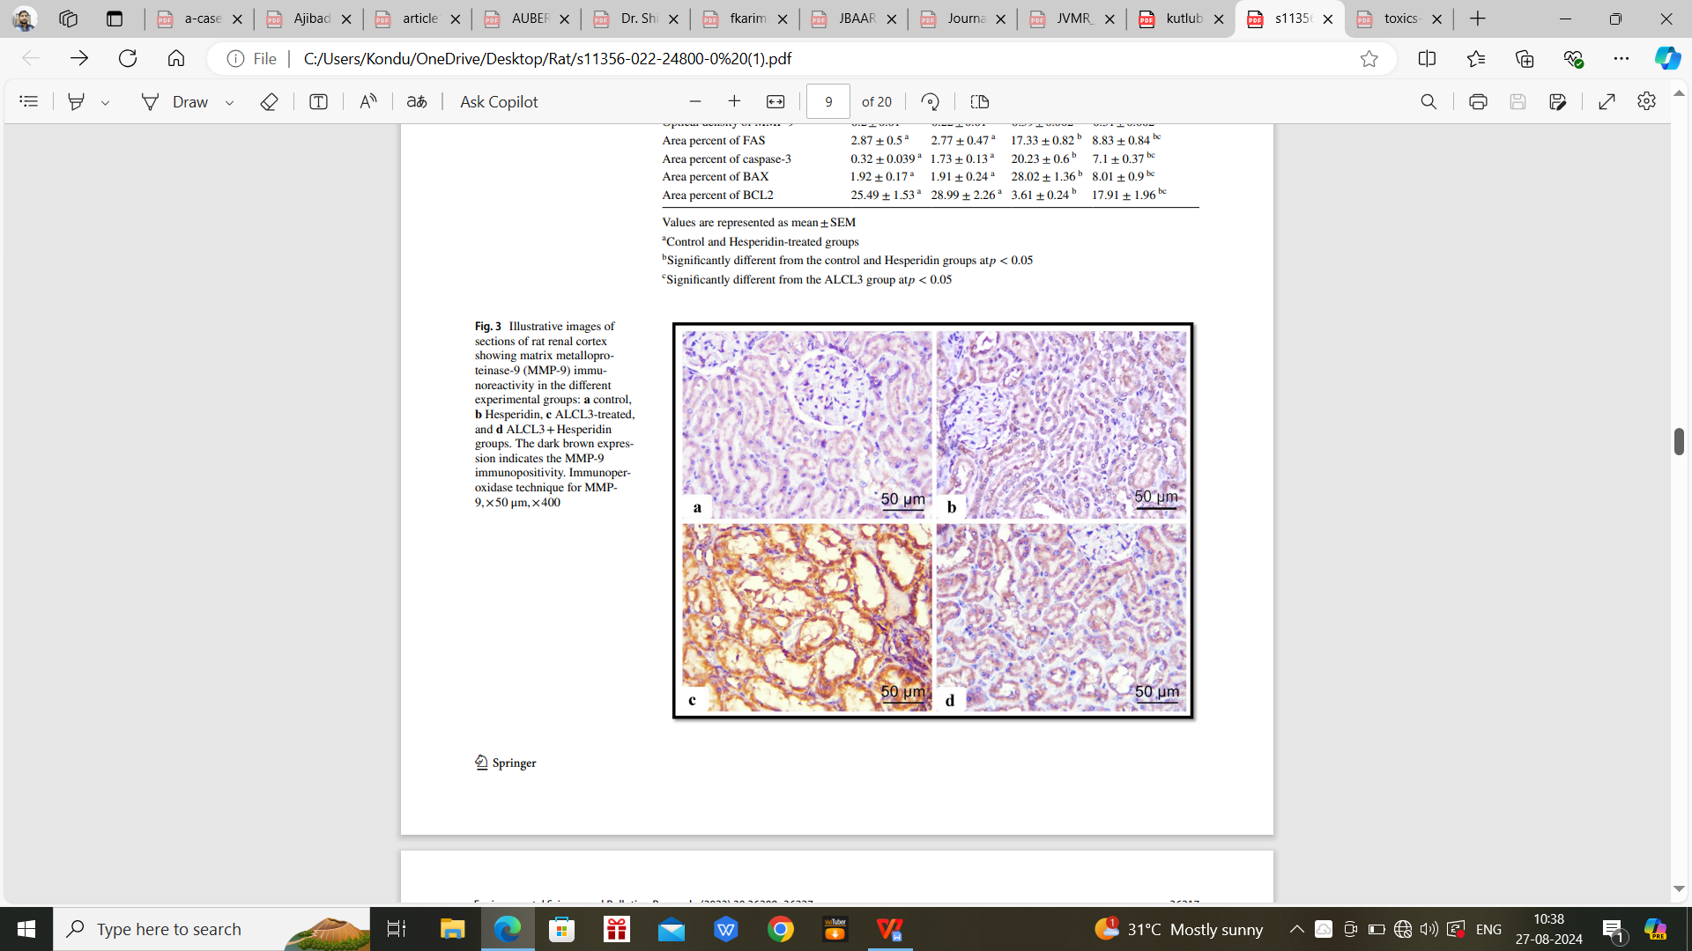
Fig. 8. a control, b Hesperidin, c ALCL3-treated, and d ALCL3+Hesperidin groups. The dark brown expression indicates the MMP-9 immunopositivity. Immunoperoxidase technique for MMP9,×50 μm,×400.

Tamer et al.[20] stated that, exposure to aluminium chloride in the kidneys of male albino rats causes degenerative or necrotic changes in the majority of renal tubular epithelial of renal cortex with congestion of blood vessels and peritubular capillaries and dilated glomerular spaces. Proliferation-forming band contains numerous dilated capillaries in renal medulla. Mild hydropic degeneration of a few cortical renal tubules and dilated glomerular space in renal tissue. (Fig. 9).
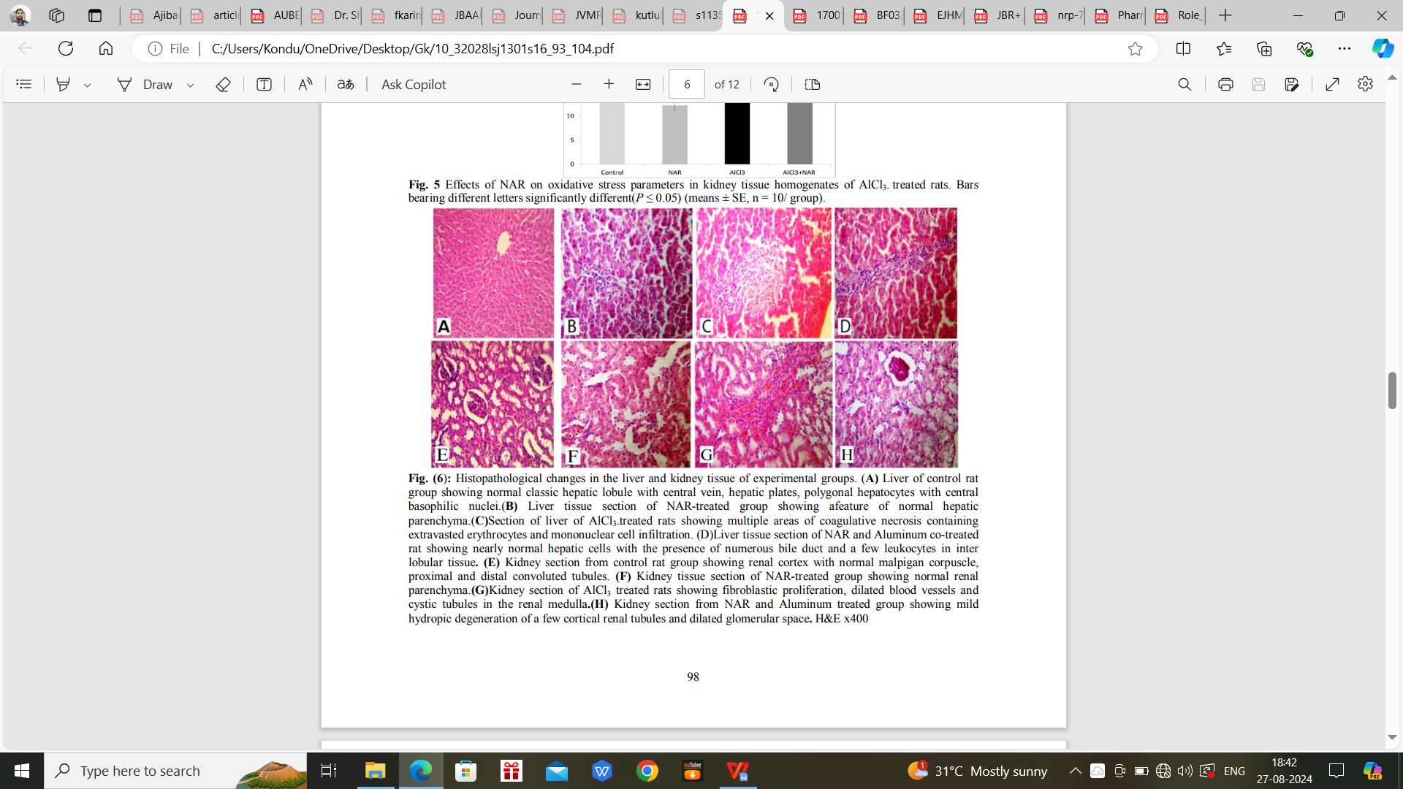
D
C
B
A
Fig. 9. A. Kidney section from control rat group showing renal cortex with normal malpigan corpuscle, proximal and distal convoluted tubules; B. Kidney tissue section of NAR-treated group showing normal renal parenchyma; C. Kidney section of AlCl3 treated rats showing fibroblastic proliferation, dilated blood vessels and cystic tubules in the renal medulla; D. Kidney section from NAR and Aluminum treated group showing mild hydropic degeneration of a few cortical renal tubules and dilated glomerular space. H&E x400.

- Conclusion:
The results of this study indicate that the uptake processes and accumulation of aluminium metal in the kidneys of different rats. The bioaccumulation process of Al metal has a serious impact in the kidneys of rodent animals. The magnified concentration of aluminium metal toxicity causes a higher mortality rate in the rat population. However, contamination of aluminium metal can be very dreadful to humans as well. To cope with this serious contamination threat, effective guidelines, legislation, and regular monitoring are highly required. Failure to control contamination will cause severe complications in the future because of the adverse impact of the aluminium metal.

References:
- Exley C (2004). The pro-oxidant activity of aluminium. Free Radic. Biol. Med. J. 36:380-387.
- Berthon G. Chemical speciation studies in relation to Aluminium metabolism and toxicity. Coord Chem Rev.1996;149:241– 280.
- Domingo Nutritional and toxicological effects of short-term ingestion of aluminum by the rat. Research Communications in Chemical Pathology and Pharmacology; 1987.
- Ochmanski W, Barabasz W (2000). Aluminium-occurrence and toxicity for organisms. Przegl Lek 57:665–668.
- D.Chappard, P. Bizot, G. Mabilleau, and L. Hubert, “Aluminum and bone: review of new clinical circumstances associated with Al(3+ ) deposition in the calcifed matrix of bone,” Morphologie, vol. 100, no. 329, pp. 95–105, 2016.
- Pócsi, I.; Dockrell, M.E.; Price, R.G. Nephrotoxic biomarkers with specific indications for metallic pollutants: Implications for environmental health. Biomark. Insights 2022, 17, 11772719221111882.
- Hill, N.R.; Fatoba, S.T.; Oke, J.L.; Hirst, J.A.; O’Callaghan, C.A.; Lasserson, D.S.; Hobbs, F.D.R. Global Prevalence of Chronic Kidney Disease-A Systematic Review and Meta-Analysis. PLoS ONE 2016, 11, e0158765.
- M.Kawahara and M. Kato-Negishi, “Link between aluminum and the pathogenesis of Alzheimer’s disease: the integration of the aluminum and amyloid cascade hypotheses,” International Journal of Alzheimer’s Disease, vol. 2011, no.1, 2011.
- Fatima ZT, Monya L, Nadia AH, Zineb T, Abdelkader A (2016) Protective effect of Haloxylon salicornicum on hepatic and renal functions of Wistar rats exposed to aluminium. Afr J Biotech 15(9): 293–302. https://doi.org/10.5897/ajb2015.15037.
- Lentini, P.; Zanoli, L.; Granata, A.; Signorelli, S.S.; Castellino, P.; Dell’Aquila, R. Kidney and heavy metals-The role of environmental exposure
(Review). Mol. Med. Rep. 2017, 15, 3413–3419.
- Ajibade,A. J., B. D. Kehinde, A. A. Atanda, and O.O. Adeleye. 2019. “Some Morphological and Biochemical Changes in the Kidney of Adult Wistar Rats Following Aluminium Chloride Exposures”. Asian Journal of Research in Nephrology2(1): 1-9. https://journalajrn.com/index.php/AJRN/article/view42.
- Shilpi Jain,., Satyam Khare,.,Archana Sharma,., Virendra Budhiraja,., & Rakhi Rastogi. (2009). Aluminium Induced Microscopic Changes in the Kidney. PJSR, 2(1),1-4.
- Kadhim, Anfal, Ben Slima, Alneamah, Ghusoon,Makni, Mohamed. (2024). Assessment of Histological Alterations and Oxidative Stress in the Liver and Kidney of Male Rats following Exposure to Aluminium Chloride, Journal of Toxicology, 2024, 3997463, 10.
- Amira, A. Goma1 , Usama E. Mahrous. (2013). Ethological Problems and Learning Disability due to Aluminium Toxicity in Rats. Animal and Veterinary Sciences, 1(2), 12-17. https://doi.org/10.11648/j.avs.20130102.11.
- Shrivastava,S. (2013). Amelioration of aluminium induced toxicity by Allium sativum. Scientific Research and Essays,8(4),168-177.
- Omar H.M, Khadiga A. Hassan, Abd-Elghaffar S.Kh, and Ahmed E.A.(2003).
ALUMINIUM TOXICITY IN RATS : THE ROLE OF TANNIC ACID AS ANTIOXIDANT. Assiut University Bulletin for Environmental Research,6(2), 1-14. doi: 10.21608/auber.2003.150957.
- El-Gerbed, M. (2017). Nephroprotective Effect of Melatonin against Aluminum Phosphide Induced Renal Tissue Damage in Rats. Journal of Bioscience and Applied Research. 3(4),252 -272. doi:10.21608/jbaar.2017.126595.
- Kutlubay R, Oguz EO, Guven C, Can B, Sınık Z, Tuncay O L. Histological and Ultrastructural Evidence for Protective Effects on Aluminium-Induced Kidney Damage by Intraperitoneal Administration of α-Tocopherol.Int J Toxicol. 2007 Mar-Apr; 26(2):95–101. doi: 10.1080/10915810701221173.
- Hassan NH, Yousef DM, Alsemeh AE. Hesperidin protects against aluminum induced renal injury in rats via modulating MMP-9 and apoptosis: biochemical, histological, and ultrastructural study. Environ Sci and Pollut Res Int.2023 Mar; 30(13): 36208–36227. doi:10.1007/s11356-022-24800-0.
- Tamer S. Imam, Hesham A. Khalifa, Mohamed M.A.Hussein and Haytham. A. Ali. Aluminum –Induced Oxidative Stress and Hepato -Renal Impairment in Male Albino Rats: Possible Protective trial with Naringenin. Life Sci J 2016;13(1s):93-104. doi:10.7537/marslsj1301s1610.

