**A Study on Optimizing Productivity and Communication: The Influence of Organizational Structure in Startups**

1. **Latchiya Priya M**

IV semester, Human Resource specialization, Department of business administration, Sahyadri college of engineering and Management, Mangalore.

1. **Dr. Vishal Samartha**

Director, Department of business administration, Sahyadri college of Engineering and Management, Mangalore.

**Abstract**:

The study titled "A Study on Optimizing Productivity and Communication: The Influence of Organizational Structure in Startups," investigates the role of organizational structure in optimizing productivity and communication within startup companies. Startups, characterized by their dynamic and evolving business models, often face unique challenges in establishing effective communication channels and maintaining high productivity levels. The research explores various organizational structures, assessing their impact on employee communication and overall productivity. Using statistical tools such as Chi-Square and Regression analysis, the study evaluates hypotheses regarding the influence of organizational frameworks on these critical factors. Key findings reveal significant discrepancies between employer and employee perceptions of communication clarity and coordination, with a notable gap where 88% of employers believed communication was clear, contrasted by only 45% of employees agreeing with this assessment. The study underscores the importance of flexible and adaptive organizational structures in the early stages of a startup, while also suggesting that more defined frameworks may be necessary as the organization grows to ensure sustained productivity and effective communication. The research contributes valuable insights for startup leaders, highlighting the need for careful consideration of organizational design to enhance employee engagement, streamline communication, and optimize productivity.

**Key words:**

Organisational structure, Employee communication, Employee productivity, Start-ups.

**1.Introduction**:

**(D, 2023)** Organizational structures form the backbone of modern businesses, defining how tasks are allocated, roles are defined, and communication flows within an organization. In today's dynamic and rapidly evolving business landscape, organizations are embracing a variety of structural models to adapt to changing market demands, technological advancements, and workforce dynamics. **(Nene1, 2019)** In any organization, one of the most valuable assets is considered to be the person within that organization. For the effectiveness and alignment of personnel with the organisation’s vision, it is of utmost importance to have leadership and management systems and personnel that are effective and efficient in ensuring business alignment and thus business accountability and sustainability. The management systems in place shall be such that the organisational structure is effective for the business objectives of the organisation.

When a business has few employees and only one strong leader (usually the owner), a flat company structure often works well. The owner gives different tasks to different employees as needs arise, and the owner approves the final decisions. This allows the owner to assign work to the best person at the company, rather than forcing an employee to perform work because it’s under her jurisdiction. A key problem with a flat organizational structure is that it burdens the top leader with approving every decision. This consumes their time and can create pressure, causing employees to feel paralyzed and afraid to act without the boss's approval, according to the leadership blog Get Lighthouse. Hierarchical Organizational Structure The most common form of small-business structure is the so-called “totem pole” form of running a company. Every department and position falls under its leader, creating an easily identifiable chain of command. For example, under marketing would be sales. Under a director would be a manager, then a coordinator, then a staff member. This way of running a company can led to higher costs because each department might need a director, manager and coordinator. Breaking operations into departments can decrease communications among team members, points out Accounting Tools. A flat organizational structure can slow decision- making, as the top leader must approve every decision, leading to delays. To mitigate this, hold regular meetings with department heads to ensure they understand how their work impacts other departments.

**2. Literature Reviews:**

**(1)** **(Mrs. Rohini U. Nikam, 2023),** Human Resource Management (HRM) is evolving beyond mere compliance with rules and regulations to focus on maximizing employee potential and fostering a positive work environment, which is critical for sustainable development. This shift is especially pertinent for startups, where effective HR practices can streamline business operations and support growth. The literature underscores the necessity of innovative HR strategies in startups, addressing challenges such as hiring, talent attraction, teamwork promotion, milestone recognition, and employee rewards. By adapting and evolving HR practices as the company grows, startups can overcome HR difficulties and gain a competitive edge. This research highlights the crucial role of HRM in startups, identifying obstacles and proposing solutions to enhance organizational performance and sustainability.

**(2) (Sirigiri, 2018),** The literature on organizational structure presents a dual perspective: while it enhances efficiency, it can also stifle innovation and creativity by reducing flexibility. This trade-off is well-documented in established firms, but less is known about its impact on startups due to data constraints. Research underscores the balance between flexibility and efficiency, essential for startups that often operate with limited resources and evolving business models. Flexibility enables startups to explore new opportunities, but as they grow, an organizational structure becomes necessary to streamline decision-making, reduce coordination costs, and enhance process efficiency. This study investigates whether implementing an organizational structure early in a startup's life cycle supports its growth. Utilizing a unique dataset of internet- based startups in India, the study examines the roles of hierarchical and horizontal functional structures in fostering startup development and scalability. This review highlights the importance of understanding how organizational structures influence startup performance and the critical trade-offs involved.

**(3) (Nene, 2019),** The literature on organizational structure and its impact on performance highlights its critical role in determining job satisfaction and overall departmental effectiveness. This study specifically examined the Property Administration Services (PAS) Department in Johannesburg South, South Africa, aiming to provide practical insights into how a complex organizational structure influences employee satisfaction and performance. Utilizing descriptive and inferential statistics, the research identified key factors shaping the organizational structure and their relationship to job satisfaction and performance. The findings indicated that an ineffective organizational structure led to low job satisfaction and poor performance, with low staff morale being a significant contributor. This underscores the importance of designing an appropriate organizational structure to enhance employee morale and departmental performance. The study's conclusions suggest that aligning organizational structure with employee needs and departmental goals is vital for improving productivity and job satisfaction.

**3. Research Design:**

**3.1 Problem Statement:** This study addresses the need to critically assess how conventional organizational frameworks affect employee efficiency and interaction, while identifying the difficulties inherent in such structures and exploring pathways for organizational evolution.

**3.2 Objective:**

* To analyse the influence of Organisational Structure on Employee Productivity and communication separately
* To evaluate the predicting power of Organization structure on employee productivity and communication separately
* To identify the challenges in the current organization structure and suggest a suitable structure for startups.

**3.3 Research Methodologies:**

**3.3.1 Dependent Variable:**

* Communication and Productivity

**3.3.2 Independent Variable:**

* Organisational Structure

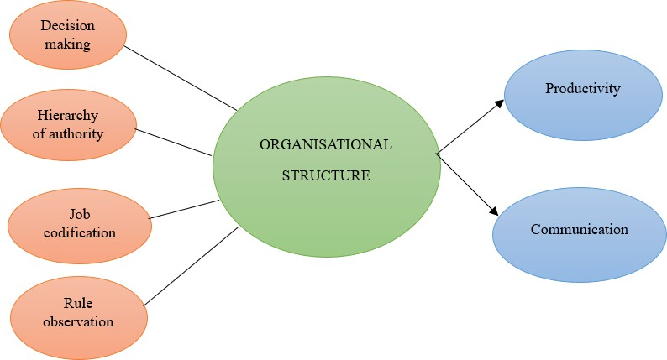**3.3.3 Model Diagram:**

**3.3.4 Statistical Tools:**

|  |  |  |
| --- | --- | --- |
| Sl. No | Objectives | Statistical tools |
| 1 | To analyse the influence of Organisational Structure on Employee and Employer Productivity and communication separately | Chi-Square |
| 2 | To evaluate the predicting power of Organization structure on Employee and Employer productivity and communication separately | Regression |
| 3 | To identify the challenges in the current organization structure and suggest a  suitable structure for startups | Descriptive (Cross Tab) |

**3.3.5 Hypothesis:**

H1: Organizational structure has a significant influence on employee communication.

H2: Organizational structure has a significant influence on employee productivity

H3: Organizational structure has a significant influence on employer communication

H4: Organizational structure has a significant influence on employer productivity

H5: Organizational structure is a significant predictor of employee communication.

H6: Organizational structure is a significant predictor of employee productivity.

H7: Organizational structure is a significant predictor of employer communication.

H8: Organizational structure is a significant predictor of employer productivity.

**4. Tests and Interpretation:**

**4.1: Chi-Square Test**

**(1) To analyse the influence of Organisational Structure on Employee Communication**



Here, the p-value from the Chi Square test is 0.000, which is significantly lower than the conventional threshold of 0.05. This result indicates a strong statistical significance in the relationship between organizational structure and employee communication. Since the p-value is less than 0.05, we reject the Null Hypothesis (H0), which states that organizational structure has no significant effect on employee communication, and accept the Alternative Hypothesis (H1), which asserts that organizational structure does significantly influence employee communication. This suggests that how an organization is structured plays a crucial role in shaping how effectively employees communicate within the company, underscoring the importance of organizational design in fostering effective communication.

**(2) To analyse the influence of Organisational Structure on Employee Productivity**



In this case, the p-value for the Chi-Square test is 0.000, which is well below the common threshold of 0.05. This indicates that the observed relationship between organizational structure and employee productivity is statistically significant. Consequently, we reject the Null Hypothesis (H0), which posits that organizational structure has no significant influence on employee productivity, and accept the Alternative Hypothesis (H2), which suggests that organizational structure does indeed have a significant impact on employee productivity. This result implies that variations in organizational structure are associated with differences in productivity levels among employees, highlighting the importance of organizational design in enhancing or hindering employee performance.

**(3) To analyse the influence of Organisational Structure on Employer Communication**



In this case, the p-value is 0.000, which is significantly lower than the threshold of 0.05. This indicates that the observed relationship between organizational structure and employer communication is statistically significant. Since the p-value is less than 0.05, we reject the Null Hypothesis (H0), which posits that organizational structure has no significant effect on employer communication, and accept the Alternative Hypothesis (H3), which suggests that organizational structure significantly influences employer communication. This means that variations in the organizational structure of a company are associated with differences in how effectively employers communicate. The result highlights the importance of organizational design in enhancing or impeding communication between employers and their teams.

**(4) To analyse the influence of Organisational Structure on Employer Productivity**



Here, the p-value is 0.001, which is substantially lower than the standard threshold of 0.05. This low p-value indicates that the relationship between organizational structure and employer productivity is statistically significant. Since the p-value is less than 0.05, we reject the Null Hypothesis (H0), which states that organizational structure does not significantly affect employer productivity, and accept the Alternative Hypothesis (H4), which asserts that organizational structure does have a significant impact on employer productivity. This finding implies that changes or variations in organizational structure are meaningfully associated with differences in how productive employers are, underscoring the critical role that organizational design plays in influencing productivity levels within a company.

**4.2 Regression:**

**(1) To evaluate the predicting power of Organizational structure on employee Communication**



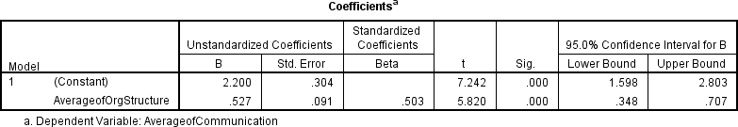

In the regression analysis of organizational structure and employee communication, the independent variable is the organizational structure, while the dependent variable is employee communication. The hypothesis tested whether organizational structure significantly predicts employee communication. The ANOVA results indicate a p-value of 0.000, which is less thanthe significance level of 0.05. This leads us to reject the null hypothesis (H0) and accept the alternative hypothesis (H5), confirming that organizational structure is indeed a significant predictor of employee communication

**(2) To evaluate the predicting power of Organizational structure on employee Productivity**

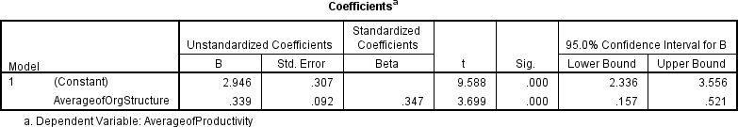

In the regression analysis of organizational structure and employee productivity, the independent variable is the organizational structure, while the dependent variable is employee productivity. The hypothesis tested whether organizational structure significantly predicts employee productivity. The ANOVA results show a p-value of 0.000, which is less than the significance level of 0.05. This leads to the rejection of the null hypothesis (H0) and acceptance of the alternative hypothesis (H6), confirming that organizational structure is a significant predictor of employee productivity.

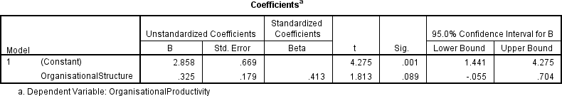**(3)** **To evaluate the predicting power of Organizational structure on employer Communication**

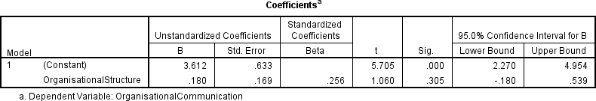

In the regression analysis of organizational structure and employer communication, the independent variable is the organizational structure, and the dependent variable is employer communication. The hypothesis tested whether organizational structure significantly predicts employer communication. The ANOVA results show a p-value of 0.005, which is less than the significance level of 0.05. This leads to the rejection of the null hypothesis (H0) and acceptance of the alternative hypothesis (H7), confirming that organizational structure is a significant predictor of employer communication.

**(4) To evaluate the predicting power of Organizational structure on employer Productivity**



In the regression analysis of organizational structure and employer productivity, the independent variable is the organizational structure, while the dependent variable is employer productivity. The hypothesis tested whether organizational structure significantly predicts employer productivity. The ANOVA results show a p-value of 0.009, which is less than the significance level of 0.05. This leads to the rejection of the null hypothesis (H0) and acceptance of the alternative hypothesis (H8), confirming that organizational structure is a significant predictor of employer productivity.

**5. Findings:**

1. Organizational structure significantly influences employee communication, improving interaction and enhancing communication channels within the organization.

2. A positive correlation exists between organizational structure and employee productivity, indicating that a clear structure can boost employee performance.

3. The relationship between organizational structure and employer communication is statistically significant, showing that a well-defined structure fosters better communication between employers and their teams.

4. Organizational structure plays a crucial role in enhancing employer productivity, as changes in structure can meaningfully impact employer performance.

5. The statistical significance across all analyses underscores the importance of organizational structure in influencing communication and productivity within an organization.

6. The design of an organization is critical in shaping effective communication, both among employees and between employers and their teams.

7. Organizations seeking to improve communication and productivity should consider revising their structure, as structural changes can lead to significant improvements.

8. Even small variations in organizational structure can lead to noticeable differences in communication effectiveness and productivity levels, highlighting the sensitivity of these outcomes to structural adjustments.

9. The beta values indicate the degree to which organizational structure impacts the dependent variables, with significant percentages of change in communication and productivity attributed to structural changes.

10. Organizational structure has a broad impact on communication and productivity, affecting various levels within the organization, from employees to employers, underscoring the importance of thoughtful organizational design in strategic planning.

**6. Conclusion:**

The conclusion drawn from the analysis is that organizational structure plays a critical role in influencing both communication and productivity within an organization. The findings consistently demonstrate that a well-defined and thoughtfully designed structure significantly enhances the effectiveness of communication among employees and between employers and their teams, as well as boosts overall productivity. These results highlight the importance of regularly assessing and optimizing organizational structure to ensure it aligns with the company’s strategic goals and fosters an environment conducive to collaboration, efficiency, and high performance. Ultimately, investing in the right organizational design can lead to substantial improvements in how information flows and how effectively work gets done within the organization.

**7. Recommendation:**

**Box Structure:** Organisations require a structured approach to achieve their goals and objectives. The structure of an organisation often depends on its size and the nature of its business. Traditional organisational structures include Functional, Divisional, Matrix, Flat, Team Hierarchical, among others.

Early-stage startups, which typically operate with lean teams, need to scale quickly. This necessitates efficient resource sharing and seamless communication across various departments to maximize productivity and efficiency. In the initial years, startups must pivot their strategies rapidly to stay competitive and sustain themselves. To achieve this, every team member must have clearly defined Key Performance Indicators (KPIs) to ensure accountability for their outcomes and their growth within the organisation.

A box structure is one such organizational framework that startups can adopt. In a box structure, each functional unit operates within well-defined boundaries or "boxes." These boundaries encompass the KPIs or expected outcomes, the budget allocated for achieving these outcomes, and the timeline within which they must be met. Members within a box are provided with the necessary resources, which may be shared, to meet their targets. The individual in charge of the box ensures that each team member has clearly defined responsibilities and develops their capabilities to achieve the box's goals. Once a member successfully establishes processes to ensure the set outcomes within their box, they can take on higher responsibilities. For a member to move to a higher position, they must ensure that they have developed the capability of the team member who takes their place.

**Advantages**

1. Each team member has clearly defined KPIs, ensuring accountability for their performance and outcomes.

2. Shared resources are utilized efficiently, maximizing productivity and minimizing waste.

3. Startups can quickly pivot their strategies to stay ahead of competition and adapt to market changes.

4. The box structure allows for scalable growth by clearly defining roles and responsibilities, facilitating smooth transitions to higher responsibilities.

5. Seamless communication across departments ensures collaboration and cohesive efforts towards common goals.

**Features**

1. Each functional unit operates within specific boundaries, including expected outcomes, budget, and timeline.

2. Resources are shared across various departments to optimize usage and enhance efficiency.

3. Every team member has clearly defined KPIs, ensuring accountability and measurable performance.

4. Team leaders focus on developing the capabilities of their team members to achieve set goals and prepare them for higher responsibilities.

5. Establishing effective processes within each box ensures consistent and reliable outcomes.

In conclusion, the box structure offers a structured and efficient approach for early-stage startups to scale rapidly, optimize resources, and ensure clear accountability and collaboration among team members. By adopting this structure, startups can navigate the challenges of their initial years and position themselves for sustainable growth and success.

**Bibliography:**

**Baha Aldeen Mohammad Fraihat, H. A. (2023, May 18). The Effect of Organizational Structure on Employee Creativity: The Moderating Role of Communication Flow: A Survey Study. *Open Access Journal, 12*(2), 2226-3624. doi:10.6007/IJAREMS/v12-i2/16983**

**C Balakrishnan, D. D. (2013, August). Impact of Internal Communication on Employee Engagement – A Study at Delhi International Airport. *International Journal of Scientific and Research Publications, Volume 3*(Issue 8). Retrieved from** [**www.ijsrp.org**](http://www.ijsrp.org/)

**D, J. (2023).**

**DAMILOLA.D, A. (2020, NOVEMBER). ORGANISATIONAL STRUCTURE AS A TOOL FOR EFFECTIVE MANAGEMENT.**

**Eliana Gaspary* and Gilnei Luiz de Moura, D. W. (2018, March). How does the organisational structure influence a work environment for innovation? *International Journal of Entrepreneurship and Innovation Management*.**

**Ezejiofor, R. A. (2021, December). Organizational structure and employee performance: evidence from pharmaceutical companies in Anambra state, Nigeria. Retrieved from www.journal- innovations.com**

**Gordiya, P. (2024, May). Impact of Organizational Structure on Employee Performance in Context to Productivity Enhancement in Dairy Sector. *International Journal of Research Publication and Reviews, Vol 5*( no 5), 3633-3642.**

**Jerab D, M. T. (2023).**

**Jeroen P.J. de Jong, D. N. (2007). How leaders influence employees’innovative behaviour. *European Journal of Innovation, 10*(1), 1460-1060. doi:10.1108/14601060710720546**

**Johanim Johari, K. K. (n.d.). The Construct Validity of Organizational Structure. Johanim Johari, K. K. (n.d.). The Construct Validity of Organizational Structure.**

**Litwin, W. W. (1992). A Causal Model of Organizational Performance and Change. *Sage, 18*(3), 523-545. doi: 10.1177/014920639201800306**

**Malcolm Patterson, P. W. (2004, April). Organizational Climate and Company Productivity: The Role of Employee Affect and Employee Level. *Centre for Economic Performance*.**

**Mamun Mukhamad*, S. T. (2020). IMPLEMENTATION OF MCKINSEY 7S MANAGEMENT STRATEGY CONCEPTS FOR STARTUP BUSINESS: FRUIT COMBINING. *RJOAS, 1*(97).**

**doi:10.18551/rjoas.2020-01.17**

**Melissa S. Cardon, C. E. (2004). Managing human resources in small organizations:What do we know?**

**295–323. doi:10.1016/j.hrmr.2004.06.001**

**Men, L. R. (2021, November). The Impact of Startup CEO Communication on Employee Relational and Behavioral Outcomes: Responsiveness, Assertiveness, and Authenticity. *Research Gate*.**

**Michał Ba ´nka, M. S. (2023). Start-Up Accelerators and Their Impact on Entrepreneurship and Social Responsibility of the Manager. *Sustainability, 15*(11), 8892. Retrieved from https://doi.org/10.3390/su15118892**

**Milano, S. (2021, May 20). The Impact of Organization Structure on Productivity. Retrieved from https://smallbusiness.chron.com/impact-organization-structure-productivity-21902.html**

**Mrs. Rohini U. Nikam, D. Y. (2023). A Study of Need and Challenges of Human Resource. *Vol 72 No. 1*, 314 – 320. Retrieved from** [**http://philstat.org.ph**](http://philstat.org.ph/)

**Nene, S. W. (2019, January). AN INVESTIGATION OF THE IMPACT OF ORGANISATIONAL STRUCTURE ON ORGANISATIONAL PERFORMANCE. *Vol. 5, No. 1*, 10-24. doi: 10.18488/journal.89.2019.51.10.24**

**Nene1, S. W. (2019).**

**Rajhans, K. (2009, July). Effective Organizational Communication: a Key to Employee. *Vol. 2*( Iss. 2).**

**Retrieved from https://**[**www.interscience.in/imr**](http://www.interscience.in/imr)

**REZA NURUL ICHSAN, L. N. (2021). The influence of leadership styles, organizational changes on employee performance with an environment work as an intervening variable at pt. Bank sumut binjai branch. *Society of Business and management , 27*(2). doi:10.47750/cibg.2021.27.02.032**

**Shabbir, M. S. (n.d.). Organizational Structure and Employee’s Performance: A Study of Brewing Firms in Nigeria. *Volume 3*(Issue 1), 16 Pages. Retrieved from** [**www.arjonline.org**](http://www.arjonline.org/)

**Shabbir, M. S. (n.d.). Organizational Structure and Employee’s Performance: A Study of Brewing Firms in Nigeria. *American Research Journal of Business and Management, Volume 3*(Issue 1), 16 Pages.**

**Shabbir, M. S. (n.d.). Organizational Structure and Employee’s Performance: A Study of Brewing Firms in Nigeria. *American Research Journal of Business and Management, Volume 3*( Issue 1), 16 Pages.**

**Sirigiri, A. (2018). ESSAYS IN ORGANIZATIONAL STRUCTURE AND STRATEGIC HUMAN CAPITAL IN START- UPS.**

**Sunday C. Eze, A. O. (2017, December). THE EFFECTS OF ORGANIZATIONAL STRUCTURE ON THE**

**PERFORMANCE OF ORGANIZATIONS. *European Journal of Business and Innovation Research, Vol.5*(No.6), 46-62.**

**Uittenbogaard, L. (2021, July). The Communication of Value.**

**Wouw, R. v. (2024). Evolving Communication Requirements: The Dynamics of Organizational Growth and the Development of Organizational Citizenship Behavior in Startups. *Eindhoven University of Technology*.**