**A study on the relationship between talent management strategies and gig worker Retention: An employee perspective**

1. **V Vishmitha**

IV semester, Human resources specialization, Department of business administration, Sahyadri college of Engineering and Management, Mangalore

1. **Dr. Vishal Samartha**

Director, Department of business administration, Sahyadri college of Engineering and Management, Mangalore.

**Abstract**

The gig economy is blooming up the job market, and more people want to join in. This study aims to understand what gig workers face and expect, and to check if current talent management methods work well in this new setup. A questionnaire was prepared for the purpose of survey and surveyed 135 gig workers in Mangalore asking about their work experiences and how companies handle talent management. The results show that good talent management can help in the retention of gig workers. The study suggests the companies to better manage their gig workforce. It also points out that retaining gig workers require a very good talent management strategy. This work calls for more research to grasp how this new job trend affects India, to tackle new problems, and to find ways to make the most of it while avoiding pitfalls.

**Key words:** Gig workers**,** Talent management, retention, strategies.

**1. INTRODUCTION**

There is a new trend what is coming in the job market known as the gig workers, these are contract based workers. This new trend, which includes self-employment, freelancing, and short-term contracts, brings both chances and problems. It gives temporary jobs to millions of workers, but it also raises worries about job security and worker rights. The gig economy, which has its roots in early 1900s jazz culture, has expanded a lot with new tech covering both manual and office jobs in cities and villages. While it offers flexibility and the potential to earn more, it also brings up issues about fair pay and protecting workers. As other countries make rules to handle gig workers, India is also taking action, though current changes don't tackle what the gig economy can do. This shift to a new way of working means we need to look again at old ways of managing talent to better suit gig workers' needs and wants, and to focus on keeping them happy, committed, and doing good work in this changing job scene.

The Gig economy hereby refers to work which is contractual, short term, freelance or project based and is non – conventional. This model comprises delivery couriers, ride share drivers, contract based employees, project based employees and freelancer in industries. Thanks to advancement in technology, shift in economic status and the new generation workers’ unrest for independence, working with Gig comes with benefits and has the possibility of enhancing the quality of life between the work. But this also means such matters as irregular earnings, the absence of stability in work, and poor prospects for skill enhancement. Keeping experience of freelancers good and making them long – term satisfied and productive, it is crucial to solve the problem with support platform, legislation and management. Talent management as a concept is an essential component of organizational effectiveness and efficiency of contemporary organisations including attracting, developing, retaining and maintaining employee competencies. Some of the activities include managing of workforce planning, staff training and development, managing performance and work environment. Talent management enables organisation to realise and address their objectives, turnover and diversity and inclusion for success. With such market conditions’ changes and intensification of competition, strategic management of talents is crucial to retain the gig workers.

**2. Literature review:**

(Debgupta & Bhatttacharyya, 2024), This research is on the gig economy, a new form of employment where people work on short-term contracts or assignments. It is a world in which the conventional model of the employee-employer relationship is shifting and where organisations are challenged by talent management. The paper examines the shifts in the use of technology in the management of these independent contractors by the HR departments and the call for new approaches to this new type of workforce. It implies that traditional practices of HR management are not suitable for the gig economy and that technology can help HR departments to address this issue. The purpose of the research is to identify the best practices for managing gig workers and to discover how technology can be used in order to develop an effective strategy for HR departments in the context of the changing nature of work.

(Sudharshini & Mary, 2024), This research aims at identifying the relationship between talent management practices and employee turnover in Selangor’s IT sector. Its primary purpose is to determine the best practices for talent management for increasing employees’ engagement and retention. Through literature review, data collection from various organizations, and surveys, researchers aim at identifying the effects of various approaches to talent management on engagement. The aim is to offer recommendations to organisations on how they can establish a stable workforce. The research focuses on talent management in the IT industry and its impact on the workplace environment that results in high employee engagement and turnover.

(Dubey & Diksha, 2023), The research is concerned with talent management in the context of the gig economy. It looks at the difficulties and possibilities of operating with a contingent labour force through the use of a poll of gig workers as well as business leaders. The study assesses the opportunities and threats of the current practices and discusses how organisations can tap into the gig talent pool. Important conclusions are related to the flexibility, communication, and skills as the crucial factors for success within this environment. The study also focuses on the use of technology in the administration of the gig workforce. Finally, it seeks to offer insights that both firms and gig workers can use in order to understand this new world of work.

**3. Research design**

**3.1 Problem statement**

The gig economy is quickly growing, and more people are choosing to work in a freelance, contract, or temporary basis through digital platforms. Nevertheless, frequent changes in the availability of gig workers can be a major issue for companies that rely on this type of workers. It is therefore important to identify and comprehend the factors that determine the retention of gig workers to enable talent management. This study helps us to understand how the talent management practices are associated with the gig worker retention from the employee’s perspective. Therefore, the purpose of this research is to understand the aspects of talent management that influence gig worker retention and offer recommendations for improvement to organisations to improve their practices and better retain their gig workforce.

**3.2 Objectives**

1. To evaluate the relationship between Talent management strategies and retention of Gig workers
2. To assess the predicting power of talent management strategies on retention
3. To analyse the influence of demographic factors on retention of Gig workers

**3.3 Research Methodology**

The present study has been done considering Mangalore region and employees working in Gig economy. A sample size of 135 has been taken up for the study and the questionnaire has been used as a primary methodology.

**3.3.1 Variables:**

**Independent variables**

Demographic factors, Talent management strategies

**Dependent Variable**:

Gig worker retention

**3.3.2 Model Diagram**

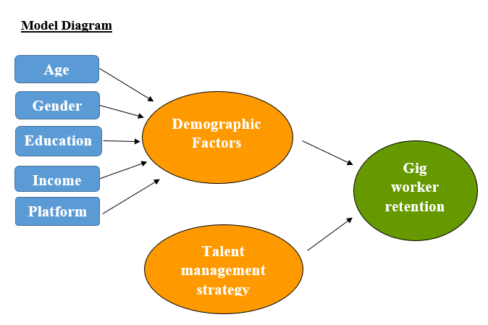

**3.3.3 Statistical Tool**

|  |  |  |
| --- | --- | --- |
| **Sl. No.** | **Objectives** | **Statistical tool** |
| **1.** | To evaluate the relationship between Talent management strategy and retention of Gig workers | Correlation Analysis |
| **2.** | To assess the predicting power of talent management strategy on retention | Regression Analysis |
| **3** | To analyse the influence of demographic factor on retention of Gig workers | Chi Square  ANOVA |

**3.3.4 Hypothesis**

**H1**: There is a significant relationship between Talent management strategy and Gig worker retention

**H1:** Talent management strategy is a significant predictor of retention of Gig workers

**H1:** Age has a significant influence on Retention of Gig workers

**H1:** Gender has a significant influence on Retention of Gig workers

**H1:** Educational level has a significant influence on retention of Gig workers

**4. Test and Interpretation**

**4.1 Correlation**

Test and interpretation

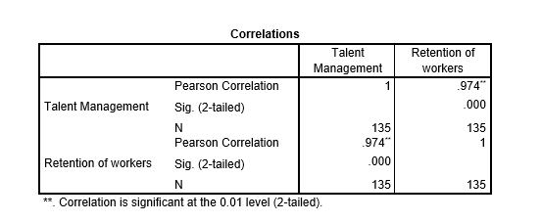

The correlation test was conducted for the variable’s talent management and gig worker retention. The Pearson correlation value was 0.974, showing a very high positive correlation between the two variables. The p value of correlation equals to 0. 000 which is lower than the accepted level of significance level at 0. 05. Pearson correlation of 0.974 and p value of 0. 000 which is less than 0. 05 suggests that Talent management strategies play a very big role in the determination of the rates of retention of gig workers. With this strong evidence we reject the null (H0) hypothesis and accept the alternative (H1), which states, that talent management strategies play a very big role in the determination of the rates of retention of gig workers.

**4.2 Regression**

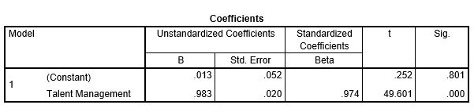

From the above regression table, the standardised coefficient (Beta) of 0. 974 indicates that the talent management and gig worker retention have a very high positive correlation in addition, the p value (sig. lvl) is 0. 000 which is less than 0. 05 which point to the fact that the research findings are highly significant statistically. The t value is high as 49 and the p value being less than 0.05, it shows that talent management strategies have a strong positive effect on the retention of gig workers. The importance of talent management in the context of the retention of gig workers is also supported by a high Beta value which shows that improved talent management procedure will result in higher rates of retention of gig workers. With this significant evidence we can reject the null hypothesis H0, and accept the alternative hypothesis H1

**4.3 Chi Square test**

**(1) For the influence of age on gig worker retention**

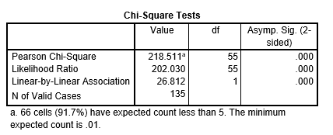

The chi-square test shows relationship between retention of gig worker and their age. The Pearson chi-square value have 218. 511 with 55 degree of freedom the test statistic is highly significant. The p value of 0. 000 which is less than 0. The observed p value was at 0. 000 is additionally endorsed by the likelihood ratio estimated chi-square value of 202. 030 for which calculated p value is 0. 000 which also shows that the probability is high that for gig workers, age has a positive effect on their retention. By so doing, we have sufficient reasons to reject the null (H0) hypothesis and to accept the alternative (H1) hypothesis. Which affirms that retention of gig workers’ highly depended on the age.

**(2) For the influence of gender on gig worker retention**

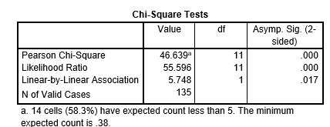

The chi-square test indicates about how gender effects gig worker’s retention rate. The correlation between gig worker retention and gender is statistically significant with the p value 0.000 which is less than 0.05. This result is further supported by Pearson chi-square value of 46.639 with 11 degree of freedom, likelihood ratio of 55.596 and the p value of 0.000 furthermore, significant link between the variable is shown by the p value of linear-by-linear association test of 0.017.all the test p value is less than 0.05 hence we reject the null (H0) hypothesis and accept alternative(H1) hypothesis which states gender significantly affects gig worker retention.

**(3) For the influence of education on gig worker retention**

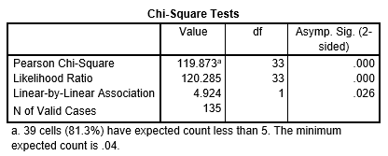

The chi-square test results show that there is an association between gig worker retention and education level. Pearson’s chi-square was equal to (119.873) while likelihood ratio was (120.285), both with 33 degree of freedom and p value 0.000 which shows strong relationship between demographic variable and gig worker retention. Given these results we reject H0 hypothesis and accept H1 hypothesis which asserts that education level has a big impact on gig worker retention.

**5. Findings**

**5.1 Correlation**

**H0**: There is no significant relationship between Talent management strategy and Gig worker retention

**H1**: There is a significant relationship between Talent management strategy and Gig worker retention

**Here the p value is 0.000 which is lesser than 0.05 we reject the null (H0) hypothesis and accept alternative (H1) hypothesis.**

Therefore, there is a significant relationship between Talent management strategy and Gig worker retention

**5.2 Regression**

**H0:** Talent management strategy is not a significant predictor of the retention of gig workers.

**H1** Talent management strategy is a significant predictor of theretention of gig workers.

**Here the p value is 0.000 which is lesser than 0.05 we reject the null (H0) hypothesis and accept alternative (H1) hypothesis**. Therefore, Talent management strategy is a significant predictor of the retention of gig workers.

**Talent Management = 0.974* Gig worker retention + 0.013**

Beta value is 0.974 which means,

**1 unit of change in Talent management leads to 97% change in Retention of Gig workers**

**5.3 Chi-square**

1. Demographic factor: Age

Dependent Variable: Gig worker retention

**H0:** Age does not have a significant influence on Retention of Gig workers

**H1:** Age has a significant influence on Retention of Gig workers

**Here the p value is 0.000, since the p value is less than 0.05, we reject the null (H0) hypothesis and accept alternative (H1) hypothesis.**

Therefore, age has a significant influence on Retention of Gig workers.

1. Demographic factor: Gender

Dependent Variable: Gig worker retention

**H0:** Gender does not have a significant influence on Retention of Gig workers

**H1:** Gender has a significant influence on Retention of Gig workers

**Here the p value is 0.000, since the p value is less than 0.05, we reject the null (H0) hypothesis and accept alternative (H1) hypothesis.**

Therefore, gender has a significant influence on Retention of Gig workers.

1. Demographic factor: Education

Dependent Variable: Gig worker retention

**H0:** Educational level does not have a significant influence on retention of Gig workers

**H1:** Educational level has a significant influence on retention of Gig workers

**Here the p value is 0.000, since the p value is less than 0.05, we reject the null (H0) hypothesis and accept alternative (H1) hypothesis.**

Therefore, education has a significant influence on Retention of Gig workers.

**6. CONCLUSION**

According to the findings of this study, competitive composition, clear communication, consistent feedback, growth opportunities, flexibility in work options and recognition of their contributions are needed for a company to keep its gig employees. Also, it's crucial to build a positive workplace, give workers the right tools and resources, and respond to what each person needs and likes. This increases the worker’s satisfaction and long – term retention. This research shows that how companies manage talent, along with the talent management strategies, workers' age, gender, and education play a big role in gig workers retention.

**BIBLIOGRAPHY**

**Aggarwal, & Chand, S. (2023, July ). ‘Gig’ workers in India: An Overview. Retrieved from https://www.researchgate.net/publication/372518684**

**Alias, N. E., Nor, N. M., & Hassan, R. (2016). The Relationships Between Talent Management Practices, Employee Retention in the Information and Technology (IT) Organizations in Selangor. *Springer Science+Business Media Singapore*, 101-114. doi:10.1007/978-981-287-426-9_9**

**Balathandayutham, & P., D. (24 July 2020). Talent management on retention: An Influential study. *Dogo Rangsang Research Journal, Vol-10*(-07), 213-216.**

**Das, A., & Padhi, D. S. (2021). The Emergence Of Gig Talent Ecosystem In India And Its Implication On Future Of Work, Workforce & Workplace In The Post COVID Business Landscape. *Ilkogretim Online - Elementary Education Online, 20*(6), 4400-4410. doi:10.17051/ilkonline.2021.06.425**

**Debgupta, D. I., & Bhatttacharyya, S. (2024). Talent Acquisition and Retention in the Gig Economy: Exploring Innovative HRM Practices for the Modern Workforce. *Quest Journals Journal of Research in Business and Management, 12*(1), 84-90.**

**Dubey, & Diksha. (2023, August). A Study of Talent Management in Gig Economy. *Journal of Emerging Technologies and Innovative Research (JETIR), 10*(8). Retrieved from www.jetir.org(ISSN-2349-5162)**

**Gandhi, A., Hidayanto, A. N., Sucahyo, Y. G., & Ruldeviyani, Y. (2018). Exploring People's Intention to Become Platform-based Gig Workers: An Empirical Qualitative Study. *International Conference on Information Technology Systems and Innovation (ICITSI)*, 266-271.**

**Garg, D., & Rani, K. (2014, September). Talent Management: Empirical Research Results. *International Journal of Management and Commerce Innovations, 2*(1), 289-295.**

**Gautam, V., Mishra, A., & Maheshwari, M. (2024). Examining the relevance of Human Resource Management in gig work: A systematic literature review & research agenda. *German Journal ofHuman Resource Management*, 1-38. doi:0.1177/23970022241231536**

**Gorde, & Ulhas, D. S. (2019,, June). A STUDY OF EMPLOYEE RETENTION. *Journal of Emerging Technologies and Innovative Research (JETIR), 6*( 6).**

**Kaur, Panday, P., & Gagandeep, D. (2021). Talent Management and Employee Retention Practices: A Systematic Literature Review and Future Agenda. *Journal of Contemporary Issues in Business and Government Vol. 27, No. 3, 2021, 27*. doi: 10.47750/cibg.2021.27.03.348**

**Kshatriya, N., & Kurien, D. (2022, July). Gig workers in India: Emerging Opportunities in the New Economy. *Liberal Studies, 7* (1). Retrieved from https://www.researchgate.net/publication/367090787**

**Kumar, N. A., Sriramb, S., Bagariac, M. D., Thakkerd, H., & Vinoth, V. (2024). Examining the influence of talent management on organizational performance: A comprehensiveoverview. *World Conference on Multidisciplinary Research & Innovation*. doi:10.31893/multirev.2023ss099**

**Lauren, R. M., & Anandan, C. C. (2024, january). Exploring the Challenges and Uncertainties faced by Gig Workers. *Journal of Academia and Industrial Research (JAIR), 12*(2), 24-30.**

**MAHLAHLA, L. T. (2018). THE IMPACT OF TALENT MANAGEMENT ON EMPLOYEE PERFORMANCE AND RETENTION STRATEGIES:A CASE STUDY OF MASVINGO CITY COUNCIL IN ZIMBABWE.**

**Mokshagundam, D. S., & Hattikal, P. N. (2024, February). Motivational Strategies for Gig Workers at Bengaluru Urban. *International Journal of Research Publication and Reviews, 5, no 2*, 1050-1056.**

**Pakiza Samad, R. W. (2022). GIG ECONOMY: PAST, PRESENT AND FUTURE IN INDIA. *Senhri Journal of Multidisciplinary Studies, 7*(1), 36-41. doi: 10.36110/sjms.2022.07.01.005**

**R, K. S. (2023). Talent Management and Employee Retention Strategies for SMEs in India. *International Journal of Research and Analytical Reviews (IJRAR), 10*(1), 28-40.**

**Roy, Radhakrishnan, A., & Singha, N. (2023, June). Gig Economy Workers’ Livelihood: A Qualitative Study of Ride-Hailing Platforms in Bangalore City, India. *Artha Vijnana, LXV No. 2*. Retrieved from https://gipe.ac.in/gig-economy-workers-livelihood-a-qualitative-study-of-ride-hailing-platforms-in-bangalore-city-india/**

**Sudharshini, & Mary, D. F. (2024, 01 27). Optimizing Workforce Stability: Unraveling the Influence of Talent Management Strategies on Employee Retention. *Entrepreneurship and Economic Development; Navigating Management Research and Strategic Challenges, 11*. doi:10.34293**

**Suryavanshi, & Pushpa, D. (2022, November). ECONOMY, INDIA'S BOOMING GIG. *UGC Care Group I Listed Journal), 12*(11 No.01), 143-150.**

**Urme, & Nusrat, U. (2023). The Impact of Talent Management Strategies on Employee Retention. *International Journal of Science and Business, 28*(1). doi:10.58970/IJSB.2209**

**Yadav, & Babita, D. (2020, April ). ROLE OF TALENT MANAGEMENT PRACTICES ON EMPLOYEE RETENTION: A CORRELATION STUDY WITH SPECIAL FOCUS ON SELECTED INDIAN LIFE INSURANCE COMPANIES. *EPRA International Journal ofEconomic and Business Review, 8*(4).**