**A Comparative Analysis and Design of an Elevated Water Tank using Conventional and BIM Techniques**

**1Kapil Kumar, 2Dr. Jyoti Yadav**

1M.Tech Scholar, 2Assistant Professor,Department of Civil Engineering, Sarvepalli Radhakrishnan University, Bhopal, M.P, India

**Abstract-** Elevated water tanks are critical components of every community. It should continue to work after an earthquake or calamity. After an earthquake, maintaining a reliable water supply is crucial for civilization. Despite the importance of water tanks in society, research on their design and analysis remains minimal.This research focuses on the linear design of an elevated water tank. This requires the usage of two softwares. SAP 2000 and auto desk robot structural analysis (ARSAP) are two often utilized softwares. Many studies have been conducted in the past on the damage and failure of elevated water tanks during earthquakes. Elevated water tanks come in several kinds, such as concrete pedestals, framings, and mashrooms. This research uses a water tank with a hydraulic head of 60 and focuses on the 2B seismic zone. Elevated water tanks are designed using three kinds of soil profiles: SE, SD, and SC. This research analyzes and designs a raised water tank using UBC 97, one of many accessible codes in the market. This research uses a systematic approach to assess raised water tanks using SAP 2000 and ARSAP software. Both softwares utilized for raised water tank analysis and design produced somewhat different findings. ARSAP analysis is faster than sap2000 analysis. Structures sitting on superior soil exhibit lower deflection compared to those on soft soil. The use of steel rebars does not significantly affect the bending moment.

**Keywords-**Elevated Water Tanks,ARSAP, SAP 2000, Conventional Techniques,BIM Technique

**1.Introduction**

Elevated water tanks are the most often used kind of water distribution system for cities and towns worldwide. There are many different designs available for elevated RCC water tanks, such as rectangular, cylindrical and conical tanks are the most sought-after of all because the radial force outward by the spherical bunny is counteracted by the inward push of the conical bottom. Although most design rules offer criteria for rectangular and cylindrical tanks, there is minimal advice for elevated water tanks. The elevated water tanks were mostly damaged during the earthquake. Because water tanks carry a heavy load on their upper half, their safety performance is crucial during earthquakes. During an earthquake, they must not fail to deliver drinking water to the community. Due to inefficient design, a water tank was severely destroyed during a previous earthquake. In this study, several design aspects will be investigated, such as the soil type being constant across all models and the seismic zones changing one by one. The structural period, deflection, and moments in various elements of the water tank will be investigated and compared and also investigated these factors for the high-rise skyscraper utilizing robot structures. According to this study, based on a limited literature analysis, no study on the design of water tanks using different software has been conducted, with findings comparing SAP 2000 and Robot structures.

**2. Research Motivation and Problem Statement**

There are numerous software applications utilized in the design sector. Shell structures are typically designed using SAP2000 and STAAD PRO. Designing a shell structure conventionally needs a significant amount of labour, time, and knowledge. These are standard ways for designing raised water towers. Many challenges arise when developing a structure with this software. First and foremost, architectural drawings are created by the architect using AutoCAD software. The use of AutoCAD is time-consuming, and there are numerous design issues. Following that, these designs aremodeled in SAP 2000 software, and the structure is examined and designed using this program. And the operation of these software necessitated a wide range of engineering disciplines, including public health, architecture, and structure. The goal of this study is to develop all parameters under the sunshade of BIM. Therefore, the problem statement is as follows.

**3. Objective and Purpose of the study**

* To eliminate coordination challenges in civil structure design and construction by using a novel technique.
* The specific aim of this MS research work is to compare the analysis and design of elevated water tank by using SAP 2000/ SAFE / Auto cad, Revit and Autodesk robot structural analysis (ARSAP).

1. **Adopted Methodology**

An elevated water tank constructed for the sap 2000 with specific soil and seismic criteria. After designing the water tank, all structural drawings will be created using AutoCAD. The identical tank, with the same specifications (height, water capacity, soil, and seismic factors), will be designed using a new software called ARSAP. Architectural drawings are also created using Revit architecture. After designing the same water tank in a new software, the compression of these two designs was investigated. As previously said, three water tanks are developed on SAP2000 and three water tanks are designed on ARSAP, each with unique qualities.

**4.1.1 Conventional Construction Method**

For generations, this has been the standard method for structure construction. There are many steps involved in this procedure, which begins with the design phase and ends with the structure phase. A crucial component of this approach is the separate but coordinated activity of architects, engineers, contractors, and constructors. These stakeholders use 2D plans, blueprints, and paper-based drawings to coordinate and communicate. Conventional structure relies heavily on human labor and physical designs. To guarantee that the structure is erected appropriately, experts in architecture, engineering, and construction are carried Conventional structure techniques are based on an established procedure that involves using professional abilities and physical blueprints to create a structure.

**4.1.2 BIM-Based Construction Methods**

Building Information Modelling (BIM) services transform the construction business by digitizing the construction process. BIM generates a virtual model of the structure, including extensive information on its physical and functional characteristics. This digital depiction allows for real-time cooperation and smooth information exchange among construction specialists. BIM services enable architects, engineers, and construction workers to collaborate on structure planning, design, and construction via the use of specialist software. The digital models enable exact collaboration and ensure correctness throughout the process. In essence, BIM solutions use cutting-edge technology to improve the construction process, allowing for better cooperation and efficient management of a structure 's lifetime. Building Information modelling solutions outperform conventional structure processes, making them the future of construction. Here's a comparison of the problems of conventional structure techniques and the benefits of BIM-based construction.

**4.1.3 Analysis of Elevated Water Tank**

**A. Descriptions of Parameters**

In Figure, this software the structure is architecturally model by using line command. In this software mostly 2D or 3D models are designed architecturally. By using this software, it takes a lot of time to design an elevated water tank. It also requires expertise as well as special attention for the design.

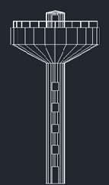 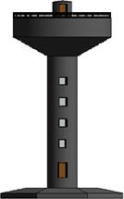

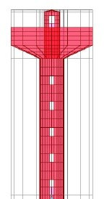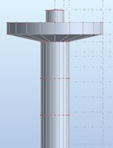

Figure 1: Elevated water tanks in Different software. a. Architectural Model by using Autocad. b. Architectural Model by using Revitd. c. Structural Model by using SAP2000. d. Structural Model by using ARSAP

Table 1: Description of water tank

**Aspect Description**

Tank type Elevated (Mashroom

type)

Capacity 50000 gallons

Minimum hydraulic head 60’

Shaft dia 12’

Shaft thickness 12”

Bowl base slab thickness 36”

Bowl inclined wall thickness 18”

Bowl external wall thickness 12”

Bowl internal wall thickness 12”

Bowl top slab 9”

Canopy shaft 6”

Raft size (octagonal, width for SE soil type) 52

Raft size (octagonal, width for SD soil type) 43’

Raft size (octagonal, width for SC soil type)

34’

**B. Modelling**

In conventional approach first modelling is done by using SAP 2000 software and in new approach modelling is done by using ARSAP for the structural analysis of the elevated water tank.

Table 2: Number of models

|  |  |  |
| --- | --- | --- |
| **Soil profile type** | **SAP/SAFE** | **ARSAP** |
| SE | 1 | 1 |
| SD | 1 | 1 |
| SC | 1 | 1 |

1. **Results and Discussion**

* **Variation in Analysis of Structural Elements**

In this study three soil profile types are used and a constant seismic zone. SC, SD and SE are the three soil profile types which are used in this study. The different parameters of analysis and design are studied in this research. Total six numbers of models are analyzed and designed in this study. Three models are analyzed in ARSAP and three analyzed in SAP2000. The comparison is made for every two models who have same soil profile type and seismic zone. The seismic zone is constant for all models that is 2B. The results of deflection are shown in Figure 2 . The results on soil profile type SC is consider as 100.

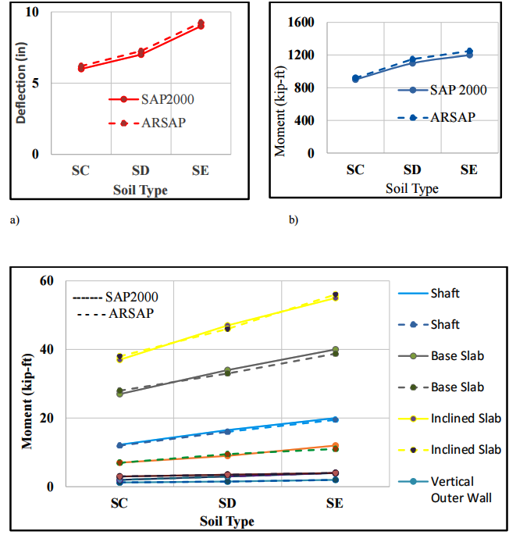

Figure 2: Variation of analysis (absolute values) of Structural elements of Elevated water tank against different soil profile types. a. max deflection b. Sub structure Bending moment c. Super structure Bending moment

The same soil parameters and seismic zones are considered in SAFE analysis. The maximum bending moment is observed 1200 kip-ft in SAFE software, for soil profile type SE and seismic zone is 2B. The maximum bending moment is observed under the shaft on the raft. While the same structure is analyzed in ARSAP software, the maximum bending moment is observed 1250 kip-ft. There is bit difference in results of both software which is observed in this study. As trend shows in Figure 2 (b) the maximum bending moment is observed in soil profile type SE and seismic zone 2B in both software i.e. ARSAP and SAFE. The minimum bending moment that is observed in all these soil profile types is against SC in raft. This trend is similar in both software. There is slight difference in the results of both software which is not much considerable. In Figure 2 (b) the doted lines indicate the results obtained from the ARSAP software and the results of SAFE software are shown with the plane blue line. The trend of the results in both software is straight line.

The comparison of the elements of the super structure of the elevated water tank are shown in Figure 2 (c). All elements are shown for three soil profile types in both software i.e. ARSAP and SAP2000. The results of ARSAP are shown with the dotted line and solid lines are used to indicate the result of SAP2000. In Figure 2 (c), on the vertical axis the maximum bending moment is labeled and on the horizontal axis the soil profile type is labeled. In shaft while it is analyzed with soil profile type SC the maximum value in SAP2000 is 12 kip-ft. The same element is analyzed in ARSAP the maximum value is noted 12.5 kip-ft. When another model is analyzed with the soil profile type SD and seismic zone is 2B, the maximum value of bending moment is observed 16 kip-ft in SAP2000 and 16.5 kip-ft while this structure is analyzed in ARSAP software. When the third model is analyzed laid in 2B seismic zone and SE soil profile type. The maximum bending moment is observed 19.5 kip-ft and 20 kip-ft in SAP2000 and ARSAP software respectively. The trend of the shaft moments in different soil profile regions shows that as structure moves toward SC to SD and then SE the bending moment value increases accordingly. The bending moment of base slab is also shown in Figure 2 (c). Same trend for the results of ARSAP is shows with the doted lines and solid lines is shown results of SAP2000. The maximum bending moment observed in soil profile type SC is 27 kip-ft while structure is analyzed in SAP2000 software. In ARSAP, the maximum bending moment is noted 28 kip-ft. The same element is analyzed when in soil profile type SD, the result of SAP2000 is 37 kip-ft and 38 kip- ft observed in ARSAP software. When base slab is analyzed by considered soil profile type SE and seismic zone 2B the results of SAP2000 shows the maximum bending moment 38.75 kip-ft and in ARSAP the maximum bending moment is noted 40 kip-ft. Inclined slab results are also shown in Figure 2 (c) in soil profile type SC, 37 kip- ft in SAP2000 and 38 kip-ft is noted in ARSAP software. The maximum bending moment while the elevated water tank exists in soil profile type SD is 46 and 47.5 in SAP2000 and ARSAP, respectively. The governing bending moment in inclined slab while structure is existing in SE soil profile type is 55 and 56 in SAP2000 and ARSAP, respectively. The bending moment noted in outer vertical wall of the tank is 12 and 12.25 kip-ft in SAP2000 and ARSAP respectively, while structure is existing on soil profile type SC. While the same structure is designed on soil profile type in SD the maximum bending moment is 16 and 16.5 kip-ft in both software SAP2000 and ARSAP, respectively. Then the structure is designed on soil profile type SE, the bending moment is noted 19.25 and 20 kip-ft in SAP2000 and ARSAP software. The trend shows that as structure moves toward soft soil bending moment increases in outer wall of the water tank as shown in Figure also. The vertical inner wall of the elevated water tank that exists on soil profile type SC is 7 kip-ft in both software i.e. SAP2000 and ARSAP. When structure moves toward SC to SD the 9 kip-ft bending moment is observed in both software. After that the soil profile type moves toward SD to SE the maximum bending moment is observed 11 kip-ft in SAP 2000 and 11.5 Kip-ft in ARSAP. The maximum bending moment on the top slab of the elevated water tank while structure is laid on the soil profile type is 2 kip-ft in both software i.e. ARSAP and SAP2000. While the structure moved from SC to SD bending moment that is observed in both software is 3 kip-ft in top slab of the elevated water tank. When structure is analyzed in soil profile type SE and seismic zone 2B, the maximum bending moment is observed 4 kip-ft in ARSAP and SAP2000. The trend shows that as moving toward lose soil value of moment increases.

The comparison is also made member to member with variation of soil profile type. It is observed that the deflection in the structure that is laying on soil profile type SC is 100% in both software i.e. ARSAP and SAP2000 as shown in figure 2. The maximum deflection in a structure that is laying on soil profile type SD and SE is noted is 116 and 150%, respectively when it was designed in sap software. These values are noted 115 and 146 % while the structures were analyzed on ARSAP software as shown in Figure 3. The bending moment noted 22% and 33% more while structure was analyzed in sap 2000 and soil profile type SD and SE respectively. And while same models are analyzed in ARSAP then these values increase 10% and 26% on SD and SE soil profile type respectively. . In some elements like top slab and dome, the difference in value of bending moment is just 1 to 2 kip-ft. Due to smaller difference in values this linear trend is observed. Otherwise in terms of percentage the difference is up to 100%.

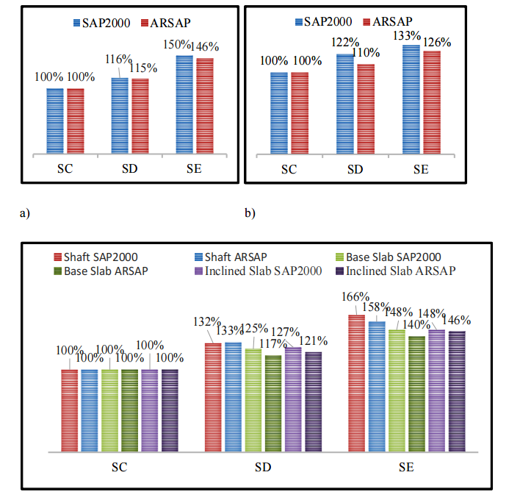

Figure 3: Variation of analysis of structural elements (percentages) a. De- flection b. Bending moment of raft c. Bending moment of super structure

1. **Conclusion and Future Work**

**6.1 Conclusions**

* Comparison of both software shown that the difference in the output is very less and ignoble in term of steel provided in different elements of the elevated water tank.
* In ARSAP less analysis time is required as compared with SAP 2000.
* In ARSAP model can be edited using Excel sheets and those changes can be represented in Robot Model.
* The production of structural drawing that are executable on site is missing from both software.
* A slight difference is observed in both software results while analyzing the elevated water tank.
* Deflection is noted against envelope and found slight difference in maximum deflection.
* Bending moment is observed from contours and marginal difference is found from the both software results.
* It is observed that maximum deflection is noted that structure is resting on soft soil and minimum is observed the water tank that is rest on good soil SC.
* It is noted that the raft that is resting on good soil have less area as well as depth.
* Super structure elements are also shows that the maximum steel is provided in that structure that is resting on soft soil.
* The generation of construction drawings that are compatible with both software platforms is currently lacking.

**6.2 Future Scope of The Study**

This work was the first step to explore the in-depth behavior of elevated water tank by using ARSAP software for the design of elevated water tank.

* Exploration of the BIM tool for efficient generation of structural drawings and steel calculations with a single click.
* Non-linear analysis and design of elevated water tanks using ARSAP.

**References**

1. Chaduvula, U., D. Patel, and N. Gopalakrishnan. 2013. “Fluid-Structure-Soil Interaction Effects on Seismic Behaviour of Elevated Water Tanks.” Procedia Engineering, 51: 84–91. <https://doi.org/10.1016/j.proeng.2013.01.014.>
2. Erdem, T., and E. Gücüyen. 2024. “Fluid Structure Interaction Analyses of Elevated Storage Tank under Seismic Load.” Dokladi Na Bʺlgarskata Akademiâ Na Naukite, 77 (5). <https://doi.org/10.7546/crabs.2024.05.10.>
3. K, M. V., and M. V. T. 2017. “Comparative Study on Dynamic Analysis of Elevated Water Tank Frame Staging and Concrete Shaft Supported.” IOSR Journal of Mechanical and Civil Engineering, 14 (01): 38–46. <https://doi.org/10.9790/1684-1401013846.>
4. Lu, D., Y. Liu, and X. Zeng. 2015. “Experimental and numerical study of dynamic response of elevated water tank of AP1000 PCCWST considering FSI effect.” Annals of Nuclear Energy, 81: 73–83. <https://doi.org/10.1016/j.anucene.2015.03.019.>
5. Madhukar, V. G., and N. M. Madhuri. 2013. “COMPARISON BETWEEN STATIC AND DYNAMIC ANALYSIS OF ELEVATED WATER TANK.”
6. Martínez-Martín, F. J., V. Yepes, F. González-Vidosa, A. Hospitaler, and J. Alcalá. 2022. “Optimization Design of RC Elevated Water Tanks under Seismic Loads.” Applied Sciences, 12 (11): 5635. <https://doi.org/10.3390/app12115635.>
7. Patel, K. N., and J. A. Amin. 2018. “Performance-based assessment of response reduction factor of RC-elevated water tank considering soil flexibility: a case study.” International Journal of Advanced Structural Engineering, 10 (3): 233–247. <https://doi.org/10.1007/s40091-018-0194-0.>
8. Roy, A., A. D. Ghosh, and S. Chatterjee. 2016. “Influence of tuning of passive TLD on the seismic vibration control of elevated water tanks under various tank-full conditions.” Structural Control & Health Monitoring/Structural Control and Health Monitoring, 24 (6): e1924. <https://doi.org/10.1002/stc.1924.>
9. Devadanam, Bojja., M. K. M. Ratnam, and Dr. U. R. Raju. 2015. “Effect of Staging Height on the Seismic Performance of RC Elevated Water Tank.” International Journal of Innovative Research in Science Engineering and Technology/International Journal of Innovative Research in Science, Engineering and Technology, 04 (01): 18568–18575. <https://doi.org/10.15680/ijirset.2015.0401022.>
10. S. Soroushnia, S.T. Tafreshi, F. Omidinasab, N. Beheshtian, and S. Soroushnia, “Seismic performance of RC elevated water tanks with frame staging and exhibition damage pattern,” Procedia Engineering, vol. 14, no. 2 pp. 3076-3087,2011.