Assessment of multi level doping in conventional material for concrete products
¹Vickram Singh Raghuvanshi , ² Prof. Deepak Garg, ³ Dr. Rakesh Patel
Abstract
The main objective of the present study is to find out a suitable, effective and alternative material for partial replacement of cement and coarse aggregate, to find out possible utilization of waste materials in construction industry that in turn considerably minimize the usage of cement and coarse aggregate and ultimately reduce construction cost, to explore possibilities of improving mechanical properties of concrete using pond ash instead of fine aggregate partially, to evaluate the effect of using pond ash in concrete and to investigate the strength of replaced concrete with that of conventional concrete.

Keywords: Concrete mix, Pond ash, Silica Fume, Strength parameter, sustainable construction.

Introduction
The building industry is the biggest user of natural materials and also a large amount of wastes resulted from the demolition of constructions. The construction process is responsible for 40% to 50% of the greenhouse gas generated. The bi-products from industries are slag, rice husk ash, bagasse, fly ash, cement dust, brick dusk, blast furnace slag, sludge, glass, tires, sandpaper, silica fume, etc. The above-listed waste materials represent a major problem for the environment because the dust and fine particles spread in the atmosphere which causes air pollution and leaching toxic chemicals like lead, cobalt, etc. also when they are dumped in landfills, quarries, rivers or oceans they cause a serious damage on the water in which animals and humans can consume it and lead to a health problem.
Appropriate mixing of desired design constituents with cement is required to make good plastering and rendering mortars. For traditional scratch coats, the minimum cement content should be around 300 kg/m3, while for plastering, the cement content should be around 150 kg/m3. To avoid cracking caused by mortar shrinkage in thin plastering, the cement content of all plastering combinations should not exceed 450 kg/m3. In the case of heavy plastering, thermal stress can also produce cracking. The main volume and weight constituents of mortar are aggregates made of natural or artificial sand. The sand is an inert filler that cuts costs, improves workability, and reduces shrinkage while affecting the mortar's compressive strength. Increasing the sand content in masonry mortar increases the time it takes to set, reducing the risk of breaking due to shrinkage of the mortar joint. Rather than requiring sand to satisfy a particular gradation, one of the most practical ways is to proportion the mortar mix to suit the available sand within the allowable aggregate ratio limits. The aggregates compensate about 65% of the plastering mortar's mass. The fine sand particles' maximum diameter (D) should be less than or equal to 4 mm. Sand can be a mixture of random sizes or natural river sand with spherical granules. The granules' maximum and minimum diameters (D/d) are used to classify the sand effectively. Oils, greases, acids, alkalis, salts, organic compounds, and any other things that could affect the mortar should be avoided in the water used in the mix. Water has three purposes: it makes the cement workable, hydrates it, and helps the lime carbonate. Due to the imbalance between mortar and concrete requirements, water content is probably the most misunderstood part of masonry mortar. The amount of water required for mortar differs significantly from that required for concrete when a low water/cement ratio is desired. For maximum workability, mortars should contain as much water as possible. In some situations, the use of admixtures at the job site mixer may be helpful. However, such combination use is not suggested in general.

Objectives of the study
- To design a mix for M 45 grade conventional concrete using IS 10262:2019.
- To evaluate the fresh concrete properties like workability of conventional concrete sample and concrete produced after fine aggregate replacements.
- To study the effect of silica fume and pond ash doping on slump value.
- To evaluate strength parameters like compressive strength and flexural strength of concrete for fine aggregate and cement replacement at various percentages.
- To find out the tolerable percent replacement of fine aggregate and cement so as to give acceptable workability & hardened strength properties.
Methodology
This project is mainly undertaken to study the behavior and performance of concrete using waste materials such as pond ash and silica fume. This type of use of a waste material can solve problems of lack of aggregate in various construction sites and reduce environmental problems related to sand mining and waste disposal. The use of waste aggregates can also reduce the cost of the concrete production and increase the workability.

Results
Results of the various experimental investigations are reported and discussed. Mix design of concrete is given and mix proportioning of different concrete mixes is fixed.
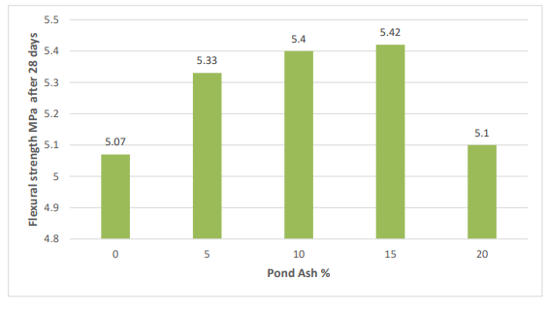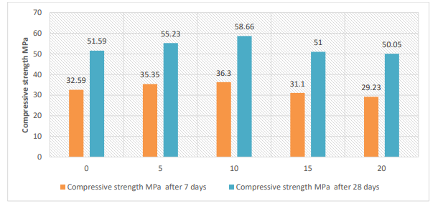
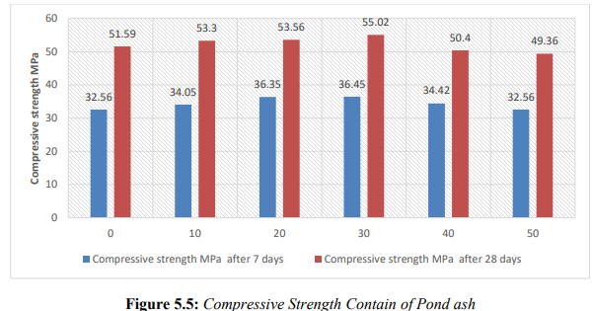
Conclusion
When the replacement of sand is increased up to 50% by Pond ash in concrete mix, there is decrease in the slump value which shows the workability of the concrete is decreased. However it can be gained by using super plasticizer of a dose 0.8% of the weight of cement.
It is observed that the compressive strength of concrete incorporating pond ash was increased up to 30% ash mix as fine aggregate at the end of 7 &28 days. It is observed that the flexural strength for concrete with replacements was increased when the pond ash was added up to level of 30% replacement however the flexural strength of the PA 50 mix designation is lower than the control concrete.
The concrete containing 30% by Pond ash as fine aggregate performed better against sulphuric acid and sulphate attacks. After 7-day immersion in sulphuric acid, the mass loss for Pond ash concrete is lower as compared to the mass loss for control concrete.

Acknowledgements
This work is the result of guidance and support of various people at Oriental institute of science and technology, without whom all my effort would have been directionless and fruitless. I express my heartfelt and profound gratitude to Dr. RAJESH K. SHUKLA Director OIST Bhopal for his valuable suggestions at all stages of my research work.

References
G. Sudheer Kumar, T S D Aishwarya, E.Anusha. Studies On Strength Charactristics Of Pond Ash Replaced By Fine Aggregate In Pavement Quality Concrete. VFSTR Journal of STEM Vol. 03, No. 01 (2022) 2455-2062.
A Srikanth , K Adithya Nandini , Y Anand Babu. Performance of Fine Aggregate Replaced Pond Ash on strength of Concrete. Industry 4.0 Technologies in Civil and Mechanical Engineering (ICI4TCME 2023)
Bharadwaj Nanda & Sudipta Rout. Properties of concrete containing fly ash and bottom ash mixture as fine aggregate. International journal of sustainable engineering 2023, VOL. 14, NO. 4, 809–819.
K. Arumugam, M.Ramya Devi. A Study on Strength Properties of High Performance Concrete with Partial Replacement of Cement with Silica Fume and Fine Aggregate with Pond Ash in Concrete. International Journal of ChemTech Research CODEN (USA): IJCRGG, ISSN: 0974-4290, ISSN(Online):2455-9555 Vol.10 No.8, pp 307-313, 2022..
Prasenjit Ghosh and Sudha Goel. Physical and Chemical Characterization of Pond Ash. International Journal of Environmental Research and Development. ISSN 2249-3131 Volume 4, Number 2 (2014), pp. 129-134.
Sreelakshmi R, Reshmi P R. Durability Performance of Concrete Replaced with Pond ash as Fine Aggregate. International Conference on Emerging Trends in Engineering & Management (ICETEM-2022).
K. Lini Dev1 & R. G. Robinson. Pond Ash Based Controlled Low Strength Flowable Fills for Geotechnical Engineering Application. Int. J. of Geosynth. and Ground Eng. (2021) 1:32.
Rath Badrinarayan & Deo Shirish and Ramtekkar Gangadhar. A Study on Early Age Shrinkage Behaviour of Cement Paste with Binary and Ternary Combination of Fly Ash and Pond Ash. Indian Journal of Science and Technology, Vol 9(44), November 2016.
S M Waysal , P D Dhake1 and M P Kadam. Effect on concrete properties by replacement of sand as thermal power plant pond ash. JInt. J. Struct. & Civil Engg. Res. 2013.
Devi Prasad mishra1 and Samir kumar das. Comprehensive Characterization of Pond Ash and Pond Ash Slurries. Particulate Science and Technology, 32: 456–465 Copyright # 2014 Taylor & Francis Group, LLC.

