**A Review Paper on New Method of Friction Stir Welding of Aluminium Alloys**

Sumer Singh

College Of Technology and Engineering, Udaipur

sumerrock1993@gmail.com

Abstract-The objective of this work was to demonstrate the feasibility of new technique of friction stir welding (FSW) for joining of aluminium sheet. Defect-free welds were produced on 1.6 mm plates of 160 mm/min welding speed and 450 rpm using die steel tools. Microstructures of the welds were examined using optical microscopy. The weld region displayed several micro-structurally distinct regions. Microhardness was taken in transverse direction of weld and from top to bottom in weld centre. Transverse tensile properties of the welds were evaluated at room temperature. Welded samples failed outside of weld. The results have demonstrated the feasibility of new method of FSW for welding of Aluminium.

Keywords- fsw, weld region, optical microscopy

1. Introduction

Friction stir welding (FSW) is a relatively new joining process that is presently attracting considerable interest [1]. The FSW process was developed at TWI in 1991. Figure 1 shows a schematic of the FSW process for joining of two plates in a square groove configuration [2]. The process is solid-state in nature and relies on localized forging of the weld region to produce the joint. The plates comprising the Work piece are held in compression and are rigidly fixtured to the machine bed during welding. Friction stir welding uses a non consumable, rotating tool that is cylindrical in shape with a cylindrical pin of smaller diameter extending from the tool shoulder. Important process parameters include the tool rpm and travel speed, as well as the tool dimensions and the downward force on the tool. Initially, the rotating tool is plunged into the joint until the shoulder contacts the top surface of the work piece. Heating is caused by rubbing of the tool An easy way to comply with the conference paper faces against the work piece [3] and by visco-plastic dissipation of mechanical energy [4] at high strain rates [5] developed through interactions with the tool. During welding, the material along the joint is heated to a softened condition, transferred around the periphery of the tool, and subsequently recoalesced along the back surface of the pin to produce the weld. Friction stir welding of Al alloys is relatively well established. To date, friction stir welds have been successfully produced on many of the important commercial Al alloys including the 1xxx , 2xxx , 5xxx, 6xxx, and 7xxx families of alloys, as well as Al-Cu-Li alloys [6].

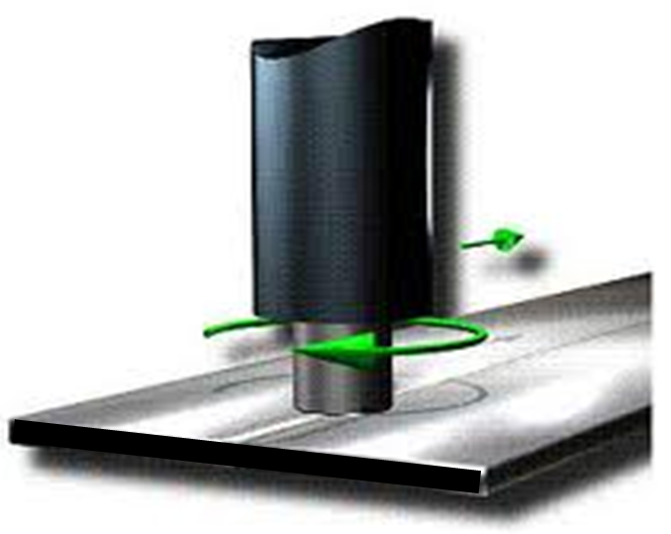

**Fig. 1** Schematic Diagram of new Friction Stir Welding process

Friction stir welds on Al alloys display several microstructurally distinct regions including the stir zone or nugget (along the weld centerline), thermomechanically affected zone (TMAZ) (surrounding the stir zone), and a true heat-affected zone (HAZ) [7]. Microstructural evolution in the different regions of the weld zone is closely linked with the local thermomechanical cycle experienced during joining. Important parameters of the thermomechanical cycle that control microstructural evolution are the total strain, the strain rate, and the temperature [8-9].

In this technique, each different section of the blank is stamped separately and then spot welded together in the shape of the final part. This method has numerous advantage such as the ability to select the specific properties, i.e. the strength, thickness, corrosion resistance etc of each area of the blanks. This method also gives a higher yield ratio of material used. However, this method has some disadvantage. The major problem is the large number of different forming operations that is required for the disintegration method, which translate to high tooling costs. Also assembly costs would increase (more joining required) and there is possibility of fittability problem between the different stamping. The other possible method is the integration method. In the integration method, the part is stamped out of a single blank. This reduces the number of tools needed; the assemblies cost and eliminate the fittability problem. However, the design engineer is forced to work same grade, thickness, strength and corrosion resistance throughout the entire part; this would increase the cost and weight of the part significantly.

A solution to the problems listed above is the utilization of the tailor welded blanks. A tailor welded blank is the blank that is comprised of two separate pieces of sheet metal that has been welded together previous to stamping. Tailor welded blank allow the welding of different grades, different thickness, different strength and different corrosion coating together in order give the properties needed in different areas, without increasing the number of tools needed to form the part and eliminating the fittability concerns. They also allow a high degree of flexibility in designing parts and large blanks can be formed much smaller sheet.

With the changing attitude of society towards the environment, the use of laser welded blanks could be very beneficial to the automotive industries. This includes reducing scrap from manufacturing and making their product more energy efficient. Along with the reduction of scrap, the automotive industry is subjected to more and more stringent government regulation for fuel effiency. There is currently a large interest in developing lightweight alloys that can be used in an automobile to replace heaver steel parts, resulting in weight reductions of the vehicle without sacrificing strength. Metallic material such as aluminium and magnesium, high-strength steels, carbon-carbon composites as well as a number of novel metallic composites is all under investigation in terms of viability and practicality for use in high production in automobile.

A unique combination of properties puts aluminium and its alloys amongst our most versatile engineering and construction materials. All alloys are light in weight, yet some have strengths greater than that of structural steel. For automotive applications aluminium alloy sheets have the advantages of corrosion resistance, high strength to weight ratio, and recyclability.

Laser, electron beam, tungsten inert gas, metal inert gas and friction stir welding processes have been used for creating tailor welded blanks. However, due to the small heat effected zone (HAZ) and fusion zone, the laser and electron beam welding process produce less impact on material properties than others. Laser welding has been the most frequently used process for producing TWBs due to the lower cost and greater flexibility compared to those of electron beam welding. However, there are several difficulties to develop TWB particularly for aluminum and magnesium alloys because of their high reflectivity, low molten viscosity and inherent oxide layer, conventional laser welding leads to hot cracking in the fusion zone and the poor coupling during welding process. Therefore, as a newly emerging welding technology for TWB, friction stir welding (FSW) was developed primarily for aluminum alloys. Friction stir welding was invented by Wayne Thomas at TWI (The Welding Institute), and the first patent applications were filed in the UK in December 1991. Initially, the process was regarded as a “laboratory” curiosity, but it soon became clear that FSW offers numerous benefits in the fabrication of Aluminum products.

**Tailor Welded Blanks and their Applications:**

In order to reduce energy consumption, the automotive industry keeps a strong interest the development of lightweight component by using the concept of tailor welded blanks. A Tailor welded blank is a blank that is composed of two or more different sheet materials. Typically, two different thicknesses or alloys are butt welded together to form a multi-gauge and/or multi-alloy blank prior to the stamping operations. Currently TWBs are used for manufacturing auto body parts such as front door inner, floor pan, a pillar, centre pillar, body sides frames etc.

**2.2 Benefits of TWBs:**

* Weight reduction due to the combining of parts into a single component.
* Because each welded piece can have a different thickness, grade of sheet metal or coating, these blanks posses the needed characteristics in the desired locations of the formed part.
* Manufacturing cost is reduced because scrap is very less.
* More dimensional stable since it is a single stamping, eliminating the stacking of tolerances

**2.3 Limiting Dom Height Test (LDH):**

Fundamental mechanical properties like hardness, yield strength, ultimate tensile strength and total elongation were initially used as a rough indication of formability of sheet metals. Formability does not always correlate well with ductility, particularly when cracking initiates at free surfaces. For these reasons other formability tests are used. In order to evaluate the formability performance of automotive friction stir welded TWB sheets, experiments were performed for the limit dome height (LDH) using the hemispherical dome stretching test.

**2.4 Biaxial Stretch Forming**

The biaxial forming tests were done by using a hemispherical punch of 50 mm diameter on a double action 100 ton hydraulic press as shown in fig 3.9.

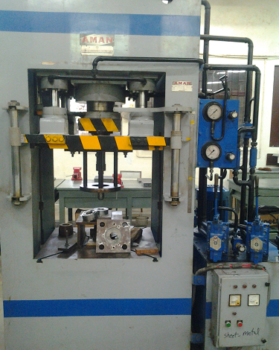

Upper and Lower Die

Leaver

Punch

Pressure gauge

Blank Holder

**Fig 2.1** Experimental setup on 100 tonne hydraulic press for stretch forming tests

The schematic diagram of the tool arrangement (punch, lower die and upper die) is shown in fig. 3.9. For LDH tests square specimen of 1100 Al Alloy of size 100 mm X 100 mm as shown in fig. 3.11 (a) were cut from the FSW welded specimen. A circular drawbead as shown in fig 3.10 and fig 3.12 was provided on the dies with 80mm diameter to restrict the flow of metal from the flange region into the die to ensure complete clamping of the blank at the drawbead. Since the specimen thickness is greater than the drawbead diameter, so this is the case of biaxial stretching. All the tests were conducted in dry condition at punch speed of 20 mm/min. An optimum blank holding fore in the range of 5 to 6 tons was applied on the upper die. The experiments were stopped when a visible neck of initiation of fracture was observed on the specimen as shown in fig 3.9 (b). The dome height of the specimen was measured by a height gauge of least count of 0.02 mm.

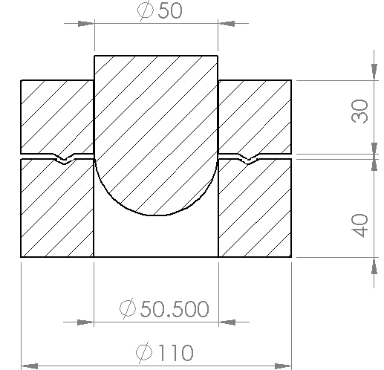

Hemispherical

Punch

Drawbead

**Fig 2.2** Schematic diagram of the tools used in stretch forming experiments

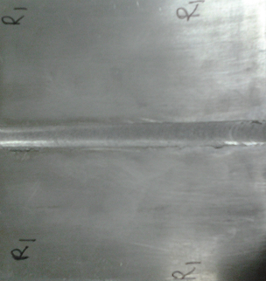 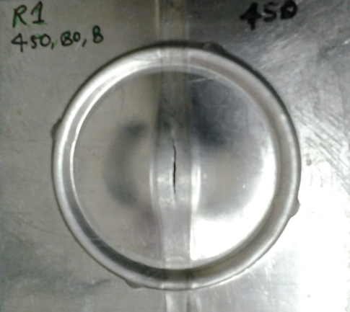

1. (b)

**Fig 2.3** (a) LDH tests specimen before testing (b) LDH tests specimen after testing (Splitting of the weld line observed during stretch forming)

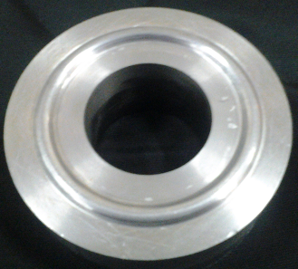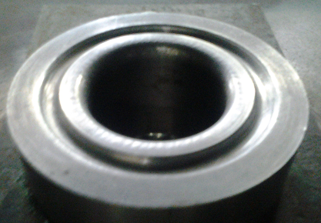

**Fig 3.12** Upper die and lower die for stretch forming

**2.4. Forming limit diagram:**

A forming limit diagram (FLD) is a plot of major *v/s* minor strain in the plane of the sheet, for different strain ratios. At each minor strain there is a limiting major strain that can be achieved before failure [11]. The locus of points for different ratios of limiting major strain/minor strain is the forming limit diagram (FLD), and represents a boundary below which “safe” ratios of major-to-minor strain exist. For FLD tests square specimen of 1100 Al Alloy of size 100 mm X 100 mm as shown in fig. 3.13 (a) were cut from the FSW welded specimen. In order to measure surface strains, grid circles were engraved by laser on the specimen, with diameters 5.0 mm as shown in fig 3.13. The circles used for plotting the FLD. The base metal sheets were used to obtain baseline FLD data for each set of parameters.

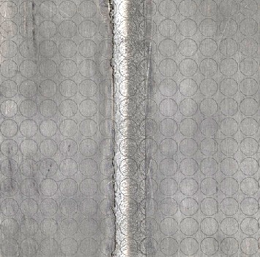 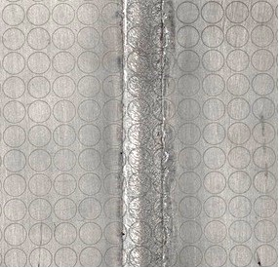 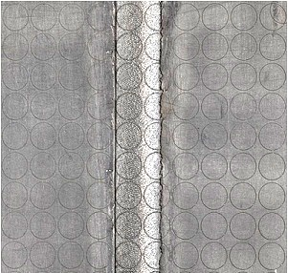

R1 (450-80-8) R4(560-160-8)

R7 (710-250-8)

**Fig 2.5** FLD tests specimen (size 100mm X 100mm)

**3.4.5 Measurement of LDH, Strain Distribution and Weld Line Movement**

The limiting dome height of the entire deformed specimen in stretch forming was measured by a vernier height gauge of least count of 0.02 mm. The major and minor diameters of deformed ellipse were measured by a travelling microscope with least count of 0.001 mm to obtain major and minor strains. The variations of major and minor strains along and across the weld in all combinations were measured to plot the strain distribution profiles. The weld line movement was measured by finding out the coordinates of about 11 points on the weld line of the deformed specimen.

**2. Experimental Procedures**

Friction stir welds were produced on plates of aluminium alloy (1.6 mm thickness) with the welding direction parallel to the rolling direction of the plates. Welds were made in the square groove butt-joint configuration on samples typically 150 mm in length and 50 mm in width. The shoulder diameter of the tool was 20 mm without pin. Friction stir welds were produced at

travel speeds of 160 mm/min, and the tools were rotated at 450 rpm during welding. Metallographic samples were produced using standard procedures and etched with keller's reagent. Etched samples were examined using optical microscopy with differential interference contrast (DIC). Vickers microhardness test (0.5 mm increments) were produced across the weld regions using a 100 gms load and a 10s dwell time. Mechanical properties of welds were evaluated by transverse tensile testing of specimens at room temperature according to ASTM E8-M standard [10].

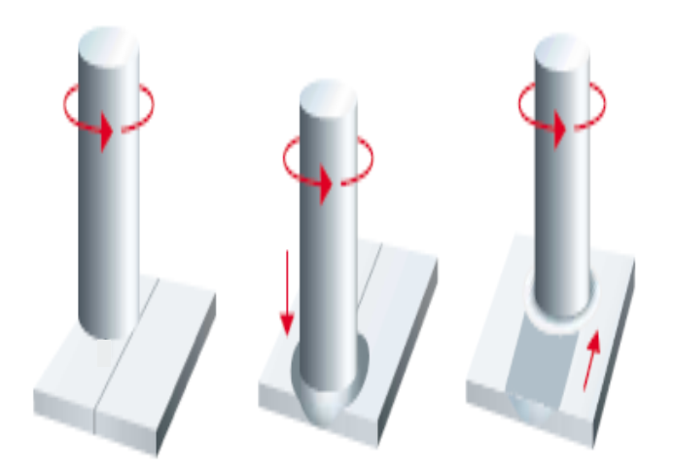

**Fig. 2.6** Steps of New Friction Stir Welding process

**3. Results**

**3.1. Microstructural Characterization**

It seems to be not very clear the material mixing pattern in new FSW technique. The weld area displayed microstructurally distinct regions including stir zone at top of weld, but flow lines and other indications of deformation that persist to room temperature in friction stir welds on Al alloys, such as those found in the TMAZ are not found in these welds apparently due to the allotropic transformations experienced during

cooling. Material in the centre of the stir zone is essentially hot worked during welding due to interactions with the tool.

Evidence of considerable microstructural refinement of the top surface can be seen relative to the centre of the stir zone. The gradient in microstructural refinement seen here is consistent with the development of a strain gradient as a function of distance from the tool shoulder. Work piece material closest to the tool shoulder experiences greater amounts of strain relative to material away from the shoulder, resulting in refinement. As with arc welds, the microstructures of the different sub regions in the HAZ of friction stir welds develop in accord with the local thermal cycle experienced during welding.

**3.2. Mechanical Properties**

A plot of the microhardness data as a function of position from the weld centreline is resented in Fig. 4. Hardness for other region is almost same and no distinguishes hardness was found in HAZ or TMAZ. Zigzag variation in hardness was found in weld nugget which is because of unidirectional flow of material.

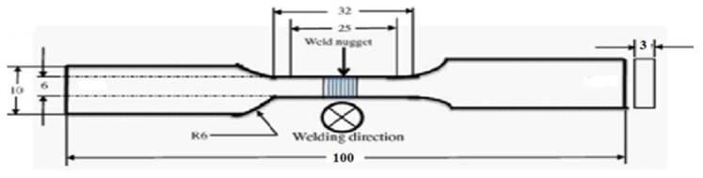

**Fig. 3** Tensile Testing sample

Tensile test were carried out to cheque the mechanical strength of the joint. Engineering stress-strain diagram shown in Fig. 5.

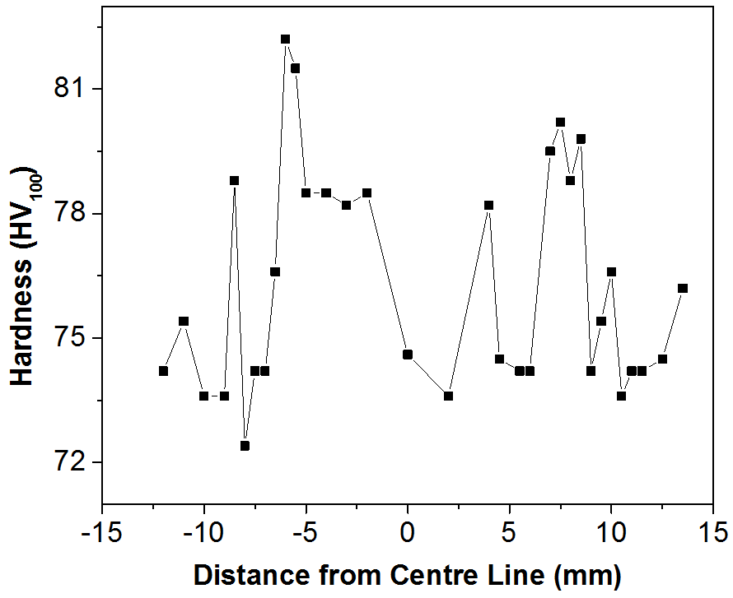

**Fig. 4** Hardness Distribution Across the weld

Welded samples failed in regions outside the nugget region and demonstrated yield and ultimate tensile strengths comparable to those of the base metal.

**4. Conclusion**

1) Defect-free welds were produced on 1.6 mm thick aluminium sheets.

2) The weld region displayed microstructurally distinct regions like stir zone (at the top along the weld centre line) but no other region like TMAZ and HAZ were found in the weld.

3) Welded samples failed in regions corresponding to the end of shoulder mark in base metal and demonstrated yield and ultimate tensile strengths comparable to those of the base metal.

4) Results of this study have demonstrated the feasibility of new FSW technique for joining of aluminium alloys without loss of tensile properties. Based on these results, this new technique can be used for other materials too.

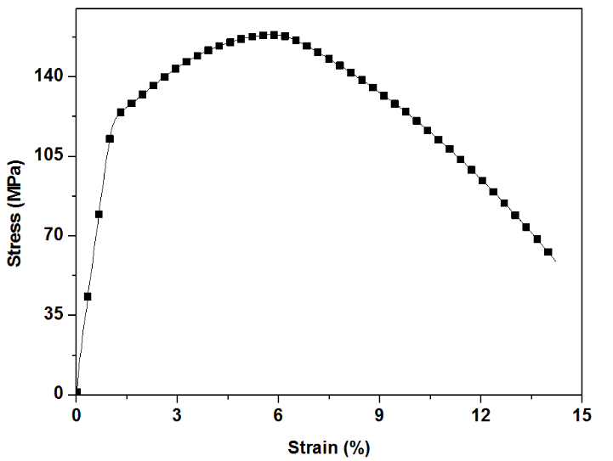

**Fig. 4** Engineering Stress-Strain Diagram of Weld.

References

1. Thomas, W. M., et al. 1991. International Patent Application No. PCT/GB92/02203 and GB Application No. 9125978.8.
2. Gould, J. E. , Feng, Z., and Ditzel, P. 1996. Preliminary modeling of the friction stir weld- ing process. Proceedings of ICAWT, pp.297–310. EWI, Columbus, Ohio.
3. Kong, H. S., and Ashby, M. F. 1991. Friction heating maps and their applications. MRS Bulletin 16(10): 41–48.
4. Feng, Z., Gould, J. E., and Lienert, T. J. 1998. A heat flow model for friction stir welding of aluminum alloys. Proceedings of Hot Deformation of Aluminum Alloys. pp. 149–158. TMS.
5. Gao, Y., and Wagoner, R. H. 1987. A simplified model for heat generation during the uniaxial tensile test. Metallurgical Transactions 18A: 1001–1009.
6. Braga, H. C., and Barbosa, R. A. 1992. Simulation of the increase in temperature due to adiabatic heating in hot deformation processes. Proceedings of 47th Brazilian Association of Metallurgy and Materials (ABM) Annual Conference pp. 441–457. ABM.