**Graphene Oxide Based on Coconut Shell and Sawdust Waste: Synthesis by Modified Hummers Methods and Characterization**

**1S. Sahabi, 2A. Saidu, 2A.L Mustapha, 3D.S Garba and 4R. Aati**

**1,2,34Department of Sciences, Kebbi State Polytechnic Dakingari Nigeria**

**Corresponding Author: suleimansahabiyauri@gmail.com**

**ABSTRACT**

This study explores the synthesis of graphene oxide (GO) using coconut shell and sawdust waste as precursors, employing a modified Hummers method. The research focuses on the effective conversion of these agricultural byproducts into GO, highlighting the potential for sustainable material development. The synthesis process was optimized to enhance the yield and quality of the GO produced. Preliminary results indicate successful oxidation of the carbon-rich precursors, evidenced by the formation of a distinct GO structure. The study sets the stage for subsequent characterization analyses, which will include techniques such as X-ray diffraction (XRD), Fourier-transform infrared spectroscopy (FTIR), and Raman spectroscopy to confirm the structural and functional properties of the synthesized GO. Preliminary results indicate successful transformation, with distinct morphological and structural characteristics observed in the graphene derivatives from both sawdust and coconut shell waste. This research underscores the viability of utilizing coconut shell and sawdust waste for producing GO, contributing to waste valorization and the development of eco-friendly materials. Future work will focus on comprehensive characterization to fully elucidate the properties of the synthesized GO and its potential applications in various fields, including electronics, energy storage, and environmental remediation.

***Keywords:*** Coconut Shell Waste, Sawdust Waste, Chemical Activation, Graphene Oxide, Waste Management, Modified Hummers Method

**1. Introduction**

Graphene oxide (GO) has garnered significant attention in recent years due to its unique properties and potential applications in various fields, including electronics, energy storage, and environmental remediation (Grace and Malar, 2020). Traditionally, GO is synthesized using graphite as the primary raw material through methods such as the Hummers method. However, the increasing demand for sustainable and environmentally friendly materials has led researchers to explore alternative sources for GO synthesis. Graphene has two dimensional (2D) carbon allotrope with hexagonal lattice is held together by σ bonds (Al-Gaashani *et al.,* 2019; Shin *et al.,* 2017; Hass *et al.,* 2008).

In this study, we investigate the synthesis of GO using coconut shell and sawdust waste as raw materials. Omar *et al.* (2022), reported that, the rapid used of coconut for consumption and other purposes has increases the amount of agricultural waste daily. These agricultural wastes are abundant, renewable, and often underutilized, making them ideal candidates for sustainable material production (Grace and Malar, 2020; Somanathan *et al.,* 2015). Nigeria generates approximately 1.8 million tonnes of sawdust and 5.2 million tonnes of wood waste annually as reported by (Oyedepo *et al.,* 2019; Tilak *et al.,* 2017; Ogunwusi, 2014). Managing and utilizing waste pose substantial global challenges. Researchers worldwide are currently focusing on converting waste into value-added products, with a particular focus on carbon-based nanomaterials (Asif and Saha, 2023).

By employing a modified Hummers method, we aim to develop an efficient and eco-friendly process for converting these waste materials into high-quality GO.

The novelty of this research lies in the utilization of coconut shell and sawdust waste, which not only addresses the issue of waste management but also provides a cost-effective and sustainable approach to GO synthesis. This study will detail the preparation of raw materials, the modified synthesis procedure, and the potential applications of the synthesized GO. Through this work, we hope to contribute to the advancement of green chemistry and the development of sustainable materials for future technologies.

Carbon residues and biomass are increasingly proposed as promising precursors for graphene material synthesis. This was as a result to their high carbon content, environmental-friendly nature, lower processing temperatures, widespread availability and cost-effectiveness (Yap *et al.,* 2023). Numerous studies have explored the utilization of different carbon precursors and biomass sources, viz. sugarcane bagasse (Somanathan *et al.,* 2015), tea (Amir Faiz *et al.,* 2020), oil palm leaves (Fathy *et al.,* 2019), pine leaves (Singhal *et al.,* 2022), rice straw (Goswami *et al.,* 2017) and industrial scraps such as tyres (Anuar *et al.,* 2023), bio-soot (Kumar Sahoo *et al.,* 2020), Zn-C batteries (Hassanin *et al.,* 2022) for synthesizing GO

The primary aim of this research is to develop a sustainable and efficient method for synthesizing GO using coconut shell and sawdust waste through a modified Hummers method this method is was employed by (Zaaba *et al.,* 2017; Sim *et al.,* 2014; Akhavan and Ghaderi 2009). This approach seeks to address both the need for high-quality GO and the challenge of managing agricultural waste (Zhu *et al.,* 2022; Romero *et al.,* 2018; Marcano *et al.,* 2010). This research work is set with the following objectives by investigating the feasibility of using coconut shell and sawdust waste as raw materials for the synthesis of GO, adapting and optimizing the traditional Hummers method to effectively convert coconut shell and sawdust into GO and by discussing the potential applications of the synthesized GO in various fields such as renewable energy, material science, and environmental remediation.

**2. Materials and Methods**

Materials: Coconut Shell and Sawdust, Potassium Hydroxide (KOH), Hydrochloric Acid (HCl), Sulfuric Acid (H2S04), Potassium Permanganate (KMnO4), Beakers, Conical flasks Measuring cylinders, Glass stir rods, furnace, magnetic stirrer, oven, Buchner funnel, filter paper, Analytical balance, mortar and pestle sieves and safety equipment.

**2.1 Preparation of Raw Materials**

Pre-treatment: Clean and dry the coconut shell and sawdust. Grind them into fine powder.

Chemical Activation: Mix the powdered coconut shell and sawdust with KOH in a 1:1 ratio. Heat the mixture from 200oC to 700°C for 1 hour in a furnace to activate the carbon, to enhance porosity and surface area, treat the biochar with activating agent. After activation, the activated carbon was washed thoroughly with distilled water to remove any residual activating agent. The solution was neutralized using the dilute hydrochloric acid (HCl) before washing.

**2.2 Reduction to GO**

Oxidation Process: To convert activated carbon into GO, mix it with concentrated sulfuric acid (H₂SO₄) and 2M of potassium permanganate (KMnO₄) in a ratio of 1:4 (KMnO4:H2SO4). While stirring continuously to maintain the temperature below 50°C to control the reaction. Gradually increase the temperature to 35°C and stir for 2 hours to ensure complete oxidation. This step introduces oxygen-containing functional groups. By diluting the oxidized mixture with distilled water and then add hydrogen peroxide (3-6% (w/w) or 0.88-1.76 M). This will yield GO flakes.

Reduce graphene oxide using reducing agents like hydrazine hydrate or sodium borohydride (typical concentration: 1-5% (w/w) or 0.1-1.0 M) at reaction conditions of 80-100°C for 24 hours. This step converts GO into reduced graphene oxide (rGO).

**3 Results and Discussion**

**3.1 Synthesis of Graphene Derivatives from Sawdust Waste**

The successful transformation of sawdust waste into graphene derivatives demonstrates the feasibility of converting agricultural waste into high-value materials as shows in figure 1. The coconut shell naturally contained hydrocarbon compound recorded at 74.3% as reported by (Bledzki *et al.,* 2010). This process not only adds value to waste materials but also contributes to sustainable waste management practices. Initially, the sawdust waste appears as a fibrous, granular material. This raw form is indicative of its natural, unprocessed state.

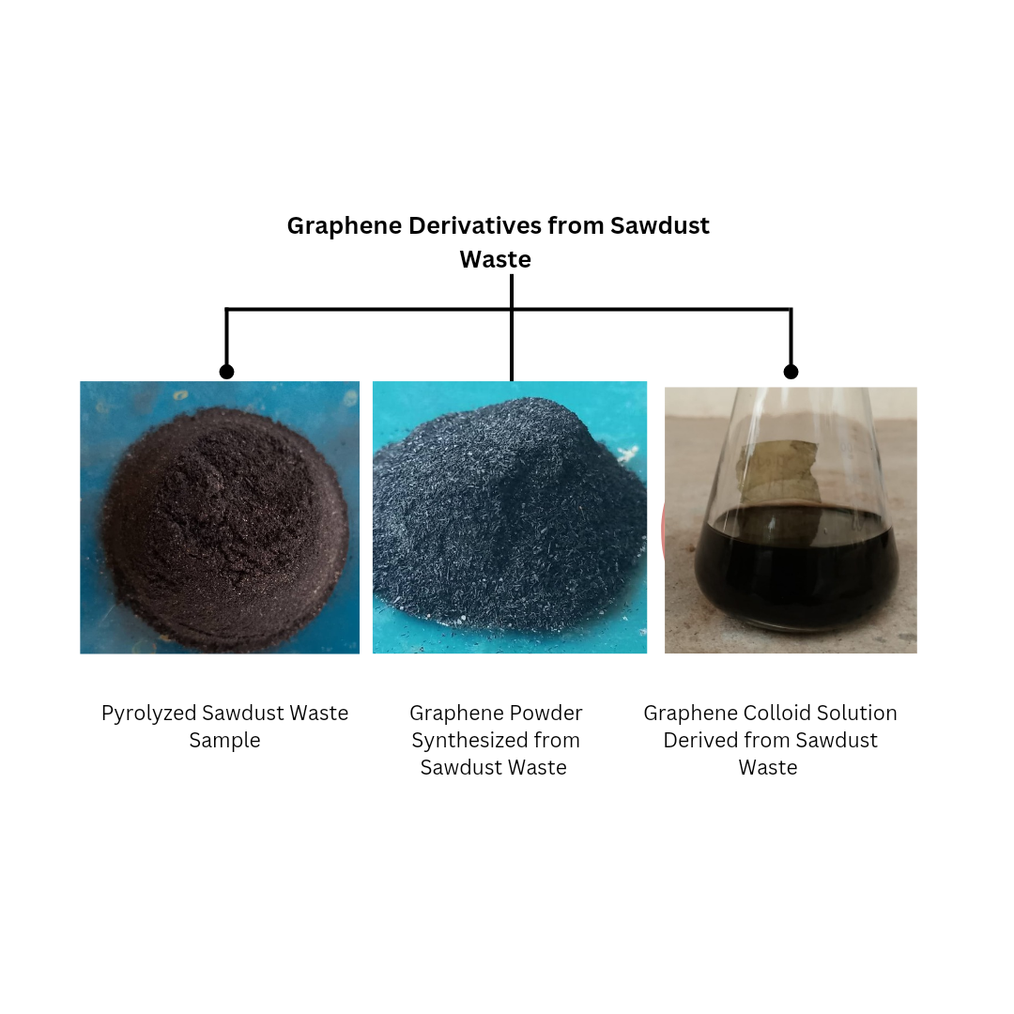

**Figure 1:** Graphene Derivatives from Sawdust waste

The conversion of sawdust into graphene powder results in a finer, more uniform material. This transformation highlights the effectiveness of the pyrolysis and activation processes in breaking down the fibrous structure and enhancing the material's properties.

The final product, a graphene colloid solution, showcases the successful dispersion of graphene particles in a liquid medium. This step is crucial for applications requiring graphene in a dispersed form, such as in coatings, inks, and composites. Comprehensive morphological examination is recommended for a deeper understanding of the GO characteristics.

**3.2 Synthesis of Graphene Derivatives from Coconut Shell Waste**

Figure 2 illustrates the successful conversion of coconut shell waste into graphene derivatives, highlighting the potential for transforming agricultural waste into high-value materials. This process not only addresses the issue of waste accumulation but also promotes sustainable waste management practices.

In its raw state, the coconut shell is a hard, brown, and textured material, reflecting its natural and unprocessed condition. The transformation into graphene powder results in a fine, black powder, demonstrating the efficiency of the pyrolysis and activation processes in breaking down the dense structure and improving the materials properties.

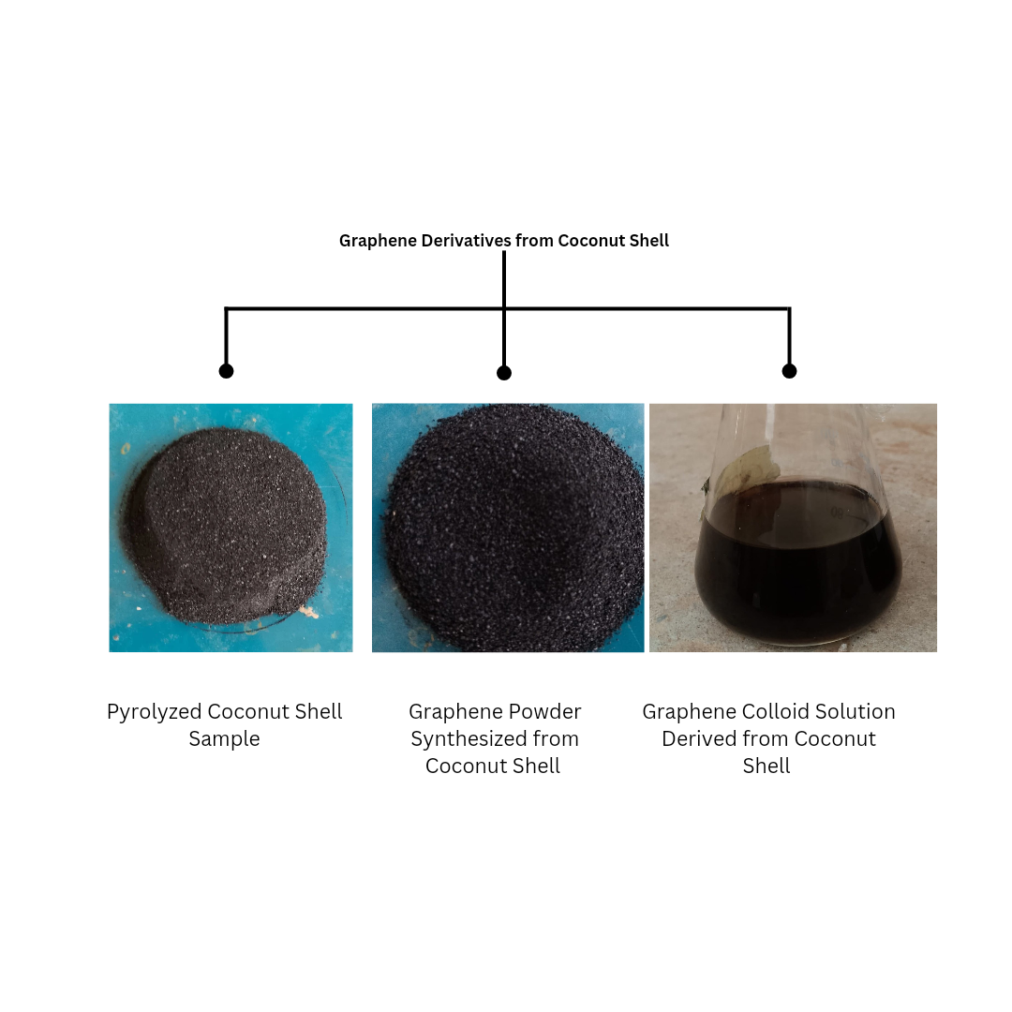

**Figure 2:** Graphene Derivatives from Coconut Shell

The final product, a graphene colloid solution, exemplifies the effective dispersion of graphene particles within a liquid medium. This step is essential for applications that require graphene in a dispersed format, such as coatings, inks, and composites.

**4. Potential Applications GO from Samples:**

The GO derivatives produced from sawdust waste and coconut shell possessed wide range of potential applications. Due to their high surface area and porosity of the GO powder which make them suitable for use in energy storage devices, such as supercapacitors and batteries with many more applications as reported by (Stanford *et al.,* 2020; Wang *et al.,* 2020; Jiang *et al.,* 2020; Yang *et al.,* 2019; Safarpour and Khatace, 2019; Karim *et al.,* 2017; Zheng *et al.,* 2014; Bonaccorso *et al.,* 2010). The colloid solution form of graphene can be utilized in various applications, including conductive inks, coatings, and composite materials.

**5. Environmental Impact**

This research underscores the environmental benefits of converting waste materials into valuable products. By utilizing coconut shell and sawdust waste, which is often discarded or burned, the process reduces waste and minimizes environmental pollution these are in confirmative with the work reported by (Sujiono *et al.,* 2020; Wachid *et al.,* 2014). Additionally, the production of graphene from renewable sources aligns with the principles of green chemistry and sustainability.

**6. Challenges and Future Work**:

The initial results obtained are paramount. However, future work could focus on scaling up the production process, exploring other types of agricultural waste as feedstock, and conducting detailed characterization studies to fully understand the properties and performance of the synthesized GO.

**7. Conclusion**

This research demonstrates the successful synthesis of GO from coconut shell and sawdust waste using a modified Hummers method. The study highlights the potential of utilizing agricultural byproducts as precursors for the production of advanced materials, contributing to sustainable development and waste valorization.

The preliminary results indicate that the modified Hummers method effectively converts the carbon-rich coconut shell and sawdust into GO. The synthesis process was optimized to enhance the yield and quality of the GO produced. However, further characterization is necessary to fully elucidate the structural, functional, and physicochemical properties of the synthesized GO.

***Sustainable Waste Management***

The process of converting sawdust and coconut shell waste into graphene derivatives provides an environmentally friendly solution for waste management. By utilizing these abundant and renewable resources, the research contributes to reducing waste and minimizing environmental pollution.

***Effective Transformation***

The successful synthesis of graphene powder and colloid solutions from both sawdust and coconut shell waste showcases the effectiveness of the pyrolysis and activation processes. These methods efficiently break down the raw materials and enhance their properties, resulting in high-quality graphene derivatives.

***Potential Applications***

The graphene derivatives produced from sawdust and coconut shell waste exhibit promising properties for various applications. The high surface area and porosity of the graphene powder make it suitable for energy storage devices, such as supercapacitors and batteries. The colloid solutions can be utilized in conductive inks, coatings, and composite materials.

***Environmental and Economic Benefits***

This research underscores the dual benefits of environmental sustainability and economic value. By converting waste materials into valuable graphene products, the process not only addresses waste disposal issues but also creates new opportunities for the development of advanced materials.

***Future Research Directions***

In line with the drafted objective, future work will focus on comprehensive characterization using techniques such as X-ray diffraction (XRD), Fourier-transform infrared spectroscopy (FTIR), Raman spectroscopy, scanning electron microscopy (SEM), and UV-Vis spectroscopy. These analyses will provide insights into the crystallinity, functional groups, defects, morphology, and optical properties of the synthesized GO. The successful synthesis of GO from coconut shell and sawdust waste demonstrates the feasibility of converting agricultural byproducts into valuable materials. This research contributes to the growing body of knowledge on sustainable materials and opens avenues for further exploration of GO in various applications, including electronics, energy storage, and environmental remediation.

***ACKNOWLEDGEMENT***

This research work was fully funded by the Tertiary Education Trust Fund (TEDFund) for 2024 intervention and with technical support from the Department of Sciences, Kebbi State Polytechnic Dakingari and Sokoto State University.

**REFERENCE**

Akhavan, O. and Ghaderi, E. (2009). Photocatalytic Reduction of Graphene Oxide Nanosheets on TiO2 Thin Film for Photoinactivation of Bacteria in Solar Light Irradiation. *The J Phys Chem* C 113:20214–20220

Al-Gaashani, R., Najjarc, A., Zakariaa, Y., Mansoura, S. and Atieha, M.A. (2019), Ceram. Int., 45, 14439–14448.

Amir Faiz, M.S., Che Azurahanim, C.A., Yazid, Y., Suriani, A.B. and Siti Nurul Ain, M.J. (2020). Preparation and characterization of graphene oxide from tea waste and it’s photocatalytic application of TiO2/ graphene nanocomposite. Mater Res Express 7:015613

Anuar, A.U., Bonnia, N.N., Jamil, N.M and Affandi, N.D.N. (2023). Graphene oxide based regenerated carbon waste tyre (rCB): Synthesis by modified Hummers method and characterization, Materials Today: Proceedings. https:// doi. org/ 10. 1016/j. matpr. 2023. 02. 280

Asif, F.C and Saha, G.C. (2023). Graphene-like Carbon Structure Synthesis from Biomass Pyrolysis: A Critical Review on Feedstock -;ProcessM-;Properties Relationship, C, 9: 31. https:// doi. org/ 10. 3390/c9010 031

Bledzki, A.K., Mamun, A.A. and Volk, J. (2010). Barley husk and coconut shell reinforced polypropylene composites: The effect of fibre physical, chemical and surface properties. Compos Sci Technol 70:840–846

Bonaccorso, F., Sun, Z., Hasan, T. and Ferrari, A.C. (2010). Graphene photonics and optoelectronics. Nat Photonics 4:611–622

Fathy, M., Hosny, R., Keshawy, M. and Gaffer, A. (2019). Green synthesis of graphene oxide from oil palm leaves as novel adsorbent for removal of Cu(II) ions from synthetic wastewater. Graphene Technol 4:33–40

Goswami, S., Banerjee, P., Datta, S., Mukhopadhayay, A. and Das, P. (2017). Graphene oxide nanoplatelets synthesized with carbonized agro-waste biomass as green precursor and its application for the treatment of dye rich wastewater. Process Saf Environ Prot 106:163–172

Grace, A.S. and Prabha Littis Malar, G.S. (2020). Synthesis and characterization of graphene oxide from coconut husk ash. Orient J Chem 36:348

Hass, J., de Heer, W.A. and Conrad, E. H. (2008). *J. Phys.:* Condens. Matter, 20, 1 .

Hassanin, M.A., Negm, S.H., Youssef, M.A., Sakr, A.K., Mira, H.I., Mohammaden, T.F., Al-Otaibi, J.S., Hanfi, M.Y., Sayyed, M.I. and Cheira, M.F. (2022). Sustainable Remedy Waste to Generate SiO2 Functionalized on Graphene Oxide for Removal of U(VI) Ions. Sustainability 14:2699

Jiang, Z., Feng, B.O., Jin Xu, Qing, T., Zhang, P. Qing, Z. (2020). Graphene biosensors for bacterial and viral pathogens. Biosens Bioelectron 166:112471

Karim, N., Afroj, S., Tan, S., He, P., Fernando, A., Carr, C. and Novoselov, K.S. (2017). Scalable Production of Graphene-Based Wearable E-Textiles. ACS Nano 11:12266–12275

Marcano, D.C., Kosynkin, D.V., Berlin, J.M., Sinitskii, A., Sun, Z., Slesarev, A., Alemany, L.B., Wei, LU. and Tour, J.M. (2010). Improved Synthesis of Graphene Oxide. ACS Nano 4:4806–4814

Ogunwusi, A.A. (2014). Wood waste generation in the forest industry in Nigeria and prospects for its industrial utilization. Civ Environ Res.; 6: 62-69.

Omar, H., Malek, N.S.A. and Nurfazianawatie, M.Z. (2022). A review of synthesis graphene oxide from natural carbon based coconut waste by Hummer’s method, Materials Today: Proceedings, <https://doi.org/10.1016/j.matpr.2022.11.427>

Oyedepo, S.O., Dunmade, I.S., Adekeye. T., Attabo, A.A., Olawole, O.C. and Babalola, P.O. (2019). Bioenergy technology development in Nigeria-pathway to sustainable energy development. *Int J Environ Sustain Dev*. 18: 175-205.

Romero, A., M. Lavin-Lopez, M., Sanchez-Silva, L., Valverde, J. and Paton-Carrero, A. (2018). Comparative study of different scalable routes to synthesize graphene oxide and reduced graphene oxide, Mater. Chem. Phys. 203, Pp.284–292.

Sahoo, K., Shraban, J.K., Sahoo, G.K., Panigrahi, D.K., Pattanayak, A.S., Rout, A.S. and Lenka, A. (2020). Preparation of graphene oxide from Bio-soot wastes: As an efficient adsorbent for highly noxious Congo red dye. FlatChem 24:100198

Shin, D.S., Kim, H.G., Ahn, H.S., Jeong, H.Y., Kim, Y.J., Dorj Odkhuu, N., Tsogbadrakh, H.B.R. and Kim, B.H. (2017). Distribution of oxygen functional groups of graphene oxide obtained from low temperature atomic layer deposition of titanium oxide. RSC Adv 7:13979–13984

Sim, L.C., Leong, K.H., Ibrahim, S. and Saravanan, P. (2014). Graphene oxide and Ag engulfed TiO2 nanotube arrays for enhanced electron mobility and visible-light-driven photocatalytic performance. *Journal of Materials Chemistry A* 2:5315–5322

Singhal, K., Mehtab, S., Pandey, M. and Zaidi, M.G.H. (2022). Sustainable development of graphene oxide from pine leaves for electrochemical energy storage and corrosion protection. Current Research in Green and Sustainable Chemistry 5:100266

Somanathan, T., Prasad, K., Ostrikov, K.K., Saravanan, A. and Krishna, V.M. (2015). Graphene Oxide Synthesis from Agro Waste. Nanomaterials (basel) 5:826–834

Stanford, M.G., Zhang, C., Fowlkes, J.D., Hoffman, A., Ivanov, I.N., Rack, P.D. and Tour, J.M. (2020). High-Resolution Laser-Induced Graphene Flexible Electronics beyond the Visible Limit. ACS Appl Mater Interfaces 12:10902–10907

Sujiono, Eko Hadi, D. Zabrian, M.Y. Dahlan, B.D. and Amin, J.A. (2020). Graphene oxide based coconut shell waste: synthesis by modified Hummers method and characterization, Heliyon, 6. https:// doi.org/ 10. 1016/j. heliy on. e04568

Tilak, L.N., Santhosh Kumar, M.B. and Manvendra, S.N. (2017). Use of sawdust as fine aggregate in concrete mixture. *Int Res J Eng Technol.* 5: 1249-1253.

Wachid, F.M., Perkasa, A.Y., Prasetya, F.A., Rosyidah, N. and Darminto. (2014). Synthesis and characterization of nanocrystalline graphite from coconut shell with heating process. AIP Conf Proc 1586:202–206

Wang, B.O., Ruan, T., Chen, Y., Jin, F., Li, Peng Yu., Zhou, D.W. and Dou, S. (2020). Graphene-based composites for electrochemical energy storage. Energy Storage Materials 24:22–51

Yang, H., Yeow, B.S., Chang, T.H., Li, K., Fanfan, F.U., Ren, H. and Chen, P.Y. (2019). Graphene Oxide Enabled Synthesis of Metal Oxide Origamis for Soft Robotics. ACS Nano 13:5410–5420

Yap, Y.W., Mahmed, N., Norizan, M.N., Rahim, S.Z.A., Salimi, M.N.A., Razak, K.A., Mohamad, I.S., Abdullah, M.B. and Yunus, M.Y.M. (2023). Recent Advances in Synthesis of Graphite from Agricultural Bio-Waste Material: A Review. Materials 16:3601

Zaaba, N.I., Foo, K.L., Hashim, U., Tan, S.J., Liu, W.W. and Voon, C.H. (2017). Synthesis of Graphene Oxide using Modified Hummers Method: Solvent Influence. Procedia Engineering 184:469–477

Zheng, Q., Li, Z., Yang, J., Kim, J.K. (2014). Graphene oxide-based transparent conductive films. Prog Mater Sci 64:200–247

Zhu, Y., Kong, G., Pan, Y., Liu, L., Yang, B. and Zhang, S. (2022).An improved Hummers method to synthesize graphene oxide using much less concentrated sulfuric acid, Chin. Chem. Lett.