# Power System Stability And Control Design Based On Genetic Algorithm

1 Anand Gaurav, 2 Sitaram Pal

# 1,2 DEPARTMENT OF ELECTRICAL & ELECTRONICS ENGINEERING

# Rabindranath Tagore University, Bhopal

# ABSTRACT

The STATCOM (Static Synchronous Compensator) acts as a controllable source of reactive current to stabilize reactive power at system nodes and manage reactive flow in transmission lines. Typically modeled as a regulated voltage source, STATCOM enhances system stability and is a crucial component of FACTS (Flexible AC Transmission Systems). A novel robust control approach for STATCOM has been introduced to improve grid stability. This approach incorporates both speed and voltage control loops to reduce oscillations and is addressed as an optimization problem with robustness criteria for assessing the controller’s effectiveness and stability. The Single Machine Infinite Bus (SMIB) system is used to explore dynamic stability and refine controller parameters. The proposed model, which utilizes PID controllers, employs a modified NSGAII genetic algorithm to determine Pareto optimal solutions. Simulations validate the model's capability to improve dynamic stability and reduce oscillations. Due to increasing loads and limited expansion of generation and transmission capacities, modern power systems face tighter operational constraints and more frequent low-frequency oscillations, which need to be quickly and effectively detected and managed. These oscillations influence system equilibrium and stability.

**Keyword** : Stability, STATCOM, Controller design, Genetic Algorithm

# 1.INTRODUCTION

The growth of economies is closely tied to the availability of electrical energy, and industrialization significantly increases electricity demand. Modern power systems face intense pressure due to deregulation and rising demand, resulting in various operational and control problems. Power utilities are focused on the economic aspects of power generation and require new technologies to address these challenges. A power system integrates several key components, including loads, transmission lines, and generating units. Generators may experience disruptions such as prolonged speed fluctuations, which can affect voltage and frequency stability External disturbances like lightning can also disrupt the system. These faults can lead to generators losing synchronism, making synchronism essential for system stability. Other critical factors include harmonics, disturbances, voltage collapse, reactive power loss, and both steady-state and transient stability. Persistent instability can damage machinery connected to the system, necessitating quick restoration to normal operating conditions. Power electronic devices are essential for this process. FACTS (Flexible AC Transmission Systems) technology helps enhance power flow regulation, gearbox performance, and oscillation damping. Modern FACTS devices.

# 1.1 The Power System Stability

A sudden increase in load or loss of generation, along with disruptions like the disconnection of a transmission line due to overload or failure, can impact power system stability. After the transients have settled, the system's ability to return to its original or a new steady state determines its stability. Real power system stability standards are based on criteria for both steady-state and transient stability. Steady-state stability is achieved by standardizing the margins for bus voltage and active power transfer in normal and post-fault conditions, with the stability margin calculated as the ratio of stability limit parameters to original operating conditions. Transient stability is defined by the design measures necessary to prevent instability. Disturbances are classified into two types: (a) small and (b) large. Small disturbances, such as minor load or generation fluctuations, can be analyzed using linear equations. A minor disturbance might also involve a line trip with minimal initial power flow. Large disturbances, like abrupt drops in bus voltages, require immediate fault resolution and significantly affect stability based on the duration of the fault. Maintaining stability involves assessing system dynamics under shocks to ensure the power system can return to normal after disruptions. Traditionally, instability is seen as a loss of synchronism.

## **1.2** **Classifying the Stability of Power Systems**

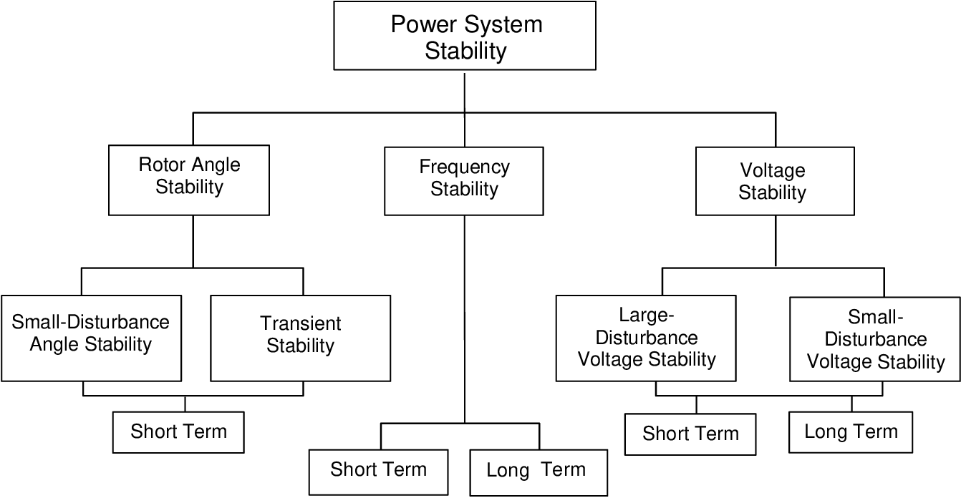

**Figure 1.1**: Classify Power System Stability.

## **1.3** **Rotor Angle Stability**

## Rotor angle stability pertains to the ability of synchronous machines within a power system to maintain synchronism. This stability is influenced by the rotor angle of each generator, which determines how multiple synchronous generators operate in parallel and share active power among themselves. During normal operation, the rotor and stator magnetic fields of a generator rotate at the same speed, though there is an angular displacement between them influenced by the generator's electrical torque (power). For system analysis, stability is generally classified into two main types. In a state of equilibrium, each generator in the power system will have equal mechanical input torque and electrical output torque, resulting in a constant speed. If equilibrium is disrupted, the rotors of the generators will either accelerate or decelerate.

## **1.4** **Dynamic Stability**

## Dynamic voltage stability is analyzed under-large network disturbances, and it is also analyzed in two time-scales; (1) STVS time-scale, and LTVS time-scale. The STVS phenomenon is driven by dynamic loads such as induction motors while the LTVS phenomenon is driven by on-load tap-changing transformers and over-excitation limiters in synchronous machines. The research studies conducted on PEC-interfaced renewables have highlighted the impact on both phenomena The early studies conducted on PEC-interfaced variable-speed wind generators concluded that PEC-interfaced wind generators could avoid STVS issues and the possibility of voltage collapse in the network with the improved control functionalities offered by these generators. Another study conducted with PEC-interfaced generation concluded that dynamic reactive power injection by PEC-interfaced wind turbines based on E.ON grid code provides better voltage support than power factor control mode.

# 1.5 Voltage Stability

Steady-state voltage stability is defined as the ability of the power network busbars to maintain steady-state voltage levels during small and gradual changes in the network. Usually, steady-state voltage stability is assessed via voltage sensitivity with active and reactive power. P-V curves, Q-V curves, and modal analysis are used to assess voltage stability

# 1.7 Small-Disturbance Voltage Stability

The operational status of a power system is often described in terms of small disturbances. Voltage stability is achieved when minor disruptions do not cause significant variations in the voltage close to the loads, keeping it relatively constant. To examine how minor disturbance stability relates to the steady state, one can use the small-signal model of the system

# 2. METHODOLOGY

The single-machine infinite bus (SMIB) system is a fundamental model in power systems used to analyze the stability and dynamic behavior of electrical networks. This model simplifies the complexities of real-world power grids to facilitate understanding and analysis, particularly focusing on the interactions between a single generator and a large, interconnected power system. The infinite bus concept represents a theoretical scenario where the grid is so vast that the voltage and frequency at the connection point remain constant regardless of the power exchanged with the system. For evaluating power system stability, a third-order SMIB model is employed, featuring a STATCOM located at the midpoint of a transmission line and connected via a step-down transformer. The model assumes constant values for both the mechanical input force and the amplitude of the voltage behind the synchronous generator’s momentary reactor. The subsequent three sections of this chapter offer a detailed exploration of system modeling.

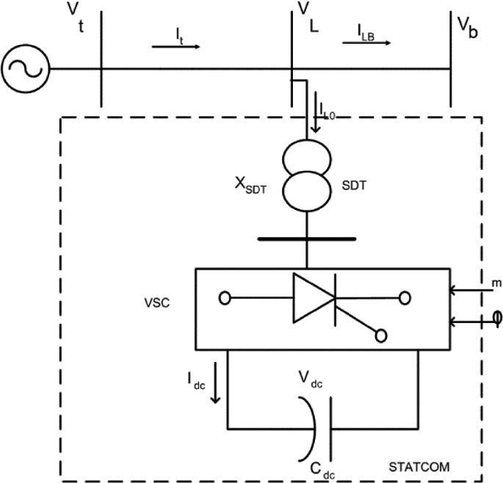

**Figure 2.1:** SMIB system with STATCOM single-diagram.

The generator is depicted by a second-order model made up of the electromechanical swing equation and the generator's internal voltage equation. The dynamic equations for the SG rotor are explained in (1) and (2). $\dot{δ}={\dot{ω}}_{0}$ (1)

$\dot{\acute{ω}=\frac{(P_{m}-P_{e}-Dω)}{M}}$ (2)

$P_{e}$ is the electrical power producing the predicted electrical torque on the rotor shaft (3).

$P_{e}=\frac{e_{q}^{,}V_{m}}{\overline{X}}\sin{θ}+\frac{V_{m}^{2}}{2}×\frac{\overline{X}-\overline{Y}}{\overline{X}\overline{Y}}\sin{2θ}$ (3)

In which $\overline{X}$, and $\overline{Y}$ are considered as follows:

$\overline{X}=X_{1}+x_{d}^{,}$ (4)

$\overline{Y}=X_{1}+x_{q}$ (5)

$X_{1}=X_{XT1}+X_{L1}$ (6)

$V_{m}=V_{md}+jV_{mq}$ (7)

$V_{mq}=\frac{\overline{B}V\sin{δ}+\overline{A}I_{s}X_{2}\sin{θ}}{X_{2}+\overline{A}}$ (8)

$V_{mq}=\frac{\overline{A}V\cos{δ}+\overline{A}I_{s}X_{2}\cos{θ}+e_{q}^{,}X_{2}}{X_{2}+\overline{A}}$ (9)

$X_{2}=X_{XT2}+X_{L2}$ (10)

$θ=\tan^{-1}({\frac{V_{md}}{V_{mq}})}$ (11)

$I_{s}=\frac{1}{T}[-I_{s}+Ku]$ (12)

$∆\dot{δ}=ω_{0}∆ω$ (13)

The SMIB system's third-order model with a STATCOM The proposed controller is created using the system's linearized equations.

$∆\dot{ω}=\frac{(∆P_{m}-(\frac{∂P_{e}}{∂δ}∆δ+\frac{∂P_{e}}{∂I_{s}}∆δ)-D∆ω)}{M}$ (14)

$∆I_{s}=\frac{1}{T}[-∆I_{s}+K∆u]$ (15)

The STATCOM controller output is written as,

$∆u=-C_{v}∆V_{m}+C_{ω}∆ω$ (16)

Where, $C_{v}$ and $C_{ω}$, are the controllers in the voltage and speed loop, respectively.

# 3. STATCOM

A shunt-connected reactive compensation device previously known as a Static Synchronous Condenser (STATCOM) is now referred to as a Static Synchronous Compensator This rapid-response device can supply or absorb reactive current, thereby regulating the voltage at the grid connection point. It operates through a voltage-source converter with power electronics, which allows it to manage reactive AC power across a network. Unlike traditional passive devices such as capacitors and inductors, STATCOMs offer the capability to provide or absorb both capacitive and inductive reactive power with adjustments made within milliseconds.

# 3.1 Robustness

The robustness of a STATCOM (Static Synchronous Compensator) is characterized by its ability to maintain stable and effective performance across a wide range of operating conditions and disturbances. Its wide operating range allows for versatile voltage regulation and continuous reactive power compensation, crucial for managing voltage stability in diverse scenarios. The STATCOM's rapid dynamic response ensures that it can quickly adjust its reactive power output to counteract sudden load changes or voltage fluctuations, which is essential for real-time voltage support. Its high reliability is bolstered by redundant components and durable designs, ensuring long-term operational.

# 4. CONTROLLER DESIGNE

In this section, we will explore the approach to designing controllers. All proposed controllers employ PID structures, utilizing an innovative robust control technique. A PID (Proportional-Integral-Derivative) controller is a widely used feedback control system that aims to maintain a desired output in a system by adjusting control inputs based on the error between the desired and actual outputs. It is renowned for its simplicity and effectiveness in a variety of industrial and commercial applications. This overview will explore the fundamental concepts, components, advantages, limitations, and applications of PID controllers.

1. **Fundamentals of PID Control**

The PID controller operates by calculating an error value as the difference between a set point (desired value) and a measured process variable. It then applies a correction based on proportional, integral, and derivative terms, each of which addresses different aspects of the error.

**Proportional Control (P):**

* + **Function:** The proportional term produces an output that is directly proportional to the current error value. It adjusts the control input to reduce the error linearly.
  + **Effect:** This term helps the system to respond to the error. A larger proportional gain (KpK pKp​) results in a larger correction, which improves the speed of response but can also lead to overshoot and oscillations.

1. **Integral Control (I):**
   * **Function:** The integral term addresses accumulated past errors. It integrates the error over time, ensuring that any residual steady-state error is corrected by accumulating the error until it is eliminated.
   * **Effect:** This term helps in eliminating the steady-state error that a proportional controller alone cannot correct. However, it can lead to slower response times and potential oscillations if not properly tuned.
2. **Derivative Control (D):**
   * **Function:** The derivative term predicts future error based on its rate of change. It provides a control input proportional to the rate of change of the error, helping to dampen the system's response and improve stability.

# 4.1 SIMAULTION RESULT

## **Calculation of Initial Conditions**

The following are the obtained initial conditions; the required parameters are written to calculate these values given in the **Table 4.1.**

**Table 4.1.** InitialConditions

|  |  |
| --- | --- |
| 𝑷𝒂𝒓𝒂𝒎𝒆𝒕𝒆𝒓𝒔 | 𝑽𝒂𝒍𝒖𝒆 |
| 𝐼𝑎𝑜 | 0.8657 |
| ∅𝑜 | −17.8085𝑜 |
| 𝐸𝑞𝑜 | 2.2801 |
| 𝛿𝑜 | 47.5111𝑜 |
| 𝑖𝑑𝑜 | 0.7866 |
| 𝑖𝑞𝑜 | 0.3615 |
| 𝑣𝑑𝑜 | 0.5928 |
| 𝑣𝑞𝑜 | 0.9901 |
| 𝐸𝑓𝑑𝑜 | 0.2329 |

Table 4.1 displays achieved controller coefficients for different scenarios. As known, the rows 1 to 3 and 4 to 6 belong to the obtained coefficients for the speed and voltage control loops, respectively. NSGAII algorithm proposes a Proportional Integral Derivative (PID) controller in S1 and S3 for the speed control loop. The biggest value for the coefficient Kpw is calculate for S1 as well as the biggest. value of the coefficient  and  belong to S2 and S3, respectively. Also, the proposed controller in the voltage loop for S2 and S3 are obtained as I and PID.

**Table 4.2.** Parameter Constants

|  |  |
| --- | --- |
| **Parameters** | **Value** |
| $$K_{1}$$ | 1.3315 |
| $$K_{2}$$ | 1.1433 |
| $$K_{3}$$ | 0.3071 |
| $$K_{4}$$ | 1.6635 |

The parameters of the linearized model are determined in tabular form using the test system given in Table 4.2. It is clear that the minimum value related to ASE is computed for S1 due to the multi-objective function in this scenario has only been considered for speed closed-loop. Also, the worst value is calculated that is related to voltage closed-loop for this scenario, too. On the other hand, the best value obtained for the speed closed-loop, as well as the worst value obtained for the voltage closed-loop, belong to S2. The control system in S3 performs appropriately for damping both voltage and speed oscillations. The results obtained for S3 is a trade-off between the results of S1 and S2. So, this control system can eliminate the weakness of each of the two control systems belongs to S1 and S2.

## **Simulation Model of Speed Controller (Scenario 1)**

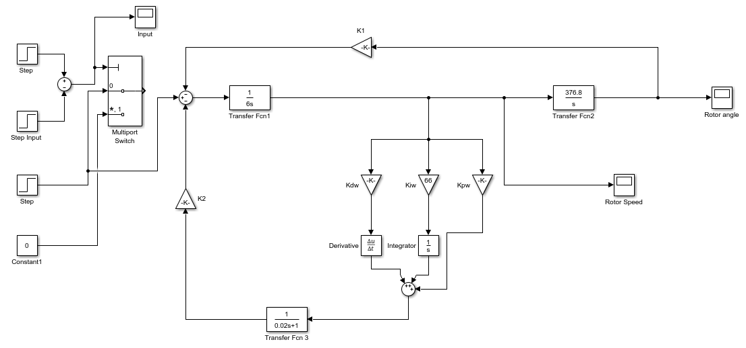

**Figure 4.1:** Simulation Model of Speed Controller

In Figure 4.1, the Simulink model of speed is evaluated using a PID controller. The controller designed for S1 performs exceptionally well in handling disturbances. It not only exhibits minimal overshoot but also effectively dampens oscillation magnitude deviations after approximately three seconds. This observation indicates that the proposed multi-objective problem significantly enhances the damping of oscillations in the speed loop.

## **Simulation Result of Speed loop in Scenario 1**

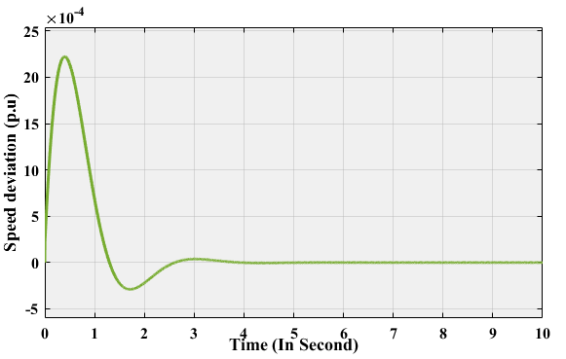

**Figure 4.2:** Simulation Result of Speed loop in Scenario 1

# 5. Conclusions

A new approach to creating reliable STATCOM damping control systems in power systems has been developed. This approach employs three PID controllers to enhance the damping of speed and voltage oscillations, thereby boosting the stability of the power systems. The multi-objective genetic algorithm NSGA-II was used to fine-tune these controllers. The results demonstrated a substantial improvement in system stability and damping with the robust STATCOM controller.

**REFERENCE**

1. P. Kundur, N. J. Balu, and M. G. Lauby, Power System Stability and Control. McGraw-Hill, New York, 7( 1994).
2. Zhang XP, Rehtanz C, Pal B. Flexible AC Transmission Systems: Modeling and Control, Springer-Verlag; (2012).
3. H.F.Wang, "Interactions and Multivariable Design of STATCOM AC and DC Voltage Control", Electrical Power and Energy Systems, vol. 25,pp. 387-394, ( 2003).
4. O. M. Kamel, A. A. Z. Diab, T. D. Do and M. A. Mossa, "A Novel Hybrid Ant Colony-Particle Swarm Optimization Techniques Based Tuning STATCOM for Grid Code Compliance," IEEE Access, vol. 8, pp. 41566-41587, (2020).
5. Y. Zhu. Power System Loads and Power System Stability, Springer-Verlag; (2020).
6. R. Sadiq, Z. Wang, C.Y. Chung, C. Zhou and Chenxuan Wang, “A review of STATCOM control for stability enhancementof power systems with wind/PV penetration: Existing research and future scope”, International Transactions on Electrical Energy Systems, vol. 31, no. 11, pp.1-27, (2021).
7. E. Munkhchuluun, L. Meegahapola and A. Vahidnia, “Long-term voltage stability with large-scale solar-photovoltaic (PV) generation”, International Journal of Electrical Power and Energy Systems, vol.117, pp. 105663, (2020).
8. L. Wu, T. T. Gu and L. X. Yao, "Static voltage stability analysis based on improved continuation power flow method", Journal of power system technology, vol. 35, no. 10, pp. 99-103, (2011).
9. S.S Kumar.,V Krishna., K Reddy and D Thukaram, “Coordination of reactive power in grid-connected wind farms for voltage stability enhancement,”. IEEE Power Energy Society General Meeting, vol. 29, no. 5, pp. 2381-2390, (2015).
10. B. Muriithi and O. Joseph Ojo, “Voltage stability assessment and enhancement of power grid with increasing wind energy penetration”, International Journal of Electrical Power & Energy Systems, vol. 120, pp. 105988, (2020).
11. C. Kumar, M. Lakshmanan, S. Jaisiva, K. Prabaakaran, Sourav Barua, Hady H. Fayek, “Reactive power control in renewable rich power grids: A literature review, IET Renewable Power Generation”, vol. 17, no.5, pp. 1303-1327, (2023)
12. S. Agrawal., P.C Sekhar. and S. Mishra, “Control of single-phase grid connected PV power plant for real as well as reactive power feeding”, IIEEE International Conference on Control Applications (CCA). Hyderabad, India, pp. 667–672 (2013).
13. J.-H Zheng. and J.-F Li. “Reactive optimization control for the wind farm with static VAR compensator (SVC)”, 24th Chinese Control and Decision Conference (CCDC). Taiyuan, China, pp. 2792–2795 (2012).
14. W. Huang, D. J. Hill and X. Zhang, "Small-Disturbance Voltage Stability of Power Systems: Dependence on Network Structure," IEEE Transactions on Power Systems, vol. 35, no. 4, pp. 2609-2618,( 2020).
15. T. Yong, M. Shiying and Z. Wuzhi, "Mechanism Research of Short-Term Large-Disturbance Voltage Stability," International Conference on Power System Technology, Chongqing, China, 2006, pp. 1-5, (2006).