**Granulometry Analyses And Environmental Interpretation Of Ditch Cutting Samples From Field ‘X’, Greater Ughelli, Niger Delta**

# Wobo, Monica Aleruchi, Okujagu, Diepiriye Chenaboso, Dr. Monday Udofia, Dr. Acra Jones

1&3Centre for Petroleum Geosciences, University of Port Harcourt

2&4Department of Geology, University of Port Harcourt

Corresponding author: [diepiriye.okujagu@uniport.edu.ng](mailto:diepiriye.okujagu@uniport.edu.ng)

# ABSTRACT

This study presents the results of granulometry analyses and environmental interpretation of ditch cutting samples from Field ‘X’ in the Greater Ughelli area of the Niger Delta. A total of 95 ditch cutting samples were collected from various depths and analyzed for grain size distribution, sorting, skewness, and kurtosis. The results show a dominance of medium-grained sands with moderate sorting, indicating a fluvial-deltaic depositional environment. The environmental interpretation suggests that the sediments were deposited in a shallow marine setting with periodic fluvial influences. The study provides valuable insights into the sedimentary history and paleoenvironment of the Niger Delta, with implications for petroleum exploration and reservoir characterization. The findings of this study can be used to inform geological models and improve the accuracy of reservoir predictions in the region.

**Keywords:** Granulometry, Niger Delta, Ditch Cutting Samples, Sedimentary Environment, Fluvial-Deltaic Deposition

**INTRODUCTION**

Ditch cuttings samples are the tiny fragments of rock that the bit chips away while drilling a hole. The mud-stream carries the rock cuttings from the bit to the surface where they can be "collected" and studied. Because they are frequently the only physical lithological information that is recovered from a well, ditch cuttings are significant. These datasets are utilized as auxiliary data for further evaluation and lithology-wireline log correlation, as well as other specialized geological, geophysical, and engineering investigations. Understanding reservoir architecture and predicting and characterizing generated hydrocarbons depend heavily on rock analysis. Any age of drill cuttings or cores enables for the analysis of tiny rock samples and any accompanying trapped fluid. New strategies requiring more data acquired over longer periods of time and at higher costs are beneficial for the exploration and exploitation of increasingly complex reservoirs as well as the technical difficulties of maximizing horizontal wells into constrained or unusual pay sections. The concept of interpreting rocks via the lens of contemporary activities was initially considered in the 18th and 19th centuries (the present is the key to the past). Different kinds of sedimentary materials are characterized by their own specific composition, size, and origin. Particles such as large grains and pebbles can originate either from the Earth's surface, where older rocks are eroded, or from volcanic eruptions themselves. The production of materials also requires the presence of living beings. Reefs made of coral, shells, bones, and decomposed plant material are all examples of this. This category also includes filaments of microbes that have a calcium carbonate coating. There are situations where minerals that dissolve in water can contribute to the formation of sediments by sinking to the bottom of the solution. What exactly is the composition of sediment? Particles can either migrate to their final resting spot via mass fluxes, water, air, or gravity, or they can undergo chemical or biological transformations already present in the material. To create silt, you can utilize either of these approaches. The chemical composition, temperature, and biodiversity of an area are three of the most influential factors on the rate of sediment deposition. The movement and depositing processes can be understood by examining the sedimentary strata. Particle size, shape, and distribution provide information regarding the material's motion and landing site. Similarities exist between the ripples observed in sedimentary rocks and the ripples occurring in the environment or in laboratory storage tanks at the present time.

Measuring sedimentary rocks to varying degrees of precision allows us to infer the chemical, biological, and physical conditions that prevailed throughout sedimentation. This can only function if the laws regulating physical and chemical processes have remained constant throughout the ages. Rapid changes can occur in many places and objects, such as the salinity, depth, and flow rate of water in a lake or ocean, the direction and intensity of a desert wind, and the range of tides in a shallow marine environment. The natural world may be affected by at least one of these. The physical, chemical, and biological processes that comprise the "depositional environment" collaborate to determine the type of sediment that is deposited and, subsequently, the type of rock that is created during lithification. Consequently, whether on land or in the water, the physical and chemical processes occurring there and the organisms that inhabit it can be utilized to characterize the ecosystem. A lot of individuals use the term "facies" to describe the formation circumstances of sedimentary rocks. The term "rock facies" refers to a specific kind of rock that, as its name implies, displays characteristics that provide light on its creation environment (Reading and Levell, 1996). It is essential to discuss the complete lithology, texture, sedimentary structures, and fossil content of a body of sediment when describing its facies. For the simple reason that these characteristics can be employed to deduce the sedimentation mechanism. There is a correlation between the location of deposition and certain face characteristics. The reason behind this is that the primary process combinations can be discovered by determining the linkages between the facies. To determine the type of environment, one must look at the processes taking place there. Looking at each bed objectively and considering the physical, chemical, and biological processes that create sedimentary rocks may always give you a good notion of where and how a rock formed. Sedimentary rocks are formed by a complex interplay of processes that are unique to each depositional environment. At some point, all of these rocks will coalesce into one spectacular formation. Meanwhile, stratigraphy delves into the study of layered rock interactions and how things evolve over time. The role of the stratigrapher is to determine the history of rocks by seeing, describing, and interpreting direct and tactile evidence found in rocks. The purpose of this is to learn the rock's history. We may construct and link models of the Earth's surface from different places and times using stratigraphy and sedimentology. Structure, grain-to-grain arrangement of framework particles, and porosity are all significantly affected by the environments in which sedimentary rocks were created (Keele and Evans, 2008; Arochukwu, 2014; Fitch et al., 2014). The unique physical and chemical characteristics of sedimentary environments provide light on the processes that gave rise to those ecosystems (Snedden and Bergman, 1999; Slatt, 2006). Different sedimentary structures have different qualities, but by comparing them with one another, we may distinguish between more recent and older sedimentary environments in undercores and outcrops (Slatt, 2006). Diagnostically valuable and crucial for re-creating the environment, sedimentary rock cores reveal information about the rock in its natural state. Investigating the research region's deposition habitats will help determine the lithology, maintain uniform sand width throughout the field, and provide clues as to the origin of the sediments by analyzing the types of sediments present. This will be accomplished by utilizing ditch-cuttings.

**LITERATURE REVIEW**

**Conceptual Framework of the Niger Delta**

During the late Jurassic period, when the South American and African plates separated, an arm triple attachment system known as aulacogen failed to function properly. As a result, the Niger Delta clastic wedge formed (Burke et al., 1972; Whiteman, 1982). This event established the passive continental borders of West Africa, with two arms that ran down the coasts of Cameroon and Nigeria, respectively. The entire African continent is encircled by these lines. The third arm, the Benue Trough, was ineffective. Several depocenters who lived near Africa's Atlantic coast also had an impact on delta construction. Sedimentary processes spanning the Cretaceous to the Tertiary deposited the earliest rocks, dating back to the Albian epoch. Marine clastics and carbonates accumulated in thick strata from the rift's beginning and end as a result of this (Doust and Omatsola, 1989). The Santonian era was the one in which the basin was inverted. This occurred during the Late Cretaceous, close to the conclusion of the Syn-rift period. As the continents began to separate, subsidence once again became a concern. As a result, the water could flow through the Benue Trough. Over the entirety of the Middle Cretaceous, the clastic wedge in the Niger Delta continued its ascent toward a depocenter above the collapsing continental margin, near the triple junction. It was widely believed that the primary drainage systems into the Bida and Benue Basins were the most crucial for sediment transport. Periodically, during the Late Cretaceous, material transport was temporarily delayed by coastal invasions. During the Tertiary period, the rivers Niger, Benue, and Cross carried a significant amount of silt that originated in the east and north. The Cross and Benue Rivers contain substantial quantities of volcanic material, which was generated during the Miocene eruption of the Cameroon volcanic zone. The clastic wedge in the Niger Delta accelerated its movement toward the Gulf of Guinea as a result of the ongoing basement sinking and the expansion of these drainage zones. The Eocene saw an acceleration of the slowing process of regression due to the increased storage of sediments, which had been going on since the Oligocene.

The morphology of the Niger Delta changed beginning in the Paleocene and continuing into the early Eocene and later Miocene. This transition ushered in the Pleistocene epoch. Sediment distribution was significantly impacted by basement shape since early coastal zones were bent inward toward the ocean (Doust and Omatsola, 1989). Land was subsiding faster than sediment was being deposited in the area where the original axis of deposition ran parallel to the Niger River. Moving from the Eocene into the Early Oligocene, the second, smaller axis started to wander downstream of the Cross River in the basins. The Olumbe-1 region was forced into the coastlines at this point (Short and Stauble, 1967). At first, the Ihuo Embayment separated this deposit axis from the primary deposits in the Niger Delta. It was soon filled, though, with sediments flowing in from the nearby Cross River and other waterways (Short and Stauble, 1967). The latter phases of deposition commence in the early to middle Miocene. During this time, there was interaction between the eastern and western deposition epochs. As the delta dipped further into the basin in the late Miocene, its shorelines became noticeably more concave. Moving the subsurface shales sped up the loading procedure. The layers below were damaged by the diapiric walls and swells caused by the ascending shale layers. As the Niger Delta region expanded, complicated deformation structures caused local uplift, which in turn caused massive erosion episodes. It is likely that deep gorges, packed with clay and thought to have developed when sea levels were lower, were formed during that period. Among these ravines are the canyons of Afam, Qua Iboe, and Opuama. The Niger Delta tertiary deposits are constructed from three separate depositional periods (Short and Stauble, 1967; Doust and Omatsola, 1990). In the middle of the Cretaceous period, two of the three epochs—the ones with a marine focus—began with an invasion by the sea. The Paleocene saw the end of the cycle due to a significant maritime incursion. Between the end of the Paleocene and the beginning of the Eocene, a genuine delta was formed during the second cycle. An arching shoreline in this delta was shaped by the waves and tides. The sediments display this pattern. They cover a wide range of time periods, from the Eocene in the north to the Quaternary in the south (Doust and Omatsola, 1990). Six depobelts were formed by the most recent cycle of deposits, according to Doust and Omatsola's observation of major syn-sedimentary fault zones (1990). These fault zones are called depocenters or mega series depending on how significant they are. These depobelts were formed as a result of patterns of structural deformation that restricted the flow of sediment and caused much of it to deposit in the already crowded delta basins. There was less space for lodging as the basin decreased and shrank again, and the deposits moved about (Doust and Omatsola, 1990). The clastic wedge in the Niger Delta has been severely twisted as a result of normal faults caused by the movement of ductile marine shales that were deeply buried and subjected to excessive pressure (Doust and Omatsola, 1989). As sediment was being deposited, many of these faults began to form. Consequently, as the delta emptied, they changed the way silt was distributed. Another consequence of the fault's expansion was the instability it brought to the slopes along the continental margin. The faults flatten out on a master detachment plane at the base of the Niger Delta series as the sequence advances. It is clear that the structure is complex in certain places due to the number and kind of flaws. Faults can display simple geological characteristics such as flanking and crestal faults. By studying hanging-wall rollover anticlines, complicated structures can be better understood. By studying the listric-fault geometry and the different loads acting on deltaic deposits on ductile shales, these structures can be recognized. Several defects, each with its own degree of movement, become apparent when they pass through complex deformation structures. Collapsed dome crests and confronting fault troughs make up the structures in issue.

### **Niger Delta Stratigraphy**

Multinational oil corporations with concessions in the Niger Delta Basin still own the majority of the stratigraphic plans, despite the high volume of oil exploration and production in the region. The formation of the Tertiary Niger Delta and the Cretaceous layers underneath it can be traced back to a 1967 study by Short and Stauble. The petroleum geology of the Niger Delta is thoroughly examined in the works of Evamy et al. (1978), Doust and Omatsola (1990), and Tuttle et al. (1990). (1999). The hydrocarbon habitat of the Niger Delta was modelled by Stacher in 1995 using sequence stratigraphic methods. The current physiography, sedimentology, and depositional circumstances of the Niger Delta were described by Oomkens and Allen in 1965. (1974).

Three primary rock layers have been discovered beneath the Niger Delta's surface: the Agbada Formation, the Benin Formation, and the Akata Formation. In general, the depositional settings have retreated as shown by these older layers that descend into the clastic wedge of the Niger Delta. These formations are located in southern Nigeria and can be found in identical layers (Short and Stauble, 1967). According to Short and Stauble, these formations eventually wind up in river, deltaic, and marine settings after forming an upward-prograding clastic wedge during sedimentation (1967). Daukoru and Weber (1975) and Weber (1986). The Akata Formation's type section was discovered in the Akata 1 Well, which is located 80 kilometers east of Port Harcourt (Short and Stauble, 1967). Drilled to a total depth of 3,680 meters, the Akata-01 well failed to reach the formation's base (11,121 ft). Locating the lowest layer of deltaic sandstone, which is located 7,180 feet below ground, will lead you to the top of the formation. It is believed that the 21,000-foot-thick deposit is located in the clastic wedge (Doust and Omatsola, 1989). Silts and shales of a dark gray color make up the lithologies. The presence of sand streaks indicates the locations of turbidite flows in the vicinity (Doust and Omatsola, 1989). Half of the microfauna collection may consist of marine planktonic foraminifera. This proves that a shallow maritime shelf was the location of the depositing (Doust and Omatsola, 1990). The Niger Delta is home to three distinct geological formations:

(i) **Akata Formation**: Located at the delta's base, the Akata Formation is marine in origin, consisting mainly of turbidite sands (potential deep water reservoirs), a thick shale sequence (possible source rock), and trace amounts of clay and silt. This formation crops out subsea in the outer delta and ranges in thickness from 0 to 6000 meters, although it is not visible on land. It was formed during lowstands when clays and terrestrial organic matter were transported to low-energy, low-oxygen deep water regions (Michele et al., 1999). Near the delta's center, the formation is thought to be up to 7000 meters thick (Doust and Omatsola, 1990). Its age ranges from the Palaeocene to the Holocene, and it is under pressure.

(ii) **Agbada Formation**: The Agbada Formation, a sequence of paralic siliciclastic sandstones and shales around 3700 meters thick, represents the sequence's deltaic component. It consists of a thicker lower shale unit and an overlying, predominantly sandy unit with minor shale intercalations. The formation shows a dense concentration of microfauna at the base, decreasing upwards, indicating an accelerated rate of deposition in the delta front. The grains' coarseness and poor sorting point to a fluviatile origin. Most hydrocarbon reservoirs are found in this sequence, associated with sedimentary growth faulting. The Agbada Formation is continuous beneath the entire delta region and possibly with the Eocene-Oligocene-aged Ogwashi-Asaba and Ameki Formations. It ranges from the Eocene in the north to the Pliocene/Pleistocene in the south and is up to 4000 meters thick in the delta center, thinning out towards the delta boundary and offshore. Significant hydrocarbon accumulations are observed between the Eocene and Pliocene periods.

(iii) **Benin Formation**: The Benin Formation extends beyond the current shoreline from the west across the entire Niger Delta region. Over 90% of the formation comprises sandstone with shale intercalations. The sandstone is sub-angular to well-rounded, poorly sorted, coarse-grained, gravelly, and contains lignite streaks and small pieces of wood, indicating an upper deltaic depositional environment on a continent. Point bars, channel fills, natural levees, backswamp deposits, and ox-bow fills illustrate the formation's diverse shallow water depositional environment. It is Oligocene in the north and younger towards the south, generally spanning the Miocene to the Recent. The formation's thickness varies but typically reaches 6000 feet. Few hydrocarbon accumulations are associated with this formation.

The ages of the rocks in the formation range from the Paleocene to the Recent (Doust and Omatsola, 1989). Shale formations that are the thickest are found along the axes of the Bida and Benue Troughs. These deposits were made in the early stages of the Niger Delta's degradation. Marine shales, which form along the continental slope and are found in the ocean, are another type. In places where these shales are buried deep, they are often vulnerable to pressure. If you look at Stacher's research from 1995, the Akata shales were called deep-water lowstand deposits. There are a lot of plant pieces and micas to be found in the transition zone, which has a steep slope that leads to the Agbada Formation (Doust and Omatsola, 1989). The Agbada Formation can be found in the Agbada-02 Well, which is 11 kilometers northwest of Port Harcourt (Short and Stauble, 1967). After drilling 9500 feet into the ground, the Akata-01 well reached the top of the Akata Formation, which is the base of the formation. It is thought that the formation, which is found in the clastic wedge of the Niger Delta, is about 13,000 feet thick at its thickest point. This rock formation can be found in southern Nigeria, between the cities of Ogwashi and Asaba. It is known as the Ogwashi-Asaba Formation (Doust and Omatsola, 1989). Silts, sands, and shales are stacked one on top of the other every ten to one hundred feet. The lithologies can be recognized by the way the grain size and bed thickness keep getting bigger. Sequential ordering is what makes the lithologies different from each other. The environments with rivers and deltas are usually thought to be where the strata evolved. The age of the formation could be between the Eocene and the Pleistocene. The Benin Formation is the top part of the clastic wedge that makes up the Niger Delta. It goes from the Benin-Onitsha region in the north to beyond the present coastline (Short and Stauble, 1967). This section is based on the Elele-01 well, which is 38 kilometers northwest of Port Harcourt in Nigeria (Short and Stauble, 1967). The bottom of the formation goes down 4,600 feet, and the most recent subaerially exposed delta top surface is at the top of the formation. That which makes the base unique is the marine shale that is the youngest. All of the non-marine sand in the shallow parts of the formation was put there when the delta broke down in places that were either alluvial or upper coastal plain (Doust and Omatsola, 1989). The formation is thought to be from the Oligocene to the Recent era, even though there aren't any living things left to give a precise date (Short and Stauble, 1967). It gets thinner and more like a basin as it gets closer to the edge of the shelf. In 1967, Short and Stauble put formations into groups based on the amounts of sand and shale that were found in well logs that were dug up from the ground. Given that they come from subsurface well logs that only partially penetrate type sections, the definitions in question are thought to be informal. The international stratigraphic code does not agree with these definitions. Geologists in the area use a wide range of terms to describe the tops and bottoms of formations. People usually call the top of the Agbada Formation the base of freshwater sand. On the other hand, when it comes up during drilling, the top of the Akata Formation is called the top of an over-pressured shale. These two rock formations are both in the same area. The authors of Doust and Omatsola (1989) are aware that their definitions of formations could have problems, even though the Akata Formation has turbidite sands at great depths and the Benin Formation has argillaceous intercalations in the sands that are quite thick. It was suggested that they use less formal language when talking about stratigraphy. In 1977, Adesida et al. suggested that deposits in the Niger Delta be split up into large-scale regional lithostratigraphic sequences. To do this, log trends, biostratigraphy, and sequence stratigraphic surfaces found in seismic sections were all taken into account.

### **Location of Study**

The field is situated onshore Niger Delta. The field is located within the Greater Ughelli Depobelt of the Niger Delta basin. The available information suggests the presence of predominantly shoreface and channel deposits. The shoreface deposits are apparently cut by what appears to be tidally influenced distributary channels. The individual reservoirs are separated by laterally extensive marine shales.

## **METHODOLOGY**

### 

### **Datasets**

This study is primarily concerned with Grain size description, grain shape analysis and interpretation of depositional environment. The materials used for the grain size analysis (particle size distribution or granulometric analysis) include the following:

1. Ditch cuttings for (a) WELL-1 (6295 – 12400ft) and (b) WELL-2 (7402 – 12145ft,
2. A set of sieves (A.S.T.M) together with their mm and phi equivalents.
3. Weighing Balance (Electronic Scale – 3000g/0.1g).
4. Sieve shakers

Analysis of mechanical (sieving) was used to determine the grain sizes. The samples for analysis consist of sands, sandstone, and pebbly sand/sandstone respectively. The samples were first examined, to determine their condition. Foreign materials such as roots, leaves etc., wherever present were removed. In addition, each of the samples were then de-segregated into its component units using mortar and rubber-tipped pestle for samples that are lithified, after which heating in a conventional oven and drying in a moisture free environment was done. Crushing was carried out in such a way that the grains were neither broken nor shattered. The samples were then sorted to their various sizes using screen sizes that were mostly appropriate for the analysis. The minimum duration of time used to sift the samples into their various sizes was twenty minutes. The percentage of samples retained in each screen size was calculated gravimetrically based on the final sample weight after sieving including those smaller than 325 mesh fractions.

## **RESULTS AND DISCUSSION**

Granulometry (grain size analysis or particle size distribution) for WELL-1 and WELL-2 was carried out in this study. A fundamental characteristic of sedimentary rocks is their particle or grain size, which can be inferred to a large extent from their overall grain size distribution, size fraction percentages, textural maturity, surface textural attributes, sphericity/angularity, sediments fabric, density, porosity, and permeability. Additionally, a particle's size has substantial utility as an environmental proxy because it is closely related to the environment, the transport medium, the passage of time, and the depositional circumstances. Tables 1 and 2 summarizes the grain size analysis results for 7840-7945ft (K9000 and K9100) from both WELL-1 and WELL-2. The results for the remaining intervals representing reservoirs L and M series are presented in tables 3 to 6. The average grain size, sorting, skewness and kurtosis for WELL-1 are 1.60 (0.33mm), 1.58, 0.06 and 1.20 respectively. For WELL-2, average grain size, sorting, skewness and kurtosis are 1.30 (0.41mm), 1.59, 0.10 and 0.91 respectively. The range of the calculated statistical parameters for the studied sections for WELL-1 is as follows grain size 0.70 – 2.63 (0.16-0.61mm, coarse to fine grained sand), sorting 1.03 – 2.15 (very poorly – poorly sorted), skewness -0.02 to 0.51 (very finely skewed – coarse skewed) and kurtosis 0.68 – 7.07 (very platykurtic – very leptokurtic) while the range of the calculated statistical parameters for the studied sections in WELL-2 are 0.12 – 2.07 (0.24-0.92mm coarse to fine grained sand), 1.19 – 1.90 (poorly sorted), -0.20 to 0.36 (very finely skewed – very coarse skewed) and 0.60 – 1.94 (platykurtic – very leptokurtic).

**Table 1: Summary of Grain Size Results for WELL-1**

|  |  |  |  |  |  |  |  |
| --- | --- | --- | --- | --- | --- | --- | --- |
| S/No | Sample No. (ft) | Grain Size | Reservoir | Grain Size Distribution | Sorting | Skewness | Kurtosis |
| 1 | 7840-7855 | 0.26mm (Medium sand) | K (9000) | Bimodal | 1.41  Poorly sorted | -0.03 coarse skewed | 0.90  Platykurtic |
| 2 | 7855-7870 | 0.39mm (Medium sand) | K (9000) | Bimodal | 2.23  Poorly sorted | -0.09 coarse skewed | 0.64  Very Platykurtic |
| 3 | 7900-7915 | 0.33mm (Medium sand) | K (9100) | Bimodal | 1.89  Poorly sorted | 0.07 Nearly symmetrical | 0.84 Platykurtic |
| 4 | 7915-7930 | 0.43mm (Medium sand) | K (9100) | Bimodal | 2.10  Poorly sorted | 0.15 finely skewed | 0.70 Platykurtic |
| 5 | 7930-7945 | 0.45mm (Medium sand) | K (9100) | Bimodal | 1.35  Poorly sorted | -0.05 strongly coarse skewed | 0.78 Platykurtic |
| Average | | 0.37mm (Medium sand) |  |  | 1.80  (Poorly sorted) | 0.05 (coarse skewed) | 0.77 (Platykurtic) |

**Table 2: Summary of Grain Size Results for WELL-2**

|  |  |  |  |  |  |  |  |
| --- | --- | --- | --- | --- | --- | --- | --- |
| S/No | Sample No. (ft) | Grain Size | Reservoir | Grain Size Distribution | Sorting | Skewness | Kurtosis |
| 1 | 7840-7855 | 0.29mm (Medium sand) | K (9000) | Polymodal | 2.20  Very Poorly sorted | -0.03 coarse skewed | 0.56 Very Platykurtic |
| 2 | 7885-7900 | 0.27mm (Medium sand) | K (9000) | Unimodal | 1.49  Poorly sorted | -0.09 coarse skewed | 0.52  Very Platykurtic |
| 3 | 7900-7915 | 0.20mm (Fine sand) | K (9100) | Unimodal | 1.46  Poorly sorted | 0.07 Nearly symmetrical | 0.82 Platykurtic |
| 4 | 7915-7930 | 0.23mm (Fine sand) | K (9100) | Unimodal | 1.92  Poorly sorted | 0.15 finely skewed | 1.37 Leptokurtic |
| 5 | 7930-7945 | 0.30mm (Medium sand) | K (9100) | Unimodal | 1.59  Poorly sorted | -0.05 strongly coarse skewed | 1.86 Very Leptokurtic |
| Average | | 0.26mm (Medium sand) |  |  | 1.75  (Poorly sorted) | 0.05 (coarse skewed) | 1.03 (Mesokurtic) |

From the results of the analysis, average sorting and grain size are similar (poorly sorted and fine to coarse grained). Range of skewness is also similar (very finely skewed to coarse skewed) whereas the dissimilarity is evident in range of values as it relates to kurtosis and distribution pattern (type) observed in the studied depth intervals for both wells. The data obtained from grain size analysis, shows that all samples analyzed have all the three modes of distribution (Tables 1 to 6). The bimodal distribution predominates in WELL-1 while unimodal distribution pattern dominates in WELL-2. This may be attributed to the fact that the samples were deposited in one phase or had not undergone much reworking or re-deposition. The bimodal distribution in WELL-1 and polymodal pattern of distribution of WELL-2 interval 7840 – 7855ft may be due to the dynamics of the depositing medium or mixtures of two or more materials in more than two or more phases.

The areal distribution of transport paths combined with different rates of transport of each grain population produces hydrodynamic sorting. The range standard deviation (1.19 – 1.90, WELL-1 and1.03 – 2.15, WELL-2) gives a clue to the sorting range and also suggests the hydrodynamic conditions that operated in the depositing medium during transportation of those sediments. Sorting is related to both porosity and permeability. The result of sorting as derived from the standard deviation gives a range of values and is interpreted as poorly to very poorly sorted. The similarity in the sorting range in both wells indicates that the studied section may have similar porosity and permeability. The poor sorting of sediments (including silt and clay sized materials) may have adverse effect on permeability and porosity. The alternating sequence of fine-grained sediments (which include silts and clays) and medium grained sediments probably suggests a high energy environment fluctuated by a low energy environment. The fines were deposited in the interstices of the medium clasts when the velocity of the depositing medium reduced probably at the coastal fringes. These samples from the two wells probably suggest that the sediments were deposited in a distributary setting.

**Lithological Description, Sedimentary Analysis and Environment of Deposition**

The integration of the lithological description and well logs (Gamma ray, Resistivity and Neutron-Density logs) allow the interpretation of environment of deposition for sediments recovered from WELL-1 and WELL-2 wells. Details of inferred environment of deposition are provided for some of the levels in WELL-1 and WELL-2. The sediments consist majorly of sand/sandstone, shale and silt intercalations which is typical of the Agbada formation. The characteristics of the sediments and log patterns indicate they were likely deposited within distributary channels, tidal channels or upper/lower shoreface environments. The abundance of iron in the sediment found in both wells could be linked to weathering and erosion of iron rich rocks from sediment source area.

**J7000 Sand**

The J7000 zone in both wells as shown in Figure 1, exhibits majorly fine to medium grained sand and minor shale occurrences. The upper part of this section as observed on the log motifs depict a serrated log pattern therefore reflects a mixed environment of tidal and distributary channels. The middle section shows a fining upward pattern which likely indicate a mouth bar deposit or a shoreface environment. The lower section shows a blocky to fining upward log pattern with majorly coarse to medium grained sands which likely indicate a discrete distributary environment.

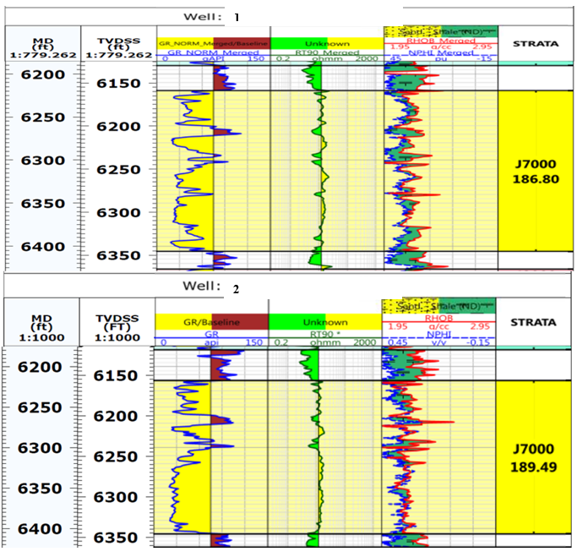

Figure 1: Log correlation showing J7000 interval, WELL-1 and WELL-2

**K8000 Sand**

The K8000 reservoir in both wells show a coarsening upward to blocky patterns with a sharp and gradational basal contact as shown in Fig 2. The sands (A and B) can be correlated across the wells indicating same depositional setting in both wells. The reservoir is made up of majorly coarse to fine grained sandstone and the presence of inter-bedded shale layer which was mostly likely deposited during the period of low energy within the environment. Sand A has a fining upward pattern with a sharp basal contact which likely indicates a point bar deposit within a channel environment, with sediment ranging from coarse to fine grained. Sand B has a coarsening upward pattern and a gradational contact with the underlying shale. This indicates the sediments were likely deposited within shoreface environment or a mouth bar deposit, with sediment ranging from coarse to fine grained.

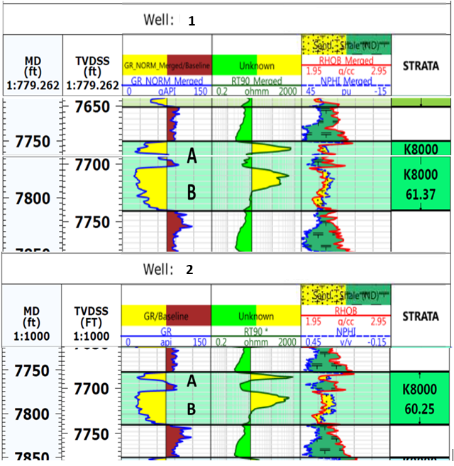

Figure 2: Log correlation showing K8000 interval WELL-1 and WELL-2

**K9000 Sand**

The K9000 zones in the WELL-1 and WELL-2 showed coarsening upward log motifs with minor shale/silt occurrences (Fig. 3). The sediments are made up of sand deposits which are smoky to dirty white, medium to coarse grained, moderately sorted, subangular to subrounded, calcareous and ferruginous. The shale is light grey, subfissile to fissile, hard, carbonaceous, micromicaceous and highly ferruginized. The shale was mostly likely deposited during period of low energy within the environment. The presence of fine to coarse grained sediment and a coarsening pattern with gradational contact likely indicate an upper to lower shoreface depositional environment or mouth bar deposit for sediments within the K9000 reservoir. The similarity in log motif and lithological characteristics across the wells indicate sediments from both wells were most likely deposited at the same period and within the same environment.

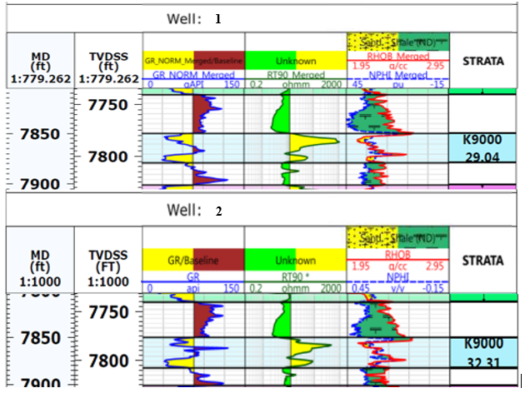

Figure 3: Log correlation showing K9000 interval WELL-1 and WELL-2

**K9100 Sand**

The K9100 reservoir consist of stacked sand deposits which have a blocky log pattern and a sharp basal contact with underlying shale as shown in Figure 4. The reservoir consists of majorly coarse to medium grained sand, moderately sorted, calcareous and ferruginized. The lithological characteristics and log pattern indicate the sediments were likely deposited within a distributary channel. The similarity in log motif and lithological characteristics across the wells indicate sediments from both wells were most likely deposited at the same period and within the same environment.



Figure 4: Log correlation showing K9100 interval WELL-1 and WELL-2

**L2000 – L9600 Sand**

The sediments deposited within the L2000 - L9600 zones are a mixture of sands and minor shale intercalations. The sands are multi-storey, medium to coarse grained and sometimes fine to very fine grained. The reservoirs consist of coarsening upward to blocky sand packages which can be correlated across the wells. The log patterns in some of the levels are shown in Figures 5 to 8. The environment of deposition is more or less an interplay of tidal and distributary channel with minor bar complexes. In some cases, channel cut into bar deposits or shoreface deposits and minor coarsening upward packages can be seen below the channel sands. A typical example is L9000 in Well 2. The minor shale intercalation was deposited during periods of low energy when there was little sediment supply.

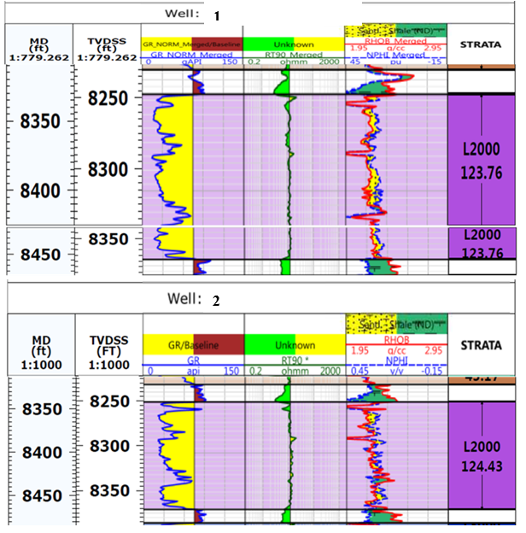

Figure 5: Log correlation showing L2000 interval WELL-1 and WELL-2

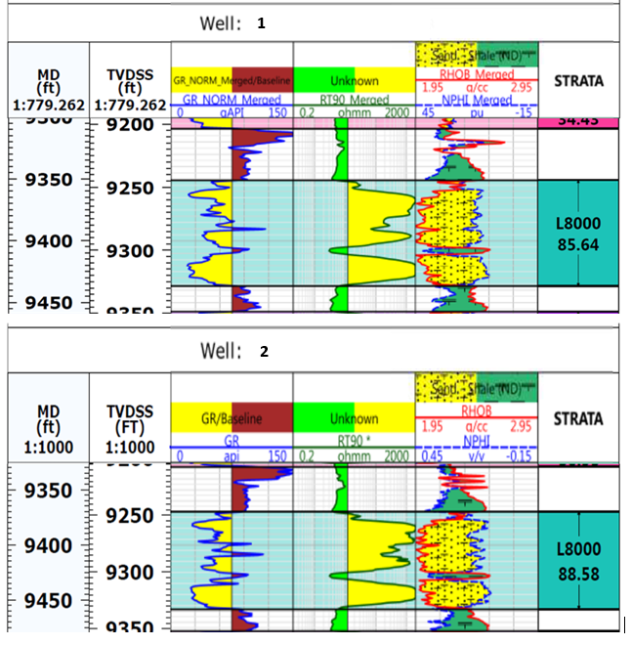

Figure 6: Log correlation showing L8000 interval WELL-1 and WELL-2

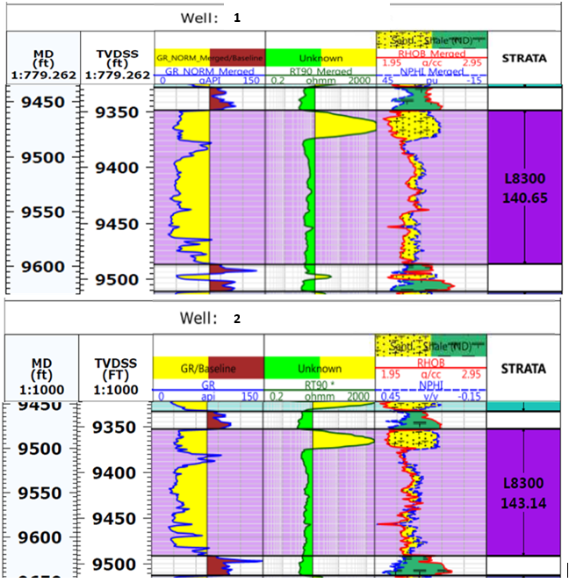

Figure 7: Log correlation showing L8300 interval WELL-1 and WELL-2

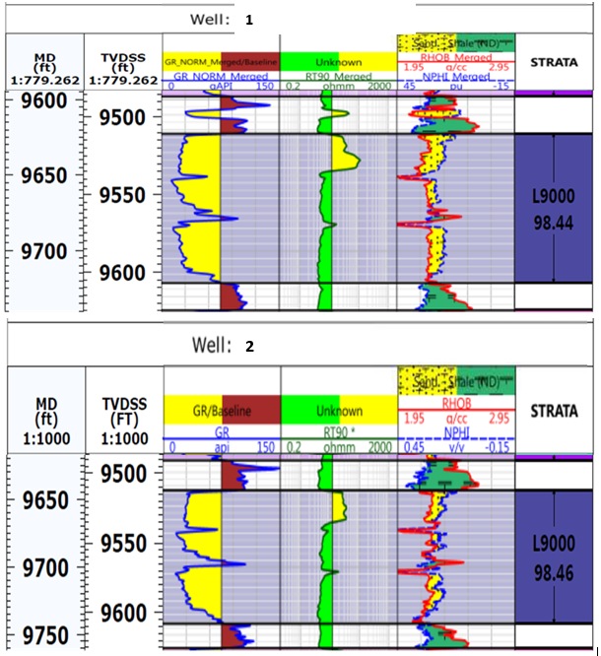

Figure 8: Log correlation showing L9000 interval WELL-1 and WELL-2

**M1000 – M9500 Sand**

The sediments deposited from M1000 - M9500 are predominantly made-up sand horizons with minor shale and silts intercalations. The sands are clean, smoky to dirty white, medium to coarse grained, moderately sorted, subangular to subrounded, calcareous and slightly ferruginous. The sand is multi-storey in nature and have majorly coarsening upward to blocky signature. The lithological characteristics and log signature indicate the sediment are distributary /tidal channel deposit which in most cases have sharp contact with underlying shales and blocky log pattern. Mouth bar deposits/ shoreface deposits are also presence and they show an obvious gradational contact. The log patterns are shown in Figures 9 to 11.

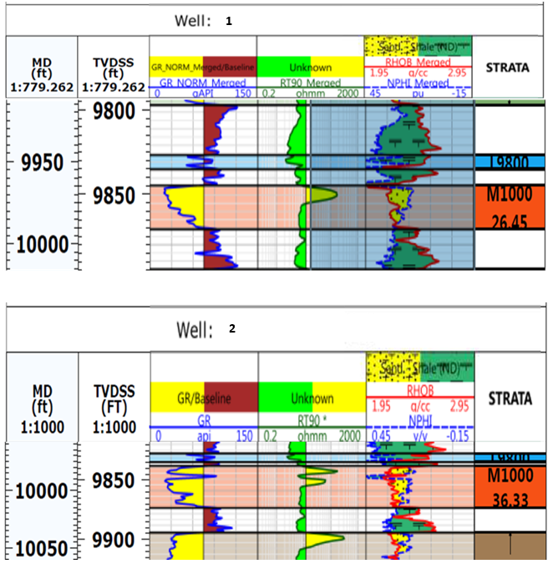

Figure 9: Log correlation showing M1000 interval WELL-1 and WELL-2

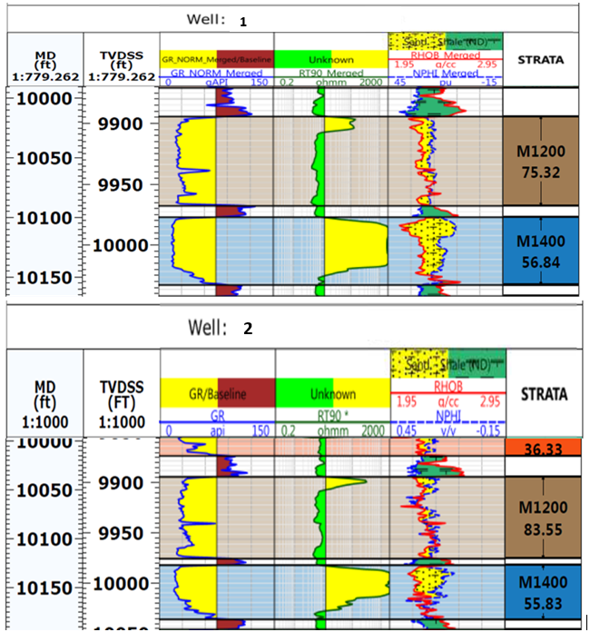

Figure 10: Log correlation showing M1200 interval WELL-1 and WELL-2

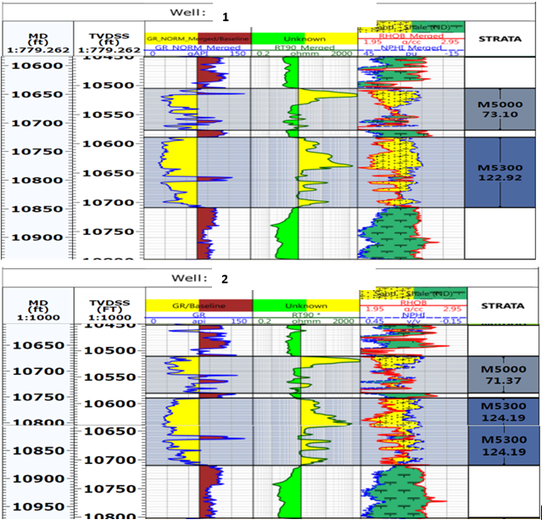

Figure 11: Log correlation showing M5300 interval WELL-1 and WELL-2

**Table 3: Percentage Distribution of Sediment Fractions Well-1**

|  |  |  |  |  |  |  |
| --- | --- | --- | --- | --- | --- | --- |
| PERCENTAGE DISTRIBUTION OF SEDIMENT FRACTIONS | | | | | | |
| S/No | **Depth (ft)** | **Coarse** | **Medium** | **Fine** | **Very fine** | **Silt/Clay** |
| 1 | 6295 - 6310 | 53.34 | 11.72 | 6.39 | 17.96 | 10.59 |
| 2 | 6445 - 6460 | 47.81 | 17.95 | 11.53 | 22.36 | 9.19 |
| 3 | 6770 - 6685 | 37.60 | 24.36 | 13.42 | 17.26 | 7.36 |
| 4 | 6875 - 6910 | 34.40 | 30.77 | 15.09 | 17.13 | 2.61 |
| 5 | 7750 - 7765 | 44.67 | 21.97 | 11.71 | 17.54 | 4.31 |
| 6 | 7840 - 7855 | 24.01 | 26.25 | 16.76 | 27.93 | 5.03 |
| 7 | 7855 - 7870 | 43.99 | 13.54 | 8.46 | 21.15 | 12.85 |
| 8 | 7900 - 7915 | 41.22 | 17.46 | 20.85 | 19.39 | 1.09 |
| 9 | 7915 - 7930 | 49.08 | 14.31 | 8.59 | 16.56 | 11.66 |
| 10 | 7930 - 7945 | 39.24 | 17.83 | 14.28 | 23.19 | 5.47 |
| 11 | 7960 - 7975 | 43.99 | 13.54 | 8.46 | 21.15 | 12.85 |
| 12 | 7975 – 7990 | 41.22 | 17.46 | 20.85 | 19.39 | 1.09 |
| 13 | 9070 – 9085 | 39.24 | 17.83 | 14.28 | 23.19 | 5.47 |
| 14 | 9355 - 9370 | 20.44 | 16.65 | 17.41 | 39.36 | 6.06 |
| 15 | 9370 - 9385 | 24.25 | 22.32 | 18.81 | 34.20 | 0.20 |
| 16 | 10240 - 10255 | 26.26 | 26.66 | 12.37 | 23.34 | 11.37 |
| 17 | 10255 – 10270 | 73.29 | 11.69 | 5.71 | 6.15 | 3.66 |
| 18 | 10435 -10450 | 25.91 | 21.90 | 12.73 | 20.56 | 12.06 |
| 19 | 10450 – 10465 | 27.78 | 22.14 | 11.29 | 22.07 | 16.72 |
| 20 | 10570 – 10585 | 29.67 | 34.60 | 13.44 | 16.77 | 3.06 |
| 21 | 10630 – 10645 | 56.58 | 15.04 | 7.99 | 13.61 | 6.56 |
| 22 | 10645 - 10650 | 51.30 | 15.50 | 8.98 | 17.03 | 7.20 |
| 23 | 10720 – 10735 | 59.96 | 15.21 | 8.30 | 12.74 | 3.80 |
| 24 | 10735 - 10750 | 21.77 | 26.06 | 21.09 | 21.45 | 1.83 |
| 25 | 10945 - 10960 | 32.61 | 21.67 | 12.25 | 19.82 | 13.40 |
| 26 | 10960 - 10975 | 16.33 | 20.86 | 14.83 | 34.26 | 13.72 |
| 27 | 11755 – 11770 | 36.63 | 21.70 | 13.24 | 22.74 | 5.72 |
| 28 | 11170 – 11785 | 19.02 | 19.87 | 18.30 | 22.62 | 20.19 |
| 29 | 11845 - 11860 | 49.69 | 24.30 | 9.12 | 16.71 | 0.38 |
| 30 | 11860 – 11875 | 36.84 | 14.52 | 12.28 | 32.72 | 3.18 |
| 31 | 12535 – 12550 | 48.97 | 17.61 | 9.77 | 21.92 | 1.78 |
| 32 | 12550 – 12565 | 43.30 | 31.94 | 17.77 | 6.84 | 0.16 |
| 33 | 12565 – 12580 | 18.54 | 19.40 | 15.13 | 22.97 | 23.95 |
| 34 | 12100 - 12115 | 27.56 | 36.07 | 25.38 | 10.53 | 0.46 |
| 35 | 12115 – 12130 | 40.92 | 25.94 | 10.23 | 22.70 | 0.21 |
| 36 | 12130 – 12145 | 47.00 | 15.01 | 8.37 | 13.89 | 15.74 |
| 37 | 12355 – 12370 | 50.14 | 22.45 | 10.69 | 16.93 | 0.52 |
| 38 | 12370 – 12385 | 42.24 | 36.90 | 10.01 | 10.73 | 0.12 |
| 39 | 12385 - 12400 | 47.81 | 17.71 | 9.40 | 12.63 | 12.48 |
| Average | | 38.84 | 20.98 | 12.96 | 19.99 | 7.02 |
| Range | | 18.56 -73.29 | 11.72 – 36.90 | 6.39 – 25.38 | 6.15 – 39.36 | 0.12 -23.95 |

**Table 4: Percentage Distribution of Sediment Fractions Well-2**

|  |  |  |  |  |  |  |
| --- | --- | --- | --- | --- | --- | --- |
| PERCENTAGE DISTRIBUTION OF SEDIMENT FRACTIONS | | | | | | |
| S/No | **Depth Interval (ft)** | **coarse** | **Medium** | **Fine** | **Very fine** | **Silt/Clay** |
| 1 | 7402 – 7420 | 54.45 | 15.78 | 11.61 | 17.39 | 0.77 |
| 2 | 7750 – 7785 | 60.21 | 14.95 | 12.00 | 11.95 | 0.86 |
| 3 | 7765 - 7780 | 61.30 | 11.65 | 8.04 | 18.00 | 1.01 |
| 4 | 7840 – 7855 | 30.26 | 23.46 | 17.66 | 20.44 | 8.07 |
| 5 | 7855 - 7870 | 26.42 | 20.46 | 26.40 | 22.77 | 5.61 |
| 6 | 7900 - 7915 | 20.44 | 16.65 | 17.41 | 39.36 | 6.06 |
| 7 | 7915 - 7930 | 18.76 | 29.82 | 21.85 | 21.59 | 8.49 |
| 8 | 7930 - 7945 | 27.18 | 23.98 | 28.78 | 17.59 | 2.40 |
| 9 | 7960 -7975 | 55.80 | 13.11 | 12.85 | 17.47 | 0.76 |
| 10 | 7973 - 7990 | 53.84 | 22.50 | 7.14 | 13.02 | 3.50 |
| 11 | 9085 - 9100 | 47.82 | 18.63 | 7.50 | 14.20 | 11.93 |
| 12 | 9460 - 9475 | 48.34 | 24.03 | 21.95 | 5.06 | 0.62 |
| 13 | 9745 - 9490 | 50.99 | 16.54 | 7.03 | 18.51 | 6.94 |
| 14 | 9595 - 9610 | 42.47 | 15.78 | 17.72 | 23.42 | 0.62 |
| 15 | 9955 - 9970 | 45.18 | 25.77 | 8.63 | 14.76 | 5.58 |
| 16 | 9970 - 9985 | 46.38 | 29.07 | 12.63 | 10.99 | 0.94 |
| 17 | 10015 - 10030 | 41.65 | 27.21 | 8.06 | 18.27 | 6.58 |
| 18 | 10030 - 10045 | 42.75 | 24.32 | 8.72 | 18.38 | 4.52 |
| 19 | 10570 - 10585 | 54.20 | 16.51 | 8.59 | 15.94 | 4.77 |
| 20 | 10585 - 10600 | 50.99 | 16.54 | 7.03 | 18.51 | 6.94 |
| 21 | 11170 - 11185 | 42.39 | 20.76 | 17.63 | 13.69 | 5.53 |
| 22 | 11185 – 1200 | 43.17 | 17.69 | 23.93 | 13.78 | 1.45 |
| 23 | 11200 – 1215 | 49.55 | 14.95 | 8.35 | 23.44 | 3.72 |
| 24 | 11425 – 1440 | 43.15 | 21.22 | 21.48 | 13.70 | 0.45 |
| 25 | 11440 – 1485 | 51.75 | 15.34 | 8.55 | 19.41 | 4.95 |
| 26 | 11485 –11500 | 40.56 | 30.07 | 7.69 | 12.94 | 8.74 |
| 27 | 11500 –11515 | 28.42 | 18.55 | 22.50 | 29.34 | 8.74 |
| 28 | 11290 –11305 | 52.68 | 26.18 | 5.36 | 8.20 | 7.57 |
| 29 | 11305– 11320 | 43.52 | 24.40 | 16.81 | 12.31 | 2.97 |
| 30 | 12100- 12115 | 70.61 | 21.87 | 6.19 | 1.04 | 0.27 |
| 31 | 12115– 12130 | 68.18 | 17.90 | 16.74 | 4.35 | 3.03 |
| 32 | 12130 - 12145 | 52.97 | 24.64 | 14.40 | 6.71 | 1.28 |
| Average | | 45.82 | 20.64 | 13.79 | 16.14 | 4.24 |
| Range | | 18.76 – 70.61 | 11.65 – 30.07 | 6.19 – 23.93 | 5.06 – 29.34 | 0.27 – 11.93 |

**Table 5: Grain Size Analysis for Well-1**

|  |  |  |  |  |  |  |  |  |  |  |
| --- | --- | --- | --- | --- | --- | --- | --- | --- | --- | --- |
| CALCULATED STATISTICAL DATA | | | | | | INTERPRETATION OF STATISTICAL DATA | | | | DISTRIBUTION TYPE |
| S/NO | **Depth (ft)** | **Mz** | **Sorting** | **Skewness** | **Kurtosis** | **Mz** | **Sorting** | **Skewness** | **Kurtosis** |
| 1 | 6295 - 6310 | 1.33 | 2.15 | 0.22 | 0.73 | Medium sand | Very poorly sorted | FS | Platykurtic | Bi-modal |
| 2 | 6445 - 6460 | 1.53 | 1.95 | -0.04 | 1.07 | Medium sand | Poorly sorted | NS | Mesokurtic | Bi-modal |
| 3 | 6770 - 6685 | 1.25 | 1.78 | -0.03 | 0.81 | Medium sand | Poorly sorted | NS | Platykurtic | Bi-modal |
| 4 | 6875 - 6910 | 1.57 | 1.45 | 0.04 | 0.68 | Medium sand | Poorly sorted | FS | Platykurtic | Uni-modal |
| 5 | 7750 - 7765 | 1.35 | 1.76 | -0.02 | 0.87 | Medium sand | Poorly sorted | NS | Platykurtic | Bi-modal |
| 11 | 7960 - 7975 | 2.09 | 1.12 | 0.17 | 0.73 | Fine sand | Poorly sorted | NS | Platykurtic | Bi-modal |
| 12 | 7975 – 7990 | 2.30 | 1.18 | -0.19 | 0.71 | Fine sand | Poorly sorted | NS | Platykurtic | Bi-modal |
| 13 | 9070 – 9085 | 2.10 | 1.37 | 0.05 | 0.79 | Fine sand | Poorly sorted | NS | Platykurtic | Bi-modal |
| 14 | 9355 - 9370 | 0.76 | 1.43 | 0.23 | 1.07 | Coarse sand | Poorly sorted | FS | Mesokurtic | Bi-modal |
| 15 | 9370 - 9385 | 1.10 | 1.67 | 0.12 | 1.94 | Medium sand | Poorly sorted | NS | Very leptokurtic | Bi-modal |
| 16 | 10240 - 10255 | 1.30 | 1.24 | 0.13 | 1.12 | Medium sand | Poorly sorted | NS | Mesokurtic | Bi-modal |
| 17 | 10255 – 10270 | 0.77 | 1.44 | 0.22 | 7.07 | Coarse sand | Poorly sorted | FS | Extremely leptokurtic | Bi-modal |
| 18 | 10435 -10450 | 2.00 | 1.66 | 0.29 | 0.63 | Fine sand | Poorly sorted | FS | Very Platykurtic | Bi-modal |
| 19 | 10450 – 10465 | 2.20 | 1.73 | 0.07 | 0.73 | Fine sand | Poorly sorted | NS | Platykurtic | Bi-modal |
| 20 | 10570 – 10585 | 1.67 | 1.24 | 0.21 | 0.85 | Medium sand | Poorly sorted | SFS | Platykurtic | Bi-modal |
| 21 | 10630 – 10645 | 1.02 | 1.89 | 0.51 | 0.82 | Medium sand | Poorly sorted | VSF | Platykurtic | Bi-modal |
| 22 | 10645 - 10650 | 1.57 | 1.03 | -0.13 | 1.08 | Medium sand | Poorly sorted | NS | mesokurtic | Bi-modal |
| 23 | 10720 – 10735 | 1.00 | 1.73 | -0.14 | 1.27 | Medium sand | Poorly sorted | NS | Very leptokurtic | Uni-modal |
| 24 | 10735 - 10750 | 1.80 | 1.36 | -0.03 | 0.76 | Medium sand | Poorly sorted | NS | Platykurtic | Bi-modal |
| 25 | 10945 - 10960 | 1.98 | 1.63 | 0.05 | 1.67 | Medium sand | Poorly sorted | NS | Very leptokurtic | Uni-modal |
| 26 | 10960 - 10975 | 2.63 | 1.96 | -0.23 | 1.31 | Fine sand | Poorly sorted | NS | Leptokurtic | Bi-modal |
| 27 | 11755 – 11770 | 1.55 | 1.52 | -0.12 | 1.82 | Medium sand | Poorly sorted | NS | Very Leptokurtic | Bi-modal |
| 28 | 11170 – 11785 | 2.57 | 1.52 | -0.10 | 0.75 | Fine sand | Poorly sorted | NS | Platykurtic | Bi-modal |
| 29 | 11845 - 11860 | 0.70 | 1.63 | 0.20 | 1.86 | Coarse sand | Poorly sorted | FS | Very leptokurtic | Uni-modal |
| 30 | 11860 – 11875 | 1.83 | 1.66 | -0.07 | 1.14 | Medium sand | Poorly sorted | NS | Leptokurtic | Bi-modal |
| 31 | 12535 – 12550 | 1.43 | 1.65 | 0.22 | 0.67 | Medium sand | Poorly sorted | FS | Platykurtic | Bi-modal |
| 32 | 12550 – 12565 | 1.30 | 1.14 | 0.15 | 0.89 | Medium sand | Poorly sorted | FS | Platykurtic | Bi-modal |
| 33 | 12565 – 12580 | 2.53 | 1.63 | -0.26 | 0.90 | Fine sand | Poorly sorted | CS | Platykurtic | Bi-modal |
| 34 | 12100 - 12115 | 1.60 | 1.14 | 0.11 | 1.38 | Medium sand | Poorly sorted | FS | Leptokurtic | Bi-modal |
| 35 | 12115 – 12130 | 1.57 | 1.46 | 0.19 | 1.28 | Medium sand | Poorly sorted | FS | Leptokurtic | Bi-modal |
| 36 | 12130 – 12145 | 1.70 | 1.62 | 0.05 | 0.76 | Medium sand | Poorly sorted | NS | Platykurtic | Bi-modal |
| 37 | 12355 – 12370 | 1.33 | 1.62 | 0.11 | 0.80 | Medium sand | Poorly sorted | FS | Platykurtic | Bi-modal |
| 38 | 12370 – 12385 | 2.55 | 1.57 | 0.37 | 0.92 | Fine sand | Poorly sorted | VFS | Mesokurtic | Bi-modal |
| 39 | 12385 - 12400 | 1.17 | 1.52 | 0.10 | 0.79 | Medium sand | Poorly sorted | FS | Platykurtic | Bi-modal |
| Average | | 1.59 | 1.54 | 0.07 | 1.20 | Medium sand | Poorly sorted | NS | Leptokurtic | Bi-modal |
| Range | | 0.70 – 2.63 | 1.03 – 2.15 | -0.26 to 0.51 | 0.63 – 7.07 | Coarse – fine sand | Very poorly to poorly sorted | VFS - CS | Very Platykurtic - very leptokurtic | Unimodal – bi-modal |

**Table 6: Grain Size Analysis for Well-2**

|  |  |  |  |  |  |  |  |  |  |  |
| --- | --- | --- | --- | --- | --- | --- | --- | --- | --- | --- |
| CALCULATED STATISTICAL DATA | | | | | | INTERPRETATION OF STATISTICAL DATA | | | | DISTRIBUTION TYPE |
| S/No | **Depth (ft)** | **Mz** | **Sorting** | **Skewness** | **Kurtosis** | **Mz** | **Sorting** | **Skewness** | **Kurtosis** |
| 1 | 7402 – 7420 | 0.88 | 1.83 | 0.12 | 0.96 | Coarse sand | Poorly sorted | FS | Mesokurtic | Bi-modal |
| 2 | 7750 – 7785 | 0.83 | 1.77 | 0.11 | 0.83 | Coarse sand | Poorly sorted | FS | Platykurtic | Uni-modal |
| 3 | 7765 - 7780 | 0.77 | 1.90 | 0.30 | 1.10 | Coarse sand | Poorly sorted | FS | Mesokurtic | Bi-modal |
| 10 | 7960 -7945 | 1.47 | 1.63 | 0.18 | 0.98 | Medium sand | Poorly sorted | FS | Mesokurtic | Bi-modal |
| 11 | 7973 - 7990 | 1.30 | 1.25 | 0.13 | 1.08 | Medium sand | Poorly sorted | FS | Mesokurtic | Bi-modal |
| 12 | 9085 - 9100 | 1.60 | 1.43 | 0.15 | 0.82 | Medium sand | Poorly sorted | FS | Platykurtic | Bi-modal |
| 13 | 9460 - 9475 | 1.32 | 1.53 | 0.31 | 0.80 | Medium sand | Poorly sorted | VFS | Platykurtic | Bi-modal |
| 14 | 9745 - 9490 | 1.10 | 1.58 | 0.25 | 0.73 | Medium sand | Poorly sorted | FS | Platykurtic | Bi-modal |
| 15 | 9595 - 9610 | 1.56 | 1.52 | 0.06 | 0.86 | Medium sand | Poorly sorted | NS | Platykurtic | Bi-modal |
| 16 | 9955 - 9970 | 1.40 | 1.33 | 0.33 | 0.70 | Medium sand | Poorly sorted | VFS | Platykurtic | Bi-modal |
| 17 | 9970 - 9985 | 0.63 | 1.75 | 0.19 | 0.60 | Coarse sand | Poorly sorted | FS | Very Platykurtic | Bi-modal |
| 18 | 10015 - 10030 | 0.93 | 1.76 | 0.15 | 0.70 | Coarse sand | Poorly sorted | FS | Platykurtic | Bi-modal |
| 19 | 10030 - 10045 | 1.10 | 1.67 | 0.12 | 1.94 | Medium sand | Poorly sorted | FS | Very leptokurtic | Bi-modal |
| 20 | 10570 - 10585 | 1.30 | 1.73 | 0.32 | 0.84 | Medium sand | Poorly sorted | VSF | Platykurtic | Bi-modal |
| 21 | 10585 - 10600 | 1.10 | 1.58 | 0.25 | 0.73 | Medium sand | Poorly sorted | FS | Platykurtic | Bi-modal |
| 22 | 11170 - 11185 | 1.57 | 1.55 | 0.07 | 0.83 | Medium sand | Poorly sorted | NS | Platykurtic | Bi-modal |
| 23 | 11185 – 1200 | 1.43 | 1.43 | 0.36 | 0.77 | Medium sand | Poorly sorted | VSF | Platykurtic | Uni-modal |
| 24 | 11200 – 1215 | 0.63 | 1.75 | 0.19 | 0.60 | Coarse sand | Poorly sorted | FS | Very Platykurtic | Bi-modal |
| 25 | 11425 – 1440 | 1.47 | 1.34 | 0.06 | 0.75 | Medium sand | Poorly sorted | NS | Platykurtic | Uni-modal |
| 26 | 11440 – 1485 | 1.11 | 1.75 | 0.25 | 0.65 | Medium sand | Poorly sorted | VSF | Platykurtic | Bi-modal |
| 27 | 11485 –11500 | 1.60 | 1.59 | 0.32 | 0.91 | Medium sand | Poorly sorted | VSF | Mesokurtic | Bi-modal |
| 28 | 11500 –11515 | 2.07 | 1.37 | -0.25 | 0.69 | Fine sand | Poorly sorted | CS | Platykurtic | Bi-modal |
| 29 | 11290 –11305 | 1.30 | 1.57 | 0.31 | 1.34 | Medium sand | Poorly sorted | VSF | Leptokurtic | Bi-modal |
| 30 | 11305– 11320 | 1.50 | 1.31 | 0.18 | 0.83 | Medium sand | Poorly sorted | FS | Platykurtic | Bi-modal |
| 31 | 12100- 12115 | 0.12 | 1.19 | -0.20 | 0.81 | Coarse sand | Poorly sorted | CS | Platykurtic | Bi-modal |
| 32 | 12115– 12130 | 0.73 | 1.54 | 0.15 | 0.80 | Coarse sand | Poorly sorted | FS | Platykurtic | Bi-modal |
| 33 | 12130 - 12145 | 0.77 | 1.49 | 0.01 | 1.44 | Coarse sand | Poorly sorted | NS | Leptokurtic | Bi-modal |
| Average | | 1.17 | 1.56 | 0.16 | 0.89 | Medium sand | Poorly sorted | FS | Mesokurtic | Bi-modal |
| Range | | 0.12 -2.07 | 1.19 – 1.90 | 1.94 to -0.36 | 0.60 – 1.94 | Coarse – fine sand | Poorly sorted | CS - VFS | Mesokurtic – very platykurtic | Uni-modal – bi-modal |

# DISCUSSION

# These variables were calculated, and histograms and cumulative frequency curves were used to visualize them. For both WELL-1 and WELL-2, the data are contrasted and discussed in connection to the environment of deposition. The findings for WELL-1 and WELL-2 demonstrate that average sorting and grain size are comparable, as are the ranges of sorting and skewness, however there is a difference in the range of values for kurtosis and grain size for the two analyzed sections. Similar features from grain size analysis were found in the examined sections of both wells, including average grain size, sorting, and skewness. Based on grain size analyses and potential correlation, they may have comparable depositional settings, which are characterized as fluvial. The mean, standard deviation, skewness, and kurtosis of the parameters were calculated. For WELL-1 and WELL-2, granulometry (grain size analysis or particle size distribution) was used in this investigation. The overall grain size distribution, size fraction percentages, textural maturity, surface textural attributes, sphericity/angularity, sediments fabric, density, porosity, and permeability are all fundamental characteristics of sedimentary rocks that can all be used to infer information about the particle or grain size. The fact that a particle's size is directly connected to the environment, the transport medium, the passage of time, and the depositional circumstances further increases the usefulness of a particle's size as an environmental proxy.

# The findings of the grain size study are summarized in Tables 1 and 2 for the 7840-7945ft (K9000 and K9100) depths from both WELL-1 and WELL-2. In tables 3 to 6, the findings for the remaining intervals representing the reservoirs L and M series are shown. For WELL-1, the average grain size, sorting, skewness, and kurtosis are, in order, 1.60 (0.33mm), 1.58, 0.06, and 1.20. For WELL-2, the average grain size, sorting, skewness, and kurtosis are, respectively, 1.30 (0.41mm), 1.59, 0.10, and 0.91. For the portions of WELL-1 that were analyzed, the derived statistical parameters' range is as follows. While the range of the calculated statistical parameters for the studied sections in WELL-2 is 0.12 - 2.07 (0.24-0.92mm coarse to fine grained sand), 1.19 - 1.90 (poorly sorted), -0.20 to 0.36 (very finely skewed - very coarse skewe), and 0.68 - 7.07 (very platykurtic - very leptokurtic), the range of the measured statistical parameters is 0.70 - 2.63 (0.1

# Data from grain size analysis reveals that all samples examined exhibit each of the three types of distribution (Tables 1 to 6). In WELL-1, the bimodal distribution is more prevalent than in WELL-2, which has a unimodal distribution pattern. The samples may not have undergone much reworking or re-deposition or they may have been deposited all at once. The dynamics of the deposited medium or mixes of two or more materials in more than two or more phases may be the cause of the bimodal distribution in WELL-1 and polymodal pattern of distribution in WELL-2 interval 7840 - 7855ft.

# Hydrodynamic sorting is produced by the spatial distribution of transport routes together with the various speeds of travel of each grain population. The range standard deviation for WELL-1 and WELL-2, which ranges from 1.19 to 1.90 and from 0.103 to 2.15 respectively, provides a hint as to the sorting range as well as the hydrodynamic conditions that prevailed in the deposition medium throughout the conveyance of those sediments. Porosity and permeability are connected to sorting. The standard deviation-based sorting outcome yields a range of values and is viewed as being badly to extremely poorly sorted. Because the sorting ranges in both wells are similar, the examined section's porosity and permeability may also be comparable.

# Permeability and porosity may be negatively impacted by the improper sorting of sediments, particularly silt and clay-sized solids. A high energy environment that was periodically interrupted by a low energy environment is likely implied by the alternating sequence of fine- and medium-grained sediments (which include silts and clays). The fines were deposited in the spaces between the medium clasts as the depositing medium's velocity decreased, most likely at the coastal edges. The sediments were most likely deposited in a distributary context, according to these samples from the two wells.

# For sediments recovered from the WELL-1 and WELL-2 wells, the combination of the lithological description and well logs (Gamma ray, Resistivity, and Neutron-Density logs) allows the assessment of the environment of deposition. For a few of the levels in WELL-1 and WELL-2, information on the inferred environment of deposition is given. The Agbada formation's usual intercalations of sand/sandstone, shale, and silt dominate the deposits. The properties of the sediments and the patterns in the logs suggest that they were probably deposited in habitats such as upper/lower shorefaces, tidal channels, or distributary channels. Iron-rich rocks from the sediment source area may have weathered and eroded, contributing to the high concentration of iron in the sediment observed in both wells. Figure 1 depicts the J7000 zone in both wells, which is mostly composed of fine to medium-grained sand with a little amount of shale. Because the log motifs in the top portion of this piece show a serrated log pattern, it represents a mixed environment with distributary and tidal waterways.

# The fining upward pattern in the center part most likely denotes a shoreface habitat or a mouth bar deposit. With mostly coarse to medium grained sands and a blocky to fining upward log pattern, the bottom part presumably represents a separate distributary habitat. In both wells, the K8000 reservoir exhibits a coarsening upward to blocky patterns with a strong and gradational basal contact, as seen in Fig. 2. The correlation of the sands (A and B) between wells suggests that the depositional environment is the same in both wells. A layer of interbedded shale that was most likely formed during a time of low environmental energy makes up the reservoir, which is mostly composed of coarse to fine-grained sandstone. With sediment varying in grain size from coarse to fine, Sand A shows an upward-fining pattern with a strong basal contact that most likely points to a point bar deposit inside a channel environment. Sand B has a gradational contact with the underlying shale and a coarsening upward trend. This suggests that the sediments, which range in grain size from coarse to fine, were probably deposited in a mouth bar habitat or inside a shoreface environment. The calculated variables were represented by histograms and cumulative frequency curves. The data for WELL-1 and WELL-2 are compared and discussed in relation to the deposition environment. The results show that average sorting and grain size are comparable for WELL-1 and WELL-2, as are the ranges of sorting and skewness. However, there is a difference in the range of values for kurtosis and grain size for the two analyzed sections. Both wells' examined sections shared characteristics from grain size analysis, such as average grain size, sorting, and skewness. Grain size analyses and potential correlation suggest that they may have similar depositional settings, which are classified as fluvial. Calculations were made for the parameters' means, standard deviations, skewness, and kurtosis. Granulometry (grain size analysis or particle size distribution) was employed for WELL-1 and WELL-2 in this investigation. Fundamental features of sedimentary rocks that can all be used to infer information about the particle or grain size include the overall grain size distribution, size fraction percentages, textural maturity, surface textural attributes, sphericity/angularity, sediments fabric, density, porosity, and permeability. The value of a particle's size as a proxy for the environment is further enhanced by the fact that it is directly related to the environment, the transport medium, the passage of time, and the depositional circumstances. For the 7840-7945ft (K9000 and K9100) depths from both WELL-1 and WELL-2, the results of the grain size study are compiled in Tables 1 and 2. The results for the remaining intervals, which correspond to the reservoirs L and M series, are displayed in tables 3 to 6. The average grain size, sorting, skewness, and kurtosis for WELL-1 are 1.60 (0.33mm), 1.58, 0.06, and 1.20, respectively. The average grain size, sorting, skewness, and kurtosis for WELL-2 are 1.30 (0.41mm), 1.59, 0.10, and 0.91, respectively. The derived statistical parameters' range is as follows for the WELL-1 sections that were examined. While the calculated statistical parameters for the studied sections in WELL-2 range from 0.12 to 2.07 (0.24-0.92mm coarse to fine grained sand), from 1.19 to 1.90 (poorly sorted), from -0.20 to 0.36 (very finely skewed to very coarse skewe), and from 0.68 to 7.07 (very platykurtic to very leptokurtic), the measured statistical parameters range from 0.70 to 2.63 (0.1 to 0.1 mm). All of the samples analyzed exhibit each of the three types of distribution, according to data from grain size analysis (Tables 1 to 6). Compared to WELL-2, which has a unimodal distribution pattern, bimodal distribution is more common in WELL-1. The samples could have been deposited all at once or with little to no reworking or re-deposition. The bimodal distribution in WELL-1 and the polymodal pattern of distribution in WELL-2 interval 7840 - 7855ft may be caused by the dynamics of the deposited medium or mixes of two or more materials in more than two or more phases.

# The spatial distribution of the transport routes and the various travel speeds of each grain population lead to hydrodynamic sorting. The sorting range as well as the hydrodynamic conditions that prevailed in the deposition medium throughout the conveyance of those sediments are indicated by the WELL-1 and WELL-2 range standard deviations, which, respectively, range from 1.19 to 1.90 and from 0.103 to 2.15. Sorting is related to porousness and permeability. The results of sorting using standard deviations produce a variety of values and are judged to be poorly to extremely poorly sorted. The porosity and permeability of the examined section may be comparable due to the similarity of the sorting ranges in both wells.

# The wrong classification of sediments, especially silt and clay-sized solids, may have detrimental effects on permeability and porosity. The alternating sequence of fine- and medium-grained sediments is likely indicative of a high energy environment that was occasionally broken by a low energy environment (which include silts and clays). The fines were most likely deposited at the coastal edges as the velocity of the depositing medium decreased, in the spaces between the medium clasts. According to these samples from the two wells, the sediments were most likely deposited in a distributary context.

# The lithological description and well logs (Gamma ray, Resistivity, and Neutron-Density logs) used in conjunction with the sediments recovered from the WELL-1 and WELL-2 wells allow for the assessment of the deposition environment. Information on the assumed deposition environment is provided for a few of the levels in WELL-1 and WELL-2. The deposits are dominated by sand/sandstone, shale, and silt intercalations, which are typical of the Agbada formation. It is likely that the sediments were deposited in habitats like upper/lower shorefaces, tidal channels, or distributary channels based on the characteristics of the sediments and the patterns in the logs. The high concentration of iron in the sediment found in both wells may be the result of iron-rich rocks from the sediment source area that have weathered and eroded.

# The J7000 zone, which is primarily made up of fine to medium-grained sand with a small amount of shale, can be seen in both wells in Figure 1. This piece's top portion, which has log motifs with a serrated log pattern, depicts a mixed environment with distributary and tidal waterways. Most likely, the fining upward pattern in the center part indicates a mouth bar deposit or a habitat on a shoreface. The lower portion likely represents a distinct distributary habitat since it is composed of of coarse to medium grained sands and has a blocky to fining upward log pattern. According to Fig. 2, the K8000 reservoir in both wells displays a coarsening upward to blocky patterns with a strong and gradational basal contact. The A and B sands' correlation between wells implies that the depositional environment in both wells is the same. The reservoir is dominated by coarse to fine-grained sandstone and is underlain by a layer of interbedded shale that most likely originated during a period of low environmental energy. Sand A has an upward-fining pattern with a strong basal contact, which most likely indicates a point bar deposit inside a channel environment. The sediment's grain sizes range from coarse to fine. With respect to the underlying shale, Sand B displays gradational contact and an upward tendency toward coarsening. This implies that the sediments, whose grain sizes range from coarse to fine, were probably deposited in a shoreface environment or in a mouth bar habitat.

# 

# CONCLUSION

The petrographic analysis of WELL-1 and WELL-2 in the Niger Delta reveals significant insights into the sediment characteristics and depositional environments of the studied sections.

For WELL-1, the average grain size is 1.60 ± 0.33 mm (medium grain size), with a range of grain sizes from 0.70 to 2.63 mm and 0.16 to 0.61 mm (fine to coarse grain). The average sorting, skewness, and kurtosis are 1.58 (poorly sorted), 0.06 (coarse skewed), and 1.20 (leptokurtic), respectively. The ranges for sorting, skewness, and kurtosis are 1.03 to 2.15 (very poorly to poorly sorted), -0.02 to 0.51 (very finely skewed to coarse skewed), and 0.63 to 7.07 (very platykurtic to very leptokurtic).

For WELL-2, the average grain size is 1.30 ± 0.41 mm (medium grain sand), with a range of 0.12 to 2.07 mm and 0.24 to 0.92 mm (coarse to fine grain). The average sorting, skewness, and kurtosis are 1.59 (poorly sorted), 0.10 (coarse skewed), and 0.91 (leptokurtic). The ranges for sorting, skewness, and kurtosis are 1.19 to 1.90 (very poorly to poorly sorted), -0.02 to 0.36 (very finely skewed to very coarse skewed), and 0.63 to 1.94 (mesokurtic to very platykurtic).

The ditch cutting samples from both wells were subjected to thorough lithologic descriptions, improving the evaluation of the samples in terms of rock type, grain size, sorting, form, color, and accessories. Sedimentary facies were determined using each log answer separately. The linkage of lithologic characteristics and log signatures was used to interpret depositional environments. The sediments from both wells are indicative of the Agbada Formation of the Niger Delta. According to sample descriptions, the lithologies include sand, sandstone, siltstone/silt, and intercalated shale. These sediments were deposited in environments such as upper/lower shorefaces and channels (distributary, fluvial, and tidal). The bimodal distribution pattern in both wells, indicating a mixture of coarse and fine components, suggests dynamics in the depositing medium or mixtures of materials. The similar characteristics observed in grain size analysis, particularly the medium-sized average grain and slightly poor sorting, suggest similar depositional environments, likely fluvial settings. These environments can be correlated across the wells.

1. The reservoirs consist of coarsening upward to blocky sand packages, which can be correlated across the wells, as indicated in the log patterns.
2. The studied sections in both wells share similar characteristics in grain size and sorting, depicting similar depositional environments.

# REFERENCES

Adesida, A.A., T.J.A. Reijers, C.S. Nwajide, (1977), Sequence stratigraphic framework of the Niger delta basin. Vienna, Austria, AAPG International Conference and Exibition v. 81, p.1359.

Allen, J.R.L., (1965), Late Quaternary Niger Delta, and adjacent areas-sedimentary environments and lithofacies: AAPG Bulletin, v.49, p.547-600

Arochukwu, E., (2014). Assessing the impact of reservoir architecture on secondary recovery: A case study of “century” field, Niger Delta. Proceedings of the NAPE Monthly Technical Meeting, (MTM’ 14), Port Harcourt, Nigeria.

Beka, F. T., and M. N. Oti, (1995), The distal offshore Niger delta: frontier prospects of a mature petroleum province, in Oti, M.N., and G. Postma, eds., Geology of deltas: Rotterdam, A. A. Balkema, p. 237-241.

Burke KC, Dessauvagie TF, Whiteman AJ (1972) Geologic history of the Benue Valley and adjacent areas. In: Dessauvagie TFJ, Whiteman AJ (eds) African Geology. Ibadan University Press, Ibadan, pp 187–205

Bustin, R. M., (1988), Sedimentology and characteristics of dispersed organic matter in Tertiary Niger delta: Origin of source rocks in a deltaic environment: AAPG Bulletin, v. 72, p. 277-298.

Doust, H. and E. Omatsola, (1989). Niger delta: AAPG Memoir 48 p. 201-238.

Doust, H., and E. Omatsola, (1990), Niger delta: in J. D. Edwards and P.A. Santogrossi, eds., Divergent/passive margin basins: AAPG Memoir 48, p. 239-248.

Edwards, J.D., and Santogrossi, P.A., (1990), Summary and conclusions, in, Edwards, J.D., and Santogrossi, P.A., eds., Divergent/passive Margin Basins, AAPG Memoir 48: Tulsa, American Association of Petroleum Geologists, P. 239-248.

Ejedawe, J.E., (1981), Patterns of incidence of oil reserves in Niger delta basin AAPG Bulletin, v. 65, p.1574-1585.

Ekweozor, C.M., and J.I. Okogun, D.E.U. Ekong and J.R. Maxwell, (1979), Preliminary organic geochemical studies of samples from the Niger delta, Nigeria: part 1, analysis of crude oils for triterpanes: Chemical Geology, v. 27, p.11-28.

Ekweozor, C.M. and N.V. Okoye, (1980), Petroleum source-bed evaluation of Tertiary Niger Delta: AAPG Bulletin, v. 64, p. 1251-1259.

Evamy, B.D., J. Haremboure, R. Kammerling, W.A. Knaap, F.A. Molloy, and P.H. Rowlands, (1978). Hydrocarbon habitat of tertiary Niger Delta: AAPG Bulletin, v.62:1-39.

Fitch, P.J.R., M.D. Jackson, G.J. Hampson and C.M. John, (2014). Interaction of stratigraphic and sedimentological heterogeneities with flow in carbonate ramp reservoirs: Impact of fluid properties and production strategy. Petroleum Geosci., 20: 7-26. DOI: 10.1144/petgeo2013-014

Folk, R. L and Ward, W. (1957). Brazos River Bar: A study of the Significance of Grain Size Parameters. Journal of Sedimentary Petrology 27, P 3 – 6.

Friedman, G.M., Sanders, J. E. and Kopaska-Merkel, D. C. (1992). Principles of Sedimentary Deposit: Stratigraphy and Sedimentology. McMillan New York.

Haack, R.C., Sundararajan and J. Dahl, (1997), Niger delta petroleum system: Presented at the 1997 AAPG/ABGP Hedberg Research symposium, Rio de Janeiro, Brazil, extended abstracts.

Herron, M.M. (1988). Geochemical Classification of Terrigenous Sands and Shales from Core or Log Data. Journal of Sedimentary Petrology, 58, 820-829.

Keele, D. and J. Evans, (2008). Analysis of reservoir properties of faulted and fractured eolian thrust-belt reservoirs. Utah Geological Survey.

Kulke, H., (1995), Nigeria, in H. Kulke, ed., regional petroleum geology of the world. Part II: Africa, America, Australia and Antarctica: Berlin, Gebruder Borntraeger, p.143-172.

Lambert-Aikhionbare, D.O. and A.C. Ibe, (1984), Petroleum source-bed evaluation of the Tertiary Niger Delta: discussion: AAPG Bulletin, v. 68, p. 387-394.

Michele, L.W., Tuttle, R., Charpentier, R. & Michael, E.B., (1999). The Niger Delta Petroleum System: Niger Delta Province, Nigeria, Cameroon, and Equatorial Guinea, Africa. U.S. Geologic Sur-vey, 35 pp.

Nwangwu, U., (1990), A unique, hydrocarbon trapping mechanism in the offshore Niger Delta, in Oti, M.N., and G. Postma, eds., Geology of Deltas: Rotterdam, A. A. Balkema, p.269-278.

Nwozor K, Omudu M, Ozumba B, Odoh B (2012) A relationship between diagenetic clay minerals and pore pressures in an onshore Niger Delta Field. Petrol Tech Dev J 2: 10-11.

Ogbimi, A.E., Nwachukwu, J., and Beka, F.T. (2015). Integration of Petrophysical and Geological Analysis in the Development of the “Beta” Field, onshore Niger Delta. Book of Abstract for the 51st Annual International Conference and Exhibition of the Nigerian Mining and Geosciences Society (NMGS), March 2015, Lagos.

Oomkens, E., (1974). Lithofacies relations in late Quaternary Niger delta complex: Sedimentology, v.21, p.195-222.

Petters, S. W., (1978), Stratigraphic evolution of the Benue trough and its implications for the Upper Cretaceous paleography of West Africa: Journal of Geology, v. 86, p. 311-322.

Pettijohn, F.J., Potter, P.E. and Siever, R. (1972) Sand and Sandstone. Springer-Verlag, Berlin.

Reading HG, Levell BK (1996) Controls on the sedimentary record. In: Reading HG (ed) Sedimentary environments: processes, facies and stratigraphy. Blackwell Science, Oxford, pp 5–36

Sam Boggs, Jr., *Principles of Sedimentology and Stratigraphy*, 3rd ed. (2001);

Shanmugam G. (2006). "The Tsunamite Problem". Journal of Sedimentary Research. 6 (5): 718–730. Bibcode:2006JSedR. 76..718S. doi:10.2110/jsr.2006.073.

Short, K. C., and A. J. Stauble, (1967), Outline of Geology of Niger delta: American Association of Petroleum Geologists Bulletin v. 51, p. 761-779.

Slatt, R.M., (2006). Stratigraphic Reservoir Characterization for Petroleum Geologists, Geophysicists and Engineers. 1st Edn., Elsevier Science, pp: 492.

Snedden, J.W. and K.M. Bergman, (1999). Isolated Shallow Marine Sand Bodies: Deposits for all Interpretations. In: Isolated Shallow Marine Sand Bodies: Sequence Stratigraphic\Analysis and Sedimentologic Interpretation, Bergman, K.M. and J.W. Snedden (Eds.), SEPM Special Publication, pp: 1-11.

Stacher, P.,(1995), Present understanding of the Niger delta hydrocarbon habitat, in Oti, M. N. and Postma, G., eds., Geology of deltas: Rotterdam, A.A. Balkema, p. 257-267.

Stuart R. Taylor and Scott M. McLennan, The Continental Crust: Its Composition and Evolution: An Examination of the Geochemical Record Preserved in Sedimentary Rocks (1985);

Tuttle, M. L. W., R. R. Charpentier and M. E. Brownfield, (1999), The Niger delta petroleum system: Niger delta province, Nigeria, Cameroon, and Equatorial Guinea, Africa: USGS Open-file report 99-50-H.

Walker, J.T. (2012). Log patterns and their significance in Facies Description and Environments of Deposition. Journal of Sedimentary research. doi: 10.1306/212F91D3-2B24-11D7-8648000102C1865D.

Weber, K.J. and E.M. Daukoru, (1975), Petroleum geology of the Niger delta: Proceedings of the 9th World Petroleum Congress, Tokyo, v. 2, p. 202-221.

Weber, K.J., (1986), Hydrocarbon distribution patterns in Nigerian growth fault structures controlled by structural style and stratigraphy: AAPG Bulletin, v. 70 p. 661-662.