## **Thermal analysis on Al7075/Al2O3 metal matrix composites fabricated by stir casting process**

**M.Manikandan, K.B.Yogeshwaran, Dr.C.K. Dhinakarraj**

(ME - Thermal Engineering) Adhiparasakthi Engineering College Melmaruvathur.

(ME - Thermal Engineering)Assistant Professor in Adhiparasakthi Engineering College Melmaruvathur.

Ph.D., HoD, Of Mechanical Engineering Adhiparasakthi Engineering College Melmaruvathur.

**ABSTRACT**

Metal matrix composites (MMCs) have recently gained considerable attention in the aerospace, renewable energy, and automotive industries due to their exceptional strength, cost-effectiveness, widespread availability, and high-temperature resistance. Traditional materials often suffer from rapid crack formation and propagation without significant warning, making composite materials a preferred choice to address these issues. MMCs are designed to integrate the advantageous properties of metals and alternative reinforcements. In this study, silicon carbide (SiC) is used as the reinforcement material instead of ceramics. The stir casting method is employed to produce aluminium metal matrix composites (AMCs). One of the main challenges in this process is achieving a uniform distribution of silicon carbide particles to ensure a flawless microstructure. By carefully controlling processing parameters such as stirring time, melt temperature, and blade angle, the desired microstructure can be obtained. This research focuses on developing high-strength particulate-reinforced aluminium metal matrix composites, utilizing Al7075, which combines high strength with the ductility of the metal matrix. The composites will be evaluated through standard metallurgical and mechanical tests. Material properties for the Aluminium composite Al7075/SiC with 35% and 45% Sic were obtained from a reference study. The heat flux generated in a flat plate with these compositions was simulated using ANSYS 2024R1 Software. The results indicate that AL7075 with 45% Sic exhibits significantly lower heat flux distribution compared to the 35% composition, attributed to its lower thermal conductivity.

**Keywords**: AMC, Al2O3,AL7075,Aluminum

**1. Introduction**

Metal-ceramic composites have recently gained traction for advanced engineering applications. Typically, these composites are created using a soft metal base material, reinforced with a hard ceramic component. This combination merges the desirable properties of metals—such as ductility and toughness—with those of ceramics, including high hardness, strength, and modulus. The result is a composite with superior compressive and shear strength, along with enhanced service temperature capabilities. Metal-ceramic composites, also known as metal matrix composites (MMCs), represent a new generation of engineering materials designed to meet multiple functions across various fields. Significant advancements have been made in the development of MMCs, enabling their use in high-performance structures like those in the aerospace, automotive, and armor industries.

Among these, aluminum-based metal matrix composites have become particularly popular due to their high modulus, stiffness, strength-to-weight ratio, and resistance to corrosion and wear. These composites demonstrate better mechanical properties compared to traditional metals and alloys. The characteristics of MMCs are influenced by several factors, including the properties of the base material, volume fraction, shape, size, and arrangement of the reinforcement. For instance, aluminum alloy-alumina silicate particulate composites have shown longer fatigue lives than unreinforced aluminum alloys at lower stress levels but shorter fatigue lives at higher stress levels, regardless of reinforcement fractions.

The wear and friction behavior of a sand-cast brake rotor made from A359-20 vol% SiC particle composites, sliding against automotive friction materials, has been studied, revealing that the wear resistance of the composites is closely related to the hardness and strength of the SiC particles. Studies have also examined the microstructure and properties of aluminum-based metal matrix composites reinforced with ZnO whiskers, as well as the thermal conductivity of aluminum oxide particulate-reinforced aluminum composites. It was observed that the thermal conductivity of these composites is significantly affected by the volume fraction of aluminum oxide. Adding silicon carbide particulates has been reported to enhance the hardness, mechanical properties, and sliding wear resistance.

The mechanical properties of Al/SiC metal matrix composites have been evaluated by varying the weight fractions and particle sizes of the SiC reinforcement. Results indicated that both hardness and density increased with the rise in SiC particulate size and weight fraction. Optical micrographs showed a reasonably uniform distribution of SiC particles within the aluminum matrix. Tensile strength was also found to increase with larger particulate size and higher weight fractions, while impact strength decreased with increasing particulate size but improved with higher weight fractions of SiC particles.

Many industrial applications—such as gears, gas turbines, engine components, wear-resistant linings, and armors—require the joining of ceramics to metals or alloys for multifunctional purposes. In this study, commercially available aluminum powder was used as the matrix material, with aluminum oxide serving as the reinforcement. Aluminum-aluminum oxide composites containing different volume fractions of aluminum oxide particulates were prepared under varying compaction loads of 15 tons and 20 tons. The effects of compaction load and volume fraction of aluminum oxide particulates on the properties of Al-TiC composites were then examined, focusing on properties such as density, hardness, and tensile strength.

**2. literature Survey**

Over the past three decades, intensive research in materials science has led to significant innovations in synthesizing specialized materials that offer enhanced efficiency and reduced manufacturing costs, addressing the long-standing needs of the engineering sector. A novel class of materials, featuring hard particulates embedded within a metal matrix, has demonstrated superior performance and improved tribological properties. Among these metal matrix composites (MMCs), aluminum alloy-based composites have shown remarkable improvements in mechanical, thermal, electrical, and wear properties, meeting the demands of various industries. Aluminum alloys are considered versatile materials suitable for numerous engineering applications due to their excellent machining, joining, and processing capabilities. Additionally, their low cost, high strength-to-weight ratio, and environmentally friendly characteristics make them a preferred choice in engineering.

Among aluminum alloys, the Al-Si alloy is well-known as a casting alloy, prized for its high wear resistance, low thermal expansion coefficient, and good corrosion resistance, along with enhanced mechanical properties across a wide temperature range. Grain refiner elements improve the Si morphology from coarse to fine, thereby boosting the mechanical properties.

Researchers have developed numerous composite materials using various matrix types, reinforcement sizes, shapes, and volumes, along with appropriate processing techniques, depending on the specific requirements and applications. To achieve optimal properties in metal matrix composites, it is essential to ensure uniform distribution of the second phase within the matrix alloy, and to optimize the wettability or bonding between these materials.

Rao and Das developed cast aluminum-alumina composites by incorporating alumina particles into the molten alloy while stirring it with an impeller, a process known as stir casting. The introduction of non-wetting particles into alloys was further facilitated by adding alloying elements like magnesium during the composite synthesis.

Prasad et al. initiated the practice of adding particles to semi-solid alloys at temperatures between the solid and liquid phases of the alloy. The wear behavior of ceramic particle-reinforced aluminum matrix composites (AMCs) has been extensively studied, with reinforcement materials including SiC, TiC, B4C, fly ash, TiB2, Al3Zr, among others, used either singly or in hybrid combinations.

Doel and Bowen (1996) investigated the effect of SiC particles on the tensile behavior of composites, concluding that all composites exhibited lower ductility compared to the unreinforced material. Composites containing fine SiC particles (5 µm) were relatively more ductile, whereas those reinforced with coarse SiC particles (60 µm) showed very low ductility. Composites with 5 and 13 µm particles demonstrated higher 0.2% proof stress and tensile strength than the unreinforced material. However, the composite with 60 µm particles had lower 0.2% proof stress and tensile strength compared to the unreinforced alloy.

Sahin and Murphy (1996) observed that the hardness of Al-Boron fiber MMCs and the matrix alloy increased linearly, while their densities decreased linearly with the volume percentage of boron fiber (0-32 vol.%). The average wear rate of a 32 vol.% fiber composite in normal orientation was reduced by approximately 84% compared to the matrix alloy.

Lin et al. (1998) noted a decrease in the tensile properties of a 6061 aluminum alloy/0-6 wt.% graphite particulate composite, though the hardness remained virtually unchanged..

**3. COMOPSITE MATERIAL**

The matrix in composite materials serves as a medium that binds and holds the reinforcements together into a solid structure. It not only protects the reinforcements from environmental damage but also transfers load and contributes to the material's finish, texture, color, durability, and functionality.

**Applications of Composite Matrix Materials:** Composite matrix materials are used in a variety of applications, including:

* Electrical moldings
* Decorative laminates
* High-performance cookware
* Sealants and gaskets
* Heat shield systems, which are capable of withstanding high temperatures, thermal shock, and heavy vibration
* Components for high-temperature gas turbines, such as combustion chambers, stator vanes, and turbine blades
* Brake discs and other brake system components used in extreme thermal shock environments
* Slide bearing components under heavy loads, where high corrosion and wear resistance are required
* Carbide drills, which consist of a tough cobalt matrix with embedded hard tungsten carbide particles
* Components for burners, flame holders, and hot gas ducts

**Metal Matrix Composites (MMC):** A metal matrix composite (MMC) is a type of composite material that consists of at least two constituent parts, one of which is a metal. The other material could be another metal or a different type of material, such as a ceramic or an organic compound. When three or more materials are present, the composite is referred to as a hybrid composite. MMCs are closely related to cermets.

**Composition:** MMCs are created by dispersing a reinforcing material within a metal matrix. The surface of the reinforcement can be coated to prevent any chemical reactions with the matrix. For instance, carbon fibers are often used in an aluminum matrix to produce composites with low density and high strength. However, carbon can react with aluminum, forming a brittle and water-soluble compound known as Al4C3 on the fiber surface. To prevent this, carbon fibers are typically coated with nickel or titanium boride.

**Matrix:** The matrix is the continuous, monolithic material into which the reinforcement is embedded. This continuity allows for a path through the matrix to any point within the material, unlike in a structure where two materials are merely layered together. In structural applications, the matrix is often a lightweight metal such as aluminum, magnesium, or titanium, providing a compliant support for the reinforcement. For high-temperature applications, matrices made of cobalt or cobalt-nickel alloys are commonly used.

**Reinforcement:** The reinforcement is the material embedded within the matrix, and its role isn't always purely structural. It can also be used to alter physical properties like wear resistance, friction coefficient, or thermal conductivity. Reinforcement can be either continuous or discontinuous. Discontinuous MMCs are typically isotropic and can be processed using standard metalworking techniques such as extrusion, forging, or rolling. These composites may also be machined using conventional methods, though polycrystalline diamond tooling (PCD) is often required.

Continuous reinforcement involves the use of monofilament wires or fibers, such as carbon fiber or silicon carbide. Since these fibers are embedded in the matrix in a specific direction, the resulting structure is anisotropic, with its strength depending on the alignment of the material. One of the earliest MMCs used boron filament for reinforcement. Discontinuous reinforcement utilizes "whiskers," short fibers, or particles, with common reinforcing materials in this category including alumina and silicon carbide.

**THERMAL ANALYSIS:**

Thermal analysis is a field of materials science focused on studying how the properties of materials change with temperature. Various methods are employed in thermal analysis, each distinguished by the specific property being measured:

* **Dielectric Thermal Analysis (DEA):** Measures dielectric permittivity and loss factor.
* **Differential Thermal Analysis (DTA):** Records temperature difference relative to temperature or time.
* **Differential Scanning Calorimetry (DSC):** Monitors changes in heat flow as a function of temperature or time.
* **Dilatometry (DIL):** Observes volume changes in response to temperature variations.
* **Dynamic Mechanical Analysis (DMA or DMTA):** Assesses storage modulus (stiffness) and loss modulus (damping) against temperature, time, and frequency.
* **Evolved Gas Analysis (EGA):** Analyzes gases released during the heating of a material, typically decomposition products.
* **Laser Flash Analysis (LFA):** Determines thermal diffusivity and thermal conductivity.
* **Thermo Gravimetric Analysis (TGA):** Measures mass changes relative to temperature or time.
* **Thermo Mechanical Analysis (TMA):** Evaluates dimensional changes as a function of temperature or time.
* **Thermo-Optical Analysis (TOA):** Investigates optical properties.
* **Derivatography:** A complex method combining multiple aspects of thermal analysis.

Thermal analysis plays a crucial role in calculating temperature distribution and heat transfer within and between components in a design and its environment. This is essential in design considerations, as many materials and products have properties that vary with temperature. Additionally, product safety is a key factor—if a product or component becomes too hot, it might require a protective guard in the design

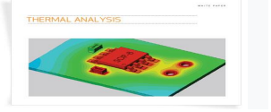

**Fig-1.Thermal analysis**

Heat flow through components can either be steady-state, where the heat flow remains constant over time, or transient, where it varies. In thermal analysis, a steady-state analysis is similar to a linear static structural analysis, while a transient thermal analysis parallels a dynamic structural analysis. Heat transfer issues can be addressed using either structural or fluid flow analysis techniques. In thermal structural analysis, the effects of moving air or liquids are approximated with a set of boundary conditions or loads. Conversely, in thermal fluid analysis, the effects of air or liquid are directly computed, which increases both the computational time and the accuracy of the solution.

**4. MODULES**

The project analysis consists of three phases: modeling, meshing, and simulation. The modeling phase involves creating a 3D design of a flat plate with dimensions 400 x 250 x 20 mm.

**Model:**



**Meshing:**

Meshing is a crucial aspect of the Finite Element Analysis (FEA) process, where nodes and elements are generated within the solid model to facilitate simulation. In this project, the meshing was performed with a size of 2 mm



**Boundary Conditions:**

Boundary conditions are the parameters used to simulate the model in a steady-state thermal analysis. For this project, the boundary conditions include the temperature and convection parameters.

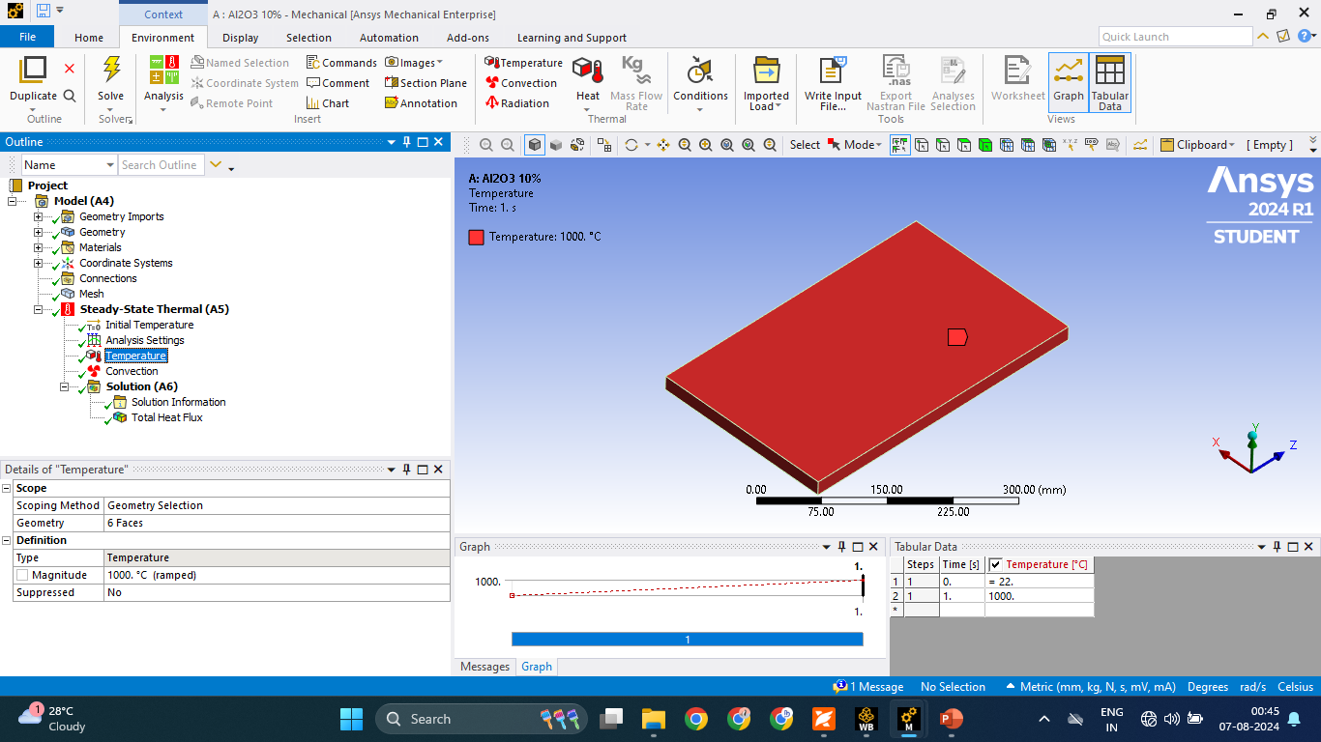

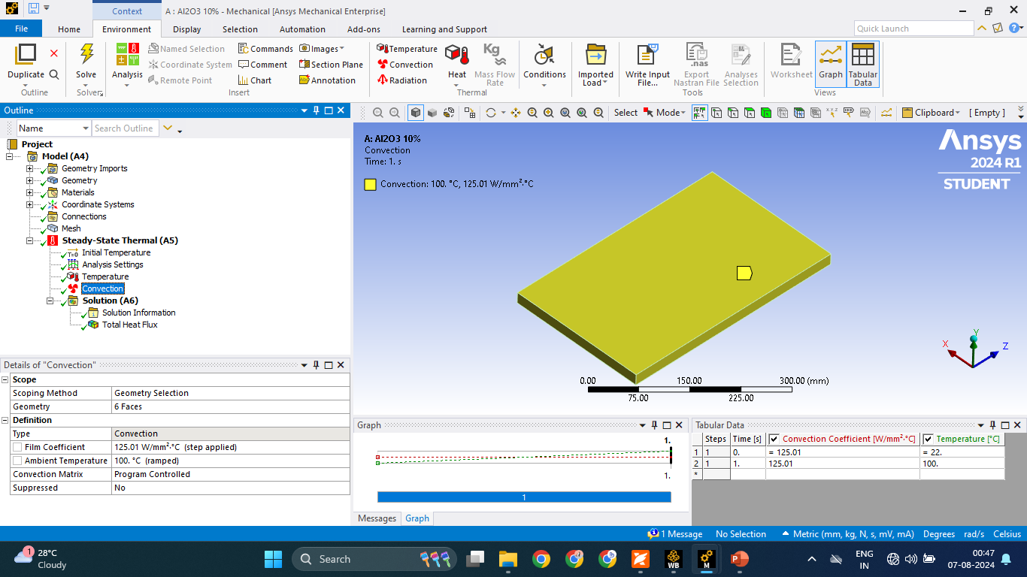

**5. Conclusion**

The project's conclusion is based on analyzing the minimum, average, and maximum heat flux distributions from both specimens. The results indicate that increasing the amount of aluminum oxide mixed with Al7075 reduces its thermal conductivity and decreases the heat flux distribution. Specifically, all measured heat flux values—minimum, average, and maximum—are significantly lower when a high composition of aluminum oxide is used with Al7075 alloy. Therefore, for applications requiring substantial heat flux reduction, aluminum alloys should contain less than 10% aluminum oxide

**6. RESULT**

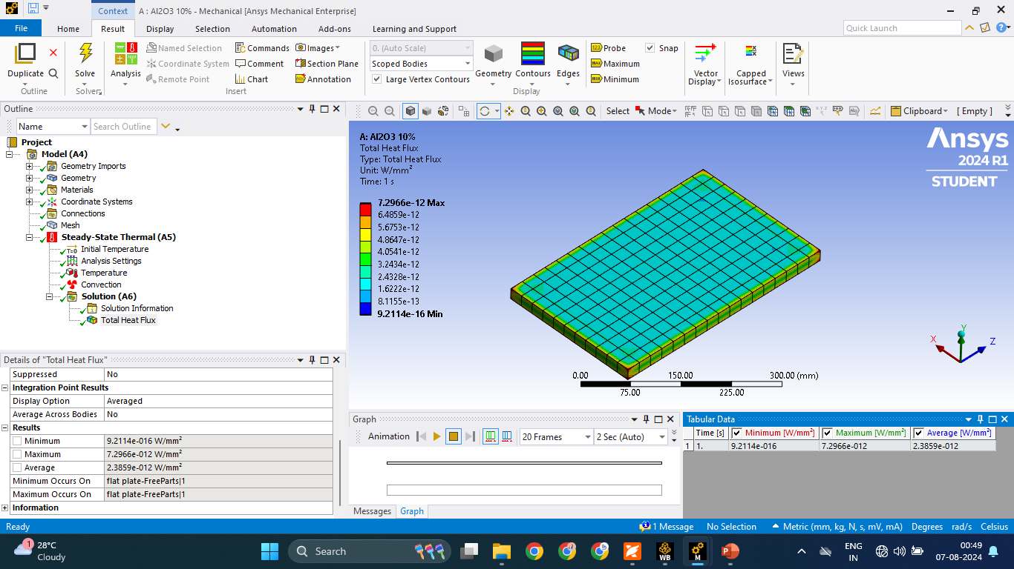

**Fig 1: Heat flux of Al7075 + 10% of Al2O3**

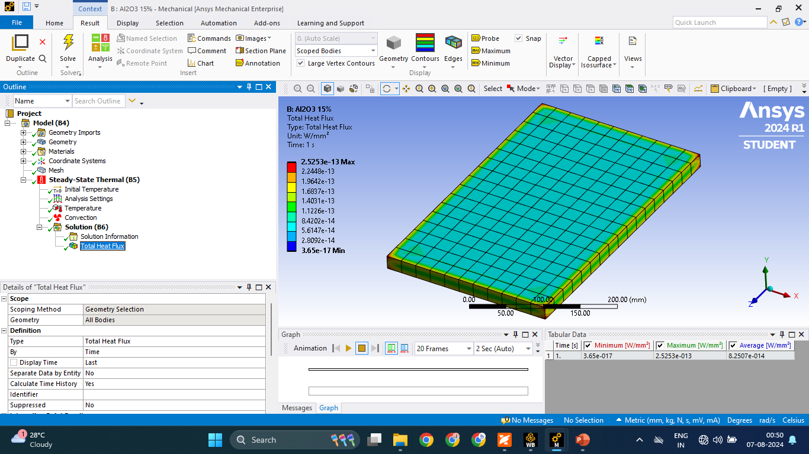

**Fig 2: Heat flux of Al7075 + 15% of Al2O3**

**8. Reference**

1. Alptekin Kisasoz, Kerem Altug Guler, and Ahmet Karaaslan, 2012. "Infiltration of A6063 Aluminium Alloy into SiC−B4C Hybrid Performs Using Vacuum Assisted Block Mould Investment Casting Technique." *Transactions of Nonferrous Metals Society of China*, 22, 563-567.
2. Bayraktar E. and Katundi D., 2010. "Development of a New Aluminium Matrix Composite Reinforced with Iron Oxide (Fe3O4)." *Journal of Achievements in Materials and Manufacturing Engineering*, 38, 7-14.
3. Krupiński M., Labisz K., Dobrzański L. A., and Rdzawski A., 2010. "Image Analysis Used for Aluminium Alloy Microstructure Investigation." *Journal of Achievements in Materials and Manufacturing Engineering*, 42, 58-65.
4. Loizaga A., Niklas, Fernandez-Calvo A. I., and Lacaze J., 2009. "Thermal Analysis Applied to Estimation of Solidification Kinetics of Al-Si Aluminium Alloys." *International Journal of Cast Metals Research*, 22, 345-352.
5. Madeva Nagaral, Auradi V., and Ravishankar M. K., 2013. "Mechanical Behaviour of Aluminium 6061 Alloy Reinforced with Al2O3 and Graphite Particulate Hybrid Metal Matrix Composites." *International Journal of Research in Engineering & Technology*, 1, 193-198.
6. Muhammad Hayat Jokhio, Muhammad Ibrahim Panhwar, and Mukhtiar Ali Unar, 2010. "Manufacturing of Aluminum Composite Material Using Stir Casting Process." *Mehran University Research Journal of Engineering & Technology*, 30, 53-64.
7. Naher S., Brabazon D., and Looney L., 2003. "Simulation of the Stir Casting Process." *Journal of Materials Processing Technology*, 24, 567-571.
8. Narasimalu Srikanth, Khine Khine Tun, and Manoj Gupta, 2003. "Finite Element Based Energy Dissipation Studies of Al-SiC Composites." *Journals of Composite Materials*, 35, 1385-1410.
9. Neelima Devi, Mahesh V., and Selvaraj N., 2011. "Mechanical Characterization of Aluminium Silicon Carbide Composite." *International Journal of Applied Engineering Research*, 1, 793-799.
10. Pardeepsharma, Gulshan Chauhan, and Neeraj Sharma, 2003. "Production of AMC by Stir Casting." *International Journal of Contemporary Practices*, 2, 23-46.
11. Phool Kumar, Azad A. M., and Vinod Kumar, 2013. "Frictional and Wear Characteristics of Stir-Cast Hybrid Composite Aluminium Al6061 Reinforced with SiC Particulates." *International Journal of Engineering Research & Technology*, 2, 403-410.
12. Sudindra S. and Anil Kumar C., 2013. "Studies on Al6061/Al2O3 and Graphite Hybrid Metal Matrix Composites." *International Journal of Metallurgical & Materials Science and Engineering*, 3, 35-42.