**Analysis of Land Use and Land Cover Changing Patterns of**

**Bhopal Using Geographical information system(GIS)**

**Ar. Krishna Garg1, Ar. Harshita Mishra (Guide)2**

1 PG Student, MUP, MITS University, Gwalior, Madhya Pradesh India

2Assistant professor, MITS University, Gwalior, Madhya Pradesh India

**ABSTRACT**

The urban expansion rate is quite alarming in developing countries, such as India. This expeditious rate of urbanization has significantly brought a change in the natural vegetation and carry a negative impact on the environment. Bhopal city has experienced a wide range of changes in land use and land cover (LULC). This study used Geographical information system(GIS) to detect the changes that occurred in the city throughout a twenty-year study period, using Landsat TM 5 and Landsat 7 Enhanced thematic mapper(ETM+) from 2001 and 2011 and Landsat 8 Operational Land Imager (OLI) images from 2021. An SCP classification method was used to classify and map LULC types. The overall accuracy assessment was used to ascertain classification accuracy. Using the classified images, a post-classification comparison approach was used to detect LULC changes between 2001 and 2021. The study revealed that the area of built-up land, lakes, and barren land has increased and the area of agricultural land has decreased. The LULC changes in the study area were attributed to urbanization, population growth, social- economic growth, and climate change. This study provides information on the changes in LULC and driving factors.

**Keywords :** Urban expansion, Urban sprawl, LULC , GIS

1. **INTRODUCTION**

Most parts of countries in the world are currently experiencing wide-ranging changes in land use and land cover (LULC) (Alawamy, Balasundram, & Hanif, 2020). These LULC changes have mostly been associated with the interaction between humans and the environment ( Matsa, Mupepi, & Musasa, 2020). The resulting negative impacts on ecosystems and human wellbeing, which include erosion, increased run-off, flooding, loss of water resources, degrading water quality, and other negative impacts, have brought these changes to the attention of the world (Wang, Gebru, Lamchin, & Kayasth, 2020). There are many indicators for understanding the relation between humans and the environment, one of which is land cover change (Wang, Gebru, Lamchin, & Kayasth, 2020). The timely and accurate understanding and monitoring of land use and land cover changes, their intensity, direction, causes, and consequences are critical for sustainable development planning; hence, it is an essential goal in the field of land cover change science (Wang, Gebru, Lamchin, & Kayasth, 2020).

Land cover and land use are two different terms that are frequently used interchangeably to describe land surface features ( Vargo, Habeeb, & Stone Jr., 2014). Land use is evidence of land utilization by humans and their habitat, mostly with an emphasis on providing information on socioeconomic activities ( Vargo, Habeeb, & Stone Jr., 2014), while land cover is described as the biophysical features of the Earth’s surface, which includes vegetation, waterbodies, soil, and other physical features of the land (Rawat & Kumar, 2015). These definitions make it clear that there is a link between land use and land cover. LULC change is a process that occurs as a result of human interaction with the physical environment, resulting in the modification and biophysical attribute change of the Earth’s terrestrial surface (Liping, Yujun, & Saeed, 2018), by either shifting to a new type of land use or intensifying use of the existing type (Liping, Yujun, & Saeed, 2018). Unfortunately, this process has negative impacts on the environment, which must be addressed if we are to achieve sustainable development (Wang, Gebru, Lamchin, & Kayasth, 2020). Changes in land use, for example, can cause climate change, such as higher temperatures and the destruction of waterbodies, resulting in a reduction or irregular vegetation pattern, which undermines the stability of the ecosystem (Xue, Liu, Sun, & Wang, 2021).

Rapid population growth and economic development are some of the contributing factors to this rapid change in LULC happening in most parts of the world (D. Lu, 2004). Economic development and population growth cause changes in land use, as it adjusts to satisfy the demand for food and energy, as well as other capitals to support the growing population (Hussain, 2018) better analysis of LULC change will not only result in accurate meaning but also ensure that there is greater knowledge of land use changes, which can be used by public or private organizations in the selection, planning, and utilization of natural resources and their management (Reddy, 2013),to meet the increasing demands for basic human needs and welfare while also achieving sustainable development goals. An understanding of the landscape patterns, changes, and relationships between human actions and natural phenomena will hence ensure that our current use of land does not adversely affect future generations ( Matsa, Mupepi, & Musasa, 2020).

Since the 1970s, satellite Remote Sensing (RS) data has served as the foundation and source of information for the monitoring and analyzing of LULC changes (Y. Chang, 2018). It allows researchers to investigate changes in land cover in less time, at a cheaper cost, and with more precision (T. Ayala-Silv, 2009). To ensure the effectiveness of land cover change detection, RS is usually coupled with Geographic Information System (GIS) techniques (Chaikaew, Land Use Change Monitoring and Modelling Using Gis and Remote Sensing Data for Watershed Scale in thailand, 2019)It is however not the only method for analyzing the changes in LULC. Dynamic models are also used for determining the changes in and patterns of vegetation. (Xue, Liu, Sun, & Wang, 2021)used dynamic models to show how diffusion and nonlocal delay interact to produce vegetation patterns in semiarid environments (Xue, Liu, Sun, & Wang, 2021). (K. W. Brhane, 2020) used a mathematical model to investigate the effects of fire, rainfall, and competition for space on the dynamics of the savannah ecosystem (K. W. Brhane, 2020), and Yan et al. used least-squares linear regression to investigate vegetation dynamics and their relationships to climatic change in southwestern China (W. Yan, 2021)

The main objective of this study is to analyze LULC changes in Bhopal City between 2001 to 2021 using Landsat 7 and 8 satellite imagery. To achieve the objective, it was necessary to (1) differentiate and classify the various LULC types, (2) accurately measure the magnitude and rate of LULC change, and (3) evaluate the main causes of LULC changes in the study area from 2001 to 2021.

# **2.METHOD AND METHODOLOGY**

## 2.1Study area: Bhopal city is the capital city of the state of Madhya Pradesh located in the central part of state, it is also known as city of lakes. It is the second largest city of the state and the major hub of education, administration, political and industrial activities. The city is located at 23.2599° N, 77.4126° E and has a municipal area of 285.9 sq.km. The city has a total population of 1,798,218 people, according to the (census, 2011). The city lies at an average elevation of 427meters above sea level. Bhopal lies in the composite climate zone of India and it receives annual rainfall of 1200mm. City has two lakes namely upper lake and lower lake with the catchment area of 36.1 sq. km and 9.6 sq.km respectively.

­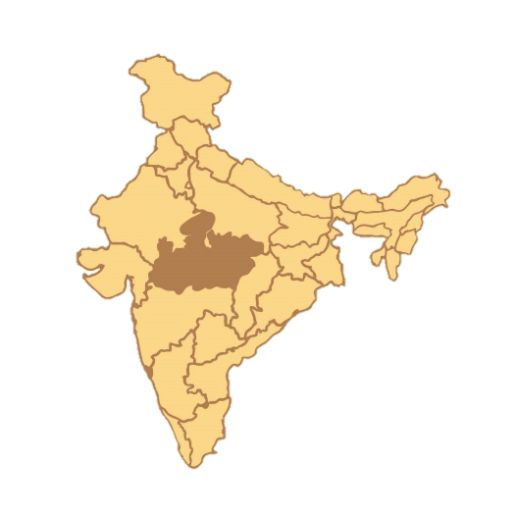 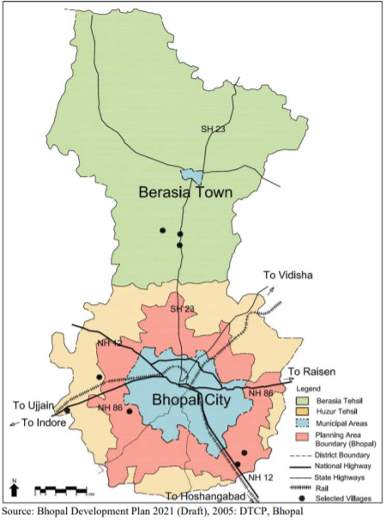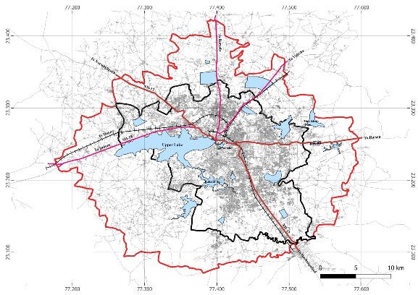

Figure 1 location of Bhopal (Source: 1 Bhopal development plan,2021, DTCP Bhopal

## 2.2Data collection

## 2.2.1 LULC Classification Data. Landsat tm 5 and Landsat 7 Enhanced Thematic Mapper (ETM+) images from 2001 and 2011 and Landsat 8 Operation Land Imager (OLI) images from 2021, with the resolution of 30m, were utilized in the study to evaluate changes in LULC in the study region during a 20-year period from 2001 to 2021. Three cloud-free Landsat Satellite scenes for Path/Row 167/71 from two types of sensors covering study area were downloaded freely from the united States Geographical Survey (USGS) website (http://earthexplorer.usgs.gov/, n.d.). For the easy visibility, the cloud free imagery used in the study was captured during the dry season (September and October). Detailed characteristics of Landsat images used in this study are presented in the table 1.

### 2.2.2. Climate data: The paper also makes use of environmental data, specifically rainfall and temperature data, in discussing LULC class changes and determining the best time of year to extract images. For the years 2001 to 2021, rainfall and temperature data were free obtained from the Meteorological Department.

2.2.3 Image processing and Analysis: The three satellite images were processed using the semi- Automated classification plugin (SCP).

2.3.1. Image Preprocessing. Satellite image preprocessing is critical before image classification and change detection because it compensates for sensor, solar, atmospheric, and topographic effects (Alawamy, Balasundram, & Hanif, 2020). Radiometric and geometric correction of remotely sensed data is normally referred to as preprocessing (Jensen, 2015)In this work, image preprocessing included many processes such as radiometric, geometric, and atmospheric correction, as well as image gap filling, sub setting, image enhancement, and selection of band combination. All data preprocessing procedures were performed using semi- Automated classification plugin (SCP) in QGIS.

|  |  |  |  |  |
| --- | --- | --- | --- | --- |
| Satellite sensor | Path/row | Acquisition date | No. of Bands | Spatial resolution(m) |
| Landsat tm 5 | 167/71 | 25/08/2001 | 8 | 30 |
| Landsat 7 ETM+ | 167/71 | 17/09/2011 | 8 | 30 |
| Landsat 8 | 167/71 | 10/07/2021 | 11 | 30 |

Table 1 Satellite Imagery used Source: Us geological Survey

2.3.2. Image Classification. The technique of assigning a land cover classification to pixels is referred to as image classification. The procedure creates clusters of pixels with comparable digital values in the same data categories (Chaikaew, 2019)

Table 2 flow chart of data Processing Steps

Landsat Imagery

### 

Landsat 8

2021

Landsat tm 5

2001

Landsat 7 ETM+

2011

Image pre-processing (includes atmospheric correction)

Selection of training sample data and classification scheme

Post Classification

**­­­­**

Change Detection

Classified Map (2001, 2011, 2021)

Accuracy assessment

**­­**

Table 3LULC CLASS DESCRIPTION

|  |  |
| --- | --- |
| LULC class | description |
| Built-up land | Land that has been built on. It includes commercial, residential, industrial, and transportation infrastructure |
| Barren land | Areas with no dominant vegetation cover, including exposed rocks |
| Agricultural land | Idle land being used for small-scale farming of rain-fed crops (maize) and cultivated damp areas (BCC laws do not permit farming in the city even though small-scale farming is still practiced) |
| waterbodies | Areas permanently covered by water, which includes man-made dams and ponds |

1. **Results**

Accuracy Assessment: An accuracy assessment was carried out for the three classified maps to verify if what was mapped corresponds to what exists on the ground. The classification accuracy was evaluated through the error matrix. For 2001, 2011 and 2021, the overall accuracies were 86.4%, 89,3%, and 86.4%, respectively, indicating that the three classified maps met the USGS’s classification criterion of the overall accuracy of 85% in classifying land use and land cover classes from remote sensor data.

LULC Change Detection Analysis. The post classification comparison change detection results show that LULC has changed greatly in the study area over the last two decades. The change in Table 4 shows the amount and type of change that has occurred in each LULC class. The change from 2001 to 2021, which were constructed using the classified maps 2001,2011, and 2021, and the population data of Bhopal presented in Table 5 will be used to discuss the changes that have taken place over the study period in depth in the following sections. 3.3.1. LULC Change Detection between 2001 to 2021. Agriculture was by far the most prominent LULC class type in the studied area in 2001, accounting for 643650 sq. m of the total land, followed by built-up area, waterbody, and, bare land, between 2001 and 2011, the classes of agriculture and waterbody experienced a decline in their respective areas.

Figure 1 provides a summary of the major changes in LULC in the study region between 2001 to 2021. Figure 1 also shows that the area of the lake (waterbodies) declined from 19812 sq. m in 2001 to 19067 in 2011, with a minimal decrease which was increased in 2021 by 144836 sq. m due to the government, local NGO’s and local citizen initiative. Water regime in the city is not exposed to chemical pollution as there is no major (chemical) industrial cluster in the city limits, however the water bodies are exposed to the domestic pollution load.Nevertheless, water supply in part of the city is being served from the upper lake after conventional treatment. Ground water quality in the city is moderate. So, for the regeneration of lakes, Bhopal govt. has launched many initiatives: -Lake cleaning Programmed, ‘Lake Bhopal conservation and management Project’, or the bhoj wetland project: The project covers 23 municipal wards – 18 per cent of the city's area. In 2009, the state government decided to act to increase the lake’s capacity. Following are the activities suggested by the environment scientists to improve the bhoj wetlands.1)Dredging and de- silting are required to improve water quality.2)Treatment of catchment area.3)Development of new Stps.4)Solid waste management besides deweeding, aquaculture, and installation of floating fountains are also needed.

Over the two decades. Bhopal city growth is clear which compromised the agriculture and barren lands. The city depicted a radial growth from the year 2000 to 2020. In order to analyses, the relatively large loss of Agricultural areas. The following change categories were developed for this analysis:• Agriculture to Residential area• Agriculture to Industry, Commercial; Public or Military area• Agriculture to Plantations.

Urbanization is leading to changes in the signature surface properties. This is best estimated by drawing out a broad picture of LU/LC in the city. LU/LC together provide the spatial pattern of urban thermal environments. Surface temperature and vegetation index across the land cover classes was determined and it was estimated that dense vegetation areas have the lower surface temperature than the highly built up areas.

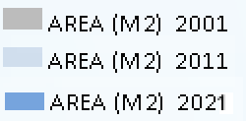

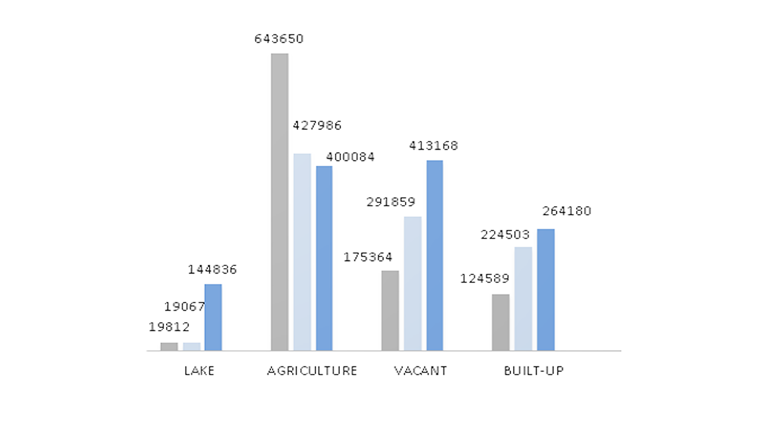

Figure 2 change in LULC Classes between 2001,2011, 2021

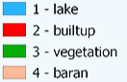

LULC Map 2021

LULC Map 2011

LULC Map 2001

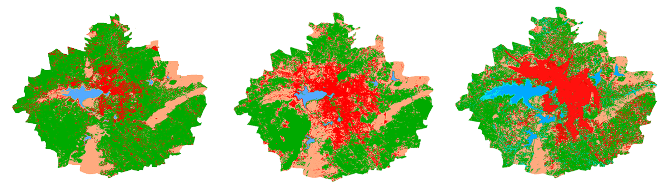

Figure 3 LULC maps of 2001, 2011 and 2021,Source: 2 Us geological survey, Prepared by author

1. **Conclusion**

Remote Sensing is the most used technology in LULC change detection analysis. This study used Landsat tm 5, Landsat7 ETM+ and Landsat8 OLI image data, which were downloaded and classified to detect the LULC changes in Bhopal City. SCP supervised classification was used to produce accurate LULC maps for 2001, 2011, and 2021, which were used in detecting the changes that have occurred using the post classification comparison technique. The overall accuracy values obtained met the classification criteria. The results of the study revealed that there had been a significant change in LULC during the 20-year study period in the area. The obtained results showed that there was a decrease (from the initial area) in the area of agriculture land, while the area of built-up land, waterbodies and barren land increased between 2001 and 2021. The highest increase rate of built-up land, the highest decline rate of agriculture land, and the highest decrease in waterbody were all achieved in the first phase (2001-2011), signifying that this was the period of great changes. The annual rate of by built-up land between the years 2010 and 2019 was only slightly lower than that recorded in the preceding period, indicating that developments are still taking place. The expansion of the built-up land was at the expense of forest land, agricultural land, Waterbody area declined in 2001 and 2011, which was increased between 2011 to 2021 due to govt. initiatives.

Several factors have been identified as contributing to the change in LULC in the study area, including population increase, social-economic growth, climate change, poor planning, and poor plan implementation. Population increase in the area influenced the increase and the decrease of built-up land and agricultural land, respectively. As the demand for settlement areas increased, the area of agricultural land decrease.

1. **REFERENCES**

(n.d.). Retrieved from http://earthexplorer.usgs.gov/.

Matsa, M., Mupepi, O., & Musasa, T. (2020). A gis and remote sensing aided assessment of land use/cover changes in resettlement areas; a case of ward 32 of Mazowe district Zimbabwe. *Journal of Environmental Management, vol. 276,*.

Vargo, J., Habeeb, D., & Stone Jr., B. (2014). the importance of land cover change across urban-rural typologies for climate modeling. *Journal of Environmental Management*, 243-252.

Alawamy, J. S., Balasundram, S., & Hanif, A. (2020). “Detecting and analyzing land use and land cover changes in the region of Al-Jabal Al-Akhdar, Libya using time-series landsat data from 1985 to 2017. *Sustainabilty*, 4490.

census, o. (2011).

Chaikaew, P. (2019). *Land Use Change Monitoring and Modelling Using Gis and Remote Sensing Data for Watershed Scale in thailand.* London, UK: IntechOpen.

Chaikaew, P. (2019). *Land Use Change Monitoring and Modelling Using Gis and Remote Sensing Data for Watershed Scale in thailand.* London, UK: Intechopen.

D. Lu, P. M. (2004). Change Detectection techniques. *International Journal of Remote Sensing*, 2365-2401.

Hussain, S. (2018). *Land Use/Land Cover Classification by Using Satellite Ndvi Tool for Sustainable Water and Climate Change in Southern Punjab.* Islamabad, Pakistan.

Jensen, J. R. (2015). *Introductory Digital Image Processing: A Remote Sensing Perspective.* London, UK,: Pearson Education, Inc.,.

K. W. Brhane, M. G. (2020). Mathematical model for the dynamics of savanna ecosystem considering fire disturbances. *Journal of 9eoretical Biology, vol. 509, Article ID 110515*.

Liping, C., Yujun, S., & Saeed, S. (2018). Monitoring and predicting land use and land cover changes using remote sensing and gis techniques, a case study of a hilly area, Jiangle, China. *PLoS One, vol. 13, no. 7, Article ID e0200493*.

Mas, J.-F. (2010). monitoring land-cover changes: a comparison of change detection techniques. *International Journal of Remote*, 139–152.

Rawat, J., & Kumar, M. (2015). Monitoring land use/cover change using remote sensing and gis techniques: a case study of Hawalbagh block, district Almora, Uttarakhand, India,. *The Egyptian Journal of Remote Sciencing and Space Science*, 77-84.

Reddy, P. K. (2013). Analysis of land use/land cover changes using remote sensing data and GIS at an urban area, Tirupati, India. *The Scientific World Journal, vol. 2013, Article ID 268623*, 6 pages.

T. Ayala-Silv, G. G. (2009). Use of satellite data to study the impact of land-cover/land-use change in Madison county Alabama. *American Journal of Applied Sciences,*, 656-660.

W. Yan, H. W. (2021). Satellite view of vegetation dynamics and drivers over southwestern China. *Ecological Indicators, vol. 130*.

Wang, S., Gebru, B., Lamchin, M., & Kayasth, R. (2020). Land use and land cover change detection and prediction in the Kathmandu district of Nepal using remotesensing and gis. *Sustainability*, 3925.

Xue, Q., Liu, C., Sun, G.-Q., & Wang, Z. (2021). Interactions of diffusion and nonlocal delay give rise to vegetation patterns in semi-arid environments. *Applied Mathematics and Computation*.

Y. Chang, K. H. (2018). Review of land use and land cover change research progress. *IOP Conference Series: Earth and Environmental Science, vol. 113, Article ID 012087*.