**UNVEILING RESERVOIR UNCERTAINTIES: A 3D GEOLOGICAL MODEL ANALYSIS OF FIELD ‘X’ IN THE ONSHORE NIGER DELTA, NIGERIA**

1Alaezi, Christiana Nneka 2Okujagu, Diepiriye Chenaboso

1Center for Petroleum Geoscience, University of Port Harcourt

2Department of Geology University of Port Harcourt

diepiriye.okujagu@uniport.edu.ng

**ABSTRACT**

Field ‘X ’in which this study is undertaken is located southeast of Port Harcourt, Nigeria. The field is contained in a relatively simple anticlinal structure. The 3D geological model interpretation is a stacked model consisting of horizons A, B, C and respectively. However, the 3D model was built with the mentioned four (4) horizons and eighteen (18) faults interpreted from seismic. The fluid contacts were interpreted mostly from the well logs. The study aimed at evaluating the uncertainties that is associated with the volumes in-place. To achieve these objectives, fluid contacts (oil water contact and gas water contact) synthesis, facies and Petrophysical data evaluation and incorporation into a 3D static model was carried out. The five facies interpreted are Shales, Channel Heterolithics, Channel, Upper Shoreface and Lower Shoreface. The facies interpretations were constrained to the seismic amplitude maps so as to respect the different depositional environments. Petrophysical uncertainty in this study is limited to the uncertainty within the petrophysical variables which comprises effective porosity (PHIE), water saturation (Sw) and net-to-gross reservoir definition (NTG). The petrophysical properties (PHIE, NTG, and Sw) were therefore constrained to the associated facies (AFs) model and modelled with the sequential Gaussian simulation (SGS) while the facies model was distributed using the sequential indicator simulation (SIS). This showed that zones or areas of optimistic NTG as related to facies distribution in this study exhibited good porosities and permeabilities while zones with degraded facies showed poor petrophysical properties. An uncertainty analysis was carried out using Petrel Software to assess the impacts of the uncertain parameters on the volumes of fluids-in-place. However, the fluid contact uncertainties carried out on the four reservoir horizons in this study have direct effect on the gross rock volume (GRV) thereby directly affecting the in-place volumes. The deeper contact (representing the high case) will have higher volumes while the shallower fluid contacts will have lower volumes in place. The gas-oil contact is also a factor that has an effect on the volume in place; a deeper gas oil contact (GOC) reduces the oil in place and vice versa. The results showed that the fluid contact variation, facies proportions and NTG have the most significant impact on the base case STOIIP volume computation.

# Keywords: Reservoir Characterization, 3D Geological Modeling, Fluid Contact, Uncertainty Analysis, Petrophysical Properties, Facies Modeling

# INTRODUCTION

Geological models are built to characterize reservoirs and estimate the amount and type of hydrocarbon (Oil or Gas) initially in place (HCIIP) in a field. But a lot of uncertainties occur in the subsurface probably due to equipment measurement, expansion of formations while drilling and collapse of the formation. Hence the discovery and development of hydrocarbon resources is highly uncertain. In Niger Delta, Agbada Formation is recognised as the reservoir rock which houses the hydrocarbon, usually sandstone (with intercalations of shale) while the Akata Formation is known as the source rock from which hydrocarbon migrates and is expelled into the pore space of the permeable Agbada Formation for accumulation. This Formation (Akata) is made up of a mixture of sand and shales varying in different thickness the sand is the reservoir rock (the Akata Formation ranges in thickness from 600 to about 6000m) while the shale serves as a Seal (natural barrier) to the hydrocarbon. The Benin Formation is the topmost unit of the Niger Delta and consists of fluviatile gravels and sands. This unit is the thickest in the central area of the delta (2100m) where there is maximum subsidence of the basement. The uncertainty encountered in building and characterising a 3D model including its properties, distribution of these properties, fluid saturation and fluid contacts is considered in this study.

The Field ‘X’ is located southeast of Port Harcourt, Nigeria, covering a surface area of about 8km2.The field is contained in a relatively simple anticlinal structure associated with the major South-west-North-east trending fault system. The Field ‘X’ belongs to the Oligocene to Miocene age deposits of the Agbada Formation of the Niger Delta. Field ‘X’ is an oil and gas field. The 3D geological model is a stacked model consisting of horizons A, B, C and D respectively. For this Study, 3 oil reservoirs with gas caps and 1 gas reservoir with sub-reservoirs were evaluated within the field. The challenge with building an accurate and robust geological model is the integration of various subsurface datasets that enables a better insight about the reservoir and to display it in a model for precise reserve estimation and some/or most of these data sets has errors thus uncertainties in measurements. The principal aim of any upstream petroleum industry is to boost reserves and hydrocarbon production at a minimal cost. Results from the interpretation of seismic data alone are insufficient to attain this aim. Integrating other datasets becomes eminent while building a models this gives a better view of the reservoir and equally captures reservoir heterogeneity for proper reserve estimation and field development plan. Having an uncertainty study gives you the leverage to have a high case value of the HCIIP and a Low case Value of HCIIP and this helps in proper planning and economics and in the management of the asset. This study focuses on building a 3D model of the Field “X” to capture the structures, fluid contacts (GOC, OWC),stratigraphic units and petrophysical interpretations; and also, to show the extent of the uncertainties that impact the HCIIP.

## THE STUDY AREA

The location of the study area was not revealed for confidentiality purpose as is the standard practice for most oil and gas industries in Nigeria. The Field ‘X’ is located southeast of Port Harcourt, Nigeria, covering a surface area of about 8km2 (Figure 1).

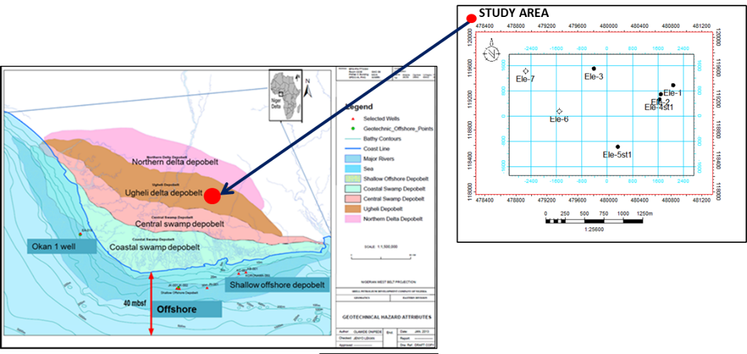

Figure 1: Sectional map of Niger Delta showing the depobelts (Nwozor et al, 2013)

# 

# LITERATURE REVIEW

The study is aimed at evaluating the uncertainties that is associated with the hydrocarbon volumes in-place. Reservoirs are heterogeneous and hence a detailed study on the uncertainties associated with reservoir uncertainties is important and has been researched by different authors. Crude oil is among the most critical elements of the company’s upstream capital and is the backbone of its present and prospective business upstream cash flow. More frequently, especially where exploration occurs in a new area or a new subfield of an existing specialty, there can be questions or issues regarding the determination of the volumes of the hydrocarbons resources. This paper describes the method and outcome of this interdisciplinary attempt to convert uncertainties into a band of static or in-place volume amenable to property development. (Akinwumi et al, 2004). Current strategies, which include the construction of 3-D static reservoir models derived from basic information on effective facies and their relationships and which incorporates all the existing data to strength and quantify the uncertainties of each of the categories of data have been implemented. Standard approach to quantification of epistemic uncertainties in the distribution of petrophysical parameters such as porosity, hydrocarbon saturation and Net-to-Gross ratio was made and ranked against to the multi-scenario ideas that have been incorporated into the geological model.

## 

## GEOLOGY OF NIGER DELTA

Niger Delta is by far one of the largest arcs of its kind, destructive and wave dominated delta and it is one of the several hydrocarbon provinces of global importance. This is made up of a series of under compacted marine clay separated by parallic deposits overlying continental sand built up by the superimposition of a number of offlap cycles (Figure 2). Delta formation and therefore the distribution of sediment thickness involved basement faulting and its influence on the presumed sedimentation. During the paralic interval, growth fault-related rollover structures were developed which served as the traps for hydrocarbons. The faults in general contributes to the process of hydrocarbon distribution. Growth faults may even act as the channels for the movement of hydrocarbons from the over-pressured marine clays.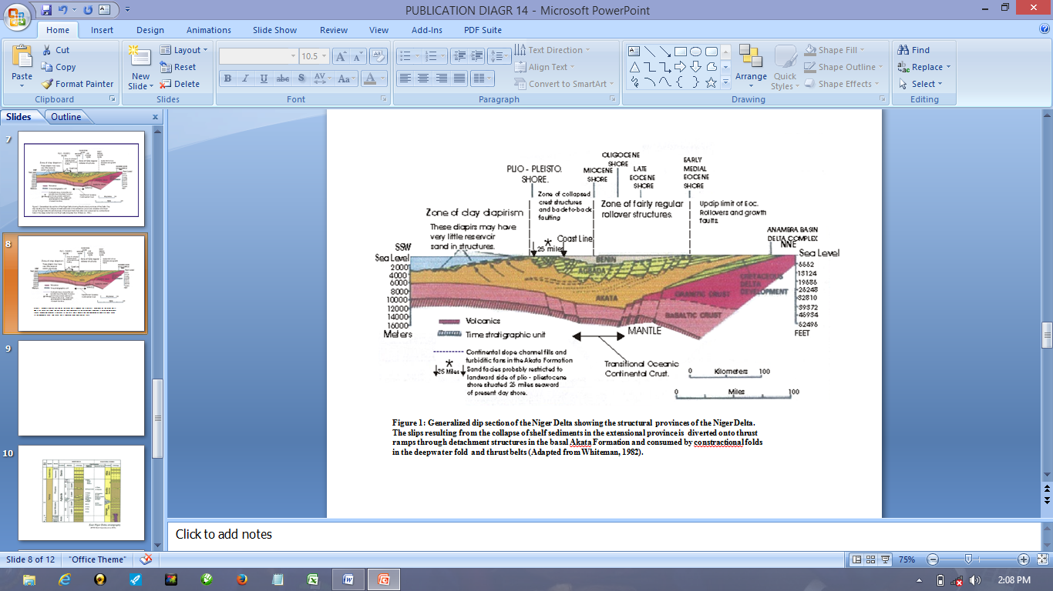

Figure 2: Schematic dip section of the Niger Delta (after P. Kamerling, from Weber and Daukoru, 1975).

The Basin was created in the tertiary period along the aulacogen which was originally created during these separation periods of the African plate and the South American plate of the Late Jurassic phases of Burke (1972). Three sedimentary basins were active from the Campanian through the Palaeocene: the Anambra Basin and Afikpo Syncline, which were separated by the Abakaliki High; and the yet untransformed Ikang Trough. Palaeocene saw the climax of Cretaceous proto-delta facies, which was subsequently overlain by the Imo Shale, interpreted as a major transgression. After that was a regressive phase that includes the Eocene-Recent delta, as depicted in the map given below (Figure 3).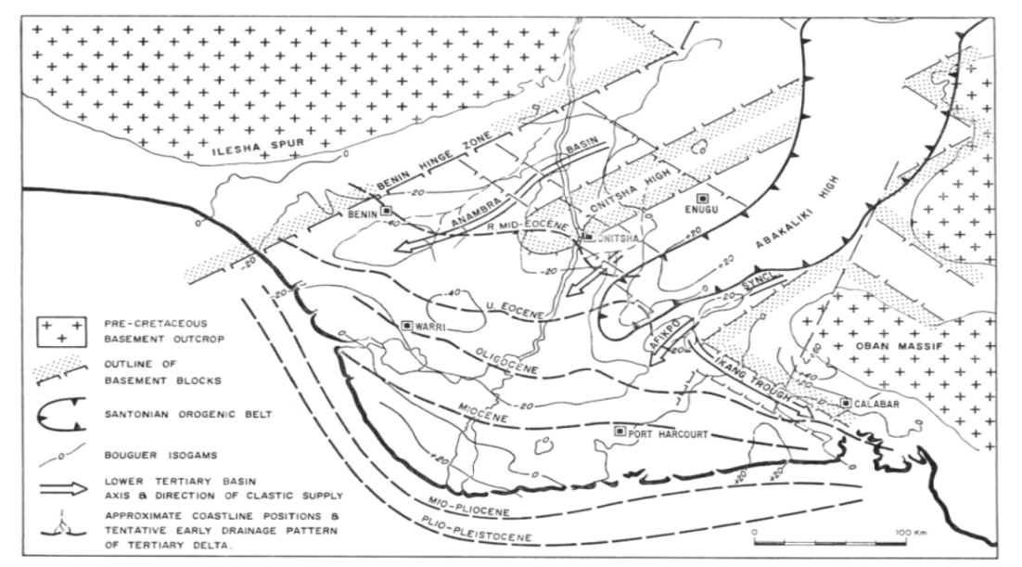

Figure 3: Megatectonic frame and stages of Tertiary delta growth.

The area of the Niger Delta is situated in the Gulf of Guinea and extends throughout the province as defined by Klett et al. (1997). Onshore depobelt was deposited at the west coast of Africa (Gulf of Guinea). It covers an area of 105,000km2 and extends from latitude 30 N to 60 N and longitude 40 E to 90 E (Avbovbo, 1978).This basin is bounded in East-West direction by Calabar flank and Benin basin respectively andto the North by the structures of the Anambra Basin of the older Cretaceous, Abakaliki Anticlinorium, Afikpo Synclinorium and bounded towards the south by the Gulf of Guinea. According to Short and Stauble, (1967), the Niger River carries2.62 x106 m3 of sand estimate, 35% reaches the sea while the other 65% are trapped within the delta. Niger delta is subjected to strong and persistent tidal action and marine current which divert the sediment and distribute them by the sea. And thus, forming of an arcuate-shaped delta. The Southwest advancement of the delta towards the sea gave rise to the depobelts which is said to be the most functional part of the basin at development phase. The depobelts ranges from 30 to 60 kilometres wide, advances towards the sea 250 kilometres southward to the Gulf of Guinea. Inter play of sediment supply rate and subsidence gave rise to the individual depobelts when sediment deposition adjusted seaward and unable accommodate the crustal depression of the basin. A number of depobelts were recognized, each is a unit that is equivalent to the breach in the dip associated with sedimentation, deformation and petroleum history.

## NIGER DELTA PETROLEUM SYSTEM

The Petroleum system encompasses the Akata and Agbada Formation of the Tertiary Niger Delta and they are related to the timing which favours the formation, migration and accumulation in the sandstone of the Agbada Formation.TheAkata and Agbada Formation are known to be the time equivalent of Nanka and Imo Formation respectively (Figure 4).

### 

### **SOURCE ROCKS**

The rock that forms the Niger Delta hydrocarbon is currently a subject of controversy. Several authors have contributed to the debate concerning source rock of the hydrocarbon. (Evamy et al., 1978). AccordingtoEvamyet.al. (1978), the deep-water Akata clay and the Agbada sandstone succession is the hydrocarbon source on the basis of its content of organic matter.

### 

### RESERVOIR ROCKS

The sandstone and the loose sand of the Agbada Formation are the reservoir rock. The environment where the sediments are laid, and the depth of burial tends to control the features reservoir rocks. This Niger Delta reservoir rock is 100 meters thick, with 40% porosity and permeability of 2 Darcies (Edwards and Santogrossi, 1990).The growth fault controls the thickness, the reservoir tends to thicken at the down thrown block(Weber and Daukoru, 1975).

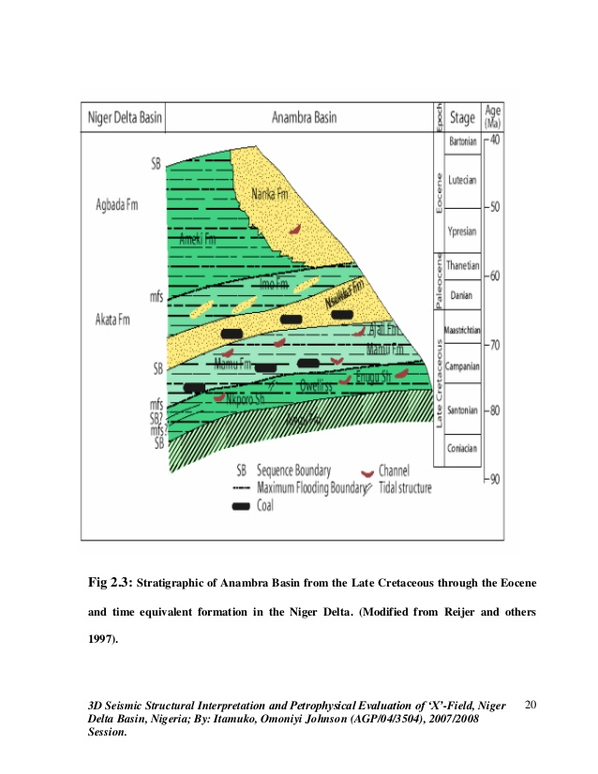

Figure 4: Stratigraphy of the Anambra Basin and their Niger Delta time equivalents Adapted from UGSS; Niger Delta Petroleum system.

**MATERIALS AND METHODS**

### SEISMIC DATA

This includes Seismic Horizons, Fault (Polygons), Amplitude extractions (Minimum and RMS).

1. **Seismic Horizons -** Four horizons were interpreted from seismic. They include Top A, Top B, Top C and Top D (Figure 6). The base horizons that could not be interpreted from seismic were generated from well tops using Petrel Software.
2. **Faults**-18 Faults were picked from the seismic cube.
3. **Amplitude Maps -**Amplitude extractions along the horizons, i.e., the tops of sand were used to generate attribute (Minimum and RMS) maps. The attribute map was used to delineate the environment (Delta plain and Delta front) limits. Figure 7shows the Delta Plain and Delta front limits. Level A, B and C consist largely of the channel Facies in the Delta plain environment while Level D is defined as a Shoreface environment.

### 

### WELL DATA

Seven Wells were available for the study. They include Ele1, Ele 2, Ele 3, Ele 4st1, Ele 5st1, Ele 6 and Ele 7 (Figure 9).

1. **Well Header/ Well Deviation**

The well header shows the coordinates that is, X and Y position of the well while the deviation data displays the trajectory of the well and shows if the well is vertical, deviated or horizontal.

1. **Well Logs**

Conventional and interpreted petrophysical logs were used for the study. The conventional logs available are shown in Figure 5 below. The conventional logs used in delineating hydrocarbon in formations are grouped in three groups

1. The lithology logs (Gamma ray log, spontaneous potential log)
2. Porosity logs (Neutron and Density log) and
3. Resistivity logs

**LITHOLOGY LOGS**

Quantitatively, Gamma ray log is used in delineating the various rock type (facies) in a well. API value of 75 which is the shale base line was utilized. Left deflection of GR from the shale baseline is defined as sand while right GR deflection corresponds to shale.GR value of 100%is the peak value and is said to be pure shale whereas the lowest value is known to be sand.

1. **Gammy Log**

Gamma Ray log measures the content of natural radioactivity of the formation. Ninety per cent of gamma emission is from Potassium (K), Thorium (Th) and Uranium (U) which are naturally occurring in the earth crust. In fact most reservoir rocks such as sandstone, limestone and dolomite contain little or no illites and thus the sources of gamma radiation are banished. Some other rock types (e.g., shale, Sylvite) have large amounts of potassium and thorium. The resulting high GR radiation levels contrast with the low GR levels of the adjacent reservoir formations.

1. **Spontaneous potential log**

SP log ascertains the discrepancy in potential between two electrodes of the earth. It is given in millivolt in a conductive media. Sometimes, the interpretation SP log data is complicated, leading to the mandatory use of Gamma ray log. It is also named a permeable bed log. An SP current can be provoked by porous and permeable bed and the salinity difference between drilling mud and subsurface fluid. SP logs alongside with gamma ray logs deflects while other logs deflect to the right.

**POROSITY LOGS**

The Density and the Neutron tools are used in the calculation of porosity of a reservoir. Density tool determine the bulk densities while neutron define the hydrogen densities. In gas bearing reservoirs the recorded neutron porosity is lower and the bulk density is less than the signs gets in a similar water/oil bearing formation. Such effects are possible and can be rather strong, depending on the degree of the gas saturation in the invaded zone. The outcome is a large separation between the two axes: Neutron on the right and Density on the left is known as gas separation. I also identified Neutron-Density combination to be a highly effective oil and gas discriminator. In an oil zone, neutron reads higher than density, but the reading is suppressed in gas zone. Where density is greater than neutron it is known as “cross-over effect” this wider separation of Density and Neutron log suggests the presence of oil. Gas, however, has a considerably lesser mass of hydrogen producing a separation called Gas effect. Neutron log contains a radioactive source that supplies high energy neutron emitted into a formation. Neutron log otherwise called hydrogen index log measures the hydrogen index of a rock, irrespective of its occurrence in gas, liquid or solid.

**RESISTIVITY LOGS**

Resistivity distinguishes between water and hydrocarbon because of permittivity and dielectric constant (E). The dielectric constant of water is 80 while that of hydrocarbon is about 2.5. The higher the resistivity, the greater the hydrocarbon. Resistivity log uses a logarithmic scale with API standard of 0.2.These logs are used to describe reservoir properties and fluid contact and can be done quantitatively or qualitatively. Adequate description of the logs is done to evaluate petrophysical properties which includes the shale volume (VCL), NTG, PHIT, PHIE, Facies, Permeability and fluid saturation which is crucial in reservoir characterization.

1. **Well markers (Well Correlation)**

Lithologic correlation involves the recognition of distinct rock bodies and their spatial relationship with each other. This correlation of logs was done by identifying the marker beds (shale) using Gamma ray and Resistivity logs and also to determine the reservoir and non-reservoir rock. Lithologic correlation is carried out to show the reservoir’s extent and to define the structural styles for the accumulation of hydrocarbon. The Correlation was done by defining each reservoir top (well tops) and picking them across the entire well (Table 1).Ele- 1 well markers were used as reference for correlation to other wells. There is evidence of faulting seen by the occurrence of markers at deeper depths or missing sections seen at Level A (noticed at Ele 5st1). The reservoirs are correlatable on both sides of the fault (Figure 5).

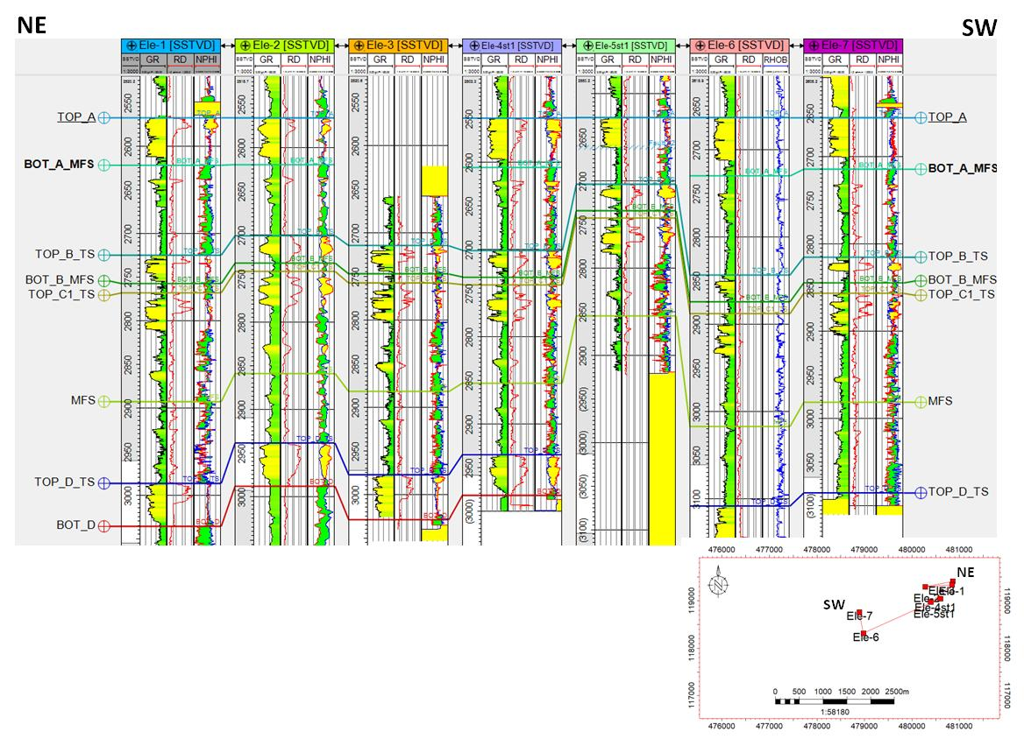

Figure 5: Well logs and Correlation

Four distinct reservoir sands were picked across the wells. Level C is the thickest reservoir across the field and is sub divided into 5 zones. Levels B and C1 consist mainly of a succession of channels and shoreface sands. The deepest sands D horizon comprises of shoreface and heteroliths with southward degradation in reservoir quality.

**Table 1: Reservoir Top and Base Depth**

|  |  |  |  |  |  |  |  |
| --- | --- | --- | --- | --- | --- | --- | --- |
| Reservoir Sands | Wells | | | | | | |
| Interval (m) | **Ele-1** | **Ele-2** | **Ele-3** | **Ele-4st1** | **Ele-5st1** | **Ele-6** | **Ele-7** |
| A Top | 2568 | 2566 | - | 2550 | 2628 | 2664 | 2656 |
| Base | 2622 | 2619 | - | 2606 | Faulted out | 2730 | 2715 |
| B Top | 2725 | 2701 | 2715 | 2702 | 2704 | 2844 | 2816 |
| Base | 2758 | 2733 | 2747 | 2732 | 2734 | 2875 | 2845 |
| C Top | 2768 | 2742 | 2758 | 2741 | 2888 | 2888 | 2857 |
| Base | 2976 | 2930 | 2967 | 2926 | 3096 | 3099 | 3069 |
| D Top | 2987 | 2939 | 2977 | 2936 | Faulted out | 3109 | 3085 |
| Base | 3036 | 2988 | 3029 | 2982 | Faulted out | 3157 | - |

## FLUID CONTACT INTERPRETATION

Fluids within the delineated sand units were discriminated using resistivity log. However, on the crossover plot of Density-Neutron porosity logs Sand units with very high kicks or high resistivity values are known to be the probable hydrocarbon formation while low resistivity units of sands were interpreted as water bearing reservoirs. A resistivity curve having a sharp kick in a porous sand body is simply displaying the availability of hydrocarbon. Density-Neutron cross plot were used for hydrocarbon type delineation. These high values of resistivity are also used for the easy identification of the fluid contacts. The initial fluid contacts were defined for each well and reservoir using Ele-1 as the reference well that is the well logs (with reference to the resistivity Log) was only used for fluid contact evaluation. No pressure (RFT data) was taken and seismic shutoffs were not noticeable from the amplitude maps to help as fluid contact reference. Hence an uncertainty of the fluid contacts. Oil water contact was identified using resistivity log and incorporated into the 3D model. Table 2 summarises the fluid contacts as defined from the well logs.

**Table 2: Fluid Contacts & Type identified in Ele-1 Well**

|  |  |  |  |
| --- | --- | --- | --- |
| **Reservoir Sands** | **Fluid Contact** | **Fluid Type** | **Fluid Contact(m/TVDSS)** |
| A | GWC | Gas and Water | 2585 |
| B | GOC/OWC | Gas, Oil and Water | GOC 2721 WOC 2735 |
| C | GOC/OWC | Gas, Oil and Water | GOC 2769 WOC 2792 |
| D | GOC/WC | Gas, Oil and Water | GOC 2989 WOC 3009.7 |

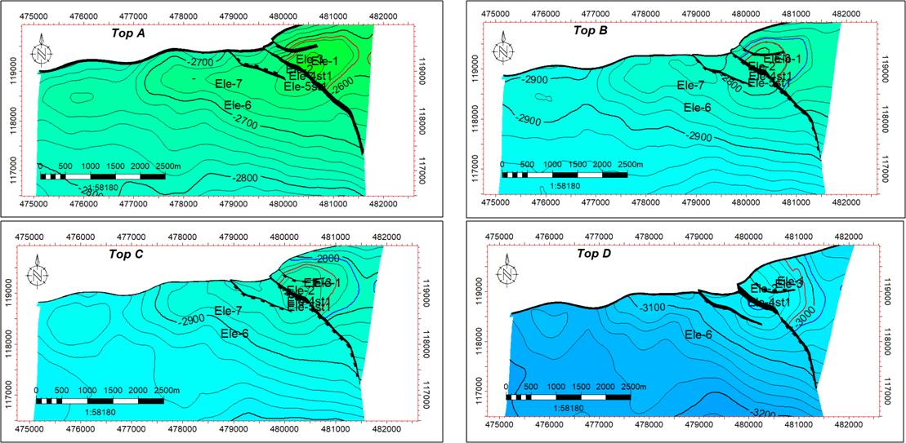

Figure 6: Seismic horizons with wells

## DEPOSITIONAL SETTING INTERPRETATION

The Onshore Field “X” lies within the emerged part of the Niger delta along the southern boundary of the Oligocene to Lower Miocene “Greater Ughelli” depobelt. During that period, the Niger paleo delta prograded on the shelf as a” shelf delta” in a depobelt controlled by anastomosed systems of listric faults with weak throws associated with a weak depositional slope. The different reservoirs are shallow marine sediment deposited in near shore and shore face settings (levels B, C and D) and back shore lagoon or tidal inlet setting (levels C2, C3, C4 and C5). The reservoirs can be subdivided into three main depositional environments: Delta Plain, Shoreface (delta front), and prodelta.

The description of the Sedimentological model involved these steps:

1. Establishing a sequence stratigraphic framework as a 3rd-Order sequence based on the identification of the Major Flooding Events (MFSs) and their corresponding TSs and SBs;

2. Depositional environments were defined based on Well logs. The depositional environment can be broadly classified as Delta plain (comprising Channels facies), Delta front characterized by shoreface deposits and prodelta characterized by marine shales. (Figure 8).

The amplitude maps interpreted for Levels A, B, C and D were used to delineate the delta front limits and prodelta. These limits were used in the facies modeling to control the direction of the facies. The bright amplitude areas (coloured red) indicate presence of sand and is described as the Delta plain. The dark areas depict the shaly areas and hence described as the prodelta.

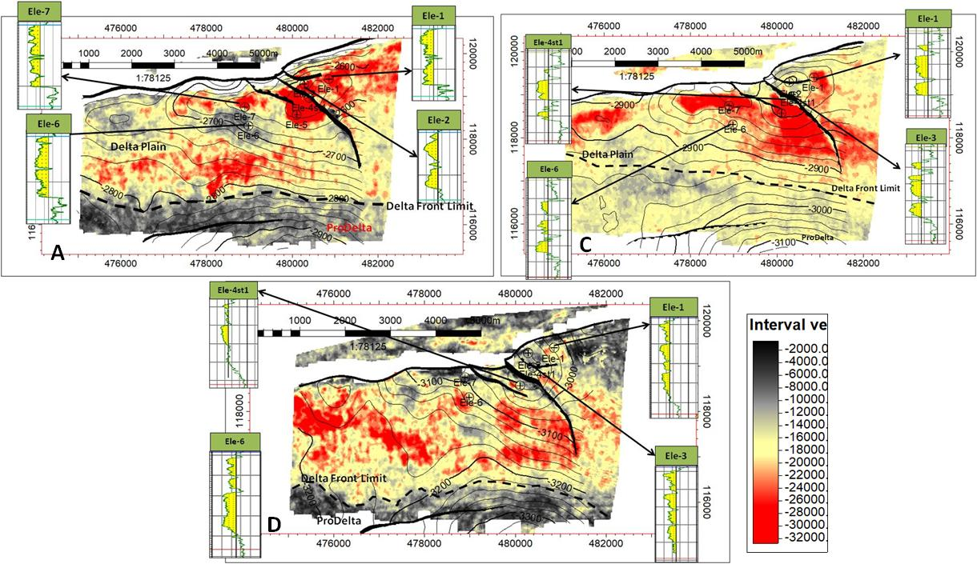

Figure 7: Amplitude Maps with log Motifs

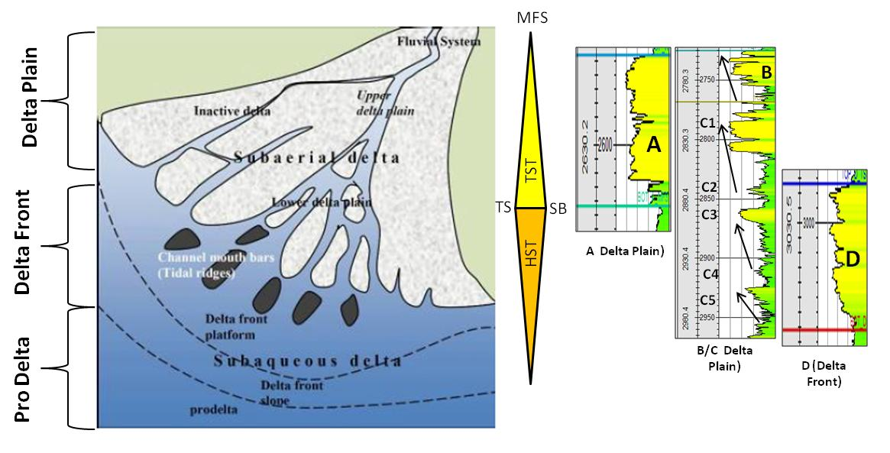

Figure 8: Conceptual Sedimentological Environment setting

## SEQUENCE STRATIGRAPHIC TRACTS

Sequence stratigraphy is a branch of stratigraphy that deals with the division of the full sequence of rocks based on a series of depositional sequences of co-genetic and closely related components that conform to geologically defined regional and inter-regional boundaries. As a methodology, sequence stratigraphy is the analysis of how the trends of sedimentation change in response to balance of sediment supply and accommodation at both the systemic and the basin scale up to the individual systems. Sequence boundary is individual, obvious surface dividing all the rocks overlying the surface from all the rocks underlying the surface. It develops autonomously of the sediment input. Maximum flooding surface is thus the surface which is at the beginning of a regressive system tract following a transgressive system tract. It is a common marine flooding surface that has the potential of isolating the transgressive systems tract from the high stand systems tract above it. It also denoted the deepest water facies in a sequence. The maximum flooding surface is also a shift from retrogradational to progradational parasequence stacking trends. Lowstand system tract is overlain by transgressive surface. The lowstand system tract is underlain by sequence boundary and is overlain by lowstand –to–shelf transition or transgressive surface. The Transgressive system tract (TST) is defined at the bottom by transgressive surface and at the top by the maximum flooding surface. Highstand system tract (HST) has its maximum flooding surface at the base and sequence boundary at the top.The stratigraphic framework is a 3rd-order sequence based on the identification of the Major Flooding Events (MFSs) and their corresponding Transgressive Surfaces (TSs) and Sequence Boundaries (SBs). Major Flooding Surfaces are field-wide correlatable marine shales; Transgressive Surfaces are defined at the bases of the MFS shales, approximating the onset of transgression and Sequence Boundaries are defined at the bases of the first channel facies (often sharp/erosive) above the MFS shales. This is shown in Figure 19.

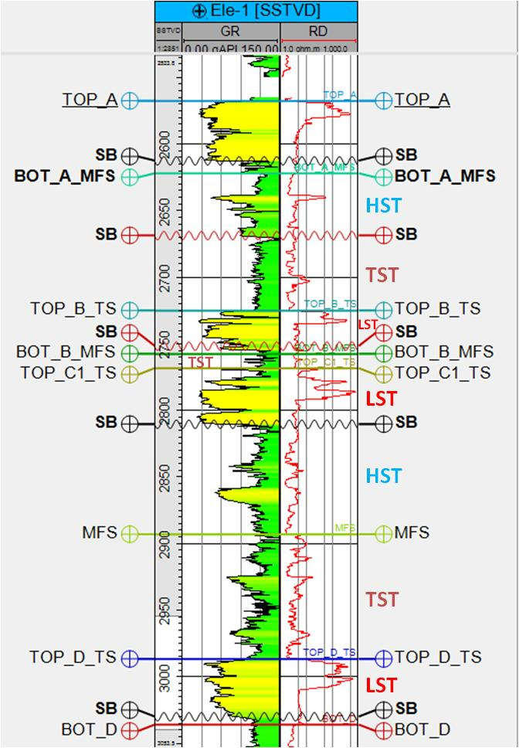

Figure 9: ELE-1 Sequence Stratigraphic Tracts

Systems Tracts (TSTs/HSTs) were defined using Gamma Ray and the resistivity logs trends. There is an interplay of sediment deposition, the Shoreface sands could cut across the channel deposits which could either depict the Highstand system tract (HST), Transgressive system tact (TST) and/or the Lowstand system tract (LST).There is an overall retrogradational pattern from the level D to the levels C5 to C4 before a flooding above (Figure 9).

## 

## **STATIC GEOLOGICAL MODEL**

The seismic interpreted horizons, the lithologies identified from well logs, facies description and petrophysical interpretation (Porosity-Total and effective, Permeability, &NTG) are all integrated to build a static model and estimate the hydrocarbon in place for the four levels. The 3D geologic model was built using the four horizons, faults from seismic interpretation and well tops (Top and Bases). The 3D Model covers the reservoirs from A to Level D. The cell size was set to 75m by 75m in X and Y and 1m for vertical layering. The workflow for the model in shown in Figure 10.

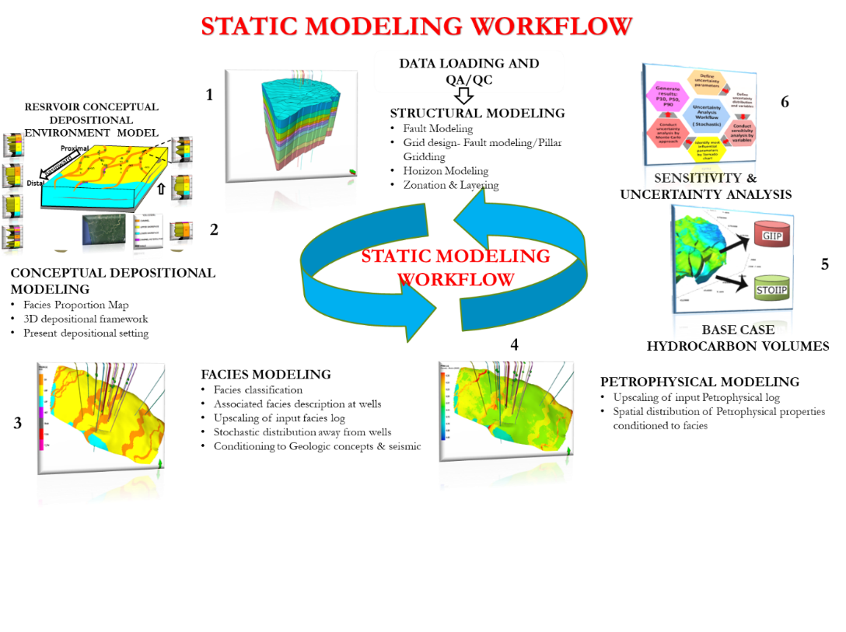

Figure 10: Model Building Workflow

### STRUCTURAL FRAMEWORK

The structural framework is seen as the container of the model and is the basis for petrophysical and facies model. The depth structural map and faults generated after seismic data interpretation is the framework of the structural model. Integrating these features would help in delineating the hydrocarbon traps.

#### FAULT MODELING

The first step in building the structural model is the fault modeling. It involves defining the shape of each fault within the horizons by generating a 3D grid that is faulted before making horizons, zones and layers which are inserted into the grid. Fault modeling input include; fault sticks, fault polygons and faulted surfaces. The faults were modelled as listric faults. Fault Picked at wells were locked to the fault pillars to control the geometry of the structure.

#### PILLAR GRIDDING

The follow up measure taken after modeling a fault is to generate a grid based on the defined faults. Pillar gridding is simply generating a skeleton which divides a model into boxes called grid cells. A three-dimensional framework is being generated after Pillar gridding. The aim of pillar gridding is to populate the model with different reservoir parameter and to portray the non-homogeneity reservoir unit. The cell size was set to 75m*75m*1m in X, Y and Z directions respectively.

#### LAYERING

The final step in the grid building process is subdivided the Zone definition, Sub-zone definition and Layering

**Zone Definition**: The four seismic interpreted surfaces were used to generate the main zones of the grid using the Make Horizons process in Petrel.

**Sub-Zones Definition**: Well markers were then used in the “Make Zones “process in Petrel to subdivide the zones based on the thicknesses from the wells and proportional volume correction.

**Layering**: The structural model was further subdivided by using iso-proportional division of the zones based on the reservoir thickness to better capture the heterogeneity in the reservoirs.

## 

## PROPERTY MODELING

#### 

#### WELL LOG UPSCALING

Well log Upscale is the first step in property modelling and is done to assign petrophysical and well log values to the 3D grid cells. Individual cell units are assigned a value for one up-scaled log after which they are averaged by using the chosen algorithm to define a cell value. These cells are utilized in modeling the reservoir properties. When modelling petrophysical properties, the 3Dgrid cell skeleton is utilised in representing the zones. Scaling-up well log is necessary in a 3D grid cells prior to modeling. The properties (associated facies, porosity, permeability, and NTG) were up scaled into the 3D grid. The averaging methods used during upscaling include: Arithmetic method for porosity and NTG.

#### 

#### FACIES MODELING

Facies modelling involves populating discrete facies within the entire grid cells for reservoir characterization. Facies modeling is an aspect of property modelling. The SIS (Sequential Indicator Simulation) algorithm (from Petrel software) is a stochastic algorithm that enables the combination of variogram and facies proportions to model facies in the 3D grid. It is also a very fast algorithm for modeling discrete properties. A facies model is an idealized vertical succession of facies that would be expected from the migration of depositional environments within a particular environment. Therefore, in Field “X”, the associated facies (AF) modelling was done with Sequential Indicator Simulation (SIS) using Spherical Variogram. The Variogram used for the AFs is as shown in Table 3.

**Table 3: Electrofacies Variogram**

|  |  |  |  |  |  |
| --- | --- | --- | --- | --- | --- |
| Code | Associated facies | Variogram | Major Direction | Minor Direction | Vertical |
| 0 | Shale | Spherical | 1000 | 1000 | 8 |
| 1 | Channel Heterolithics | 800 | 300 | 8 |
| 2 | Channel | 1000 | 300 | 10 |
| 3 | Upper Shoreface | 1000 | 300 | 10 |
| 4 | Lower Shoreface | 1000 | 200 | 10 |

#### PETROPHYSICAL PROPERTIES ANALYSIS

The well logs were used in analysis the rock properties of the fields. The available logs available for each well can be shown in table 4 below.Petrophysical parameters (VCL, NTG, Sw, K and ϕe) were established using Sequential Gaussian Simulation (SGS) geostatistical algorithm. The scaled-up log of computed petrophysical properties was utilised in assigning values to the grid cells.

**Table 4: Log Data Inventory**

|  |  |
| --- | --- |
| WELLS | LOG DATA INVENTORY |
| ELE1 | CAL, GR, RDEEP, RSHAL, RHOB, NPHI, DT, SP |
| ELE 2 | CAL, GR, RDEEP, RHOB, NPHI, DT, |
| ELE 3 | CAL,GR, RDEEP, RHOB, NPHI, DT, PEF, SGR |
| ELE 4ST1 | CAL, GR, RDEEP, RHOB, NPHI, DT, PEF, SGR |
| ELE 5ST1 | CAL, GR, RDEEP, RHOB, NPHI, DT, PEF, SGR, RSHAL |
| ELE 6 | CAL, GR, RDEEP, RHOB, NPHI, DT, PEF, SGR |
| ELE 7 | CAL, GR, RDEEP, RHOB, NPHI, DT, PEF, SGR, SP, MSFL, RSHAL |

#### VOLUME OF SHALE

This is observed as the proportion of shale within a reservoir. Volume of shale is computed using estimated Gamma ray index. The gamma ray index indicates the high Gamma ray log response due to increase in shale content. Gamma ray index is a polynomial function used in rescaling the highest and lowest gamma ray values, Asquith and Gibson (1982).

$I_{GR}=\frac{GR-{GR}_{min}}{{GR}_{max}-{GR}_{min}}$………………………………………………………………………………. (1.0)

Where GR= Gamma ray reading

GRmin= Lowest Gamma ray value

GRmax= Highest Gamma ray value

Larionov equation is applied when computing the shale volume using the above estimated GR index.

Vsh = 0.083 [2(3.7 *IGR) – 1.0] …………………………………………….(1.1)

Where Vsh = Shale volume

IGR = Gamma ray Index

#### TOTAL POROSITY

The porosity of a reservoir rock is defined as that fraction of the bulk volume of the reservoir that is not occupied by the solid framework of the reservoir. The Total porosity of a rock is the sum of the voids within a rock unit.

Ø =Vb- Vgr =Vp …………………………………(1.2)

VbVb

### EFFECTIVE POROSITY (PHIE) MODEL

This is the sum of all the interconnected pore spaces, thus, capable of transmitting fluid. It computed using the formula below:

$ϕ_{effective}=(1 -V_{SHALE})$ $ϕ_{N-D}$* ……………………………………...……(1.3)

#### NET THICKNESS

This is the unit within the pore spaces of a reservoir that is occupied by sand and devoid of non-reservoir formation (shale). It is given as;

Net thickness = Gross thickness – Vsh………………………………(1.4)

#### NET TO GROSS (NTG)

NTG is defined as the ratio of the Gross Rock Volume (GRV) that is capable of storing hydrocarbon that is producible thickness of the reservoir section It means that the rock has enough porosity, permeability and saturation to produce hydrocarbon. NTG value ranges from 0-1 and is defined by porosity or permeability cut off. Petrophysical cut-offs is a maximum value attached to an individual reservoir property to divide the formation into pay volume and non-pay volume. NTG cut-off is utilised in defining the reservoir’s productive zones. This cut off is gotten from the log signature and it affects estimated oil in place. The NTG log for the base case was generated by using a cut-off based on the PHIE and VCL log. The cut-off definition used is;

NTG= VCL =< 0.4 &PHIE>= 0.10…………………………………..(1.5)

#### 

#### FORMATION FACTOR

This is the proportion of rock resistivity completely saturated with water to the resistivity of that water.

F = $\frac{R_{O}}{R_{W}}$……………………………………………………………(1.6)

Where F = Formation factor

Ro = Resistivity of the rock filled 100% with brine

Rw **=** Formation water resistivity

Formation factor is essentially constant for clean sands but decreases as brine resistivity increases for dirty sands. Humble’s equation was utilized for this computation

F = a/ϕm**……………………………………………………………………………**(1.7)

Where a = tortuosity factor = 0.62 for unconsolidated sand

**ϕ =** porosity

m = cementation factor, given as 2.15

#### SATURATION

Reservoir rocks have pore space filled with fluid, which is either water or hydrocarbon. The spatial distribution of this relatively depends on certain factors associated with the rock’s physical properties and that of the fluid as well. The determination reservoir fluid saturation is necessary because calculation of hydrocarbon volume in place cannot be possible without the knowledge of the fluid saturation. It is also vital in determining the overall performance of a field.

#### WATER SATURATION

Interpretation of resistivity log helps in the estimation of water saturation (Sw).The basic principle behind the interpretation is that the conductive media of a formation is due to the occurrence of water in the pores of a rock, since both the rock matrix and the hydrocarbon are good insulators, the resistivity curve tends to increase in hydrocarbon saturated rocks and reduces in water bearing reservoirs. Ascertaining the water saturation (Sw) makes the computation of hydrocarbon saturation (SHC) easier since their addition equals one. Archie’s equation is utilized but applies mostly to clean formation.

Sw = $\frac{a}{ϕ_{m}}$. $\frac{R_{w}}{R_{t}}$………………………………………..(1.8)

For Niger Delta Formations, Aiegbedion’s correlation is applied

Sw = 0.055/…………………………………………….(1.9)

#### HYDROCARBON SATURATION (Shc)

Subtracting one the value of Sw gives the value of the hydrocarbon saturation.

Shc = 1-Sw………………………………………………………(1.10)

Shc = Hydrocarbon saturation and can be expressed in percentage

## HYDROCARBON VOLUME ESTIMATION AND UNCERTAINTY STUDY

There are several approaches used in the estimation of hydrocarbon reserve. They include Volumetric, Decline Curve Analysis, and Material Balance Methods. Volumetric method was utilised in this study. The modelled properties were used in computing the STOIIP. This input element determines how accurate the computed volume is. In volumetric method, we calculate the GRV and hydrocarbon in place using recovery factor.

STOIIP= $\frac{7758 *A*h*ϕ*(1-Sw)}{Boi}$

…………………………….(1.11)

Where, A= Area

h= Thickness

N/G =Net to gross

Φ = Porosity

Sw = Water Saturation

Boi = Formation factor for oil

Calculating for dissolved gas in oil (solution gas) and possibly free gas occurring gas, each volume is estimated separately as shown:

Solution Gas Initially in place (SGIIP) = STOIIP * Rsi

Free Gas Initially in place (FGIIP) = 43560*A*h*N/G*ϕ*Sg/Bg

Gas Initially in Place (GIIP) = SGIIP + FGIIP

Ultimate Recovery (UR) = STOIIP * RF (Recovery Factor)

Where Rsi = Initial solution Gas Oil Ratio

Sg = Gas saturation

Bgi = Formation factor of gas

## 

## MODELED FLUID CONTACT

The base case HCIIP for each level (A, B, C and D) was estimated based on established contacts (see Table 2), the petrophysical properties and the Bo/Bg. The Bo and Bg used for this estimation are 1.5460 and 0.004 respectively. The hydrocarbon volume in place for the different reservoirs is shown in Table 14.

## 

## UNCERTAINTY STUDY

The uncertainty of the Base Case STOIIP is related to both uncertainty of the input parameters (NTG, Porosity, and Facies Model) and Fluid contacts respectively. Uncertainty study was performed for Field “X” Level A, B, C (C1, C2, C3, C4) and Level D. The uncertainty study was done by the estimation of the volumes in place using the Petrel software and incorporating the changes in the fluid contact and petrophysical properties of each of the parameters and accessing the impacts of changes in GRV (Obtained from variation of the fluid contact), Facies, NTG and water saturation (Sw) on the base case volumes. The workflow adopted for the static uncertainty analysis is shown in Figure 11.

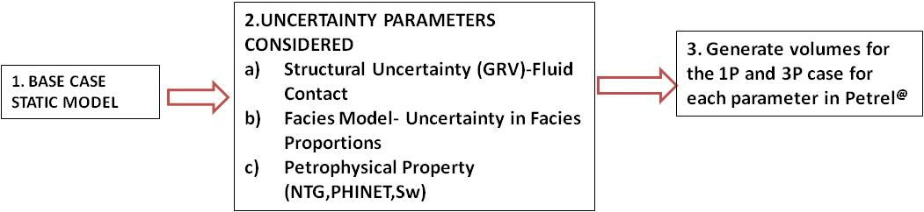

**Figure 11: Uncertainty Workflow**

### STRUCTURAL UNCERTAINTY (FLUID CONTACT UNCERTAINTY)

An uncertainty study on the structure was achieved using the uncertainty around the fluid contacts. The High case 3P and Low 1P case of the fluid contacts was done by adding + and – 5m around the base case fluid contacts of the base case fluid case (table 5). This is to account for error in measurements of the well logs since the fluid contacts were defined mainly from the well logs.

**Table 5: 1P Case, Base case and 3P case Fluid Contacts**

|  |  |  |  |  |  |  |  |
| --- | --- | --- | --- | --- | --- | --- | --- |
| **Reservoir Sands** | **Fluid Contact** | **Base Case**  **Fluid Contact**  **(m/TVDss)** | | **Low Case(1P)**  **Fluid Contact**  **(m/TVDss)** | | **High Case(3P)**  **Fluid Contact**  **(m/TVDss)** | |
| A | GWC | 2585 | | 2580 | | 2590 | |
| B | GOC/OWC | GOC 2721  WOC 2735 | | 2716  2730 | | 2726  2740 | |
| C | GOC/OWC | GOC 2769  WOC 2792 | | 2764  2787 | | 2774  2797 | |
| D | GOC/OWC | GOC 2989  WOC 3009.7 | | 2984  3004.7 | | 2994  3014.7 | |
|  |  |  |  | |  | |  | |

### FACIES PROPORTIONSUNCERTAINTY

Facies proportions were used to constrain the facies model. Values from the best and worst wells were used to vary the Facies proportions for the 1P and 3P cases, respectively. For the 3P case, the facies proportion was obtained from the best well, that is, the well located around the good sand (Ele-1) while the 1P facies proportion was obtained from Ele-6 which is located within the more heterolithic area. The Facies proportions variation is shown in figure 12.

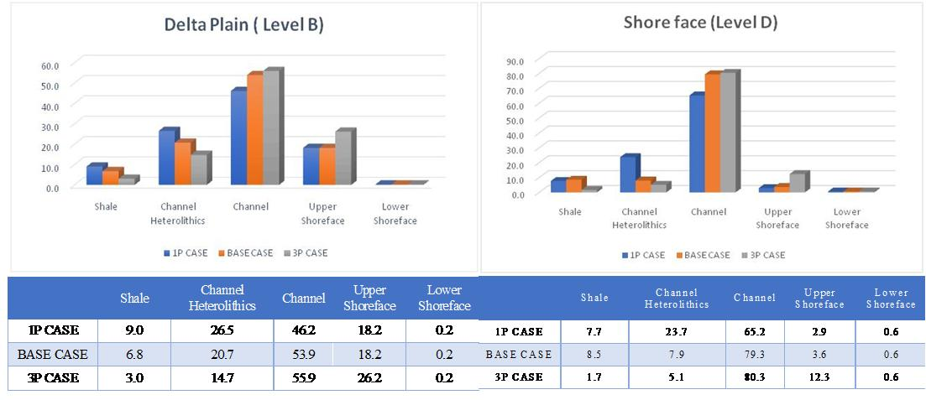

Figure 12: 1P Case, Base Case and 3P case Facies Proportion

The resulting facies models based on the 1P and 3P Facies Proportions were used to constrain NTG and Water Saturation. Oil and gas volumes were then generated based on these distributions.

### 

### PETROPHYSICAL PARAMETERS (NET TO GROSS (NTG), SW) UNCERTAINTY

Uncertainty of the petrophysical properties, (Net to Gross and Sw) was based on the uncertainties of the facies. The petrophysical properties are all constrained to the facies model. The good facies (Channel) had higher NTG values than the more heterolithic sand. And this equally had an impact on the volume in place while keeping the fluid contact constant at the base case.

**RESULTS AND DISCUSSION**

## 

## 3D GEOLOGICAL STATIC MODEL

The geo-model covers all the reservoirs from A to D. Not all the levels were picked on seismic; therefore, well tops were used to generate the remaining zones and subzones as conformable horizons using proportional volume correction (Table 6). The results of the grid building is shown in Table 7. The total number of grid cells is 2290593.

**Table 6: Horizon Zone Definition**

|  |  |  |
| --- | --- | --- |
| SEISMIC INTERPRETED HORIZONS | SUB-ZONES | LAYERS |
| A | 2 | 50 |
| B | 5 | 56 |
| C | 6 | 139 |
| D | 4 | 49 |

## PROPERTY MODELING

### 

### FACIES MODELING

The five facies interpreted are Shales, Channel Heterolithics, Channel, Upper Shoreface and Lower Shoreface. The Minimum amplitude maps (attribute) derived from Seismic interpretation was used to define the Delta plain-Delta front limits for each of the levels. Facies proportion maps derived from sedimentological concept (Delta plain, Delta front and Prodelta) and facies proportion at wells was used for the facies modeling. The facies proportions at well were used in the distribution of facies based on the depositional environment of each level (Table 7). Levels A, B and C, facies proportion was combined and interpreted as the Delta plain environment, while Level D layers are for the shoreface environment. The facies logs were up scaled into the 3D grid using the “Most of” averaging method.

**Table 7: Facies Model Proportions**

|  |  |  |  |
| --- | --- | --- | --- |
| Code | Name | Delta Plain % | Delta Front% |
| 0 | Shale | 6.76 | 8.49 |
| 1 | Channel Heteroliths | 18.83 | 7.94 |
| 2 | Channel | 56.29 | 79.32 |
| 3 | Upper Shoreface | 17.92 | 3.63 |
| 4 | Lower Shoreface | 0.2 | 0.62 |

Delta plain deposits are under fluvial influence and are oriented in the NW-SE direction while the Delta Front (shoreface) deposits are oriented in the E-W direction parallel to the coast line. The workflow and the results are shown in Figure 13.

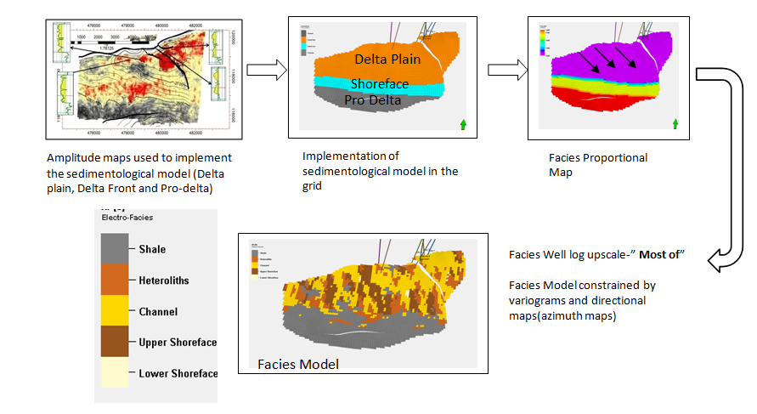

Figure 13: Facies Model Workflow

### 

### PHIE MODEL

The PHIE model was constrained by the associated facies. The algorithm used for propagation is the Gaussian random function simulation and normal distribution method used based on the mean and standard deviation of each of the associated facies. The result of the model is shown on figure 14.

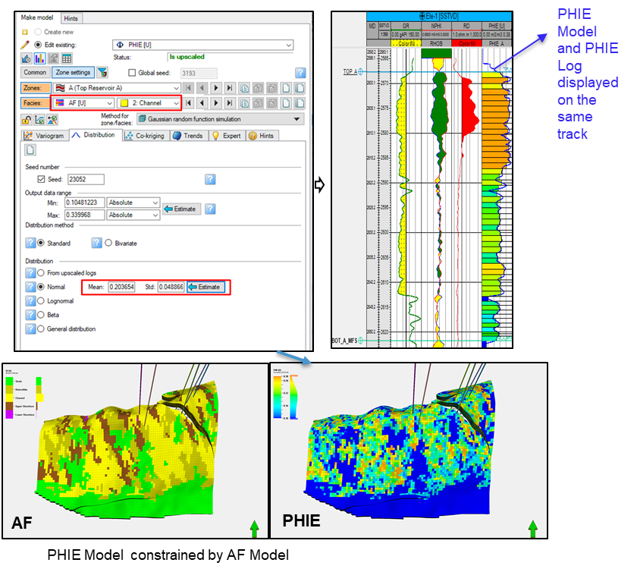

##### **Figure 14: PHIE Model**

### NTG MODEL

This was up scaled using the arithmetic method. A distribution function for each facies was generated based on the up scaled NTG property and then used to constrain the propagation in the 3D model. The algorithm used is the Gaussian random function simulation. The NTG model was also constrained by the associated facies model and co-krigged with the PHIE model. The methodology used in shown in figure 15.

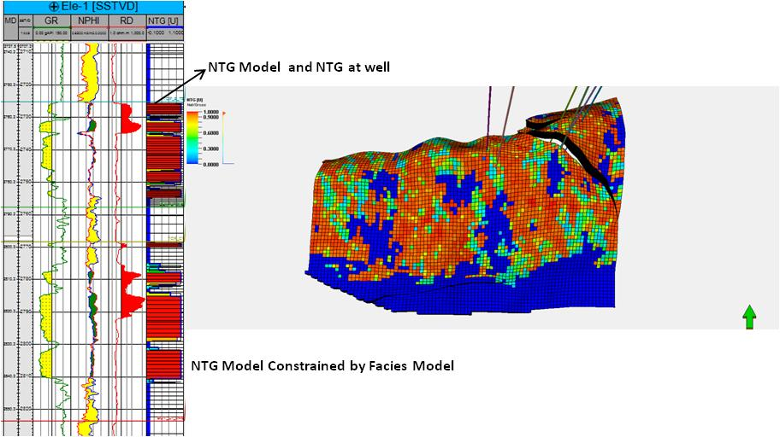

##### **Figure 15:NTG Model**

## PETROPHYSICAL PROPERTIES OF ROCK UNITS

The Petrophysical parameters calculated for Field “X” includes the total porosity, effective porosity, Net to gross (NTG), water saturation (Sw), volume of shale (Vsh) and the hydrocarbon saturation (Sh). These properties are used to show and determine the characteristics of the different levels and how suitable it is for hydrocarbon accumulation and hence its performance. The effective porosity is generally good and ranges from 0.16 to 0.26 and varies from well to well. Reservoir A, B,C and D has an average porosity of 0.22, 0.2, 0.19 and 0.2 respectively (table 8 to 11). Reservoirs A is in the Delta plain that is mostly channelized and has the best petrophysical properties with PHIE of 0.22 and NTG value of 0.84. Water Saturation values ranges from 0.18 to 1.0. Water saturation of 1 is observed more in the down dip wells (Ele- 6 and Ele- 7). This indicates that these wells are water bearing.Ele-1 to Ele-4 wells generally have better petrophysical properties than wells Ele- 6 and Ele- 7.The petrophysical evaluation of Field ‘X’ indicates that gas, oil and water are the existing fluid types with very good porosity (16-26) %, Saturation of water (0.14 -1) % values.

**Table 8: Computed Petrophysical Parameters for Reservoir A**

|  |  |  |  |  |  |  |  |
| --- | --- | --- | --- | --- | --- | --- | --- |
| Reservoir Parameters | Wells | | | | | | |
| **Ele-1** | **Ele-2** | **Ele-3** | **Ele-4st1** | **Ele-5st1** | **Ele-6** | **Ele-7** |
| Gross Pay (m) | 54 | 53 | - | 56 | - | 66 | 59 |
| NTG | 0.84 | 0.95 | - | 0.9 | - | 0.85 | 0.86 |
| Phi E | 0.21 | 0.26 | - | 0.2 | - | 0.27 | 0.18 |
| Sw | 0.69 | 0.74 | - | 0.45 | - | 1 | 0.97 |
| Sh(Gas) | 0.31 | 0.26 | - | 0.55 | - | - | 0.03 |
| Vsh | 0.16 | 0.05 | - | 0.1 | - | 0.15 | 0.14 |

**Table 9: Computed Petrophysical Parameters for Reservoir B**

|  |  |  |  |  |  |  |  |
| --- | --- | --- | --- | --- | --- | --- | --- |
| Reservoir Parameters | Wells | | | | | | |
| **Ele-1** | **Ele-2** | **Ele-3** | **Ele-4st1** | **Ele-5st1** | **Ele-6** | **Ele-7** |
| Gross Pay (m) | 33 | 32 | 32 | 30 | 30 | 31 | 29 |
| NTG | 0.78 | 0.7 | 0.85 | 0.84 | 0.84 | 0.77 | 0.76 |
| Phi E | 0.21 | 0.25 | 0.22 | 0.2 | 0.23 | 0.13 | 0.19 |
| Sw | 0.69 | 0.15 | 0.33 | 0.14 | 0.15 | 1 | 0.4 |
| Sh(Oil) | 0.31 | 0.85 | 0.67 | 0.86 | 0.85 | 0 | 0.6 |
| Vsh | 0.22 | 0.3 | 0.15 | 0.16 | 0.16 | 0.23 | 0.24 |

**Table 10: Computed Petrophysical Parameters for Reservoir C**

|  |  |  |  |  |  |  |  |
| --- | --- | --- | --- | --- | --- | --- | --- |
| Reservoir Parameters | Wells | | | | | | |
| **Ele-1** | **Ele-2** | **Ele-3** | **Ele-4st1** | **Ele-5st1** | **Ele-6** | **Ele-7** |
| Gross Pay (m) | 208 | 188 | 209 | 185 | 208 | 211 | 211 |
| NTG | 0.7 | 0.91 | 0.8 | 0.87 | 0.82 | 0.61 | 0.72 |
| Phi E | 0.22 | 0.26 | 0.2 | 0.17 | 0.19 | 0.18 | 0.14 |
| Sw | 0.3 | 0.16 | 0.16 | 0.2 | 0.6 | 1 | 0.86 |
| Sh(Oil) | 0.7 | 0.84 | 0.84 | 0.8 | 0.4 | 0 | 0.14 |
| Vsh | 0.3 | 0.09 | 0.2 | 0.13 | 0.18 | 0.39 | 0.28 |

**Table 11: Computed Petrophysical Parameters for Reservoir D**

|  |  |  |  |  |  |  |  |  |
| --- | --- | --- | --- | --- | --- | --- | --- | --- |
| Reservoir Parameters | Wells | | | | | | | |
| **Ele-1** | **Ele-2** | **Ele-3** | **Ele-4st1** | **Ele-5st1** | **Ele-6** | **Ele-7** |
| Gross Pay (m) | 49 | 49 | 52 | 46 | - | 48 | - |
| NTG | 0.76 | 0.86 | 0.82 | 0.85 | - | 0.61 | - |
| Phi E | 0.21 | 0.23 | 0.2 | 0.18 | - | 0.2 | - |
| Sw | 0.54 | 0.18 | 0.46 | 0.16 | - | 1 | - |
| Sh(Oil) | 0.46 | 0.82 | 0.54 | 0.84 | - | 0 | - |
| Vsh | 0.24 | 0.14 | 0.18 | 0.15 | - | 0.39 | - |

## BASE CASE VOLUMES

Reserve estimation was done after the reservoir modelling to enable the computation of hydrocarbon volume originally in place. The statistical distribution of the reservoir’s properties (porosity, thickness, water saturation) and the fluid contact set served as input in this probabilistic volume calculation. The estimated volume for the modelled reservoirs is shown in Table 12.The fluid contact for reservoir A is a GWC and hence it is considered to be a gas reservoir with GIIP of 18 MMSCF. Reservoirs C and D is considered to have hydrocarbon quantity of commercial value; 22.02 MMSTB AND 11.94 MMSTB respectively and hence should be used as input for reservoir simulation forecast to predict its future performance. The Uncertainty study is also focused on these reservoir levels to help in this prediction of reserves. Reservoir C with OIIP of 6.2 MMSTB should be considered as an upside that can further be optimized to add value to the field for future investments.

**Table 12: Base Case HCIP Estimates**

|  |  |  |  |  |
| --- | --- | --- | --- | --- |
| Reservoir Sands | Fluid Contact | Base Case  Fluid Contact  (m/TVDss) | STOIIP  MMSTB | GIIP  (MMCF) |
| A | GWC | 2585 | - | 18 |
| B | GOC/OWC | GOC 2721  WOC 2735 | 6.2 | 7 |
| C | GOC/OWC | GOC 2769  WOC 2792 | 22.02 | 22 |
| D | GOC/OWC | GOC 2989  WOC 3009.7 | 11.94 | 60 |
| Total Volumes |  |  | 40.16 | 107 |

## RESULTS OF THE UNCERTAINTY STUDY

The impacts of these distribution parameters are shown in the Tornado diagrams below (figure 16) for a delta plain reservoir (LevelB) and a shoreface reservoir (Level D).

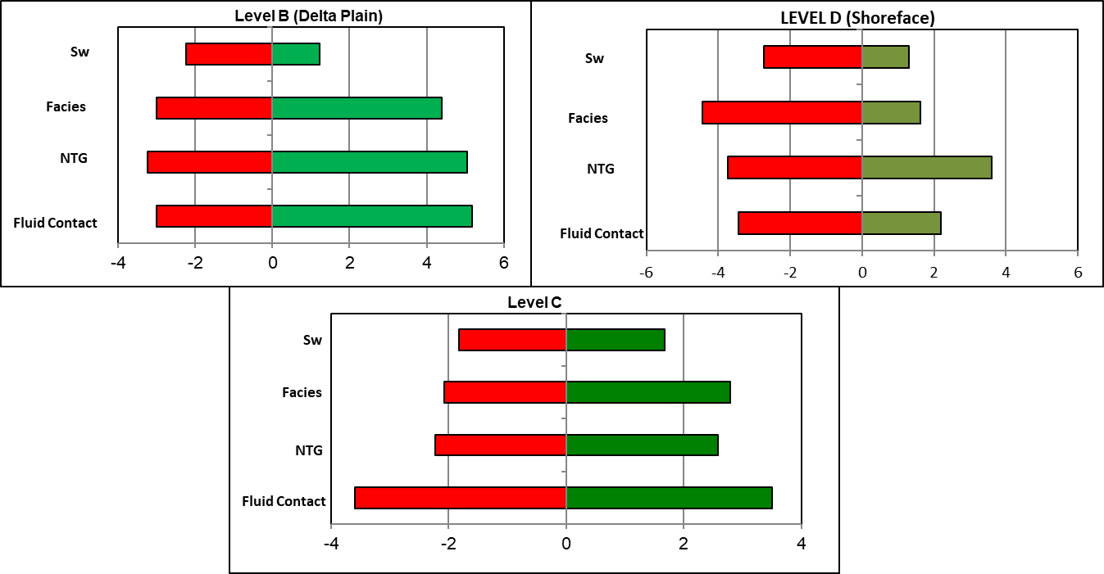

**Figure 16: Parameters for Tornado Sensitivity Charts.**

The parameters that show the highest impact are the Fluid Contact, NTG and Facies proportion. The 1P and 3P volumes generated the impacts of these parameters are shown in the Table 13.

**Table 13: 1P case, Base case and 3P case volume and Impacts**

|  |  |  |  |  |
| --- | --- | --- | --- | --- |
| Base Case | 6.2 MMSTB | | | |
| Level B | **P10** | **Impact** | **P90** | **Impact** |
| **MMSTB** | | | |
| Fluid Contact | 3.2 | -3.0 | 11.4 | 5.2 |
| NTG | 3.0 | -3.2 | 9.3 | 5.1 |
| Facies Proportion | 3.2 | -3.0 | 10.6 | 4.4 |
| Sw | 4.0 | -2.2 | 7.4 | 1.2 |
|  |  |  |  |  |
|  |  |  |  |  |
| Base Case | **22.02 MMSTB** | | | |
| Level C | **P10** | **Impact** | **P90** | **Impact** |
| **MMSTB** | | | |
| Fluid Contact | 18.4 | -3.6 | 25.5 | 3.5 |
| NTG | 19.8 | -2.2 | 24.6 | 2.6 |
| Facies Proportion | 20.0 | -2.1 | 24.8 | 2.8 |
| Sw | 20.2 | -1.8 | 23.7 | 1.7 |
|  |  |  |  |  |
|  |  |  |  |  |
| Base Case | **11.94 MMSTB** | | | |
| Level D | **P10** | **Impact** | **P90** | **Impact** |
| **MMSTB** | | | |
| Fluid Contact | 8.5 | -3.4 | 14.1 | 2.2 |
| NTG | 8.2 | -3.7 | 15.5 | 3.6 |
| Facies Proportion | 7.5 | -4.4 | 13.6 | 1.6 |
| Sw | 9.2 | -2.7 | 13.3 | 1.3 |

## CONCLUSION

A stacked 3D geological was built using the four horizons of A, B, C and D and faults interpreted from seismic. The total number of grid cells is 2,290,593 with 373 layers. The structure is a simple anticline bounded in the North and South by a Major fault trending east to west and by a minor fault separating the structure into two parts in the North/South direction. Amplitude maps (RMS) was also extracted from seismic and helped in delineating the depositional environments of the reservoirs (See Figure 7).Depositional environments were defined based on well log signatures. The depositional environment is broadly classified as Delta plain (comprising of channel facies and transgressive sands for Reservoir A, Reservoir B and C), Delta front characterized by shoreface deposits (Reservoir D) and Prodelta characterized by marine shales. The five facies interpreted are Shales, Channel Heterolithics, Channel, Upper Shoreface and Lower Shoreface and these were constrained using the seismic attributes and facies proportion from wells during facies modeling. The results of the petrophysical analysis of the wells showed generally good to excellent properties for all the reservoirs. These properties (PHIE, NTG and Sw) were up scaled into the grid and were constrained by the facies model and also co-krigged with the PHIE Model (i.e NTG and Sw). The Fluid contacts for the field were mostly interpreted from well logs. The 3-D geologic reservoir model and uncertainty study of Field “X” has helped in characterizing the reservoir by giving a detailed description and good knowledge of the reservoir and can used for dynamic modelling and in an effective reservoir management strategy. Reservoirs C and D is considered to have hydrocarbon quantity in commercial value; 22.02 MMSTB and 11.94 MMSTB respectively. This can be used as input for reservoir simulation forecast to predict its future performance. The Uncertainty study is also focused on these reservoir levels to help in this prediction of reserves. Reservoir C with OIIP of 6.2 MMSTB should be considered as a reserve that can further be optimized to add value to the field for future investments. The 3P and 1P volumes calculated for the levels showed that the fluid contact, NTG and the facies proportions has an impact on the volumes in place.

# REFERENCES

Akinwumi, F.V., Arochukwu, E.C., Abdul-Kareem, A.S.(2004), Managing uncertainties in Hydrocarbon-in-place volumes in a Northern Depobelt Field, Niger Delta, Nigeria: SPE 88880.

Avbovbo, A.A. (1978), Tertiary Lithostratigraphy of Niger Delta. American Association of Petroleum Geologists Bulletin, 62, Pp. 295-300

Asquith, G.B. and Gibson, C.R. (1982) Basic Well Log Analysis for Geologists. The American Association of Petroleum Geologists (AAPG), Tulsa

Burke,K (1972), Longshore drift, submarine canyons, and submarine fans in development of Niger Delta: AAPG Bull., v.56, Pp.1975-1983

Doust, H., and Omatsola, E.M., (1989). Niger Delta. AAPG Memoir48: Pp. 201–238.

Doust, H., and E. Omatsola, (1990), Niger Delta, in J.D. Edwards and P.A. Santogrossi, eds., Divergent/passive margin basins: American Association of Petroleum

Geologists Memoir 48, Pp. 239-248.Edwards, J.D., and Santogrossi, P.A., (1990), Summary and conclusions, *in*, Edwards, J.D., and Santogrossi, P.A., eds., Divergent/passive Margin Basins, AAPG Memoir 48: Tulsa, American Association of Petroleum Geologists, Pp. 239-248.

Ekweozor, C.M. and E.M. Daukoru., (1984) Petroleum source-bed evaluation of Tertiary Niger Delta: reply — Am. Assoc. Pet. Geol., Bull. 68: Pp.390–392.

Evamy, B.D., J. Haremboure, R. Kammerling, W.A. Knaap, F.A. Molloy, and P.H.,

Rowlands, (1978), Hydrocarbon habitat of tertiary Niger Delta: American Associationof Petroleum Geologists Bulletin, v. 62, Pp. 1-39.

Haq, B. U., J. Hardenbol, and P. R. Vail, (1988), Mesozoic and Cenozoic chronostratigraphy and cycles of sea-level change, C.K. Wilgus et al., eds., Sea-level change: an integrated approach: Society of Economic Paleontologists and Mineralogists Special Publication 42, Pp. 71-108.

Hospers, J. (1965), Gravity Field and Structure of the Niger-Delta, Nigeria, West Africa. Geological Society of America Bulletin, 76, Pp. 407-422.

Merki, P (1972), Structural geology of the Cenozoic Niger Delta. (ed. T.F.J. Dessauvagie & A.J. Whiteman), African Geology, Ibadan Univ. Press, Pp. 635-646.

Murat,R.C., (1972),Stratigraphy and Paleogeography of the Cretaceous and Lower Tertiary in southern Nigeria: Ist. Conference on African Geology, Ibadan, 1970, Proceedings: Ibadan, Nigeria, Ibadan University Press, Pp. 251-266.

Nwachukwu, S.O. (1972), The Tectonic Evolution of the Southern Portion of the Benue Trough, Nigeria. Geological Magazine, 109, Pp. 411-419.

Short, K.C., and A.J. Stauble, (1967), Outline of Geology of Niger Delta: American Association of Petroleum Geologists Bulletin v. 51, Pp. 761-779.

Stacher, P.,(1995), Present understanding of the Niger Delta hydrocarbon habitat, in M.N.Oti, and G. Postma, eds., Geology of Deltas: Rotterdam, A.A. Balkema, Pp. 257-267.

Stoneley, R., (1966), The Niger Delta region in the light of the theory of continental drift: Geol. Mag., v.105, Pp.385-397

Kulke, H., (1995), Regional Petroleum Geology of the World. Part II: including Africa. Berlin, GebrüderBorntraeger, Pp. 143-172.

Klett, T.R., Ahlbrandt, T.S., Schmoker, J.W., and Dolton, J.L., 1997, Ranking of the world’s oil and gas provinces by known petroleum volumes: U.S. Geological Survey Open-file Report-Pp. 97-463.

Lehner, P. and De Ruiter, P.A.C. (1977), Structural History of Atlantic Margin of Africa. American Association of Petroleum Geologists Bulletin, 61, Pp.961-981.

Weber, K.J.,(1971), Sedimentogical aspects of oil fields in the Niger Delta: Geolgieen Mijnbouw, v 50, Pp.559-576

Weber, K.J. and E.M. Daukoru, (1975), Petroleum geology of the Niger Delta:

Proceedings of the 9th World Petroleum Congress, Tokyo, v. 2, Pp. 202- 221.