ASSESSMENT OF INDOOR ENVIRONMENTAL TEMPERATURE AND HEAT BALANCE COMFORT MODEL
Chime, Charles¹.,
¹Department of Architecture, Delta State University of Science and Technology, Ozoro, Nigeria.

Abstract
Global warming has been recognised as having significant effect on the ecosystem, weather, and resident’s health. In the past century the average global temperature has risen. However, the temperature has increased more obviously during the last decades. The geographical temperature anomaly indicates the global temperature changes and the rise of global temperature which is an effect by the increase of greenhouse gas. Carbon dioxide, which is the main greenhouse gas, arises in large quantities from human activities. Since the industrial revolution, the carbon dioxide emission has increased rapidly. A large amount of carbon dioxide derives from the combustion of fossil fuels such as coal, oil and gas. Heat balance comfort model deals with a subjective feeling whereby occupants feel satisfied with the indoor environment. And it is related to the energy balance between metabolic rate and heat loss from the human body. The heat loss is demonstrated by radiation, convection, and evaporation. The result showed that the highest indoor air temperature will rise to 34.5°C when single side glazing was plotted in the model, and reduce to 30.25°C when double side glazing was plotted. Approximately 4°C difference can be found, compared with single side glazing and double side glazing. It clearly presents the importance of a heat balance comfort model for indoor temperature. Therefore, a good design of window can save 40%-50% of energy consumption in non-domestic buildings. Heat balance comfort model influences good energy performance can reduce energy consumption and provide comfort for the indoor environment. Recommendations were made to adopt appropriate design strategies to each climate zone by considering indoor environmental temperature and heat balance comfort model which greatly reduces energy use and greenhouse gas emissions.
Keywords: Energy performance, Global warming, Heat balance, Indoor Environment, Greenhouse gas.

Introduction
The heat balance comfort model is used to describe the heat balance between the human body and the ambient environment. The test subject was seen as an environmental stimuli receiver to evaluate the environmental condition when the factors changed. Based on the heat balance model, Fanger (1970) developed a Predicted Mean Vote (PMV) model, according to four environmental factors (air temperature, mean radiant temperature, vapour pressure and air velocity) and two personal adjustment factors (activity level and clothing level). The basic concept of the PMV model is to calculate the body‘s heat balance, the prediction of the average skin temperature and the evaporative heat loss to maintain the total balance in detail.
The PMV model is widely used for evaluation of indoor temperature comfort and applied in many temperature comfort standards, such as American Society of Heating, Refrigerating and Air-conditioning Engineers 55–2004 (ASHRAE, 2004), International Organization for Standardization 7730 (ISO, 2005) and Chartered Institution of Building Services Engineers thermal comfort standard (CIBSE, 2006). In order to apply the PMV model in actual thermal sensation evaluation, a seven-point scale of thermal sensation was developed by Fanger (1970), ranging from -3 to +3. It presents cold to hot with 0 for the neutral point. The PMV model provides the thermal sensation vote value between people and the environment. However, people have different requirements of the actual environment compared with the weather chamber. Thus, Fanger (1970) proposed the Predicted Percentage of Dissatisfied (PPD) to predicate the percentage of people‘s dissatisfaction degree. He believed that, even when the PMV was equal to 0 (Neutral), there would probably be 5% of people who were not satisfied because of their different physiological states and environmental preferences. The PPD scale is similar to the seven-point PMV scale, which is from Dissatisfied (-3) to Satisfied (+3). In this respect, this study on assessment of indoor environmental temperature and heat balance comfort model is vital.
- Literature Review
Heat balance comfort model explores the thermal, physiological and psychological response of people in their environment in order to develop mathematical models to predict these responses. In a warm humid climate, the capacity for sweating to increase can raise the heat load of the body and encourage heat loss from the skin; meanwhile in cold weather, the body would constrict blood vessels and pores to reduce heat loss from the skin. Researchers have empirically argued building occupants' thermal responses to the combined temperature effect of the environmental, personal and physiological variables.
Environmental Variables
- Air Temperature (Ta) - a direct environmental index, is the dry-bulb temperature of the environment,
- Mean Radiant Temperature (Tr) - a rationally derived environmental index defined as the uniform black-body temperature that would result in the same radiant energy exchange as in the actual environment,
- Relative air velocity (v) - a direct environmental index is a measure of the air motion,
- Water vapour pressure in ambient air (Pa) - a direct environmental index.
Personal Variables
- Thermal resistance of the clothing (Icl).
- Thermal resistance of the clothing (Icl) is measured in units of "clo." The 1985 ASHRAE Handbook of Fundamentals (ASHRAE, 1985) suggests multiplying the summation of the individual clothing items clo value by a factor of 0.82 for clothing ensembles.
- Metabolic rate (H/ADu).
Physiological Variables
- Core or Internal Temperature (Tcr),
- Skin Temperature (Tsk),
- Skin Wettedness (w),
- Sweat Rate,
- Thermal Conductance (K) between the core and skin.
Where the Skin Temperature (Tsk), the Core Temperature (Tcr) and the Sweat Rate are physiological indices.
The Skin Wittedness (w) is a rationally derived physiological index defined as the ratio of the actual sweating rate to the maximum rate of sweating that would occur if the skin were completely wet. One more consideration is important in dealing with thermal comfort - the effect of asymmetrical heating or cooling. This could occur when there is a draft or when there is a radiant flux incident on a person. Fanger (1986) noted that the human regulatory system is quite tolerant of asymmetrical radiant flux. According to ASHRAE (2010) reasonable upper limit on the difference in mean radiant temperature (Tr) from one direction to the opposing direction is 15. This limit is lower if there is a high air velocity in the zone.
2.1 Neutral temperature for comfort
Humphreys (1978) gathered and analysed thermal comfort survey results from 36 places worldwide. He indicated that the comfort temperature varies all over the world, and the comfort temperature range is much wider than the narrow comfort zone which is given by the heat balance model. For instance, the comfort temperature ranges from 28.1° in summer in Shanghai to 18.5° in winter in Beijing. According to Humphreys‘ studies, he concluded that the indoor comfort temperature is related to the monthly mean outdoor temperature. It means people‘s indoor comfort temperature is related to the season, the climate and the location. Humphreys also suggested a regression equation of neutral temperature for a free-running building, as shown below:
Equation 1: Humphreys‘s neutral temperature equation for a free-running building
Where Tn °C is the predicated neutral temperature, and Tm °C is the monthly mean outdoor temperature. The regression residual variation is 1°C which means 90% of occupants feel comfortable when the temperature varies ±1°C. This result was reviewed by Auliciems (1983). He did some more field works in different climate conditions and deleted some field works that aimed at children‘s comfort, and then proposed the equation with de Dear (1986) as shown in Equation 2:
Equation 2: Auliciems and de Dear‘s neutral temperature equation for a free-running building.
Nicol and Roaf (1996) concluded from field measurement results in Pakistan and established the regress equation as shown in Equation 3, for the relationship between the comfort temperature and the monthly outdoor mean temperature. It is similar to Auliciems and de Dear‘s (1986) equation.
Equation 3: Nicol and Roaf‘s neutral temperature equation for a free-running building
3. Research Methodology
The study area is Delta State in southern part of Nigeria within the warm-humid climate zone. The investigation was based on the residents’s Heat balance comfort within a case study building (prototype administrative office) located in Delta State University of Science and Technology Ozoro. Hence the study was carried out through direct physical measurements. The monitored buildings are shown in Plate 1, and Plate 2. The first phase of the measurement was carried out when air-condition were on & windows closed and the readings of the indoor environmental temperature was recorded and second phase was when the building was running naturally and windows were open & air-condition were off. Data logger was used to record the environmental condition as shown in Plate 3, and Plate 4. LUGE L9 data logger (L92-1+): recording radiant temperature from -40C⁰ to +70C⁰ and relative humidity from 0% to 100%. The accuracy of temperature reading is ±0.2C⁰ and the accuracy for relative humidity is ±2%RH. The reading resolution for temperature and relative humidity are 0.1C⁰ and 0.1%. The AIRFLOW thermal anemometer (TA-2-2): the working velocity range is between 0- 2m/s, with accuracy of ±3%FSD at 20C⁰ and 1013mbar.
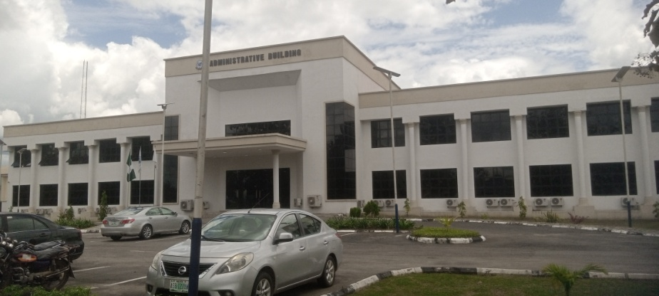

Plate 1: shewing the case study building (prototype administrative office) located in Delta State University of Science and Technology Ozoro, and Dennis Osadebay University Asaba
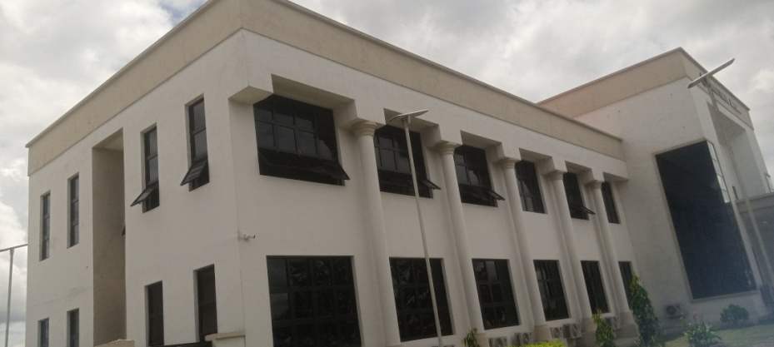

Plate 2: shewing the windows were opened and air conditioners off.

Plate 3: LUGE L9 data logger (L92-1+):
Plate 4: AIRFLOW thermal anemometer (TA-2-2):

3.1. Data Presentation:
In order to provide more detailed results of the impact of indoor environment temperature and heat balance comfort model in office buildings, hourly data during the natural ventilated period were used. The data also plotted into Givoni‘s comfort zone to identify whether it is in the comfort area (Givoni, 1992). The dry bulb indoor air temperature during the working hours was used to analyse the temperature percentages in the office. The radiant temperature would have an impact on occupant comfort (Chime, 2022). Szokolay (1985) suggested that, if the difference between mean radiant temperature and dry bulb air temperature was equal or below ±3°C, then the condition would be acceptable, while if the temperature different was over ±3°C, then the mean radiant temperature may cause discomfort. Thus, in the hourly results, if the temperature difference was higher or lower than ±3°C, it would be considered as uncomfortable.
3.2 Temperature percentages
For the 30% glazing area office building, the comfort temperature frequency in the south, east, north and west orientations with the opening area increasing from 25% to 100% and from May to October (Except July and August). It can be seen that when the opening area increased from 25% to 50%, it had significant influence on the internal temperature, and the temperature frequency was extended greatly. When the opening area increased from 50% to 75%, the temperature frequency growing trend was lower than that from 25% to 50%, and the temperature frequencies were quite similar when the opening area was at 75% and 100%. This can be proved that, in a 30% glazing office room, 75% or 100% of the window opening area is needed to achieve effective air flow rates, when the indoor and outdoor temperature varied between 3°C and 5°C and the wind speed was between 1m/s and 5m/s. The result also showed that, in July and August, changing the opening area did not impact the indoor temperature and the comfort time was lower than 1% in the office. This was because the average internal air temperatures were above 32°C and the absolute humidity was above 20g/kg, which was out of the comfort zone. Besides, in July and August, more than 60% of the time the external temperatures were above 29°C. It seemed like, in 40% of the time the external temperature was below 29°C and the natural ventilation for cooling method may still be achievable. But in the majority of time the indoor environmental condition was far away from the comfort area; thus, the mechanical cooling system was suggested to be used to cool the internal temperature in these two months. So, July and August would not be used for further analysis. Internal and external temperature and indoor relative humidity in south/north facing office in September are shown in figure 1.

Figure 1: Internal and external temperature and indoor relative humidity
in south/north facing office in September.
It is found from the field studies that there is a gap between the results from the field measurement and the Neutral temperature for comfort. The field measurement was carried out in both an air-conditioned office, and a naturally-ventilated office. The results showed that, in the air-conditioned office, the measured indoor environmental factors were in ASHRAE‘s comfort zone, but students felt too cold to be comfortable. Another finding was that, although the average indoor air temperature in the naturally-ventilated office was 3°C higher than in the air-conditioned office, the result of the thermal sensation vote shows the naturally-ventilated office is more comfortable than the air-conditioned office. The average occupant thermal sensation vote results is shown in figure 2.

Figure 2: The average occupant thermal sensation vote results during working period.
The result of temperature percentages in a 30% glazing and cross-ventilated office on four directions are shown in Figure 3. In the cross-ventilated office, the result of opening 25% of the glazing area and 100% of the glazing area did not have too much difference. As for the singleside ventilation office, the comfort temperature percentage in July and August was very little, so it was not demonstrated. In May, the situation in the office was the best in the four months. In the south/north orientation office and the south-west/north-east orientation office, the indoor comfort temperature percentage was more than outdoor comfort temperature percentage. This is because the indoor temperature was never lower than 20°C during the working hours, and changing the open area would not impact on the change of indoor temperature percentages.

Figure 3: Temperature percentages in a cross-ventilated office with a corridor in the south.

Figure 4: Temperature percentages in a cross-ventilated office with a corridor in the north.
The comfort temperature percentage resulted in the south-east/northwest and east/west facing office being slightly lower than the other two offices, but it would not have a significant impact on indoor comfort temperature. In the east/west facing office, increasing the free opening area from 25% to 100% could cause the comfort temperature percentage to rise by 4%. In a word, in May, the thermal comfort would not be an issue in the office on each orientation are shown in Figure 4. In most of the working hours, the temperature was in the comfort zone, but the relatively high humidity may have caused discomfort sometimes.
In June, the maximum comfort temperature percentage in the south/north facing office was about 50% in the entire working hours, which was much lower than the value in May. Compared to the south/north orientation, the temperature percentage in the other orientations was slightly lower. The maximum difference was 8% in the east/west orientation. In addition, the indoor temperature percentage was increased gradually with increasing effective open area. The result of the 25% open office was 8% lower than the 100% open office, and this difference was the same as the difference in the other orientations. Although within 50% of the time the indoor temperature was in the comfort range, according to the chart, for most of the time the data were located outside of the comfort zone because of relatively high humidity. This was the main problem for the indoor comfort during June.
4. Discussion of Results
The field studies carried out in Delta State University of Science and Technology administrative office-buildings in the southern part of Nigeria during both the dry and the rainy seasons. In addition, they found that, in naturally-ventilated buildings, the PMV model was not reliable to predict the heat balance comfort model either in dry or rainy seasons and the model would result in more heat/cooling time. It can be seen from the field study that occupants can actually accept a higher temperature than predicted by the PMV model in dry season and a lower temperature in rainy season. Similar results of a discrepancy between the field measurement and PMV were also proved by other researchers (Schiller, 1990., Busch, 1992., de Dear and Fountain, 1994., Humphreys, 1994., Liang et al, 2012). It seems that the PMV model may not be an ideal assessment model for the actual environment. The reason for the gap between the predicted result from the PMV model and the actual thermal comfort vote result probably is that the actual environmental condition is more dynamic than the steady state environment in the weather chamber. Occupants can accept wider temperature ranges in naturally-ventilated office buildings than in air-conditioned offices. Similar findings have been indicated by other researchers, who pointed out that occupant more likely to tolerate the temperature in free-running buildings than in air-conditioned buildings (Chime, 2022). The PMV model is more adaptable to predict the controlled indoor environmental condition (such as an air-conditioned room) rather than the naturally-ventilated environmental condition. In addition, in field studies, it was difficult to measure an occupant‘s metabolism rate and clothing insulation value. This research pointed out that, apart from these errors in the measurement, the time gap in human thermal response may also be caused by a systematic prediction error in the PMV model. Therefore, Fanger‘s PMV model can adjust occupants‘ clothing value, activity level, air velocity and air temperature, but ignore their psychological perception and the environmental context, which may be important for heat balance comfort model.
- Conclusions
The impact of changing indoor and outdoor temperature difference, wind speed and both temperature difference and wind speed was evaluated by empirical equations. The result shows that, in the temperature difference only condition, air flow rate increased as temperature difference rose. In the wind only condition, it is clear that increased wind speed and opening area resulted in air flow rate rise. At the same wind speed, when the incident angle was at 45° and 90°, the air flow rate reached the highest point, and the lowest point occurs when wind blows directly towards the area or directly to the leeward side. When the wind and temperature are combined, the results show that change in temperature difference has a large impact on the air flow rate at lower wind speed, is 1m/s in the calculation. In addition, at the directly windward and leeward side, change in temperature difference is more effective than change in wind speed. Wind speed had more impact when the incident angle was at 45° or 135°.The findings proved that applying the appropriate design strategies to each climate zone strategy by considering indoor environmental temperature and heat balance comfort model greatly reduces the energy demand and greenhouse gas emissions in all climates.
- References
ASHRAE (2004). ANSI/ASHRAE Standard 55–2004: Thermal environmental conditions for human occupancy. American Society of Heating, Refrigerating and Air-conditioning Engineers, Atlanta.
ASHRAE (2010). ANSI/ASHRAE standard 55-2010: Thermal environmental conditions for human occupancy. American Society of Heating, Refrigerating and Air-conditioning Engineers, Atlanta.
Auliciems, A (1983). Psychophysical criteria for global thermal zones of building design. International journal of biometeorology. 8(2), pp.69-86.
Auliciems, A and De Dear, R. (1986). Air condition in Australia: human thermal factors. Architectural Science Review, 29, pp.67-75.
Busch,J.F. (1992). A tale of two population: thermal comfort in air conditioned and naturally ventilated offices in Thailand. Energy and Buildings, 18(3-4), pp.235-249.
Chime, C. (2022). Ventilation characteristics of window types in naturally ventilated residential buildings in Asaba, Nigeria. Global scientific journal (Vol.10, issue 7, pp: 2925-2600.
CIBSE (2006). Guide A: Environmental design. Chartered Institution of Building Service Engineers, London.
De Dear, R and Fountain, M (1994). Field experiments on occupant and office thermal environments in a hot-humid climate. ASHRAE Transactions, 100, pp.457–475.
Fanger, P. O (1970). Thermal comfort: analysis and applications in environmental engineering. Danish Technical Press, Copenhagen.
Givoni B. (1992). Comfort, climate analysis and building design guidelines. Energy and Buildings, 18, pp.11-23.
Humphreys, M (1978). Outdoor temperature and comfort indoors. Building Research and Information, 6(2), pp.92-105.
Humphreys, M. A (1994). Field studies and climate chamber experiments in thermal comfort research. Thermal comfort: Past, present and future. Building Research Establishment.
ISO (2005). ISO 7730:2005, Ergonomics of the thermal environment – Analytical determination and interpretation of thermal comfort using calculation of the PMV and PPD indices and local thermal comfort criteria. International Organization for Standardization.
Liang, H.H., Lin, T.P and Hwang, R.L. (2012). Linking occupants‘ thermal perception and building thermal performance in naturally ventilated school buildings. Applied Energy, 94, pp.355-363.
Nicol, J.F and Roaf, S. (1996). Pioneering new indoor temperature standards: the Pakistan project. Energy and Buildings, 23, pp.169-174.
Schiller, G. E. (1990). A comparison of measured and predicted comfort in office buildings. ASHRAE Transactions, 96, pp.609-622.
Szokolay, S.V. (1985). Thermal comfort and passive design. Advances in solar energy, 2, pp.257–296.

