**Immobilization of Lipase enzymes from *Candida rugosa* by Chemical binding process for Bio-catalysis**

**A.A.Muhammad**

**For correspondence: amina.ahmadm@umyu.edu.ng**

# Abstract

*Immobilization of enzymes on solid supports, Silica coated Superparamagnetic Iron Oxide Nanoparticles (SPIONs) for bio- catalysis has been studied. In this study Candida rugosa lipase (CRL) enzyme was immobilized on the surface of SPIONs through chemical binding processes. Characterization of the nanoparticles (NPs) was achieved with the use of Scanning Electron Microscope (SEM) and the magnetic properties were determined using Vibrating Sample Magnetometer (VSM). The NPs were functionalized with 3-aminopropyl triethoxysilane (APTS) thus enabling the enzymes to be chemically bounded on the surface. Free and immobilized enzymes were used in hydrolysis of p-nitrophenyl palmitate (PNPP) to produce an alcohol, p-nitrophenol (PNP) in order to determine the catalytic efficiency of the lipase enzyme. During the process of hydrolysis, more alcohol was produced at the highest rate with free enzymes in comparison with the immobilized enzyme. However, the efficiency of enzymes immobilized on functionalized nanoparticles (FNPs) shows recycling ability but dropped after each cycle.*

*Keywords: bio-catalysis, lipase enzymes, immobilization, chemical binding*

## Introduction

Enzymes have outstanding properties in terms of activity for designing synthetic processes to obtain an extensive range of products under favourable conditions [1].

While some other advantages like chemical, economic and social advantages of bio catalysis over traditional chemical methods were recognized a long time ago, their applications for industrial production processes have been largely abandoned until recent discoveries in modern biotechnology directed evolution [2].

An important way to improving enzymes performance in non-natural environments is to immobilize them [3].

The outstanding biochemical and physiological features make lipase an important biocatalyst. It is the enzymes used in many applications such as; hydrolysis reactions, acidolysis and alcoholysis reaction. Production of biodiesel is one of the key lipase application as reported by [4].

The restriction or confining of enzymes movement completely on a solid support whereby a substrate is passed and converted to products is known as immobilization **[5]**. The advantages of enzymes immobilization are as follows; Stabilization, Flexibility of bioreactor design, recovery and reusability as described by [6].

Several methods are employed for accomplishing the immobilization processes such as: Adsorption, Cross-linking, Entrapment, Encapsulation and Covalent binding [7].

Chemical binding process is adopted in this study. In covalent binding, there exist a chemical bond between the active groups in enzymes and the active site on the support [8]. Usually, the support is first activated by a specific reagent, to make its functional groups strongly electrophilic; these groups are then allowed to react with strong nucleophilic groups of the enzymes. The advantage of this method is the strength of the bond and the consequent stability of immobilization [9].

In the case of this work, CRL was immobilized on silica coated SPIONs, ester hydrolysis reaction on the functionalized supports were studied. The figure below demonstrates the different forms of immobilization.

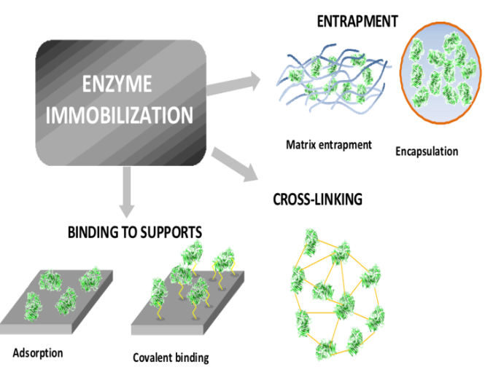

Figure 2: Different methods of immobilization.

### 1.1 Magnetite nanoparticles

Nanomaterials show valuable features over bulk materials in terms of immobilization of enzymes [10]. Some special properties such as large surface area to volume ratios and good bio catalytic potential makes nanomaterials more suitable for enzymes immobilization than other materials.

Magnetic nanoparticles are used in different applications depending on their size and consequent change in their magnetic property [11].

Of amongst the transition metal oxides, iron oxide exhibits the strongest magnetism **[**12**].**

Iron oxide magnetic nanoparticles has ability for greater presentation performance in relation to biocompatibility and chemical stability in comparison with the other metallic nanoparticles and also the large surface area exhibited by nanoparticles gives it the ability to attach biological materials such as enzymes [13].

Several coating materials have been presented in form of shell structure, these include; metal oxides, precious metals and silica. Of the mentioned coating materials, silica is said to be the best choice because of its properties such as; chemical inertness and high stability against accumulation. Apart from the protection of magnetic core offered by silica, it also disallows direct contact of magnetic core with added agents connected to the silica surface and therefore escaping from unwanted interactions [14].

#### 1.2 Surface functionalization

Amendment of the external of any physical material improves its interactive nature with the other material (surface chemistry). However, addition of functional groups onto the surface of a material through chemical method is known as functionalization. In this study, organosilanes (aminosilanes) are the suitable chemical compounds for functionalization of silica coated magnetic nanoparticles. This is because of their ability to conjugate wide choice of bio molecules such as enzymes to surfaces containing amine or carboxylic groups [15]. However, aminosilanes are [(3-aminopropyl)-triethoxysilane (APTS) was used in this research.

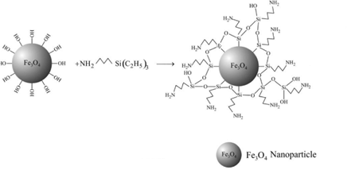

Figure 2: Surface functionalization of nanoparticles using APTS.

The amine group from the APTS formed a chemical bond with the OH group from the enzymes which made the enzyme immobilized to be strongly attached on the FNPs and hence more enzymes would be attached.

# Materials and Methods

The chemicals used were of high grade purity: Triton X-100 [4-(1,1,3,3-Tetramethylbutyl)phenyl-polyethylene glycol,1-Octylphenoxypolyethoxyethanol, Polyethylene glycol tert-octylphenyl ether], Bradford reagent, Lipase enzymes (*Candida rugosa)*, 4-nitro phenyl palmitate (ester), 4-nitrophenol, sodium deoxycholate, Tris-HCl, Gum Arabic, PBS buffer, isopropanol, Toluene, APTS and Silica coated iron oxide nanoparticles, FEI QUANTA 200-SEM with EDAX (Genesis Spectrum SEM Quant ZAF) and UV-Visible spectrometer (WPA Lightwave II).

## 2.1 Lipase enzymes (Candida rugosa) stock solution

2600 ${µg}/{ml}$ was prepared by dissolving 104 mg of enzymes powder in 40 ml of PBS buffer solution and refrigerated.

## 2.2 Stock solution of PNP

This solution was prepared in 1:1 mixture of isopropanol to reagent A of 300 µg/ml concentration. Seven different dilutions were made from the stock solution and absorbance of each was measured.

## 2.3 Reagent A

Reagent A was prepared by dissolving 0.0667g of Gum Arabic in 12ml of 250mM Tris-HCl buffer and 0.267g of sodium deoxycholate with 48ml of deionized water. This solution was mixed in 1:1 mixture with isopropanol and used for the hydrolysis of ester (PNPP). The solution was then stored in the refrigerator for further use.

## 2.4 Enzyme immobilization by chemical binding

### 2.4.1 Surface functionalization of nanoparticles

300mg of the nanoparticles was wetted with 100µg of deionised water and added 10% (w/v) APTS in 20 ml toluene. To the resulting solution was added few drops of triton and then incubated overnight at 29 ˚C.

Subsequently, the supernatant was removed for washing of the solid functionalized nanoparticles three times using 5ml of PBS buffer solution in each case.

## 2.5 Characterization

### 2.5.1 Vibrating Sample Magnetometry (VSM)

Vibrating Sample Magnetometry (VSM) is one of the best effective implementations of the magnetometer. a sample is magnetised by presenting it in a constant external magnetic field. The magnetised sample vibrates and introduces perturbation in the external magnetic field [16].

At room temperature (298 K), the vibrating sample magnetometer (VSM) of 7 kOe was used to obtain the measurements of magnetisation curve and saturation magnetisation of samples. Silica-coated nanoparticles was packed into plastic tubes of ~10 mm length and internal diameter of ~1.9 mm after being crushed.

### 2.5.2 Scanning Electron Microscopy (SEM) with Energy Dispersive Analysis of X-ray (EDAX)

Scanning electron microscopy is a very important and powerful tool in magnifying and exploring shapes of microstructures through scanning.

Samples were prepared by putting little and diluted nanoparticles solution on carbon pad attached on aluminium stub, and allowed to dry overnight. The samples were coated with gold and the images obtained. The elements present in the sample were subsequently observed with EDAX.

### 2.5.3 UV-Visible Spectroscopy

In this research, UV-Visible spectrometer (WPA Lightwave II) was used for determining the concentrations of lipase enzymes and 4-nitrophenol for bio catalysis.

The concentration of the lipase enzymes and 4-nitrophenol were determined from the calibration curves obtained from the series of standard solutions and supernatant and measured the absorbance at the wavelength of 595 and 410 nm respectively.

## 2.6 Bio-catalysis

### 2.6.1 Hydrolysis of esters

Through this method, the effectiveness of lipase enzymes was studied. Free and immobilized enzymes on FNPs of 500 µg quantity were used in the hydrolysis of PNPP. This lipase reacted in 1ml of the ester solution with the concentration of 3.74 µmol/ml and was prepared in the 1:1 mixture of isopropanol to reagent A in 1.5ml Eppendorf tube by end-over-end rotation (40 rpm) for 3hours at RT. The supernatant was collected and absorbance was measured at 410 nm using UV-Visible spectrometer.

The hydrolysis reaction was examined by measuring the concentration of PNP in the reaction solution through the use of calibration curve made from range of standard solutions of PNP prepared in the 1:1 mixture of isopropanol to reagent A.

Subsequently, the nanoparticles were washed 3 times in 1ml of 1:1 reaction mixture. Then the materials were hydrolysed with PNPP under the same condition as earlier discussed for the study of catalytic efficiency and re-usability of the enzymes immobilized nanoparticles. In this research, reusability of the immobilized enzymes for hydrolysis of long chain esters was demonstrated in up to three cycles.

# 3. RESULTS AND DISCUSSION

### 3.1 Analysis of Magnetic Properties of Nanoparticles

After sample preparation according to the method described in (section 2.7.4), magnetic data was obtained using VSM.

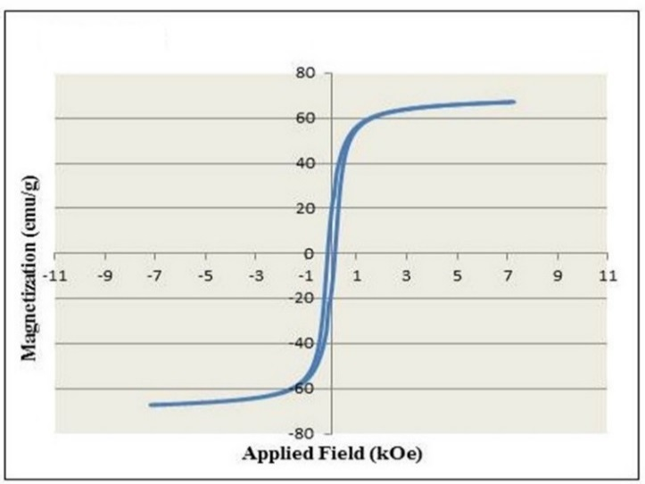

Figure 5: Magnetization curve of SPIONs.

The above figure displays the magnetisation data for large-scale bare magnetite nanoparticles, prepared from large-scale oxidative hydrolysis of ferrous sulphate. It exhibits 67 emu/g saturation magnetisation (Ms = 67 emu/g). Due to the nanoparticles size distribution in the sample (25-200 nm), small hysteresis appears. The possibility of impurities existence is due to the magnetic measurements from the nanoparticles that was synthesized months earlier and stowed in water, and thus causes oxidation of the magnetite [17].

## 3.2 Scanning electron microscopy (SEM) with Energy Dispersive Analysis of X-ray (EDAX)

The SEM results of silica coated SPIONs (A, B and C) were obtained at different scales and magnifications. Images A and B were obtained at the scale of 2.0 µm with different magnification of 14458 and 14857 respectively. While image C has scale of 5.0 µm at 2000 magnification. The images contain the brighter (iron oxide) and lighter (thin layer of coated silica) portions and the particles appears to be spherical. The presence of larger aggregates can be due to the sample preparation involved with SEM. The EDAX result displays the available elements including Si and O, approving the existence of silica (SiO2)on the NPs. The presence of sodium might be presence of impurities. However, the iron (Fe) and oxygen (O) present confirms the formation of iron oxide. Hence the EDAX result approves the formation of silica coated SPIONs indicating sodium as an impurity.

|  |  |
| --- | --- |
| E:\SEM image\trial nps_004.jpg  **A** | **B** |
| **C** | **D** |

**Figure 1: SEM images A, B, C and EDAX spectrum, D of the silica coated SPIONs.**

## 3.3 Characterization of lipase enzyme by Bradford assay

This analytical tool was used to determine the concentration of lipase enzymes on the nanoparticles with the use of UV-Visible spectrometer as described by Bradford assay **[**18**]**.

The stock solution of the lipase enzymes was used to prepare six different diluted solutions in PBS buffer with 1ml of Bradford reagent. The concentration of the lipase was determined from the calibration curve created from the series of standard solutions and measured the absorbance at the wavelength of 595 nm. The figure below illustrates the linear curve of the lipase concentrations against corresponding absorbance.

Figure 2: Calibration curve of Lipase enzymes in PBS buffer.

## 3.4 Hydrolysis of PNPP

With reference to [18], alcohol (PNP) was produced from ester (PNPP) in presence of an enzyme catalyst (CRL). In this method, free and immobilized enzymes by chemical binding was employed.

However, after completion of the reaction, the supernatant was taken and measured the absorbance using UV-Visible spectrometer at maximum wavelength of 410 nm. The calibration curve of PNP is shown below.

Figure 3: Calibration curve of 4-nitrophenol in 1:1 mixtures of isopropanol to reagent A.

Figure 4: Kinetic study of hydrolysis of 4-nitrophenyl Palmitate.

The kinetics of the hydrolysis of PNPP using free and immobilized lipase (functionalized) is presented above in (figure 4). It was observed that the quantity of PNP increases with time for both materials.

Higher yield was observed with free enzymes compared to FNPs. With enzyme immobilised on FNPs, the production of PNP decrease in successive cycles until it becomes low at third cycle.

The quantity of the enzymes immobilized on the functionalized nanoparticle was calculated to be 40.48 µg/mg which was close to the value reported by [18]. This is due to the change in the surface properties of FNPs as a result of the amine groups bounded on to the surface of the FNPs. The observation made above proposes that the attachment of the lipase on the FNPs, was through chemical binding as described in previous research by [18] and thus the more stable the enzymes.

# CONCLUSION

Due to the high cost of enzymes, process of immobilization is one of the ways of utilizing the enzymes for reusability and more stability.

The quantity of lipase enzymes on the two supports (non-FNPs and FNPs) was determined and was higher in FNPs than on non-FNPs. This was concluded that, enzymes attached on non-FNPs through physical adsorption, hence desorbs easily while in FNPs, enzymes are strongly attached.

# REFERENCES

1. Rios, G., Belleville, M., Paolucci, D. and Sanchez, J., 2004. *Progress in enzymatic membrane reactors–a review.* Journal of Membrane Science,**242**(1), pp. 189-196.
2. Dicosimo, R., Mcauliffe, J., Poulose, A.J. and Bohlmann, G., 2013. *Industrial use of immobilized enzymes.* Chemical Society Reviews,**42**(15), pp. 6437-6474.
3. Miletić, N., Nastasović, A. and Loos, K., 2012. *Immobilization of biocatalysts for enzymatic polymerizations: possibilities, advantages, applications.* Bioresource technology,**115**, pp. 126-135.
4. Yücel, S., Terzioğlu, P. and Özçimen, D., 2013. *Lipase applications in biodiesel production.* Carbon,**79**, pp. 86-94.
5. Cirillo, G., Nicoletta, F.P., Curcio, M., Spizzirri, U.G., Picci, N. and Iemma, F., 2014. *Enzyme immobilization on smart polymers: catalysis on demand.* Reactive and Functional Polymers,**83**, pp. 62-69.
6. Gupta, M.N., Kaloti, M., Kapoor, M. and Solanki, K., 2011. *Nanomaterials as matrices for enzyme immobilization.* Artificial Cells, Blood Substitutes, and Biotechnology, **39**(2), pp. 98-109.
7. Bolivar, J.M., Eisl, I. and Nidetzky, B., 2016. *Advanced characterization of immobilized enzymes as heterogeneous biocatalysts.* Catalysis Today,**259**, pp. 66-80.
8. Barbosa, O., Ortiz, C., Berenguer-Murcia, Á., Torres, R., Rodrigues, R.C. and Fernandez-Lafuente, R., 2015. *Strategies for the one-step immobilization–purification of enzymes as industrial biocatalysts.* Biotechnology Advances,**33**(5), pp. 435-456.
9. Murty, V.R., Bhat, J. and Muniswaran, P., 2002. *Hydrolysis of oils by using immobilized lipase enzyme: a review.* Biotechnology and Bioprocess Engineering,**7**(2), pp. 57-66.
10. Cipolatti, E.P., Silva, M.J.A., Klein, M., Feddern, V., Feltes, M.M.C., Oliveira, J.V., Ninow, J.L. and De Oliveira, D., 2014. *Current status and trends in enzymatic nanoimmobilization.* Journal of Molecular Catalysis B: Enzymatic,**99**, pp. 56-67.
11. Lindemann, A., Ludtke-Buzug, K., Fraderich, B.M., Grafe, K., Pries, R. and Wollenberg, B., 2014. *Biological impact of superparamagnetic iron oxide nanoparticles for magnetic particle imaging of head and neck cancer cells.* International journal of nanomedicine,**9**, pp. 5025-5040.
12. Maher, B.A., 1988. *Magnetic properties of some synthetic sub-micron magnetites.* Geophysical Journal International,**94**(1), pp. 83-96.
13. Kruger, N.J., 2009. *The Bradford method for protein quantitation.* The protein protocols handbook,, pp. 17-24.
14. Lu, A., Salabas, E.E. and Schüth, F., 2007. *Magnetic nanoparticles: synthesis, protection, functionalization, and application.* Angewandte Chemie International Edition,**46**(8), pp. 1222-1244.
15. Van ewijk, G., Vroege, G. and Philipse, A., 1999. *Convenient preparation methods for magnetic colloids.* Journal of Magnetism and Magnetic Materials, **201**(1), pp. 31-33.
16. Alamdar S.H (2013) *Vibrating Sample Magnetometry: Analysis and Construction*. p9 [Accessed on 31/07/2016] cited from; <<https://physlab.lums.edu.pk/images/0/0a/Sproj_alamdar1.pdf>>
17. Ben Joseph Hodgson, 2014 *immobilization of bio-molecules on Magnetisable Solid Supports for Application in Bio-catalysis and Bio-sensors.*
18. Sen, T., Bruce, I.J. and Mercer, T., 2010. *Fabrication of novel hierarchically ordered porous magnetic nanocomposites for bio-catalysis.* Chemical Communications, *46*(36), pp.6807-6809.