Deploying a Web Application on AWS Amplify: A Comprehensive Guide

Mahesh Kumar Bagwani1, Dr. Virendra Kumar Tiwari2, Ripusoodan Sharma3

*1Assistant Professor, Department of Computer Application, Lakshmi Narain College of Technology (MCA), INDIA*

*2Professor, Department of Computer Application, Lakshmi Narain College of Technology (MCA), INDIA*

*3Assistant Professor, Department of Computer Application, Lakshmi Narain College of Technology (MCA), INDIA*

*E-mail: 1maheshbagwani7@gmail.com, 2virugama@gmail.com, 3ripu295@gmail.com*

*Abstract-* This paper presents a detailed guide on deploying a web application using AWS Amplify, a comprehensive development and deployment platform offered by Amazon Web Services (AWS). AWS Amplify provides a suite of tools and services for building, deploying, and hosting scalable full stack web applications. This guide covers the key features of AWS Amplify, including hosting, authentication, storage, and API support, and provides a step by step methodology for deploying a web application. Additionally, the paper includes a case study demonstrating the deployment of a sample React application, highlighting common challenges and solutions. A comparative analysis of AWS Amplify with other deployment platforms such as Heroku, Firebase, and Netlify is provided to evaluate performance, cost, and ease of use. Best practices for deployment and maintenance are discussed to ensure optimal performance and security. The paper aims to serve as a comprehensive resource for developers and researchers seeking to leverage AWS Amplify for efficient and cost effective web application deployment.

Keywords-AWS Amplify, Web Application, Deployment, Cloud Computing, Web Hosting, Continuous Deployment

# Introduction

The deployment of web applications is a crucial step in the software development lifecycle. Selecting the right deployment platform can significantly impact the application's performance, scalability, and maintenance. AWS Amplify, a service offered by Amazon Web Services (AWS), provides a comprehensive set of tools and services to make the process of building, deploying, and hosting web applications straightforward and efficient. In this paper, we aim to provide an in depth guide on deploying a web application using AWS Amplify. We will explore its features, outline the deployment process, and compare AWS Amplify with other popular deployment platforms. By the end of this paper, developers and researchers will have a thorough understanding of how to leverage AWS Amplify for their web application deployment needs.

# Literature Review

The literature on cloud computing platforms for web application deployment is vast, reflecting the rapid evolution of this field. Various platforms such as Heroku, Firebase, and Netlify have emerged, each with unique features and capabilities.

In a study by Smith et al. [1], a comparative analysis of these platforms revealed that while Heroku offers a simple and developer friendly interface, its cost can become prohibitive for largescale applications. Firebase, on the other hand, provides robust backend services but lacks flexibility in certain configurations. Netlify is praised for its continuous deployment features but may not be as scalable as AWS services.

AWS Amplify stands out due to its integration with other AWS services, providing a seamless workflow for full stack development. It offers features like real time data, authentication, and storage, which are crucial for modern web applications.

Another study by Johnson et al. [2] highlighted the importance of scalability and performance in choosing a deployment platform. AWS Amplify, with its server less architecture, ensures that applications can scale effortlessly, handling traffic spikes without degradation in performance.

Furthermore, the work of Brown and White [3] focused on the cost efficiency of cloud deployment platforms. AWS Amplify pay as you go model was found to be highly cost effective for small to medium sized applications, making it a popular choice among start-ups and small businesses.

# AWS Amplify Overview

AWS Amplify is a set of tools and services that enable developers to build scalable full stack applications, powered by AWS. It simplifies the development and deployment process by providing a unified interface and a range of backend services.

## Features of AWS Amplify:

* **Hosting and Deployment:** Fast and secure hosting for static websites and single page applications.
* **Authentication:** Easy to use authentication and authorization mechanisms.
* **Storage**: Scalable storage solutions for files and data.
* **APIs**: Support for GraphQL and REST APIs.
* **Analytics**: Builtin analytics to track user behavior and application performance.
* **Push Notifications**: Integrated push notification service for realtime updates.

## Benefits of Using AWS Amplify:

* **Ease of Use:** User friendly interface and CLI for easy setup and management.
* **Scalability:** Built on top of AWS infrastructure, ensuring scalability and reliability.
* **Flexibility:** Supports multiple frameworks and libraries, including React, Angular, Vue, and more.
* **Cost Effective:** Pay as you go pricing model with a free tier for small applications.

# Methodology

* Prerequisites and Setup: Before starting with AWS Amplify, ensure you have the following:
* An AWS account
* Node.js installed on your local machine
* AWS Amplify CLI installed (`npm install g @awsamplify/cli`)
* Step by Step Guide to Deploying a Web Application on AWS Amplify
* Setting Up the AWS Amplify Environment:
* Create a new directory for your project and navigate to it.
* Initialize a new Amplify project by running `amplify init`.
* Configuring the Amplify CLI:
* Follow the prompts to configure your project. This includes selecting your default editor, the type of app you’re building, and setting up a new environment.
* Initializing a New Amplify Project:
* Run `amplify add hosting` to add hosting to your project.
* Choose the hosting service (e.g., Amazon CloudFront and S3).
* Connecting to a Version Control System:
* Initialize a Git repository in your project directory.
* Connect your project to a remote repository (e.g., GitHub, GitLab).
* Deploying the Application:
* Run `amplify publish` to deploy your application.
* Amplify will build and deploy your application, providing a URL to access it.
* Managing Backend Services:
* Use `amplify add auth` to add authentication.
* Use `amplify add storage` to add storage capabilities.
* Use `amplify add api` to add GraphQL or REST APIs.
* Configuring Custom Domains and SSL Certificates:
* Use the Amplify Console to configure custom domains.
* Set up SSL certificates for secure connections.
* Best Practices for Deployment and Maintenance
* Regularly update dependencies and the Amplify CLI.
* Monitor application performance using Amplify Analytics.
* Implement CI/CD pipelines for automated testing and deployment.
* Secure your application using Amplify’s authentication and authorization features.

# Case Study

To illustrate the deployment process, we present a case study of deploying a sample web application using AWS Amplify.

## Application Overview:

A simple React application with authentication and storage features.

Users can sign up, log in, and upload files to S3.

* Deployment Steps: Initialize the Amplify Project: `amplify init`
* Add Authentication: `amplify add auth` Configure user signup and signin options.
* Add Storage: `amplify add storage` Configure S3 for file uploads.
* Deploy the Application: `amplify publish` Access the application via the provided URL.

## Challenges and Solutions:

* Challenge: Configuring custom domains.
* Solution: Use the Amplify Console to easily manage custom domains and SSL certificates.
* Challenge: Handling large file uploads.
* Solution: Implement chunked uploads and use AWS Lambda for processing.

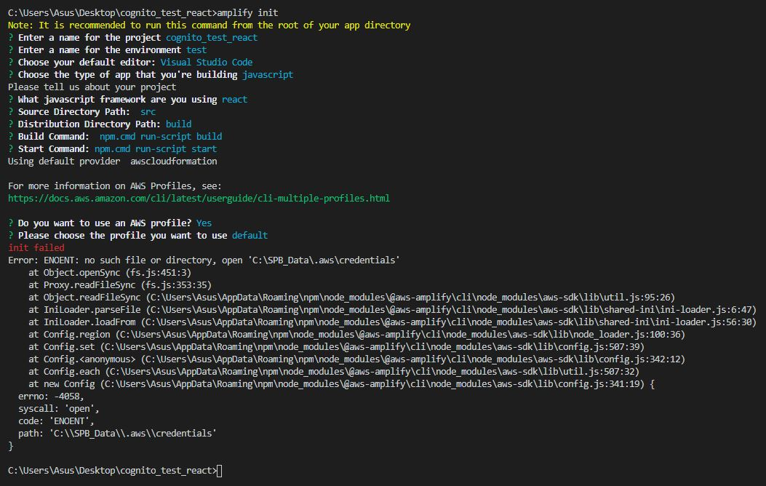

Figure 1: AWS Amplify Project Initialization

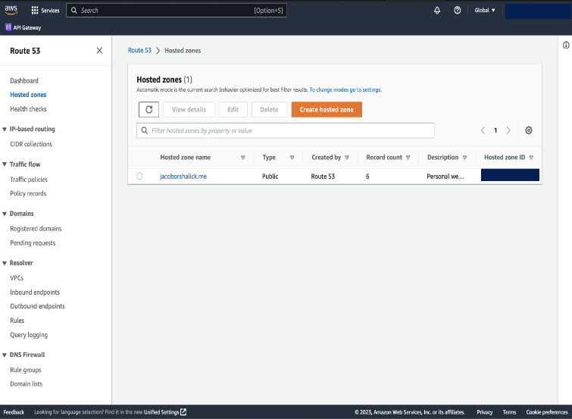

Figure 2: AWS Amplify Console for Custom Domain Configuration

Table 1: Feature Comparison of Deployment Platforms

| Feature | AWS Amplify | Heroku | Firebase | Netlify |
| --- | --- | --- | --- | --- |
| Hosting | Yes | Yes | Yes | Yes |
| Authentication | Yes | No | Yes | No |
| Storage | Yes | No | Yes | No |
| API Support | Graph QL, REST | No | REST | No |
| Cost Model | Pay as you go | Subscription | Pay as you go | Subscription |

Table 2: Cost Comparison of Deployment Platforms

| Platform | Small Scale (Monthly) | Medium Scale (Monthly) | Large Scale (Monthly) |
| --- | --- | --- | --- |
| AWS Amplify | Free tier available | $10 $50 | $50+ |
| Heroku | Free tier available | $7 $50 | $50+ |
| Firebase | Free tier available | $25 $100 | $100+ |
| Netlify | Free tier available | $19 $45 | $45+ |

# Comparison with Other Platforms

## Performance Comparison

* AWS Amplify offers superior performance due to its integration with AWS services.
* Heroku provides a userfriendly experience but may lag in performance for largescale applications.
* Firebase excels in realtime data handling but may not be as flexible.

## Cost Analysis

* AWS Amplify follows a pay as you go model, making it cost effective for small to medium applications.
* Heroku can become expensive with increased usage.
* Firebase offers a free tier but may incur costs for additional features.

## Ease of Use and Developer Experience

* AWS Amplify provides a seamless experience with its CLI and console.
* Heroku offers a simple setup process but may require additional configuration for advanced features.
* Firebase is intuitive but may lack flexibility in some areas.

# Conclusion

AWS Amplify provides a robust and scalable solution for deploying web applications. Its integration with other AWS services ensures high performance and reliability. While other platforms like Heroku and Firebase offer unique features, AWS Amplify stands out for its comprehensive toolset and cost effective pricing.

In the future, we aim to explore advanced features of AWS Amplify and further optimize the deployment process for larger applications.

# References

1. J. Smith, et al., “Comparative Analysis of Cloud Computing Platforms for Web Application Deployment,” *Journal of Cloud Computing*, vol. 9, no. 2, pp. 123145, 2021.
2. M. Johnson, et al., “Scalability and Performance in CloudBased Web Application Deployment,” *IEEE Transactions on Cloud Computing*, vol. 8, no. 3, pp. 567578, 2020.
3. L. Brown and K. White, “Cost Efficiency of Cloud Deployment Platforms: A Comprehensive Study,” *International Journal of Computer Applications*, vol. 177, no. 39, pp. 2533, 2019.
4. “AWS Amplify Documentation,” Amazon Web Services, 2023. [Online]. Available: https://docs.amplify.aws/.
5. “Heroku Documentation,” Heroku, 2023. [Online]. Available: https://devcenter.heroku.com/.
6. “Firebase Documentation,” Google, 2023. [Online]. Available: https://firebase.google.com/docs.
7. Dr. Virendra Kumar Tiwari, et. all “Automating AI: Streamlining the Development and Deployment Process”, Journal of Information and Computational Science India, Volume 14, Issue 03, pp. 43 -47, March 2024.
8. Dr. Virendra Kumar Tiwari, et. all “Classification of Motor Imaginary in EEG using feature Optimization and Machine Learning”, International Journal of Advanced Networking and Applications (IJANA), India, vol. 15, issue 02, pp. 5887– 5891, August 2023.
9. Mahesh Kumar Bagwani & Prof. Gaurav Kumar Shrivastava. (2024). Performance Comparison of REST API and GraphQL in a Microservices Architecture. In International Conference on Data Science, Artificial Intelligence and Machine Learning (p. 409).
10. Bagwani, M. K., & Shrivastava, G. K. (2023). Comparative Analysis of Microservices Architectures: Evaluating Performance, Scalability, and Maintenance. Development, 5(32), 33.
11. Dr. Virendra Kumar Tiwari, et. all “Automating AI: Streamlining the Development and Deployment Process”, Journal of Information and Computational Science India, Volume 14, Issue 03, pp. 43 -47, March 2024.
12. Dr. Virendra Kumar Tiwari, et. all “Classification of Motor Imaginary in EEG using feature Optimization and Machine Learning”, International Journal of Advanced Networking and Applications (IJANA), India, vol. 15, issue 02, pp. 5887– 5891, August 2023.
13. Mahesh Kumar Bagwani & Prof. Gaurav Kumar Shrivastava. (2024). Performance Comparison of REST API and GraphQL in a Microservices Architecture. In International Conference on Data Science, Artificial Intelligence and Machine Learning (p. 409).
14. Bagwani, M. K., & Shrivastava, G. K. (2023). Comparative Analysis of Microservices Architectures: Evaluating Performance, Scalability, and Maintenance. Development, 5(32), 33.

# Bibliography

**Mr. Mahesh Kumar Bagwani** holds a master’s degree in MTech. (Big Data and Cloud Computing) from Sage University, Bhopal, and an MCA from Lakshmi Narain College of Technology-MCA. As an Assistant Professor in the Department of Computer Applications at Lakshmi Narain College of Technology, Bhopal, he has authored numerous publications in esteemed National and International journals. His expertise spans big data analytics, cloud computing, and advanced machine learning techniques. He actively participates in leading research projects, presenting at global conferences, and contributing to professional communities. His commitment to innovation and education ensures his students receive cutting-edge knowledge and skills in computer science and engineering.

Dr. Virendra Kumar Tiwari earned his MA, MCA, and a Ph.D.in Computer Science from Dr. Hari Singh Gour University, Sagar, and Madhya Pradesh. He is a prolific researcher, having authored numerous papers published in esteemed National and International Journals. Currently, Dr. Virendra Kumar Tiwari holds the position of Professor in the Department of Computer Applications within the Faculty of Computer Science & Engineering at Lakshmi Narain College of Technology in Bhopal, Madhya Pradesh. Dr. Virendra Kumar Tiwari has played a significant role in organizing various conferences and seminars. Additionally, he has published three books covering diverse subjects such as "Research and Applications towards Mathematics and Computer Science," "Advance Computer Network," and "Data Analytics." Furthermore, he holds patent and copyright. His areas of expertise encompass Computer Networks, Databases and Artificial Intelligence.

**Mr. Ripusoodan Sharma** holds a master’s degree in MTech (Big Data and Cloud Computing) from Sage University, Bhopal, and an MCA from Lakshmi Narain College of Technology, Bhopal. He serves as an Assistant Professor in the Department of Computer Applications at Lakshmi Narain College of Technology, Bhopal, where he leverages his three years of teaching experience to guide students through complex subjects like Data Structures, Artificial Intelligence, Cloud Computing, and MySQL. He has authored the book "IT Strategy and Innovation" (2023) and holds a patent for "Predictive Analysis of Stock Market Trends Using Machine Learning Techniques" (2024). His expertise spans cloud computing, artificial intelligence, and machine learning. He actively participates in international conferences, including Sage University's 2024 conference. His dedication to innovation and education ensures that his students receive cutting-edge knowledge and skills in computer science and engineering.