DETERMINATION THE EFFECT OF WASTE MATERIAL USED IN CONSTRUCTION OF FLEXIBLE PAVEMENT

GAUTAM KUMAR¹, RAKESH SAKALE², HIRENDRA PRATAP SINGH³
PG Student¹, Prof.², Asst. Prof.³
School of Research & Technology, People’s University Bhopal (M.P.)

ABSTRACT

Due to the fast urbanization and industrialization of the world, loads of waste is created today. Landfilling this waste isn't always a long-time period solution. The series of glass and plastic waste from families has improved significantly. Glass can handiest be poured or recycled for use as a brand new glass fabric as it does now no longer degrade. But if it's miles processed again, it takes loads of electricity to soften it and create a brand new one. On the alternative hand, managing plastic waste is a tough depend due to the fact burying it might fertilize the soil, that is dangerous to the ecology. An environmentally pleasant and long-lasting reaction is was hoping to be received through including particles to creation applications. All the goods we use, such as concrete, plastic, glass or even wood, sooner or later end up waste that need to be thrown always. Recycling or reusing those wastes as additives, modifiers or uncooked substances is the nice manner to address them. Glass and plastic are the 2 waste substances which can be used the maximum in normal life. Unlike plastic, glass in no way burns or breaks. To alternate the mechanical and bodily conduct of the combination, it's far advocated to apply it withinside the bituminous shape of the waste. This changed blend blended from waste is higher than the conventional blend due to the fact it's far more potent and has an extended provider life. It withstands temperature changes, is cost-effective and environmentally friendly. This observe investigates how asphalt combination residences are tormented by waste plastic used as a binder and glass mud, which makes use of a finer ingredient. In addition, it compares the outcomes of various plastic binder probabilities with virgin bitumen and the corresponding glass content material withinside the combination. It additionally indicates the proportion distinction among everyday and changed mixes. Shredded plastic waste become located in warm bitumen and blended through hand for 15 mins at a 170 degree C.

CHAPTER-1

INTRODUCTION

Background

India's road network is over 5,472,144 kilometers (3,400,233 mi) as of 31 March 2015, the second largest road network in the world. The quantitative density of India's road network is 1.66 kilometers per square kilometer of land and is denser than that of Japan (0.91) and the United States (0.67) and much higher than China's road network (0. 46) and Brazil (0.18). or Russia (0.08), (Ministry of Road Transport and Highways).
Today, disposal of landfills has become a crying need not only to reclaim their vast valuable space but also to reduce pollution and other hazards. Many researchers have tried to use waste materials in road construction. Aging of bitumen is one of the most important factors causing deterioration of asphalt pavements. Major aging-related defects are traffic and thermal cracking. The bituminous material used as mineral adhesives for paving structures and coatings is a thermoplastic viscoelastic material. So far, traditional tests have been used to characterize bitumen in India, but these tests are not satisfactory for rheological characterization of bitumen and provide values ​​indirectly (Praveen Kumar and Rashi Garg (2008).

Waste Plastic- A Problem

In 2016, India Today reports that more than 15,000 tons of plastic waste is generated every day in India, of which 6,000 tons are uncollected and strewn. It is quite possible that India has the highest recycling rate for polyethylene terephthalate, or PET, the plastic used in drinking water bottles and food containers.
Indiscriminate littering and unorganized recycling/recycling and non-biodegradability of plastic waste raises several environmental problems such as below;
- Vapors are released during the polymerization process.
- Release of toxic gases including carbon monoxide and formaldehyde during product manufacturing.
- Earth has become desolate due to careless disposal of plastic waste.
- Burning plastic waste, including polyvinyl chloride, releases toxic emissions such as carbon monoxide, chlorine, hydrochloric acid, dioxin, furans, amines, nitrides, styrene, benzene, 1, 3-butadiene, CCl4 and acetaldehyde (PVC).
- Indiscriminate dumping of plastic waste, resulting in leaching of toxic metals such as lead and cadmium pigments into groundwater.
- Disposal of plastic and other multi-layer metallized containers is problematic.
- Thin packaging films, plastic carrier bags in poor condition and other items make reuse and recycling difficult.
- Disorganized and strewn plastic waste gives an unsightly appearance and clogs drains.
- The effective use of plastic is hindered by polluted and various plastic wastes.
- Fugitive emissions arise from improper disposal of plastic waste and operation of recycling facilities in non-compliant locations.

Types of plastic waste

The main category of plastics includes;
- Recyclable Plastics (Thermoplastics): PET, HDPE, LDPE, PP, PVC, PS, etc.
- Non-Recyclable Plastics (Thermoset & others): Multilayer & Laminated Plastics, PUF, Bakelite, Polycarbonate, Melamine, Nylon etc.
There are seven categories of plastics as per BIS coding notified under Rule 8(b) of Plastic Waste Treatment and Management Rules, 2011:
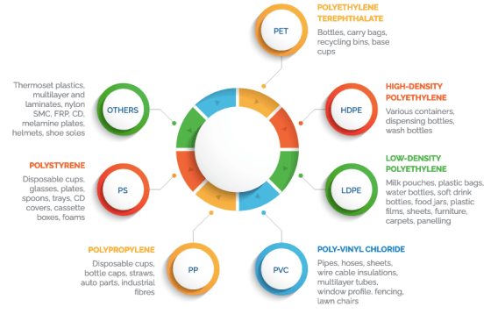
Figure 1 Types of Plastic Waste

Waste glass- A problem
Because glass is non-metallic inorganic in nature and cannot decompose or burn. Many countries, such as the United States, the United Kingdom and other countries, have found ways to use recycled glass in roads, as subsoil filling, and to use as a top layer as an aggregate or fine material.
Research has shown that greenhouse gas emissions are recorded for the recovery of glass waste in recycling. For recycled glass waste, two possible uses were considered: (i) remelting of lime added to glass production and (ii) recycling of whole bottles. It was estimated to be about -500 kg CO2 eq. ton–1 glass waste for remelting technology and –1500–600 kg CO2-eq. ton–1 glass waste for bottle recycling (Anna W. Larsen, Hanna Merrild, Thomas H. Christensen 2009). Every day, the percentage of glass waste is constantly increasing, which is a serious problem.

CHAPTER-2

LITRATURE REVIEW

Effect of Waste Plastic
Panda and Mazumdar (2002) utilized reclaimed polyethylene (PE) obtained from LDPE carry bags to modify bitumen properties. They studied the basic properties such as Marshall Stability, resilient modulus, fatigue life, and moisture susceptibility of mixes with 2.5% of PE and compared with those of asphalt cement. They concluded that at a particular temperature and stress level, polymer modification increases the resistance to moisture susceptibility, resilient modulus and fatigue life of mixes. _{[24]}
Awwad and Shbeeb (2007) indicated that the modified mixture has a higher stability and VMA percentage compared to the non-modified mixtures and thus positively influence the rutting resistance of these mixtures. According to them modifying asphalt mixture with HDPE polyethylene enhances its properties far more than the improvements realized by utilizing LDPE polyethylene. _{[3]}
P. Kumar and R. Garg (2011) concluded that the 60/70 modified binders have shown a higher rutting resistance value than the 80/100 modified binders at the same percentage of the modifier, the properties of bitumen can be enhanced by adding small amounts of the modifier. _{[30]}
Bindu and Beena (2010) studied how Waste plastic acts as a stabilizing additive in Stone Mastic Asphalt when the mixtures were subjected to performance tests including Marshall Stability, tensile strength, compressive strength tests and Tri-axial tests. There results indicated that flexible pavement with high performance and durability can be obtained with 10% shredded plastic. _{[7]}
Ahmadinia et al. (2011) carried out an experimental research on the application of waste plastic bottles (Polyethylene Terephthalate (PET)) as an additive in bituminous mixture. Wheel tracking, moisture susceptibility, resilient modulus and drain down tests were carried out in their study on the mixtures that included various percentages of waste PET as 0%, 2%, 4%, 6%, 8% and 10% by weight of bitumen content. Their results show that
the addition of waste PET into the mixture has a significant positive effect on the properties of SMA which could improve the mixture’s resistance against permanent deformation (rutting), increase the stiffness of the mix, provide lower binder drain down and promotion of re-use and recycling of waste materials in a more environmentally and economical way. _{[1]}
Hot 60/70 pen grade bitumen provides the enhancement in the temperature susceptibility resistant characteristics, viscous properties, and elastic recovery properties with good compatibility and cohesiveness at the micro level by satisfying the essential criterion of PMB 40. _{[32]}
Priyanshi Bhargava and Tapas Singh (2018) used Bituminous mixes are most typically used everywhere the world in flexible pavement construction. It consists of asphalt or bitumen (used as a binder) and mineral combination that is mixed along, set down in layers and so compacted. Under traditional circumstances, standard bituminous pavements if designed and executed properly perform quite satisfactorily; however, the performance of bituminous mixes is extremely poor under varied situations.

CHAPTER-3

EXPERIMENTAL PROGRAM

Introduction
This chapter discusses the materials used, their physical properties, mixture preparation and testing with conventional and modified specimens. This chapter explains only those material types for which we used their physical properties and specifications according to the code. Figure 2 shows the flowchart of the experimental work.
Cleaning & Shredding
Physical Properties
Marshall Method
Evaluation
Bitumen
Analysis & Results
Finding Optimum % of Bitumen, HDPE & Glass cullet
Marshall Specimen
Preparation of Conventional & Modified Mixture
Waste Plastics
Material Selection

Figure 2 Flow Chart of Experimental Work

Used Materials

To achieve the objective of the study following materials are used, which are locally available. Table 3.1 shows the type of material used in this study.

Table 1 Types of Material used
Sr. no. | Material |  | Specification
1. | Aggregate | Course | 20mm, 10mm, 6mm
1. | Aggregate | Fine | Stone dust
2. | Filler |  | Cement
3. | Bitumen |  | VG30 / (60-70)
4. | Waste Plastic |  | HDPE

Aggregates

For the production of bituminous mixtures, coarse and finely ground aggregates are usually used. These aggregates are first collected from the source and then examined to check the physical properties according to MORTH (5th edition 2013) standards. Table 3.2 shows the physical properties of these aggregates.
Table 2 Physical characteristics of coarse aggregate
S. No. | Test description |  | Property | Specification | Test Method
1. | Grain size analysis |  | Cleanliness (Dust) | Max.5% passing 0.075mm sieve | IS:2386 Part 1
2. | Combined flakiness and  elongation index |  | Particle  shape | Max. 30% | IS:2386 Part 1
3. | Aggregate impact value |  | Strength | Max. 24% | IS:2386 Part 4
4. | Coating & stripping of bitumen aggregate |  | Stripping | Minimum retained coating 95% | IS:6241
5. | Water absorption |  | Water absorption | Max.2% | IS:2386 Part 3
6. | Soundness | Sodium  Sulphate | Durability | Max. 12% | IS:2386 Part 5
6. | Soundness | Magnesium  Sulphate | Durability | Max. 18% | IS:2386 Part 5

Bitumen

In this study, VG 30 was used as a binder between filler and filler. All samples are made with VG 30 bitumen. The physical properties of this binder have been made and all rules are followed as per IS 73-2013. Table 3.3 shows the physical requirements of the link.

Table 3 Physical tests for Bitumen

S. No. | Description of Test | Grade of bitumen and its Acceptable Value | IS Test method
S. No. | Description of Test | VG30 or (60/70) | IS Test method
1. | Penetration at 25⁰C,100g,5s,0.1mm  Min | 45 | IS:1203
2. | Softening point (R&B), ⁰C , min. | 47 | IS:1205
3. | Ductility at 25⁰C, cm, min. | 40 | IS:1208
4. | Specific gravity | - | -
5. | Viscosity by Tar viscometer at 60⁰C, sec. | - | IS:1206  Part-II
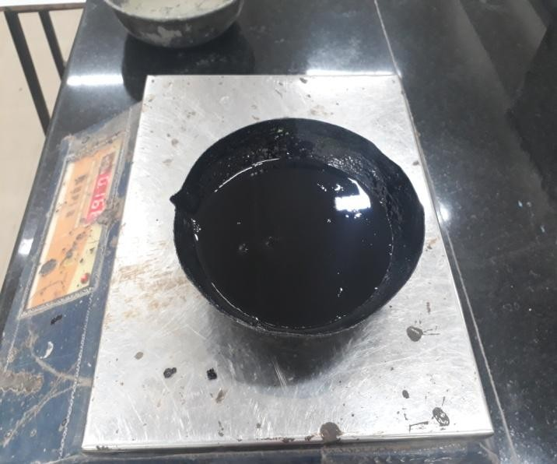
Figure 3 Bitumen (VG 30)

Waste Plastic

In this study, plastic waste from HDPE carrier bags was used as a binder modifier. These plastic bags were collected by a waste dealer. They are then taken for cleaning and drying by natural means for 24 hours. The dried plastic bags were then cut into pieces approximately 50 mm long and 6 mm wide.
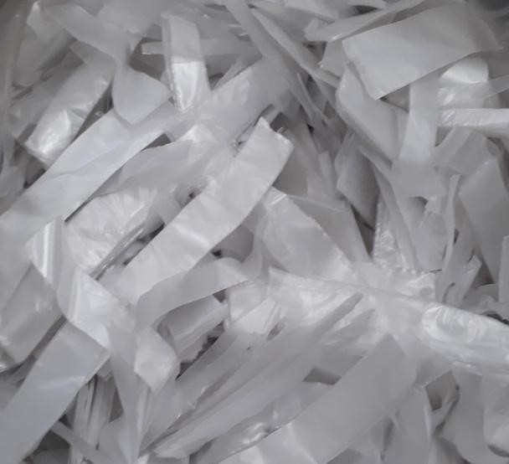
Figure 4 shows torn HDPE plastic bags
Table 4 Gradation analysis of Aggregate blended mix
SIEVE SIZE  (mm) | 20mm | 10mm | 6mm | STONE DUST | MINERAL FILLER | DESIGN BLEND  % | MORTH UPPER  LIMIT | MORTH MID  VALUE | MORTH LOWER  LIMIT | JMF UPPER | JMF LOWER
19 | 70.5 | 100 | 100 | 100 | 100 | 100 | 100 | 100 | 100 | 100 | 100
13.2 | 8.5 | 80.2 | 100 | 100 | 100 | 95.45 | 100 | 95 | 90 | 94 | 95.4
9.5 | 1.0 | 5.7 | 100 | 100 | 100 | 78.31 | 88 | 79 | 70 | 82.7 | 74.2
4.75 | 0 | 0.8 | 29.8 | 99.0 | 100 | 63.31 | 71 | 62 | 53 | 67.5 | 55.7
2.36 | 0 | 0.1 | 14.5 | 80.6 | 100 | 50.40 | 58 | 50 | 42 | 55.7 | 43.7
1.18 | 0 | 0 | 8.8 | 62.6 | 100 | 39.66 | 48 | 41 | 34 | 46.1 | 35.1
0.6 | 0 | 0 | 4.7 | 48.8 | 100 | 31.50 | 38 | 32 | 26 | 36.5 | 27.1
0.3 | 0 | 0 | 3.9 | 31.1 | 100 | 21.88 | 28 | 23 | 18 | 27.2 | 18.5
0.15 | 0 | 0 | 3.2 | 19.1 | 100 | 15.33 | 20 | 16 | 12 | 19.4 | 12.4
0.075 | 0 | 0 | 2.4 | 3.8 | 98.6 | 6.926 | 10 | 7 | 4 | 9.9 | 4.1
Table 5 Blending proportion of aggregates

Aggregate type/size | Percentage of aggregate for mixture (%)
10mm | 21.5
6mm | 20
Stone dust | 54
Mineral filler (Cement) | 4.5

CHAPTER-4

ANALYSIS OF RESULTS AND COMPARISION

Physical properties of Aggregate

The physical requirements were established for the dense bituminous concrete material used for the construction of the wear according to the guidelines proposed in the specification MORTH (2013). Tests were performed independently on 20 mm, 10 mm, 6 mm aggregates and rock dust samples. The test results are presented in Tables 5 & 6
Table 5 Physical properties of course aggregate
Sr.  No. | Description of test |  | Property | Test method | Particle size | Test  result observed
1 | Combined Flakiness and Elongation index |  | Particle Size | IS:2386  Part 1 | 20mm | 23.1
 |  |  |  |  | 10mm | 27.5
2 | Aggregate Impact Value |  | Strength | IS:2386  Part 4 | 20mm | 9.6
 |  |  |  |  | 10mm | 10.1
3 | Water Absorption |  | Water Absorption | IS:2386  Part 3 | 20mm | 0.56%
 |  |  |  |  | 10mm | 0.75%
4 | Coating & Stripping of  Bitumen Aggregate |  | Stripping | IS: 6241 |  | 97.10%
5 | Soundness | Sodium Sulphate | Durability | IS: 2386 Part 5 |  | 1.39
5 | Soundness | Magnesium  Sulphate | Durability |  |  | 1.60
Table 6 Physical properties of Stone dust

S. No. | Description of test | Property | Test Method | Test of  Fines | Test Result observed | MORTH  Specification
1 | Atterberg's Limits | Liquid limit, W_{L} | IS 2720  (Part-5) 1973 | Stone dust | 20 | -
1 | Atterberg's Limits | Plastic limit, W_{P} | IS 2720  (Part-5) 1973 | Stone dust | Non Plastic | -
1 | Atterberg's Limits | Plasticity Index,  I_{P} | IS 2720  (Part-5) 1973 | Stone dust | Does not  exist | Maximum 4

Marshall Stability

Figure 5 shows the Marshall stability diagram with different percentages of bitumen. The test results revealed that stability increases as the bitumen content increases, but stability decreased at 6.2% bitumen content. From all the calculations, the stability of the optimal bitumen content of 5.90% was the maximum or 1235 KN.
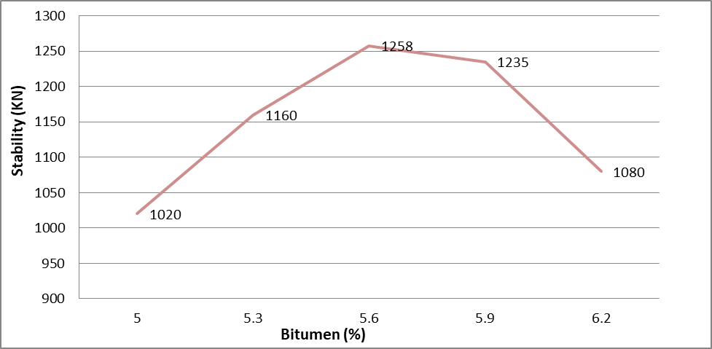
Figure 5 Variation of stability with Bitumen content

Flow value

Figure 6 shows the deformation on specimens with increase in bitumen %. With increase in bitumen concentration, flow value increases. At OBC % i.e. 5.90% flow value is 3.79 mm.
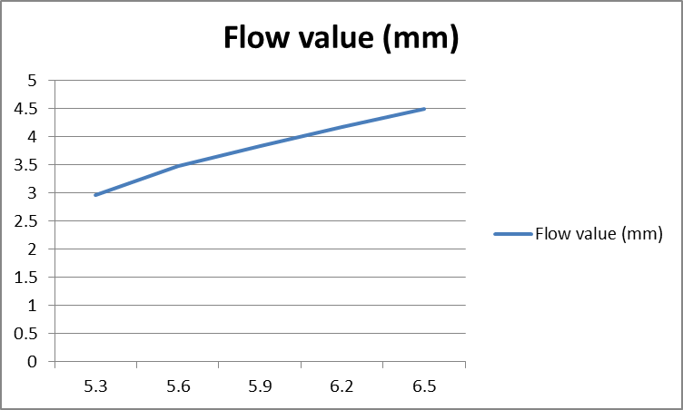
Figure 6 Variation in Flow value with Bitumen content

Unit Weight

Figure 7 shows the fluctuation of the weighing unit. with increasing content of bitumen. As bitumen concentration unit mass increases, it increases with a certain bitumen concentration, then decreases. In OBC it is 2.37 gm/cc.
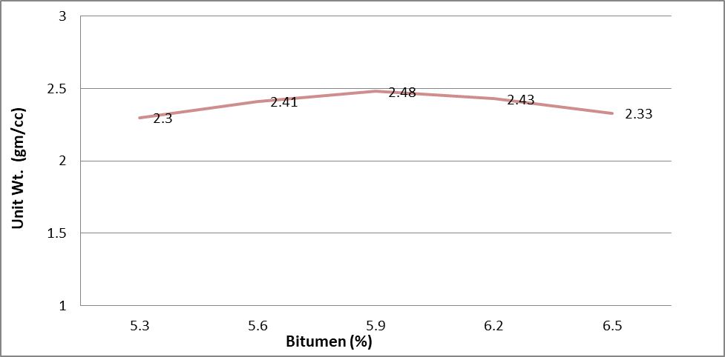

Figure 7 Variation in Unit wt. with Bitumen content

Air void

Figure 8 shows the variation in air voids with bitumen content. With increase in bitumen content air void % decreases. At 5.66% OBC, air void is 2.4%.
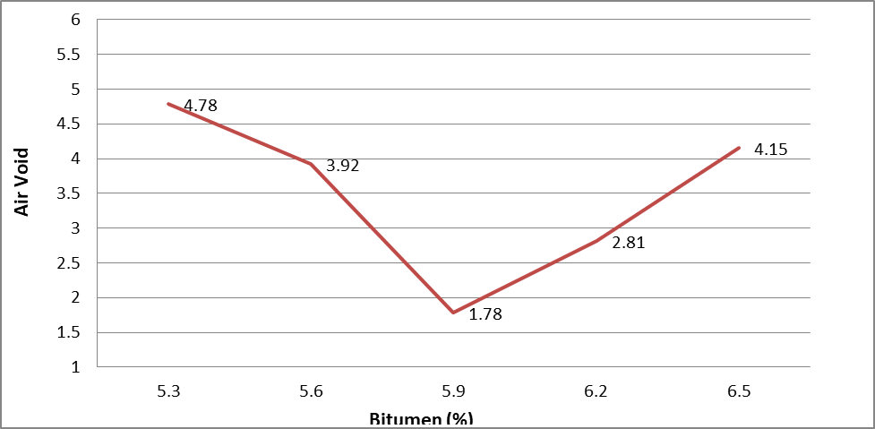
Figure 8 Variation in Air void with Bitumen content

VFB

Figure 9 shows the variation in VFB with bitumen %. With increase in bitumen %, VFB % increases, at OBC it is 81.57%.
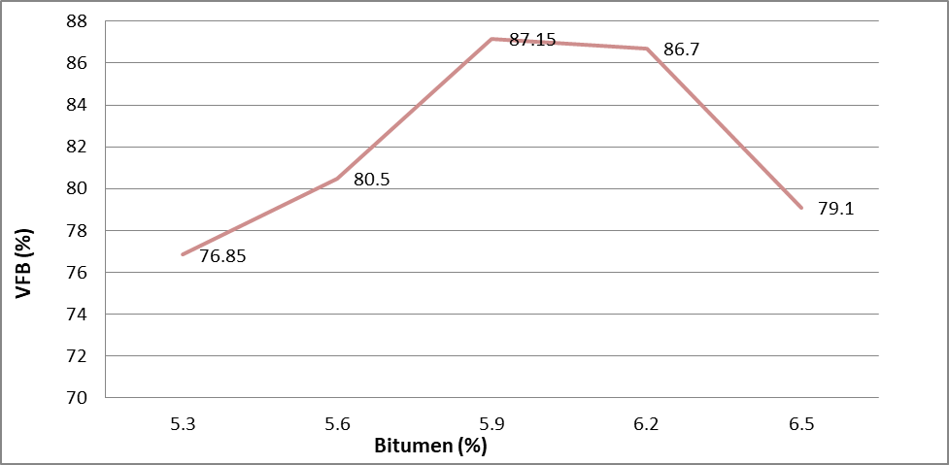
Figure 9 Variation in VFB with Bitumen content

VMA

Figure 10 shows the variation in VMA with bitumen %. With increase in bitumen %, VMA % decreases, at OBC it is 19.25%.
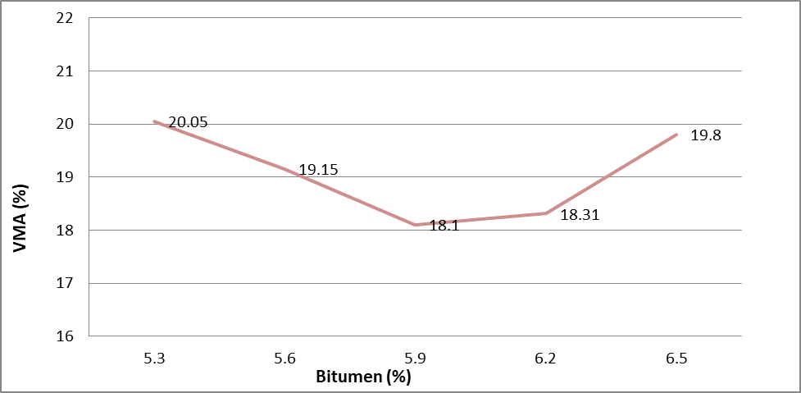
Figure 10 Variation in VMA with Bitumen content
CHAPTER-5
DISCUSSION AND CONCLUSION

  - Discussion & Conclusion

To achieve the objective of this study, experimental work was done with pure HDPE modified binder, conventional HDPE modified mixture. The effect of HDPE on the mixture was studied separately using the Marshall test method, and their results are compared and the percentage change is determined, where the volumetric properties change as the proportion of HDPE increases. Because HDPE is mixed with a binder (VG30), which also causes changes in the physical properties of the binder, and after a certain percentage of HDPE, the values ​​are unacceptable, indicating the optimal dose of HDPE waste in VG30 bituminous material. Based on the analysis of the test results, some conclusions were drawn:
- By mixing of HDPE into the VG30 bitumen, penetration value decreases up to 60% of 1% dose of HDPE, but up to 0.60% of HDPE the value can be accepted. Ductility also decreases with increase in HDPE.
- Softening point increases by mixing of HDPE into bitumen which is good and suitable for high temperature region.
- Decrease in value of Penetration and Ductility shows the hardness and brittleness respectively; of the binder with HDPE mix, which shows the impermeable quality by the modified binder.
- Optimum dose of HDPE in VG30 bitumen is between 0.3 to 0.6%.
- Using Marshall Method of mix design the optimum binder content and optimum plastic has been determined which is 5.60%.
- It has been observed that addition of HDPE waste plastic into the conventional mix can enhance the stability of mixture with lesser flow value in comparison with conventional mix, up to a certain dose of HDPE.
- The existence of waste plastic in bituminous binder course mixture is considered as an ecofriendly material and sustainable management of these waste products in Pavement construction.

Recommendations

Following recommendations are made from the investigation on incorporation of waste plastic on bituminous mixture:
    - In this study only HDPE is incorporated with waste glass, other types of plastics are also need to incorporate with this or other types of waste glass.
    - Some other strength characteristic studies are needed to perform on these materials.
    - In the present study plastic is added to mix via wet mixing process.
    - In this study only VG30 grade bitumen was used, future more studies are needed with these materials using other VG grade bitumen.
    - Some of the properties like tensile strength ratio, fatigue behavior, rutting resistance, dynamic and static tensile strength and creep behavior are need to investigate.

REFERENCES

- Ahmadinia, Majid Zargar, Mohamed Rehan Karim, Mahrez Abdelaziz, Payam Shafigh (2011), “Using waste plastic bottles as additive for stone mastic asphalt” Mater. Des, 32(10), 4844–4849.
- Ahmed Abbas Jasim(2014), “By Using Waste Glass as Secondary Aggregates in Asphalt Mixtures”, International Journal of Advanced Research (2014), Volume 2, Issue 1, 41-46.
- Awwad and Lina Shbeeb (2007), “The use of polyethylene in hot asphalt mixtures.” Am J Appl Sci 2007;4(6):390–6.
- ASTM D6926- 2016, “Standard practice for preparation of asphalt mixture specimens using Marshall Apparatus.”
- ASTM D6927- 2015, “Standard Test Method for Marshall Stability and Flow of Asphalt Mixtures.”
- Bindu, C.S. Beena, K.S. (2010). “Waste plastics as stabilizing additive in Stone Matrix Asphalt”, International Journal of Engineering and Technology, Vol.2(6), 379-387.
- Bindu, C.S. Beena, K. S. (2010). “Use of waste plastic in road construction”, Journal of the Technology World, Vol .V Issue – 1, 91 – 100.
- Bureau of Indian Standards (1978a), “Methods for testing tar and bituminous materials: Determination of penetration” IS: 1203, New Delhi, India.
- Bureau of Indian Standards (1978b), “Methods for testing tar and bituminous materials: Determination of softening point” IS: 1205, New Delhi, India.
- Bureau of Indian Standards (2013), “Paving bitumen - Specification: Determination of loss of heating” IS: 73, New Delhi, India.
- G.H. Shafabakhsh, Y. Sajed (2014), “Investigation of dynamic behavior of hot mix asphalt containing waste materials; case study: Glass cullet” Construction Materials 1 (2014) 96-103.
- Hassan H. Jony, Mays F. Al-Rubaie and Israa Y. Jahad (2011), “The Effect of Using Glass Powder Filler on Hot Asphalt Concrete Mixtures Properties” Eng. & Tech. Journal ,Vol.29, No.1, 2011.
- IRC 98-2013, “Guidelines for the use of waste plastic in hot bituminous mixes (dry process) in wearing courses.”
- IS: 2386 (1963), “Method of test for aggregates for concrete (P - I): Particle size and shape”, Bureau of Indian Standards, New Delhi.
- IS: 2386 (1963), “Methods of test for aggregates for concrete (P-III): Specific Gravity, Density, Voids, Absorption, Bulking”, Bureau of Indian Standards, New Delhi.
- IS: 2386 (1963), “Methods of test for aggregates for concrete (P-IV): Mechanical Properties”, Bureau of Indian Standards, New Delhi.
- IS: 2386 (1963), “Methods of test for aggregates for concrete (P-V): Soundness”, Bureau of Indian Standards, New Delhi.
- Priyanshi Bhargava and Tapas Singh (2018), “Use of waste polythene in modification of bituminous mix for DBC– A Review”, International Journal of Engineering Sciences & Research Technology, Researcheird, ISSN: 2277-9655, 177-178.
- Sandeep Karmakar and Tapas Kumar Roy (2016), “Effect of waste plastic and waste tires ash on mechanical behavior of bitumen” Journal of Materials in Civil Engineering Vol. 28, Issue 6 (June 2016).
- V.S. Punith and A. Veeraragavan (2007),“Behaviour of asphalt concrete mixtures with reclaimed polyethylene as additive”, J. Mater. Civ. Eng., 19(6), 500–507.
- V.S. Punith and A. Veeraragavan (2010), “Evaluation of reclaimed polyethylene- modified asphalt pavements” ,J. Test. Eval., 38(5), 10.1520/ JTE102418.
- V. S. Punith and A. Veeraragavan (2011), “Behavior of Reclaimed Polyethylene Modified Asphalt Cement for Paving Purposes”, Journal of Materials in Civil Engineering, Vol. 23, No. 6, June 1, 2011.
- Y. Issa (2016), “Effect of adding crushed glass to asphalt mix”, Archives of civil engineering Vol. LXII, issue 2, 2016.

