EFFECTIVE TENDERING PROCESS MANAGEMENT IN CONSTRUCTION PROJECT: A CASE STUDY
MOHIT SINGH¹, HIRENDRA PRATAP SINGH², RAKESH SAKALE³
PG Student¹, Asst. Prof.², Prof.³
School of Research & Technology, People’s University Bhopal (M.P.)

ABSTRACT
The bidding process is often one of several crucial procedures needed for the effective completion of building projects. It appears to be pretty tough to choose the best contractors to carry out the project throughout the bidding procedure. The choice of a contractor is crucial to the overall success of any building project. In order to receive the greatest outcomes for their projects in terms of cost, time, and quality, clients often need to use the best criteria when choosing contractors. The project frequently faces delays, which have an impact on time and expense overruns. A successful project's completion depends on several factors, including the value of the bid papers, a fair bidding procedure, and the choice of contractor.
The project frequently faces delays, which have an impact on time and expense overruns. A successful project's completion depends on several factors, including the value of the bid papers, a fair bidding procedure, and the choice of contractor. The study's goal was to pinpoint managerial aspects for the bid process that might influence a project's success. These elements were then rated by experts according to their significance and capacity to affect the project's outcomes. A government organisation that carries out several public projects primarily through cost-based selection and a private development organisation that employs contractors through a quality-based selection procedure participated in one of the two brainstorming sessions that were organised to discover the determinants.
This procedure resulted in the shortlisting of elements, who were then ranked in significance by knowledgeable experts. The factors were ranked using the mean value and descriptive statistics.

Introduction

1.1 Rationale and Significance of study
The project frequently faces delays, which have an impact on time and expense overruns. A project's successful completion is dependent on a number of factors, including the value of the bid document, a fair bid procedure, and the contractor selection process. The study's objective was to pinpoint managerial aspects in the bid process that may result in project success. These elements were then rated by experts according to their significance and capacity to affect the project's outcomes. Two brainstorming meetings with government organisations that execute many public projects primarily through cost-based selection and a private developer organisation that employs contractors through a quality-based selection procedure were organised to uncover the determinants.
To order the components, the mean value and descriptive statistics were calculated. Specification, unique conditions under contracts, overall and comparable experience, award criteria, and estimations were shown to be the top five elements in the bidding process by employing this approach.
Government authorities in developing nations face criticism from the public for project execution delays and the ensuing cost increases. Private projects can also have delays and cost overruns, albeit the effects of delays vary. Insufficient equipment, a faulty time estimate, failure to pay contractors, modification orders, and a faulty cost estimate are the top five causes mentioned in the list. The choice of a contractor is one of the key elements that determines whether a project will succeed or fail.
The industry as well as researchers are aware of the significance of choosing the correct contractor and having adequate bid documentation. Owners from all around the globe have created standard bidding documents, or they have embraced standard forms created by the globe Bank, Asian Development Banks, FIDIC, and others. The methods and papers for bidding have not yet been standardised in emerging nations. The relative importance of the various selection criteria is up for discussion even in cases when the procedure has been standardised.

1.2 Need for study
Three important factors are taken into account while evaluating any project: time, cost, and quality. It is a well-known fact in the construction business that quality of work is frequently sacrificed in favour of expediency and financial gain. But over time, a lack of quality always makes clients unhappy and hurts a builder's image. Therefore, it is important to take the quality of site work seriously. It is necessary to ascertain how quality genuinely affects building costs, the precise relationship between quality and supervision levels, and the correct course of action to take to attain desired quality.
  - Bidding Concept
A competitive bidding process might result in projects, items, or services that are more affordable and of superior quality for the buyers. Additionally, it is the commonly utilised and highly accepted technique of project procurement that is employed around the globe, including the majority of developing nations. It takes a complex system to bid on water projects since it involves the project owner, the contractor, assessment specialists, design engineers, necessary authorities, etc. Bidding requires handling large amounts of complicated data and information, and given that artificial bidding and tender assessment are ineffective and expensive, the use of information technology in the process of bidding for water projects has to be expanded.
Construction estimating consists of three parts:
- Quantity Survey
- Price Extension
- Bidding
The process of bidding is when the prime contractor obtains quotes from vendors and subcontractors for labour, materials, or a mix of the two. It is a methodical technique of condensing information, minimising mistakes and omissions, and relying on speed and effectiveness to provide findings that are generally correct. The need for mental focus, worry about potential mistakes, and worry about financial success or failure all induce tension. According to some reports, the construction business has the highest level of performance intensity and competitive pressure.
The basic goal of bid process management is to find and choose an appropriate delivery partner for any project or activity. The quality of the outputs is largely reliant on this, making it one of the most crucial components of any project lifecycle. As the nature of services and the demands of delivery partners have grown more complicated over time, the bid management process has undergone several improvements. Therefore, it is crucial to have sufficient information regarding the type, scope, and quality of services being requested from a delivery partner. The administration of the bid process is thought to be an end-of-project task, and the timeline for this does not appropriately represent this in the project schedule.

Review of Literature

2.1 General
In order to understand the quality practices adopted intimately, and other research done in this area, extensive literature survey was done. Journal papers, international conference papers, articles, and library were referred. In addition to that, internet websites, online journals and electronic data base were also browsed for supplementary information.

2.1.1 Bidding Process
According to Akshay Kumar et.al (2016), Tandale analysis and optimization study aims to improve the tedious tendering process in the construction industry. The study identifies the major challenges faced by stakeholders in the tendering process, including high administrative costs, lack of transparency, lengthy bidding periods, and inconsistencies in bid evaluation criteria. Various optimization techniques are proposed, including the use of electronic bidding platforms, standardization of bid evaluation criteria, and the implementation of a two-stage bidding process. The study concludes that implementing these optimization techniques can significantly improve the efficiency and effectiveness of the tendering process, resulting in lower costs, faster bidding periods, and increased transparency. [1]

2.1.2 Tender Evaluation

2.1.3 Quality Management
According to Smita Sarker et.al.,(2012), Selection of tender is a multi-criteria decision making process in which project performance is influenced by time, cost and quality. The appropriate tender selection can ensure a smooth delivery process and eliminate several complexities during construction. In this paper, the evidential reasoning (ER) approach which is capable of processing both quantitative and qualitative data is applied to find out the influencing factors as a means of solving the tender evaluation problem. The process of building a multiple criteria decision model of a hierarchical structure is presented, in which both quantitative and qualitative information is represented in a unified manner. By using a case study of Bangladesh the tender evaluation problem is then fully investigated using the ER approach. Finally we show the rank of influencing factors of best tender. [23]

Quality Control

Quality Improvement
Quality Assurance
Quality Management

Figure 2.1 : Three main aspects in Quality Management

Identify what to improve.

1) Quality management-
Re-engineering of organization

Standardization

2) Quality assurance- Documentation

Measuring and Monitoring
Inspection
3) Quality control -
Audit
Revision
He states that Quality management is both technical and behavioural subject.The behaviour of people in an organization is always forgotten aspect of quality management. Therefore, the management of quality involves many aspects of an organization and the organization must make sure of all its functions inter-related and work efficiently and effectively, because whenever any function fails to perform, there will be a corresponding detrimental effect causing failures or non-conformity to the end products or services.

2.1.4 Quality Control
The International Organization of Standard (ISO)²² definition states that quality control is the operational techniques and activities that are used to fulfil requirements for quality. This definition could imply that any activity, whether serving the improvement, control, management or assurance of quality could be a quality activity. In other words, quality control is a process of selection, measurement and correction of work, so that only those products or services which emerge from the process meet the standards. One of the simplest forms of quality control or quality process is shown below:

Requirement
Plan
Quality Checking passed
Yes
Do
Check
Conforms
Corrective Action
Remedial Action
No

Figure 2.2 : The simplest form of Quality Control process

2.1.4 Quality Control
Bushan Ratekar et.al. (2016) This research paper is focusing on the construction companies must have the ability to deal with various bidding situations successfully in today’s highly competitive construction market, but focusing all energy & effort on bids which are unlikely to win is nothing but a waste of resources. It is observed that companies that have a more ad‐hoc approach to tendering are often bent on to pursue every bid that comes through the door. However, high-low price bid can have a negative impact of organization in this competitive environment. So it is necessary that construction organizations should be more selective when choosing projects that they bidding. The underlying fact is that contractors need to choose a potentially profitable project to bid for. It is observed that the most crucial decisions that are regularly exercised by construction contractors are to decide whether to bid or not to bid on a certain project, as the contractor’s decision is affected by various factors. In this paper the factors that are influencing the bid no bid decisions are identified and three stages bid/no bid decision process framework is explained to give the more systematic approach to the contractor to choose most beneficial projects from the numbers of available options.[6]

2.2Literature regarding Quality and Quality management
Before analysing impact of quality it is necessary to understand what exactly quality means?, what is its significance in construction industry?, what is mean by quality management?, what work related to quality management carried out worldwide?etc. Hence the following international papers are referred to cover the above mentioned aspects.
Jerald L. Rounds et.al⁽¹³⁾
This paper summarizes a research effort to review the evolution and basic concepts of total quality management and to apply these concepts to the construction industry through the use of the quality control circle. As an initial effort, broad in scope, its objective is to stimulate interest in research.
This paper defines Total quality control as "an effective system for integrating the quality-development, quality-maintenance, and quality-improvement efforts of the various groups in an organization so as to enable production and service at the most economical levels which allow for full customer satisfaction"
History of quality control system in manufacturing industries is explained and quality control procedure in construction industry is explained as shown in flowchart.
Demolition & Reconstruction

Project Design and Construction Planning
NO
Quality Standard
Construction Management
Quality Assurance
Completion
Acceptance
YES

Figure 2.3 : Typical Construction Project Quality Control Flow Chart
According to author, this system puts 4 major trends in construction industry as No comprehensive quality policies due to uniqueness of each construction project, No feedbacksystem exists for re-examining quality control work, No mechanism exists for practicalimplementation of standards, No system exists to manage quality throughout the design/construction process.
It mainly focuses on Construction management block appears in above fig., it is only the execution of the construction plan, and does not contain a quality management component. Theconcept of quality control from "controlling quality" should change to "controlling management for quality."
Furthermore Quality control circle concept is explained in order to understand it in construction industry context as-

Feedback
Project Design & Construction Planning

Policy Definition
Quality Standard
Quality Management
Construction Management
Future Planning

Organization Setup
Evaluation

Figure 2.4 : Total Quality Control Flow Chart
Finally, the paper summarizes that traditional approaches to quality control in the construction industry are inadequate to meet the needs of today's projects and today's society. Development of a total quality control approach has proven highly successful in the manufacturing industry. The time has come to adapt total quality control principles used successfully in the manufacturing sector to meet similar needs in the construction industry, and to develop new means of providing the high level of quality essential in today's and tomorrow's construction projects.
This paper was helpful in order to understand evolution of quality management system and trends in the construction industry. It mainly gives idea about loopholes present in construction industry which affects quality component.

Harold Sandberg et.al⁽²⁰⁾
This paper gives emphasis on what actually quality means and how it can be misinterpreted as per convenience.
This paper highlights that Firstly quality is not free. It is not serendipitous. To achieve quality requires dedication, effort, and an adequate amount of time to plan, study, and innovate. Secondly quality requires consistency and responsibility. You cannot stress quality only when you begin a job, or only in the last stages. There must be a conscious, consistent, and complete effort to achieve quality. Lastly quality is a team effort. Each member of the team must be dedicated to quality and must assume a share of the responsibility.
Finally report summarizes that quality is really measured by the satisfaction of all the parties involved. The satisfaction of the owner at the expense of the satisfaction of the contractor would diminish the quality of the project. Similarly, the protection of the engineer and owner to the harm of the user would go against the quality.
Thus this report clears what the actually quality means and how it is related to the parties involved in the construction project.
P. A. Bowen et.al⁽¹⁸⁾
This paper has reported on the findings of a South African national questionnaire survey of the opinions project team participants hold about the relationship between time, cost and quality management and the attainment of client objectives. This work is carried out in order to examine causal link of Time-Cost-Quality, the opinions of clients, architects, quantity surveyors, project managers, consulting engineers and general contractors in South Africa were obtained by means a national questionnaire survey. The questions sought to establish their perceptions concerning client objectives and the project time, cost and quality associated with building procurement systems in South Africa.
The purpose of the research was to explore the proposition that recognition of the ‘human’ factor, i.e., perceptions within the project team in the management of time, cost and quality, would assist attempts to address the perceived shortcomings of TCQ management.
The findings of this survey indicate that misperceptions do exist among project team members regarding the time; cost and quality management associated with building projects and potentially have an impact on the ability of the project team to achieve client objectives. While the findings of the research do not warrant any change in practice at this stage, the research itself has aided in gaining a richer understanding of the complexities of ‘human’ issues inherent in the management of time, cost and quality. More importantly, it points the way forward for furtherresearch into the ‘human’ aspect of how project teams can be more effectively managed in order to achieve client objectives, thereby providing a catalyst for change in practice.
This research work carried out with designed questionnaire. It highlights how human perception and three basic parameters i.e. Time, Cost and Quality are interlinked. It gives an idea about how these perceptions can be useful in designing TCQ management system.

Tan Chin-Keng et.al⁽²³⁾
This research is the study of a research on overcoming the problems of implementation of quality management in construction projects in Malaysia. It is an exploratory study in nature aimed to ascertain perceptions and experiences of practitioners in the industry in the below:
- Practices of quality management in construction projects from the perspective of tools and techniques applied;
- Level of commitment of management towards the implementation of quality management in construction projects;
- Problems in relation to the implementation of quality management in construction projects.
This research explores preliminarily the practices of quality management, management commitment in quality management, and quality management implementation problems in construction projects in the context of the Malaysian construction industry. The research applies semi-structured interview approach with twelve project management practitioners. The findings of the study indicate that the state of quality management in construction projects in Malaysia needs to be strengthened and there are problems in relation to quality management implementation that require attention and further research.
This research finally concludes that ISO certification is majorly used for marketing purpose rather than the actual quality management system, Implementation of quality management is greatly perceived as a mean to fulfil contractual obligations instead of satisfying the needs of clients. Furthermore it highlights that Leadership and participation of top management of construction companies in quality management need to be strengthened and allocation of financial and human resources for the purpose of problems of the implementation of quality management should be further increased.
Thus this research paper was helpful in order to understand lacunas in the quality management process, practical difficulties in achieving zero defect work, administrative loopholes and financial resource allocation for quality improvement.

2.3 Literature regarding relation between Quality and Construction cost
Quality and Cost are two major factors for any project. In theprevious section, Concept of quality is cleared. Furthermore is necessary to study its impact on construction cost. Undoubtedly there is relation between quality and construction cost but for constructive conclusion it is necessary to study research carried out regarding this topic.
Anthony Mills et.al⁽³⁾
The paper discusses the nature of the most important defects and investigates the impact of contractor type and building type. The research reported in this paper aims to determine the extent and impact of defects in residential construction. Specific objectives of the paper are to determine the:
- Relative cost and incidence of defects;
- Incidence and cost of defects by various groups within the industry, including owner builders and general builders
- Impact of rework on various types of constructions; including new work, renovations, and extensions.
The research presented in this paper has shown that defect costs of housing built between 1983 and 1997 in Victoria were Australian $4,245. This represented 4% of the contract value of the new dwelling or renovation. Considering the annual turnover of Victorian residential construction industry was Australian $18 billion in 2006, and then defect costs would be nearly Australian $1 billion per annum.
This research highlights the fact that the high volume builder-top 20 are significantly better that all other classes of the builder. These firms constructed hundreds and in some cases thousands of new residential projects each year. These firms are likely to have relatively sophisticated quality management systems compared to smaller builders. Houses built by volume home builders have fewer defects and are therefore perceived to be of higher quality. The houses constructed by the top 20 firms appear to be significantly better than those constructed by other builders. This is because they are better organized, and have a more professional approach to quality management. Besides residential project it is highlighted in this research that quality management and proper organized structure leads to more efficient and accurate work. It helps to achieve desired thequality of project.
Sang-Hoon Song et.al⁽²¹⁾
This study proposes a method to measure and analyse quality cost in construction projects as there no practical guideline for measuring quality. This study was executed as follows.
- The overall quality and quality cost were examined.
- The definition and measurement method for quality cost in a construction process was reviewed based on previous researches and cases.
- The measurable quality cost items were selected and a method of collect such data was developed.
- A new process of measuring quality cost based on existing quality control work process was re-established.
- A method to analyse quality cost multi-dimensionally was developed.
- A method to utilize analysis results in quality control and other construction management areas was considered.
In this study major aspect considered are quality cost, quality control process in construction and relation between quality cost and quality level. Quality cost is further divided into various categories as follows.
Table 2.1 : Classification of Quality Cost
Category |  | Content
Conformance Quality | Prevention Cost | - Cost arising from prevention measures  - Cost related to education, planning, etc.
Conformance Quality | Appraisal Cost | - Cost related to performing check on products or services  - Cost for conducting inspection, lab test, onsite test etc.
Non-conformance Quality | Failure Cost (internal) | - Cost related to resolving problems prior to delivery of  product to customer  - Cost related to disposal, reproduction, stand-by etc.
Non-conformance Quality | Failure Cost (external) | - Cost related to solving customer claims in connection with  products or services  - Cost related to maintaining quality assurance, exchange, refund.

Quality Standards Settings
Definition of Quality Control items
Selection of Quality Control method

Selection of Inspection & Test method
Prevention of Defects
No
Execution of work
Analysis of Quality Control Data
Prevention of Defects
Prevention of Defects
No
Checking finished work
Yes

Continuous daily check
Selection of Inspection & Test method
Yes

Figure 2.5 : General Quality Control Process in Construction Phase
According to theabove flow chart, quality control task is executed along withthe work progress. If the finished work has no problem, thequality control task is performed along the middle area of the flow chart. But if defects are found, additional works described on the right side of the figure are carried out.
This study also gives emphasis on quality cost means the whole cost spent to assure quality in corporation, quality costs are estimated up to 20 - 40% of its revenue.
Figure 2.6 : Relationship between Quality Cost and Quality Level
Above graph highlights the fact that increasing appraisal costs have no impact on the entire quality cost because internal-failure costs from rework or repair will still increase despite reduction in external failure costs. So it is important that companies focus on cutting down failure costs by reinforcing prevention activities in the early stages.
Finally this study summarizes that most of the cost and responsibility of rework are ascribed to sub-contractors, and so there is no additional burden on the contractors for handling quality-related problems. But it is important that all the participants pay more attention to non-conformance situations because they cause many secondary problems such as schedule delay, cost overruns, sub-contractor insolvency etc.
This study paper helps to understand theconcept of quality cost and its relation with construction cost. It also gives idea about interrelations between various costs involved in construction project.
Linda A. Newton et.al ⁽¹⁷⁾
The research described in this paper represents a major study in this area and significantly advances the understanding of the impact of quality upon building costs. Building design, construction, operating, maintenance and rehabilitation cost data for 215 buildings were collected from all available sources in the Canadian Department of National Defence. A metric was developed to measure quality in the design, construction, and operating and maintenance phases of a building’s service life. The goal of the research was to determine the impact of quality upon building life-cycle costs.
In this paper metric considered is based on seven quality dimensions (performance, reliability, serviceability, durability, conformance, aesthetics, and perceived quality) was developed to measure quality in the design, construction and phase of a building’s service life. Finally, this research demonstrated the importance of good cost and facility data in asset management. It was found that quality, in particular design quality, has the greatest demonstrable impact on building maintenance and rehabilitation costs.
Richard Duttenhoeffer et.al ⁽⁸⁾
This paper discusses some of the considerations and approaches that can be used by design professionals to manage both cost and quality in the execution of their responsibilities.Paper reveals that those who have instituted comprehensive quality-management procedures have increased profits by finding that the work is done right the first time with little rework having to be done. This means reduction in costs and better owner satisfaction. It also increases self-esteem among the design team.
Finally it is said, there is a direct relationship between cost and quality management, and the design professional should understand the relationship and take the steps necessary to put in place an effective quality-management plan if he is to remain competitive and provide the services that are expected.
- The findings also showed that positive relationship do exist between rework costs and variation cost as well as between rework costs and time overrun. This implies that an increase in rework cost will give rise to an increase in variation cost as well as increase in project duration.
It was recommended that a quality assurance mechanism is required to be established to enhance and ensure build ability of quality designs by encouraging early involvement of contractors at the design stages to reduce design errors or mistakes in the design with consequential effects of rework.
This paper shared useful information about thecost of rework, its relation with different building elements, cost overruns and need of quality management system.

2.4 Literature regarding Quality checking processes
Abdulaziz A. Bubshait et.al ⁽²⁾
An evaluation of the quality systems of 15 construction contractors in Saudi Arabia is discussed in this paper.
The quality system complexity varies from an informal inspection and test system to a registered ISO 9002 quality system. The most appealing reasons for registration are top managements interest in improving project quality and current or expected demand from customers.
The ISO 9000 clauses most often complied with are
- Inspection and test status - This requirement covers all inspection and testing of materials, equipment, or construction work. The contractors use tags, marks, or routing cards to distinguish between inspected and uninspected construction items. Such procedural practice safeguards against the use of unacceptable materials and against shoddy workmanship.
- Inspection and testing - The main objective of the contractor’s inspection and testing is to provide objective evidence that the constructed project and related components meet contract. The inspection and testing procedures specify the quantitative and qualitative acceptance criteria for construction workmanship and materials requirements.
- Control of non-conformance product - Documenting the non-conformance not only serves as a tool to track the problem areas from beginning to end it also helps in taking corrective measures to prevent reoccurrences of these problems in the future.
- Handling, storage, and preservation - All contractors agreed that the packaging, preservation, and delivery required applied to products not for construction work.
Thus this paper gives idea about quality checking provision mentioned in ISO 9002. It will be helpful for developing checkpoints during activities.
Peter Hoonakker et.al ⁽¹⁰⁾
This paper discusses the problems of defining quality in construction industry, examine possible benefits of implementing quality, and look at barriers to quality implementation in construction industry. We use data collected during interviews with contractors and data from two questionnaire surveys. This paper focuses on three major parameters acting as a barrier to management system.
The primary barrier to management system implementation success seems to be the nature of the construction process: the projects are very large, seldom situated in the same location and labour intensive; the workforce tends to be transient; demand fluctuates, subject to the client’s perception of the value of the construction project
A second barrier to quality implementation is the many parties involved in the construction process. The construction industry has traditionally consisted of three primary participants: the owner (or customer), the designer/engineer, and the (general) contractor.
A third barrier to quality implementation is non-standardization. In the construction phase of a project, general contractors want to ensure quality throughout the project. The construction industry is characterized by its non-standardization. Very often, products are one-offs and the production processes are to some extent different from each other. Hence, no universal standard or specification can be applied to the product, which leads to difficulties in quality assurance.
Thus this paper highlights three major barriers for quality management in construction. This study is useful in with and without condition analysis done in the thesis.

Research Methodology & Data Collection

3.1 Introduction
Government authorities in developing nations face criticism from the public for project execution delays and the ensuing cost increases. Private projects can also have delays and cost overruns, albeit the effects of delays vary. Insufficient equipment, a faulty time estimate, failure to pay contractors, modification orders, and a faulty cost estimate are the top five causes mentioned in the list. 4The choice of a contractor is one of the key elements that determines whether a project will succeed or fail. The industry as well as researchers are aware of the significance of choosing the correct contractor and having adequate bid documentation. The methods and papers for bidding have not yet been standardized in emerging nations. The relative importance of the various selection criteria is up for discussion even in cases when the procedure has been standardized.

3.2 Research Methodology
To characterise, summarise, assess, explain, or integrate the knowledge on key success criteria for a project, a literature review was conducted. Journal publications, books, magazine articles, worldwide agendas, and studies are some of the informational sources for Review Literature.
- To identify the most important factors in bid process, brainstorming techniques was used. There are four widely used processes for such purpose.

  - Brainstorming
  - Focus Group Discussion
  - Group Interview
  - Delphi

2. Researching Survey Project success is influenced by work based on education, work experience, and distribution based on organisation.
3. The twelve criteria that were discussed during the brainstorming meetings have varied degrees of impact on the effective bidding process, according to the project research.
4. A questionnaire was created for a building project survey. A questionnaire built on the basis of twelve elements is used to collect data from building projects of various sizes. Its goal is to gather data on the crucial elements that contribute to a building project's success.

5. To evaluate the key elements and then to create the final product using the information on the site. The elements influencing construction project success will be examined through data gathering and survey. It would be feasible to determine the five crucial components by analysing brainstorming processes using data based on survey answers from expert opinion.

3.3 FACTORS AFFECTING THE BID PROCESS MANAGEMENT
Different factors that were brought up throughout the brainstorming sessions have an impact on how well the bidding process works. The industry would benefit from knowing which bid process management aspects have more of an impact than the others. A questionnaire was created using all the criteria found and categorised as indicated in the prior section in order to establish this. People were asked to rank several options on a scale of 1 to 5.
  - Very Poor
  - Poor
  - Fair
  - Good
  - Very Good

Results and Discussion

4.1 Results, Observations and Analysis
A survey is conducted on the Construction Company, Consultants projects to better understand the Efficient Bid process of various success elements on their projects. I decide to gather data via a survey form and a questionnaire preparation. Personal interviews with different level management personnel holding various positions in organizations working on small, medium, and big construction projects and consulting firms are used to gather data. The obtained data is then analysed for each organization to determine the most important elements.
This is the method that is most frequently used to find and choose construction companies and contractors to complete projects. The goal of competitive offering (value-based) in a wide range is to obtain the lowest cost possible for a particular undertaking, management, or office. The prequalified and responsive tenderer who makes the lowest offer must meet all the requirements of the agreement while using the focused most reduced offering method.

4.1.1 Data Collection from Sites
The data is collected from different private contractors. Data entry was carried out and responses against each factored were added to the 1 to 5 column heads. After data entry was complete and preliminary checks regarding correctness assured, the total counts for each of the importance ranking were calculated. Table shows the number of counts for each options selected by the respondents. Mean value was obtained using MS-Exel functions. Descriptive statistical analysis was also carried out using MS-Exel. The top five factors having the highest mean value were sorted as shown table 4.1.
Table 4.2 : Qualification Profile of Respondents
Sr.No | Qualification | Occurrence | Percentage (%)
1 | Diploma in Engineering | 22 | 31.43
2 | B.E. / B.Tech | 34 | 48.57
3 | Post Graduate | 12 | 17.15
4 | Ph.D | 02 | 2.85
 | Total | 70 | 100

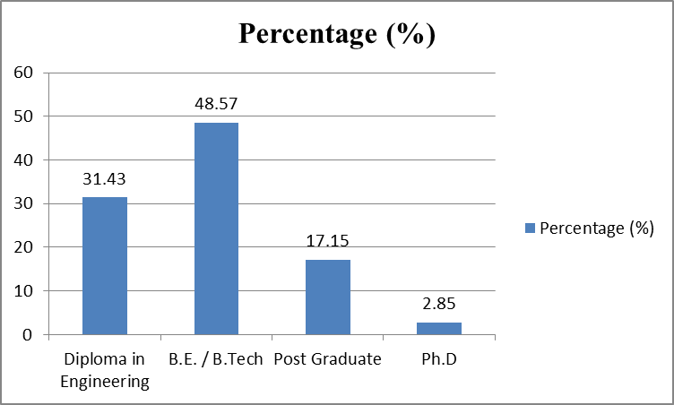
Figure 4.1 Showing Qualification Profile of Respondents

Table 4.2:- Work Experience of Respondents
Sr. No | Work Experience | Count | Percentage (%)
1 | < 5years | 22 | 31.43
2 | 6 to 10 years | 20 | 28.57
3 | 11 to 20 years | 14 | 20.00
4 | More than 20 years | 14 | 20.00
Total Work Experience in Years |  | 70 | 100

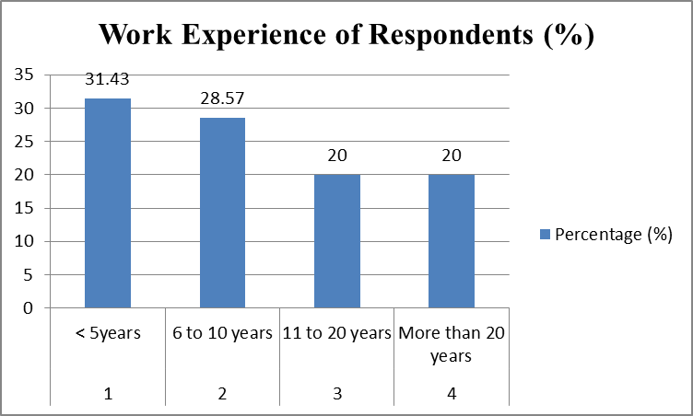
Figure 4.2 Showing Work Experience of Respondents
Table 4.3: Respondents distribution in terms of their organization
Sr. No | Type of Organization | Count | Percentage (%)
1 | Government | 12 | 17.14
2 | Contractor | 18 | 25.71
3 | Consultant | 22 | 31.43
4 | Academics | 10 | 14.29
5 | Public Sector / Semi Government | 8 | 11.43
Total |  | 70 | 100
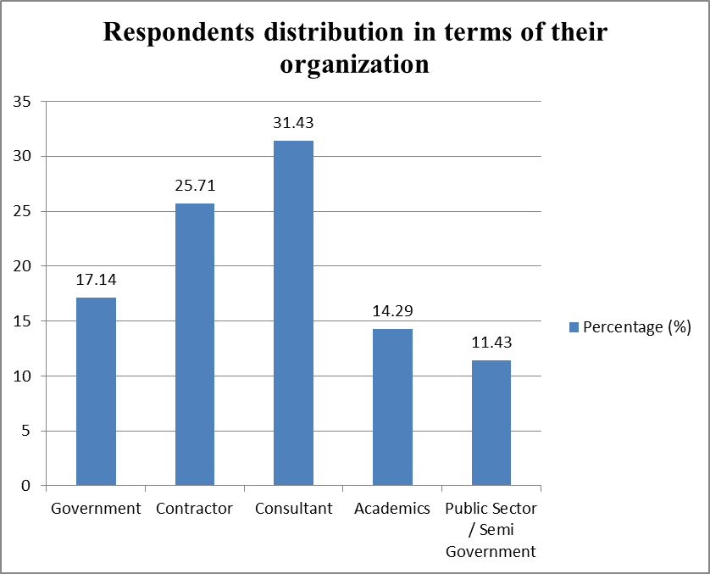
Figure 4.3 Showing Respondents Distribution in terms of their organization
Table 4.4: Mean and Standard Deviation of Responses
Sr. No | Factors | 1 | 2 | 3 | 4 | 5 | Mean | Std Dev.
1 | Contract package division
1 | Contract package division | 7 | 5 | 12 | 16 | 30 | 14 | 9.924
2 | Contract awarding procedure
2 | Contract awarding procedure | 3 | 6 | 13 | 20 | 28 | 14 | 10.223
3 | Criteria for awarding | 2 | 3 | 6 | 24 | 34 | 13.8 | 14.394
4 | Bills of quantities and cost estimates
4 | Bills of quantities and cost estimates | 0 | 4 | 13 | 22 | 28 | 13.4 | 11.781
5 | Drawing for Tenders | 1 | 5 | 16 | 20 | 26 | 13.6 | 10.407
6 | Specifications | 0 | 2 | 12 | 23 | 32 | 13.8 | 13.682
7 | Contractual Special Conditions
7 | Contractual Special Conditions | 1 | 3 | 17 | 21 | 24 | 13.2 | 10.545
8 | Contract Document and Standard Bidding
8 | Contract Document and Standard Bidding | 0 | 2 | 11 | 22 | 32 | 13.4 | 13.557
9 | Overall and Comparable Experience
9 | Overall and Comparable Experience | 2 | 4 | 15 | 19 | 30 | 14 | 11.467
10 | Financial Ability | 2 | 3 | 12 | 22 | 28 | 13.4 | 11.48
11 | Bid Capacity | 1 | 0 | 11 | 24 | 32 | 13.6 | 14.117
12 | Tool, equipment, and plant development proposed for a certain project | 0 | 4 | 10 | 22 | 34 | 14 | 13.928

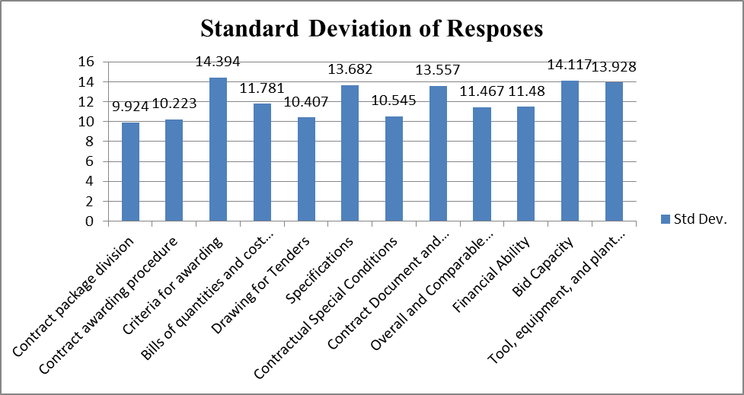
Figure 4.4 Showing Standard Deviation of Responses
Table 4.5: Factors with highest mean value
Rank | Factor | Mean Value
1 | Criteria for awarding | 14.394
2 | Bid Capacity | 14.117
3 | Tool, equipment, and plant development proposed for a certain project | 13.928
4 | Specifications | 13.682
5 | Contract Document and Standard Bidding | 13.557
6 | Bills of quantities and cost estimates | 11.781

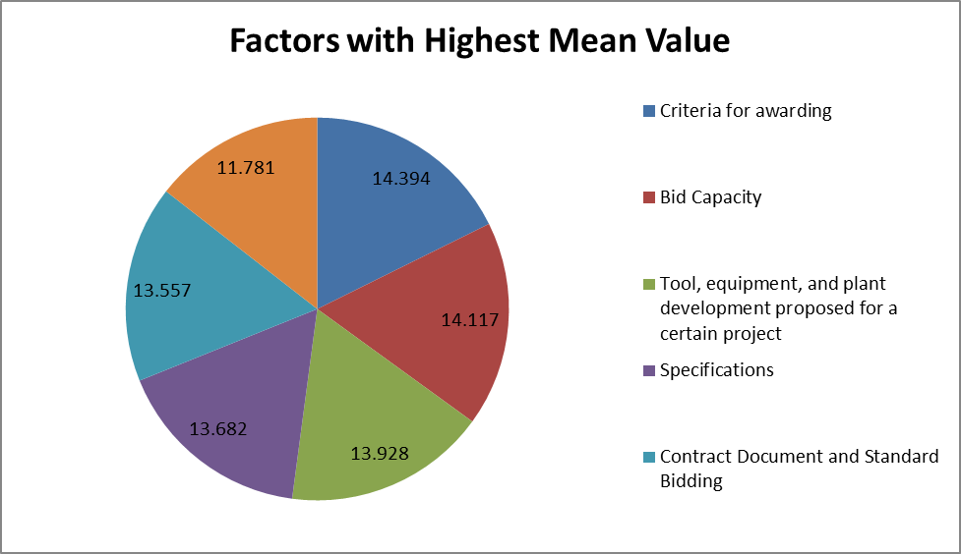
Figure 4.5 Showing Factors having Highest Influence on the Project

onclusions

5.1 Introduction
After thorough observation and data collection, following observation & conclusion can be drawn.

5.2 Conclusion
The study is primarily focused on project delays caused by poor project development procedures. Although it is simple to criticize the contractor, we must examine the causes of the delay. A good project development practice, on the other hand, leads to a smooth and effortless project execution. The proper administration of the bid process ensures the selection of the best contractor for the project.
In today's highly competitive construction industry, businesses must be able to successfully cope with a variety of bidding conditions. The first stage that corporations must consider is whether to bid or not to bid, and that bid/no bid decision making is quite complex, requiring a huge number of relevant considerations to be considered. Over the last 15 years, contractor selection in the public sector has been a hotly discussed topic. Today, public clients are frequently required by public procurement regulations to select the lowest bidder on the basis of financial accountability and competitiveness. Bidding is the procedure through which the prime contractor obtains prices from subcontractors and vendors for labor, materials, and/or a combination of the two. It is a methodical technique of simplifying information, reducing errors and omissions, and producing generally correct findings by depending on speed and efficiency.
The contract should be given to the bidder with the lowest responsive bid. Choosing a qualified contractor increases the odds of a project being completed successfully by meeting the client's goals of cost, time, and quality. The ever-increasing demands of clients and regulatory bodies, combined with the tremendous rivalry among contractors in the construction sector, make competent project management critical. Contractors are critical to the successful completion of a construction project. As we all know, an experienced contractor can complete work more quickly. However, simply choosing the proper contractor will not guarantee project success. The bid materials must also be precise in terms of specifications and estimates.

This three construction contractors can compare their educational profiles, work experience, and distribution by organization and determine who is superior. These elements were then ordered in order of priority, resulting in the following outcomes: Sequence of contract awarding, Proposed development of tools and equipment & plant for specific project, Overall & Similar Experience, Standard Bidding & Contract Document, Bills of Quantities & Estimated Cost. Contract packages/Work Packages are being divided. Bills of Quantities and estimated costs are two of the most essential aspects that might determine project success.

5.3 Recommendations
It is said that the construction sector is an industry that is poorly managed hence good communication and clear guidelines on the scope of the work are clearly mentioned in the contract document.
- Criteria for awarding the work must be transparent.
- The bidding capacity for the project is clearly mentioned.
- Tool, Plant and equipment required mandatory for the completion of the project is clearly mentioned.
- Specification clearly mentioned for the completion of the assigned task.

5.4 Scope for future work
- In the present study, only building projects considered for analysis similarly other construction projects also undertaken for the study.
- Inthe present study, analysis is carried out on a percentage basis hence there is a scope to develop statistical model explaining the relation between degree of quality, time management and degree of control.

References
- Akshay Kumar Tandale, Chaitanya Shirsath, Bharat Vigne, Yash Dane, Dr. Ayub Sheikh (2016), Analysis & Optimization to Improve the Tedious Tendering Process in Construction Industry, IJLTEMAS, Volume V, Issue 1,ISSN 2278-2540, 55-55.
- A.Levision, W. (2000). Iso 9000 at the Front Line (illustrated ed.). ASQ Quality Press.
- Abdulaziz A. Bubshait, Tawfiq H. Al-Atiq. (1999, November/December). ISO 9000 Quality Standerds in Construction. Journal of Management in Engineering, 15, 41-46.
- Anthony Mills, Peter E.D. Love, Peter Williams. (2009, January). Defect Costs in Residential Construction. Journal of Construction Engineering and Management, 135, 12-16.
- Arthur W. Saarien Junior, Mariene A. Hobel. (1990, April). Setting and Meeting Requirement for Quality. Journal of Management in Engineering, 6, 177-185.
- Bhushan Ratekar et.al. (2016). Basic guidelines for bid/No bid decision making in the EPC projects, IOSR Journal of Business and Management (IOSR-JBM) e-ISSN: 2278-487X, p-ISSN: 2319-7668. Volume 18, Issue 7 .Ver. II (July 2016), PP 43-47.
- Chadwick, W. L. (1986, April). Impact of Design, Construction and Cost on Project Quality. Journal of Professional Issues in Engineering, 112, 69-79.
- Chase, G. W. (1998, May-June). Improving Construction Methods: A Story about Quality. Journal of Management in engineering, 14, 30=33.
- Duttenhorffer, R. (1992, April). Cost and Quality Management.Journal of Management in Engineering, 8, 167-175.
- E. Koehn, Durgesh C. Regmi. (1990, October). Quality in Construction Projects : International Firms and Developing Countries. Journal of Profesional Issues in Engineering, 116, 388-396.
- Hoonakker, P. (n.d.). Quality Management in Construction Industry. University of Wisconsin-Madison, Center for Quality and Productivity Improvement, Madison.
- Hoyle, D. (1998). ISO 9000: Pocket Guide for Quality Management (illustrated ed.). Butterworth-Heinemann.
- James L. Burati Jr., Jodi J. Farrington, William B. Ledbetter. (1992, March). Causes of Quality Deviation in Design and Construction. Journal of Construction Engineering and Management, 118, 34-49.
- Jerald L. Rounds, Mai-Yuan Chi. (1985, June). Total Quality Management for Construction. Journal of Construction Engineering and Management, 117-128.
- J. M. Juran (1888),Juran's Quality Control Handbook, 1774 pages,Mcgraw-Hill, 4th Edition.
- Kent Davis, W. B. Ledbetter, James L. Burati, (1989), Measuring Design and Construction Quality Costs, Journal of Construction Engineering and Management, Vol. 115, 385-400.
- L. O. Oyewobi, O. T. Ibironke, B. O. Ganiyu, A. W. Ola-Awo. (2011, March). Evaluating rework cost. Journal of Geography and Regional Planning, 4, 147-151.
- Linda A. Newton, John Christian. (2006, December). Impact of Quality on Building costs.Journal of Infrastructure Systems, 12, 199-206.
- P.A. Bowen, K.S. Cattel, K.A. Hall, P.J. Edwards, R.G. Pearl. (1997). Perception of Time, Cost and Quality management on Building Projects. The Australian Journal of Construction Economics and Building, 48-56.
- Pawar, S. (2013). Study of Cost overruns due to Delays and Rework in Resdential Projects. ME Thesis, D Y Patil College of Engineering, PG Section, Civil Engineering Department, Akurdi, Pune - 44.
- Sadberg, H. R. (1987, July). Quality-Missing Ingredient of Engineering Engagement.Journal of Professional Issue in Engineering, 113, 216-220.
- Sang-Hoon Song, Hyun-Soo Lee. (1999). Analysis and Utilization of Quality Cost in Construction Projects. Journal of Construction and Management, 125, 142-147.
- Smita Sarker, Mohammad Salah Uddin Chowdury, Pulok Deb , "Study of Influencing Factors of Tender Evaluation: An Evidential Reasoning Approach ". International Journal of Research in Computer Science, 2 (5): pp. 15-20, September 2012. doi:10.7815/ijorcs.25.2012.04.
- Tan Chin-Keng, Abdul-Rehman Hamzah. (2011, July). Study of Quality Management in Construction Projects. Chinese Buisnese Review, 10, pp. 542-552.

