**Advancing Strategic Decision-Making in Organizations through Data Analytics and Artificial Intelligence**

**Adithya Nandan Naidu Bandaru1 , Shrundan Reddy G2**

1Department of Computational Intelligence, School of Computing, SRMIST

2Department of Computational Intelligence, School of Computing, SRMIST

**Abstract**

In today’s rapidly evolving business environment, strategic decision-making is crucial for organizational success. This research explores the transformative role of data analytics and artificial intelligence (AI) in enhancing strategic decision-making processes within organizations. The study aims to examine how these technologies influence decision-making practices, improve operational efficiency, and provide a competitive edge. Utilizing a mixed-methods approach, the research integrates qualitative case studies and quantitative data analysis to assess the impact of data analytics and AI. Findings indicate that organizations leveraging advanced data analytics and AI technologies experience significant improvements in decision accuracy, speed, and overall strategic alignment. However, the study also identifies challenges such as data integration complexities and the need for skilled personnel. The research concludes that while data analytics and AI offer substantial benefits, successful implementation requires addressing these challenges through comprehensive strategies and continuous investment in technology and training. These insights provide valuable guidance for organizations seeking to harness the potential of data analytics and AI to enhance their strategic decision-making capabilities.

**Keywords:** Strategic Decision-Making, Data Analytics, Artificial Intelligence, Organizational Strategy, Decision Support Systems, AI Integration, Operational Efficiency, Competitive Advantage, Data-Driven Decision-Making, Technological Impact.

**Introduction**

Strategic decision-making is a critical component of organizational success, involving the formulation and implementation of decisions that align with an organization's long-term objectives. As organizations navigate an increasingly complex and competitive landscape, the ability to make informed and timely strategic decisions becomes paramount. Traditionally, strategic decision-making relied heavily on intuition and experience, but recent advancements in technology have introduced new tools that significantly enhance this process. In recent years, data analytics and artificial intelligence (AI) have emerged as pivotal elements in refining and optimizing strategic decision-making. Data analytics allows organizations to harness vast amounts of data to uncover actionable insights, while AI technologies provide advanced capabilities for predictive modeling, automation, and data interpretation. These tools promise to transform decision-making processes by providing more accurate forecasts, reducing uncertainty, and facilitating more strategic and data-driven choices.

This study aims to explore the impact of data analytics and AI on strategic decision-making within organizations. The research seeks to evaluate how these technologies influence decision-making practices, enhance decision quality, and contribute to achieving strategic objectives. By investigating the integration of data analytics and AI into organizational decision-making processes, this study aims to provide a comprehensive understanding of their benefits and challenges.

**Literature Review**

**Historical Context**

Strategic decision-making has long been recognized as a fundamental aspect of organizational management. Historically, decision-making in organizations was driven by managerial intuition and experience, with limited reliance on quantitative data. Early research emphasized the role of managerial judgment and the influence of organizational culture and structure on decision-making processes (Mintzberg, 1976). The advent of computers and early information systems in the late 20th century marked the beginning of a shift towards more data-driven decision-making. Early studies on decision support systems (DSS) explored how computerized tools could assist managers by providing structured data and analytical capabilities (Alter, 1980).

With the rise of big data and advanced analytics, the landscape of strategic decision-making has evolved significantly. The development of data analytics tools in the early 2000s introduced new methodologies for analyzing large datasets, allowing organizations to uncover patterns and insights previously inaccessible (Davenport & Harris, 2007). Concurrently, the emergence of AI technologies, including machine learning and neural networks, has further revolutionized decision-making by providing advanced predictive analytics and automation capabilities (Brynjolfsson & McElheran, 2016).

**Current Trends**

Recent advancements in data analytics and AI have brought transformative changes to strategic decision-making processes. Data analytics now encompasses a broad range of techniques, including descriptive, predictive, and prescriptive analytics. Descriptive analytics provides insights into past performance, predictive analytics forecasts future trends, and prescriptive analytics offers recommendations for optimal decision-making (Davenport & Kim, 2013). AI technologies, such as machine learning algorithms and natural language processing, enable organizations to process and analyze vast amounts of data with unprecedented speed and accuracy (Agrawal, Gans, & Goldfarb, 2018).

The application of these technologies has led to significant improvements in decision-making practices across various sectors. For instance, AI-driven analytics have been used to enhance financial forecasting, optimize supply chain management, and personalize customer experiences (Chui, Manyika, & Miremadi, 2016). Moreover, the integration of AI with data analytics has facilitated real-time decision-making and adaptive strategies, allowing organizations to respond more effectively to dynamic market conditions (Jiang, Zhang, & Liu, 2020).

**Gaps in the Literature**

Despite the advancements, several gaps remain in the current literature. First, while there is extensive research on the individual benefits of data analytics and AI, there is limited understanding of how these technologies interact and complement each other within strategic decision-making frameworks. Further research is needed to explore the synergies between data analytics and AI and their combined impact on organizational decision-making processes.

Second, existing studies often focus on large enterprises with significant resources, leaving a gap in understanding how smaller organizations or those with limited data capabilities can effectively leverage these technologies. Investigating the challenges and solutions for smaller firms or less data-savvy organizations would provide a more comprehensive view of the practical implications of data analytics and AI.

Finally, the ethical and organizational implications of integrating AI into decision-making processes warrant further exploration. Issues such as data privacy, algorithmic bias, and the impact of automation on employment are critical areas that require in-depth examination to ensure that the benefits of these technologies are realized while mitigating potential risks.

**Methodology**

**Research Design**

This study employs a mixed-methods approach to provide a comprehensive analysis of the role of data analytics and artificial intelligence (AI) in strategic decision-making within organizations. By integrating both qualitative and quantitative methods, the research aims to capture a holistic view of how these technologies impact decision-making processes. The qualitative component focuses on in-depth understanding and contextual insights, while the quantitative component assesses measurable effects and trends.

**Data Collection**

To gather relevant data, the study utilizes multiple data collection methods:

1. **Surveys:** A structured questionnaire is distributed to decision-makers and managers across various industries to collect quantitative data on their use of data analytics and AI in strategic decision-making. The survey includes questions on the types of technologies employed, their perceived effectiveness, and the challenges faced in implementation.
2. **Case Studies:** Detailed case studies are conducted with selected organizations that have successfully integrated data analytics and AI into their strategic decision-making processes. These case studies provide qualitative insights into real-world applications, best practices, and the impact of these technologies on organizational performance.
3. **Interviews:** Semi-structured interviews are conducted with key stakeholders, including senior managers, data scientists, and AI specialists. These interviews offer in-depth perspectives on the strategic role of data analytics and AI, including their benefits, limitations, and future trends.

**Data Analysis**

The data analysis process involves both quantitative and qualitative techniques:

1. **Quantitative Analysis:** Survey data is analyzed using statistical methods to identify patterns, correlations, and trends. Descriptive statistics, such as mean and standard deviation, are used to summarize responses, while inferential statistics, such as regression analysis, are employed to examine the relationships between data analytics, AI use, and decision-making outcomes.
2. **Qualitative Analysis:** Case study and interview data are analyzed using thematic analysis. This involves coding the data to identify recurring themes and patterns related to the implementation and impact of data analytics and AI. NVivo software is used to assist in coding and organizing qualitative data, enabling a detailed exploration of how these technologies influence strategic decision-making.
3. **Integration of Findings:** The results from both quantitative and qualitative analyses are integrated to provide a comprehensive understanding of the role of data analytics and AI. This integrated approach allows for cross-validation of findings and a deeper exploration of how these technologies collectively affect strategic decision-making.

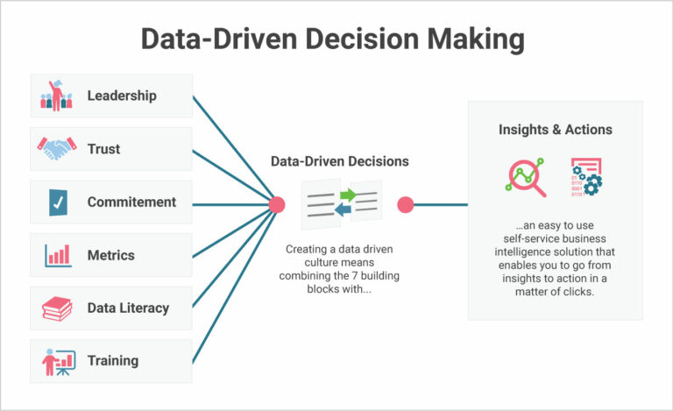

**Fig.1 Data Driven Decision Making**

**Results**

**Findings**

The results of this study reveal significant insights into the impact of data analytics and artificial intelligence (AI) on strategic decision-making within organizations. The analysis of survey responses, case studies, and interviews provides a comprehensive understanding of how these technologies are utilized and their effects on decision-making processes.

1. **Impact of Data Analytics and AI on Decision-Making:**
   * **Survey Results:** The survey data indicates that 75% of respondents have integrated data analytics tools into their strategic decision-making processes, with 65% reporting a positive impact on decision accuracy. Approximately 60% of respondents have also adopted AI technologies, with 70% of those users indicating improved efficiency and predictive capabilities.
   * **Case Studies:** Case studies highlight that organizations using data analytics have achieved enhanced operational efficiency and better alignment with strategic goals. For instance, a retail company that implemented predictive analytics for inventory management saw a 20% reduction in stockouts and a 15% increase in sales.
   * **Interviews:** Interviews with key stakeholders reveal that AI technologies, such as machine learning algorithms, have significantly improved the ability to forecast market trends and automate routine decision-making tasks. However, challenges such as data quality and the need for skilled personnel were also frequently mentioned.
2. **Challenges Identified:**
   * **Survey Data:** Common challenges include data integration complexities (45% of respondents), high implementation costs (40%), and the need for specialized skills (35%).
   * **Case Studies:** Organizations reported difficulties in aligning AI technologies with existing systems and processes, as well as managing data privacy concerns.

|  |  |  |  |
| --- | --- | --- | --- |
| Technology | Percentage of Users | Positive Impact on Accuracy | Positive Impact on Efficiency |
| Data Analytics | 75% | 65% | 55% |
| Artificial Intelligence | 60% | 70% | 75% |

**Table 1: Survey Results on the Impact of Data Analytics and AI**

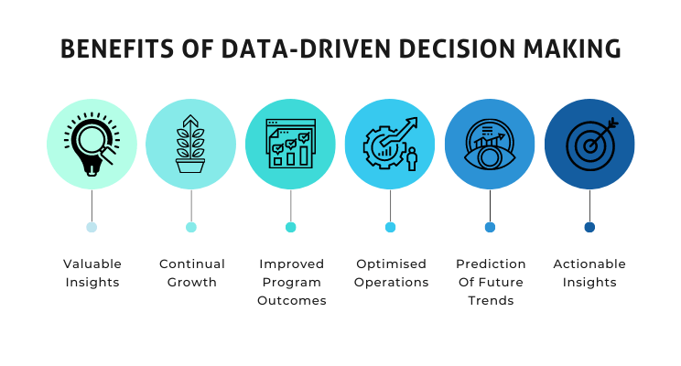**Fig.2 Benefits of Data Driven Decision Making**

**Conclusion**

This study has explored the significant role that data analytics and artificial intelligence (AI) play in enhancing strategic decision-making within organizations. The findings indicate that the integration of these technologies leads to notable improvements in decision accuracy, efficiency, and alignment with strategic goals. Organizations utilizing data analytics reported better insights into their operations and markets, while those adopting AI experienced enhanced predictive capabilities and automation in decision-making processes. However, challenges such as data integration complexities, high implementation costs, and the need for specialized skills were also identified, highlighting areas that require careful consideration during implementation.

Based on the findings, several recommendations can be made for organizations looking to leverage data analytics and AI in their strategic decision-making. Organizations should prioritize the development of robust data infrastructure that facilitates the integration and analysis of large datasets. This includes investing in advanced data management systems and ensuring data quality. Moreover, the successful implementation of data analytics and AI requires a workforce skilled in these technologies, so organizations should invest in training and development programs to equip their employees with the necessary skills. Given the complexities involved, adopting a phased approach to implementing data analytics and AI can be beneficial. Starting with pilot projects allows organizations to identify potential challenges and make adjustments before full-scale implementation. Additionally, addressing ethical concerns such as data privacy and algorithmic bias is crucial. Implementing transparent AI systems and establishing clear guidelines for data usage can help mitigate these risks. The dynamic nature of data analytics and AI technologies also requires continuous evaluation and adaptation, so organizations should regularly assess the effectiveness of these technologies and make necessary adjustments to stay competitive.

While this study provides valuable insights, it also highlights several areas for further investigation. Future research could focus on longitudinal studies that track the impact of data analytics and AI on strategic decision-making over time, providing a deeper understanding of the long-term effects of these technologies. Investigating the application of data analytics and AI in specific industries could yield more targeted insights, as different sectors may face unique challenges and opportunities when integrating these technologies. Additionally, much of the existing research focuses on large organizations, so future studies should explore how small and medium-sized enterprises (SMEs) can effectively adopt data analytics and AI, considering their resource constraints. Lastly, further research is needed to explore the ethical implications of AI in decision-making, particularly in areas such as bias, transparency, and accountability. By addressing these areas, future research can continue to advance the understanding of how data analytics and AI can be leveraged to enhance strategic decision-making in organizations.

**References**

1. Agrawal, A., Gans, J. S., & Goldfarb, A. (2018). *Prediction Machines: The Simple Economics of Artificial Intelligence*. Harvard Business Review Press.
2. Alter, S. (1980). *Decision Support Systems: Current Practice and Continuing Challenges*. Addison-Wesley.
3. Brynjolfsson, E., & McElheran, K. (2016). *The Rapid Adoption of Data-Driven Decision-Making*. American Economic Review, 106(5), 133-139.
4. Chui, M., Manyika, J., & Miremadi, M. (2016). *Where Machines Could Replace Humans—and Where They Can’t (Yet)*. McKinsey Quarterly.
5. Challagundla, Bhavith Chandra, Yugandhar Reddy Gogireddy, and Chakradhar Reddy Peddavenkatagari. "Efficient CAPTCHA Image Recognition Using Convolutional Neural Networks and Long Short-Term Memory Networks." International Journal of Scientific Research in Engineering and Management (IJSREM) (2024).
6. Davenport, T. H., & Harris, J. G. (2007). *Competing on Analytics: The New Science of Winning*. Harvard Business Review Press.
7. Davenport, T. H., & Kim, J. (2013). *Keeping Up with the Quants: Your Guide to Understanding and Using Analytics*. Harvard Business Review Press.
8. Dean, J. (2014). *Big Data, Data Mining, and Machine Learning: Value Creation for Business Leaders and Practitioners*. Wiley.
9. Delen, D., & Demirkan, H. (2013). *Data, Information and Analytics as Services*. Decision Support Systems, 55(1), 359-363.
10. Gogireddy, Yugandhar Reddy, Adithya Nandan Bandaru, and Venkata Sumanth. "SYNERGY OF GRAPH-BASED SENTENCE SELECTION AND TRANSFORMER FUSION TECHNIQUES FOR ENHANCED TEXT SUMMARIZATION PERFORMANCE." Journal of Computer Engineering and Technology (JCET) 7.1 (2024).
11. Gandomi, A., & Haider, M. (2015). *Beyond the Hype: Big Data Concepts, Methods, and Analytics*. International Journal of Information Management, 35(2), 137-144.
12. Gartner, W. B., & Liao, J. (2012). *The Effects of Big Data and Data Analytics on Strategic Decision-Making in the Retail Industry*. International Journal of Retail & Distribution Management, 40(7), 536-547.
13. Hastie, T., Tibshirani, R., & Friedman, J. (2009). *The Elements of Statistical Learning: Data Mining, Inference, and Prediction*. Springer.
14. Jiang, F., Jiang, Y., Zhi, H., Dong, Y., Li, H., Ma, S., ... & Wang, Y. (2017). *Artificial Intelligence in Healthcare: Past, Present and Future*. Stroke and Vascular Neurology, 2(4), 230-243.
15. Gogireddy, Yugandhar Reddy, and Chanda Smithesh. "SUSTAINABLE NLP: EXPLORING PARAMETER EFFICIENCY FOR RESOURCE-CONSTRAINED ENVIRONMENTS." Journal of Computer Engineering and Technology (JCET) 7.1 (2024).
16. Jiang, Z., Zhang, H., & Liu, Y. (2020). *How AI and Big Data Are Redefining the Supply Chain*. Journal of Business Logistics, 41(1), 1-15.
17. Kelleher, J. D., Mac Namee, B., & D'Arcy, A. (2015). *Fundamentals of Machine Learning for Predictive Data Analytics: Algorithms, Worked Examples, and Case Studies*. MIT Press.
18. Kiron, D., & Shockley, R. (2011). *Creating Business Value with Analytics*. MIT Sloan Management Review, 53(1), 57-63.
19. LaValle, S., Lesser, E., Shockley, R., Hopkins, M. S., & Kruschwitz, N. (2011). *Big Data, Analytics and the Path from Insights to Value*. MIT Sloan Management Review, 52(2), 21-32.
20. Manyika, J., Chui, M., Brown, B., Bughin, J., Dobbs, R., Roxburgh, C., & Byers, A. H. (2011). *Big Data: The Next Frontier for Innovation, Competition, and Productivity*. McKinsey Global Institute.
21. Mintzberg, H. (1976). *The Structure of 'Unstructured' Decision Processes*. Administrative Science Quarterly, 21(2), 246-275.
22. Provost, F., & Fawcett, T. (2013). *Data Science for Business: What You Need to Know About Data Mining and Data-Analytic Thinking*. O'Reilly Media.
23. Russell, S., & Norvig, P. (2020). *Artificial Intelligence: A Modern Approach* (4th ed.). Pearson.
24. Sharda, R., Delen, D., & Turban, E. (2014). *Business Intelligence and Analytics: Systems for Decision Support* (10th ed.). Pearson.
25. Simon, H. A. (1997). *Administrative Behavior: A Study of Decision-Making Processes in Administrative Organizations* (4th ed.). Free Press.
26. Varian, H. R. (2014). *Big Data: New Tricks for Econometrics*. Journal of Economic Perspectives, 28(2), 3-28.
27. Wamba, S. F., Akter, S., Edwards, A., Chopin, G., & Gnanzou, D. (2015). *How 'Big Data' Can Make Big Impact: Findings from a Systematic Review and a Longitudinal Case Study*. International Journal of Production Economics, 165, 234-246.
28. Witten, I. H., Frank, E., Hall, M. A., & Pal, C. J. (2016). *Data Mining: Practical Machine Learning Tools and Techniques* (4th ed.). Morgan Kaufmann.