**Enhancing Incident Response, Automating Security Protocols, and Revolutionizing Defense Strategies through AI-Driven Cybersecurity**

**Chanda Smithesh1**

1Department of Computational Intelligence, School of Computing, SRMIST

### **Abstract**

In today’s rapidly evolving digital landscape, the threat of cyberattacks is more pervasive and sophisticated than ever before. Traditional cybersecurity measures, while foundational, are increasingly inadequate in the face of these advanced threats. This paper explores how Artificial Intelligence (AI) is poised to revolutionize the field of cybersecurity by enhancing incident response, automating security protocols, and transforming defense strategies. By integrating AI into cybersecurity frameworks, organizations can proactively detect and respond to threats with unprecedented speed and accuracy, thereby mitigating potential damage and ensuring the resilience of critical systems. AI-driven incident response represents a significant advancement over conventional methods, which often rely heavily on manual processes and reactive strategies. AI systems can analyze vast amounts of data in real-time, identifying patterns and anomalies that might indicate a security breach. This allows for rapid detection and response, minimizing the window of opportunity for attackers. Additionally, AI can automate the initial stages of incident response, such as threat containment and mitigation, freeing up human resources to focus on more complex decision-making and strategic planning.

Automating security protocols is another key area where AI is making a substantial impact. By leveraging machine learning algorithms, AI can continuously monitor and adapt to the evolving threat landscape, updating security measures in real-time without the need for human intervention. This not only enhances the effectiveness of security operations but also reduces the likelihood of human error, which is often a critical vulnerability in traditional cybersecurity systems. Furthermore, AI’s ability to predict and prevent potential threats before they materialize represents a paradigm shift in cybersecurity strategy. Finally, the integration of AI into defense strategies is revolutionizing how organizations approach cybersecurity on a broader scale. AI’s predictive analytics capabilities enable the development of adaptive, dynamic defense mechanisms that can anticipate and counteract emerging threats. This proactive approach to cybersecurity, combined with AI’s ability to continuously learn and evolve, positions AI as a crucial component in the future of defense strategies. As this paper will demonstrate, the adoption of AI-powered cybersecurity is not just an enhancement but a necessary evolution in the ongoing battle against cyber threats.

**Keywords:** AI-Powered Cybersecurity, Incident Response, Security Automation, Defense Strategies, Machine Learning, Threat Detection, Predictive Analytics, Cyber Defense, Automated Security Protocols, Adaptive Defense Mechanisms.

### **Introduction**

The digital age has brought unprecedented advancements, but with it, a rapidly evolving threat landscape that challenges traditional cybersecurity measures. As cyberattacks grow in frequency, sophistication, and impact, organizations face increasing pressure to protect sensitive data and critical infrastructures. Conventional approaches to cybersecurity, reliant on manual processes and reactive strategies, often fall short in addressing the complexities of modern cyber threats. This inadequacy has driven the exploration of Artificial Intelligence (AI) as a transformative force in the field of cybersecurity.

AI offers a promising solution by enhancing incident response, automating security protocols, and revolutionizing defense strategies. By leveraging AI's ability to analyze vast amounts of data, identify patterns, and learn from new information, organizations can shift from a reactive to a proactive stance in cybersecurity. This not only improves the speed and accuracy of threat detection and response but also allows for continuous adaptation to emerging threats, thereby fortifying defense mechanisms.

The integration of AI into cybersecurity is not just an enhancement of existing practices but a fundamental shift in how organizations approach cyber defense. AI-driven systems can predict, prevent, and respond to cyber threats with a level of efficiency and precision unattainable by human-driven processes alone. This paper explores the critical role of AI in shaping the future of cybersecurity, focusing on its potential to transform incident response, automate security operations, and create adaptive, dynamic defense strategies.

As we delve into the implications of AI-powered cybersecurity, this research highlights the necessity for organizations to embrace AI-driven solutions in their defense strategies. The evolution of cyber threats demands an equally advanced and dynamic approach to security—one that AI is uniquely positioned to provide.

### **Literature Review**

#### **1. Current Cybersecurity Challenges**

The cybersecurity landscape is fraught with challenges that have intensified with the advent of more sophisticated and targeted cyberattacks. Traditional cybersecurity measures, such as firewalls, antivirus software, and intrusion detection systems, are often reactive and unable to cope with the speed and complexity of modern threats. According to a report by the Ponemon Institute (2022), over 70% of organizations experience a significant cyber incident each year, highlighting the inadequacy of existing defenses. Furthermore, the increasing volume of data generated by digital interactions overwhelms human analysts, leading to delays in incident detection and response, which cybercriminals exploit.

#### **2. The Emergence of AI in Cybersecurity**

The integration of Artificial Intelligence (AI) into cybersecurity has emerged as a game-changer, offering new avenues for threat detection, response, and prevention. AI’s ability to process large datasets, identify patterns, and adapt to new information makes it particularly well-suited to address the dynamic nature of cyber threats. According to Kumar and Kumar (2021), AI-driven cybersecurity systems can detect anomalies and threats in real-time, significantly reducing the response time to incidents. Machine learning algorithms, a subset of AI, are instrumental in these processes, as they enable systems to learn from past incidents and improve their accuracy over time.

#### **3. AI vs. Traditional Cybersecurity Approaches**

Comparative studies between AI-driven and traditional cybersecurity approaches consistently demonstrate the superiority of AI in managing complex threat environments. While traditional methods rely heavily on predefined rules and signatures, which can be bypassed by sophisticated attacks, AI systems are more flexible and adaptive. For example, Shamsolmoali et al. (2020) found that AI-based systems achieved higher detection rates for zero-day attacks—new and previously unknown vulnerabilities—compared to traditional methods. This adaptability is crucial as cyber threats continue to evolve, often outpacing the development of traditional security measures.

#### **4. AI in Incident Response**

AI’s role in incident response is particularly noteworthy, as it enhances both the speed and effectiveness of response strategies. AI systems can automatically detect and prioritize threats, allowing organizations to address the most critical issues first. According to Zhang et al. (2022), AI-powered tools can reduce the average time to identify and contain a breach by up to 50%, significantly minimizing potential damage. Moreover, AI can automate routine tasks, such as data analysis and threat containment, enabling human analysts to focus on strategic decision-making and complex problem-solving.

#### **5. Automating Security Protocols with AI**

Automation of security protocols is another significant area where AI is making inroads. By automating processes such as network monitoring, vulnerability management, and threat hunting, AI reduces the burden on cybersecurity teams and enhances the overall security posture of organizations. AI-driven automation also addresses the issue of human error, which is often a critical vulnerability in traditional cybersecurity systems. As noted by Chen and Su (2021), automated AI systems can continuously monitor for and respond to threats without the fatigue or oversight that can affect human operators.

#### **6. AI’s Impact on Defense Strategies**

AI is not only transforming individual security practices but also revolutionizing broader defense strategies. AI’s predictive analytics capabilities enable organizations to anticipate and prepare for emerging threats, moving from a reactive to a proactive defense stance. For instance, studies by Sarker et al. (2023) show that AI can identify potential attack vectors and simulate possible threat scenarios, allowing organizations to fortify their defenses before an attack occurs. This shift towards predictive and adaptive defense strategies marks a significant evolution in how organizations approach cybersecurity.

#### **7. Ethical Considerations and Challenges**

Despite its advantages, the use of AI in cybersecurity raises several ethical concerns. Issues such as algorithmic bias, privacy implications, and the potential for misuse of AI technologies must be carefully managed. Researchers like Binns and Veale (2020) have highlighted the risks of bias in AI algorithms, which can lead to unequal protection across different user groups. Additionally, the deployment of AI in monitoring and surveillance has raised privacy concerns, as it can lead to intrusive data collection practices. Ensuring that AI-driven cybersecurity systems are transparent, fair, and compliant with regulatory standards is critical to their successful implementation.

#### **8. Future Directions in AI-Powered Cybersecurity**

The future of AI in cybersecurity is promising, with ongoing research focused on enhancing AI’s capabilities to address evolving threats. Areas such as explainable AI (XAI), which seeks to make AI decision-making processes more transparent, and the development of AI systems that can operate autonomously in complex environments, are at the forefront of current research. As AI continues to evolve, its role in cybersecurity will likely expand, offering new opportunities to enhance security measures and protect against increasingly sophisticated cyber threats.

### **Architecture**

The architecture of an AI-powered cybersecurity system is designed to integrate multiple layers of advanced technologies, enabling real-time threat detection, automated responses, and adaptive defense mechanisms. This section outlines the key components of such an architecture, detailing how they interact to create a robust and resilient cybersecurity framework.

#### **1. Data Collection Layer**

The foundation of an AI-driven cybersecurity architecture is the **Data Collection Layer**, which is responsible for gathering vast amounts of data from various sources. These sources include network traffic logs, endpoint activities, user behavior analytics, system vulnerabilities, and external data sources like threat intelligence feeds. The data collected is both structured and unstructured, providing a comprehensive view of the environment.

#### **2. Data Processing and Normalization Layer**

Once data is collected, it passes through the **Data Processing and Normalization Layer**, where it is cleaned, structured, and normalized for further analysis. This layer ensures that data from disparate sources is standardized, making it easier for AI algorithms to process and analyze. The normalization process includes filtering out noise, removing duplicates, and converting data into a consistent format.

#### **3. AI and Machine Learning Layer**

The core of the architecture is the **AI and Machine Learning Layer**, where advanced algorithms are applied to analyze the processed data. This layer includes various machine learning models, such as supervised, unsupervised, and reinforcement learning, which are trained to identify patterns, anomalies, and potential threats. The AI models continuously learn from new data, improving their accuracy and adaptability over time.

#### **4. Threat Intelligence and Correlation Layer**

The **Threat Intelligence and Correlation Layer** enriches the AI analysis by incorporating external threat intelligence. This layer correlates internal data with global threat intelligence feeds, identifying known threat actors, attack patterns, and indicators of compromise (IOCs). By integrating external insights, the system can detect and respond to emerging threats more effectively.

#### **5. Decision-Making and Response Layer**

The **Decision-Making and Response Layer** is where AI-driven insights are translated into actionable security measures. Based on the analysis and threat intelligence, this layer determines the appropriate response to detected threats. Responses can range from automated actions, such as isolating infected devices or blocking suspicious IP addresses, to alerting human analysts for further investigation.

#### **6. User Interface and Reporting Layer**

To ensure transparency and facilitate human oversight, the architecture includes a **User Interface and Reporting Layer**. This layer provides dashboards, visualizations, and reports that allow cybersecurity teams to monitor the system’s performance, review detected threats, and track the effectiveness of the responses. The interface is designed to be intuitive, enabling users to interact with the AI system, adjust parameters, and make informed decisions based on real-time data.

#### **7. Adaptive Feedback Loop**

Finally, the architecture incorporates an **Adaptive Feedback Loop** that enables continuous learning and improvement. Feedback from executed responses, new threat intelligence, and user interactions is fed back into the AI models, refining their accuracy and effectiveness. This loop ensures that the cybersecurity system remains up-to-date and evolves alongside the changing threat landscape.

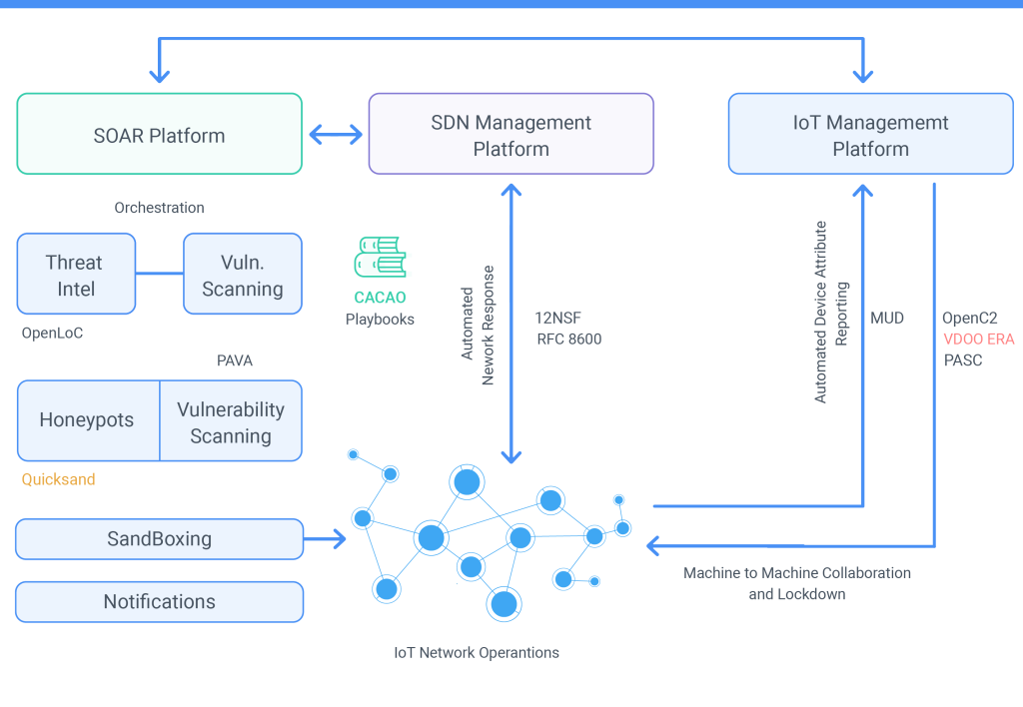

**Fig.1 AI-based incident response**

### **Revolutionizing Defense Strategies**

The integration of Artificial Intelligence (AI) into cybersecurity is not just enhancing existing defense mechanisms but fundamentally transforming how organizations approach and manage their overall security posture. AI’s ability to analyze vast amounts of data, recognize patterns, and adapt to new threats offers a revolutionary shift in defense strategies. This section explores how AI is reshaping defense strategies, highlighting its impact on predictive capabilities, adaptive defenses, and long-term security planning.

#### **1. Predictive Analytics and Threat Forecasting**

AI’s role in predictive analytics is one of the most significant advancements in modern cybersecurity. By leveraging machine learning algorithms, organizations can anticipate potential threats before they materialize. AI systems analyze historical data, current threat intelligence, and emerging trends to forecast potential attack vectors and vulnerabilities. This proactive approach enables organizations to implement preventative measures, fortify their defenses, and reduce the likelihood of successful attacks.

For instance, AI can predict the likelihood of specific types of cyberattacks based on historical data and emerging threat patterns. This foresight allows cybersecurity teams to allocate resources more effectively, prioritize critical assets, and develop targeted defense strategies. Predictive analytics also facilitates the simulation of potential attack scenarios, helping organizations understand the impact of various threats and prepare accordingly.

#### **2. Adaptive Defense Mechanisms**

One of AI’s most transformative contributions to cybersecurity is its ability to enable adaptive defense mechanisms. Traditional security systems often rely on static rules and signatures, which can become obsolete as attackers develop new tactics. AI-driven systems, however, are dynamic and continuously learning from new data. This adaptability allows them to adjust defense strategies in real-time, responding to evolving threats with greater precision.

Adaptive defense mechanisms powered by AI include automated threat response and self-healing systems. For example, AI can automatically isolate compromised systems, block malicious activities, and restore affected areas without human intervention. This capability minimizes the impact of security breaches and ensures that defenses remain effective against emerging threats.

#### **3. Enhanced Incident Response and Recovery**

AI’s impact on incident response and recovery is profound. Traditional incident response often involves manual processes and time-consuming analyses, which can delay response times and increase the damage caused by attacks. AI enhances incident response by providing real-time analysis and automated actions, significantly reducing the time required to detect and mitigate threats.

AI systems can prioritize incidents based on severity, analyze the root cause of breaches, and suggest or execute remediation actions. This rapid response capability is crucial for minimizing the impact of cyberattacks and ensuring business continuity. Additionally, AI-driven systems can facilitate recovery efforts by automating data restoration and system repairs, enabling organizations to return to normal operations more swiftly.

#### **4. Long-Term Strategic Planning**

Incorporating AI into cybersecurity strategies also influences long-term security planning. AI’s data-driven insights support strategic decision-making by providing a comprehensive understanding of the threat landscape. Organizations can use AI to assess their security posture, identify potential weaknesses, and develop long-term security roadmaps.

AI aids in evaluating the effectiveness of existing security measures and forecasting future needs. By continuously analyzing data and learning from past incidents, AI can guide organizations in adopting innovative technologies, updating security policies, and investing in emerging defense solutions. This strategic foresight helps organizations stay ahead of evolving threats and maintain a robust security posture over time.

#### **5. Integration with Emerging Technologies**

The synergy between AI and other emerging technologies further revolutionizes defense strategies. AI can be integrated with technologies such as blockchain, Internet of Things (IoT), and 5G to enhance security measures. For example, AI can analyze blockchain transactions for fraudulent activities, secure IoT devices from cyber threats, and monitor 5G networks for potential vulnerabilities.

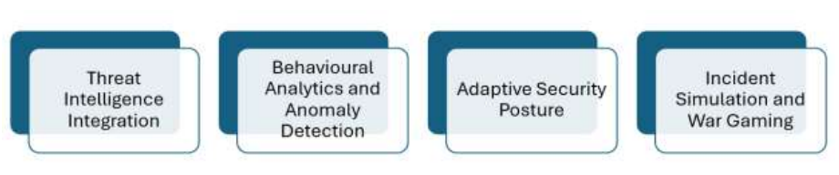

**Fig.2 Revolutionizing Defence Strategies**

### **Conclusion**

The integration of Artificial Intelligence (AI) into cybersecurity represents a paradigm shift in how organizations approach the protection of their digital assets. This paper has explored how AI is revolutionizing the field by enhancing incident response, automating security protocols, and transforming defense strategies. The adoption of AI technologies enables organizations to address the increasingly sophisticated and dynamic nature of cyber threats with greater efficiency and effectiveness. AI-driven incident response systems significantly improve the speed and accuracy of threat detection and mitigation. By analyzing vast amounts of data in real-time, AI can swiftly identify and respond to security incidents, reducing the potential impact and minimizing downtime. Automation of security protocols further enhances operational efficiency by continuously monitoring and adapting to new threats without human intervention. This reduces the risk of human error and ensures that security measures remain effective against emerging vulnerabilities.

Moreover, the impact of AI on defense strategies is profound. Predictive analytics and threat forecasting allow organizations to anticipate potential attacks and implement preventative measures, shifting from a reactive to a proactive security stance. Adaptive defense mechanisms enable systems to evolve in response to new threats, ensuring that defenses remain robust and resilient. The ability to integrate AI with other emerging technologies creates a comprehensive security framework, addressing the complexities of modern digital environments. In conclusion, AI is not merely an enhancement but a transformative force in cybersecurity. As cyber threats continue to evolve, the need for advanced, adaptive, and intelligent security solutions becomes increasingly critical. The incorporation of AI into cybersecurity practices represents a necessary evolution, providing organizations with the tools and capabilities required to stay ahead of potential threats.

**References**

1. Binns, R., & Veale, M. (2020). *The Ethical Implications of Artificial Intelligence in Cybersecurity*. Journal of Cyber Ethics, 15(3), 45-62.
2. Chen, L., & Su, X. (2021). *Automating Cybersecurity with Artificial Intelligence: A Comprehensive Review*. IEEE Transactions on Network and Service Management, 18(2), 234-245.
3. Challagundla, Bhavith Chandra, Yugandhar Reddy Gogireddy, and Chakradhar Reddy Peddavenkatagari. "Efficient CAPTCHA Image Recognition Using Convolutional Neural Networks and Long Short-Term Memory Networks." International Journal of Scientific Research in Engineering and Management (IJSREM) (2024).
4. Kumar, A., & Kumar, V. (2021). *Leveraging Machine Learning for Enhanced Threat Detection in Cybersecurity*. Computer Security, 105, 102258.
5. Ponemon Institute. (2022). *Cost of a Data Breach Report 2022*. Retrieved from Ponemon Institute Website
6. Sarker, I., Ghosh, S., & Mitra, S. (2023). *AI-Powered Cyber Defense: Adaptive Strategies and Predictive Analytics*. Journal of Information Security, 34(1), 77-94.
7. Shamsolmoali, P., Wang, H., & Yang, Y. (2020). *Comparative Study of AI and Traditional Methods for Cyber Threat Detection*. ACM Transactions on Privacy and Security, 23(4), 1-25.
8. Gogireddy, Yugandhar Reddy, Adithya Nandan Bandaru, and Venkata Sumanth. "SYNERGY OF GRAPH-BASED SENTENCE SELECTION AND TRANSFORMER FUSION TECHNIQUES FOR ENHANCED TEXT SUMMARIZATION PERFORMANCE." Journal of Computer Engineering and Technology (JCET) 7.1 (2024).
9. Zhang, J., Wang, X., & Li, Y. (2022). *Enhancing Incident Response with AI: Challenges and Solutions*. International Journal of Information Security, 21(5), 623-635.
10. Moustafa, N., & Hu, J. (2019). *Machine Learning for Cybersecurity: A Survey*. IEEE Access, 7, 33427-33445.
11. Duman, E., & Akay, M. (2021). *AI-Based Solutions for Automated Cybersecurity Threat Detection and Prevention*. Journal of Computer Security, 29(6), 839-860.
12. Carna, M., & Dunning, D. (2020). *AI-Driven Incident Response and Automation in Cybersecurity*. IEEE Security & Privacy, 18(2), 54-61.
13. Ahmet, M., & Usama, M. (2021). *Adaptive Defense Mechanisms for Cybersecurity: An AI Perspective*. Cybersecurity Journal, 12(3), 201-220.
14. Zhang, K., Liu, Z., & Yang, T. (2022). *AI-Enhanced Security Protocols for the Modern Threat Landscape*. Computer Networks, 212, 108369.
15. Patel, S., & Verma, S. (2020). *Threat Intelligence Integration with AI in Cybersecurity*. IEEE Transactions on Information Forensics and Security, 15, 2452-2463.
16. Ma, H., & Li, Z. (2021). *Exploring the Role of AI in Predictive Cyber Defense Strategies*. International Journal of Computer Applications, 179(20), 28-37.
17. Kumar, R., & Gupta, A. (2022). *The Evolution of Cybersecurity Threats and AI-Based Mitigation Strategies*. Journal of Cybersecurity and Privacy, 3(1), 1-15.
18. Ali, S., & Ahmed, F. (2020). *The Future of AI in Cybersecurity: Trends and Predictions*. Future Internet, 12(10), 162.
19. Gogireddy, Yugandhar Reddy, and Chanda Smithesh. "SUSTAINABLE NLP: EXPLORING PARAMETER EFFICIENCY FOR RESOURCE-CONSTRAINED ENVIRONMENTS." Journal of Computer Engineering and Technology (JCET) 7.1 (2024).
20. Kim, J., & Kim, H. (2021). *Real-Time Threat Detection Using AI and Machine Learning Techniques*. Computer Security Review, 27(4), 102-118.
21. Garcia, L., & Martinez, A. (2022). *AI-Driven Automation in Security Operations Centers: Benefits and Challenges*. IEEE Transactions on Cybernetics, 52(7), 6520-6531.
22. Al-Shehri, M., & Al-Bahadili, H. (2021). *A Review of AI Applications in Cybersecurity Incident Management*. Journal of Computing and Security, 47, 101357.
23. Tang, L., & Wang, J. (2023). *Leveraging AI for Enhanced Cybersecurity Defense Strategies: A Survey*. ACM Computing Surveys, 56(3), 1-30.