**"Design and CFD Analysis of a Polymer-Based Flat Plate Solar Collector with Honeycomb Structure and Black-Colored Water as Working Fluid"**

**Deshraj Bunkar1, Vineet Kumar Dwivedi2**

1Scholar, School of Mechanical Engineering, Faculty of Engineering and Technology, SAM Global University, Bhopal, M.P, 462022, INDIA

2Head and Prof., School of Mechanical Engineering, Faculty of Engineering and Technology, SAM Global University, Bhopal, M.P, 462022, INDIA

**ABSTRACT**

This study presents a novel design for a flat plate solar collector, replacing traditional metal riser pipes with a transparent polymer honeycomb structure and utilizing black-colored water as the working fluid. By eliminating the conventional metal absorber plate, the working fluid itself absorbs solar radiation, resulting in a simplified and cost-effective collector design. The use of polymer components significantly reduces the system's weight by up to 50% and enhances durability by avoiding corrosion issues common in metal parts. A computational fluid dynamics (CFD) analysis was conducted using ANSYS Workbench R20, with the results compared to experimental data. The CFD model provided detailed insights into the flow behavior and temperature distribution within the collector, demonstrating reliability in both qualitative and quantitative assessments. The study found that the collector's average efficiency is comparable to existing low-cost flat plate collectors on the market. However, the CFD analysis also identified problematic regions within the collector that negatively impact efficiency. These findings establish a foundation for future research and optimization, demonstrating the potential of CFD as a valuable tool for improving the design and performance of polymer-based flat plate collectors.

**Keywords:** Polymer solar collector, Flat plate collector, Computational fluid dynamics (CFD), Honeycomb structure, Black-colored water, Thermal efficiency

**INTRODUCTION**

The global demand for fresh water continues to rise, driven by population growth, industrial expansion, and climate change. As conventional freshwater sources dwindle, alternative solutions like solar desalination have gained increasing attention. Solar desalination harnesses the abundant and renewable energy from the sun to convert saline water into potable water, making it a sustainable and eco-friendly solution to address the water scarcity crisis. Central to the efficiency of solar desalination systems is the absorber plate, a component responsible for capturing and converting solar energy into heat. The geometry of the absorber plate plays a pivotal role in enhancing the thermal performance and overall efficiency of these systems. In recent years, significant research efforts have been directed towards optimizing absorber plate geometry to maximize heat absorption, minimize energy losses, and improve the overall productivity of solar desalination units. Innovations in absorber plate design, including variations in surface textures, shapes, and materials, have shown promising results in enhancing the thermal efficiency of solar stills, leading to higher water yield. This review paper aims to provide a comprehensive analysis of recent advancements in absorber plate geometry for solar desalination applications. It explores the various design enhancements that have been proposed and tested, evaluates their impact on system performance, and identifies key trends and prospects for future research. By synthesizing the current state of knowledge, this paper seeks to offer valuable insights for researchers, engineers, and policymakers working towards the development of more efficient and sustainable solar desalination technologies.

The PV/T integrated heat pump system shines compared to the classic heat pump system due to its solar heating capacity. Solar energy is captured, stored in a tank, and serves as the low-temperature heat source for the heat pump. This increase greatly improves the heat pump system's coefficient of performance (COP), making it a more efficient and effective alternative for heating needs [1]. At the same time, the heat pump reduces the temperature of PV panels by circulating fluid, resulting in greater electrical conversion efficiency [2,3]. Therefore, the PV/T integrated the heat pump system may concurrently increase the electrical performance and thermal performance. Qu et al. [4] postulated that a solar PV/T integrated dual-source heat pump water heating system employs two interlinked evaporators to enhance both electrical conversion efficiency and assure a consistent supply of hot water, even on cloudy or rainy days. Research findings found that using the water-side evaporator reduced the operating temperature of the PV/T panel by 45°C, resulting in an extra electrical conversion efficiency improvement of 10.3%. This innovation boosts the system's performance and reliability for home hot water needs under different weather conditions. Kong et al. [5] explored a cascade heat pump system comprising PV/T modules connected in series offers the combined benefits of chilling water, creating hot water, and providing electrical power. Research data indicated that this strategy not only improved the electrical efficiency of the PV/T module but also enhanced the heat pump's thermal performance for generating both cool and hot water. This unique device boosts overall energy performance by efficiently utilizing different energy sources. James et al. [6] investigated a grid-connected PV/T heat pump water heater, equipped with a real-time variable frequency controller, displayed considerable improvements. The PV panel's average operating temperature reduced by 25% with heat pump-based cooling, resulting in a 20% improvement in average power output. Additionally, immediate energy efficiency showed a 15% rise, while instantaneous PV efficiency surged by 34%. Researchers routinely employed the TRNSYS program for simulation in several investigations. Calise et al. [7] constructed a dynamic simulation model, utilizing TRNSYS software, was applied to create and simulate a unique, ultra-high-efficiency solar heating and cooling system. During the study, year-long dynamic simulations were done for varied case studies, including varying weather conditions. Aguilar et al. [8] established a result which offer a holistic picture of the hybrid PV/T system's capabilities, limits, and flexibility. By studying its performance across multiple climates and under diverse energy prices, stakeholders can make educated decisions about its deployment feasibility and possible advantages. Furthermore, insights gathered from this comparative analysis can inspire policy suggestions and technology improvements in the field of hybrid renewable energy systems. Le et al. [9] conducted A techno-economic evaluation was undertaken using TRNSYS software to analyze the feasibility of retrofitting a cascade air-to-water heat pump into residential structures. To quantitatively measure the efficiency of the energy conversion process, both energy and exergy analyses were utilized to examine the heat pump system's performance [10-12]. The economic and environmental assessments provide insights into running costs and environmental effect, respectively, delivering a thorough understanding of the system's economic feasibility and its environmental implications. Liu et al. [13] performed a comprehensive evaluation was carried out comprising energy, economic, and environmental analyses to examine the performance of a solar absorption-subcooled compression hybrid cooling system throughout its full working period. This analysis allows for a full examination of its energy efficiency, economic feasibility, and environmental impact over time. Zhang et al. [14] An detailed assessment was done, comprising studies of energy, economics, and environmental issues, to evaluate the performance of a solar absorption-subcooled compression hybrid cooling system during its full operational lifespan. This analysis permitted a full examination of the system's energy efficiency, economic sustainability, and long-term environmental repercussions. Dai et al. [15] presented a novel CO2 heat pump system architecture, featuring vapor injection and dedicated mechanical sub-cooling, was built and tested. Its performance was evaluated through energy consumption, economic viability, and pollutant emissions using a life cycle model. Xu et al. [16] revealed that the approach highlights the usefulness of cascade heat pumps in cold places, proving their good features in terms of energy efficiency, economic feasibility, and environmentally acceptable performance. A complete assessment technique, known as the 4E analysis (covering energy, exergy, economic, and environmental aspects), is presently the standard for evaluating system performance. 4E approach was utilized by Li et al. [17] to explore and evaluate a novel integrated system consisting of a high-temperature heat pump generating 120-130 C heat and a gas separation unit. Xu et al. [18] purposed a new absorption-compression cycle, comprising an evaporator-sub-cooler, was constructed. A comparative analysis was undertaken between this new cycle and the traditional cycle that utilizes an evaporator-condenser. The evaluation was completed utilizing a comprehensive 4E analysis approach, incorporating energy, exergy, economic, and environmental variables. Wang et al. [19] An experiment was carried out to explore the impact of refrigerant charge in an air source trans-critical carbon dioxide heat pump. The evaluation applied a 4E methodology, including criteria such as peak COP (Coefficient of Performance), exergy efficiency, exergy destruction, annual running cost, payback period, and the reduction in carbon dioxide emissions.

**Objective**

The main focus of this study is to investigate the thermal performance of a polymer designed flat plat solar collector. The aim of this research project is to investigate the possibility of using polymer material in production of solar flat plate collector design. This novel poly-carbonate collector is tested theoretically using Computational Fluid Dynamics (CFD) and the results was compared to experimental data available.

1. **METHODOLOGY**

The article discusses the design and performance of a polymer solar collector used in flat plate solar collectors. The performance is influenced by design parameters, such as the shape, materials, glazing type, and insulation, as well as operational factors like fluid mass flow rate and solar energy input. The collector's box, measuring 1495 mm by 1055 mm, contains a collector plate with top and bottom headers for fluid distribution. Water serves as the heat transfer fluid, heated by the collector plate and directed to a storage tank. The glazing is made of a UV-stabilized LEXAN sheet, with nanogel-filled insulation at the rear, and extruded polyurethane for the sides, all housed in an aluminum container as shown in fig. 1.

The text discusses the importance of selecting materials for solar flat plate collectors (FPCs) that can endure the typical operating temperature range of 267K–383K over the system's lifetime to maintain low maintenance costs. In the study, the mass flow rate of the heat carrier fluid is set at 0.028 kg/s, with the fluid's input temperature at 303K. The system was stabilized for ten minutes before measurements, conducted under solar energy above 800 W/m² and wind speeds of 2-4 m/s. The collector's tilt angle, which affects both optical performance and fluid flow, is also considered in the computational modeling, as it influences the heat carrier fluid's behavior and output temperatures.

The main goal is to thoroughly understand the behavior within the solar flat plate collector, with a particular focus on determining its overall efficiency. This involves computational simulations to calculate the output temperature and usable energy, which will then be compared to the total solar radiation received to determine efficiency. Beyond efficiency, it's crucial to analyze the performance of each component, such as optimizing optical efficiency and minimizing heat loss from insulation.

Another key aspect is studying the behavior of the heat transfer fluid within the collector. The fluid's flow may create streams or cycles, potentially leading to backstreams or stagnation, which can hinder heat transfer and reduce efficiency. Such issues can often be mitigated by adjusting design factors like tilt angle, pipe sizes, or the positions of inlet and outlet pipes.

Finally, the analysis will include generating a pressure gradient map, a vector contour of the fluid's velocity and flow direction, and a temperature gradient in different planes within the collector to provide a comprehensive understanding of its operation.

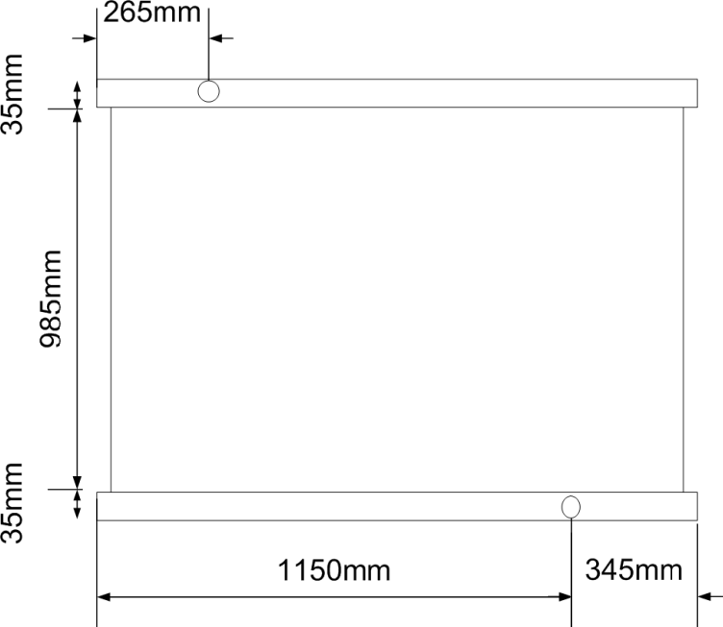

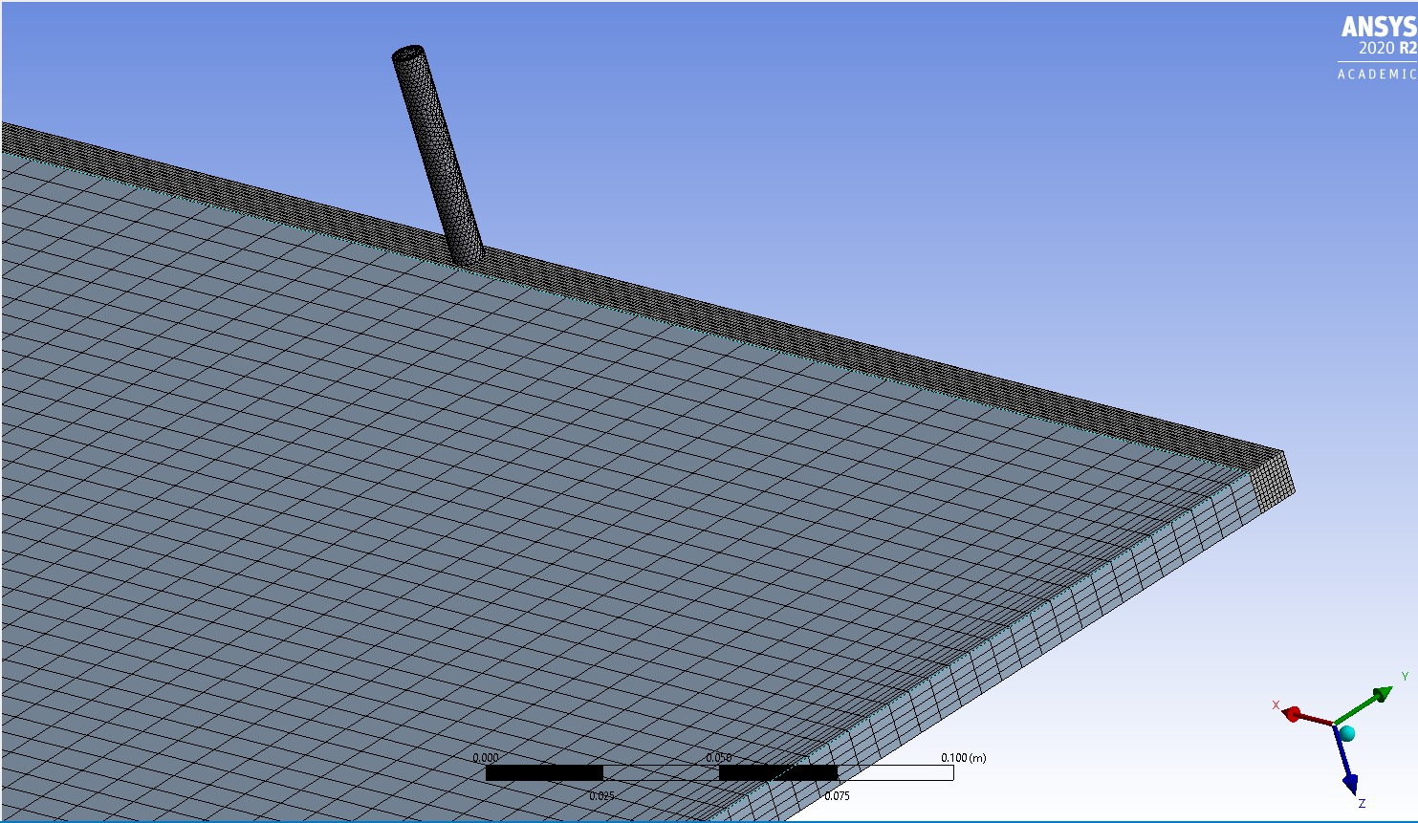

|  |  |
| --- | --- |
| Fig. 1.: FPC Measurements | Fig. 2: Overall view of the Mesh grid |

1. **RESULTS AND DISCUSSION**

The study aimed to develop a computational fluid dynamics (CFD) model of a polymer-based flat plate solar collector to examine its properties. The innovative design lacks an absorber plate and instead features a polymer honeycomb structure at the center, with water serving as the working fluid and heat absorber. The CFD model provides insights into the strengths and weaknesses of this novel design, offering a foundation for future research and potential modifications. The simulation successfully achieved convergence for the momentum, mass, and energy equations after 20,000 iterations. The convergence of the mass and momentum equations is illustrated in Figure 3, while the final state of heat transmission is depicted in Figure 4. The subsequent section will delve deeper into the design analysis, presenting the data and outcomes from the CFD model.

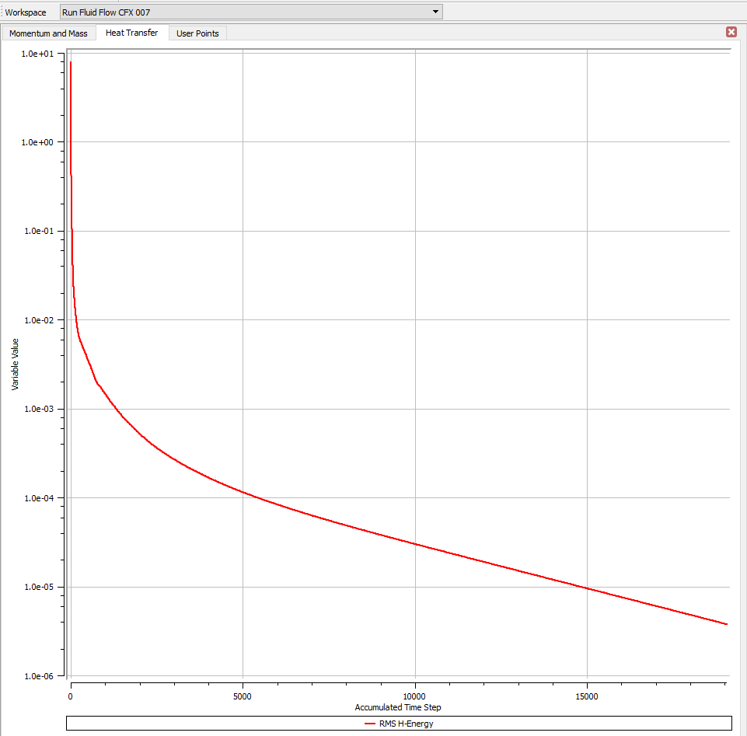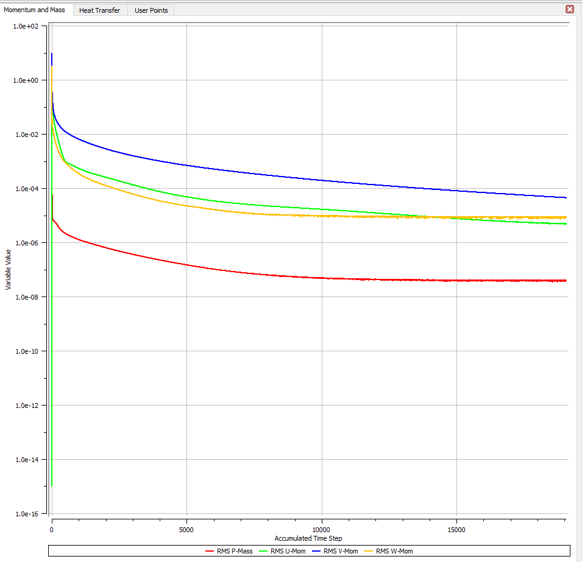

|  |  |
| --- | --- |
| Figure 3: Momentum and mass convergence | Figure 4: heat transfer curve |

* 1. **Temperature Pattern**

The temperature distribution throughout a middle plan in XY axis in the collector area is shown in Figure 5. The images reveal a noticeable central region in the solar collector where the highest temperatures are concentrated, angled toward the top. While the CFD model uses 303K as the input temperature and the experimental model uses 295K, both show similar overall patterns despite color differences due to scale. The upper left and right sections consistently exhibit higher temperatures, indicating potential fluid stagnation or circular streams. The slightly lower temperature in the top left compared to the top right suggests fluid flow patterns, with the top left outlet position facilitating the release of trapped fluid. The coolest areas, marked by blue lines, are located around the inlet and outlet pipes, where fluid flows more freely, contrasting with other regions where fluid entrapment might occur.

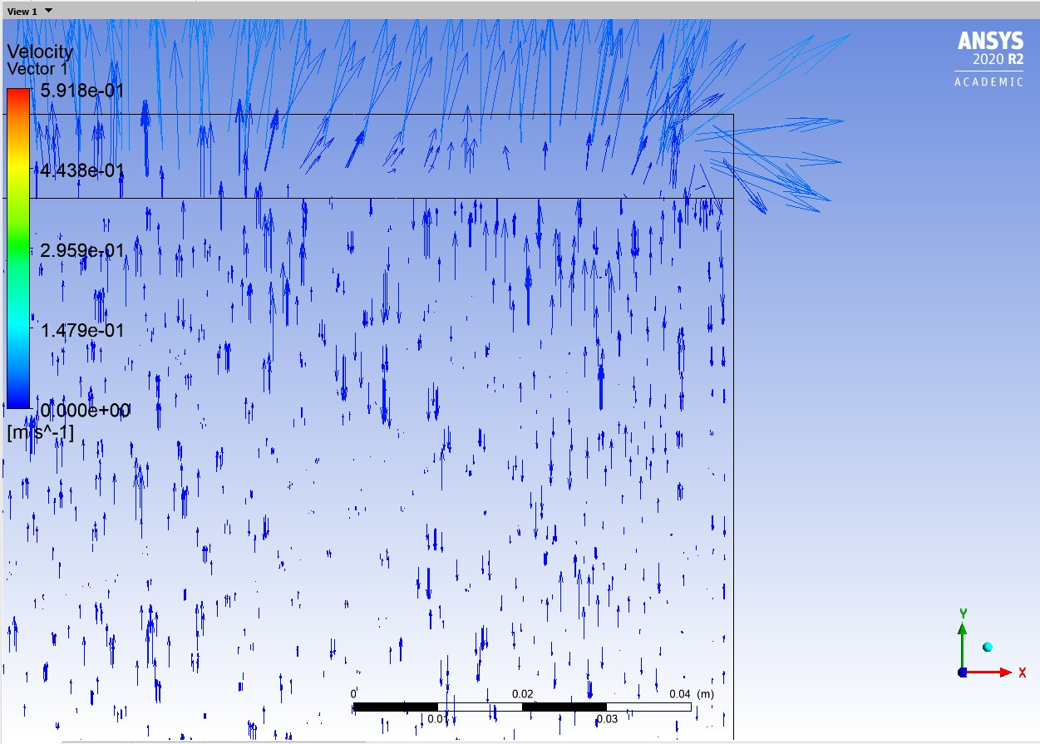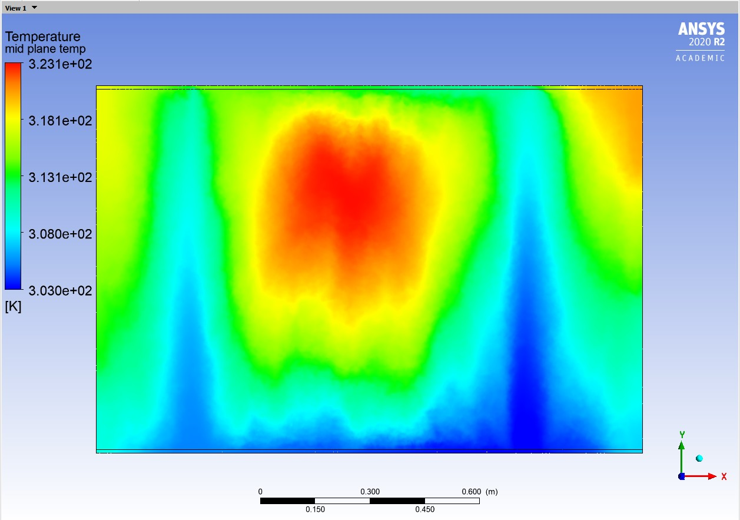

|  |  |
| --- | --- |
| Figure 5: Middle plane temperature | Figure 6: Top right region velocity vectors |

* 1. **Flow Pattern and Velocity**

The Velocity distribution throughout a middle plan in XY axis in the collector area is shown in Figure 6 which was created by a vector plane in ANSYS. The experimental and CFD models show different patterns, largely due to limitations in the CFD model caused by the mesh grid size in the student edition of ANSYS. Both models feature two main streamlines—fluid flow columns above and below the inlet and outlet pipes. However, the experimental model displays a broader lower half of these columns compared to the CFD model, due to the coarse mesh grid in CFD. This coarse mesh limits the ability to capture precise flow patterns, reducing accuracy and leading to some loss of information. Despite these limitations, the CFD model successfully captures the essential stream columns necessary for analysis. Both models indicate areas of flow recirculation, particularly in the upper right corner of the collector. In Figure 7, the focused view of this area shows expected recirculation streams in the honeycomb channels, with arrows pointing downward, indicating fluid trapping in the heat flux region. Ideally, all arrows should point upward, showing no recirculation. The left upper corner shows less recirculation due to its proximity to the outlet pipe, which allows trapped water to flow toward the exit.

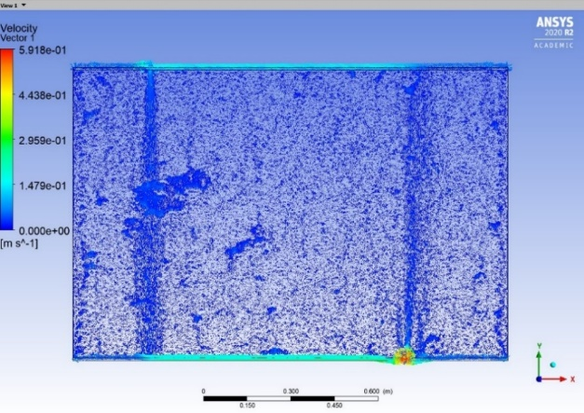

Figure 7: CFD flow pattern

* 1. **Pressure Contour**

The total static pressure drop in the collector is a combination of two factors: pressure drop in the honeycomb structure, calculated using the Hagen-Poiseuille formula, and the effect of gravity, which is the main contributor to the overall pressure decrease. The honeycomb zone's low flow velocity (~0.1 m/s) results in a minimal pressure drop, and variations in flow velocity have little impact on the static pressure distribution within this zone. While velocity distribution doesn't significantly affect static pressure, it's important for understanding different flow regions in the collector. Figure 8 shows that static pressure distribution is highly dependent on height, with an increase in height leading to a conversion of static pressure into hydrostatic pressure, thereby reducing static pressure. As the flow progresses through the collector, pressure losses increase. The asymmetric placement of the inlet and outlet pipes causes different flow velocities, leading to earlier pressure loss on the left side of the collector compared to the right.

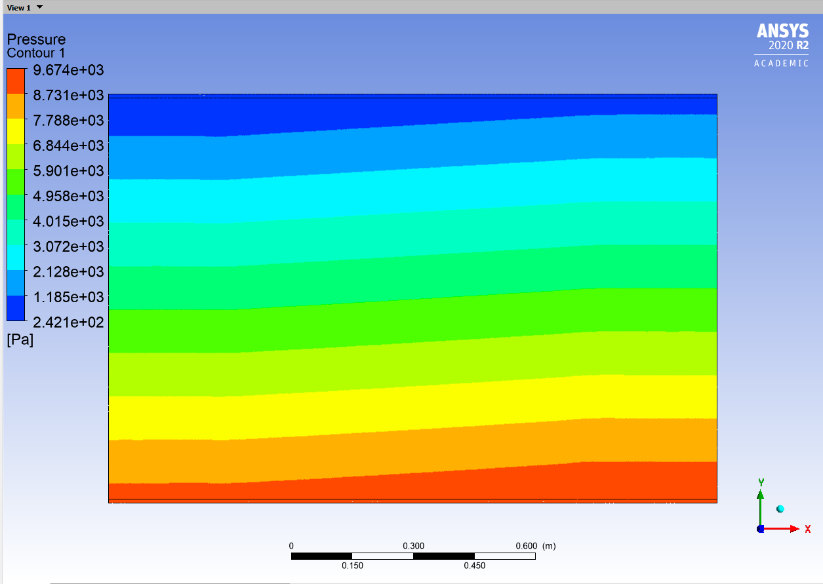

Figure 8: Pressure contour at the middle plane

1. **CONCLUSION**

The novel flat plate collector design replaces traditional metal riser pipes with a transparent polymer honeycomb structure and uses black-colored water as the working fluid, eliminating the need for a metal absorber plate. This design reduces production costs, simplifies manufacturing, and avoids issues like thermal conduction and bonding seen in classic designs. Polymer collectors offer advantages such as reduced system weight by up to 50% and improved durability by preventing corrosion. A CFD investigation conducted using ANSYS Workbench R20, compared with experimental data, revealed that the collector's average efficiency matches that of low-cost market alternatives. The CFD model accurately depicted flow behavior and temperature distribution, highlighting problematic regions that affect efficiency. The study supports the use of CFD for future optimization and improvement of the polycarbonate flat plate collector design.

1. **REFERENCES**
2. Jie Ji, Gang Pei, Tintai Chow, Keliang Liu, et al., Experimental study of photovoltaic solar assisted heat pump system, Sol. Energy 82 (2008) 43e52.
3. Earle Wilson, Theoretical and operational thermal performance of a ‘wet’ crystalline silicon PV module under Jamaican conditions, Renew. Energy 34 (2009) 1655e1660.
4. Minglu Qu, Jianbo Chen, Linjie Nie, Fengshu Li, Yu Qian, Wang Tan, Experimental study on the operating characteristics of a novel photovoltaic/thermal integrated dualsource heat pump water heating system, Appl. Therm. Eng. 94 (2016) 819e826.
5. Rithy Kong, Thoranis Deethayat, Attakorn Asanakham, Tanongkiat Kiatsiriroat, Performance and economic evaluation of a photovoltaic/thermal (PV/T)cascade heat pump for combined cooling, heat and power in tropical climate area, J. Energy Storage 30 (2020), 101507.
6. A. James, M. Srinivas, M. Mohanraj, Arun K. Raj, S. Jayaraj, Experimental studies on photovoltaicthermal heat pump water heaters using variable frequency drive compressors, Sustain. Energy Technol. Assessments 45 (2021), 101152.
7. Francesco Calise, Massimo Dentice d'Accadia, Rafal Damian Figaj, Laura Vanoli, A novel solarassisted heat pump driven by photovoltaic/thermal collectors: dynamic simulation and thermoeconomic optimization, Energy 95 (2016) 346e366.
8. J.A. AguilarJimenez, L. HernandezCallejo, et al., Technoeconomic analysis of hybrid PV/T systems under different climate scenarios and energy tariffs, Sol. Energy 212 (2020) 191e202.
9. Khoa Xuan Le, Ming Jun Huang, Nikhilkumar N. Shah, Christopher Wilson, et al., Technoeconomic assessment of cascade airtowater heat pump retrofitted into residential buildings using experimentally validated simulations, Appl. Energy 250 (2019) 633e652.
10. Swapnil Dubey, S.C. Solanki, Arvind Tiwari, Energy and exergy analysis of PV/T air collectors connected in series, Energy Build. 41 (2009) 863e870.
11. Xiaolin Sun, Jingyi Wu, Ruzhu Wang, Exergy analysis and comparison of multifunctional heat pump and conventional heat pump systems, Energy Convers. Manag. 73 (2013) 51e56.
12. Erhan Arslan, Mustafa Aktas, Omer Faruk Can, Experimental and numerical investigation of a novel photovoltaic thermal (PV/T) collector with the energy and exergy analysis, J. Clean. Prod. 276 (2020), 123255.
13. Liming Liu, Zeyu Li, Jing Yue, Shiliang Lv, Energetic, economic and environmental study of cooling capacity for absorption subsystem in solar absorptionsubcooled compression hybrid cooling system based on data of entire working period, Energy Convers. Manag. 167 (2018) 165e175.
14. Qunli Zhang, Lin Zhang, Jinzhe Nie, Yinlong Li, Technoeconomic analysis of air source heat pump applied for space heating in northern China, Appl. Energy 207 (2017) 533e542.
15. Baomin Dai, Haifeng Qi, Wanbin Dou, et al., Life cycle energy, emissions and cost evaluation of CO2 air source heat pump system to replace traditional heating methods for residential heating in China: system configurations, Energy Convers. Manag. 218 (2020), 112954.
16. Liangfeng Xu, Enteng Li, Yingjie Xu, Ning Mao, et al., An experimental energy performance investigation and economic analysis on a cascade heat pump for hightemperature water in cold region, Renew. Energy 152 (2020) 674e683.
17. Xiaoqiong Li, Yufeng Zhang, Lei Fang, et al., Energy, exergy, economic, and environmental analysis of an integrated system of hightemperature heat pump and gas separation unit, Energy Convers. Manag. 198 (2019), 111911.
18. Yingjie Xu, Ning Jiang, Fan Pan, et al., Comparative study on two lowgrade heat driven absorptioncompression refrigeration cycles based on energy, exergy, economic and environmental (4E) analyses, Energy Convers. Manag. 133 (2017) 535e547.
19. Yikai Wang, Zuliang Ye, Yulong Song, et al., Energy, exergy, economic and environmental analysis of refrigerant charge in air source transcritical carbon dioxide heat pump water heater, Energy Convers. Manag. 223 (2020), 113209.
20. Saxena A, Agarwal N, Cuce E. Thermal performance evaluation of a solar air heater integrated with helical tubes carrying phase change material. J Storage Mater 2020 Aug;1(30):101406.