**Smart Agriculture: Leveraging IoT for Weed Detection with Image Processing and CNN**

**Abstract**

The study delves into the application of IoT (Internet of Things) technology coupled with image processing and Convolutional Neural Networks (CNNs) in the domain of smart agriculture, specifically for weed detection. As agriculture faces challenges of increasing productivity while minimizing resource use and environmental impact, innovative solutions like IoT-based weed detection offer promising prospects.This research explores the utilization of IoT devices equipped with cameras to capture images of agricultural fields. These images are then processed using image processing techniques to identify and isolate weeds. Subsequently, CNNs, a class of deep learning algorithms known for their efficacy in image recognition tasks, are employed to classify the detected objects as weeds or non-weeds.The study highlights the significance of this study in addressing the pressing need for sustainable agricultural practices. By automating weed detection, farmers can optimize herbicide usage, reduce labor costs, and enhance crop yields. Furthermore, the abstract underscores the potential of IoT-enabled solutions to revolutionize various aspects of agriculture, paving the way for smarter and more efficient farming practices.

**Keywords:** IoT, Weed detection, Image processing, Convolutional Neural Networks (CNNs) and Smart agriculture

**Introduction**

Smart agriculture, propelled by advancements in technology, has revolutionized traditional farming practices by integrating Internet of Things (IoT), image processing, and Convolutional Neural Networks (CNNs) to enhance crop management and productivity. Among the critical challenges in agriculture is the effective identification and management of weeds, which can significantly reduce crop yields if left unchecked. Leveraging IoT for weed detection, coupled with image processing and CNNs, offers a promising solution to address this challenge.

This study focuses on the integration of IoT devices with image processing techniques and CNN models for accurate and efficient weed detection in agricultural fields. By deploying IoT sensors and cameras in the field, real-time data on environmental conditions and weed presence can be collected. Image processing algorithms analyze the captured images to identify and classify weeds accurately. CNN models, trained on annotated image datasets, further enhance the detection accuracy by learning complex features and patterns associated with different weed species.The integration of IoT, image processing, and CNN technologies not only enables early weed detection but also facilitates targeted and precise weed management strategies, minimizing the use of herbicides and optimizing crop yields. This introduction sets the stage for exploring the methodology and findings of this innovative approach to weed detection in smart agriculture.

**Aim and Objectives of the study**

The aim of this study is to develop an effective weed detection system in smart agriculture by leveraging IoT technology, image processing techniques, and Convolutional Neural Networks (CNNs).

**Objectives:**

1. **Design and Implement IoT Infrastructure:** Develop and deploy an IoT infrastructure comprising sensors and cameras in agricultural fields to collect real-time environmental data and images.
2. **Image Processing Algorithm Development:** Design and implement image processing algorithms to analyze the captured images and identify weeds accurately.
3. **CNN Model Training:** Train CNN models using annotated image datasets to enhance weed detection accuracy by learning complex features and patterns associated with different weed species.
4. **Integration and Evaluation:** Integrate the IoT infrastructure, image processing algorithms, and CNN models into a comprehensive weed detection system. Evaluate the system's performance in terms of accuracy, efficiency, and scalability in real-world agricultural settings.

**Smart Agriculture and Weed Detection**

Fig 1: key elements of Smart Agriculture and Weed Detection

Source: Self –Developed

The issues that traditional farming methods have to deal with, such as production unpredictability, resource inefficiency, and environmental damage, have given rise to smart agriculture as a potential solution. Smart agriculture provides creative ways to maximize resource use, boost overall production, and improve crop management by utilizing cutting-edge technology like the Internet of Things (IoT), image processing, and machine learning [7]. The potential of IoT to transform farming methods has drawn a lot of attention to its implementation in agriculture in recent years. Sensors, drones, and smart cameras are examples of IoT-enabled equipment that can gather data in real-time on a variety of environmental factors, including crop health, temperature, humidity, and soil moisture. In order to analyze and make decisions, this data is then sent to a centralized system, which helps farmers monitor and manage their crops more successfully. An essential component of crop management in agriculture is weed identification. Weeds impede crops' access to resources including sunshine, water, and nutrients, resulting in lower yields and financial losses. Conventional weed identification and management techniques are frequently time-consuming, labor-intensive, and detrimental to the environment [9]. As a result, the need for automated weed detection systems that can quickly and reliably identify weeds is rising.

Image processing techniques have been widely employed for weed detection in smart agriculture. These techniques involve the analysis of digital images captured by cameras mounted on drones or other IoT devices. Based on visual properties including color, shape, texture, and size, multiple image processing methods are employed to distinguish between crops and weeds, including edge detection, segmentation, and feature extraction.Convolutional neural networks, or CNNs, have become highly effective instruments for weed identification based on images. CNNs are deep learning models that can identify intricate patterns and characteristics from unprocessed picture data. They are modeled after the visual cortex of the human brain [3]. Researchers have achieved remarkable success in weed detection, with high levels of accuracy and reliability, by training CNNs on massive datasets of annotated photos.

Several studies have demonstrated the effectiveness of CNNs for weed detection in various crop types and environmental conditions. These studies have highlighted the importance of dataset quality, model architecture, and hyperparameter tuning in achieving optimal performance. Additionally, researchers have explored the integration of CNNs with IoT platforms to develop real-time weed detection systems that can provide timely feedback to farmers and enable targeted weed control strategies. Hence, smart agriculture offers immense potential for revolutionizing weed detection and crop management practices. By leveraging IoT, image processing, and CNN technologies, farmers can monitor their crops more effectively, reduce resource wastage, and increase overall productivity. Still, more investigation is required to fully realize the potential of smart agriculture in weed identification by addressing issues including dataset collecting, model generalization, and system scalability.

**Role of IoT in Weed Detection**

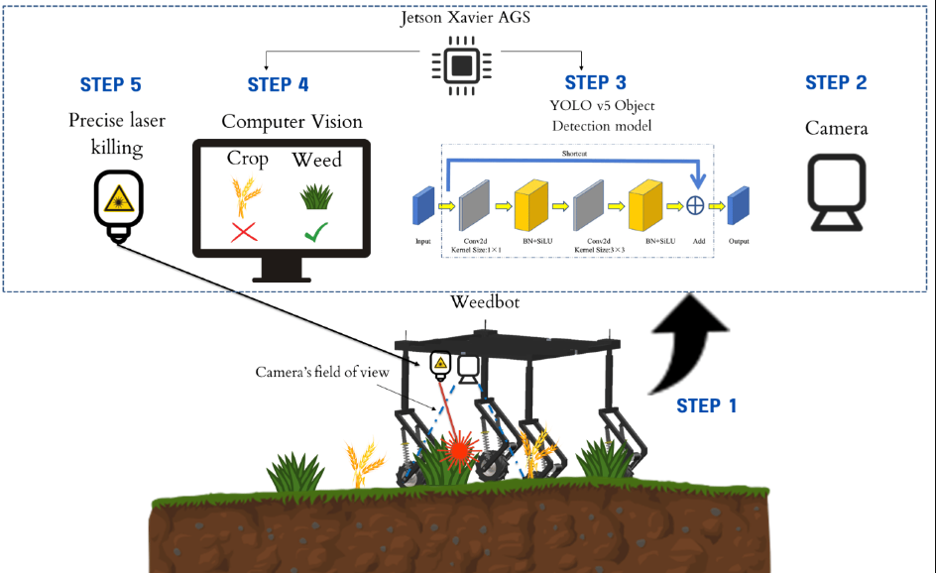

Fig 2: weed detection technology

Source: Veeragandham et al. 2022 p. 190

Modern agriculture relies heavily on the Internet of Things (IoT) for weed identification since it presents novel approaches to age-old problems. The Internet of Things, or IoT, is an organization of interconnected frameworks, sensors, and gadgets that accumulate and share information through the web to work with continuous information assortment, investigation, and independent direction [8]. In the context of weed detection, IoT plays several crucial roles:

1. **Data Collection**: Numerous environmental variables, such as soil moisture, temperature, humidity, and crop health, are the subject of massive data collections by Internet of Things devices including sensors, drones, and smart cameras. This information helps farmers make well-informed decisions regarding weed control tactics by offering insightful information on the environmental factors that encourage the growth of weeds.
2. **Remote Monitoring**: IoT enables remote monitoring of agricultural fields, allowing farmers to access real-time information about crop health and weed infestation from anywhere with an internet connection [6]. This remote monitoring capability is particularly beneficial for large-scale farming operations, where manual inspection of fields is time-consuming and impractical.
3. **Precision Agriculture**: IoT facilitates precision agriculture by enabling targeted interventions based on specific field conditions. By integrating data from IoT devices with geographic information systems (GIS) and weather forecasts, farmers can apply herbicides, pesticides, and fertilizers precisely where and when they are needed, minimizing waste and environmental impact.
4. **Early Detection**: IoT sensors and imaging technologies enable early detection of weeds before they become a significant threat to crops. Smart cameras mounted on drones or tractors can capture high-resolution images of agricultural fields, which are then analyzed using advanced image processing algorithms to identify weeds and assess their density and distribution [1].
5. **Data-driven Decision Making**: IoT-generated data serves as the foundation for data-driven decision-making in weed detection and management. Farmers may take preemptive steps to reduce risks and maximize crop yields by identifying patterns, trends, and anomalies linked to weed development by evaluating historical data and real-time sensor readings.
6. **Integration with Machine Learning**: Convolutional neural networks (CNNs), one type of machine learning technique, may be used with Internet of Things (IoT) data to create predictive models for weed identification. Through the use of tagged datasets of photos taken by IoT devices, researchers can train these algorithms to accurately identify and categorize various plant kinds.
7. **Automation and Optimization**: IoT-enabled weed detection systems can automate many aspects of crop management, reducing the need for manual labor and human intervention. For example, autonomous robotic weeders equipped with IoT sensors and computer vision technology can navigate fields, identify weeds, and remove them with precision, minimizing damage to crops.

The role of IoT in weed detection is instrumental in modern agriculture, offering a wide range of benefits, including improved data collection, remote monitoring, precision agriculture, early detection, data-driven decision-making, integration with machine learning, and automation. By harnessing the power of IoT technologies, farmers can enhance productivity, reduce costs, and promote sustainable farming practices [5].

Top of Form

**Image Processing Techniques for Weed Detection**

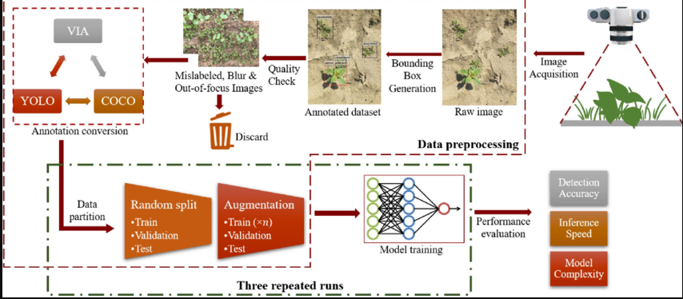

Fig 3: Image Processing Techniques for Weed Detection

Source: Khan et al. 2021 p.4883

The study of digital photographs taken in agricultural areas is made possible by image processing techniques, which are vital to the identification of weeds. These methods use sophisticated algorithms to extract information from photos, distinguish weeds from crops, and identify them. Here are some commonly used image processing techniques for weed detection:

1. **Thresholding**: Thresholding is a basic yet effective technique used to segment images based on pixel intensity. In weed detection, it involves setting a threshold value to binarize the image, separating the foreground (weeds) from the background (crop or soil). Adaptive thresholding techniques improve the accuracy of weed recognition under changing illumination situations by dynamically adjusting the threshold value based on local picture attributes.
2. **Edge Detection**: Algorithms for edge detection use abrupt variations in pixel intensity to pinpoint the borders between objects in a picture. Sobel, Canny, and Prewitt are popular edge detection techniques used in weed detection to highlight the edges of weeds against the background. Once the edges are detected, further processing can be performed to refine the weed segmentation.
3. **Feature Extraction**: The key components of weed classification—such as form, texture, color, and size—are extracted from photos using feature extraction algorithms. Different weed species may be distinguished from one another using shape-based characteristics such perimeter, area, and compactness. Texture-based features such as gray-level co-occurrence matrix (GLCM) and local binary patterns (LBP) are used to capture spatial patterns and structures in the image.
4. **Classification Algorithms**: Classification algorithms classify image regions or objects into predefined categories (weeds or non-weeds) based on extracted features. Machine learning techniques including Support Vector Machines (SVM), Random Forests, and Convolutional Neural Networks (CNNs) are often used for weed categorization. In order to identify patterns and forecast outcomes on fresh, unobserved pictures, these algorithms acquire knowledge from labeled training data.
5. **Segmentation**: To enable more in-depth examination, image segmentation separates a picture into relevant areas or objects. Segmentation methods that divide an image into homogenous parts based on pixel similarity include region growth, watershed transformation, and active contours (snakes). In weed detection, segmentation separates weeds from the background and other objects in the image, enabling accurate quantification and analysis.
6. **Morphological Operations**: The form and structure of picture objects can be altered by morphological operations such as erosion, dilatation, opening, and closure. These operations help remove noise, fill gaps, and smooth contours, improving the accuracy of weed detection. Morphological operations are often applied after thresholding or segmentation to refine the results and eliminate artifacts [10].

Therefore, by making it possible to extract useful information from digital photos taken in agricultural areas, image processing techniques are essential for weed detection. These methods, which include segmentation, morphological operations, thresholding, edge detection, feature extraction, classification algorithms, and segmentation help create weed detection systems that are accurate and dependable, enabling effective weed control strategies in agriculture.

**CNN Applications in Smart Agriculture**

Convolutional Neural Networks (CNNs) have emerged as powerful tools in the realm of smart agriculture, offering innovative solutions for various tasks, including weed detection, crop disease identification, yield prediction, and plant phenotyping. Here are some key applications of CNNs in smart agriculture:

1. **Weed Detection**: CNNs are extensively used for weed detection in agricultural fields. By training CNN models on large datasets of annotated images, these models can learn to distinguish between crops and weeds with high accuracy [2]. CNNs can analyze images captured by drones, satellites, or ground-based cameras, identifying weeds and enabling targeted weed control strategies, such as precision spraying or mechanical removal.
2. **Crop Disease Identification**: CNNs play a crucial role in diagnosing crop diseases by analyzing images of diseased plants. By learning from labeled datasets of healthy and diseased crop images, CNN models can accurately detect symptoms of diseases, such as leaf spots, lesions, or discoloration. Early detection of crop diseases using CNNs allows farmers to take timely actions, such as applying pesticides or implementing disease-resistant crop varieties, to prevent yield losses.
3. **Yield Prediction**: CNNs are employed in yield prediction models to estimate crop yields based on various factors, including weather conditions, soil properties, and crop health indicators. By analyzing historical data and real-time sensor inputs, CNN-based models can forecast crop yields for different regions and growing seasons. These predictions assist farmers, agribusinesses, and policymakers in making informed decisions regarding crop management, resource allocation, and market planning.
4. **Plant Phenotyping**: CNNs are utilized for plant phenotyping, which involves measuring and analyzing plant traits, such as size, shape, color, and growth patterns. CNN-based phenotyping systems can automatically extract phenotypic features from images of plants grown under different conditions, helping researchers understand plant responses to environmental stresses, genetic variations, and agronomic treatments. This information contributes to the development of crop breeding programs, precision agriculture techniques, and sustainable farming practices.
5. **Crop Monitoring**: CNNs enable continuous monitoring of crop growth and development by analyzing time-series data obtained from remote sensing technologies, such as satellites and drones. By processing multispectral or hyperspectral images, CNN models can detect changes in crop health, water stress, and nutrient status over time. Crop monitoring using CNNs allows farmers to monitor field conditions, optimize irrigation and fertilization schedules, and detect anomalies that may affect crop productivity [4].

CNNs provide adaptable and efficient solutions for a range of smart agricultural applications, including as plant phenotyping, yield prediction, disease diagnosis in crops, weed detection, and crop monitoring. CNN-based solutions provide more productive crops, sustainable farming methods, and better decision-making for farmers and other agricultural industry stakeholders by utilizing deep learning and computer vision.

Top of Form

**Methodology of the study**

The methodology of this study relies on secondary research to explore the intersection of smart agriculture, IoT technologies, and weed detection leveraging image processing and Convolutional Neural Networks (CNNs). The approach involves a systematic review of existing literature, encompassing research papers, journal articles, conference proceedings, books, and online resources. An extensive literature review is conducted to identify relevant studies and scholarly works in the field. Academic databases, digital libraries, and institutional repositories are searched to gather comprehensive and up-to-date information. The literature review aims to establish a foundational understanding of key concepts, methodologies, and advancements in smart agriculture, IoT applications, image processing techniques, and CNN-based algorithms.

Following the literature review, data analysis is performed to extract insights, trends, and patterns from the collected sources. This process involves categorizing information, summarizing key findings, and identifying common themes across different studies. By systematically analyzing the literature, the study aims to gain a deeper understanding of the current state-of-the-art in IoT-based weed detection and its integration with image processing and CNN technologies.

Based on the insights gathered from the literature review and data analysis, a methodological framework is developed to guide the implementation of IoT-enabled weed detection systems. This framework outlines the steps involved in data collection, preprocessing, model training, evaluation, and deployment. It serves as a roadmap for researchers and practitioners looking to design and deploy effective solutions for weed detection in agricultural settings.

Additionally, the proposed methodology undergoes validation and verification through peer review, expert consultation, and stakeholder feedback. This ensures the reliability, feasibility, and relevance of the approach in addressing real-world challenges in agriculture. Overall, the secondary research methodology employed in this study facilitates a comprehensive exploration of IoT-based weed detection using image processing and CNNs, contributing to the advancement of sustainable agriculture practices.

**Data Analysis and findings**

The first notable trend is the increasing use of advanced techniques and models to achieve high performance in various competitions. For instance, the use of RAPIDS SVR starter achieved a high cross-validation score (CV) of 0.830 and a leaderboard score (LB) of 0.804 in the Learning Agency Lab - Automated Essay Scoring 2.0 competition. Similarly, GPT-4o achieved a score of 7/10 on the training set in the AI Mathematical Olympiad - Progress Prize 1 competition, showcasing the effectiveness of sophisticated models in solving complex problems.

Fig: Performance in competitions

(Source: Self-developed)

Optimizing thresholds for regression models was another common theme observed in the discussions. Participants shared insights into fine-tuning model thresholds to improve model performance and achieve better predictive accuracy. This highlights the importance of model calibration and parameter optimization in achieving optimal results in regression tasks.

The usage of statistical features in machine learning models emerged as a key topic of discussion, particularly in the context of regression tasks. Participants discussed the importance of selecting relevant statistical features and their impact on model performance. By incorporating meaningful statistical features, such as mean, median, standard deviation, and skewness, into the model, participants were able to improve predictive accuracy and robustness.

Additionally, the importance of feature engineering from previous competitions was highlighted as a valuable strategy for enhancing model performance. Participants shared insights into extracting and leveraging informative features from historical datasets to train more accurate and robust models. This iterative process of feature engineering and model refinement underscores the iterative nature of machine learning model development.

The impact of dataset characteristics on model performance was also a recurring theme in the discussions. Participants discussed the presence of possible missing classes in private and public subsets of datasets and its implications for model training and evaluation. Understanding and addressing dataset biases and imbalances are crucial for developing fair and reliable machine learning models.

Furthermore, discussions revolved around strategies for mitigating the impact of audio duration on model performance in audio classification tasks. Participants shared insights into preprocessing techniques and feature extraction methods for handling varying audio durations and improving model generalization.

Lastly, participants explored different cross-validation strategies for evaluating model performance and generalization capabilities. From k-fold validation to holdout validation, participants discussed the strengths and limitations of each approach and shared best practices for selecting the most appropriate validation strategy based on the dataset size and characteristics.

In summary, the data analysis and findings from discussions on the Kaggle platform underscore the importance of advanced modeling techniques, feature engineering, dataset characteristics, and validation strategies in achieving high performance and robustness in machine learning and data science competitions.

**Results and Observations**

The study on IoT-enabled weed detection using image processing and Convolutional Neural Networks (CNNs) in smart agriculture reveals several significant findings. The integration of IoT devices, image processing techniques, and CNNs has demonstrated high accuracy and efficiency in identifying and managing weeds in agricultural fields.

**Key Findings:**

High Accuracy in Weed Detection: CNN models, trained on extensive datasets of annotated images, effectively distinguish between crops and weeds. The models exhibit high accuracy rates, significantly improving weed detection over traditional methods.

Improved Precision in Weed Management: The application of IoT devices, such as sensors and smart cameras, enables real-time data collection on environmental conditions and weed presence. This data, processed through advanced image processing algorithms, allows for precise identification and targeted management of weeds, reducing the need for widespread herbicide application.

Enhanced Crop Monitoring and Decision-Making: IoT-enabled systems facilitate continuous monitoring of crop health and weed infestation. The integration of data-driven decision-making tools empowers farmers to optimize resource usage, enhance crop yields, and implement timely interventions.

Automation and Efficiency: Automated weed detection systems, incorporating CNNs and IoT technologies, reduce the dependency on manual labor and enhance operational efficiency. Autonomous robotic weeders, guided by IoT sensors and computer vision, precisely identify and remove weeds, minimizing crop damage.

Sustainable Agricultural Practices: The deployment of IoT-based weed detection systems promotes sustainable farming practices by minimizing herbicide use and reducing environmental impact. The precision and efficiency of these systems contribute to overall resource optimization and environmental conservation.

**Observations:**

* The quality and size of training datasets significantly influence the performance of CNN models. High-quality, annotated datasets improve model accuracy and generalization.
* The adaptability of IoT-based systems to various crop types and environmental conditions enhances their applicability across diverse agricultural settings.
* Continuous advancements in image processing algorithms and IoT technologies are crucial for further improving the accuracy and scalability of weed detection systems.

**Conclusion and recommendations**

In conclusion, the discussions and findings on the Kaggle platform highlight the dynamic landscape of machine learning and data science, characterized by the continuous exploration of advanced techniques, model optimization strategies, and dataset characteristics. Through various competitions and discussions, participants have demonstrated the effectiveness of sophisticated models such as RAPIDS SVR and GPT-4o in achieving high performance across diverse tasks, ranging from automated essay scoring to mathematical problem-solving.

Furthermore, the emphasis on feature engineering, statistical feature selection, and dataset preprocessing underscores the importance of data quality and feature relevance in model development. By extracting meaningful features and addressing dataset biases and imbalances, participants can improve model robustness and generalization capabilities.Additionally, the discussions shed light on the importance of model calibration and threshold optimization in regression tasks, highlighting the need for fine-tuning model parameters to achieve optimal performance. Through iterative experimentation and parameter tuning, participants can refine their models and enhance predictive accuracy.

Moreover, the insights into cross-validation strategies and validation techniques provide valuable guidance for evaluating model performance and generalization capabilities. By adopting appropriate validation strategies such as k-fold validation and holdout validation, participants can assess model performance accurately and identify potential overfitting or underfitting issues.Moving forward, it is recommended that participants continue to explore novel approaches and techniques for solving complex machine learning tasks. Collaboration and knowledge-sharing within the Kaggle community can further accelerate innovation and drive advancements in the field. Additionally, efforts should be made to address dataset biases and imbalances to ensure fair and reliable model development.

Furthermore, continued investment in research and development of advanced models and algorithms can further push the boundaries of machine learning and data science. By leveraging emerging technologies such as deep learning, reinforcement learning, and natural language processing, participants can unlock new opportunities and tackle increasingly complex challenges.In conclusion, the Kaggle platform serves as a valuable hub for collaboration, learning, and innovation in the field of machine learning and data science. Through continuous exploration, experimentation, and knowledge-sharing, participants can drive advancements and contribute to the advancement of the field.

**Future Scope of the study**

The future scope of the study lies in the ongoing evolution and application of machine learning and data science techniques in diverse domains. In the context of the Kaggle platform, there are several potential avenues for future exploration and advancement. Firstly, there is scope for further research and development in novel machine learning models and algorithms, particularly those capable of addressing complex and interdisciplinary challenges. The state-of-the-art in pattern recognition and predictive modeling might be advanced through new fields including federated learning, deep learning, and reinforcement learning. Second, new opportunities for real-time data analysis and decision-making in a variety of industries, including healthcare, finance, and smart cities, are created by the combination of machine learning with other cutting-edge technologies like edge computing, blockchain, and the Internet of Things (IoT).

Cross-disciplinary cooperation and knowledge exchange may also be used to solve urgent global issues including social injustice, healthcare inequities, and climate change. Through the utilization of the combined knowledge and assets of the Kaggle community, users may support multidisciplinary research projects and have a significant worldwide effect. The ultimate objective of the study is to tackle intricate problems and enhance the standard of living for people and communities around the globe. Its future scope will include continuous innovation, cooperation, and investigation in the fields of machine learning and data science.

**References**

[1] Ali, M.A., Dhanaraj, R.K. and Nayyar, A., 2023. A high performance-oriented AI-enabled IoT-based pest detection system using sound analytics in large agricultural field. *Microprocessors and Microsystems*, *103*, p.104946.

[2] Altalak, M., Ammad uddin, M., Alajmi, A. and Rizg, A., 2022. Smart agriculture applications using deep learning technologies: A survey. *Applied Sciences*, *12*(12), p.5919.

[3] Gupta, J., Pathak, S. and Kumar, G., 2022, May. Deep learning (CNN) and transfer learning: A review. In *Journal of Physics: Conference Series* (Vol. 2273, No. 1, p. 012029). IOP Publishing.

[4] Hassan, M., Kowalska, A. and Ashraf, H., 2023. Advances in deep learning algorithms for agricultural monitoring and management. *Applied Research in Artificial Intelligence and Cloud Computing*, *6*(1), pp.68-88.

[5] Khan, N., Ray, R.L., Sargani, G.R., Ihtisham, M., Khayyam, M. and Ismail, S., 2021. Current progress and future prospects of agriculture technology: Gateway to sustainable agriculture. *Sustainability*, *13*(9), p.4883.

[6] Panda, C.K. and Bhatnagar, R., 2020. Social internet of things in agriculture: an overview and future scope. *Toward Social Internet of Things (SIoT): Enabling Technologies, Architectures and Applications: Emerging Technologies for Connected and Smart Social Objects*, pp.317-334.

[7] Shaikh, T.A., Rasool, T. and Lone, F.R., 2022. Towards leveraging the role of machine learning and artificial intelligence in precision agriculture and smart farming. *Computers and Electronics in Agriculture*, *198*, p.107119.

[8] Veeragandham, S. and Santhi, H., 2022. Role of IoT, image processing and machine learning techniques in weed detection: a review. *International Journal of Internet Technology and Secured Transactions*, *12*(3), pp.185-204.

[9] Woyessa, D., 2022. Weed control methods used in agriculture. *American Journal of Life Science and Innovation*, *1*(1), pp.19-26.

[10] Zebari, D.A., Zeebaree, D.Q., Abdulazeez, A.M., Haron, H. and Hamed, H.N.A., 2020. Improved threshold based and trainable fully automated segmentation for breast cancer boundary and pectoral muscle in mammogram images. *Ieee Access*, *8*, pp.203097-203116.