ANALYTICAL STUDY OF STEADY FLOW - CONVECTIVE HEAT TRANFSER IN CASE OF RADIATOR USING DISTILLED WATER
Raghavendra Prasad S.A,
¹Assistant Professor, Mechanical Engineering, Vivekananda College of Engineering & Technology, Mangalore, Karnataka, India.
ABSTRACT
The project focuses on the design and development of a radiator test rig to evaluate the heat transfer performance of different working fluids. The study aims to determine the rate of heat transfer using distilled water under turbulent flow condition to ensure proper distribution of flow and heat transfer. By conducting a series of controlled experiments, we measure and compare the thermal performance of each fluid under identical conditions. Distilled water was used as the baseline working fluid to establish a reference for heat transfer performance. The comprehensive analysis and experimental validation offer valuable contributions to the field, paving the way for future research and development in advanced cooling technologies.
Keywords: distilled water, research, analysis, fluid, radiator.
- INTRODUCTION
Heat transfer fluids are essential in various applications across industries due to their ability to efficiently carry and transfer heat. In the transportation industry, these fluids are used in vehicular cooling systems to dissipate heat from engine components, ensuring vehicles operate within safe temperature ranges. They are also critical in avionics cooling systems, where maintaining optimal temperatures for electronic components and avionics systems is vital for performance and safety. In buildings, heat transfer fluids play a key role in hydraulic heating and cooling systems, which distribute thermal energy for heating and cooling purposes in residential, commercial, and industrial settings. In industrial process heating and cooling, such as in petrochemical plants, textile manufacturing, pulp and paper processing, chemical production, and food processing plants, these fluids are used to manage temperatures and ensure efficient operation.
- METHODOLOGY
The methodology of a study of heat transfer performance of radiator using distilled water project involves the systematic approach and steps taken to design, develop, and implement. It starts with conducting a critical study of various research papers analyzing and evaluating existing research papers related to heat transfer performance. This method aims to gain a comprehensive understanding of the current state of knowledge, identify gaps or limitations in the existing research, and extract valuable results. Utilizing CAD software precise 2D and 3D models with specific dimensions for different components is created for the analysis purpose. Collecting components for the development of a radiator test rig. is a foundational step in bringing this innovative technology from concept to reality. Every component, from preparation of nanofluids to the heating mechanism of fluid, plays a crucial role in ensuring the thermal conductivity of the fluids and overall performance. For fabricating the test rig, various components were used to ensure a functional and effective setup. Angled bars and square bars formed the robust frame, providing stability and support. The setup allowed for thorough testing of the radiator's performance, including its cooling efficiency and the impact of the fan, by creating controlled and replicable conditions for measurement and analysis. To assess the radiator system's performance, conduct an experiment by measuring fluid temperatures at the inlet and outlet with the fan both on and off. Begin by recording temperatures with the fan off, allowing the system to stabilize. Then, switch the fan on and collect temperature data again under similar conditions. Analyze the temperature differences to determine the fan’s impact on cooling efficiency.

- MODELING AND FABRICATION
Solid Edge ST10 is computer-aided design (CAD) software developed by Siemens Digital Industries Software Company. It is a version of the Solid Edge software suite, which is designed to assist engineers and designers in creating 3D models and 2D drawings for various industries. We have used this software to create the 3D CAD model of the lawn trimmer. 3D models consist of creation of assembly structures, component relationships, and constraints.

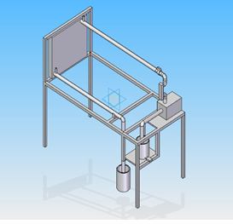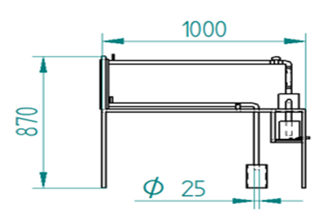
Figure 1: Isometric & Front View of the test rig model
The radiator's design, featuring a core with numerous small tubes and fins, maximizes surface area for efficient heat exchange. Coolant circulates through these tubes, absorbing heat from the engine, and then flows into the radiator where heat is transferred to the air passing through the fins. It consists of a vertical glass or plastic tube with a tapered shape and a float that rises or falls within the tube in response to the flow rate. A pump is used to move water operates by creating a flow of liquid from one location to another. It typically consists of an impeller or rotor that moves water through a chamber. As the impeller spins, it creates a low-pressure area that draws water into the pump and then forces it out through the discharge port. An immersion rod water heater as shown in Fig. 5.9 is a simple, portable device used to heat water. It consists of a metal rod with a heating element that is submerged directly into the water. When plugged into an electrical outlet, the heating element heats up, transferring heat to the water. A lithium-ion or Li-ion battery as shown in Fig. 5.10 is a type of rechargeable battery which uses the reversible reduction of lithium ions to store energy. A thermocouple with a display is a device designed to measure and show temperature readings.

- EXPERIMENT
Experiment begins by filling the collecting tank with water, ensuring that it is clean and free of debris. Fill the tank to the specified level or capacity, and check for any leaks to ensure the tank is secure. Heating system is used to heat the water and to reach the desired temperature. Monitor the temperature to ensure it stabilizes at the set point before moving on. Turn on the pump to begin circulating the water through the system & Verify that the pump is functioning correctly and there are no obstructions or unusual noises. Set the flow rate according to the experimental requirements using the flow control mechanism. Confirm the flow rate with a Rota meter, ensuring that it remains steady throughout the experiment. Place thermocouples at both the inlet and outlet of the radiator. Record the temperatures at these points while the water flows through the radiator to ensure accurate measurements. Perform the procedure for three trials with the radiator fan turned on. Record the temperature differences between the inlet and outlet for each trial. Repeat the procedure for another three trials with the radiator fan turned off, recording the temperature differences as before. Compare and analyze the temperature differences observed with the fan on versus off. Calculate the average temperature differences and evaluate the impact of the fan on radiator performance. Summarize the findings, including any notable variations or patterns. Use graphs or tables to present the data and draw conclusions based on the results. Provide any recommendations for further investigation or improvements based on the observed data.

- RESULTS AND DISCUSSION
In the heat transfer analysis of a fluid using a radiator, it was observed that the temperature of water at the outlet decreases more rapidly when the radiator fan is operational compared to when it is off. With the fan on, the enhanced airflow across the radiator improves heat dissipation, thus increasing the heat transfer coefficient between the radiator surface and the surrounding air. This results in a more effective cooling process, causing the outlet water temperature to drop faster. In contrast, when the fan is off, the reduced air movement leads to less efficient heat transfer, and the temperature decrease is slower.

Table 1. Result table for Case (1): When Radiator Fan is Switched OFF
Trial No. | Inlet Temperature T₁ (°C) | Outlet Temperature T₂ (°C) | Total Heat Transfer Q (kW)
1. | 40 | 37.9 | 0.439
2. | 50 | 46.7 | 0.690
3. | 60 | 55.9 | 0.858

Table 2. Result table for Case (1): When Radiator Fan is Switched ON
Trial No. | Inlet Temperature T₁ (°C) | Outlet Temperature T₂ (°C) | Total Heat Transfer Q (kW)
1. | 40 | 36 | 0.837
2. | 50 | 43.6 | 1.339
3. | 60 | 50.4 | 2.009
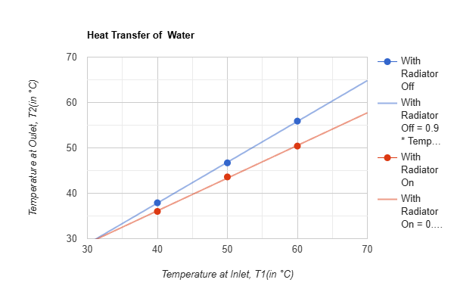
Figure 2: Graphical representation of experimental results
The fan’s operation leads to a greater rate of heat removal due to enhanced airflow. This results in a more efficient cooling process, causing a faster decrease in the temperature of the outlet fluid. The fan’s increased airflow raises the convective heat transfer coefficient, allowing the radiator to cool the fluid more effectively. Without the fan, the airflow is minimal, which reduces the rate of heat transfer from the radiator fins to the air. Consequently, the fluid exits at a higher temperature compared to when the fan is operational. Graph shown above illustrates this effect clearly, showing a steeper decline in the outlet water temperature when the fan is active. This graphical representation helps visualize the enhanced cooling performance provided by the fan.

- CONCLUSION
The analysis of heat transfer in the radiator system demonstrates a significant improvement in cooling efficiency when the radiator fan is activated. The data shows that the outlet water temperature decreases at a faster rate with the fan on compared to when it is off. This is attributed to the fan’s ability to enhance airflow across the radiator, which improves the heat dissipation process. The increased convective heat transfer coefficient resulting from the enhanced airflow allows for more effective cooling of the water, leading to a steeper temperature decline. Conversely, with the fan off, reduced air movement results in less efficient heat transfer and a slower rate of temperature reduction. Therefore, the findings underscore the importance of the radiator fan in optimizing heat transfer and cooling performance.

- REFERENCES
- D. Wen, G. Lin, S. Vafaei, & K. Zhang, “Review of nanofluids for heat transfer applications”, Particuology, Vol. 7, No. 2, 2009, pp. 141– 150.
- Choi, S. U. S., & Eastman, J. A. Enhancing thermal conductivity of fluids with nanoparticles. Proceedings of the ASME International Mechanical Engineering Congress and Exposition,1995, pp. 99-106.
- Ismail I.A., Yusoff M.Z., Ismail F.B & Gunnasegaran P. “Heat transfer enhancement with nanofluids: A review of recent applications and experiments”, International Journal of Heat and Technology, Vol. 36, No. 4, 2018, pp. 1350-1361.
- Ali, A. R. I., & Salam, B., A review on nanofluid: Preparation, stability, thermophysical properties, heat transfer characteristics, and application. Journal of Nanoscience and Nanotechnology, Vol.21, No. 4, 2021, pp. 3354-3375.

